Cavity enhanced light extraction from monolayer topological defects
Y. Cao, Y. J. Noori, J. Roberts, C. Woodhead, R. B. Gavito and R. J. Young
Physics Department, Lancaster University, Lancaster, LA1 4YB, U.K.
y.cao5@lancaster.ac.uk

The integration of two-dimensional transition metal dichalcogenides (TMDs) with nanoscale photonic structures, such as photonic crystal cavities [1] have recently emerged as a promising approach towards on-chip opto-electronic devices. Here we demonstrate a design of silicon photonic crystal [2], consisting of nano-rods arranged in a triangular lattice, with a defective cavity. The curvature of the monolayer suspended over the cavity induces lateral stress, which can promote the formation of topological defects close to the curvature minimum. We tuned the cavity to resonate with the emission wavelength of MoS₂ and showed substantial improvement to the overall optical efficiency. This result will allow topological defects in TMDs to be investigated under the light of a resonant cavity.
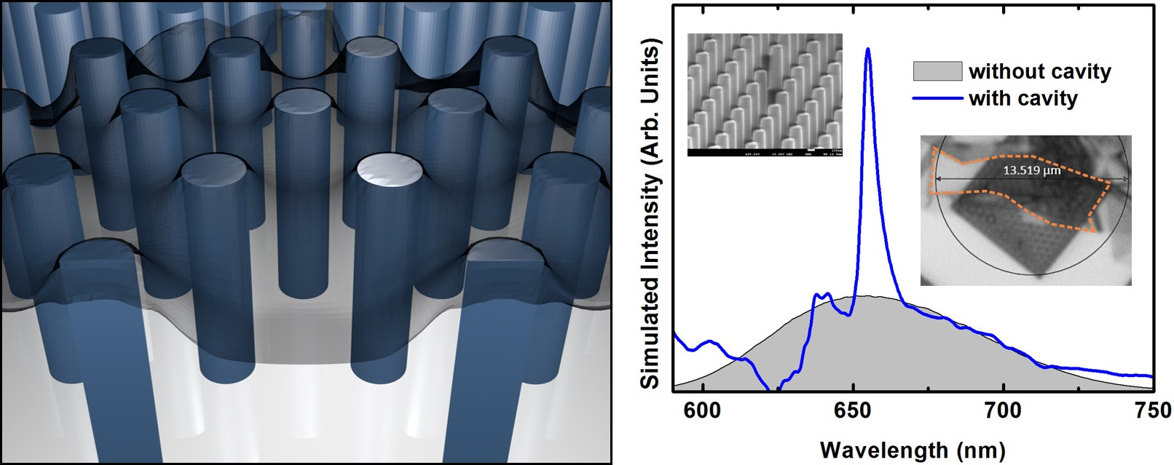Existing implementations of cavity controlled emission take advantage of slab photonic crystals, where vertical mode loss is minimised. However, spatial coupling between the cavity field maximum and the optically created excitons is limited due to geometry. Furthermore, monolayers transferred onto substrates using mechanical exfoliation or otherwise tend to have topological defects, including ripples, curvature and folds [3], further limiting the spatial coupling. We consider the alternative, where silicon nano-rods arranged in a triangular lattice provide both spectral and spatial coupling between the monolayer TMD and the cavity mode, due to the natural curvature of the suspended monolayer. We find up to 350% enhancement of collected power from cavity coupled emission, over a monolayer exfoliated on a flat substrate.
Figure 1: (Left) Illustration of nano-rods with a suspended monolayer. (Right) Simulated spectra from a monolayer suspended over a cavity and one on silicon/silicon dioxide substrate. Insets show the scanning electron micrograph of the nano-rods and an optical image of a MoS₂ flake transferred on top of a photonic crystal cavity, orange outline indicate the transferred flake.
[1] Sanfeng Wu et al., 2D Materials 1, 011001 (2014)
[2] Yasir J. Noori et al., arxiv:1607.04973 (2016)
[3] Zhong Lin et al, 2D Materials 3, 022002 (2016).

