Ontologies of…The Biosphere, Sex, the Artificial and Autonomous
Friday 24th June 2016 9.30am-4.30pm, The Reading Room, The Storey, Lancaster

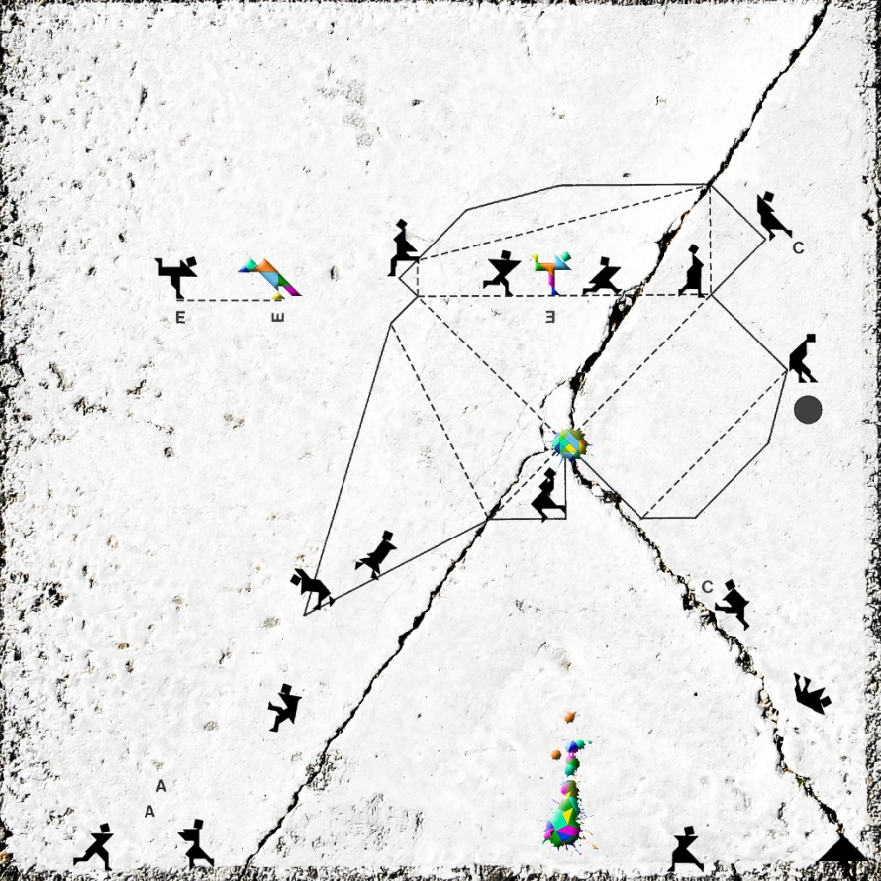

An interdisciplinary workshop organised by Centre for the Study of Environmental Change, Centre for Gender and Women's Studies and Centre for Science Studies, Lancaster University

This workshop aims to explore recent social and cultural engagements with ontology. It brings together researchers working in diverse disciplines interested in exploring what ontological politics might mean for ‘who, how and what’ we research. We will discuss key concepts such as Ontological Multiplicity. This suggests that there are not only many ways of knowing ‘an object’ – the biosphere, sex, the autonomous - but that there are many ways of practising it, that in turn enact different realities that are variously entangled and interdependent. A further implication is Ontological Politics. As we attend to specificity and learn to see multiplicity everywhere, a crucial issue becomes which differences we want to attend to and to make.

The workshop will explore two key questions:
- What are the realities of the biosphere/sex/the autonomous that are taking shape and that people are living with?
- What kinds of analytical, methodological and political interventions does this engagement with ontology make possible?
Programme
We hope that this workshop is a generative and enjoyable space in which to collectively explore what sociological and anthropological work about ontologies means for doing research and for political engagement in the realities that we study and bring into being.
Adrian, Claire, Celia and Vicky.

9. 30 – 10 Coffee/tea, biscuits and welcome.

Session 1

10 – 11 Javier Lezaun ‘A non-partisan (but opinionated) look at the ontological turn’
11 – 12 John Law ‘Ontological Suffocation: TEK, numbers and salmon’
12 – 12.30 Discussion and reflection on the workshop themes and key questions

12.30 – 1.45 Lunch
(The Hall, Trinity United Reformed Church, High Street, Lancaster, LA1 1LA)

Session 2

1.45 – 2.45 Theo Vurdubakis ‘‘Not a Place of Honor’: Risk, Organization and the Afterlives of Signs’
2.45 – 3 Coffee / tea
3 – 4 Hannah Knox 'Thinking like a Climate? An Anthropological Approach to Biospheric Ontology’
4 – 4.30 General discussion, reflection on the themes of the workshop and ideas for future workshops/collaborations

Hannah Knox is an anthropologist of the contemporary. She works at University College London. Her work explores the relationship between technology and the imagination, cultural creativity and material contingency, the politics of transformation and the challenge of the new. She has explored these issues through ethnographic research in the UK, Peru and Europe. She is interested in how people make worlds and worlds make people and has written about how culture permeates, shapes and is transformed by information systems, digital models, roads, energy infrastructure, carbon, and climate change. Her work explores how social/material entanglements and their negotiation, create both spaces for action and establish the limits of the possible. She is part of the Centre for Digital Anthropology at UCL and the Infrastructures and Social Change group at the ESRC Centre for Socio-Cultural Change.
Javier Lezaun is Lecturer in Science and Technology Governance, and Deputy Director of the Institute for Science, Innovation and Society, University of Oxford. He studied sociology and political science at the University of Deusto in Bilbao, and received a PhD in Science and Technology Studies from Cornell University. His research focuses on the relationship between scientific and political change and explores the formation of public and counter-publics around new technologies, and the role of the social sciences in fostering new forms of citizen participation and democratic governance. He recently completed the project BioProperty: Biomedical Research and the Future of Property Rights funded by the European Research Council. He is currently working on the history of antimalarial drug discovery since the turn of the century, and the application of ‘open innovation’ models to the organisation of pharmaceutical R&D on neglected diseases. Other ongoing research includes the development and release of genetically engineered insects, the governance of climate engineering technologies, and the design of experimental and performance-based methods for the involvement of citizens in public affairs.
John Law in Honorary Professor in Sociology and Centre for Science Studies at Lancaster University. Following a PhD in Edinburgh and a post-doc in Manchester, John worked at Keele, and then at Lancaster from 1992 until 2010 when he moved to the Open University before retiring in 2014. His books include Organizing Modernity, Aircraft Stories, and After Method. With colleagues in CSI friends (Centre for Sociology of Innovation, Paris) he developed what became actor-network theory. He has continued to work on the analytics and politics of ‘after ANT’. Currently he is working on post-colonial ways of knowing.
Theo Vurdubakis is Professor of Organisation and Technology. A graduate of Athens University he completed his MSc and PhD at the University of Manchester Institute of Science and Technology (UMIST) where he taught for fifteen years. His research interests include the role of technologies in social organisation and is currently working on an Economic and Social Research Council (ESRC) project looking at knowledge management and enterprise resource planning systems (ERP).

