Open Research Survey
Lancaster University February 2019
March 14th 2019, 11:47 am GMT
Q8 - Open Research Questionnaire We are interested in understanding our researcher community's support for Open Research. This questionnaire consists of five questions. You will be asked to select one or more options or to rank a number of themes. Please be assured that your responses are anonymous. This survey will take just five minutes to complete. At the end of the questionnaire, all participants will have the opportunity to be entered into a prize draw for one of two £10 vouchers for ALEX - Formerly Juicafe. Your participation is voluntary and you are free to withdraw at any time. If you withdraw by clicking close before submitting the questionnaire then your responses will not be collected. However, if you complete the questionnaire and submit your responses they will remain part of the study. Your anonymous questionnaire responses may be used in future reports, academic articles, publications or presentations by the researchers. If you would like to contact a member of the research team to discuss this research, please email rdm@lancaster.ac.uk Please remember, more detailed information about the study is available in the participant information sheet.
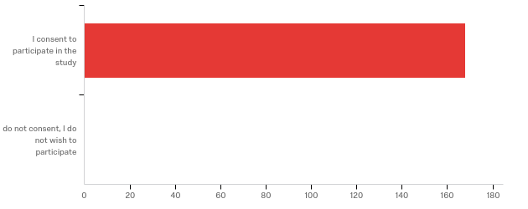

# | Field | Minimum | Maximum | Mean | Std Deviation | Variance | Count
1 | Open Research Questionnaire We are interested in understanding our researcher community's support for Open Research. This questionnaire consists of five questions. You will be asked to select one or more options or to rank a number of themes. Please be assured that your responses are anonymous. This survey will take just five minutes to complete. At the end of the questionnaire, all participants will have the opportunity to be entered into a prize draw for one of two £10 vouchers for ALEX - Formerly Juicafe. Your participation is voluntary and you are free to withdraw at any time. If you withdraw by clicking close before submitting the questionnaire then your responses will not be collected. However, if you complete the questionnaire and submit your responses they will remain part of the study. Your anonymous questionnaire responses may be used in future reports, academic articles, publications or presentations by the researchers. If you would like to contact a member of the research team to discuss this research, please email rdm@lancaster.ac.uk Please remember, more detailed information about the study is available in the participant information sheet. | 5.00 | 5.00 | 5.00 | 0.00 | 0.00 | 168

# | Answer | % | Count
5 | I consent to participate in the study | 100.00% | 168
6 | I do not consent, I do not wish to participate | 0.00% | 0
 | Total | 100% | 168

Q14 - What is your primary academic department?
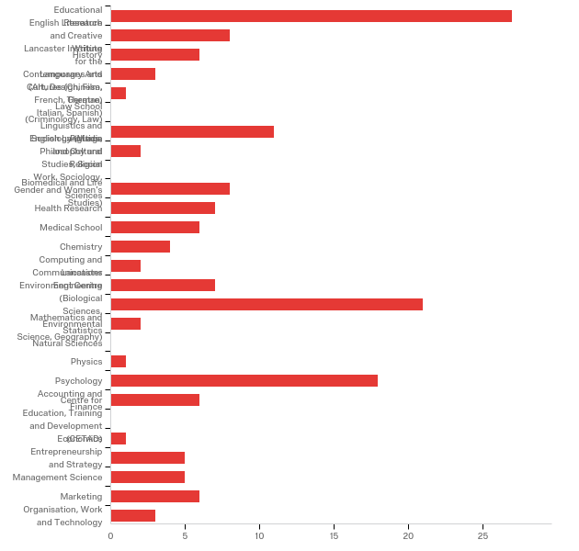

# | Field | Minimum | Maximum | Mean | Std Deviation | Variance | Count
1 | What is your primary academic department? | 1.00 | 30.00 | 13.15 | 8.77 | 76.99 | 160

# | Answer | % | Count
1 | Educational Research | 16.88% | 27
2 | English Literature and Creative Writing | 5.00% | 8
3 | History | 3.75% | 6
4 | Lancaster Institute for the Contemporary Arts (Art, Design, Film, Theatre) | 1.88% | 3
5 | Languages and Cultures (Chinese, French, German, Italian, Spanish) | 0.63% | 1
6 | Law School (Criminology, Law) | 0.00% | 0
8 | Linguistics and English Language | 6.88% | 11
9 | Politics, Philosophy and Religion | 1.25% | 2
10 | Sociology (Media and Cultural Studies, Social Work, Sociology, Gender and Women’s Studies) | 0.00% | 0
11 | Biomedical and Life Sciences | 5.00% | 8
12 | Health Research | 4.38% | 7
13 | Medical School | 3.75% | 6
14 | Chemistry | 2.50% | 4
15 | Computing and Communications | 1.25% | 2
16 | Engineering | 4.38% | 7
17 | Lancaster Environment Centre (Biological Sciences, Environmental Science, Geography) | 13.13% | 21
30 | Mathematics and Statistics | 1.25% | 2
19 | Natural Sciences | 0.00% | 0
20 | Physics | 0.63% | 1
21 | Psychology | 11.25% | 18
22 | Accounting and Finance | 3.75% | 6
23 | Centre for Education, Training and Development (CETAD) | 0.00% | 0
24 | Economics | 0.63% | 1
25 | Entrepreneurship and Strategy | 3.13% | 5
26 | Management Science | 3.13% | 5
27 | Marketing | 3.75% | 6
28 | Organisation, Work and Technology | 1.88% | 3
 | Total | 100% | 160

Q15 - Which category best describes your primary role?
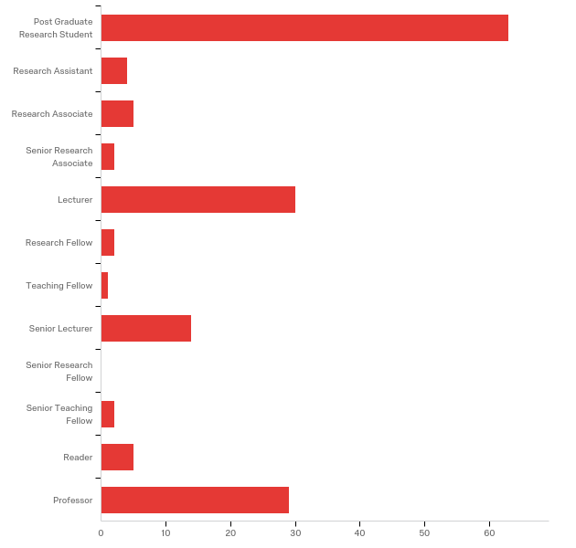

# | Field | Minimum | Maximum | Mean | Std Deviation | Variance | Count
1 | Which category best describes your primary role? | 1.00 | 12.00 | 4.76 | 4.02 | 16.15 | 157

# | Answer | % | Count
1 | Post Graduate Research Student | 40.13% | 63
12 | Research Assistant | 2.55% | 4
2 | Research Associate | 3.18% | 5
3 | Senior Research Associate | 1.27% | 2
4 | Lecturer | 19.11% | 30
5 | Research Fellow | 1.27% | 2
6 | Teaching Fellow | 0.64% | 1
7 | Senior Lecturer | 8.92% | 14
8 | Senior Research Fellow | 0.00% | 0
9 | Senior Teaching Fellow | 1.27% | 2
10 | Reader | 3.18% | 5
11 | Professor | 18.47% | 29
 | Total | 100% | 157

Q3 - To what extent do you agree with the following statement? Open Research should be an institutional priority of Lancaster University.
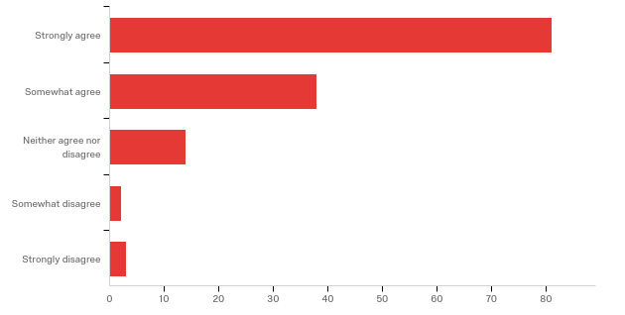

# | Field | Minimum | Maximum | Mean | Std Deviation | Variance | Count
1 | To what extent do you agree with the following statement? Open Research should be an institutional priority of Lancaster University. | 1.00 | 5.00 | 1.61 | 0.89 | 0.79 | 138

# | Answer | % | Count
1 | Strongly agree | 58.70% | 81
2 | Somewhat agree | 27.54% | 38
3 | Neither agree nor disagree | 10.14% | 14
4 | Somewhat disagree | 1.45% | 2
5 | Strongly disagree | 2.17% | 3
 | Total | 100% | 138

Q2 - The University of Reading has recently published a Statement on Open Research. Do you agree that Lancaster University should endorse a similar statement committing to the principles of Open Research?
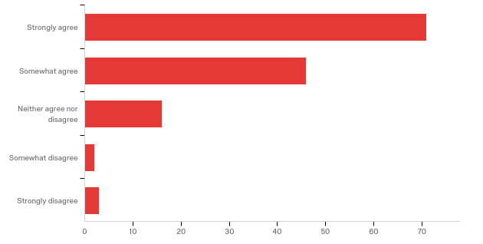

# | Field | Minimum | Maximum | Mean | Std Deviation | Variance | Count
1 | The University of Reading has recently published a Statement on Open Research. Do you agree that Lancaster University should endorse a similar statement committing to the principles of Open Research? | 1.00 | 5.00 | 1.70 | 0.89 | 0.79 | 138

# | Answer | % | Count
1 | Strongly agree | 51.45% | 71
2 | Somewhat agree | 33.33% | 46
3 | Neither agree nor disagree | 11.59% | 16
4 | Somewhat disagree | 1.45% | 2
5 | Strongly disagree | 2.17% | 3
 | Total | 100% | 138

Q4 - Please rank the following "eight themes" of Open Research in order of importance to you. Move the themes that you feel are most important and should be implemented as a priority to the top of the list. The list is an adaptation of the Eight Pillars of Open Science as described by the EU Commission. Please drag & drop statements to change the order.
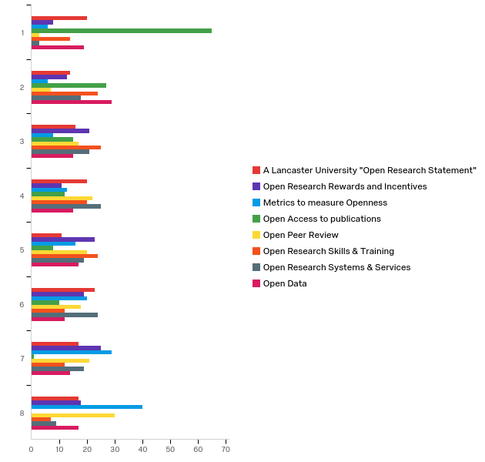

# | Field | Minimum | Maximum | Mean | Std Deviation | Variance | Count
1 | A Lancaster University &quot;Open Research Statement&quot; | 1.00 | 8.00 | 4.52 | 2.32 | 5.38 | 138
2 | Open Research Rewards and Incentives | 1.00 | 8.00 | 4.99 | 2.12 | 4.50 | 138
3 | Metrics to measure Openness | 1.00 | 8.00 | 5.92 | 2.04 | 4.16 | 138
4 | Open Access to publications | 1.00 | 7.00 | 2.31 | 1.64 | 2.69 | 138
5 | Open Peer Review | 1.00 | 8.00 | 5.44 | 1.99 | 3.96 | 138
6 | Open Research Skills &amp; Training | 1.00 | 8.00 | 3.98 | 1.98 | 3.91 | 138
7 | Open Research Systems &amp; Services | 1.00 | 8.00 | 4.68 | 1.88 | 3.52 | 138
8 | Open Data | 1.00 | 8.00 | 4.15 | 2.35 | 5.52 | 138

# | Question | 1 |  | 2 |  | 3 |  | 4 |  | 5 |  | 6 |  | 7 |  | 8 |  | Total
1 | A Lancaster University "Open Research Statement" | 14.49% | 20 | 10.14% | 14 | 11.59% | 16 | 14.49% | 20 | 7.97% | 11 | 16.67% | 23 | 12.32% | 17 | 12.32% | 17 | 138
2 | Open Research Rewards and Incentives | 5.80% | 8 | 9.42% | 13 | 15.22% | 21 | 7.97% | 11 | 16.67% | 23 | 13.77% | 19 | 18.12% | 25 | 13.04% | 18 | 138
3 | Metrics to measure Openness | 4.35% | 6 | 4.35% | 6 | 5.80% | 8 | 9.42% | 13 | 11.59% | 16 | 14.49% | 20 | 21.01% | 29 | 28.99% | 40 | 138
4 | Open Access to publications | 47.10% | 65 | 19.57% | 27 | 10.87% | 15 | 8.70% | 12 | 5.80% | 8 | 7.25% | 10 | 0.72% | 1 | 0.00% | 0 | 138
5 | Open Peer Review | 2.17% | 3 | 5.07% | 7 | 12.32% | 17 | 15.94% | 22 | 14.49% | 20 | 13.04% | 18 | 15.22% | 21 | 21.74% | 30 | 138
6 | Open Research Skills & Training | 10.14% | 14 | 17.39% | 24 | 18.12% | 25 | 14.49% | 20 | 17.39% | 24 | 8.70% | 12 | 8.70% | 12 | 5.07% | 7 | 138
7 | Open Research Systems & Services | 2.17% | 3 | 13.04% | 18 | 15.22% | 21 | 18.12% | 25 | 13.77% | 19 | 17.39% | 24 | 13.77% | 19 | 6.52% | 9 | 138
8 | Open Data | 13.77% | 19 | 21.01% | 29 | 10.87% | 15 | 10.87% | 15 | 12.32% | 17 | 8.70% | 12 | 10.14% | 14 | 12.32% | 17 | 138

Q5 - Lancaster University offers a number of Open Research related events. Please tell us more about your engagement with these. Tick as many boxes as are relevant.
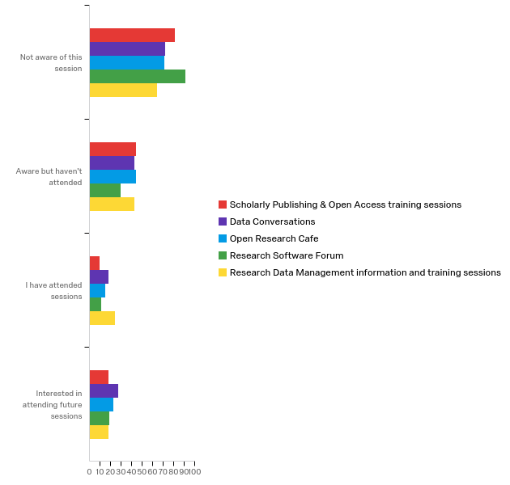

# | Question | Not aware of this session |  | Aware but haven't attended |  | I have attended sessions |  | Interested in attending future sessions |  | Total
1 | Scholarly Publishing & Open Access training sessions | 52.94% | 81 | 28.76% | 44 | 6.54% | 10 | 11.76% | 18 | 153
2 | Data Conversations | 45.00% | 72 | 26.88% | 43 | 11.25% | 18 | 16.88% | 27 | 160
3 | Open Research Cafe | 46.41% | 71 | 28.76% | 44 | 9.80% | 15 | 15.03% | 23 | 153
4 | Research Software Forum | 60.26% | 91 | 19.87% | 30 | 7.28% | 11 | 12.58% | 19 | 151
5 | Research Data Management information and training sessions | 42.95% | 64 | 28.86% | 43 | 16.11% | 24 | 12.08% | 18 | 149

Q13 - If you wish, please summarise your views on Open Research in one or two sentences.

If you wish, please summarise your views on Open Research in one or two sentences.
The tax payer, academics and universities are being exploited by global corporations. The House of Commons Select Committee exposed this years ago. Nothing has been done. The big 5 now position 'open access' as the lowest quality, and still charge for it. This racket must be addressed.
big hype, few do it well. it all starts with supporting clean, standardized data
I think open data and openness about analysis (e.g. code) is by far the most important.
I worry that there are serious differences between the Humanities and the Sciences in this area. For a start, there is hardly any funding to make research open in the Humanities (especially books, which is still one of our primary means of publication).
This questionnaire is hugely problematic. It will take uk universities out of rank I gs that compare us with American universities. It does not lay out the consequences of open research which will remove funding and stop activities of learned societies. It failed to take into account commercial nature of some kinds of data. It could reduce access for researchers. None of these potentially drawbacks are raised here. You will get many different answers if u presented both sides of the argument here.
It works for the natural sciences where there is grant funding for APCs. It does not work for social sciences or humanities where there is less grant funding so very limited funds to pay for gold open access
Should be truly open and should be encourage because it strengthens knowledge expansion
The way forward!
A fundamental feature of Science is reproducibility. Restricting full access to it represents not only an ethical but an epistemological contradiction.
It must happen due to REF etc, but never at the expense of research / publishing quality
Thi
Most of the information about open research that is available online seems geared towards the sciences, so it’s hard to envisage how this would work in practice in the humanities. More information with concrete examples would be nice.
There are more pressing issues in the research area than this.
Valuable but tends to give support to competition from other countries.
Open science is just science done right.
For research to have impact, it has to go beyond the paywalls of academic publishers. Open research has far wider reach than closed.
make sure the University has indeed the funds to pay for all peer-reviewed publication open access, since funders do not usually assume these costs..
We should be in a position where we don't have to think about open research, it is just the natural way of doing things.
Essential for future-proofing research to be as robust and transparent as possible.
This is a good idea in general and should be promoted, but I'm not in favour of enforcing e.g. pre-print publication for everyone - depending on the field this is not always feasible.
OS journal editor and crusader against lockup by commercial publishers
Open Research is a positive step forward. However, it may affect funding from certain agencies who do not wish to share the results with potential competitors.
Open research is of great importance in research not only because we are creating increasingly more digital datasets, but also for conservation and sustainability of knowledge. From my point of view Lancaster needs to make this one of its priorities,
I serve on the editorial board of a number of open access journals. I fundamentally support the principles, but am also aware of the challenges this represents when collaborating with researchers from overseas with differing scholarly backgrounds.
I think we should also push for REF to prioritise Open Access publishing across disciplines
I think it is important to have open access to publications, systems/tools and data, and for the university (the academic world) to strive to be as open as possible to develop research faster and improve the way academics view open access (thus not as less than a publication in a non-open access journal).
The fundamental problem in publications still sits with the publisher's models. Embargoing an article for two years is not open access – stakeholders don't want to access old research, nor should taxpayer pay twice to enable access to new research. Gold access is prohibitively expensive. While we should rightly care about open data, enabling research to be reproducible, etc, most outside universities care more about whether they can read it or not.
The main thing is for the university to support open access publications as much as possible, to make research output available to everyone without a paywall / institutional subscription
I have published (& continue to occasionally do so) on the need to have open access to research, but equally to accept that this openness may for good reasons sometimes need to be bounded
Essential to further research outputs for everyone’s benefit. Not least in the current political climate here and in the USA
It's vital for the advancement of science - the current 'closed' system is outdated, unethical and hinders scientific progress
Our research should be free for everyone, everywhere, always.
Needs to have financial support from the university.
The idea of open research sounds very appealing. I am in favour for example of increasing access to research for scholars in developing countries. However what these discussions always seem to miss out is the position of scholarly peer reviewed journals. How are they going to be financed? Why should anyone give their reviewing time for free if the current although almost invisible network of support for journal editors and reviewers is removed?
This is an inevitable progression and if done carefully has many benefits
If it is not open, is it really research?
I am happy to make my research openly accessible, but not if it precludes me from publishing it in ways that will be recognised by my profession, nor if I have to pay money to publish in this way.
The world of research is complex and does not fit one undifferentiated box: open science still has to find a way to become mainstream across disciplines without trying to be an undifferentiated black box that won't suit everyone. We need more training, information, discussion and solutions. It's an amazing journey!
I agree with open research in principle, but the whole open-access thing in academia is a complete joke as why should I have to pay so that people can read my own research?
Proceed with caution! We may inadvertently create negative things.
We should endeavour to make as much of our research as open as possible.
Open research is a nice idea but someone always has to pay.
It is a good idea, but should not be pursued at the expense of established publication and peer review practices.
Open Research sounds like a great idea but is not widely discussed within the university, and students are not equipped or taught how to engage in this.
Good idea but makes research im possible because of the huge cost!
I believe all research should be open in the future.
As an academic, in particular as an early career researcher, our work is mostly weighted by publications. The way the academic system is set up, spending time ensuring real openess and facilitating the reproduceability of our research is basically a waste of time towards finding the next job. Unless this changes, I don't think early career researchers should be encouraged to spend their time in activities that won't help them advance their career.
It is timely to do develop Open Research today.
Open research creates a researcher pay system for publication and proliferation of online journals that publish hundreds and hundreds of papers in every edition. This reduces the quality of publications and inundates professors with requests of peer review. It seems to have become a money-making scheme while reducing the quality and reliability of published papers. In addition, the system for open research - with all the inputs, metrics, assessments and REF etc has become a bureaucratic nightmare that diverts professors from their work. Overall, I consider it much worse than earlier, less open but more considered and reasonable ways of working.
I approve in principle but have many reservations about the manner, and speed, of implementation.
I am dedicated to and striving for open, reproducible, and diverse research.
Fundamental for the progression of ideas, to prevent waste of resources (e.g., doing studies where data already exists), and to ensure access to the latest research for all.
I think knwledge and education should be freely accessible to everyone. This is only possible with Open Research. Open Research increases the opportunities for me to find what I am searching for and for other to find my research. This should be of interest for the whole academic community.
I know very little about it - most of what I have written in the past decade is available without restriction
Open Research is critical to the future well being of science and society. It should be an institutional mission.
Publishers have too much power and rankings of universities and academics are also part of the problem

