REACT Data Annotations
Version 2.0 (01/07/2020)
Duncan Appelbe.
Edited by: Keith Kennedy
_________________________________________________________________________________________
Data extract is provided as an Excel spreadsheet with the data for each questionnaire on a separate worksheet.
Useful items:
- StudyStage:
  - 3 == Baseline
  - 6 == Followup1
  - 7 == Followup2
- All baseline questionnaires have to be completed before randomisation can occur
- On Baseline, FU1 and FU2 the first two questionnaires (About you and GHQ) are not dependent on another questionnaire being completed, all other questionnaires require completion of the GHQ.
- Data Flow:

Point | Description
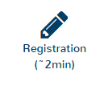 | Is the person being cared for in a REACT area
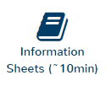 | Patient information sheets made available
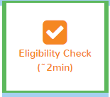 | Is the participant eligible for the study.  Note: This is the first point that we start being able to link data to a participant
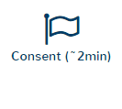 | Participant consent, E-Mail address and name
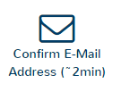 | Confirmation that the provided E-Mail address is correct
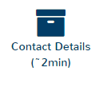 | Participant postal address and telephone contact details
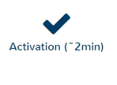 | Confirmation that Contact number is correct
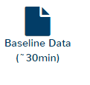 | Complete all nine questionnaires
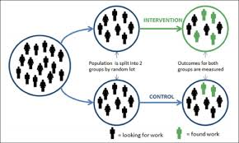 | Participant prompted to randomise – stage == randomisation (becomes randomised when randomisation has occurred)  Once randomised the subjects account in the intervention site is created.
 | 12 week follow-up
 | 24 week follow-up

- Participants may withdraw at any time by completing the withdrawal form or by contacting the study team.

- Subject Map
- Subject details and status within the study

Column | Description
ConsentId | Number used to link data for subjects
StudyStage | Where in the trial is the subject
RandomisationNumber | Randomisation Number – allocated at completion of baseline
RandomisationArm | Should be blank for stats extracts
ToolkitLastAccessedinLastWeek | Flag to let us know if they have accessed the Toolkit in the last week
BaseLineCompleted | Which questionnaires have they completed:  None = 0,  AboutYourCircumstances = 1,  GHQ = 2,  RelativesWellBeingAndSupport = 4,  ED5D5L = 8,  CSRI = 16,  BreifIPQ = 32,  BriefCope = 64,  AboutYourRole = 128,  AboutYou = 256  A complete set will have the number 511
FU1Completed | As baseline, but for Follow-up 1
FU2Completed | As baseline, but for Follow-up 2
LastAccess | Last access timestamp (dd/mm/yyyyy HH:mm:ss)
BaseLineComplete | Date baseline completed (dd/mm/yyyyy HH:mm:ss)
Randomised | Date Randomised (dd/mm/yyyyy HH:mm:ss)
FU1Complete | Date FU1 completed (dd/mm/yyyyy HH:mm:ss)
FU2Complete | Date FU2 Completed (dd/mm/yyyyy HH:mm:ss)
NumFU1Emails | Number of FU1 E-Mails sent
NumFU2Emails | Number of FU2 E-Mails sent
FU24Rando | 24 week randomisation Number
FU24Allocation | 24 week allocation (should be blank for stats)

- Eligibility
- Is the subject eligible for the study?
- ScreenNum is generated by the system
- All questions to be answered before the form will submit
- Additional questions appear if q3 is answered as “Rather more than usual” or “Much more than usual”
- Q7 was removed prior to the start of the study
- Links to subjects going forwards are in the study database, they are not displayed to stats.

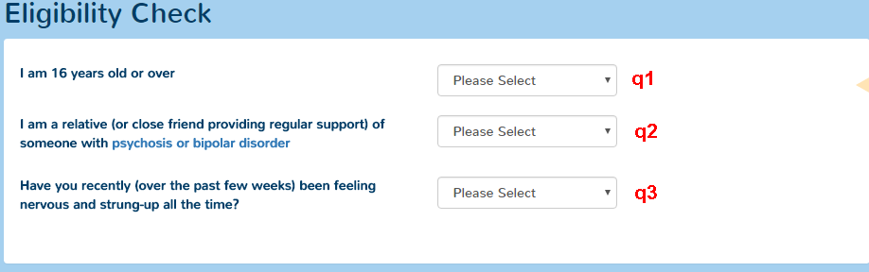

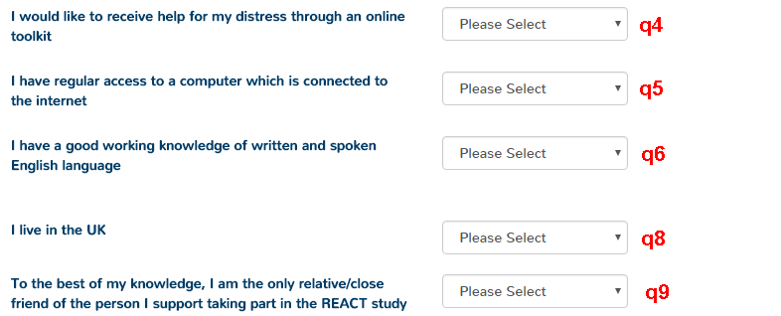

- Exclusions
- List of when subjects have been excluded based on answers to questions on forms that lead to the “sorry” react is not for you …
- This includes q3 on the eligibility check, it also includes data from the eligibility check where the subject was not eligible, but the application allowed the user to submit data

Column | Description
eligibilityId | Generated by system, can link to the eligibility table, but only if the eligibility form has been completed
FailureDate | Time point at which issue was recorded (dd/mm/yyyy HH:MM:ss)
FailurePoint | Point at which failure occurred

- RedFlags
- Automated E-Mails that are sent by the system to a participant if they answer specific questions:
Form | Question | Trigger Values
GHQ | Q24 | "Much more than usual"
GHQ | Q25 | "Definitely has"
GHQ | Q27 | "Much more than usual"
GHQ | Q28 | "Definitely has"
Relatives Well Being | "wellBeing_qa29" | "A lot"
Relatives Well Being | "wellBeing_qa30" | "A lot"

- Only one E-Mail is sent per form, irrespective of the number of triggers that fire.

Column | Description
ConsentId | Use to link to the same column in the subject map
StudyStage | Stage of the study at which the data were collected (3/6/7)
FlaggedItems | Questions on which the trigger fired
AddedOn | Timepoint data stored (dd/mm/yyyy HH:MM:ss)

- Risk Status
- What risks have been identified and recorded by the react supporters
- The database records the subject, this is not reported to stats.

Column | Description
newID | Consent identifier
Risk type | 1 = SupporterRisks  2 = TmRisks
IdentifiedFrom | Medium risk was identified from (e.g. phone)
IdentifiedOn | Timepoint data stored (dd/mm/yyyy HH:MM:ss)
Category | Recorded Category
ActionTaken | Action taken
ActionTakenOther | If action taken is “other” then this field contains the free text description

- Withdrawals
- List of people who have withdrawn from the study
- Subjects withdrawn by the administrator (due to an E-Mail being sent or a phone call will include “(Administrator Action)”

Column | Description
ConsentId | Use to link to the same column in the subject map
Opt | Level of Withdrawal:  1 := “I don’t want to complete the measures at this followup but I am happy to be contacted for the 24 week followup”  2 := “I don’t want to complete the questionnaires at this followup and DO NOT want to be contacted for the 24 week followup”
Reason | Reason for withdrawal
DateAdded | Timepoint data stored (dd/mm/yyyy HH:MM:ss)

- About You
- Form will not save if all questions that are visible are not completed.
- SubjectId – Correlates to ConsentId in the table “SubjectMap”
- Timepoint
  - 3 = Baseline
  - 6 = FU1
  - 7 = FU2
- AddedOn – Time point saved (dd/mm/yyyy hh:mm:ss)
- Actual text for answer saved in database, with the exception of Gender (Q2) which has the following map:

Value="", Text="Please Select"
Value="1", Text="Female"
Value="2", Text="Male"
Value="3", Text="Other"
Value="4", Text="Rather Not Say"

- The options for Q
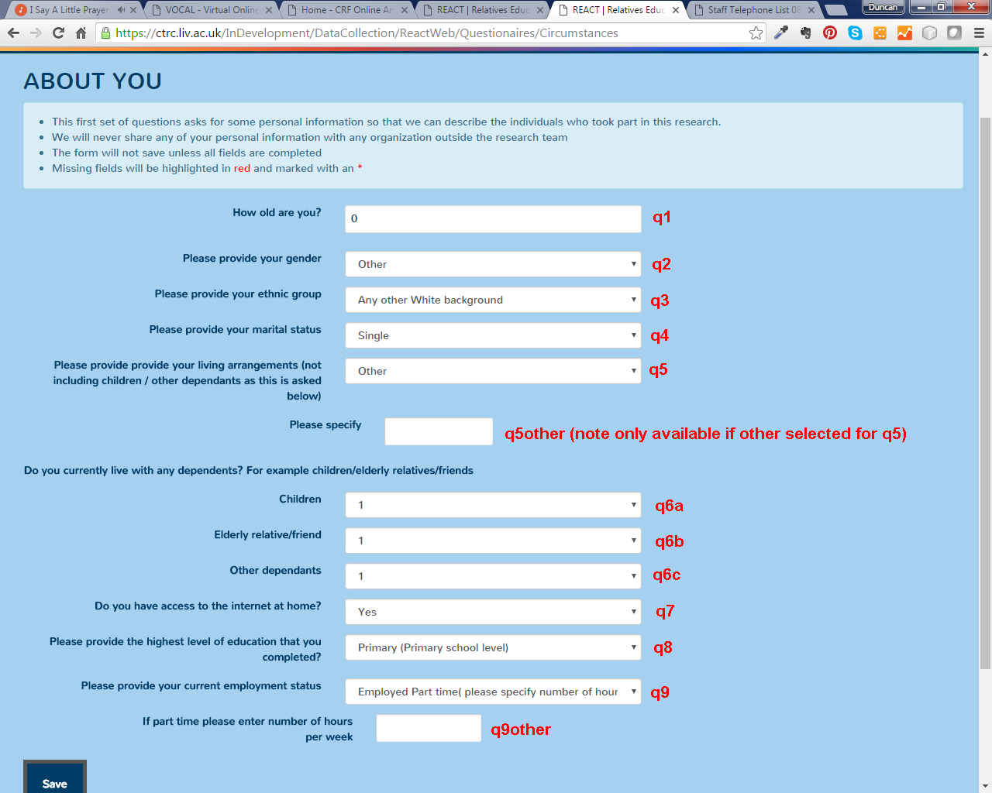

- GHQ
- Form will not save if all questions that are visible are not completed.
- Each section must be completed before you can move to the next section
- SubjectId – Correlates to ConsentId in the table “SubjectMap”
- EnteredBy – will be 0 if before change implemented, if non zero then identifies who entered, if greater than 9000 will be a member of the study team. Study team Id’s are not available in the download.
- Timepoint
  - 3 = Baseline
  - 6 = FU1
  - 7 = FU2
- AddedOn – Time point saved (dd/mm/yyyy hh:mm:ss)
- Actual text for answer saved in database

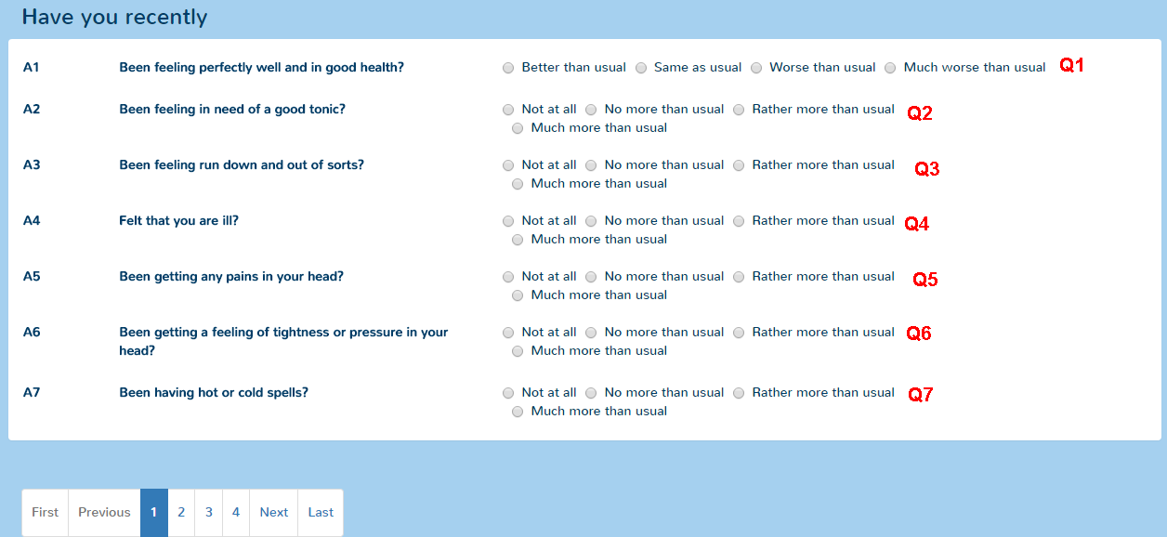
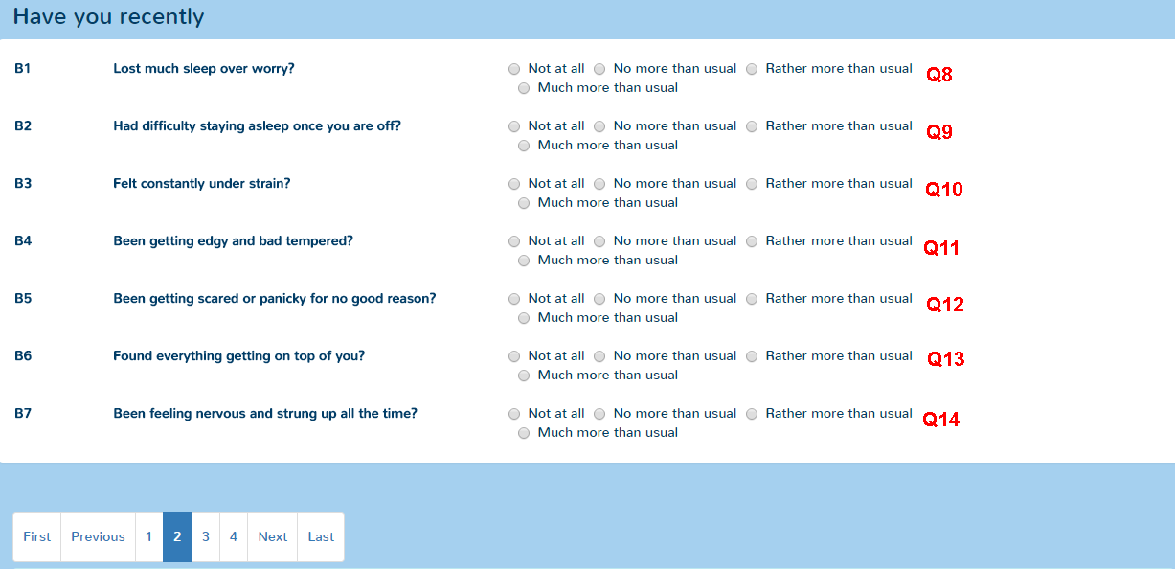
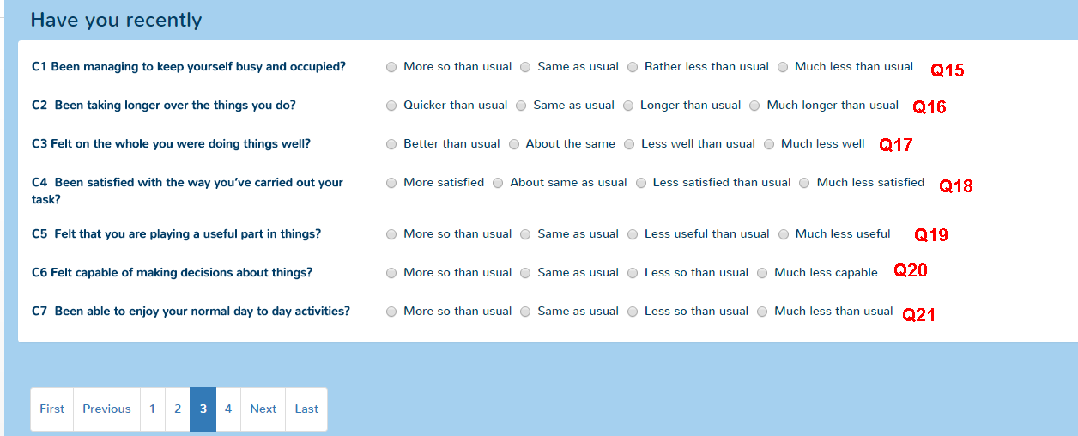
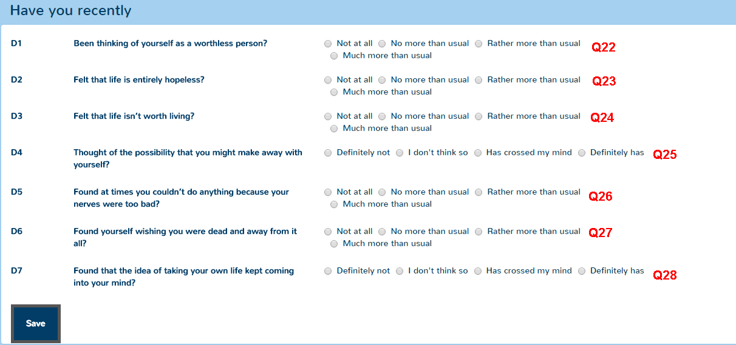

- Relatives Well Being and Support (WellBeing)
- Form will not save if all questions that are visible are not completed.
- Each section must be completed before you can move to the next section
- SubjectId – Correlates to ConsentId in the table “SubjectMap”
- Timepoint
  - 3 = Baseline
  - 6 = FU1
  - 7 = FU2
- Actual text for answer saved in database

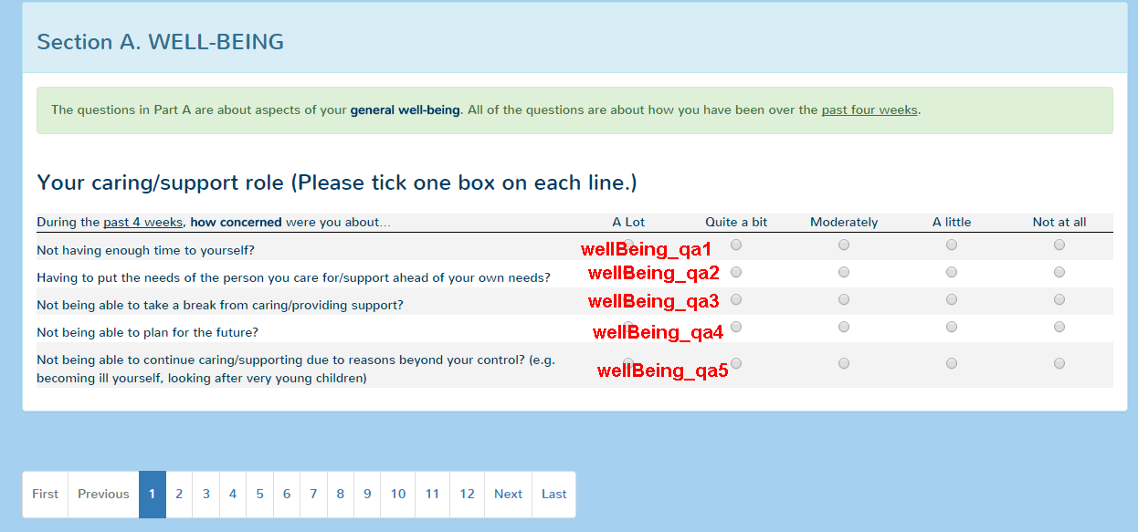
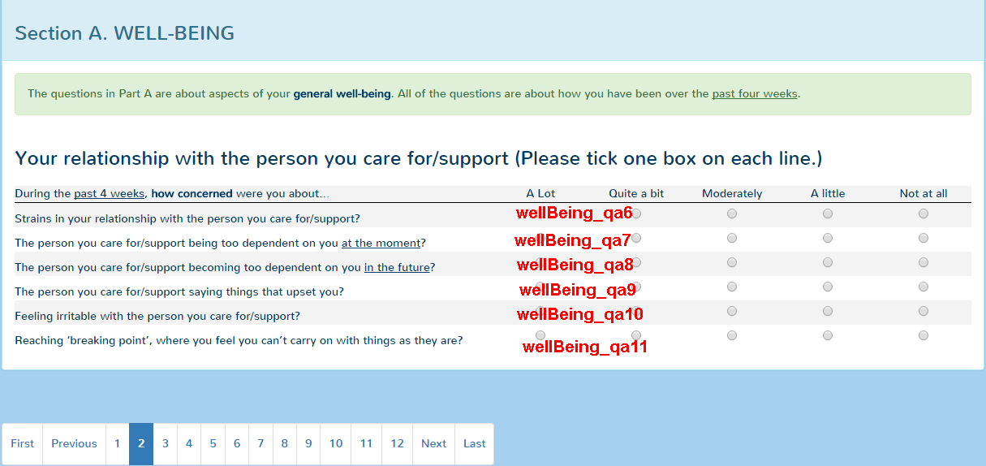
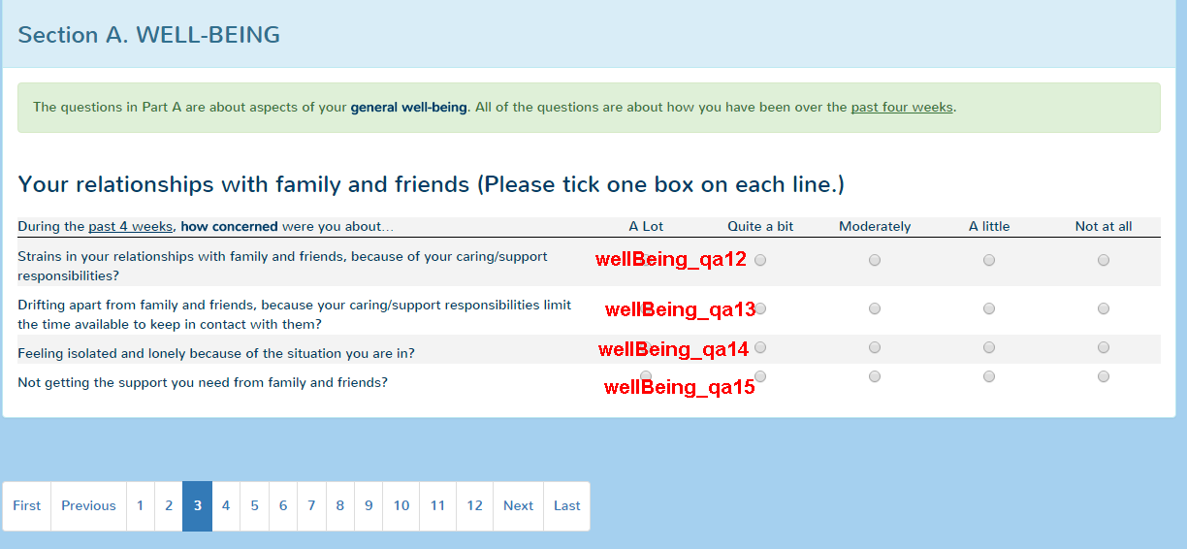
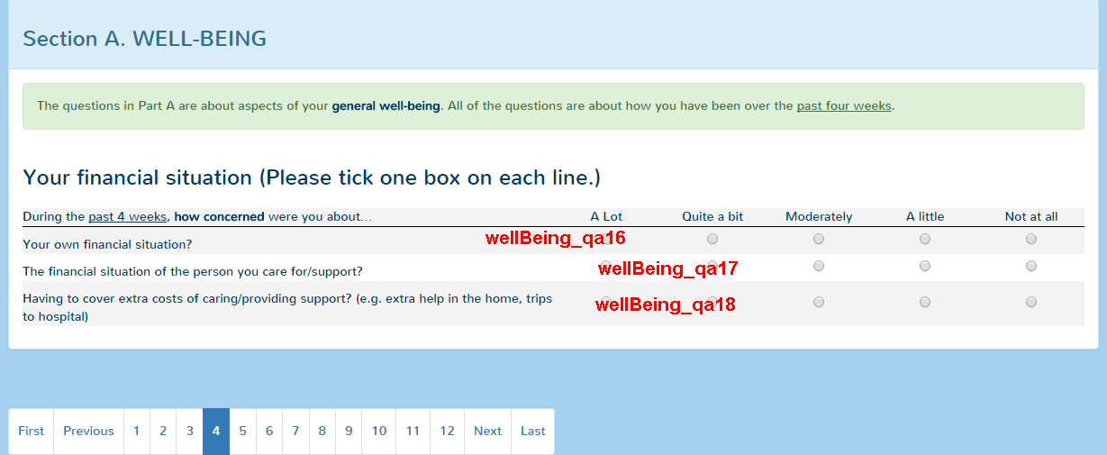
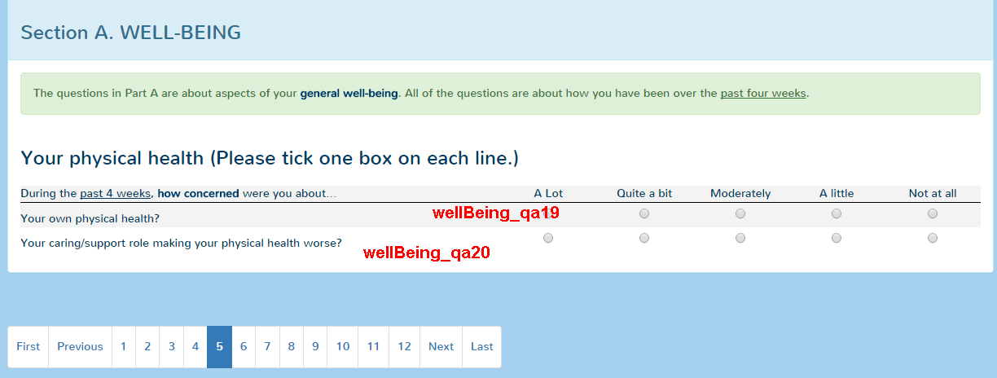
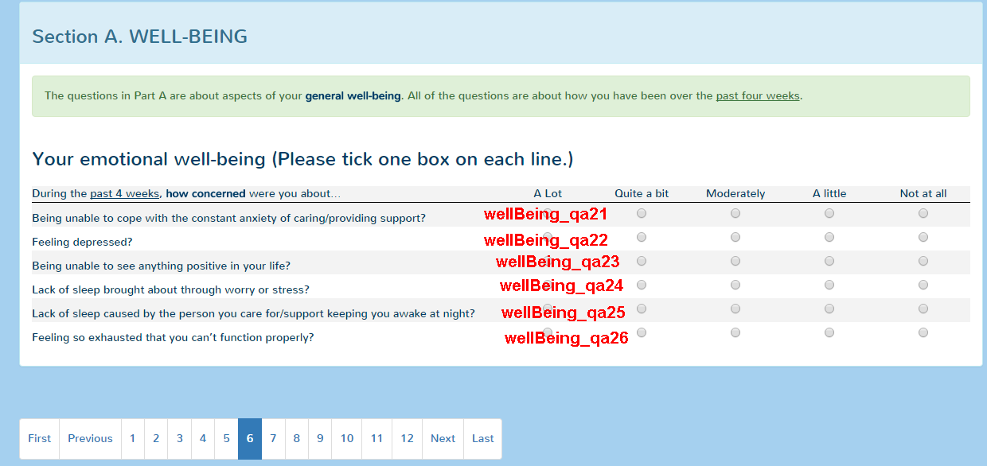
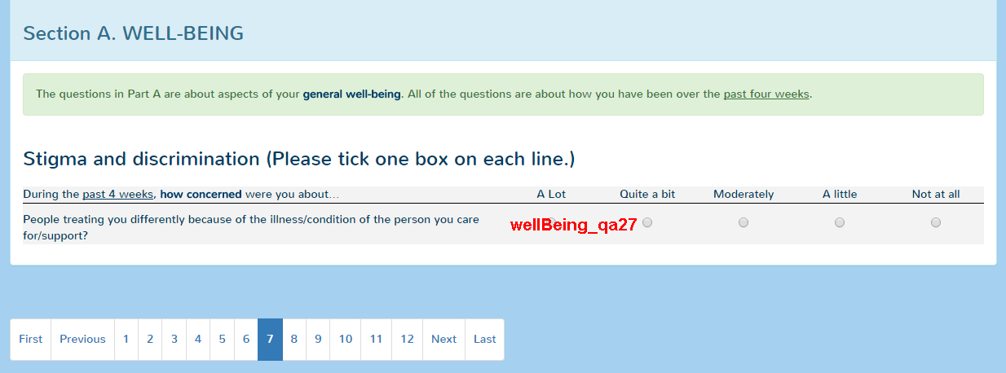
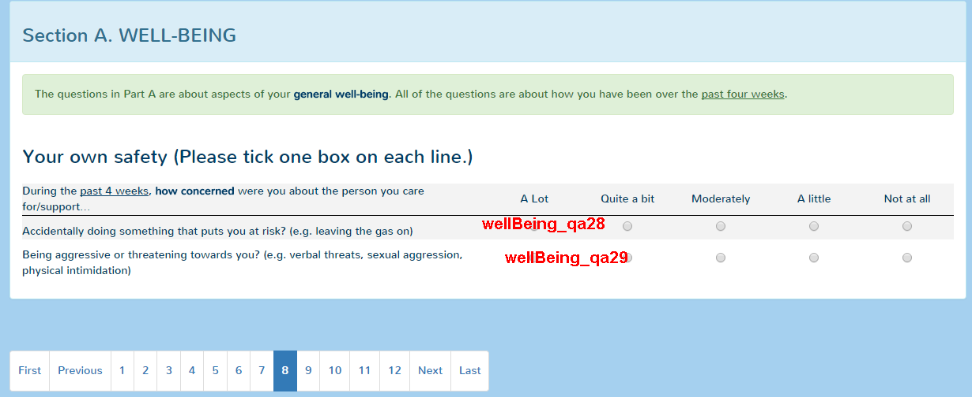
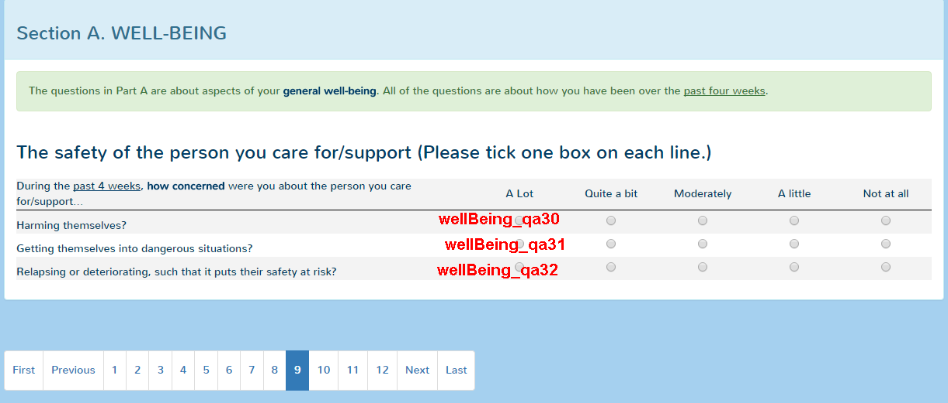

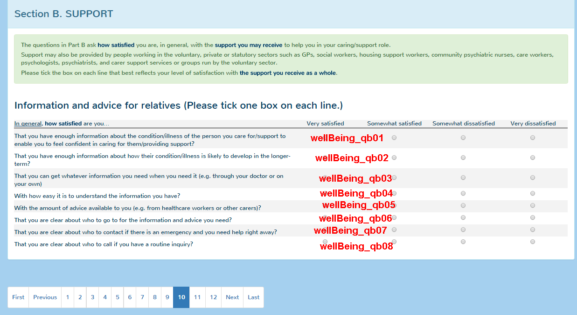
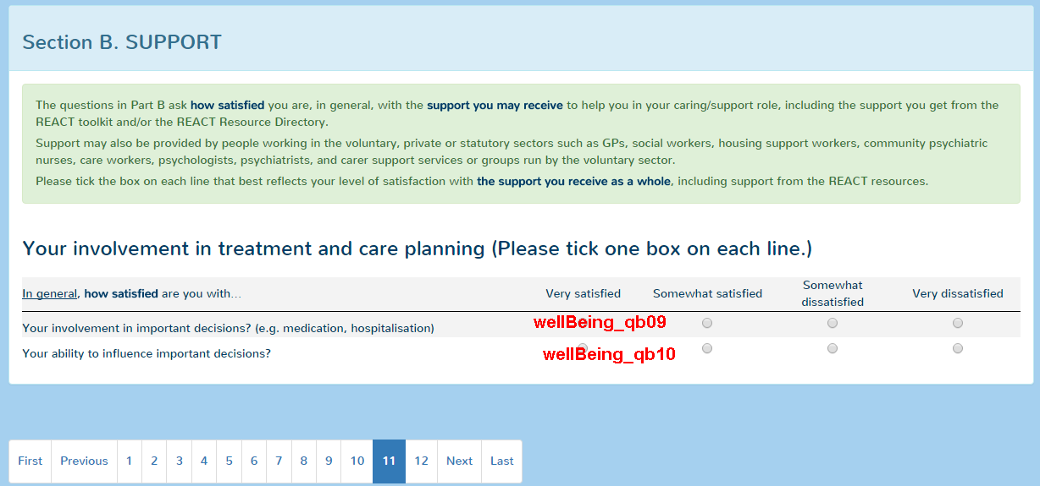
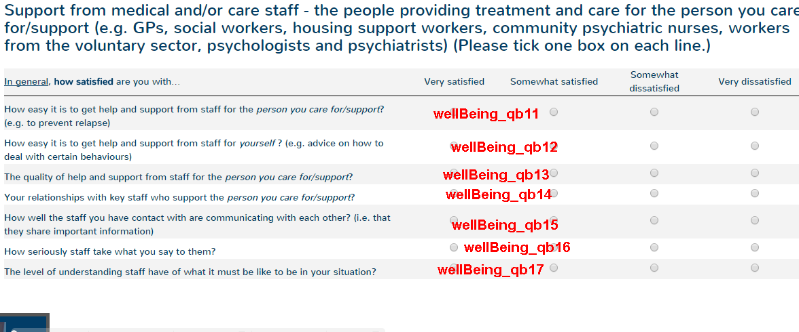

- EQ5D5L
- Form will not save if all questions that are visible are not completed.
- Each section must be completed before you can move to the next section
- SubjectId – Correlates to ConsentId in the table “SubjectMap”
- Timepoint
  - 3 = Baseline
  - 6 = FU1
  - 7 = FU2
- AddedOn – Time point saved (dd/mm/yyyy hh:mm:ss)
- Data saved is numeric based on answer
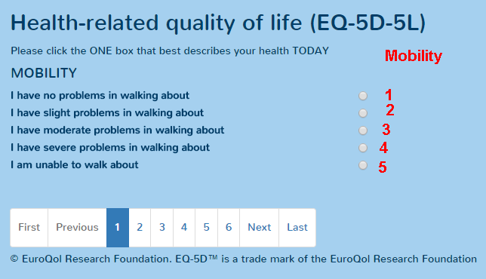
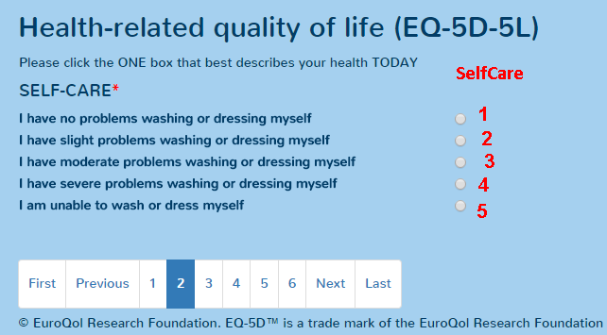
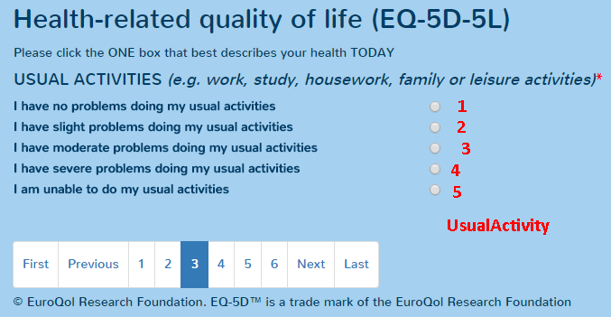
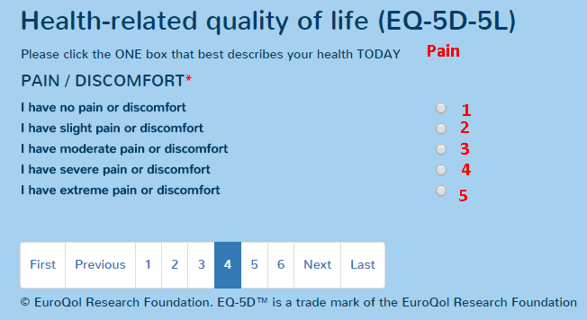
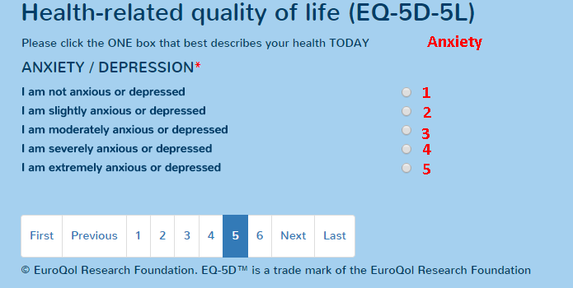
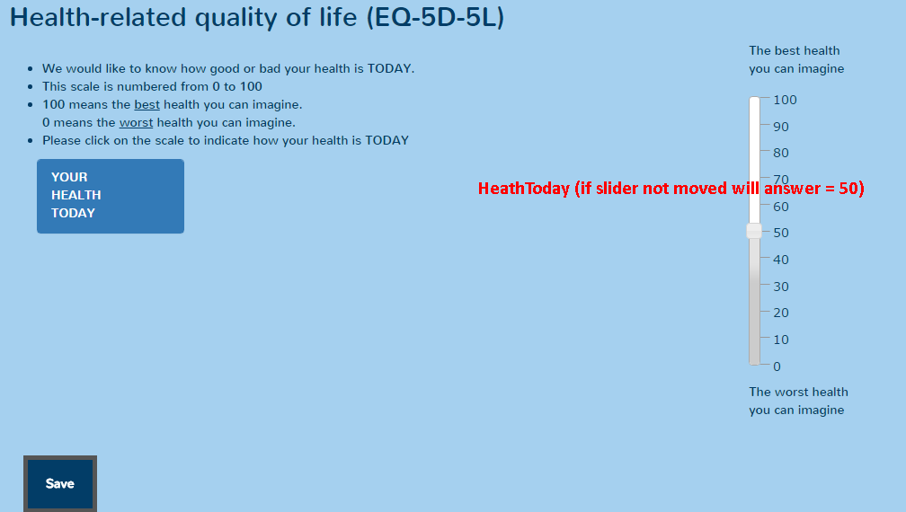
- Service Use (CSRI)
- Form will not save if all questions that are visible are not completed.
- Fields that are not visible will be empty
- Each section must be completed before you can move to the next section
- SubjectId – Correlates to ConsentId in the table “SubjectMap”
- Timepoint
  - 3 = Baseline
  - 6 = FU1
  - 7 = FU2
- Actual text for answer saved in database

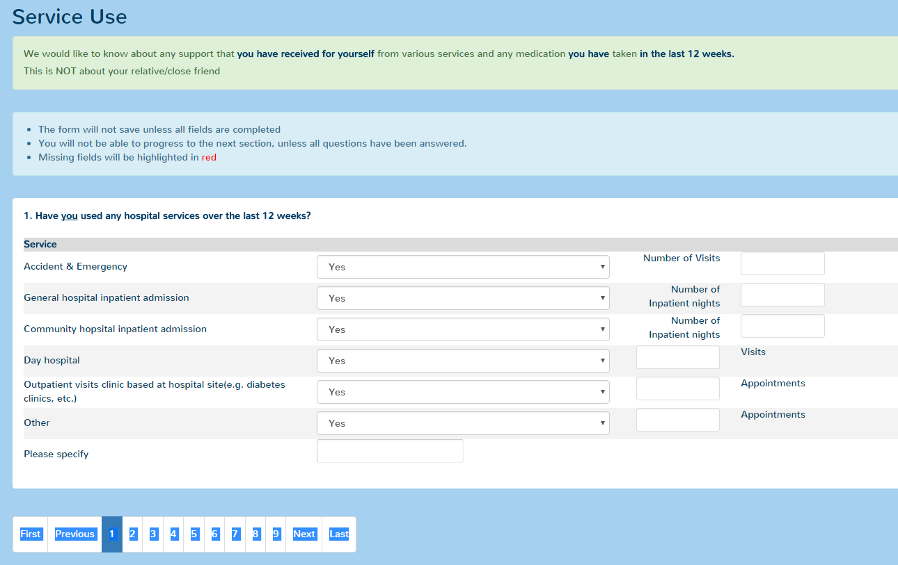

Question | key | Values | Display | Validation
Accident & Emergency | csri_q1_used_acc_emerg_YN | 1 = Yes  0 = No | Yes | Required
Number of Visits | csri_q1_acc_emerg_num_visits | As entered | csri_q1_acc_emerg_num_visits = 1 | Number  Range = 1-96
General hospital inpatient admission | csri_q1_used_gen_hosp_service_YN | 1 = Yes  0 = No | Yes | Required
Number of Inpatient nights | csri_q1_gen_hosp_num_visits | As entered | csri_q1_used_gen_hosp_service_YN = 1 | Number  Range = 1-96
Community hopsital inpatient admission | csri_q1_used_comm_hosp_service_YN | 1 = Yes  0 = No | Yes | Required
Number of Inpatient nights | csri_q1_comm_hosp_num_visits | As entered | csri_q1_used_comm_hosp_service_YN = 1 | Number  Range = 1-96

- Beliefs About Mental Health Problems – Relatives
- Form will not save if all questions that are visible are not completed.
- SubjectId – Correlates to ConsentId in the table “SubjectMap”
- Timepoint
  - 3 = Baseline
  - 6 = FU1
  - 7 = FU2
- AddedOn – Time point saved (dd/mm/yyyy hh:mm:ss)
- Actual text for answer saved in database

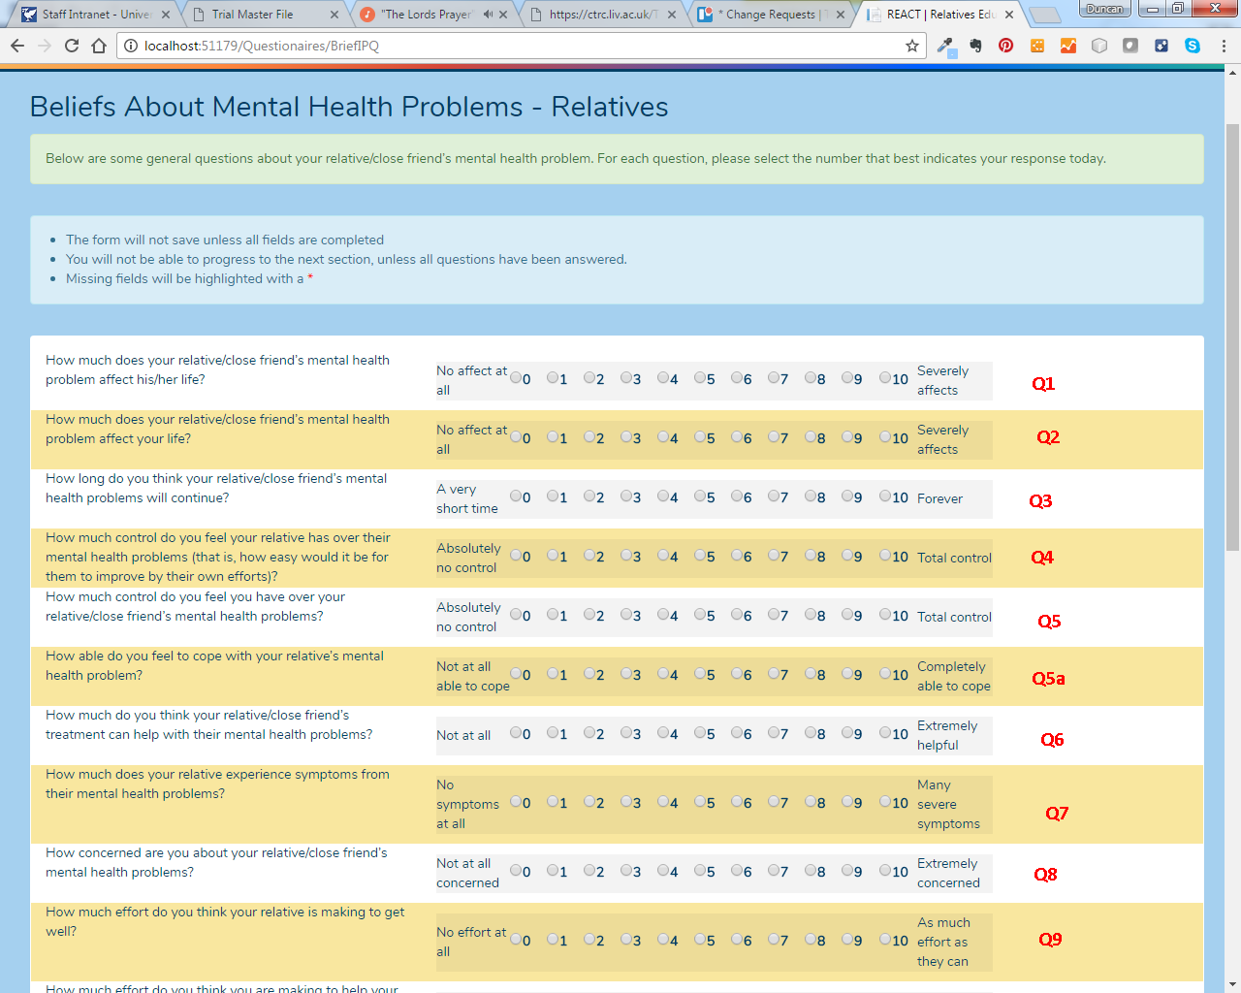

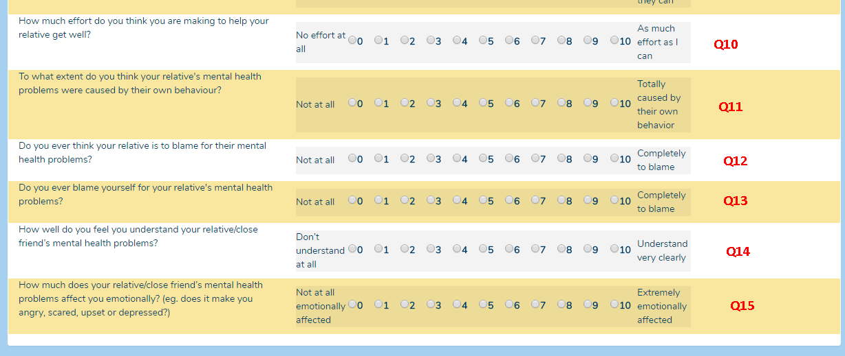

- Coping
- Form will not save if all questions that are visible are not completed.
- SubjectId – Correlates to ConsentId in the table “SubjectMap”
- Timepoint
  - 3 = Baseline
  - 6 = FU1
  - 7 = FU2
- AddedOn – Time point saved (dd/mm/yyyy hh:mm:ss)
- Database mapping for answers are (value stored, text displayed to user):

Value = "", Text = "Please Select"
Value = "1", Text = "I haven't been doing this at all"
Value = "2", Text = "I've been doing this a little bit"
Value = "3", Text = "I've been doing this a medium amount"
Value = "4", Text = "I've been doing this a lot"

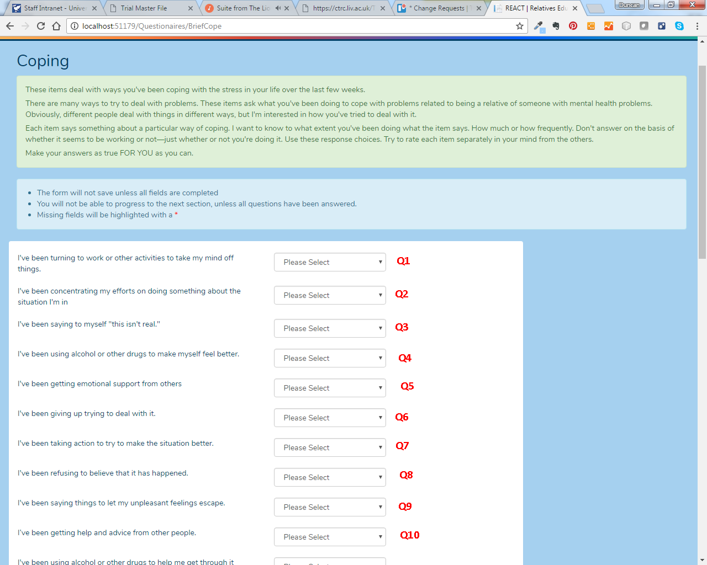

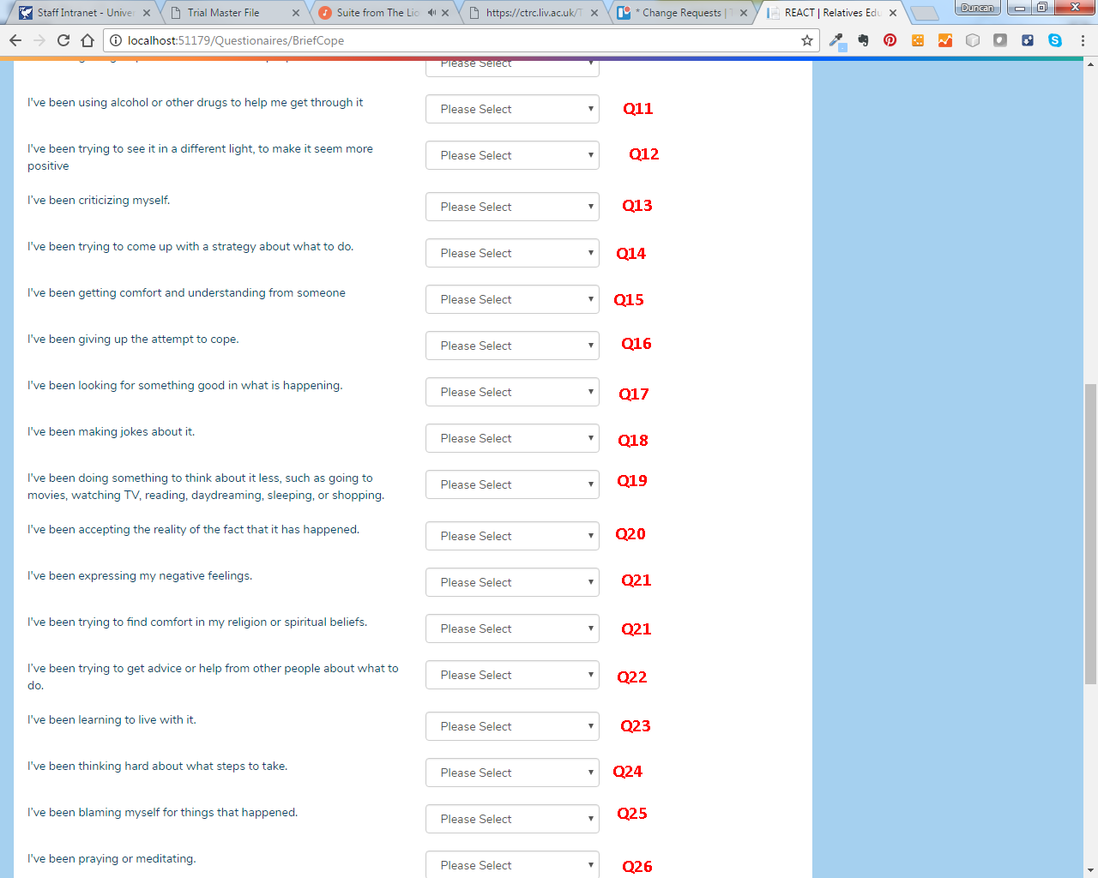

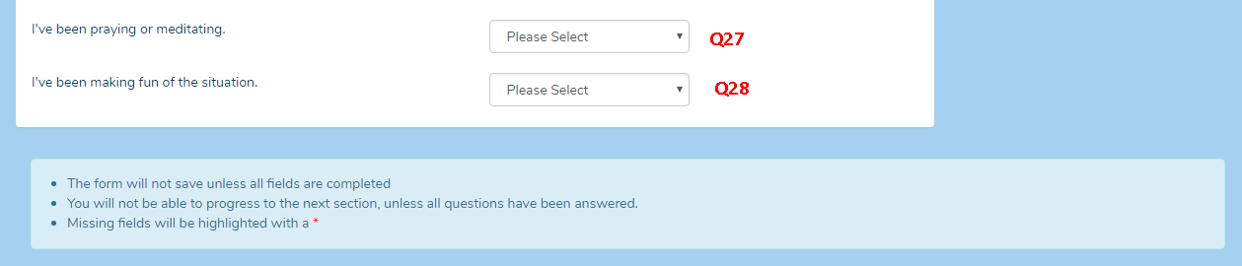

- ABOUT YOUR CARING/SUPPORT ROLE
- Form will not save if all questions that are visible are not completed.
- SubjectId – Correlates to ConsentId in the table “SubjectMap”
- Timepoint
  - 3 = Baseline
  - 6 = FU1
  - 7 = FU2
- AddedOn – Time point saved (dd/mm/yyyy hh:mm:ss)
- Actual text for answer saved in database
- For questions, the data from each row is separated by a “|”, e.g., one row would be “|Close” but two rows would have “|Close|Close”

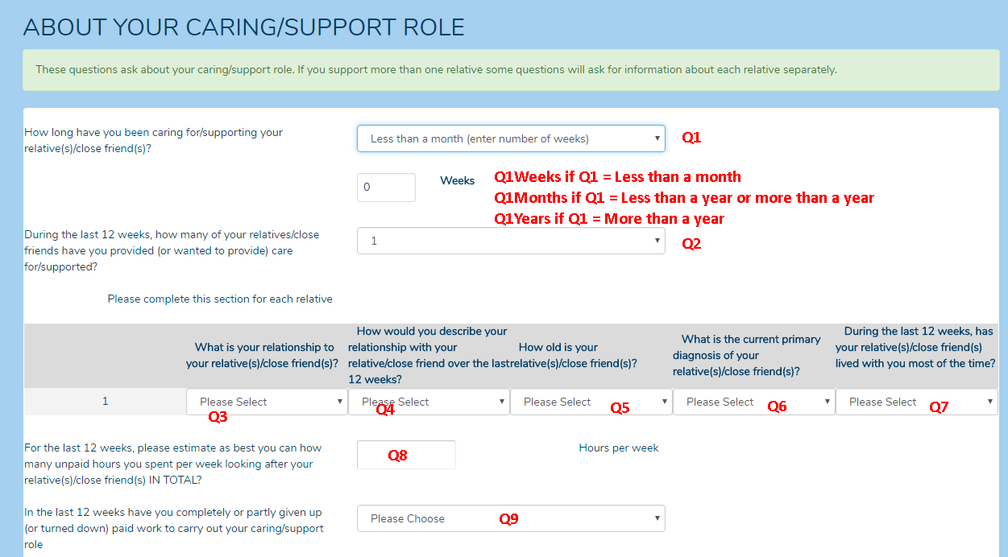
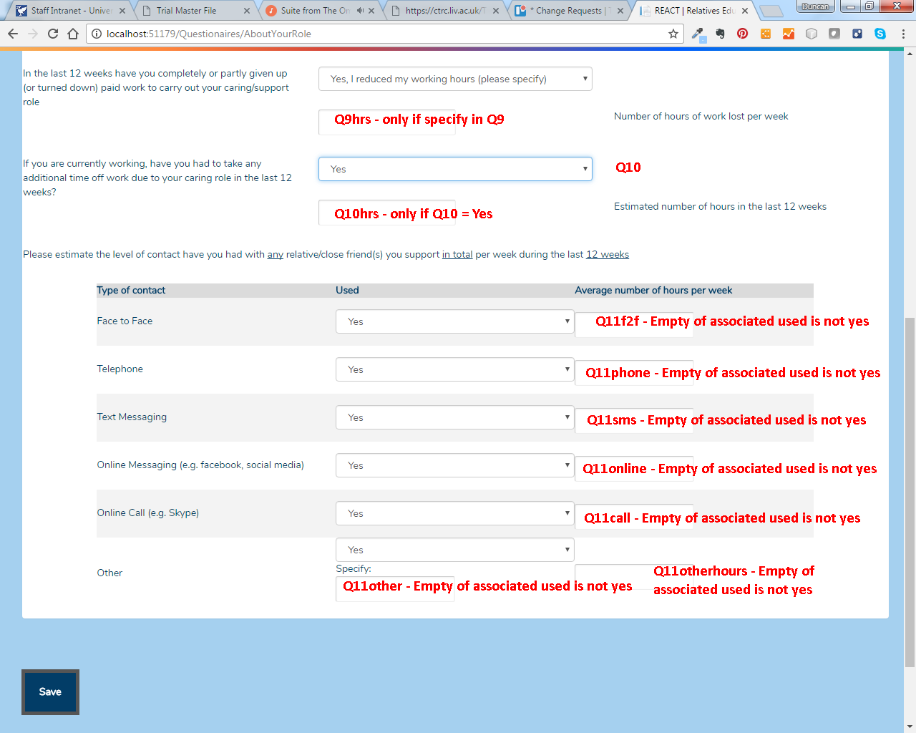

- About Your Circumstances
- Form will not save if all questions that are visible are not completed.
- SubjectId – Correlates to ConsentId in the table “SubjectMap”
- Timepoint
  - 3 = Baseline
  - 6 = FU1
  - 7 = FU2
- AddedOn – Time point saved (dd/mm/yyyy hh:mm:ss)
- Actual text for answer saved in database

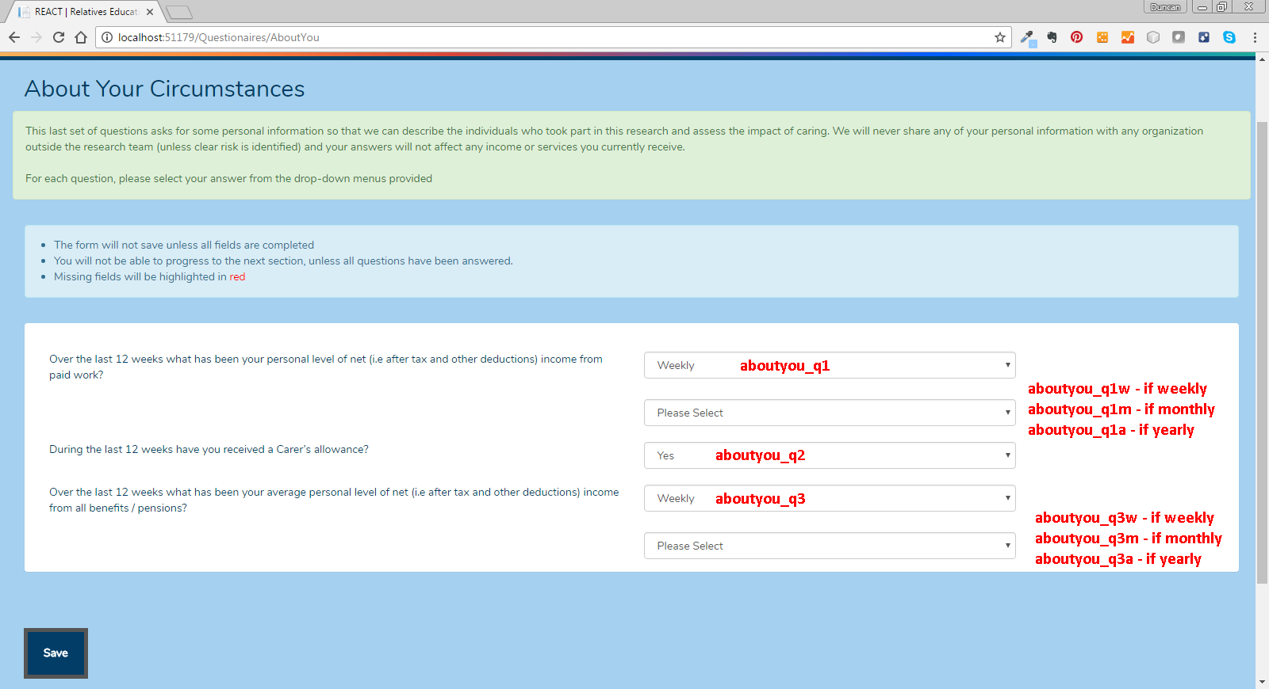

Additional Data Descriptions for Database Extract

Allocations_24
This table contains allocations for week 24.
Column | Description
newID | Consent identifier
StratID | Stratification identifier (always 1)
Block | Block number
Size | Block size
SeqInBlk | Sequence in block
Treat1 | 10/20
Treat2 | Conditional/Unconditional

Allocations_initial
This table contains allocation for baseline.
Column | Description
newID | Consent identifier
StratID | Stratification identifier (always 1)
Block | Block number
Size | Block size
SeqInBlk | Sequence in block
Treat1 | 10/20
Treat2 | Conditional/Unconditional

Consent
This table is used to record consent form data entry. Data is not recorded unless the subject consents to Q1-7. (Q8 is optional).
Column | Description
newID | Consent identifier
CompletedOn_onset | Number of days after randomisation (rounded to nearest day). Note where this is negative this indicates the number of days prior to randomisation. Also note that there is a strange value for the patient with newID 1025 as it appears that the year is incorrect
Q1-8 | Responses to questions. 1=yes, 0=no

EmailFormat
This table hold templates used for emails sent from the web application.
Column | Description
newID | Consent identifier
EmailType | A number that identifies the emails type.  ParticipantNotifyReactSupporter = 1  SupporterNotifyReactParticipant = 2  GenericSystemEmail = 3  MyDefinedEmail = 4  SendConsentForm = 5  RandomisationEmailTau = 6  RandomisationEmailIntervention = 7  ManageNotifications = 8  RedFlagParticipant = 9  ConsentFollowUp = 10  ActivationFollowup = 11  BaselineFU = 12  Week12FU1 = 13  Week12FU2 = 14  Week12FU3 = 15  Week24FU1Uncond = 16  Week24FU2Uncond = 17  Week24FU3Uncond = 18  Week24FU1Cond = 19  Week24FU2Cond = 20  Week24FU3Cond = 21  Week12Thankyou = 22  Week24ThankYou = 23  FinalThankyou = 24  Week12Chase5 = 25  Week12ChaseToday = 26  Week24Chase5 = 27  Week24ChaseToday = 28  ForgottenPassword = 1001  ResetPassword = 1002  EmailNewAdmin = 2048  NotifyActivationCodeContact = 2049  ActivationDetailsEmail = 2050  SystemPasswordReset = 2051  Week24FU1Uncond10 = 5001  Week24FU1Uncond20 = 5002  Week24FU1Cond10 = 5003  Week24FU1Cond20 = 5004  Week24FU1Blinded = 5005  Week24FU2Uncond10 = 5006  Week24FU2Uncond20 = 5007  Week24FU2Cond10 = 5008  Week24FU2Cond20 = 5009  Week24FU2Blinded = 5010  Week24FU3Uncond10 = 5011  Week24FU3Uncond20 = 5012  Week24FU3Cond10 = 5013  Week24FU3Cond20 = 5014  Week24FU3Blinded = 5015  Week24FUManualSMS = 6000  Week12FUManualSMS = 6001  Week12PartialCompleteVoucher = 9000  Week24PartialCompleteVoucher = 9001  Week24PartialCompleteThankYou = 9002
Description | Description of email types
FromAddress | From address used for email
FromName | From name used for email
Subject | Email subject
Body | Email text
VersionNumber | Version number of email template
EditedOn_onset | Number of days after CreatedOn (rounded to nearest day). Note where this is negative this indicates the number of days prior to CreatedOn.

EmailPrefs
This table captures email preferences for participants.
Column | Description
newID | Consent identifier
Emails | A number that identifies email preferences for the participant:  All = 2  Weekly = 2  Fortnightly = 4  Monthly = 8  SMSWeekly = 1024  SMSFortnightly = 2048  SMSMonthly = 4096
LastUpdate_onset | Number of days after randomisation (rounded to nearest day). Note where this is negative this indicates the number of days prior to randomisation. Also note that there is a strange value for the patient with newID 1025 as it appears that the year is incorrect.

Page Views
Table containing details of page views for the forum website hosted outside of LCTC.
Column | Description
newID | Consent identifier
URL | URL of page viewed
TimeVisited_onset | Number of days after randomisation (rounded to nearest day). Note where this is negative this indicates the number of days prior to randomisation

Subject_contact
Table containing details of contact details submitted to the system.
Column | Description
newID | Consent identifier
HearFrom
ActivationCodeSentOn_onset | Number of days after randomisation (rounded to nearest day). Note where this is negative this indicates the number of days prior to randomisation.
ActivationCodeEnteredOn_onset | Number of days after randomisation (rounded to nearest day). Note where this is negative this indicates the number of days prior to randomisation.
CompletedOn_onset | Number of days after randomisation (rounded to nearest day). Note where this is negative this indicates the number of days prior to randomisation.

Subjectcontacts
Table containing details of contact made to participants
Column | Description
newID | Consent identifier
Type | Method contact was made with (e.g. SMS)
Notes | Free text notes related to contact
ContactAt_onset | Number of days after randomisation (rounded to nearest day). Note where this is negative this indicates the number of days prior to randomisation. Also note that there is a strange value for the patient with NewID 54 as there seems to be an error in the year that it was added.
DateAdded_onset | Number of days after randomisation (rounded to nearest day). Note where this is negative this indicates the number of days prior to randomisation.

Voucher
Table containing details related to vouchers.
Column | Description
newID | Consent identifier
VoucherValue | Value of voucher
IsAllocated | Value denoting allocation of voucher. 0=no, 1=yes

Phone 12/24 (GHQ completed over the phone)
Column | Description
newID | Consent identifier
Date_onset | Number of days after randomisation (rounded to nearest day). Note where this is negative this indicates the number of days prior to randomisation.

Post 12/24 (GHQ returned by post)
Column | Description
newID | Consent identifier
Date_GHQ_sent_onset | Number of days after randomisation (rounded to nearest day). Note where this is negative this indicates the number of days prior to randomisation.
Date_GHQ_received_onset | Number of days after randomisation (rounded to nearest day). Note where this is negative this indicates the number of days prior to randomisation.
Completed_onset (only for 24) | Number of days after randomisation (rounded to nearest day). Note where this is negative this indicates the number of days prior to randomisation.

Postcodes, Postcodes_extra, Postcodes_recat, Postcodes_Scotland
Contain postcode data used to link to deprivation index

Watched
Contains 5 second interval data indicating when videos were watched

