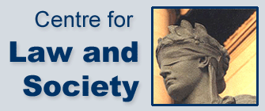

The Centre for Law and Society, Lancaster University Law School

## Constitutional Conventions Symposium

**10:30 – 11:00 Registration**

**11:00 – 12:10** **Panel 1 – Reflecting on the Nature of Constitutional Conventions**

Michael Gordon, University of Liverpool

*Can we mistake conventions for laws? The case of the rule that Parliament can’t bind its successors*

Joseph Jaconelli, University of Manchester

*The proper role of constitutional conventions*

**12:10 – 13:10 Lunch**

**13:10 – 14:20 Panel 2 – The Development of Constitutional Conventions**

Christopher McCorkindale, University of Strathclyde

Sewel Motions: the evolution of a convention

Adam Tucker, University of York, and Adam Perry, Queen Mary University of London

The move towards top-down constitutional conventions

**14:20 – 14:50 Refreshments**

**14:50 – 16:00 Panel 3 – Conventions in Practice: Governments and Bureaucrats**

David Feldman, University of Cambridge

*Makers and guardians of the constitution: Cabinet Secretary, Attorney General, judiciary, and Richard Crossman*

Petra Schleiter, University of Oxford

*The UK's recognition rules in comparative context*

16:00 Close