Musine Kokalari and the Power of Images: law, aesthetics and memory regimes in the Albanian Experience

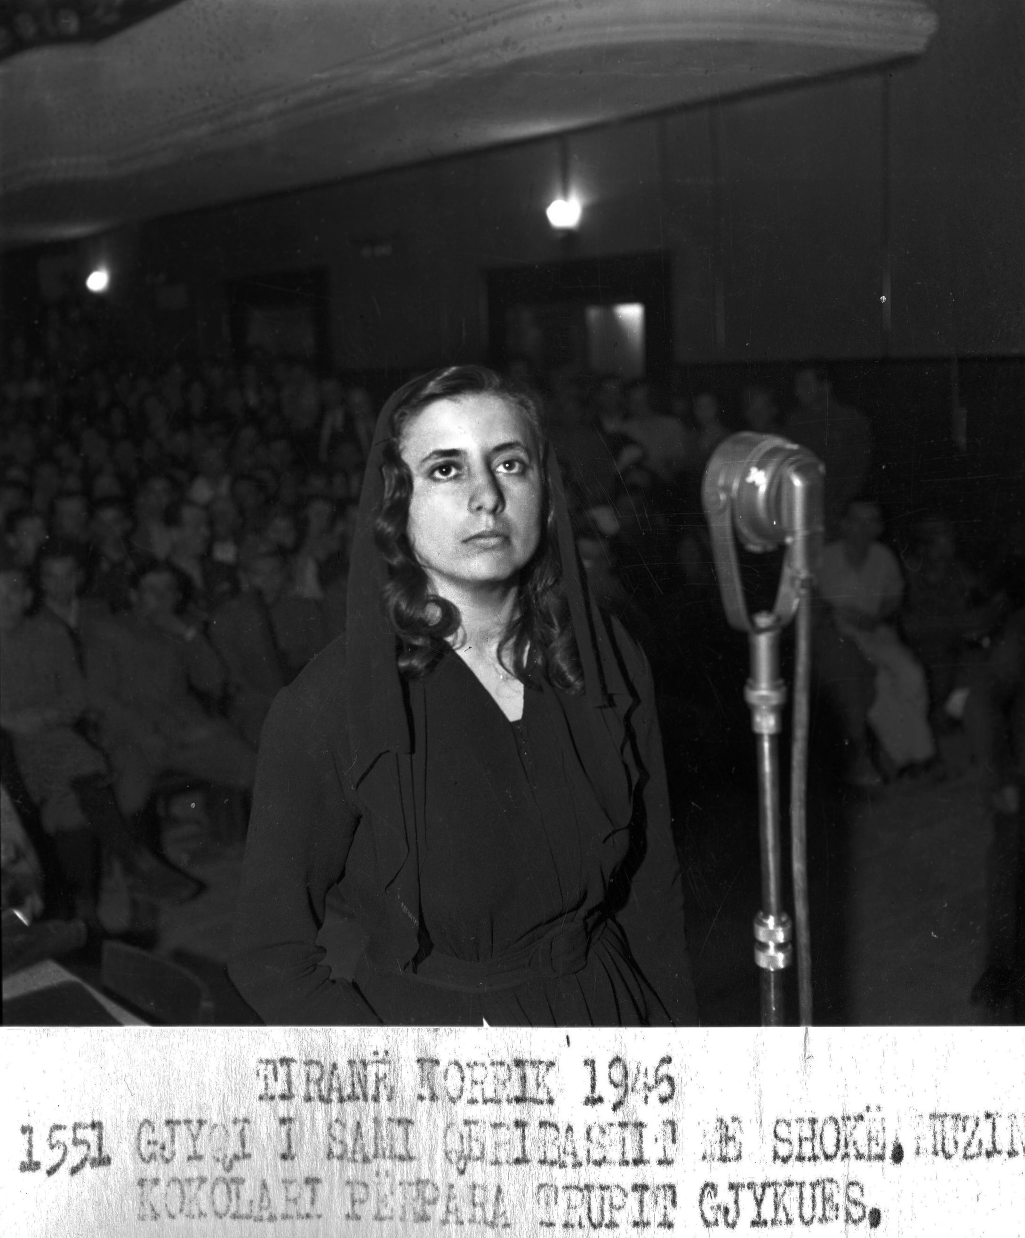
Figure 1. Tirana, July 1946
(1551) The Trial of Sami Qeribashi et al.
Musine Kokalari before the court. Albanian Telegraphic Agency

Abstract:
Tarot cards are one means to unlocking an image. In this article, the image is that of the Albanian writer and political dissident Musine Kokalari at her 1946 trial. Her photograph features in Albanian discourses about its communist past. I argue that the image provides clues as to the manner in which the country has faced up to its own history. For what is certain is that the Albanian account of the Enver Hoxha dictatorship (1944-1991) remains incomplete. Drawing on Walter Benjamin’s notion of ‘here-and-now in a flash’, and Roland Barthes’ and Italo Calvino’s reflections on photography and the power of the visual, we can identify at least two distinct memory regimes in the relevant historical, legal and political narratives.

Key words: law and aesthetics, tarot cards, photograph, Musine Kokalari, Albania, memory regimes, transitional justice

***
This article considers law in the light of aesthetics and memory. It is concerned with a photograph taken at a trial that was held in Tirana, Albania in 1946. Albanian archives are rich in visual images that have yet to be explored. To date research has largely been devoted to Soviet documents that are mainly analysed in their historical context. My article addresses the power of the image. I am interested in what it conveys about the law through the eye of the Operator (i.e. the photographer), the Spectator, (i.e. us) and the Spectrum (the person or object photographed). The Observer-Spectator relationship is dynamic and, as we shall see, their roles are often interchanged; this swapping affects the meanings assigned to the image. The production and circulation of the photographs would have occurred in the public domain, and meanings could be ascribed to these images by the Observer and the Spectator alike. A photograph can awaken strong emotional connections that go beyond its intended meaning. It can present questions about the past that are quite distinct from the written record, which includes the trial transcript, and can unsettle entrenched narratives. As such, my investigation extends into the present. Some of these visual images form part of the country’s contemporary approaches to ‘remembering the past’. But, in order to appreciate the value of a photograph, the use of the visual in the form of tarot cards, which are steeped in their own arcane meanings, will serve here as a conceptual map. My use of tarot cards, I feel, complements the use of other images in my article. The elaborate history of the game of tarot would be of profound significance for those interested in mysteries or fortune-telling – broadly, the occult, in which the choice of the card and its presentation or ‘flashing up’ was potentially of momentous import.
An enquiry into the power of visual images in the context of legal process in Albania is certainly timely. Twenty-five years have passed since the collapse of communism in Europe, providing important perspectives on the law, especially in the context of political justice during the Stalinist era, when a series of trials were staged in the Eastern bloc. ‘Political justice’ has been defined as the enlargement of the arena of ‘political action by enlisting the services of the courts on behalf of political goals’. For dictatorial regimes, despite their nearly limitless use of force, political justice was an indispensable aspect of governance. It introduced a special kind of communication, or ‘speaking legally’, between state officials and their subjects, one that was designed to achieve legitimation. Under the guise of socialist legality, the maladministration of justice was a wider phenomenon that characterised all Soviet bloc countries throughout the communist period. The communication in question extended to making visual images available to the public – a vital propaganda tool. As a result the maladministration of justice was vested with political legitimation based on ideological grounds. There have been historical analyses, but little research from a law and aesthetics perspective. ‘Unpacking’ the photograph enriches our understanding of the meaning and context of ‘speaking legally’; it may shed light on the actual process of generating meaning, with reference to ideologies that are hidden deep within a culture and its aesthetics.
It is scholars working in the field of transitional justice who usually undertake the task of analysing the ways in which a post-dictatorial regime addresses past injustices, but the key to unlocking the image in question here is not to be found in just one area of legal scholarship. This is important for three reasons. First, because transitional justice has an institutional bias, focusing on the images of selected victims assists in ‘listening anew’ and making visible hidden aspects of a regime that might explain its wholesale abuse of the legal system. Where personal testimonies are extant, they can help us appreciate the sheer scale of the repression, fostering engagement with historical fact and lived experience, one of the central aims of transitional justice. Secondly, and crucially, a break with the linear approach adopted by most transitional justice scholarship – a mode of enquiry concerned with the manner in which states address the injustices committed under the predecessor regime - also serves to unsettle its entrenched narratives, offering depth, complexity, or ‘affective justice’. As Evi Girling notes, the ‘global production, exchange, and consumption of images … necessitates embracing a cultural as well as comparative project when considering local and national legal orders’. In other words, ‘unframing’ an image and ‘witnessing a judgment act’ helps the viewer reflect on the justification of the process at a specific moment of regime change and on the actual impact of these images.
My article is concentric in form, with the image of its main protagonist, the Albanian writer Musine Kokalari at her 1946 trial, at its centre. I begin with a theoretical overview, proceed then to the importance of Albania as an object of study, and continue with Musine’s biography and its place in Albanian discourses about its dictatorial past. I argue that, while her image has been accorded a key part in the prevailing historical and political narratives about the country’s communist history, her own account of her life, and the accounts given by others, are still swathed in silence. Significantly, my analysis brings to light at least two distinct memory regimes. To assist the reader I use tarot cards throughout to serve as an aid in interpreting events and key actors, which here assumes the guise of a concatenation of images, both then and now. Tarot cards are a powerful source of archetypal visualisations that can serve to guide the reader through the life and background of the subject of the photograph.
The use of the cards provokes questions about the manner in which lives were lived at that time. Tarot cards also possess an important temporal quality, complementing the power of the photograph. These commanding images evoke the capricious nature of the regime, its perversion of the law, and the long-term consequences for society.

Theoretical Overview
In On the Concept of History, Walter Benjamin refers to a ‘flashing up’, or irruption of fragmented and dissociated imprints of reality. Benjamin sought to advance our understanding of the symbolic structuring of space in his discussion regarding the ‘now-time’ (Jetztzeit). ‘The dialectical image is an image that emerges suddenly, in a flash’. This notion of the image as a ‘flash’ [ein aufblitzendes] and the corresponding notion of historical experience as the discharge of an explosive force—the explosive force of now-time, blasting open ‘the continuum of history’— is one of the concepts for which Benjamin is perhaps best known. Susan Sontag and Judith Butler refer to Benjamin in their explorations of the power of the photograph to contain and constrain meanings. And one question they attempt to answer relates to our responses to an image. While Sontag argues that images only take on meanings when interpreted within the viewer’s own cultural and political frame of reference, Butler finds that photographs themselves actively participate in the viewer’s understanding of the subject matter by virtue of delimiting what is knowable, what is true, what can be seen.
Certainly over the last few years there has been a renewed interest in the visual – in the guise of images across new and old media. The aesthetic dimension of law may be encapsulated in an image. But the image needs to be contextualised before analysing the relationship between it and the law, and this contextualisation might involve a consideration of legal matters or a value judgement about the image itself. Peter Goodrich, for example, argues that law becomes a question of both art, or aesthetics, and memory, the result of repetition, inscription and representation. Law should be construed as a language and image-field of transmission, of the transmission of a mode of institutional life and of all that the institution in question implies. For Goodrich, to achieve this objective, we should fight against our inclination to resist pictures. In fact, scholars argue that people do not simply see the material properties of the pictorial depiction and then conclude what it is that they are supposed to represent: ‘seeing what a picture is of is a genuine case of seeing without commitment to the idea that what we see is the object itself or an illusion of it’. This is another instance of resistance; we see the pictures without any commitment to the idea that what we are seeing is the object itself or an impression of it.
To aid our understanding I believe that the use of tarot cards can serve as an important and instructive, albeit eccentric starting point. Tarots are ancient cards used in games and fortune-telling. Tarot cards have inspired a vast tradition of cartomancy that is founded on different interpretations, symbolic, astrological, kabbalistic, or alchemical. The cards were especially popular in Italy and France. Once the cards have been laid out in a sequence, events are reconstructed and interpreted. Tarot card readings can be understood as narratives, depending on who is speaking and who is listening and/or looking on. They suggest an intriguing link to contemporary studies of the past because they are social constructions of a person’s conceivable experiences in her lifetime. They offer limitless possibilities for the interpretation of an individual’s most important experiences lived and milestones reached. All interpretations are valid but not all may reveal the true meaning. This makes tarot cards an appropriate and alluring means to relay a biography. Italo Calvino understood the significance of tarot cards when writing The Castle of Crossed Destinies and The Tavern of Crossed Destinies, in which he used the pictures to set up the story. In this way, Calvino presented the reader with several stories, each stemming from the tarot cards. In one reading the heroine becomes the villain, the ruler the fool, or the disaster a triumph. In my article I adopt Calvino’s simple approach in observing the meaning, which varies according to the sequence into which each individual card is inserted. The tarot cards I use are from the Visconti-Sforza deck. I only employ trump cards, of which there are 22, and which represent, through archetypes, the full spectrum of joys and sorrows that a person may experience over a lifetime. By unlocking the image with the use of tarot, we can better understand the background and character of our protagonist and the world within which she lived. The use of tarot cards also serves as a bridge to the present, and perhaps explains why Musine Kokalari features so prominently in contemporary discourses about the past. Like a tarot card and its particular image, Musine’s image ‘flashes up’ in specific settings and discourses. Tarot cards are used by groups, and are therefore appropriate here, Musine being a shared memory for a certain generation of Albanians, a fact that lends poignancy and legitimacy to the various possible readings and interpretations.
In Camera Lucida, Roland Barthes distinguishes between the studium, that is, cultural participation in the information or the emotion that the photograph conveys, and the punctum, or the startling, involuntary transfixing element that certain images communicate. Scholars have pointed out that sight is connected to our other senses, making the experience of looking at a photograph essentially synaesthetic. This, in turn, means that historical reality can be depicted through representations of the real. Moreover, in the postmodern context, our reality is shaped by media narratives and the reporting of events. I am drawn to the idea that tarot cards can be a source of reporting.
Historical reality can differ from the image that is produced, a discrepancy that may cause problems. Additionally, a photograph is the trace of something that once existed. ‘In the photograph we are looking at something that has been and is no longer there […] the temps écrasé (‘crushed time’). Both Benjamin and Barthes address aspects of the image and of affect that can explain how bodily and sentient experience becomes meaningful. Benjamin notes that as the mechanical reproduction of an object multiplies, the more ways are provided for masking the changes made to the image under the guise of the given meaning. Barthes likewise understood the potential use of the photograph to communicate what is in reality propaganda so that it comes to seem natural. Both writers allude to the space and temporality of photography. And, although not referring to Benjamin directly, Barthes writes about the ‘type of consciousness’ the photograph contains, a consciousness that is ‘unprecedented’ – so that, when combined with the ‘awareness’ of the photograph’s ‘having-been-there’, ‘we have a new space-time category: spatial immediacy and temporal anteriority, the photograph being an illogical conjunction between the here-now and the there-then’. In this way, photographs from Musine’s trial were of importance to the regime and its propaganda machine; they served to produce knowledge about the population and its ‘treacherous’ nature. Photographs of the dictatorship’s victims form part of the mnemonical landscape of Albanian transitional justice. In her work on photography, Lindsay Smith considers a photograph to be a petrified moment. Yet, it is not still, for there exists movement in the static image that releases it from its original temporality and enables it to exist in more than one temporal space as it travels through the processes of reproduction. Smith draws our attention to the notion of the ‘presentiment of fate’ located at the heart of the concept of the longevity of art. In other words, at each moment of reproduction Musine’s image must experience its fate and her story be retold. Drawing on Benjamin, Smith provides further support for the view that in looking at the image we experience the ‘already having been of that which is yet to come’, or ‘the paradox of an instant that endures without a future’.
This has particular relevance for discussions concerning the law and its limited success in addressing the injustices of the predecessor regime. Law is a privileged site of recall, of returning to the past and dealing with the past, which might involve confronting the past. Law derives from and is diverted through all the wider normative practices of the broader body politic. Equally, aesthetic encounters are also normative encounters that raise questions about the past and place it in doubt. In fact, art can provide alternative and complementary solutions in certain societies, for example, by highlighting justice roles and documenting atrocities that legal proceedings are not able to do, for a variety of reasons, in an effort to also restore dignity to the victim. A photograph can certainly assume this role. Suddenly, law becomes jurisgenerative; it embraces creativity, through these normative encounters. This neglected feature of law can illuminate ways in which the image may have a vital part to play in restoring the dignity of oppressed or abused subjects and in facilitating the transition from dictatorship to democracy.
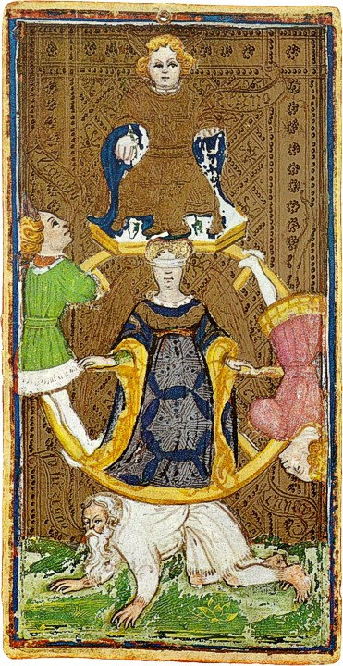
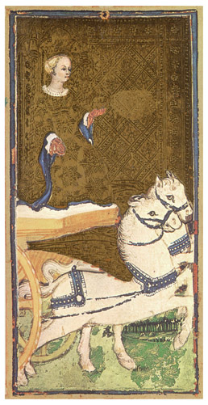
Why Albania?
Albania is presented by The Wheel of Fortune, [which] indicates destiny. The Chariot refers to conflict, turbulence, a journey.

‘The Albanians remain in many respects the little known and little understood people [...] a nation of people still unable to defend their interests and to make their wishes heard’.

At the start of the 1900s, Albania's political culture was extremely underdeveloped, with little experience of democracy, opposition or debate. In 1944, with the end of WWII near, the National Liberation movement, under the guidance of the future communist leader, Enver Hoxha, consolidated its power with the assistance of execution squads that eliminated opposition members. Albanian communism was highly centralised and the communists dominated all aspects of everyday life. The key instrument of power was the vast secret police network, the Sigurimi, created in 1943. Unlike its communist counterparts, such as Poland or Czechoslovakia, where dissidents were able to draw on a support network not just within the communist bloc but from the West as well, Albania was entirely shut off from the outside world. This makes twentieth-century Albania one of the most important examples of a European dictatorship. Albanian intellectuals in exile write that the country
could perhaps pardon communism many crimes, but not that of having deprived her of her sons’ energy of mind and spirit, a nation's most valuable capital. And when one further considers that Albania is not a nation with an abundance of intellectuals, one can more sensibly evaluate her loss.

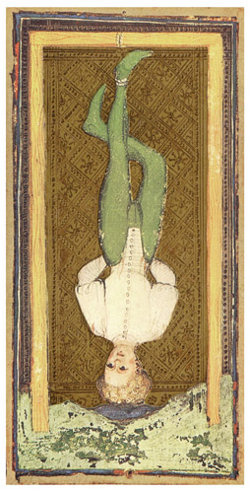
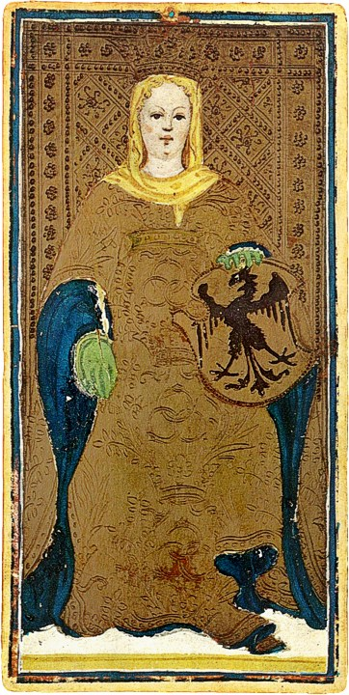

Musine Kokalari belonged to a then thriving Albanian intelligentsia. In the next section I discuss her background. More importantly, Musine is evidence for the existence of dissident Albanian political voices. This fact lends credence to Arish Pipa’s assertion as to the irreversible damage to the country’s chances of reconstructing a democracy at the next available opportunity inflicted by the systematic and near total elimination of this segment of the population.

Who was Musine Kokalari?
Musine is represented by the Hanged Man. Hanging upside down was the punishment for traitors in Italy during the Renaissance, when this deck was created. The image is apt –Musine was, after all, a criminal and the state sentenced her accordingly.
On the other hand, Musine is represented by the Empress, who symbolises feminine power, practicality, decisiveness. She was, after all, a heroine, albeit a reluctant one.

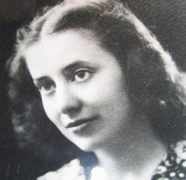
Figure 2. Musine Kokalari, 1925-1929. The Albanian National Archives
Musine Kokalari was born in 1917 in Adana, Turkey. Her family returned to their southern Albanian roots in 1920 and settled in Gjirokastra. Musine was born into a family of intellectuals; at least two of her brothers were active in politics and participated in literary life. Musine completed her studies in Literature at La Sapienza, University of Rome in 1941. She was anti-fascist and anti-nationalist. At twenty-four she published As My Grandmother Tells Me (Siç me thotë nënua plakë), signalling her entry into society as a writer. In that book she celebrates the local Gjirokastran dialect and sets out a critique of the patriarchal society to which the Albanian woman is confined. Other works include How Life Swayed (Sa u-tunt jeta) and Around the Hearth (Rreth Vatrës), both published in 1944. These literary achievements earned her an invitation to join the prestigious group of the Albanian League of Writers and Artists. These publications were unique because of the use of the local vernacular and reference to the prevailing customs of the region. The year 1944 also saw Musine arrested and released after the execution of her two brothers, Muntas and Vesim. The terrible fate of her siblings forced her to set aside her first love, writing, for politics. And, in 1945, Musine was arrested once again, this time as the alleged leader of a political opposition group (Bashkimi Demokrat, or the Social Democrat party). Her uncompromising attitude towards freedom of expression and association was made known.
While Musine was defending her view of the development of democracy in Albania, someone hysterically shouted from the trial venue: “String her up!”. To which the presiding judge asked: “Did you hear what people say for you, the accused?!” Musine responded immediately: “One day they will say the same for you, your honour!”.

Figure 3. Tirana, July 1946
(1551) The Trial of Sami Qeribashi et al.
Musine Kokalari before the court. Albanian Telegraphic Agency

Musine was given the floor after the prosecution had rested its case. She read out her defence but was interrupted by the court because it was felt that what she was saying did not relate to the charges. As what she was saying was beside the point she was ordered to be silent; her written defence would be attached to the file. Her final words at the trial made reference to Sami Fräsheri, an Ottoman Albanian, a prominent figure within the National Renaissance Movement and the subject of Musine’s thesis at La Sapienza: ‘I am a disciple of the renowned Sami Fräsheri and with me you want to condemn renaissance’. Her image is not a mere studium; the veil that she wore in defiance and as a show of mourning for her dead brothers renders it a punctum. It would have pierced even her judges to the heart. Just as Sophocles did not create Antigone entirely from the imagination, so too the audience who saw Musine’s stubborn and resolute opposition to the despotic court must have recognised in her defiance the stance of some of their own family members or acquaintances.
The court sentenced Musine to 20 years imprisonment in one of the most brutal labour camps, located in northern Albania. The authorities banned and destroyed all her works. The experience must have been unbearable. Musine asked for pardon in 1957, but her request was turned down by the Ministry of the Interior, which instructed the Supreme Court to not grant pardon, on the grounds that Musine was not fit to re-enter society [this was after eleven years behind bars]. After 16 years of incarceration, Musine was released and exiled for a period to Rrëshen, a city in the district of Mirdita, where she was forced to work as a manual labourer, and forbidden to write. Musine joked that she was a ‘mortar specialist’. She was kept under surveillance for the rest of her life. When Musine fell ill with cancer, she was refused a hospital bed. Musine died in August 1983. In 1993, the then Albanian president, Sali Berisha, declared several Albanians, including Musine Kokalari, to be ‘Martyrs for Democracy’.
Very little is available in English about Musine Kokalari’s formation and background. In Saimir Kumbaro’s 2012 documentary, ‘The Martyrs’, the Albanian writer Ismail Kadare remarks that ‘[she] was a distinguished martyr of freedom. She is the first to have formulated in a lapidary manner the idea of pluralism in Albania. She defended herself at the trial, where among other things she said: ‘It is not necessary to be a communist to love Albania’. Her case study is an important lens through which to analyse the Albanian dictatorship, not least because Musine was a pioneer whose personal narrative, and its legacy, is yet to be revealed.

The 1946 Political Dissidents Trial

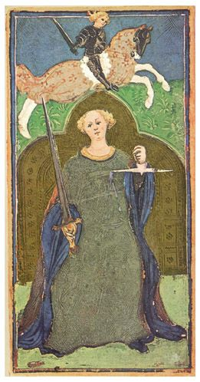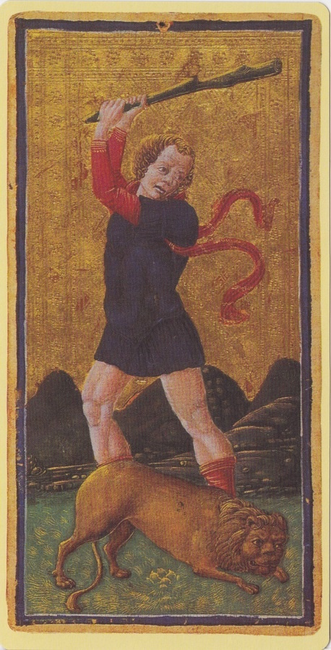
The trial is represented by [the] reversed trump card of Justice, symbolising false accusations.
The trump card of reversed Strength depicts the abuse of power.

In total, there were six trials held over the period 1945 to 1951 that successfully consolidated the dictatorship and its power over the general populace. The second trial, conducted in 1946, of the ‘Albanian Opposition,’ was the first involving political dissidents. Musine was one of 37 defendants. The political and ideological character of the criminal law provisions were confirmed by the nature of the trial: proceedings were held at the Rex Cinema in Tirana with a carefully hand-picked audience and media, where the prosecutor’s speech expressed contempt and revulsion at the opposition’s activities. Reports of the proceedings were transmitted throughout the city. Each judicial official’s role was vitally important to the trial. ‘So the shocking truth about a judicial hearing – [...] – is that the judge has the freedom to be fully present in all his or her human aspects’. In Musine’s case the judges adopted an especially aggressive stance. ‘[Musine] is filled with hate against the great victories of the people […] everything changes in our country, where a new life is born, but the diabolical soul of Musine Kokalari knows only hate against the people’. Musine did not deny her political activities but instead rejected the official position that her convictions and love for her country should be viewed as criminal. In addition to these live transmissions, her photograph twice appeared on the cover of the main Albanian broadsheets. It must have made an impression. In the contemporary context, her image becomes especially powerful in discussions about the elimination of intellectuals from Albanian life, later to be referred to by some survivors as ‘The Genocide of the Albanian Intellectuals’.
Such narratives stem from the 1946 trial transcript, and can be a particular kind of memorial device that is shared by a segment of the Albanian society, such as political prisoners. The transcript offers itself up for interpretation and while it may ‘freeze’ the record, it cannot govern its own interpretation. The transcript provides insights into the nature of the proceedings, the lawyers’ opening and closing arguments, and the responses provided in the cross- examination. But, most importantly, it invites readings of silences and exclusions. Some scholars argue that law’s integrity is jeopardised when the transcript is treated as a commemorative device, but new understandings of law’s crucial role in knitting together our past, present, and future can be attained through the recognition that several mnemonical regimes operate alongside each other. In order to understand law’s role, it is essential to look at the exclusions.
I recall when she [Nexhmije, Enver Hoxha’s wife] used to advocate the waging of the class war by saying “In conformity with the degree of guilt, the dictatorship of the proletariat will have to ruthlessly exclude one person from the ranks and keep him under strict control, imprison yet another, condemn still others to two or three years imprisonment, and others to 10-20 years, or else to be executed by the firing squad as enemies of the people”. Naturally, such crucial matters are discussed between husband and wife...In his memoirs the dictator himself wrote that “I always speak with Nexhmije about any matters of that sort”.

As we shall see, Musine’s image works effectively in the dictatorial and post-dictatorial context, as representations are not fixed once and for all. At one and the same time she is both a criminal and a heroine and the object of manipulation of those in power. The ‘presentiment of fate’, or the duration of the photograph, found at the core of Musine’s image, is released as her image travels across different zones of space and time.

Albania’s Approach to the Past
The World as an upright trump card represents a new home, clear sailing, inner happiness. As a reversed trump card it symbolises a lack of vision and failure to complete what is started.
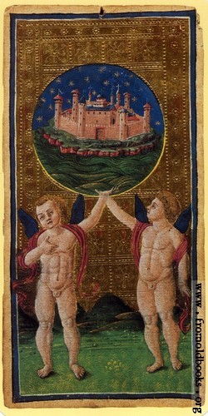
The timeline for transitional justice measures, starting in 1985 with Hoxha’s death, is arguably anachronistic. In the course of my fieldwork in Albania, in 2012, 2013 and 2015, I encountered Musine’s image from the 1946 trial, which featured prominently in two initiatives. The first refers to the work of The Institute for the Studies [sic] of Communist Crimes (ISCC), created in 2010 by parliament, which carries out research into communist crimes while leaving open the possibility of criminal prosecution. The ISCC has been reformed under the new Socialist Party government, elected in June 2013.
The second relates to the exhibition at Tirana’s National History Museum on the ‘Genocide of the Albanian Intellectual,’ and the museum’s subsequent publication of a catalogue, entitled ‘Communist Terror in Albania’. The research carried out at the ISCC, the exhibition, and the later documentation provides valuable evidence about key events and identifies the victims (such as Musine) and the perpetrators (such as the judiciary presiding over the trials and responsible for the maladministration of justice). But these were not coordinated efforts. In fact, ISCC’s Director at the time, Agron Tufa, wrote in 2011 about the lack of any political will to prosecute the perpetrators of judicial crimes, many of whom have gone on to pursue secondary careers in education and several of whom have been confronted by their victims on the streets of Tirana. This falls far short of other efforts in the sphere of transitional justice elsewhere, where storytelling has been recognised as reaffirming a commitment to the law or as offering a more coherent way to manage memories.
Albania successfully prosecuted its communist elite in the early 1990s, not for crimes against humanity or genocide, but for committing economic crimes, which in one sense trivialised the grave human rights transgressions of the regime. One of the most controversial episodes was the release of the 1991 Ruli Report, which catalogued in exhaustive detail the excesses of the Hoxha family, down to its consumption of meat.
The report, one of the most comprehensive in the region, detailing the expenses of Communist Party officials, criticised the party cadres as ‘deceitful, creating for [themselves] every opportunity to acquire privileges and enrich [themselves] while people were deceived by bogus and cynical propaganda about the struggle against privileges, luxury and inequality’. Everyone knew that the political elite lived off the fat of the land. The decision to prosecute strictly economic crimes caused grave offence to the population at large, since it seemed to play down the more serious abuses of the regime. It proved all but impossible to capture people’s attention when serious political charges emerged later. In 1991, members of the Communist Party leadership (Politburo) were criminally prosecuted for ‘stealing from the state’.
Subsequent attempts at addressing the past have been half-hearted, politically motivated and vague and should also be considered in the context of former President Sali Berisha’s contention that the past should be left to the historians, and that all were guilty, and all had jointly suffered. Berisha’s approach to the past is largely reflected in these initiatives, most strongly in the ISCC mandate and the National Museum’s exhibition and publication. This is in line with the presentation of the photographs on the walls of the ISCC, displayed in the museum and reproduced in the catalogue. The presentation of the photographs is intended to be self-explanatory and self-evident. The only context that is provided is through the narration of titles to the exhibition and of chapter headings in the catalogue. The use of the word ‘martyr’ in relation to, for example, Musine, serves to identify prominent victims and is part and parcel of a master narrative designed to offer its audience closure in relation to the atrocities committed. Yet no closure is achieved, as historicisation brings about a silencing of the victim’s and the perpetrator’s narrative.
It also blurs the line between victim and perpetrator, there being so little narration that encourages the viewer to ask how and why such atrocities occurred. For want of such narration, the victims are not empowered to participate in bringing the perpetrators to justice. Furthermore, within such a small society, anonymity is not possible. On the one hand, this acts to the detriment of legal initiatives. Of course, we can only create discourses informed by the interests of specific individuals and groups. On the other hand, the small number of survivors arguably empowers the mnemonical community to engage in ‘storytelling’, that is to say, a way of managing the past that is afforded a value in the public eye. The one-dimensional story-telling accompanying Musine’s image reveals the limits of the law – not necessarily its potential with respect to prosecution – in relation to the most notorious perpetrators of communist crimes, as seen above. In other words, where law and aesthetics overlap – at the silence of the law in relation to legal redress for the injustice - the power of the image goes beyond these interests to show at the least a second memory regime in play. This is the subject of the following section.

What’s in a Face?

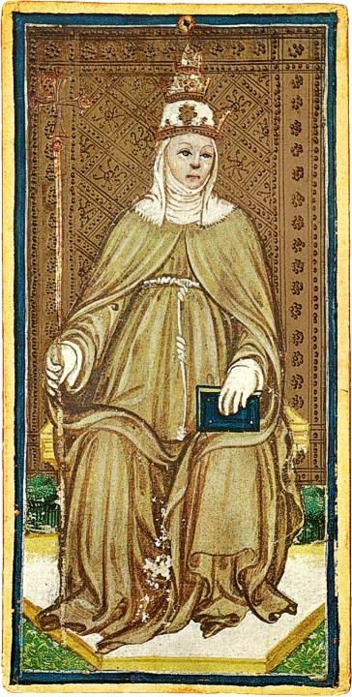
The High Priestess symbolises good judgement and sound intuition. The trump card represents introspection and serene wisdom.

Mark Osiel argues that storytelling is led by society and driven by historical tropes, such as tragedy; triumph; resistance to subordination; or irony, and so on. In contrast, criminal law’s trope is ‘vindication of society’s basic norms protecting [the] person’s rights to life and liberty, against whoever, by his or her conduct denies them. Both consciously and subconsciously tap into society’s story lines that can dominate over justice’. The legal and historical tropes converge in the analysis of Musine’s image.
As discussed above, Musine’s image is part of the master narrative that is being constructed and purveyed by specific mnemonical communities (political prisoners and government officials) and that concerns the genocide of the intellectuals and the communist terror. But her image also provides clues as to certain processes and surprises.
It is at this point that our attention is drawn to the image because it touches on ‘affective justice’, or ‘visceral notions of personal and collective responsibility’ where there is ‘not so much an emotion, as a bodily feeling, a corporeal sonority, a rhythm that places bodies on the line, an obligation that haunts and unsettles the narratives of transitional justice’, a process that discloses the legacy of the subject placed before the camera lens. There is also, in all likelihood, the unintentional legacy left by the photographer.
Musine was a successful and prolific writer, one of the first women of her generation to make her mark as one, although this is not necessarily what she handed down to those who came after her. Her stance and demeanour at her trial affected the wider society. She defended herself before the court, where among other things she said: ‘It is not necessary to be a communist to love Albania’. Her image shows the specific history and particular context and it can, of course, be read in different ways. On the one hand, Musine’s ‘lapidary’ testimony has not yet been accorded full recognition in Albanian historical and political narratives about the communist terror– but Benjamin’s concept of ‘now-time’ instructs us that political dissidence can fill the gap in law’s capacity to legitimate, and provide a voice where ‘normal instruments of criminal sanction seem inadequate’. On the other hand, the anachronistic character of the transitional justice process reveals a legal and historical discourse that should not be dismissed out of hand. The language and imagery of transmission indicates that the law still has a role to play. This has particular implications for Musine’s legacy. Her name was on everyone’s lips, or in everyone’s heart, though she lived in a country reputed to treat women harshly. Yet Albania’s reputation in this regard was not wholly deserved. If we view Musine’s legacy as one of emancipation and pluralism, then it is important to place it in the context of her contemporaries, many of whom embraced their emancipation by eschewing traditional roles (i.e. pursuing their education abroad, as Musine herself had done), or joining the partisans and ‘going to the mountain to fight’ (the path taken by her peers from Gjiroskastra), thus bringing to Albania notions of equality and progress based on a different ideological framework. Both groups were anti-fascist and many of their number were politically shrewd. But the regime’s programme of emancipation was selective, as demonstrated by the tragic case of the young, female partisan who was tried secretly and executed for reading Dante’s Inferno to her partisan peers. Another example comes in 1951, five years after Musine was sentenced, when the regime targeted another of her contemporaries at a time when it was still aligned with the Soviet Union.
Those who embraced emancipation through communism met the same fate as the generations who paid the price for their families’ alliances with the ‘enemy’. This came to be known as a ‘bad biography’, in other words, a life in which the individual or family was under constant scrutiny by the Sigurimi. Photos reveal the family’s timeline and ‘[p]hotography […] [is also a way of telling about this painful family history’. The ‘bad biography’ continues to haunt affected families, and their frustration is heightened as their voices are silenced through the historicisation of key narratives. Their stories remain ‘alive’, thanks to Musine and her image. At the time of writing this article the Albanian government has set up a commission to study the Hoxha dictatorship. The commission consists of compromised individuals, with somewhat controversial reputations, but also has one independent member.

Concluding remarks
In this article I have argued that a photograph arouses strong emotional connections that go beyond its intended meaning. I used tarot cards to guide the reader through the life and background of the subject of the photograph, whose image continues to have an impact on Albanians. The use of the cards also served to provoke questions about the manner in which lives were lived at that time. A photograph can raise questions about the past that are quite distinct from the written record. The image’s punctum serves to startle the spectator, whose attention is then drawn to the details of the case, the fate of the condemned, and the subsequent measures of justice. The image is a means to talk about the past through itself, and in its materiality. The image conveys a continuous message that subsists, and a consciousness of having been there. The manner in which the photograph is used is in reality propaganda. In this way, photographs from the trial served an important purpose for the regime, generating knowledge about the general population and the ‘traitors’ in its midst. On the other hand, the narratives between past and present are interwoven. The photograph continues to be a part of propaganda about the country’s past. And the focus of my discussion, the photograph of Musine Kokalari from her 1946 trial, and Albania’s approach to ‘remembering the past’, reveals a number of lessons. First, it is not an easy matter to unravel a dictatorial regime. Intellectuals in dictatorships tend to forge escape routes, whether real or imaginary, and never trust themselves. In Twilight of the Eastern Gods, Ismail Kadare sets out a fictionalised account of his experience at the Gorky Institute for World Literature in Moscow in the late 1950s. The main protagonist of the story, also a writer, is much preoccupied by the Albanian legend of Kostantin and Doruntine. According to the legend, when Doruntine marries and moves away, Kostantin promises his mother that he will fetch her for weddings and funerals. And when he and all his brothers are killed, his ghost takes on the same task. In Twilight of the Eastern Gods the writer comes to realise that his days are numbered, as Albania and the Soviet Union drift ever further apart. The writer becomes a veritable ghost in Moscow. In other words, he turns into a ghost even to himself, as a means to survive the terror. The intellectual, in this sense, lives amongst ghosts.
These ghosts, or experiences lived during the dictatorship, inevitably have an impact upon legal measures aimed at redressing the injustices of the predecessor regime, given all of the voices silenced through repression and the later, self-imposed censorship, the result of inexperience and fear. This state of mind has been well captured by Rubinlir:
The epidemic of persecution mania first afflicted intellectuals of western education, since the ones who were educated in the east were immune to Stalinist ways. But in a few years it spread to the most humble peasant in the land….At each turn he would look carefully back to see if the devil from the table in front of him was still following…it was enough for him to be caught by the ‘Sigurimi man’ crisis.

Secondly, when initiatives are presented as changing everything, they in fact change nothing. The best example is the official confining of the past to history on the grounds that the populace was complicit in perpetrating it. This in turn silences the role of the law. When art engages with the law, and law meets art at its apex, as in the case of a photograph, the silences have the potential to turn into opportunities that can then go on to overcome some of these obstacles to the recounting of certain narratives. For example, the tarot cards, used to guide us through the events and the image’s meanings, show not only that Musine’s name was on everyone’s lips in Albania then, but also that her image is before everyone’s eyes in Albania now, and a part of the construction of a master narrative about the communist terror. In either case, her personal narrative is suppressed, and any accompanying text is sidelined. On the other hand, we cannot ignore the meaning-making of the visual image. Musine’s hidden legacy points to the importance of making sure that reckoning with the past opens up new avenues of learning about the nature of the dictatorship, and that the process of historicising does not underplay how significant justice is for societies emerging from a dictatorship. This is an especially critical moment for a country that is examining the nature of the dictatorship. The adoption of law and aesthetics analysis is key and it points to a vital question, namely, the capacity of the law to create affective justice. The answer to ‘what’s in a face?’ is that Musine’s face is the story of many ‘Musine’s’.

REFERENCE LIST
Archival materials
- Albanian Ministry of the Interior archives in Tirana and are denoted by Dosje Gjyqësor (Judicial File), file [number], item [number], microfilm
- Albanian National Archives
- Albanian Telegraphic Agency

Journal articles
- Eamonn Carrabine, ‘Just Images: Aesthetics, Ethics and Visual Criminology’, British Journal of Criminology 52 (3) (2012), pp. 463-489
- Robert M. Cover, ‘The Supreme Court, 1982 Term—Foreword: Nomos and Narrative’, Harvard Law Review, 97 (1) (1983), pp. 4-68
- Peter Goodrich, ‘Judging Pictures: A Case Study of Portraits of the Chief Justices, Supreme Court of New South Wales’, International Journal of Law in Context, 5 (3) (2009), pp. 295-314
- Les Moran, Gary Watt, Linda Mulcahy, and David Isaac, ‘Four Reflections on the Art of Justice: the Judge’s Perspective’, Law and Humanities, 7 (1) (2013), pp. 113-128
- Eugene McNamee, ‘Eye Witness – Memorialising Humanity in Steve McQueen’s Hunger’, International Journal of Law in Context, 5 (3) (2009), pp. 281-294
- Austin Sarat, ‘Rhetoric and Remembrance: Trials, Transcription, and the Politics of Critical Reading’, Legal Studies, 23 (1999), pp. 355-378
- Rodrigo Ferrada Stoehrel, ‘The Legal Image’s Forgotten Aesthetic’, International Journal of the Semiotics of Law, 26 (3) (2013), pp. 555-577

Books
  - Tomor Aliko, Genocide on the Intellectual Elite of the Albanian Nation under the Communist Terror (Tirana: Shtypur ne Shtypshkronjen "Maluka", 2007)
  - Roland Barthes, Camera Lucida: Reflections on Photography, trans. Richard Howard (London: Vintage, 2000)
  - Roland Barthes, Image, Music, Text, trans. Stephen Heath (London: Fontana Press, 1977)
  - Roland Barthes, Mythologies, trans. Annette Lavers (London: Vintage, 2009)
  - Vikki Bell, Art and Post-Dictatorship: Ethics and Aesthetics in Transitional Argentina (London: Routledge, 2014)
  - Justus Buchler, Philosophical Writings of Charles S. Peirce (New York: Dover, 1955)
  - Judith Butler, Frames of War: When is Life Grievable? (New York: Verso, 2009)
  - Italo Calvino, Collection of Sand (New York: Mariner, 2013)
  - Italo Calvino, The Castle of Crossed Destinies and The Tavern of Crossed Destinies (London: Vintage, 1998)
  - Adam Czarnota, Martin Krygier and Wojciech Sadurski, eds., Rethinking the Rule of Law after Communism (Budapest, CEU Press, 2005)
  - Roman David, Lustration and Transitional Justice: Personnel Systems in the Czech Republic, Hungary, and Poland (Philadelphia, PA: University of Pennsylvania Press, 2011)
  - Barahona de Brito, Carmen Gonzales-Enriquez and Paloma Aguilar, eds., The Politics of Memory: Transitional Justice in Democratizing Societies (Oxford: Oxford University Press, 2001)
  - Costas Douzinas and Lynda Neal, eds., Law and the Image: The Authority of Art and the Aesthetics of Law (Chicago: University of Chicago Press, 1999)
  - Annette Dumbach and Jud Newborn, Sophie Scholl and the White Rose (Oxford: Oneworld, 2006)
  - Wassa Effendi, The Truth on Albania and the Albanians: Historical and Critical Issues, introduction Robert Elsie, trans. Edward Saint John Fairman, first published in 1879 by National Press Agency, London (London: Centre for Albanian Studies, 1999)
  - Alexander Etkind, Rory Finnin, Uilleam Blacker, Julie Fedor, Simon Lewis, Maria Mälksoo, and Matilda Mroz, eds., Remembering Katyn (London: Polity, 2012)
  - Agata Fijalkowski and Raluca Grosescu, eds., Transitional Criminal Justice in Post-Dictatorial and Post-Conflict Societies, Series on Transitional Justice, (Intersentia, 2015)
  - David Freedberg, The Power of Images: Studies in the History and Theory of Response (Chicago: University of Chicago Press, 1989)
  - Peter Goodrich, Languages of Law: from Logics of Memory to Nomadic Masks (London: Weidenfeld and Nicholson, 1990)
  - George Hodos, Show Trials: Stalinist Purges in Eastern Europe, 1948-1954 (London: Praeger, 1987)
  - Ismail Kadare, The Ghost Rider, trans. David Bellos (London: Canongate, 2014)
  - Ismail Kadare, Twilight of the Eastern Gods, trans. David Bellos (London: Canongate, 2014)
  - David King, Red Star over Russia: A Visual History of the Soviet Union from 1917 to the Death of Stalin (London: Tate, 2010)
  - Otto Kirchheimer, Political Justice (Princeton University Press, 1961)
  - Fatos Lubonja, Second Sentence: Inside the Albanian Gulag, trans. John Hodgson (London: I.B. Tauris, 2009)
  - Fatos Lubonja, The False Apocalypse: From Stalinism to Capitalism, trans. John Hodgson (London: Istros Books, 2014)
  - Geert Mak, In Europe (London: Random House, 2008)
  - James Mark, The Unfinished Revolution. Making Sense of the Communist Past in Central-Eastern Europe (New Haven and London: Yale University Press, 2010)
  - W.J.T. Mitchell, Picture Theory (Chicago: University of Chicago Press, 1994)
  - W.J.T. Mitchell, What Do Pictures Want? The Lives and Loves of Images (Chicago: University of Chicago Press, 2005)
  - Monika Nalepa, Skeletons in the Closet: Transitional Justice in Post-Communist Europe (Cambridge: Cambridge University Press, 2010)
  - Mark Osiel, Mass Atrocity, Collective Memory, and The Law (London: Transaction Books, 1997)
  - Mary Packard, The Golden Tarot: the Visconti-Sforza Deck (New York: The Book Shop, 2013)
  - Pjeter Pepa, The Criminal File of Albania's Communist Dictator, trans. Vangjel Morcka (Tirana: Shtepia Botuese Uegen, 2003)
  - Arshi Pipa, Albanian Stalinism, East European Monographs, No. CCLXXXVII (New York: Columbia University Press, 1990)
  - Jiří Přibáň, Dissidents of Law: On the 1989 velvet revolutions, legitimations, fictions of legality and contemporary version of the social contract (Aldershot: Ashgate, 2002)
  - Sad Rubinlir, 33 Years on the Cross, trans. Florian Allagiu (Tirana, Marin Barleti, 1999)
  - Fatbardha Saraçi (Mulleti), Kalvari i grave në burgjet e komunizmit (The Women’s Calvary in Communist Prisons) (Tirana:Instituti i Studimit të Krimeve dhe Pasojave të Komunizmit, 2013)
  - Ferdinand de Saussure, Course on General Linguistics (Chicago: Open Court Press, 1972)
  - Mónika Serrano and Veselin Popovski, eds., After Oppression: Transitional Justice in Latin America and Eastern Europe (New York: United Nations University Press, 2012)
  - Novruz Xh Shehu, Musine Kokalari: An Extraordinary Woman (Tirana: Greer, 2009)
  - Lavinia Stan, ed., Transitional Justice in Eastern Europe and Former Soviet Union (London: Routledge, 2008)
  - Ruti Teitel, Transitional Justice (New York: Oxford University Press, 2000)
  - Richard Terdiman, Present Modernity and the Past Memory Crisis (Ithaca, NY: Cornell University Press, 1993)
  - Miranda Vickers, The Albanians, 5th edn. (London: I.B. Tauris, 2008)
  - Susan Sontag, Regarding the Pain of Others (New York: Farrar, Straus and Giroux, 2003)
  - Frances A. Yates, ‘In the Cards’, The New York Review of Books, 19 February 1981
  - Frances A. Yates, The Art of Memory (London: Routledge and Kegan Paul, 1966)

Book Chapter
- Robert C. Austin and Jonathan Ellison, ‘Albania’, in Lavinia Stan, ed., Transitional Justice in Eastern Europe and Former Soviet Union, (London: Routledge, 2008), pp. 176-199
- Walter Benjamin, ‘On the Concept of History’, in Selected Writings, Volume 4, 1938-1940, trans. Howard Eiland and Kevin McLaughlin (Harvard: Harvard University Press, 1999)
- Walter Benjamin, ‘The Work of Art in the Age of Mechanical Reproduction’, in Walter Benjamin, Illuminations, trans. Harry Zohn (London: Fontana, 1973), pp. 219-253
- Elez Biberaj, ‘Albania: The Challenges of Transition’, in Sharon L. Wolchik and Jane L. Curry, eds., Central and East European Politics: From Communism to Democracy, 2nd edn. (London: Rowman & Littlefield, 2015), pp. 407-431
- Phil Carney, ‘Crime, Punishment and the Force of Photographic Spectacle’, in Keith J. Hayward and Mike Presdee, eds., Framing Criminology: Cultural Criminology and the Image (London: Routledge, 2010), pp. 17-35
- Gilles de Rapper and Anouk Durand, ‘Family Photographs in Socialist Albania: State Photography and the Private Sphere’, in Eckehard Pistrick, Nicola Scaldaferri and Gretel Schwörer, eds., Audiovisual Media and Identity Issues in Southeastern Europe (Cambridge: Cambridge Scholars Publishing, 2011), pp. 210-229
- Maria Elander, ‘Education and Photography at Tuol Sleng Genocide Museum’, in O. Simić and P.D. Rush, eds., The Arts of Transitional Justice (Springer, 2012), pp. 43-62
- Kathryn A. Heard, ‘Unframing the Death Penalty’, in Austin Sarat and Jürgen Martschukat, eds., Is the Death Penalty Dying?: European and American Perspectives (Cambridge: Cambridge University Press, 2011), pp. 126-149
- Evi Girling, ‘The Witnessing of Judgment: Between Error, Mercy and Vindictiveness’, in
- Austin Sarat and Jürgen Martschukat, eds., Is the Death Penalty Dying?: European and American Perspectives (Cambridge: Cambridge University Press, 2011), pp. 109-125
- Peter Rush, ‘Introduction’, in Olivera Simić and Peter D. Rush, eds., the Arts of Transitional Justice (Springer, 2012), pp. v-xi
- Lindsay Smith, ‘The Wont of Photography, or the Pleasure of Mimesis’ in Luisa Calè and Patrizia Di Bello, eds., Illustrations, Optics, and Objects in Nineteenth-Century Literary and Visual Cultures, (Basingstoke: Palgrave, 2010), pp. 65-86
- Ruti Teitel, Transitional Justice (New York: Oxford University Press, 2000)
- Malcolm Turvey, ‘Wittgenstein’, in Paisely Livingston and Carl Plantinga, eds., The Routledge Companion to Philosophy and Film (London: Routledge, 2009), pp. 470-480

Films
- The Martyrs (dir. Saimir Kumbaro, 2012)
- Sophie Scholl: the Final Days (dir. Marc Rothemund, 2005)

Images
- The tarot card images are taken from Commons Wikimedia and in the public domain because the copyright has expired PD-US-not renewed.

Interviews
- Ismail Kadare, 6 October 2014, Paris
- Linda Kokalari, Musine Kokakari’s great-niece, correspondence 21 July 2013
- Rozeta Kokalari, Musine Kokalari’s second cousin, 12 May 2015, Tirana
- Davjola Ndoja, former researcher at the ISCC, 1 May 2013, Tirana

Newspaper
- Agron Tufa, ‘Në mungesë një tribunali’(In the Absence of a Tribunal), Panorama Online, 26 August 2011

Online documents
- Norman Davies, ‘The Deep Stains of Dictatorship’, New York Review of Books, 9 May 2013, at http://www.nybooks.com/articles/archives/2013/may/09/deep-stains-dictatorship/?pagination=false (last accessed 21 July 2015)

Freedberg [26, 440] observes, in referring to Roland Barthes, ‘So much for the magnificent fullness of the photograph. It transcends death and peculiarly replenishes the lost being. What is lost or absent seems present, but we cannot know why. As soon as we strive to grasp that presence in all its fullness, we either fail or set out to tame or destroy it’
Such as King, [31].
In this article image is used interchangeably with photograph. Of course, image can refer to ‘any likeness, figure, motif, or form that appears in some medium or other’, W.J.T. Mitchell, What Do Pictures Want? The Lives and Loves of Images (Chicago: University of Chicago Press, 2005), p. xiii.
Barthes [13, 9] refers to the Spectrum of the Photograph, and its relation to the ‘spectacle’, which ‘adds to it that rather terrible thing which is there in every photograph: the return of the dead’.
Yates [50 and 51]..
Kirchheimer [32, 419].
This is a point discussed in semiotics and semiology, beginning with the work of Ferdinand de Saussure, in his Course on General Linguistics [44], based on a summary of his lectures delivered at the University of Geneva between 1906-1911. His work serves as a foundation for modern investigations into what underpins perception and communication. Charles S. Peirce, who worked on similar problems at the same time, made an important contribution to the debate with his notion of ‘Firstness’ as the primary perceptive event that is endowed with semiological meaning. See Buchler [17, 80].
This paper develops the work set out in Fijalkowski and Grosescu [28]. There is now a wealth of studies in the field of transitional justice. See for example, Teitel [54]. For considerations of domestic accountability in post-dictatorial societies, see Stan [53]; Nalepa [42]; David [22]; Serrano and Popovski; Czarnota, Krygier and Sadurski,[21. Other works in this field analyse the politics of memory applied through historical commissions and museums, such as de Brito, Gonzales-Enriquez and Aguilar [23]; and, finally, Mark [39],.
Rush [60, vii].
Rush [60, vii].
Girling [58,,109].
During her exile Musine was extremely careful about making contact with anyone. Under constant surveillance by the Sigurimi, she never discussed her account, or perhaps only with select family members, but contact with them was severely restricted. Interview with Linda Kokalari [68]. Musine’s writings have not been revisited or reissued by the state in the post-dictatorial period. This was done only by private initiatives.
Benjamin [52, 395].
Benjamin [52, 395].
Benjamin [52, 395]..
Sontag [57].
Heard [59, 130].
For example, see Douzinas and Neal [24] or Mitchell [40 and 41].
Carrabine [5] and Carney [55].
Douzinas and Neal [24, 13].
Goodrich [30, vii].
Goodrich [30, vii].
Goodrich [7]..
As argued by Wittgenstein, in his lectures on aesthetics. Richard Allen, ‘Looking at Motion Pictures’, in Richard Allen and Murray Smith, eds., Film Theory and Philosophy (Oxford: Clarendon Press, 2007), p. 77, quoted in Turvey [63, 478-479].
Calvino [20].
Images can also be found at the heart of a mnemonical community. In other words, a memory holds communities together, for example, in relation to specific events. Interpretations of these occurrences can vary, which makes the memory ‘fixed’, as a commemoration site, or ‘dynamic’, serving as a catalyst for a ‘memory event’. See, for example, the discussion concerning the Katyń massacre in Etkind, Finnin, Blacker, Fedor, Lewis, Mälksoo, and Mroz [27].
Barthes [13, 25-28]. Calvino [19, 71-76].
Stoehrel [11].
Stoehrel [11, 558].
Barthes [13, 25-28]. Calvino [19, 75].
For Benjamin, what weakens during this period is the ‘aura’ of the work of art in question, something that occurred for the first time with photography. ‘Aura’ concerns the object’s authority, which derives from history and originality. Benjamin [53].
Barthes [14,31-37]. Also [15].
Emphasis in the original. Barthes [14, 44].
Elander [57].
Smith [61, 72].
Smith [61, 72],
Smith [61, 72-73].
Bell [16, 5-15].
Bell [16, 1-15].
Bell [16, 1-15].
Cover [6] discusses the meaning of jurisgenerative as referring to the ways in which law is given meaning through a community’s narratives and rules, ‘their somewhat distinct nomos’, at p. 40. Vikki Bell uses Cover’s notion in her work [16]..
Bell [16, 1-15].
Packard [44, 68-69 and 62-63], respectively. The tarot card images are taken from Commons Wikimedia and in the public domain because the copyright has expired PD-US-not renewed.
Effendi [26, iii].
Biberaj [54, 407-408].
The Sigurimi permeated the society to the extent that every third citizen had either served time in labour camps or been interrogated by the secret police. Austin and Ellison [51,179]. See also Vickers [56].
Pipa [46, 25].
Packard [44, 72-73].
Packard [44, 54-55].
The tarot card images are taken from Commons Wikimedia and in the public domain because the copyright has expired PD-US-not renewed.
Literary circles were hubs of intellectual and political activity, and Albania was no different to Europe during this pre-war period of 1918-1939. Mak [38]
But she was very much engaged in politics. This increased as the war was drawing to a close and her political vision for Albania became tangible. Interview with Rozeta Kokalari [69].
Pepa [45, 117], translation modified. This scene recalls Sophie Scholl’s stance at the trial of the members of the White Rose. See Dumbach and Newborn [25] and ‘Sophie Scholl: the Final Days’ [65].
Pepa [45, 118].
For a personal account of this labour camp see Lubonja [36].
Dosje Gjyqësor, file 1624, item 1051/2, microfilm [1].
‘During work hours she was what they wanted her to be. But, after work, she was what she wanted to be: well dressed, beautiful and with a book in her hands. One needs to keep in mind the time and place we are referring to, the Rrëshen of those years’, interview with Linda Kokalari [68]..
Austin and Ellison [51,182].
But see Aliko [12].
Martirët (The Martys) [64].
Packard [44, 64-65]. The tarot card images are taken from Commons Wikimedia and in the public domain because the copyright has expired PD-US-not renewed.
Packard [4470-710.,
The first show trial, called the ‘Albanian Nuremberg Trial’, was held from March to April 1945 and presided over by Koci Xoxe, Minister of Defence and the Interior. Xoxe was instrumental in creating the infamous Sigurimi, the Albanian security or political police. The 60 defendants in the trial were government officials, who were charged and sentenced on multiple counts of treason and collaboration with the enemy (then Italy and Germany). The main fabricated accusation was that they were ‘traitors and enemies of the people’. Aliko [12, 17].
‘Groups of resistance', such as the ‘Groups of Legalists’ or the ‘Group of Social Democrats’. Pepa [45, 117].
Moran, Watt, Mulcahy, and Isaac [8, 121].
Dosje Gjygjsore, file 1615, item 1081, microfilm [1].
Shehu [52, 487].
Aliko [12].
Sarat, ‘Rhetoric and Remembrance: Trials, Transcription, and the Politics of Critical Reading’, Legal Studies, 23 (1999), pp. 355-378.
Sarat [10].
Pepa [[45, 119], translation modified.
Packard [44, 90-91]. The tarot card images are taken from Commons Wikimedia and in the public domain because the copyright has expired PD-US-not renewed.
Interview with Davjola Ndoja [70]..
Tufa [70]. See also Davies [71].
As in Northern Ireland, see McNamee [9].
Austin and Ellison [51, 182].
Austin and Ellison [51, 182]. Genc Ruli was the Minister of Finance at the time.
Austin and Ellison [51, 182].
Austin and Ellison [51, 182]
Austin and Ellison [51, 182].
Austin and Ellison [51, 182]. Berisha was from the Democratic Party. He was President of Albania from 2005-2013. Prior to that he was Prime Minister from 1992-1997.
Packard [44, 52-53]. The tarot card images are taken from Commons Wikimedia and in the public domain because the copyright has expired PD-US-not renewed.
Osiel [43, 114].
Osiel [43, 114-115].
Přibáň [47, 145].
Osiel [43, 276].
I am grateful to Ismail Kadare for drawing my attention to this [67]..
Again I am grateful to Ismail Kadare for drawing my attention to this [67].
Such as Professor Sabiha Kasimati. See Saraçi (Mulleti) [49, 231-232]. The basis for the charges was the same: suspicion of collaborating with the West. By 1948 the Stalinist show trial had been perfected and applied across communist Europe. See Hodos [31].
Saraçi (Mulleti) [49].
de Rapper and Durand [56, 221].
I am grateful to Elez Biberaj for the information.
See Lubonja [37].
Attributed to Lubonja, book presentation of The False Apocalypse: From Stalinism to Capitalism, Anglo-Albanian Association Meeting, London School of Economics, 15 October 2014.
The legend would later form the basis of Kadare’s story The Ghost Rider [32]. The spelling of Kostantin varies, from Konstantin, Constantine, or Constantin. I have used the spelling from The Ghost Rider.
Rubinlir [48, 77-78], translation modified. Sad Rubinlir is the name Sadri Ahmeti assumed as a writer.

