“We thought she was falling behind (at fourteen months)”
Young children’s engagement with digital media in homes in the UK and Finland
Julia Gillen, Lancaster University and Kristiina Kumpulainen, University of Helsinki
54th UKLA International Conference 2018 – Cardiff 6th – 8th July 2018
This paper focuses on research aimed at generating evidence about young children’s use of digital technologies in the home. First, we conducted a review of research published between 2005 and 2015. We identified three leading themes: Parental mediation of children’s digital literacy practices in homes; Children’s media engagement and literacy learning in homes; and Home-school knowledge exchange of children’s digital literacy practices. Second, we reviewed research on the same topic published 2016 and 2017. We found that while interest in these topics had increased further, attention to a relatively limited range of topics and approaches still dominates. In particular, our review work revealed that there are few studies that have focused their attention on the very young children and their engagement with digital technologies and media in homes. In responding to this need, we will share our ongoing European level research on “A day in the digital lives of children aged 0-3”. We explain how the research design is tailored to investigate the nuances of very young children’s engagement with digital media as it evolves over the day in the social context of their homes and share some findings from our studies in the UK and Finland.
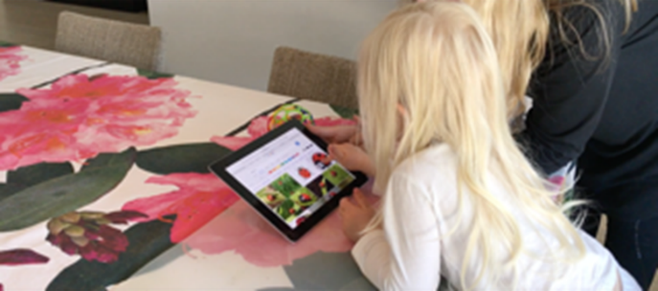 | 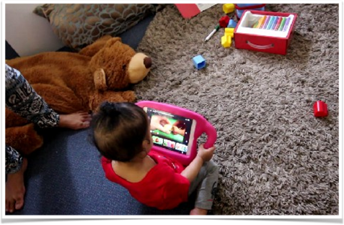

Sources for further information:
Gillen, J. et. al. (2018) A Day in the Digital Lives of Children aged 0-3. Summary report by DigiLitEY ISCH COST Action IS1410 Working Group 1 “Digital literacy in homes and communities.” http://digilitey.eu/wp-content/uploads/2018/06/DigiLitEY-A-Day-in-the-Digital-Lives-FINAL.pdf
Kumpulainen, K, Gillen, J, (2017) Young Children’s Digital Literacy Practices in the Home: A Review of the Literature. COST ACTION IS1410 DigiLitEY http://digilitey.eu/wp-content/uploads/2018/02/WG-1-Lit-Review-04-12-17.pdf
Kumpulainen, K. & Gillen, J. (in preparation) Young children’s digital literacy practices in homes: Past, present and future research directions. In The Routledge Handbook of Digital Literacies in Early Childhood, (eds) R. Flewitt, Ola Erstad, Bettina Kuemmerling-Meibauer and Iris Pereira. London: Routledge.
Email: j.gillen@lancaster.ac.uk; kristiina.kumpulainen@helsinki.fi

