TLDR – Social care for adults with learning disabilities in England: Recent trends

Author: Chris Hatton
Public Health England Learning Disabilities Observatory
Centre for Disability Research, Lancaster University, Lancaster, LA1 4YG, UK
Email: chris.hatton@lancaster.ac.uk

Abstract
Purpose
This paper examines trends over time in social care usage and expenditure for adults with learning disabilities in England.
Methodology
Returns from councils with social services responsibilities in England concerning social care usage and expenditure were analysed to examine the national picture and trends over time for adults with learning disabilities.
Findings
In 2017/18, 147,915 adults with learning disabilities were receiving long-term social care, an increase of 5.7% from 2014/15. Social care expenditure (not taking into account inflation) increased by 10.2% from 2014/15 to £5.54 billion in 2017/18. For adults with learning disabilities who receive social care, increasing numbers of people are living with families or in supported accommodation/living, with gradual declines in the number of people living in residential or nursing care. The number of adults with learning disabilities in temporary accommodation is small but increasing.
Implications
While councils appear to be attempting to protect social care for adults with learning disabilities in the face of cuts to council expenditure, social care expenditure and coverage is not keeping pace with likely increases in the number of adults with learning disabilities requiring social care.
Originality
This paper presents in one place statistics concerning long-term social care for adults with learning disabilities in England.

Introduction
This paper provides an overview of recent national statistics concerning social care usage and expenditure for adults with learning disabilities in England, as the coverage and quality of social care support for adults with learning disabilities at a time of austerity is becoming a question of increasing concern (Malli et al., 2018). Councils with social services responsibilities provide information to NHS Digital on an annual basis (NHS Digital 2018a, b), which is summarised here concerning the national picture and trends over time.
Datasets
The 152 councils with adult social services responsibilities in England provide data to NHS Digital on the receipt/usage of social care by adults with learning disabilities, and on council expenditure relating to social care. Data related to the social care activity of councils is reported in the Short and Long Term Support (SALT) collection (NHS Digital, 2018a) and, for selected indicators, in the Adult Social Care Outcomes Framework (ASCOF) (NHS Digital, 2018b). Data on council expenditure on social care is collected annually using the Adult Social Care Finance Return (ASC-FR), which is reported in the combined social care activity and finance report (NHS Digital, 2018a).
Up to 2013/14, the statistics concerned adults with learning disabilities known to councils with adult social services responsibilities (NHS Digital, 2014). As part of a suite of changes to data collection relating to social care, from 2014/15 the statistics concern adults with a primary support need of learning disabilities who are receiving long-term social care support from councils with social services responsibilities (NHS Digital, 2015, 16, 2017a, 2017b). As such, statistics over the time period 2013/14 to 2014/15 cannot be treated as continuous.

Findings
In terms of usage of long-term adult social care, the SALT dataset categorises people into one of six broad categories: residential care; nursing care; direct payment; personal budget – part direct payment; council-managed personal budget; council-commissioned community support only.
Figure 1 presents the number of adults with learning disabilities aged 18-64 in each of these categories, from 2009/10 to 2013/14 and from 2014/15 to 2017/18. In total there were 131,520 working age adults with learning disabilities getting long-term social care in 2017/18, with total numbers gradually increasing over time.
As Figure 1 shows, by 2017/18 the most common long-term social care arrangement for working age adults with learning disabilities was a council-managed personal budget (54,435 people) – this category, along with people getting a direct payment only (26,560 people) and people getting a personal budget-part direct payment (15,550 people), has been increasing substantially over time but may now be plateauing. Information on the number of working age adults with learning disabilities getting council-commissioned community support only (e.g. a day service) is available from 2014/15, with numbers relatively small and declining (8,525 people in 2017/18).
Figure 1 also reports the number of working age adults with learning disabilities in residential care, which has been steadily declining over time and was standing at 25,205 people in 2017/18; relatively few adults aged 18-64 are recorded as being in nursing care (1,245 people in 2017/18).

Figure 1 about here

Figure 2 reports equivalent figures for adults with learning disabilities aged 65 or over – these figures are available from 2014/15. In total there were 16,395 adults with learning disabilities aged 65+ receiving long-term social care in 2017/18, up from 15,320 people in 2014/15.
Figure 2 shows that for adults with learning disabilities aged 65+, the most common form of long-term social care was again a council-managed personal budget (7,205 people in 2017/18), although direct payment only (725 people in 2017/18) and personal budget-part direct payment (685 people) social care options were much rarer. In total 1,090 older adults with learning disabilities were receiving council-commissioned community support only in 2017/18, a decrease over time.
Proportionally, many more older adults with learning disabilities were in residential care (5,870 people in 2017/18) or nursing care (820 people in 2017/18), with numbers only slightly declining from 2014/15.

Figure 2 about here

From 2009/10, councils have also provided information on the types of accommodation that adults with learning disabilities aged 18-64 either known to councils (up to 2013/14) or receiving long-term social care (from 2014/15 onwards) are living in. Because of the number of accommodation types potentially recorded by councils, this information is presented in a table rather than a figure (Table 1). There are some trends that are readily apparent from this information.

Table 1 about here

First, by far the most common living situation for adults with learning disabilities aged 18-64 receiving social care is ‘settled mainstream housing with family/friends’, which for almost everyone is likely to be living with family members, with numbers increasing over time. In 2017/18, 48,165 people were reported to be in this type of accommodation, 36.7% of all working age adults with learning disabilities getting long-term social care.
Also rising rapidly are the number of working age adults with learning disabilities in supported accommodation of some kind (29,195 people in 2017/18), with tenancies previously rising but now appearing to plateau (3,720 people in tenancies with a private landlord and 12,920 people in tenancies with other types of landlord in 2017/18) and residential care gradually decreasing (currently 21,145 people in residential care and 990 people in nursing care in 2017/18). More innovative forms of accommodation, such as owner-occupier/shared ownership (3,000 people in 2017/18) or shared lives (3,535 people in 2017/18) are relatively rare.
It is also important to note the small but rapidly rising number of working age adults with learning disabilities in various types of obviously temporary accommodation (short-term stay with family/friends, council-provided temporary accommodation and other temporary accommodation), rising by 32% in three years from 1,205 people in 2014/15 to 1,590 people in 2017/18.
The final figure below (Figure 3) summarises social care expenditure on long-term and short-term social care for adults with learning disabilities in England from 2014/15 to 2017/18, broken down by age group (18-64 years old and 65+ years old). These specific expenditure figures are not adjusted for inflation. However, Figure 3 includes lines for total expenditure at 2014/15 levels, adjusting for inflation, projected forward to 2017/18. Inflators were taken from the PSSRU Unit Costs of Health and Social Care 2017 (Curtis & Burns, 2017) inflators for adult services (all sectors) pay and prices (excluding capital).
Overall, the amount of social care funding for adults with learning disabilities continues to increase in absolute terms, from £4.98 billion in 2014/15 to £5.54 billion in 2017/18. Adjusting for inflation there are still increases although they are small, with an inflation-adjusted compound annual growth rate of social care expenditure for adults aged 18-64 of 0.95%, and for adults aged 65+ of 0.47%.
Almost all this social care budget (98.5% in 2017/18) is spent on long-term care rather than short-term care, and the vast majority of the budget (89.3% in 2017/18) is spent on adults aged 18-64 rather than older people.
In terms of specific types of services, across all adult ages the largest single category of social care expenditure in 2017/18 was residential care (£1.97 billion, 35.5% of the total social care budget for adults with learning disabilities), followed by supported living (£1.3 billion), other community social care (£708 million), direct payments (£655 million), home care (£399 million) and supported accommodation (£342 million).

Figure 3 about here

Discussion
This paper presents selected information from local authorities concerning the use of social care by adults with learning disabilities, and social care expenditure on these services and supports. Before discussing some of the main issues arising from this information, it is important to mention some methodological issues that limit the interpretations that can be made from the data. First, the data can be incomplete. For example, in the detailed information on accommodation for adults with learning disabilities aged 18-64, councils were recording this as ‘unknown’ for 5,165 people (3.9% of all working age adults getting long-term social care). Second, it is possible that this information will not include some adults with learning disabilities receiving social care, where their primary support need has been identified as something other than learning disabilities. There are also other types of incompleteness, such as expenditure data not including the cost of housing benefit for people in supported living arrangements. Third, there are inconsistencies between datasets collecting ostensibly the same information. For example, it is unclear why councils report 25,205 adults with learning disabilities aged 18-64 in residential care, when the more detailed accommodation data record 21,145 people in residential care. There are also inconsistencies across categories of social care usage and expenditure that make the linkage of social care usage to social care expenditure very difficult.
Taking into account these limitations, some broad trends are still clear. The number of adults with learning disabilities receiving long-term social care, and social care expenditure, continues to gradually increase at a time when council budgets have been severely cut, including social care expenditure for older people generally (National Audit Office, 2017, 2018). In 2017/18, 147,915 adults with learning disabilities received some form of long-term social care, an increase of 5.7% from 2014/15. Similarly, in 2017/18 total gross social care expenditure on adults with learning disabilities was £5.54 billion; adjusted for inflation this was a 2.7% increase in expenditure from 2014/15. In addition to the number of adults with learning disabilities receiving long-term social care increasing at a greater rate than inflation-adjusted expenditure, it is also the case that the increase in the number of adults with learning disabilities receiving social care is not keeping pace with population projections of substantially greater numbers of adults with learning disabilities who will require social care over time (Emerson et al., 2012).
Increasingly, adults with learning disabilities in receipt of social care are continuing to live with family members and are getting social care via the vehicle of council-managed personal budgets, although the extent to which people experience council-managed personal budgets as a radical change from council-commissioned social care services is unclear. The number of adults with learning disabilities in residential care and nursing care continues to gradually decline, although these services still constitute over a third of social spending on adults with learning disabilities.

References
Curtis L & Burns A (2017). Unit Costs of Health and Social Care 2017, Personal Social Services Research Unit, University of Kent, https://doi.org/10.22024/UniKent/01.02/65559.
Emerson E, Robertson J, Coles B & Hatton C (2012). Estimating the need for social care services for adults with disabilities in England 2012-2030. Centre for Disability Research, Lancaster University, Lancaster, available at http://www.research.lancs.ac.uk/portal/en/publications/estimating-the-need-for-social-care-services-for-adults-with-disabilities-in-england-20122030(e694bcdf-2ea9-4968-93d6-0d2e44ff3bb7).html (accessed 7 February 2019).
Malli M A, Sams L, Forrester-Jones R, Murphy G & Henwood M (2018): Austerity and the lives of people with learning disabilities. A thematic synthesis of current literature, Disability & Society, DOI: 10.1080/09687599.2018.1497950
National Audit Office (2017). Local support for people with a learning disability. NAO, London, available at https://www.nao.org.uk/report/local-support-for-people-with-a-learning-disability/# (accessed 7 February 2019).
National Audit Office (2018). Adult social care at a glance. NAO, London, available at https://www.nao.org.uk/wp-content/uploads/2018/07/Adult-social-care-at-a-glance.pdf (accessed 7 February 2019).
NHS Digital (2014), Community Care Statistics: Social Services Activity, England 2013-14. NHS Digital, Leeds, available at https://digital.nhs.uk/catalogue/PUB16133 (accessed 18 December 2017)
NHS Digital (2015), Community Care Statistics: Social Services Activity, England 2014-15, NHS Digital, Leeds, available at https://digital.nhs.uk/catalogue/PUB18663 (accessed 18 December 2017)
NHS Digital (2016), Community Care Statistics: Social Services Activity, England 2015-16, NHS Digital, Leeds, available at https://digital.nhs.uk/catalogue/PUB21934 (accessed 18 December 2017)
NHS Digital (2017a), Adult Social Care Activity and Finance Report, England 2016-17, NHS Digital, Leeds, available at https://digital.nhs.uk/catalogue/PUB30121 (accessed 18 December 2017)
NHS Digital (2017b), Measures from the Adult Social Care Outcomes Framework, England 2016-17, NHS Digital, Leeds, available at https://digital.nhs.uk/catalogue/PUB30122 (accessed 18 December 2017)
NHS Digital (2017c), Adult Social Care Activity and Finance Report, England 2016-17: Data quality summary, NHS Digital, Leeds, available at https://digital.nhs.uk/catalogue/PUB30121 (accessed 30 January 2018)
NHS Digital (2018a), Adult Social Care Activity and Finance Report, England 2017-18, NHS Digital, Leeds, available at https://digital.nhs.uk/data-and-information/publications/statistical/adult-social-care-activity-and-finance-report/2017-18 (accessed 4 February 2019)
NHS Digital (2018b), Measures from the Adult Social Care Outcomes Framework, England 2017-18, NHS Digital, Leeds, available at https://digital.nhs.uk/data-and-information/publications/clinical-indicators/adult-social-care-outcomes-framework-ascof/current (accessed 4 February 2019)

Table 1: The number of adults with learning disabilities aged 18-64 known to councils (up to 2013/14) or receiving long-term social care (from 2014/15) reported by councils to be in various types of accommodation
Type of accommodation |  | 2009/10 | 2010/11 | 2011/12 | 2012/13 | 2013/14 |  | 2014/15 | 2015/16 | 2016/17 | 2017/18
Rough sleeper/squatting |  | 40 | 25 | 25 | 25 | 95 |  | 10 | 5 | 10 | 10
Night shelter/emergency hostel/direct access hostel (temp accomm accepting self-referrals) |  | 70 | 55 | 55 | 65 | 65 |  | 50 | 30 | 25 | 35
Refuge |  | 10 | 10 | 10 | 10 | 5 |  | 5 | 0 | 5 | 0
Placed in temp accomm by council (inc homelessness settlement) eg B&B, |  | 210 | 195 | 170 | 305 | 195 |  | 140 | 135 | 145 | 155
Staying with family/ friends in short term |  | 745 | 625 | 765 | 770 | 810 |  | 620 | 695 | 665 | 740
Acute/long stay healthcare residential facility or hospital |  | 1295 | 1045 | 1230 | 1075 | 1035 |  | 490 | 470 | 480 | 415
Registered care home |  | 24830 | 23465 | 26195 | 26625 | 25755 |  | 23215 | 22435 | 21985 | 21145
Registered nursing home |  | 1830 | 1290 | 1610 | 1665 | 2040 |  | 1360 | 1090 | 1010 | 990
Prison/young offenders institution/detention centre |  | 30 | 30 | 45 | 40 | 40 |  | 15 | 25 | 20 | 15
Other temp accomm |  | 705 | 1245 | 1150 | 665 | 810 |  | 445 | 485 | 530 | 695
Owner occupier/shared ownership scheme |  | 2755 | 2340 | 2885 | 2640 | 3755 |  | 2460 | 2940 | 2935 | 3000
Tenant – LA/arms length mgt org/registered social landlord/housing assn |  | 13460 | 13395 | 14785 | 15190 | 16690 |  | 12425 | 13045 | 12860 | 12920
Tenant – private landlord |  | 3710 | 4010 | 4605 | 5030 | 4815 |  | 3960 | 3855 | 3870 | 3720
Settled mainstream housing with family/ friends (inc flat-sharing) |  | 41590 | 41205 | 48785 | 50930 | 52090 |  | 44785 | 46590 | 48020 | 48165
Supported accomm/ supported lodgings/ supported group home |  | 17655 | 17610 | 21420 | 24700 | 24485 |  | 23075 | 25325 | 27025 | 29195
Shared lives scheme |  | 2695 | 2675 | 3805 | 3415 | 3550 |  | 3100 | 3355 | 3445 | 3535
Premises for offenders released from prison or under probation |  | 35 | 40 | 205 | 35 | 35 |  | 15 | 20 | 15 | 25
Sheltered housing/ extra care housing/ other sheltered housing |  | 640 | 675 | 835 | 985 | 890 |  | 1195 | 1145 | 995 | 1015
Mobile accomm for Gypsy/Roma & Traveller community |  | 20 | 35 | 25 | 25 | 25 |  | 55 | 30 | 25 | 25
Unknown accommodation |  | 0 | 0 | 0 | 0 | 0 |  | 7025 | 6395 | 6090 | 5615

Figure 1: The number of adults with learning disabilities aged 18-64 known to councils (up to 2013/14) or receiving long-term social care (from 2014/15) reported by councils to be receiving social care, by main category of social care support
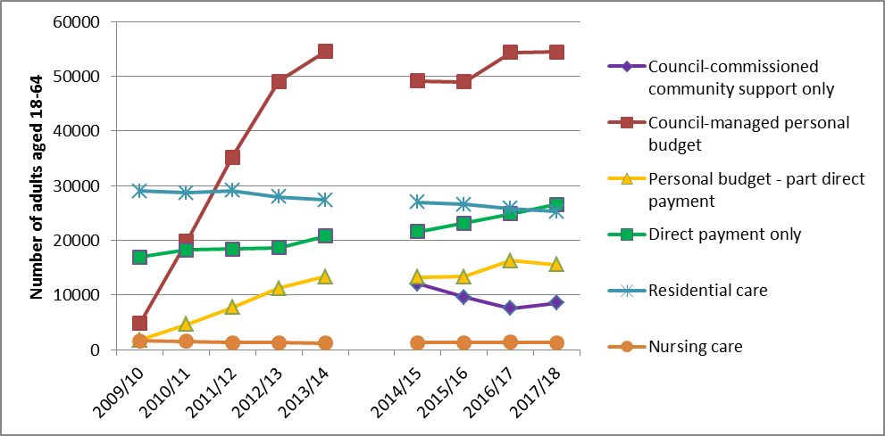

Figure 2: The number of adults with learning disabilities aged 65+ receiving long-term social care (from 2014/15) reported by councils to be receiving social care, by main category of social care support
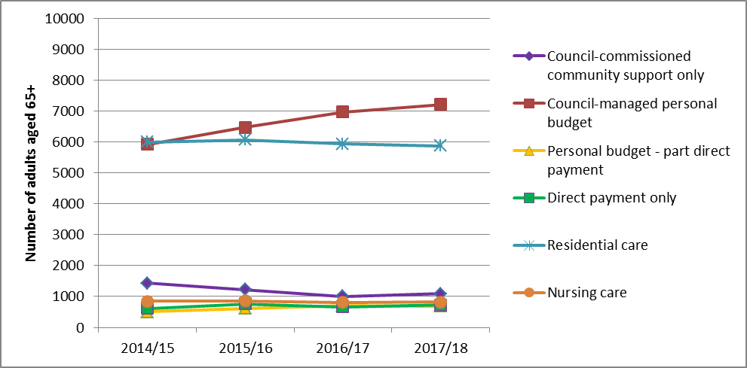

Figure 3: Gross social care expenditure on long-term and short-term social care for adults with learning disabilities
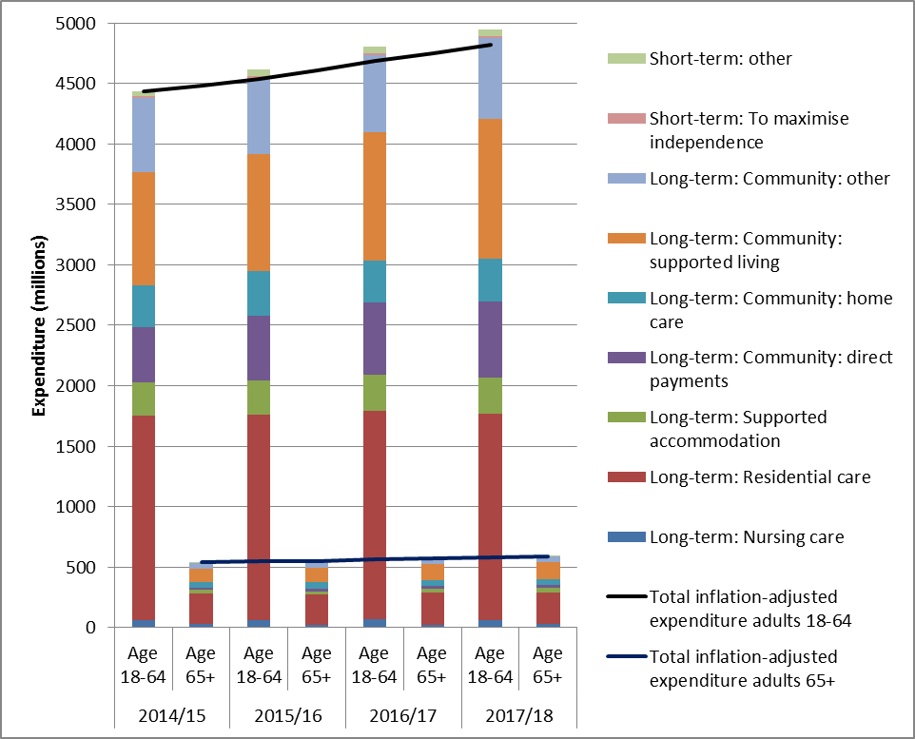
Acknowledgements
The writing of this paper has been supported by Public Health England, as part of the work of the Public Health England Learning Disabilities Observatory. Views expressed in this paper are those of the author, and not necessarily those of Public Health England.

