Health impacts of long-term ozone exposure in China over 2013 - 2017

Yuanlin Wang^{1,2,3}; Oliver Wild²; Xueshun Chen¹; Qizhong Wu⁴; Meng Gao⁵; Huansheng Chen¹; Yi Qi⁶; Zifa Wang^{1,7,8}
1 The State Key Laboratory of Atmospheric Boundary Layer Physics and Atmospheric Chemistry, Institute of Atmospheric Physics, Chinese Academy of Sciences, Beijing, 100029, China
2 Lancaster Environment Centre, Lancaster University, LA1 4YQ, United Kingdom
3 University of Chinese Academy of Sciences, Beijing, 100049, China
4 College of Global Change and Earth System Science, Beijing Normal University, Beijing, 100875, China
5 Department of Geography, Hong Kong Baptist University, Hong Kong SAR, China
6 School of Architecture and Urban Planning, Nanjing University, Nanjing, 210093, China
7 Centre for Excellence in Urban Atmospheric Environment, Institute of Urban Environment, Chinese Academy of Sciences, Xiamen, 361021, China
8 College of Earth Sciences, University of Chinese Academy of Sciences, Beijing, 100049, China
*Corresponding author address:
Prof. Zifa Wang
LAPC, Institute of Atmospheric Physics (IAP)
Chinese Academy of Sciences (CAS)
Beijing 100029, China
E-mail: zifawang@mail.iap.ac.cn
Abstract:
Increasing ozone concentrations are becoming a severe problem for air pollution in China and have an adverse impact on human health. Here we evaluate premature deaths attributable to long-term exposure to ambient ozone in China between 2013 and 2017 with an air quality model at 5 km resolution and the latest estimates of the relative risk to health. We use a modified inverse distance weighting method to bias-correct the key model-simulated ozone metrics. We find that on a 5-year average basis there are 186,000 (95% Confidence Interval: 129,000‒237,000) respiratory deaths and 125,000 (42,000‒204,000) cardiovascular deaths attributable to ozone exposure. Sichuan exhibits the largest per capita respiratory mortality (0.31‰) among all provinces. We find that there are 73,000 (51,000‒93,000) premature respiratory deaths in urban areas, accounting for 39% of total deaths. Between 2013 and 2017 the population-weighted annual average maximum daily 8-h average ozone (AMDA8) and premature respiratory deaths increased by 14% and 31%, respectively, at a national level. Changes in precursor emissions explain most of these increases, with differences in meteorology accounting for 21% and 16% respectively. Interannual variations in population-weighted ozone and premature respiratory deaths at a provincial level are much larger than those at a national level, particularly in northern, central and eastern China. These findings emphasize that ozone should be an important focus of future air quality policies in China, and tighter controls of precursor emissions are urgently needed.
Keywords: High resolution; air quality model; updated relative risk estimates; health impacts; long-term exposure; urban and rural; interannual variations.
- Introduction
Surface ozone is a secondary air pollutant that is mainly produced by photochemical reactions of volatile organic compounds (VOCs), carbon monoxide (CO) and nitrogen oxides (NOx) (Baumgaertel et al., 1999). The rapid industrialization and urbanization of China has led to a large increase in fossil fuel combustion that has released large quantities of these ozone precursors. High concentrations of ozone are now common in densely populated areas and contribute to photochemical smog (Tang et al., 2006), which is damaging for human health and ecosystems (EPA 2006, 2013; Lelieveld et al., 2013; Ashmore, 2005; Avnery et al., 2011).
The Chinese government implemented policies to control emissions and reduce air pollutants in 2013. These policies targeted key emission sectors through measures such as optimizing industrial infrastructure and increasing clean energy supply, and set specific concentration goals for a range of pollutants to be achieved by 2017 (Huang et al., 2018). Many of these policies focus on reduction of particulate matter (PM) and these have led to a general 30%-50% decrease in annual mean PM_{2.5} across China (Zhai et al., 2019; Ding et al., 2019). Although these policies may be effective in reducing the precursors of ozone, inappropriate targeting of reductions on NO_{x} rather than VOCs can increase surface ozone concentrations in polluted regions (Liu et al., 2018). Ozone has now replaced particulate matter as the chief air pollutant during summertime in most cities across China (CNEMC, 2016). The annual average daily maximum 8-h ozone concentration over the Beijing-Tianjin-Hebei (BTH) region in 2017 was 136 μg/m³ (≈68 ppb), greatly exceeding the National Grade I standard (50 ppb), and representing a 33% increase compared with 2013 (Liu et al., 2019). Ozone pollution has thus become another prominent air quality problem in China.
Many epidemiological studies have demonstrated that high concentrations of ozone pollution can lead to adverse health impacts, including morbidity and mortality through respiratory and cardiovascular diseases (U.S. EPA 2013). However, many of these studies have focused on the impacts of short-term ozone exposure (Michelle et al., 2004; Ito et al., 2005; Pattenden et al., 2010; Tao et al., 2011; Yang et al., 2012). There has been much less research on the health impacts attributable to long-term ozone exposure (Jerrett et al., 2009; REVIHAAP 2013; Lipsett et al., 2011; Crouse et al., 2015; Turner et al., 2016). Based on an analysis of the American Cancer Society Cancer Prevention Study-II (ACS CPS-II) cohort, Jerrett et al. (2009) estimated the contribution of ozone exposure to the risk of premature mortality from respiratory causes by using standard and multilevel Cox regression models (Ma et al., 2003), and demonstrated a significant increase in premature mortality from respiratory diseases associated with an increase in ozone concentration. These approaches have been widely used in other studies. Anenberg et al (2010) assessed the risk of respiratory diseases attributable to ozone exposure in 2000, and estimated 470,000 deaths worldwide. The Global Burden of Disease (GBD) attributed 152,000 to 254,000 premature deaths from chronic obstructive pulmonary disease (COPD) annually over the period 2010-2015 to exposure to ambient ozone (Lim et al., 2012; Cohen et al., 2017). For China Liu et al (2018) analyzed the mortality from COPD caused by ozone in 2015 using three methods with different exposure ozone metrics and thresholds. The mortality ranged from 56,000 to 80,000, and these deaths were mainly distributed in central and eastern China. In recent studies, Turner et al (2016) updated the ACS CPS-II analysis and evaluated cause-specific mortality related to long-term ozone exposure. Compared with the previous estimates of Jerrett et al., (2009), the updated CPS-II cohort involved more participants (almost 670,000) and a greater number of deaths (more than 237,000) over a longer period. This large-scale prospective study not only reaffirmed the link between ambient ozone and respiratory mortality, but also assessed the long-term ozone contribution to the risk of circulatory mortality. Based on this updated study, Malley et al., (2017) estimated that there were 1,240,000 respiratory deaths and 856,000 COPD deaths attributable to ozone in 2010 worldwide. For China, respiratory deaths attributable to long-term ozone exposure using the updated risk factors from Turner et al (2016) were between 180,000 and 320,000 during 2010 to 2015 (Malley et al., 2017; Shindell et al., 2018; Seltzer et al., 2018). Premature deaths related to cardiovascular disease were around 129,000 in China in 2015 (Seltzer et al., 2018).
Ground-level ozone concentrations are not only affected by emission reduction measures, but also by changes in meteorological conditions. Variations in temperature, relative humidity, solar radiation and air mass origin associated with changes in atmospheric circulation all influence the photochemical reactions of ozone (Liu et al., 2019). Few studies have focused on the variations in health impact attributable to changes in ambient ozone since 2013, or have considered the influence from variations in emissions and meteorology separately. Atmospheric models provide a valuable tool to capture the temporal and spatial distribution of ozone, and to extend measurement-based studies, particularly in remote areas. High resolution models allow evaluation of the health impacts of ambient ozone in both urban and rural districts. Although air quality models can represent the spatial and temporal variations of ozone relatively well, there are often systematic biases in estimates of ozone exposure metrics that arise from uncertainties in meteorology and emissions. These model biases can be reduced through a simple scaling approach such as that adopted by Shindell et al (2018) who reduced mean annual daily 8-h maximum ozone concentration by 25% worldwide. However, ozone exposure is strongly sensitive to the spatial distribution of ozone, and thus this simple correction is inappropriate at a local level. In order to estimate the premature mortality attributable to long-term ozone exposure accurately, bias correction techniques have been used to improve modelled ozone exposure metrics based on ambient observations (Fuentes and Raftery, 2005; Chen et al, 2014).
In this study, we estimate the premature human mortality in China over the 2013 – 2017 period attributable to ambient ozone using a high-resolution air quality model, measurement-based bias correction, multiple exposure-response relationships, and provincial level disease incidence data. We explore how premature mortality varies on national, provincial and urban scales, and estimate premature deaths in urban and rural districts. We then quantify the spatial and interannual variations in health impacts due to variations in emissions and meteorological conditions, and identify the uncertainties.
2 Methods and data
2.1 Evaluating health impacts attributable to long-term ozone exposure
Based on previous epidemiology studies, long-term ozone exposure is mainly associated with respiratory disease, chronic obstructive pulmonary disease and cardiovascular diseases (Jerrett et al., 2009; Turner et al., 2016). The definitions of these diseases are based on the International Classification of Diseases (ICD)-10 codes and we use the same definitions as Malley et al (2017) and Seltzer et al (2018). The relationships shown in Equations (1)-(3) below have been applied in many previous studies (Anenberg et al., 2010; Lim et al., 2012; Malley et al., 2017; Seltzer et al., 2018; Lin et al., 2018) and are used here to estimate premature deaths across China between 2013 and 2017.
$HR= e^{β∆Y}$ (1)
$RR=\left\{\begin{aligned}e^{β(x-x_{0})}, &x> x_{0} \\ 1, &x≤{ x}_{0}\end{aligned}\right.$ (2)
$∆M_{s,d,r}\left(C_{r}\right)={Pop}_{s,r}×B_{s,d,r}×\frac{{RR}_{s,d}\left(C_{r}\right)-1}{{RR}_{s,d}\left(C_{r}\right)}$ (3)
where HR is the hazard ratio, defined as the probability of a given health endpoint associated with a 10 ppb ($∆Y$) increase in ozone concentration, and $β$ is an observation-based concentration-response factor, i.e. the slope of the log-linear relationship between exposure concentration and mortality. In the current study, we apply hazard ratios from Turner et al (2016) who used a multi-pollutant model adjusted for near-source PM_{2.5}, regional PM_{2.5} and NO₂ to calculate health impacts attributable to ozone. HRs of 1.12 (95% Confidence Interval: 1.08, 1.16) and 1.03 (95% Confidence Interval: 1.01, 1.05) are used for respiratory disease and cardiovascular disease respectively.
RR is the relative risk, i.e. the probability of developing a given health endpoint associated with a 10 ppb increase in ozone concentration (Cairncross et al., 2007; Liu et al., 2018), x represents the value of a specific ozone metric, and $x_{0}$ is the threshold below which no adverse effect on mortality is identified. We use the annual average daily maximum 8-h ozone concentration (AMDA8) as the ozone metric and a threshold of 26.7 ppb based on the minimum ozone exposure from the study of Turner et al (2016). To explore the sensitivity to the choice of threshold, following Malley et al. (2017), we use an alternative threshold of 31.1 ppb, the fifth percentile of ozone exposure from Turner et al. (2016). To provide some context with earlier studies, we compare our results with those using the method of Jerrett et al (2009). This uses HRs of 1.040 (95% Confidence Interval: 1.013, 1.067) from a two-pollutant model adjusted for PM_{2.5} and average daily maximum 1-h ozone concentration from April to September (6mMDA1) as the ozone metric to estimate respiratory deaths. The approach uses thresholds of 33.3 ppb and 41.9 ppb representing the minimum and fifth percentile of ozone exposure from Jerrett et al (2009). The models developed by Turner et al (2016) and Jerrett et al (2009) were adjusted a priori for the following covariates: age, race, sex, education; marital status; smoking status; food and alcohol consumption; occupational exposures and ecological covariates. They also examined potential confounding impacts from temperature, elevation, metropolitan and statistical area size.
The number of premature deaths attributable to long-term ambient ozone exposure ($∆M_{s,d,r}$) is derived from the relative risk for each sex subgroup and each disease in each region (subscripts s, d, r, respectively). ${Pop}_{s,r}$ represents the population exposed in a specific age-sex group at a regional level. Population data for 2014 at 1 km resolution was obtained from Landscan (https://landscan.ornl.gov/) and re-gridded to 5 km $×$ 5 km to match the model resolution used here. $B_{s,d,r}$ represents the provincial incidence of a specific disease for each sex, and ${RR}_{s,d}$ reflects the relative risk of the disease for a specific sex. National baseline incidence rates of each endpoint were obtained from the online GBD database (http://vizhub.healthdata.org/gbd-compare) and the 2013 China Statistical Yearbook of Public Health (NBSC, 2013), and provincial baseline incidence rates were estimated using the relationships between national and provincial rates given by Xie et al (2016).
2.2 Modelled ozone concentrations
2.2.1 NAQPMS atmospheric model
The Nested Air Quality Prediction Model System (NAQPMS) is used in this study to generate hourly ozone concentrations. This 3-D regional Eulerian chemical transport model was developed at the Institute of Atmospheric Physics, Chinese Academy of Sciences (Wang et al, 2006; Li et al 2011, 2013). NAQPMS includes chemical reactions, advection, diffusion, and dry and wet deposition processes, and a more detailed description of the model can be found in Li et al (2012).
Following the configuration adopted in Wang et al., 2020, the model domain covers China and neighboring regions (Fig 1). The model horizontal resolution is 5 km and there are 999 × 1069 grid points in latitude and longitude, respectively. Vertically, the model uses 20 terrain-following layers from the surface to 20 km, with the lowest 12 layers below 3 km. Hourly meteorological fields for NAQPMS are taken from the Weather Research and Forecasting (WRF) model driven by the National Centers for Environmental Prediction (NCEP) Final Analysis (FNL) 6-hourly data. Chemical initial and boundary conditions are provided by the global model MOZARTv2.4 (Emmons et al., 2010).
Anthropogenic emissions are based on an updated version of the Multi Resolution Emission Inventory for China (MEIC) for 2013 which provides emissions of 10 major air pollutants and greenhouse gases from anthropogenic sources (http://www.meicmodel.org). The standard resolution of MEIC is 0.25° × 0.25° and the data is interpolated to the 5 km grid weighted by gridded area and location. The annual mean emission rate of NO, a key ozone precursor, is shown in Fig 1. Biogenic VOC emissions are taken from the Model for Emissions of Gases and Aerosols from Nature (MEGAN) (Guenther et al, 2012) at an original resolution of 0.1° × 0.1° and re-gridded to 5 km × 5 km using the same approach. China land cover data at 1 km $×$ 1 km resolution for 2015 were used to distinguish urban and rural areas. Based on China land suitability scores, urban areas were defined as neighborhoods with an urban ratio of at least 0.33 over a 5 x 5 km area (Feng et al., 2018).
Fig 1 Model domain and annual mean emission rate of the key ozone precursor NO (in μg m⁻² yr⁻¹).
2.2.2 Model bias correction for ozone metrics
The NAQPMS model represents the variations in surface ozone over China relatively well, but shows differences with observations that vary by region and season. We show a comparison of modelled and observed surface ozone and daily maximum ozone metrics at representative cities in northern, central and southwestern China in Fig. 2. While the seasonality and day to day variability in ozone are represented reasonably well, daily maximum ozone concentrations are underestimated, and as these are important for calculating health impacts we choose to bias-correct the model results based on the observations available. Inverse distance weighting approaches (Shepard, 1968; Deligiorgi et al., 2011) have been applied operationally by the US Environment Protection Agency (EPA) to generate air pollutant concentration distributions at a range of scales (Eberly et al., 2004). Cressman analysis (Cressman, 1959) is a modified weighting method that uses the ratio between the distance of an observation from a grid cell and a maximum allowable distance to calculate the relative importance of an observation for interpolation. This provides a simple but effective approach to bias correction that is a suitable compromise between accuracy and computational complexity.
In the current study, gridded ozone concentrations from NAQPMS simulations are bias corrected using Cressman interpolation between nearby observations which were obtained from the China National Environmental Monitoring Centre (www.cnemc.cn). Where observations are available, we calculate the difference ($∆V_{k})$ in daily maximum 1-h average or 8-h average ozone between observations and simulated values at each location, k$.$
These location-specific differences are interpolated to all grids in the model domain using Cressman interpolation.
$$∆V_{i,j}=\frac{\sum_{k=1}^{N}{(w_{i,j,k}∆V_{k})}}{\sum_{k=1}^{N}{w_{i,j,k}}} (5)$$
where $∆V_{i,j}$ is the difference between the expected ozone exposure metric and the model simulated value at grid cell (i, j). $w_{i,j,k}$ is the weighting factor for the kth measurement location at grid cell (i, j), and varies between 0 and 1. N is the total number of measurement locations within a radius of influence R, taken here as 0.5°, beyond which measurements are assumed not to contribute to the correction at that location. The weighting factor $w_{i,j,k}$ is calculated using the equation:
$w_{i,j,k}=\left\{\begin{aligned}\frac{R^{2}-d_{i,j,k}^{2}}{R^{2}+d_{i,j,k}^{2}} {,d}_{i,j,k}≪R \\ 0 {,d}_{i,j,k}>R\end{aligned}\right.$ (6)
where $d_{i,j,k}$ is the distance between grid cell (i, j) and kth measurement location. This provides a strong bias correction where observations are available, but leaves modelled concentrations unaffected in remote regions where there are no observations. This approach is suitable for the current study of health impacts as measurements tend to be in or near major population centers.
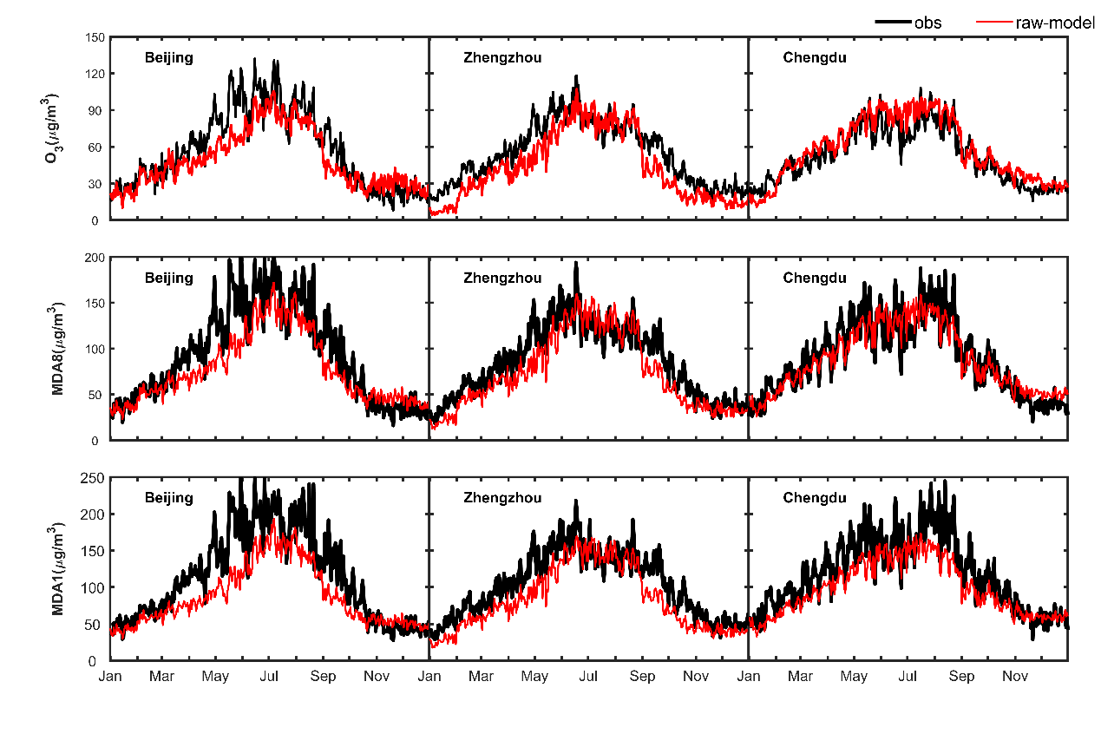
Fig 2. Comparison of daily surface ozone, maximum daily 8-h average ozone concentration (MDA8), and maximum daily 1-h average ozone concentration (MDA1) at three different cities.
3 Results
3.1 Evaluating exposure estimates
Figure 3 shows the spatial distribution of bias-corrected modelled 5-year average AMDA8 compared with observed values from 259 major cities across China. In most cities the model results are consistent with observations, with higher concentrations in Tibet, where the altitude is higher, and in coastal areas of eastern China, where anthropogenic emissions are greater. In remote areas such as Xinjiang in western China ozone concentrations are relatively low due to low precursor emissions. The bias-corrected model results reproduce the spatial variation in observation-based ozone metrics well. For comparison, we also show the distribution of 6mMDA1 compared with measurements. This is typically higher than AMDA8 as it represents daily maximum ozone in the summer half of the year.

Fig 3 Spatial distribution of bias-corrected 5-year average AMDA8 (annual average daily maximum 8-h ozone concentration; left) and 6mMDA1 (average daily maximum 1-h ozone concentration from April to September; right) across China; circles show average observed values for these metrics in 259 major cities.
A comparison of corrected and uncorrected NAQPMS model daily maximum 8-h average with observations at 1288 monitoring sites across China is shown in Table 1. Although the uncorrected model simulations reproduce the variations in the ozone exposure metrics well, there is a substantial underestimation in the simulations. The bias-corrected results agree with observations much better, and annual mean biases are reduced by about a factor of five. Root mean square errors (RMSEs) are reduced by more than a third. Comparisons for daily maximum 1-h average are shown in Table S1. We further evaluate the accuracy of model bias correction using cross validation by leaving out each site in turn and correcting all other sites. Ratios of observed and simulated values are closer to one after bias correction for both ozone metrics (Fig S1). This demonstrates that bias correction is helpful and should be routinely used to improve model-based estimates of ozone metrics where observations are available.
Table 1 Model bias (MB), root mean square error (RMSE) and correlation coefficient (R) for NAQPMS simulated daily maximum 8-h average O₃ compared with observations averaged over 1288 sites in China between 2013 and 2017.
Daily maximum 8-h average | Spring |  | Summer |  | Autumn |  | Winter |  | Annual
 | Raw model | Bias-corrected | Raw model | Bias-corrected | Raw model | Bias-corrected | Raw model | Bias-corrected | Raw model | Bias-corrected
MB (μg/m³) | -9.9 | 1.3 | 3.4 | 2.3 | -10.6 | 0.8 | -8.4 | 0.8 | -6.3 | 1.3
RMSE  (μg/m³) | 15.8 | 10.5 | 11.1 | 9.5 | 15.8 | 9.7 | 13.1 | 7.0 | 14.1 | 9.3
R | 0.82 | 0.88 | 0.67 | 0.75 | 0.90 | 0.91 | 0.63 | 0.84 | 0.89 | 0.94
3.2 Population exposure to ambient ozone
Fig 4 shows the population exposure to ozone based on the 5-year mean AMDA8 exposure metric. Around 1.3 billion people are exposed to AMDA8 concentrations of between 30 and 50 ppb, with over half (57%) exposed to 40-50 ppb (Fig 3a). Only 3 and 16 million people, respectively, are exposed to levels below the thresholds of 26.7 and 31.1 ppb defined in Turner et al (2016). There is no significant association between population density and AMDA8, which is relatively constant at just below 40 ppb, reflecting the lifetime of daytime average ozone and the regional nature of its distribution.
For comparison, population exposure to ozone based on the 5-year 6mMDA1 is shown in Fig 5. About 1.3 billion people (95% of the total population) are exposed to 6mMDA1 of greater than 40 ppb, with ~36% of those exposed to levels of between 50 and 60 ppb. Around 11 and 47 million people, respectively, are exposed to levels below 33.3 ppb and 41.9 ppb meeting the thresholds defined in Jerrett et al (2009). There is a clear increase in 6mMDA1 with population density up to 3000 person/km², highlighting an association between daily maximum ozone and population density in less populated regions. 6mMDA1 then stabilizes at around 55 ppb in more heavily populated regions.

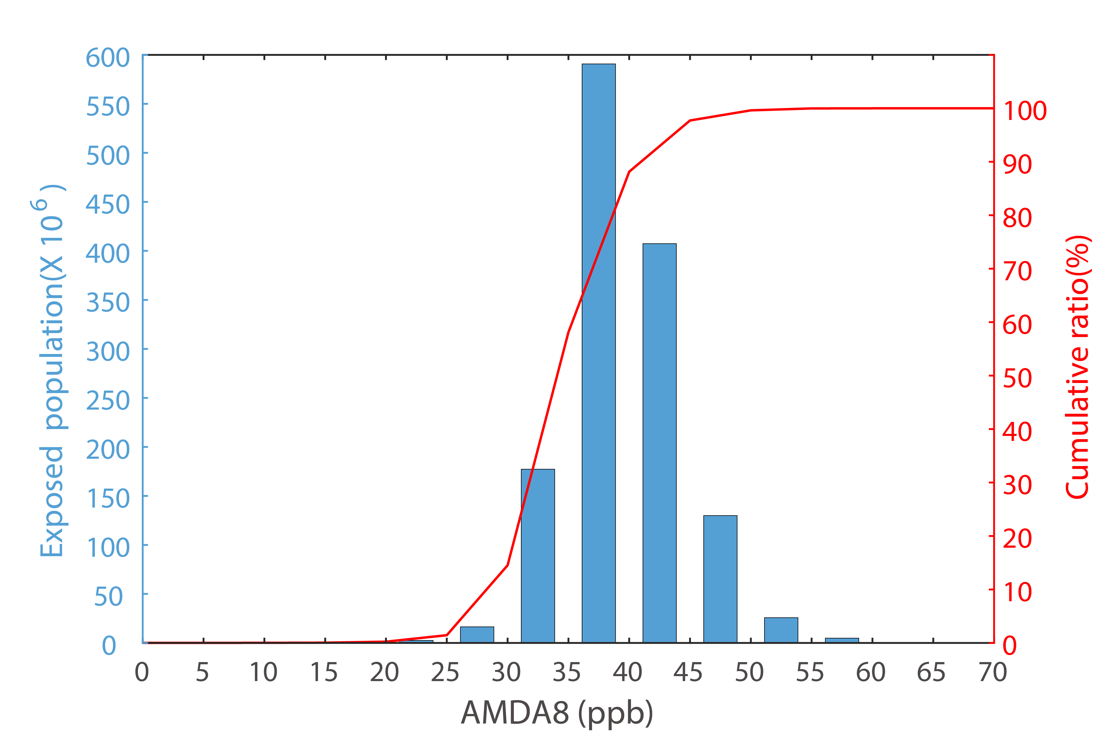 | 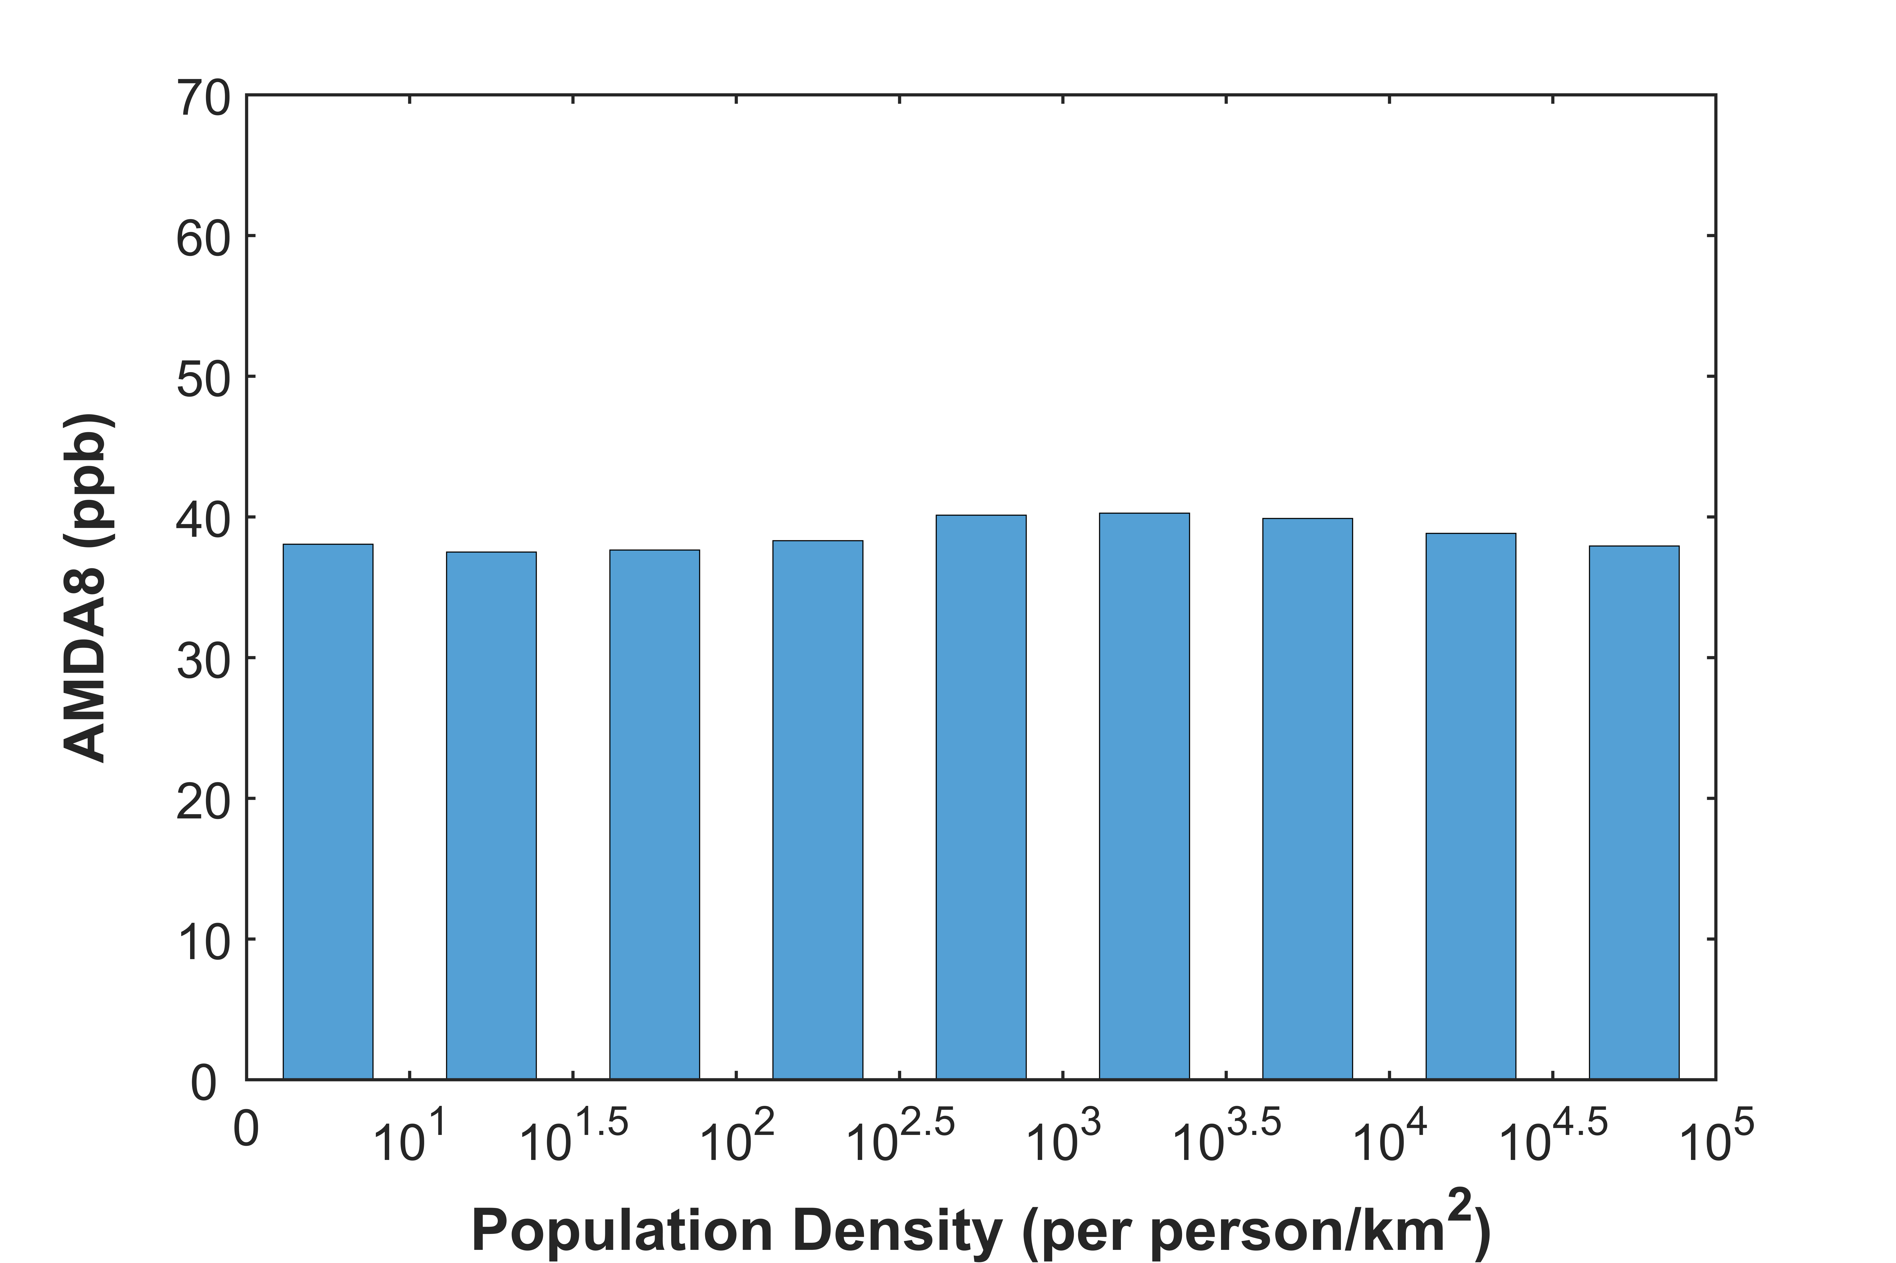
Fig 4 Population exposure to 5-year mean AMDA8 (annual average daily maximum 8-h ozone concentration). The left panel shows the number of people exposed in each 5-ppb concentration range (bars), and cumulative exposure (line) while the right panel shows the relationship between the 5-year mean AMDA8 and population density.

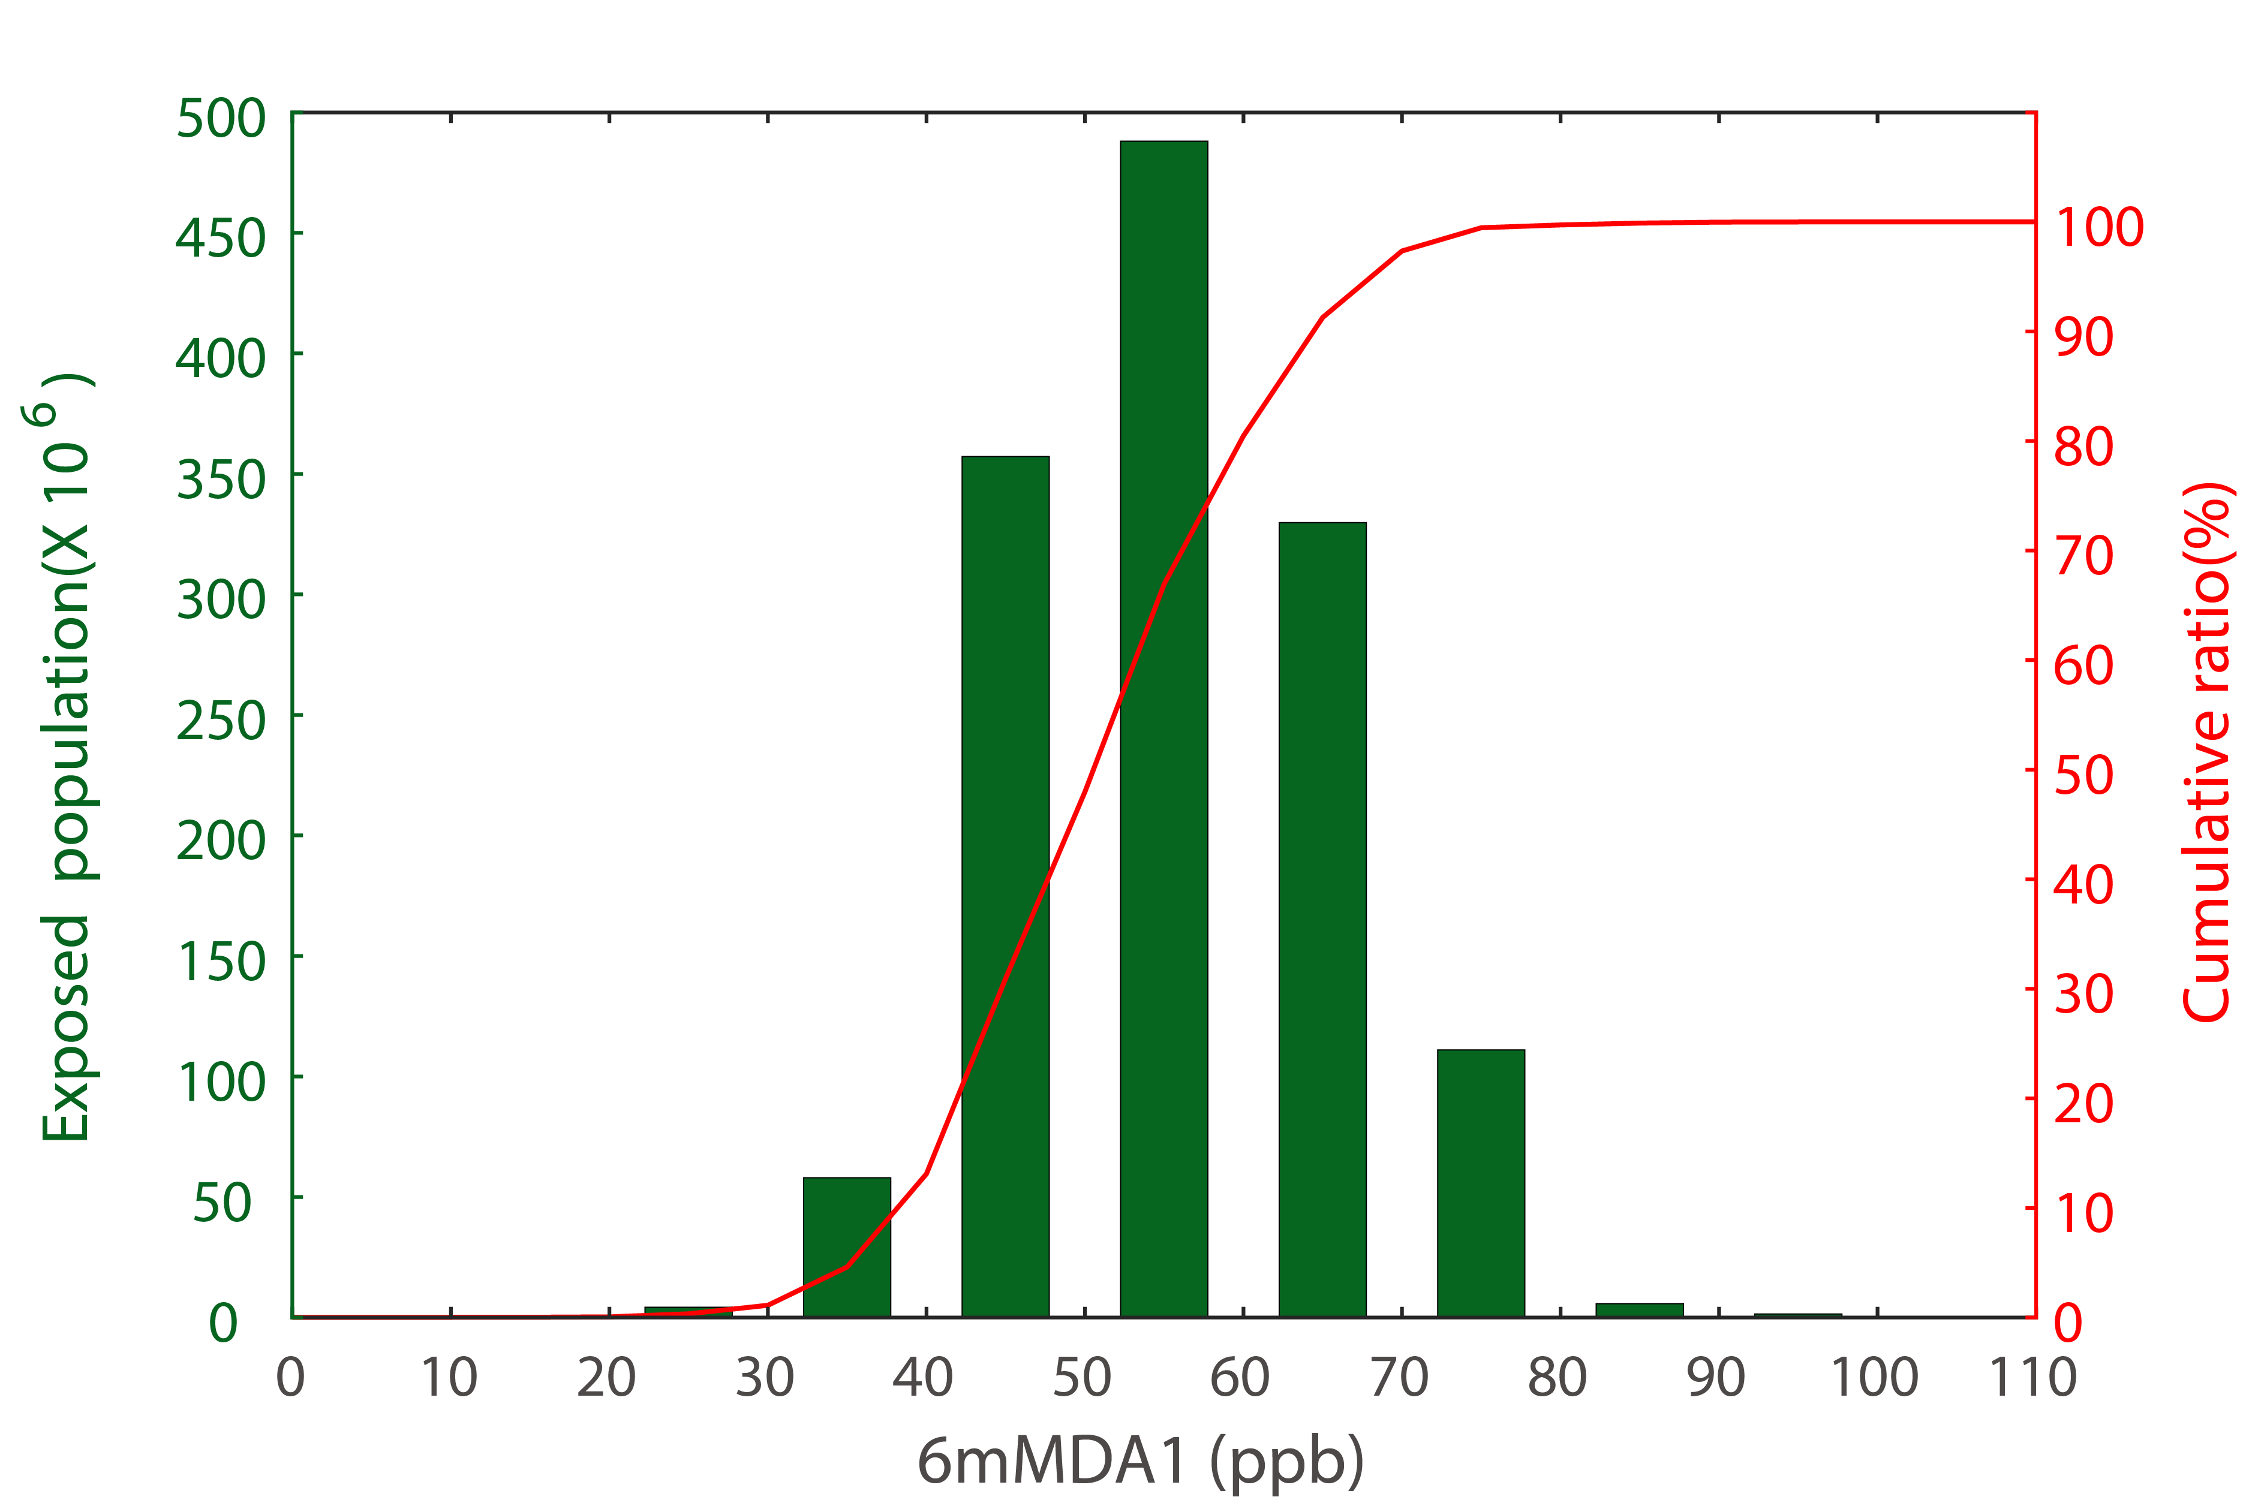 | 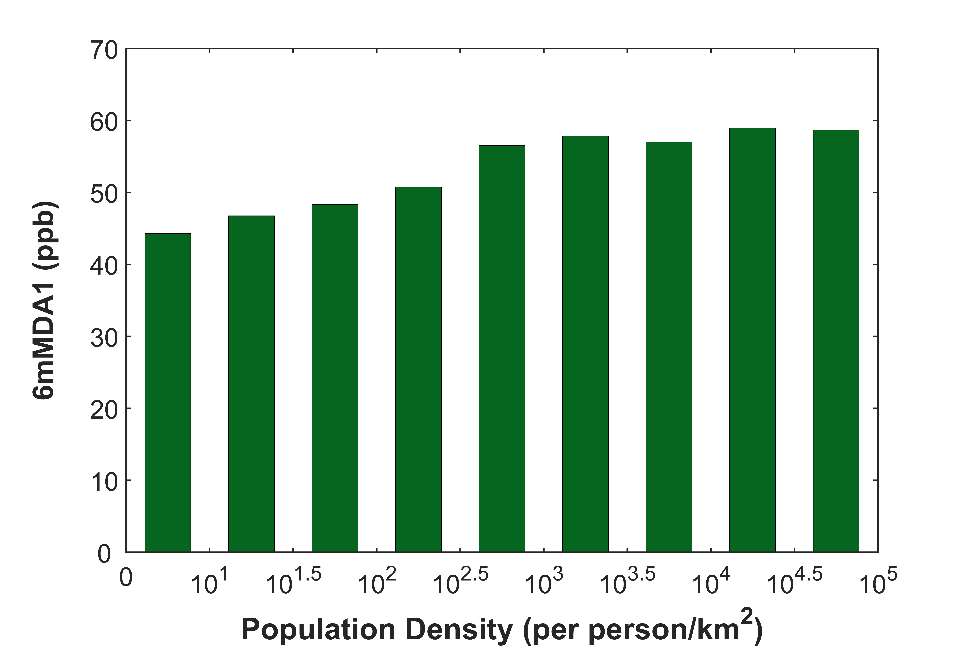
Fig 5 Population exposure to 5-year mean 6mMDA1 (average daily maximum 1-h ozone concentration from April to September)
3.3 Health impacts attributable to long-term ozone exposure
Premature respiratory and cardiovascular deaths between 2013 and 2017 are calculated here using relative risk estimates from Turner et al (2016). Using the updated hazard ratio and the AMDA8 exposure metric, we estimate that on a 5-year average basis there are approximately 186,000 (95% Confidence Interval: 130,000 - 238,000) respiratory deaths and 125,000 (42,000 - 204,000) cardiovascular deaths attributable to long-term ozone exposure in China, when the threshold is taken as 26.7 ppb. There are 32% fewer deaths when the higher threshold of 31.1 ppb is used.
Figure 6 shows the spatial distribution of attributable 5-year mean respiratory deaths per 100,000 people estimated using a threshold of 26.7 ppb. The greatest number of premature deaths occur in central and southern China, particularly in the North China Plain, Yangtze River Delta and Sichuan Basin, where there are higher ozone concentrations and a large population, with values of more than 9 (per 100,000 people), or 0.09‰. In remote areas such as Xinjiang there are very few deaths as ozone concentrations are low. For cardiovascular disease the highest number occurs in Shandong province (11,900; CI: 4,100 – 19,300).

Fig 6 Spatial distribution of attributable 5-year mean annual respiratory deaths per 100,000 people estimated using relative risk estimates from Turner et al (2016), and a threshold of 26.7 ppb.
Per capita respiratory mortality and corresponding total premature deaths attributable to long-term ozone exposure in each province in China are presented in Fig 7. The range of per capita respiratory mortality is 0.04-0.32‰, with the maximum in Sichuan in central China and the minimum in Heilongjiang in the North. Rates in many southern provinces are >0.15‰. Per capita mortality in southwestern provinces is very high (>0.16‰ except in Tibet) and three of the top five provinces for per capita respiratory mortality are in the southwest: Sichuan, Chongqing and Guizhou. Gansu in northwestern China has a low population, but relatively high per capita mortality. This is because it has higher baseline respiratory mortality rate and population-weighted ozone concentration (Zhou et al., 2015). Conversely, low per capita respiratory mortality occur in North China, including Tianjin, Beijing and Inner Mongolia, suggesting low baseline mortality in these areas. High population and relatively high ozone concentrations lead to large total premature mortality in Sichuan, Jiangsu and Shandong provinces, accounting for 43 % of total respiratory deaths. However, higher provincial per capita mortality for cardiovascular disease occurs in eastern areas, such as Shanghai, Jiangsu and Shandong, as these have higher baseline cardiovascular mortality rates (Fig S2).

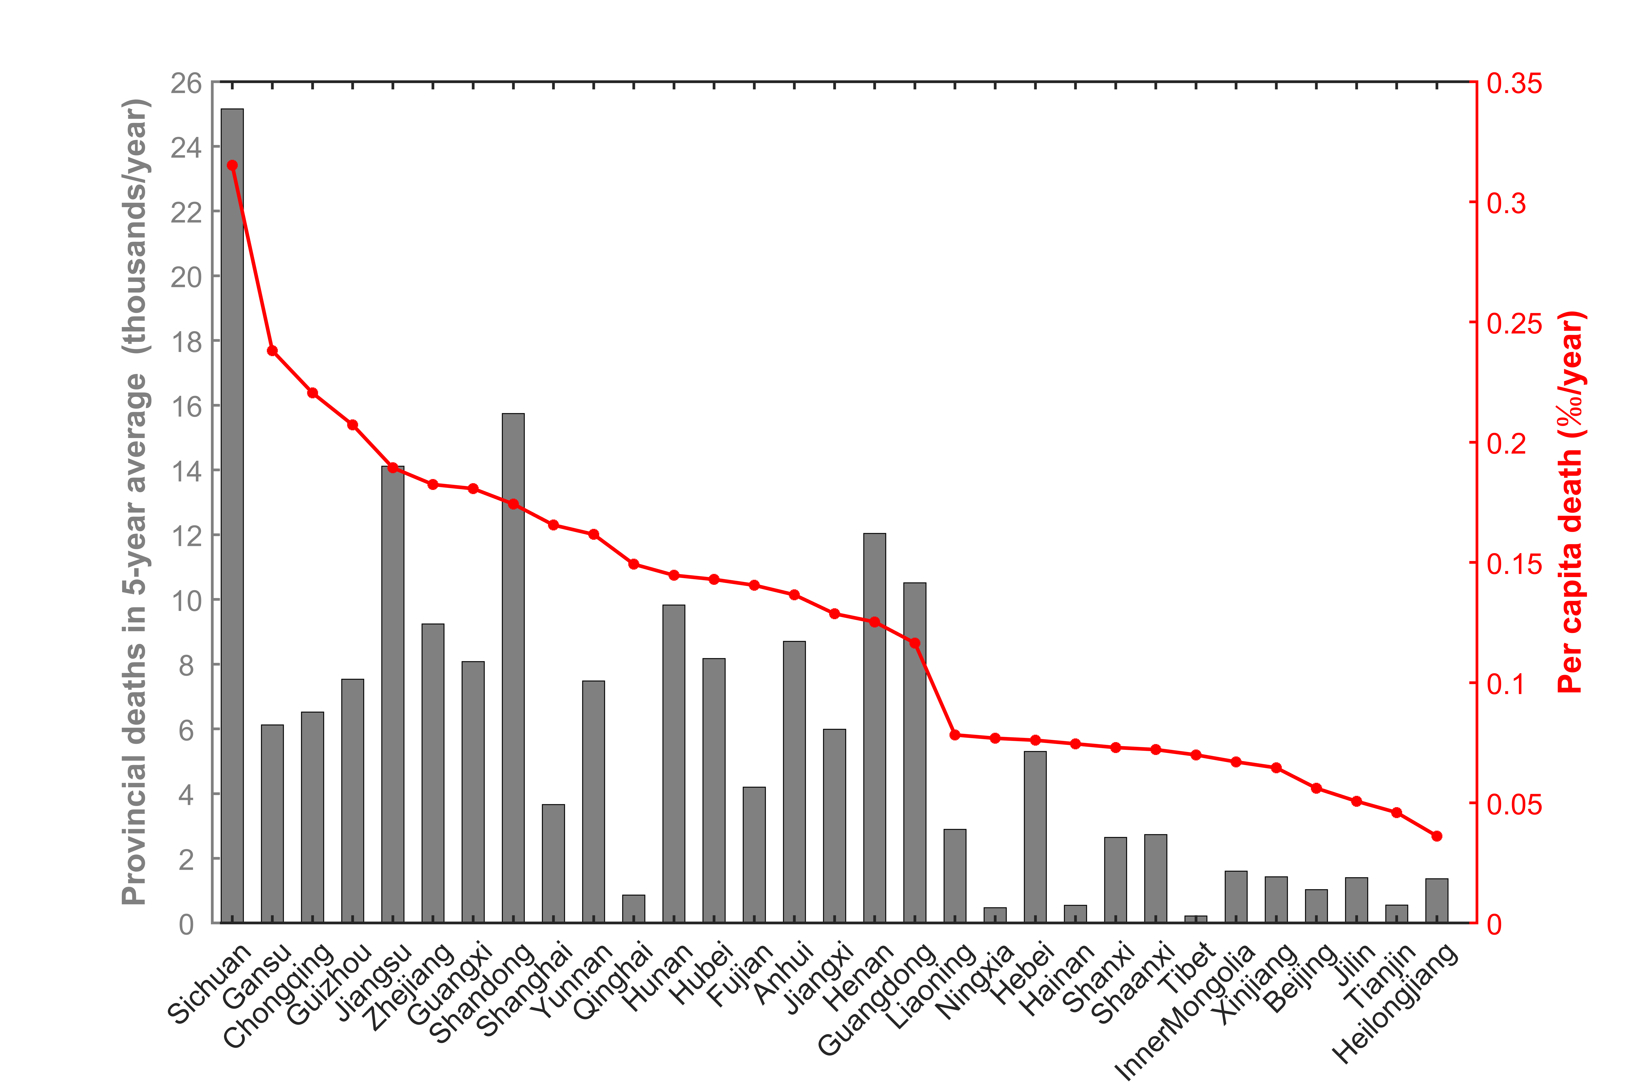
Fig 7 Provincial respiratory deaths due to long-term ozone exposure using Turner et al (2016) relative risk estimate with the lower threshold (26. 7 ppb). Provincial percapita death rates are shown in red and the total number of deaths is shown with the grey bars.
In urban areas there are about 73,000 (51,000 – 93,000) premature respiratory deaths, which accounts for just 39% of total respiratory deaths in China for 44% of the population suggesting the risk is higher in rural areas than urban areas. Fig 8 shows the per capita respiratory mortality and corresponding total premature deaths in urban and rural areas at a provincial level. The per capita mortality ranges from 0.02‰ to 0.31‰, and in most provinces per capita mortalities in rural areas are a little larger than those in urban areas. However, we note that the values are relatively similar, and this reflects the weak relationship between the AMDA8 metric and population density (shown in Fig. 4) that arises from the regional nature of ozone pollution. Sichuan has the greatest number of respiratory deaths, and the number in rural areas (20,000) is over 4 times that in urban areas (4,800). Premature respiratory deaths in urban areas are greatest in Shandong, Jiangsu, Henan and Zhejiang in eastern China where the level of urbanization is high, and together these account for 43% of total urban respiratory deaths. Owing to topographical and demographic features, provinces in southwestern and central China have a large rural population, and rural premature deaths are greatest in Sichuan, Chongqing, Guizhou and Hunan which together account for 36% of total rural deaths.

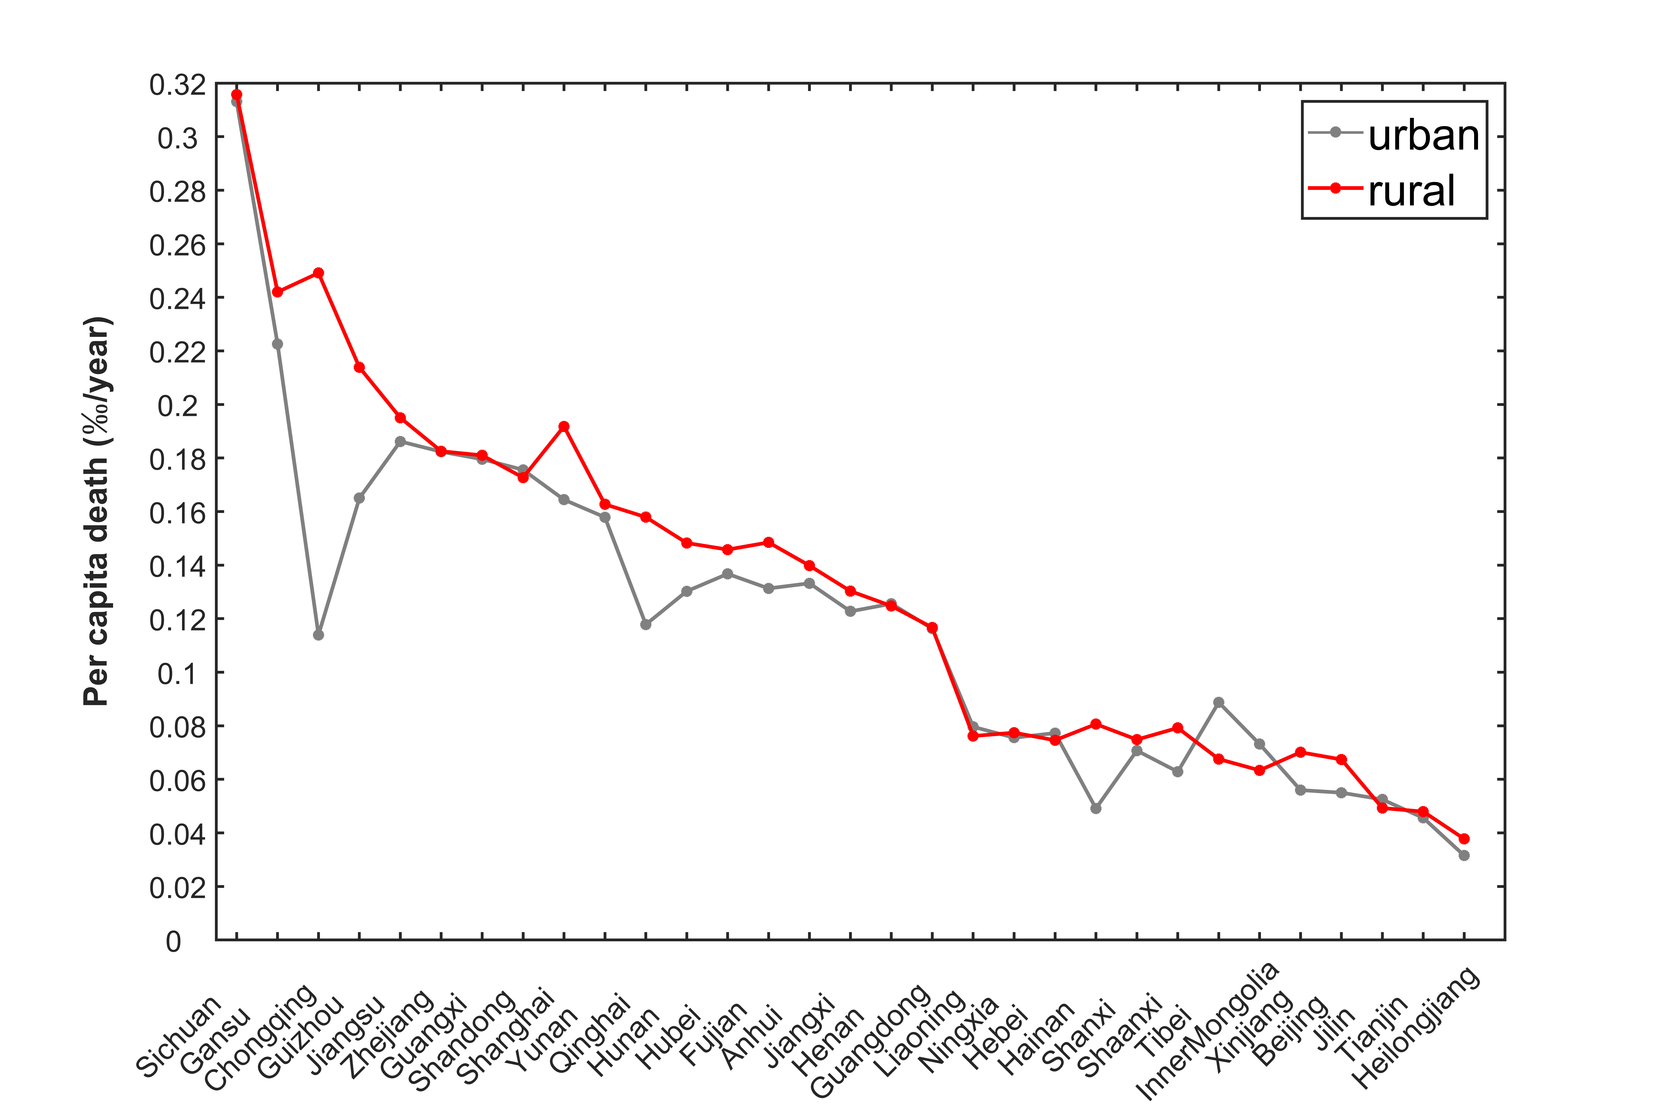 | 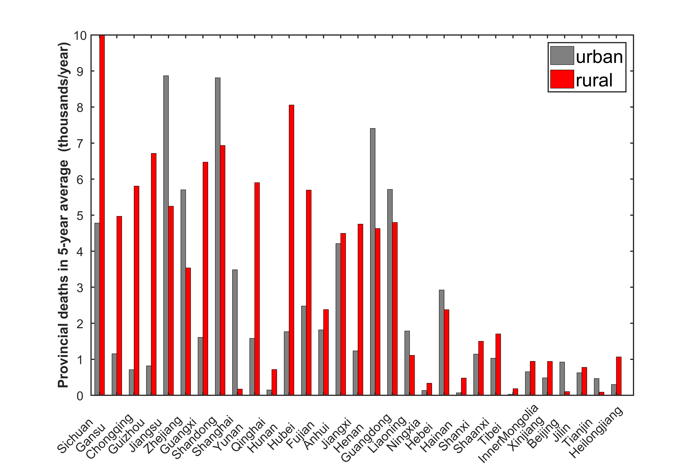
Fig 8 Provincial respiratory deaths from long-term ozone exposure using Turner et al (2016) relative risk estimate with smaller threshold (26. 7 ppb) distinguishing between urban and rural areas. Note: to show total deaths in other provinces clearly, the number of rural respiratory deaths in Sichuan is compacted.
3.4 Interannual variations in ozone exposure and premature deaths
During 2013 to 2017 a series of stringent emission control policies were implemented in China that reduced PM_{2.5} and its precursors effectively in some of the most polluted regions. However, associated reductions in NO_{x} emissions can lead to increases in ozone concentrations if VOC emissions are not also reduced (Cardelino et al., 1995; Shao et al., 2009; Tang et al., 2010). Therefore, we analyze the interannual variations in ozone concentration and their related health impacts, and investigate the contributions from changing emissions and meteorological conditions between 2013 and 2017 at a regional level.
Fig 9 shows the interannual variations in population weighted AMDA8 and related premature respiratory deaths at a national level from 2013 to 2017. From 2013 to 2015 the population weighted AMDA8 increased by 1 ppb to 38.5 ppb, but since 2016 it has risen sharply, increasing to 42.9 ppb in 2017, an increase of 14% compared with 2013. Premature respiratory deaths hence show little change from 2013 to 2015 (at around 170,000) but then increase to 223,000 in 2017, an increase of 31% compared to 2013. Similarly, cardiovascular deaths increase by 46% (Fig S4). In the current study, a fixed population and baseline mortality rates are used to estimate health impacts, so variations in premature deaths arise mainly from variations in ozone concentrations.
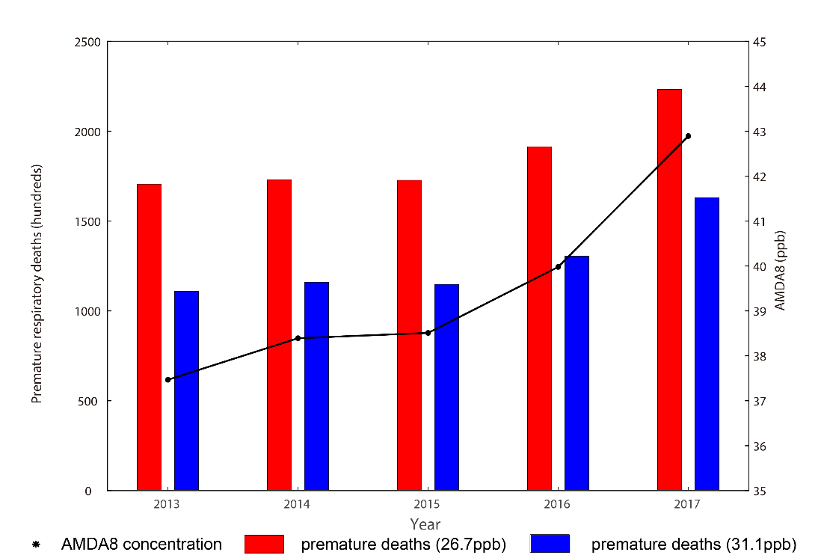
Fig 9 Population weighted AMDA8 (annual average daily maximum 8-h ozone concentration) and attributed premature respiratory deaths at a national level from 2013 to 2017.
The interannual variations in population weighted AMDA8 and related per capita respiratory mortality from 2013 to 2017 are shown at a provincial level in Fig 10. Both variables decrease slightly in southwestern provinces but increase sharply in other areas, particularly in northern, central and eastern coastal provinces. Over these areas the population weighted AMDA8 increases by between 10% and 34% from 2013 to 2017, and the corresponding per capita mortality increases by at least 50%, and doubles in some places, suggesting that small changes in AMDA8 can result in larger variations in premature death because of the nonlinear relationship between exposure and health impacts. Similarly, the per capita cardiovascular mortalities increase much more than those of respiratory deaths in these provinces (Fig S5). These findings suggest that further controls of ozone and related precursors are urgently needed, particularly in northern, central and eastern coastal provinces.
Fig 10 Population weighted AMDA8 (annual average daily maximum 8-h ozone concentration) and attributed per capita respiratory death rates at a provincial level from 2013 to 2017.
4 Discussion
4.1 Comparison of relative risk estimates
To explore the sensitivity of our results to different assumptions of relative risk, we compare our estimates of premature respiratory deaths using the Turner et al (2016) relative risk approach with those using the Jerrett et al (2009) approach, see Table 2. Using the 6mMDA1 metric and relative risk estimates of Jerrett et al. (2009) we find that there are 114,000 deaths), 39% fewer than the 186,000 we find using Turner et al (2016). In the megacity clusters of eastern China the 6mMDA1 metric is much greater than the AMDA8 metric (Fig 3), but the smaller hazard ratio for respiratory deaths and the higher thresholds in Jerrett et al (2009) contribute to fewer premature respiratory deaths than those derived from Turner et al (2016).
Per capita mortality in urban areas is a little larger for most provinces using the estimates of Jerrett et al (2009), while per capita mortality in rural areas is lower (see figure S6-S7). This suggests that in more populated regions daily maximum ozone leads to greater estimated health impacts, which is consistent with the greater sensitivity of the 6mMDA1 metric than AMDA8 to population density, as shown in Fig 5.
Table 2 Estimates of annual premature respiratory deaths attributable to long-term ozone exposure using Jerrett et al (2009) and Turner et al (2016) metrics on a 5-year basis
 | Jerrett et al (2009) |  | Turner et al (2016)
Metric | 6mMDA1 |  | AMDA8
Thresholds (ppb) | 33.3 | 41.9 | 26.7 | 31.1
Premature deaths (thousand) | 114 (39-183) | 72 (23-116) | 186 (130-238) | 127 (88-163)
Note: 6mMDA1 is 6-month average daily maximum 1-h O₃ concentration (April to September); AMDA8 is annual average daily maximum 8-h O₃ concentration. Numbers in parentheses are 95% confidence intervals.
4.2 Comparison with other studies
In the current study, premature respiratory deaths in China attributable to long-term ozone exposure are estimated at 171,000 – 223,000 and 107,000 – 157,000 from 2013 to 2017 for respiratory and cardiovascular respectively, based on the relative risk estimates and lower thresholds of Turner et al (2016). Using the estimates and lower thresholds of Jerrett et al (2009) there are ~107,000 – 139,000 respiratory deaths. A comparison of studies of premature respiratory deaths attributable to long-term exposure to ozone across China is shown in Table 3. It is clear that respiratory deaths based on the relationships from Turner et al (2016) are consistently higher than those derived from Jerrett et al (2009), and differences arise from ozone metrics, hazard ratios and thresholds (Malley et al., 2017; Seltzer et al., 2018). Coarse resolution global models often overestimate ozone concentrations over continental regions (Wild and Prather, 2006), and even small biases in ozone exposure metrics are amplified for health impacts due to the nonlinear exposure-response functions used. Yan et al (2016) found that simulations with the GEOS-Chem model (2.5°×2°) overestimated ozone concentrations with a mean bias of 10.8 ppb globally which are consistent with biases evaluated in Malley et al (2017), and studies have shown that coarse resolution models may over-predict some potential health impacts (Thompson and Selin, 2011; Punger and West, 2013). Lower concentration thresholds also influence the health burden estimates. Using a coarse resolution chemical model with preindustrial concentrations as a threshold, Lelieveld et al (2013) estimated that there are about 273,000 respiratory deaths in China, almost twice as many as other studies. Combining ground-based measurements and a modified inverse distance weighting method (Schnell et al., 2014), the number of respiratory deaths in China estimated by Seltzer et al (2018) are slightly higher than those in the present study. However, the authors did not account for changes in meteorology and emissions in areas without measurements, which may introduce biases in ozone concentration and substantial errors in estimated health impacts (Jerrett et al., 2005). Shindell et al (2018) ran the GISS-E2 model at coarse resolution, and reduced the AMDA8 exposure metric by 25% worldwide to eliminate model biases. The resulting estimates are closer to those in the current study, but this scaling does not account for spatial differences in the model error. The current study is based on high resolution, bias-corrected model simulations which account for changes in meteorology, emissions and measurements all over China, and therefore provide a more complete picture of the estimated health impacts.
To determine the benefits of using fine model resolution, we estimated the premature respiratory deaths in 2017 at coarser resolutions from 10 km to 200 km by aggregating our model results at 5 km resolution. The number of premature deaths remains similar between 5 and 45 km resolution, and then decreases gradually, so that it is about 3% lower at 200 km resolution. One reason for the relative insensitivity of mortality estimates to model resolution is that the lifetime of ozone is relatively long, allowing transport over regional scales. However, we may underestimate this sensitivity as our estimates are based on aggregation from 5 km resolution rather than native model simulations at coarse resolution where the use of coarse resolution meteorology and emissions will lead to larger differences.
Table 3 Comparison of studies for premature respiratory mortality attributable to long-term ozone exposure in China
Year | Observation or Model | Exposure Metric | Estimate Method | Threshold (ppb) | Premature Deaths (thousand) | Reference
2010 | GEOS-Chem, 2°×2.5° | AMDA8 | Turner et al (2016) | 26.7 | 316 | Malley et al (2017)
2015 | Observation derived, 0.5°×0.5° | AMDA8 | Turner et al (2016) | 26.7 | 200 | Seltzer et al (2018)
2015 | Bias-corrected GISS-E2, 2°×2.5° | AMDA8 | Turner et al (2016) | 26.7 | 181 | Shindell et al (2018)
2013-2017 | Bias-corrected NAQPMS, 5km | AMDA8 | Turner et al (2016) | 26.7 | 171 - 232 | This study
2005 | EMAC, 1.1°×1.1° | 6mMDA1 | Jerrett et al (2009) | Preindustrial | 273 | Lelieveld et al (2013)
2010 | Geos-Chem, 2°×2.5° | 6mMDA1 | Jerrett et al (2009) | 33.3 | 154 | Malley et al (2017)
2015 | Observation derived, 0.5°×0.5° | 6mMDA1 | Jerrett et al (2009) | 33.3 | 135 | Seltzer et al (2018)
2013-2017 | Bias-corrected NAQPMS, 5km | 6mMDA1 | Jerrett et al (2009) | 33.3 | 107 - 139 | This study
Note: 6mMDA1 is 6-month average daily maximum 1-h O₃ concentration (April to September); AMDA8 is annual average daily maximum 8-h O₃ concentration.
Premature deaths from COPD attributable to ambient long-term ozone exposure are estimated here for comparison with those from the GBD projects and other studies (Table S2). For the GBD projects, ozone-related COPD deaths were estimated using a maximum 3-month average daily maximum 1h ozone exposure metric (3mMDA1) and relative risk estimate derived from the single-pollutant model of Jerrett et al (2009) for respiratory mortality. In the GBD projects ozone concentrations were generated with a coarse resolution model without bias correction, and thus the population-weighted 3mMDA1 concentrations are 17% -28% higher than the present study, which leads to even greater estimates of attributed COPD. Similarly, ozone concentrations from a coarse model in Malley et al (2017) and derived from observations in Seltzer et al (2018) are higher than that in the current study, resulting in a greater number of estimated COPD deaths.
4.3 Uncertainties
There are a number of uncertainties in our analysis of the health impacts attributable to long-term ambient ozone exposure, particularly in the inverse distance weighting method used to bias-correct the model results. We applied kriging as an alternative interpolation method to derive the difference between observations and model results for the AMDA8 exposure metric in 2017. Results with the two interpolation methods are similar, and the kriging method gives population weighted AMDA8 and premature respiratory deaths that are 3% and 7% higher, respectively, than those derived with Cressman interpolation. However, the interpolated fields using kriging are too smooth to represent the spatial variation in air pollutants well (Chen et al., 2014). Therefore, in the current study Cressman interpolation is used as it provides a simpler and more suitable correction for model biases.
We estimate the health impacts attributable to long-term ozone exposure using relative risk estimates from Jerrett et al (2009) and Turner et al (2016). Both of these analyses are based on the ACS CPS-II cohort and involve people living in the U.S. The demographic information on race/ethnicity, socioeconomic environment, health care and education is substantially different for people living in China. However, there is no similar cohort research from China to date. It is important that location- and population-specific exposure-response functions or coefficients attributable to ozone are developed for China to improve evaluation of the long-term health impacts in the country.
We have analyzed the interannual variations in population-weighted ozone concentration and related health impacts to consider the effect of both emissions and meteorological conditions. To investigate the role of meteorological variations alone, we evaluate the uncorrected model results that were based on 2013 emissions, allowing us to separate the roles of changes in emissions from that of varying meteorology. We find that differences in meteorology alone led to a 3% increase in population weighted AMDA8 and a 5% increase in premature respiratory deaths at a national level between 2013 and 2017. However, the total increases in AMDA8 and ozone-related premature deaths over this period were 14% and 31% respectively, which indicates that meteorology accounted for 21% and 16% of the increase, with the rest due to changing emissions. Contributions from meteorology estimated by recent studies are consistent with our results (Han et al., 2020; Liu et al., 2019). Previous research has found an increase in ozone between 2013 and 2017 of 1-3 ppb in megacities of eastern China that arises from changes in anthropogenic emissions (Li et al., 2019a, 2019b, 2020). This suggests that the contributions of emission changes to ozone and its associated health impacts are significantly more important than those of meteorological variations. It is urgent to control anthropogenic emissions, e.g. NO_{x}, CO and VOC_{s,} at a provincial level, particularly under adverse meteorological conditions.
5 Conclusions
We have estimated premature deaths attributable to long-term ambient ozone exposure over China for 2013–2017 using the NAQPMS model at 5 km resolution and relative risk estimates derived from the ACS CPS-II cohort studies. We use a modified inverse distance weighted method to bias-correct model results. Using a hazard ratio from Turner et al (2016) and the AMDA8 ozone exposure metric with a threshold of 26.7 ppb, we estimate that on a 5-year average basis there are approximately 186,000 (95% Confidence Interval: 129,000 - 237,000) respiratory deaths and 125,000 (42,000 - 204,000) cardiovascular deaths. To put this in context, the total premature deaths associated with ambient PM_{2.5} on a 5-year average basis from the same simulations with the NAQPMS model at 5-km resolution is 1,210,000 (Wang et al., 2020).
Using the relative risk estimate of Turner et al (2016), we find that the range of per capita respiratory mortality for different provinces is between 0.03 and 0.31‰, with a maximum in Sichuan, and lower per capita respiratory mortality in North China. We find that about 73,000 (CI: 51,000 – 93,000) respiratory deaths occur in urban areas, accounting for 39% of total deaths. In most provinces per capita mortality in rural areas is a little higher than in urban areas. Because of the regional nature of ozone pollution, the health impacts estimated for rural districts may be greater using the relative risk estimates of Turner et al (2016) as they are based on the 8-h average AMDA8 metric rather than the 1-h maximum 6mMDA1 metric.
At a national level the population weighted AMDA8 increased from 37.5 ppb to 42.9 ppb, and premature respiratory deaths increased from 170,000 to 223,000 between 2013 and 2017, increases of 14% and 31%, respectively. Interannual variations at a provincial level are much larger than those at a national level, with population weighted AMDA8 increases of 10% to 34% in northern, central and east coast of China, and corresponding per capita mortality increasing by between 50 and 100%, suggesting that minor changes in AMDA8 may result in larger variations in premature deaths due to the nonlinear relationship between exposure concentration and health impacts. Differences in meteorology account for 21% and 16% of the increases in population weighted AMDA8 and premature respiratory deaths on a national scale between 2013 and 2017.The recent observed increase in ozone is mainly due to changes in emissions, particularly in anthropogenic emissions of NO_{x} and CO.
Although there are still far fewer premature deaths due to long-term ozone exposure compared with PM_{2.5} exposure, increasing ozone concentrations are becoming a severe problem in China. In addition to continuing to reduce PM_{2.5} concentration, ozone should be an important focus of future emission controls. Policies that control ozone and related precursors are urgently needed at a provincial level, particularly in northern, central and eastern coastal provinces.
Acknowledgements
We would like to acknowledge Dr Kirsti Ashworth at Lancaster Environment Centre for insightful discussion and helpful comments. This work was supported by the National Natural Science Foundation of China (Grant No 41620104008).
References
Anenberg, S.C., Horowitz, L.W., Tong, D.Q. and West, J.J., 2010. An estimate of the global burden of anthropogenic ozone and fine particulate matter on premature human mortality using atmospheric modeling. Environmental health perspectives, 118(9), pp.1189-1195. https://doi.org/10.1289/ehp.0901220
Ashmore, M.R., 2005. Assessing the future global impacts of ozone on vegetation. Plant, Cell & Environment, 28(8), pp.949-964. https://doi.org/10.1111/j.1365-3040.2005.01341.x
Avnery, S., Mauzerall, D.L., Liu, J. and Horowitz, L.W., 2011. Global crop yield reductions due to surface ozone exposure: 1. Year 2000 crop production losses and economic damage. Atmospheric Environment, 45(13), pp.2284-2296. https://doi.org/10.1016/j.atmosenv.2013.01.031
Baumgaertel, H., Gruenbein, W. and Hensel, F., 1999. Global aspects of atmospheric chemistry. Topics in Physical Chemistry, 6.
Bell, M.L., McDermott, A., Zeger, S.L., Samet, J.M. and Dominici, F., 2004. Ozone and short-term mortality in 95 US urban communities, 1987-2000. Jama, 292(19), pp.2372-2378. https://doi.org/10.1001/jama.292.19.2372
Brauer, M., Freedman, G., Frostad, J., Van Donkelaar, A., Martin, R.V., Dentener, F., Dingenen, R.V., Estep, K., Amini, H., Apte, J.S. and Balakrishnan, K., 2016. Ambient air pollution exposure estimation for the global burden of disease 2013. Environmental science & technology, 50(1), pp.79-88. https://doi.org/10.1021/acs.est.5b03709.s001
Cardelino, C.A. and Chameides, W.L., 1995. An observation-based model for analyzing ozone precursor relationships in the urban atmosphere. Journal of the Air & Waste Management Association, 45(3), pp.161-180. https://doi.org/10.1080/10473289.1995.10467356
Cairncross, E.K., John, J. and Zunckel, M., 2007. A novel air pollution index based on the relative risk of daily mortality associated with short-term exposure to common air pollutants. Atmospheric environment, 41(38), pp.8442-8454.
https://doi.org/10.1016/j.atmosenv.2007.07.003
Chen, G., Li, J., Ying, Q., Sherman, S., Perkins, N., Sundaram, R. and Mendola, P., 2014. Evaluation of observation-fused regional air quality model results for population air pollution exposure estimation. Science of the total environment, 485, pp.563-574. https://doi.org/10.1016/j.scitotenv.2014.03.107
China National Environmental Monitoring Centre. www.cnemc.cn
Cohen, A.J., Brauer, M., Burnett, R., Anderson, H.R., Frostad, J., Estep, K., Balakrishnan, K., Brunekreef, B., Dandona, L., Dandona, R. and Feigin, V., 2017. Estimates and 25-year trends of the global burden of disease attributable to ambient air pollution: an analysis of data from the Global Burden of Diseases Study 2015. The Lancet, 389(10082), pp.1907-1918. http://doi.org/10.1016/s0140-6736(17)30505-6
Cressman, G.P., 1959. An operational objective analysis system. Mon. Wea. Rev, 87(10), pp.367-374. https://doi.org/10.1175/1520-0493(1959)087<0367:aooas>2.0.co;2
Crouse, D.L., Peters, P.A., Hystad, P., Brook, J.R., van Donkelaar, A., Martin, R.V., Villeneuve, P.J., Jerrett, M., Goldberg, M.S., Pope III, C.A. and Brauer, M., 2015. Ambient PM2. 5, O3, and NO2 exposures and associations with mortality over 16 years of follow-up in the Canadian Census Health and Environment Cohort (CanCHEC). Environmental health perspectives, 123(11), pp.1180-1186. https://doi.org/10.1289/ehp.1409276
Deligiorgi, D. and Philippopoulos, K., 2011. Spatial interpolation methodologies in urban air pollution modeling: application for the greater area of metropolitan Athens, Greece. Advanced Air Pollution, pp.341-362. https://doi.org/10.5772/17734
Ding, D., Xing, J., Wang, S., Liu, K. and Hao, J., 2019. Estimated Contributions of Emissions Controls, Meteorological Factors, Population Growth, and Changes in Baseline Mortality to Reductions in Ambient PM 2.5 and PM 2.5-Related Mortality in China, 2013–2017. Environmental health perspectives, 127(6), p.067009. http://doi.org/10.1289/ehp4157
Eberly, S., Swall, J., Holland, D., Cox, B. and Baldridge, E., 2004. Developing spatially interpolated surfaces and estimating uncertainty. United States Environmental Protection Agency, pp.28-40. https://ntrl.ntis.gov/NTRL/dashboard/searchResults/titleDetail/PB2005103146.xhtml
Emmons, L.K., Walters, S., Hess, P.G., Lamarque, J.F., Pfister, G.G., Fillmore, D., Granier, C., Guenther, A., Kinnison, D., Laepple, T. and Orlando, J., 2010. Description and evaluation of the Model for Ozone and Related chemical Tracers, version 4 (MOZART-4). http://doi.org/10.5194/gmd-3-43-2010
Feng, Y. and Qi, Y., 2018. Modeling Patterns of Land Use in Chinese Cities Using an Integrated Cellular Automata Model. ISPRS International Journal of Geo-Information, 7(10), p.403. http://doi.org/10.3390/ijgi7100403
Fuentes, M. and Raftery, A.E., 2005. Model evaluation and spatial interpolation by Bayesian combination of observations with outputs from numerical models. Biometrics, 61(1), pp.36-45.
Global Burden Disease Database. https://vizhub.healthdata.org/gbd-compare
Guenther, A., Karl, T., Harley, P., Wiedinmyer, C., Palmer, P.I. and Geron, C., 2006. Estimates of global terrestrial isoprene emissions using MEGAN (Model of Emissions of Gases and Aerosols from Nature). Atmospheric Chemistry and Physics, 6(11), pp.3181-3210.http://doi.org/10.5194/acp-7-4327-2007
Han, H., Liu, J., Shu, L., Wang, T. and Yuan, H., 2020. Local and synoptic meteorological influences on daily variability in summertime surface ozone in eastern China. Atmospheric Chemistry and Physics, 20(1), pp.203-222. https://doi.org/10.5194/acp-20-203-2020
Ito, K., De Leon, S.F. and Lippmann, M., 2005. Associations between ozone and daily mortality: analysis and meta-analysis. Epidemiology, pp.446-457.
https://doi.org/10.1097/01.ede.0000165821.90114.7f
Jerrett, M., Burnett, R.T., Ma, R., Pope III, C.A., Krewski, D., Newbold, K.B., Thurston, G., Shi, Y., Finkelstein, N., Calle, E.E. and Thun, M.J., 2005. Spatial analysis of air pollution and mortality in Los Angeles. Epidemiology, pp.727-736.
doi: 10.1097/01.ede.0000181630.15826.7d.
Jerrett, M., Burnett, R.T., Pope III, C.A., Ito, K., Thurston, G., Krewski, D., Shi, Y., Calle, E. and Thun, M., 2009. Long-term ozone exposure and mortality. New England Journal of Medicine, 360(11), pp.1085-1095. DOI: 10.1056/NEJMoa0803894
LandScan. https://landscan.ornl.gov/
Lelieveld, J., Barlas, C., Giannadaki, D. and Pozzer, A., 2013. Model calculated global, regional and megacity premature mortality due to air pollution. Atmos. Chem. Phys, 13(14), pp.7023-7037. https://doi.org/10.5194/acp-13-7023-2013
Li, K., Jacob, D.J., Liao, H., Shen, L., Zhang, Q. and Bates, K.H., 2019a. Anthropogenic drivers of 2013–2017 trends in summer surface ozone in China. Proceedings of the National Academy of Sciences, 116(2), pp.422-427. https://doi.org/10.1073/pnas.1812168116
Li, K., Jacob, D.J., Liao, H., Zhu, J., Shah, V., Shen, L., Bates, K.H., Zhang, Q. and Zhai, S., 2019b. A two-pollutant strategy for improving ozone and particulate air quality in China. Nature Geoscience, 12(11), pp.906-910. https://doi.org/10.1038/s41561-019-0464-x
Li, K., Jacob, D. J., Shen, L., Lu, X., De Smedt, I., and Liao, H.: 2013–2019 increases of surface ozone pollution in China: anthropogenic and meteorological influences, Atmos. Chem. Phys. Discuss., https://doi.org/10.5194/acp-2020-298, in review, 2020
Li, J., Wang, Z., Wang, X., Yamaji, K., Takigawa, M., Kanaya, Y., Pochanart, P., Liu, Y., Irie, H., Hu, B. and Tanimoto, H., 2011. Impacts of aerosols on summertime tropospheric photolysis frequencies and photochemistry over Central Eastern China. Atmospheric environment, 45(10), pp.1817-1829. http://doi.org/10.1016/j.atmosenv.2011.01.016
Li, J., Wang, Z., Zhuang, G., Luo, G., Sun, Y. and Wang, Q., 2012. Mixing of Asian mineral dust with anthropogenic pollutants over East Asia: a model case study of a super-duststorm in March 2010. Atmospheric Chemistry and Physics, 12(16), pp.7591-7607. http://doi.org/10.5194/acp-12-7591-2012
Li, J., Wang, Z., Huang, H., Hu, M., Meng, F., Sun, Y., Wang, X., Wang, Y. and Wang, Q., 2013. Assessing the effects of trans-boundary aerosol transport between various city clusters on regional haze episodes in spring over East China. Tellus B: Chemical and Physical Meteorology, 65(1), p.20052. http://doi.org/10.3402/tellusb.v65i0.20052
Lim, S.S., Vos, T., Flaxman, A.D., Danaei, G., Shibuya, K., Adair-Rohani, H., AlMazroa, M.A., Amann, M., Anderson, H.R., Andrews, K.G. and Aryee, M., 2012. A comparative risk assessment of burden of disease and injury attributable to 67 risk factors and risk factor clusters in 21 regions, 1990–2010: a systematic analysis for the Global Burden of Disease Study 2010. The lancet, 380(9859), pp.2224-2260. http://doi.org/10.1016/S0140-6736(12)61766-8
Lin, Y., Jiang, F., Zhao, J., Zhu, G., He, X., Ma, X., Li, S., Sabel, C.E. and Wang, H., 2018. Impacts of O3 on premature mortality and crop yield loss across China. Atmospheric Environment, 194, pp.41-47. https://doi.org/10.1016/j.atmosenv.2018.09.024
Lipsett, M.J., Ostro, B.D., Reynolds, P., Goldberg, D., Hertz, A., Jerrett, M., Smith, D.F., Garcia, C., Chang, E.T. and Bernstein, L., 2011. Long-term exposure to air pollution and cardiorespiratory disease in the California teachers study cohort. American journal of respiratory and critical care medicine, 184(7), pp.828-835. https://doi.org/10.1164/rccm.201012-2082oc
Liu, H., Liu, S., Xue, B., Lv, Z., Meng, Z., Yang, X., Xue, T., Yu, Q. and He, K., 2018. Ground-level ozone pollution and its health impacts in China. Atmospheric environment, 173, pp.223-230. https://doi.org/10.1016/j.atmosenv.2017.11.014
Liu, J., Wang, L., Li, M., Liao, Z., Sun, Y., Song, T., Gao, W., Wang, Y., Li, Y., Ji, D. and Hu, B., 2019. Quantifying the impact of synoptic circulation patterns on ozone variability in northern China from April to October 2013–2017. Atmospheric Chemistry and Physics, 19(23), pp.14477-14492. https://doi.org/10.5194/acp-19-14477-2019
Ma, R., Krewski, D. and Burnett, R.T., 2003. Random effects Cox models: a Poisson modelling approach. Biometrika, 90(1), pp.157-169. https://doi.org/10.1093/biomet/90.1.157
Malley, C.S., Henze, D.K., Kuylenstierna, J.C., Vallack, H.W., Davila, Y., Anenberg, S.C., Turner, M.C. and Ashmore, M.R., 2017. Updated global estimates of respiratory mortality in adults≥ 30 years of age attributable to long-term ozone exposure. Environmental health perspectives, 125(8), p.087021. https://doi.org/10.1289/ehp1390
Multi-resolution emission inventory for China. www.meicmodel.org
National Bureau of Statistics of China. 2013. China Health Statistical Yearbook, China Statistics Press, Beijing.
Pattenden, S., Armstrong, B., Milojevic, A., Heal, M.R., Chalabi, Z., Doherty, R., Barratt, B., Kovats, R.S. and Wilkinson, P., 2010. Ozone, heat and mortality: acute effects in 15 British conurbations. Occupational and environmental medicine, 67(10), pp.699-707. https://doi.org/10.1136/oem.2009.051714
Punger, E.M. and West, J.J., 2013. The effect of grid resolution on estimates of the burden of ozone and fine particulate matter on premature mortality in the USA. Air Quality, Atmosphere & Health, 6(3), pp.563-573. https://doi.org/10.1007/s11869-013-0197-8
Schnell, J.L., Holmes, C.D., Jangam, A. and Prather, M.J., 2014. Skill in forecasting extreme ozone pollution episodes with a global atmospheric chemistry model. Atmospheric Chemistry and Physics, 14(15), pp.7721-7739. https://doi.org/10.5194/acp-14-7721-2014
Seltzer, K.M., Shindell, D.T. and Malley, C.S., 2018. Measurement-based assessment of health burdens from long-term ozone exposure in the United States, Europe, and China. Environmental Research Letters, 13(10), p.104018. https://doi.org/10.1088/1748-9326/aae29d
Shao, M., Zhang, Y., Zeng, L., Tang, X., Zhang, J., Zhong, L. and Wang, B., 2009. Ground-level ozone in the Pearl River Delta and the roles of VOC and NOx in its production. Journal of Environmental Management, 90(1), pp.512-518.
https://doi.org/10.1016/j.jenvman.2007.12.008
Shepard, D., 1968, January. A two-dimensional interpolation function for irregularly-spaced data. In Proceedings of the 1968 23rd ACM national conference (pp. 517-524). https://doi.org/10.1145/800186.810616
Shindell, D., Faluvegi, G., Seltzer, K. and Shindell, C., 2018. Quantified, localized health benefits of accelerated carbon dioxide emissions reductions. Nature climate change, 8(4), pp.291-295. https://doi.org/10.1038/s41558-018-0108-y
Tang, X., Wang, Z., Zhu, J., Gbaguidi, A.E., Wu, Q., Li, J. and Zhu, T., 2010. Sensitivity of ozone to precursor emissions in urban Beijing with a Monte Carlo scheme. Atmospheric Environment, 44(31), pp.3833-3842. https://doi.org/10.1016/j.atmosenv.2010.06.026
Tao, Y., Huang, W., Huang, X., Zhong, L., Lu, S.E., Li, Y., Dai, L., Zhang, Y. and Zhu, T., 2012. Estimated acute effects of ambient ozone and nitrogen dioxide on mortality in the Pearl River Delta of southern China. Environmental health perspectives, 120(3), pp.393-398. https://doi.org/10.1289/ehp.1103715
Thompson, T.M. and Selin, N.E., 2011. Influence of air quality model resolution on uncertainty associated with health impacts. MIT Joint Program on the Science and Policy of Global Change. https://doi.org/10.5194/acp-12-9753-2012
Tang X., Zhang Y., Shao M et al ., (2006) . Atmospheric Environment and Chemistry (second edition). Beijing: Higher Education Press.
Turner, M.C., Jerrett, M., Pope III, C.A., Krewski, D., Gapstur, S.M., Diver, W.R., Beckerman, B.S., Marshall, J.D., Su, J., Crouse, D.L. and Burnett, R.T., 2016. Long-term ozone exposure and mortality in a large prospective study. American journal of respiratory and critical care medicine, 193(10), pp.1134-1142. DOI: 10.1164/rccm.201508-1633OC
U.S. EPA. Air Quality Criteria For LEAD (Final Report, 2006). U.S. Environmental Protection Agency, Washington, DC, EPA/600/R-05/144aF-bF, 2006.
US EPA 2013 Integrated Science Assessment for Ozone and Related Photochemical Oxidants EPA/600/R-10/076F Office of Research and Development – National Centre for Environmental Assessment-RTP
Wang, Y., Wild, O., Chen, H., Gao, M., Wu, Q., Qi, Y., Chen, X. and Wang, Z., 2020. Acute and chronic health impacts of PM2. 5 in China and the influence of interannual meteorological variability. Atmospheric Environment, p.117397.
https://doi.org/10.1016/j.atmosenv.2020.117397
Wang, Z. F., Xie, F. Y., Wang, X. Q., An, J., Zhu, J. 2006. Development and application of nested air quality prediction modeling system. Chinese Journal of Atmospheric Sciences 30(5), 778. (Chinese). doi:10.3878/j.issn.1006-9895.2006.05.07
Wild, O. and Prather, M.J., 2006. Global tropospheric ozone modeling: Quantifying errors due to grid resolution. Journal of Geophysical Research: Atmospheres, 111(D11). https://doi.org/10.1029/2005jd006605
World Health Organization (WHO), 2013. Review of Evidence on Health Aspects of Air Pollution—REVIHAAP. 2013.
Xie, R., Sabel, C.E., Lu, X., Zhu, W., Kan, H., Nielsen, C.P. and Wang, H., 2016. Long-term trend and spatial pattern of PM2. 5 induced premature mortality in China. Environment international, 97, pp.180-186. http://doi.org/10.1016/j.envint.2016.09.003
Yang, C., Yang, H., Guo, S., Wang, Z., Xu, X., Duan, X. and Kan, H., 2012. Alternative ozone metrics and daily mortality in Suzhou: the China Air Pollution and Health Effects Study (CAPES). Science of the Total Environment, 426, pp.83-89. https://doi.org/10.1016/j.scitotenv.2012.03.036
Yan, Y., Lin, J., Chen, J. and Hu, L., 2016. Improved simulation of tropospheric ozone by a global-multi-regional two-way coupling model system. Atmospheric Chemistry & Physics, 16(4). https://doi.org/10.5194/acp-16-2381-2016
Zhai, S., Jacob, D.J., Wang, X., Shen, L., Li, K., Zhang, Y., Gui, K., Zhao, T. and Liao, H., 2019. Fine particulate matter (PM 2.5) trends in China, 2013–2018: Separating contributions from anthropogenic emissions and meteorology. Atmospheric Chemistry and Physics, 19(16), pp.11031-11041. https://doi.org/10.5194/acp-19-11031-2019
Zhou, M., He, G., Liu, Y., Yin, P., Li, Y., Kan, H., Fan, M., Xue, A. and Fan, M., 2015. The associations between ambient air pollution and adult respiratory mortality in 32 major Chinese cities, 2006–2010. Environmental research, 137, pp.278-286. https://doi.org/10.1016/j.envres.2014.12.016

