Addressing Research Bottlenecks to Crop Productivity
Matthew Reynolds^{1,*}, Owen K. Atkin^{2*}, Malcom Bennett^{3*}, Mark Cooper⁴, Ian C. Dodd⁵, M. John Foulkes³, Claus Frohberg⁶, Graeme Hammer⁷, Ian R. Henderson⁸, Bingru Huang^{9,*}, Viktor Korzun¹⁰, Susan R. McCouch^{11*}, Carlos D. Messina^{12*}, Barry J. Pogson², Gustavo A. Slafer^{13,14,*}, Nicolas L. Taylor¹⁵, Peter E. Wittich^{16,*}
¹International Maize and Wheat Improvement Center (CIMMYT), Km. 45, Carretera Mexico, El Batan, Texcoco, Mexico
²Research Council Centre of Excellence in Plant Energy Biology, Research School of Biology, The Australian National University Canberra, Acton, ACT, 2601, Australia
³Plant and Crop Sciences, School of Biosciences, University of Nottingham, Leicestershire, LE12 5RD, UK
⁴Queensland Alliance for Agriculture and Food Innovation, The University of Queensland, Brisbane, Queensland 4072, Australia
⁵ The Lancaster Environment Centre, Lancaster University, Lancaster, LA1 4YQ, UK
⁶BASF BBC-Innovation Center Gent, Technologiepark-Zwijnaarde 101, 9052 Gent - Belgium
⁷Queensland Alliance for Agriculture and Food Innovation, The University of Queensland, Brisbane, QLD, 4072, Australia
⁸Department of Plant Sciences, University of Cambridge, Cambridge, CB2 3EA, UK
⁹Department of Plant Biology and Pathology, Rutgers University, 59 Dudley Road, New Brunswick, NJ 08901, USA
¹⁰KWS SAAT SE & Co. KGaA, 37574, Einbeck, Germany
¹¹Plant Breeding & Genetics, School of Integrative Plant Sciences, Cornell University, Ithaca, NY, 14850, USA
¹²Corteva Agriscience, 7250 NW 62nd Ave., Johnston, IA, 50310, USA
¹³Department of Crop and Forest Sciences, University of Lleida – AGROTECNIO -CERCA Center, Av. R. Roure 191, 25198 Lleida, Spain
¹⁴ICREA, Catalonian Institution for Research and Advanced Studies, Barcelona, Spain
¹⁵ARC Centre of Excellence in Plant Energy Biology, School of Molecular Sciences and Institute of Agriculture, The University of Western Australia, Crawley, WA, Australia
¹⁶Syngenta Seeds B.V., Westeinde 62, 1601 BK Enkhuizen, The Netherlands

*Correspondence: m.reynolds@cgiar.org (M. Reynolds), owen.atkin@anu.edu.au (O. K. Atkin), Malcolm.Bennett@nottingham.ac.uk (M. Bennett), huang@sebs.rutgers.edu (B. Huang), srm4@cornell.edu (S. R. McCouch), charlie.messina@corteva.com (C. D. Messina), gustavo.slafer@udl.cat (G. Slafer), peter.wittich@syngenta.com (P. E. Wittich)

Keywords: Hormones; Recombination; Respiration; Roots; Source:sink; Public-private-partnership; Crop Growth Model

Glossary
- DNA double Strand Break (DSB): lesion to DNA backbone that initiates crossover formation during meiosis.
- Carbon use efficiency (CUE): fraction of photosynthetically fixed carbon that is retained in plant biomass, once carbon release by plant respiration is accounted for.
- CRISPR-associated protein 9 (Cas9): CRISPR (clustered regularly interspaced short palindromic repeat) associated endonuclease widely used in gene editing.
- Crop Growth Model (CGM): cognitive model that represents in mathematical form the current knowledge in crop physiology that it is relevant to solve a scientific or engineering problem.
- FANCONIA ANEMIA COMPLEMENTATION GROUP M (fancm): DEAD-box ATP-dependent DNA helicase that functions to suppress Class II crossovers.
- FIDGETIN-LIKE 1 (figl1): ATPase family AAA domain-containing protein that functions to suppress Class II crossovers.
- Harvest index (HI): the proportion of total crop measurable dry mass that is harvested.
- Histone H3 lysine 9 dimethylation (H3K9me2): A repressive heterochromatic histone modification.
- Hormone crosstalk: two or more hormones affects each other in signal transduction or metabolic pathways.
- Hormone interaction: the way of two or more hormones having effects on each other.
- Human Enhancer Of Invasion 10 (HEI10): Ubiquitin E3 ligase that promotes Class I crossovers.
- Novel Trait Variation (NTV): refers to genes or alleles that condition a trait of interest not commonly found in breeding populations.
- Photo-assimilates: carbohydrates produced by current or previous photosynthesis (the latter when using reserves) translocated to active sinks (like growing grains during the effective grain filling period).
- Quantitative Trait Locus/Loci (QTL): genetic locus showing a significant statistical association with inheritance of a quantitative trait.
- Radiation use efficiency (RUE): is the canopy net photosynthesis accumulated over a certain period of time (estimated as the ratio between biomass and photosynthetic active radiation intercepted both over the period considered).
- RECQ4a (recq4a): RecQ ATP-dependent DNA helicaseA that functions to suppress Class II crossovers.
- RECQ4b (recq4b): RecQ ATP-dependent DNA helicaseB that functions to suppress Class II crossovers.
- RECQ7: RecQ ATP-dependent DNA helicase that controls recombination in wheat.
- Root System Architecture (RSA): structural and dimensional aspects of root organ expression
- Sink-strength: refers the intrinsic capacity of sinks to uptake and utilize resources, given by the number and potential size of sinks.
- SPORULATION11 (SPO11): DNA topoisomerase VI subunit A that is required to generate meiotic DSBs.
- Target population of environments (TPE): a subset of crop environments encompassing the same breeding objectives.
- Targeting Induced Local Lesions in Genomes (TILLING): reverse genetic strategy used to identify nucleotide variation in specific genomic regions among individuals in a population.

Abstract
Asymmetry of investment in crop research leads to knowledge gaps and lost opportunities
to accelerate genetic gain through identifying new sources and combination of traits and alleles. Based on consultation with scientists from most major seed companies, we identified several research areas with three common features: (i) relatively under-represented in literature; (ii) high probability of boosting productivity in a wide range of crops and environments; (iii) could be researched in ‘pre-competitive’ space, leveraging previous knowledge, and thereby improving models that guide crop breeding and management decisions. Areas identified included research into hormones, recombination, respiration, roots, and source:sink, which along with new opportunities in phenomics, genomics and bioinformatics make it more feasible to explore crop genetic resources and improve breeding strategies.

Asymmetry in Crop Research
Research into crop growth and adaptation under diverse cultivation scenarios has underpinned global food security, especially since the Green Revolution during which time the global population has more than doubled. During the same time, the global area of cultivated cereals –which account for more than 70% of total calories consumed by humans- has barely changed while yields have tripled [i]. These two statistics alone clearly support the impact of crop research on breeding and agronomy as well as effective policy decisions and the agility of farmers to adopt new technologies [ii] [1]. Nonetheless, the challenges that global agriculture now faces are not just to feed 10+ billion people within a generation, but to do so under a harsher and less predictable climate, and in many cases with less water and declining soil quality [1]. Clearly research, breeding and agronomy must be even more effective.
Crop breeding integrates effective crossing strategies combined with efficient selection of progeny [2]. To date, the most impactful breeding objectives have been to maintain resistance to the ever-evolving spectrum of pests and diseases, e.g., [3,4], as well as an array of consumer-driven characteristics, such as storability, baking quality, etc. e.g., [5]. However, to improve productivity under harsher or less predictable environments will require specific knowledge gaps to be filled in the crop context. The technology now exists to apply new understanding of trait and allelic combinations to phenotype and genotype at breeding scale. Due to the large numbers involved in progeny screening (from thousands for a single cross to millions of double haploids), evaluation within environments that best represent the target population of environments (TPE, see Glossary) is expedient, combined with new genomic [6], phenomic [7] and crop modeling tools [8], now at an advanced stage for commercial cereals breeding [8]. In short, breeding is a practical discipline focused on products.
More upstream research tends to favor cutting-edge challenges, some methodological in nature. Research focusing on near- to medium-term crop productivity gains is typically not strategic enough to warrant upstream funding, while too upstream to risk funds allocated for crop breeding. As a result, the translation of knowledge from pure plant science to crop breeding has gaps [9]. Some notable exceptions include: boosting photosynthesis [10]; the application of tomography to capture roots images [11]; and, gene editing of crops [12].
Nonetheless, novelty is a significant driving force in academia, including the application of advanced technologies. As a result, knowledge of crop growth and adaptation does not grow symmetrically, creating instead islands of knowledge that are not necessarily well connected [13]. While this approach works well for pushing back specific frontiers of knowledge, crop improvement requires a more systematic understanding to achieve adaptation and yield gains of harvestable products (i.e., seeds, fruits, roots, tubers, etc.). For example, in order that improvement in a crop’s photosynthetic potential will boost yield, extra photo-assimilates must also be distributed in a way that optimizes the development and growth of edible organs. In the case of cereals and other seed crops, this is expressed as harvest index (HI). The large range in expression of HI in, for example modern wheat cultivars, –from approximately 0.4 to 0.55- and the attendant negative correlation between yield and biomass [14], attest to the apparent underutilization even of current photosynthetic capacity. Clearly, the understanding of partitioning of photo-assimilates and reproductive growth must match understanding of photosynthesis, if the value of research investment is to effectively translate to food security.
There are other conundrums in crop research that point to asymmetrical knowledge. For example, the definition of HI in cereals considers only above-ground biomass. This definition is quite arbitrary, there being no scientific reason to exclude investment in below-ground biomass. The reason is a practical one, as growth analysis can be relatively easily performed on above-ground structures compared with those in the soil. Since HI is an important trait in crop improvement, this source of error is not trivial. In a study in wheat, HI differed by between 7% and 20% depending on genotype, when considering only the above ground biomass versus all biomass including roots [15]. Another example of asymmetry in crop-focused academic research is the emphasis on photosynthesis over respiration, despite genetic variation in maintenance respiration associated with growth [16]. Furthermore, a number of field studies show cereal yields express a significantly stronger relationship with night temperature than day temperature [17,18]. Because temperature affects respiration - as well as other processes, such as flowering response - understanding and modeling of crop response to night as well as day temperature is a key knowledge gap. While there also needs to be renewed focus on how manipulation of photorespiration could influence crop growth and yields, the degree of asymmetry in research effort is not as great as that for respiration. Indeed, recent work has highlighted how transgenic plants engineered to use alternative photorespiratory pathways can exhibit improvements in net photosynthetic CO₂ uptake, biomass accumulation and yield [19,20]. The importance of the environment in influencing gains arising from modifications in photorespiratory pathways is also being addressed [21].
Asymmetrical investment in crop-related research leads to additional conundrums. A literature search with the keywords “photosynthesis” and “drought” identifies many studies. While plant water deficit certainly inhibits gas exchange, and severe stress can damage photosynthetic machinery, the primary determinants of crop yield under water deficit are access to water [22] and efficient budgeting of water [23]. Subtle, cultivar level differences in sensitivity of the photosynthetic apparatus to water deficit will have marginal impact in breeding at best; a mundane analogy would be tuning the carburetor of a motor to overcome a block in the fuel line. While other conundrums exist, the objective of this review is to illustrate how previous investment in crop-oriented research can be better leveraged by filling specific knowledge gaps. Since these research gaps exist for all crops to varying degrees, our premise is that addressing these could significantly boost crop improvement across a wide range of species and environments. Therefore, filling these research gaps can achieve a more systematic understanding and modeling of crop processes and how they may be improved in tandem.
Another factor that certainly influences the academic research agenda for crop species is the difficulty of working in realistic field environments, since these can only be partially controlled. Lack of control hampers rigorous research, despite the reality of most food production scenarios where no two fields or growing seasons are ever completely the same. However, Galileo’s research guideline “measure what is measurable, and make measurable what is not so” can now be applied to a much greater degree in field environments through advances in remote sensing and geographical information services. In addition, a new generation of molecular tools permit real-time estimates of DNA translation and metabolic processes to be monitored on plant tissue taken directly from field experiments. Furthermore, crop growth models (CGM) provide the mathematical framework to integrate knowledge and conduct quantitative evaluations of traits in the TPE [21,23,24], while also providing a dynamic framework to help in understanding and researching basic trait biology. As a result, unprecedented opportunities now exist to fill some of the key knowledge gaps in order to join up new knowledge with previous crop research investments.
Crop Research Opportunities for Leveraging Existing Knowledge
No matter how advanced the understanding of a component of a problem, systematic improvement -whether for a genotype or cropping system as a whole- requires broad understanding to maximize its impact. An illuminating example was work showing that zinc deficiency exacerbates drought stress due to its essential role in detoxifying reactive oxygen species; leading to foliar applications of Zn on ~four million ha of wheat in Turkey alone [25]. Before that breakthrough, the investment in breeding for drought adaptation per se was seriously confounded and achieved marginal impact (Figure 1, [26]).
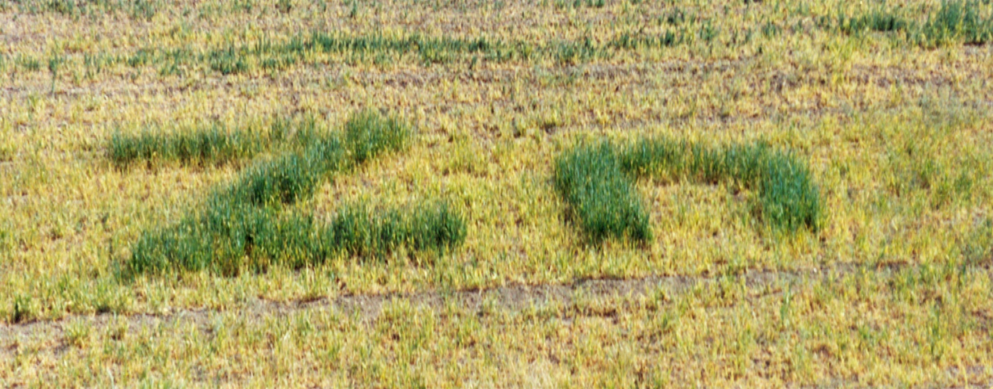
Figure 1. Effect of foliar application of Zn (100 mg Zn m⁻² as ZnSO₄.7H₂O) to barley grown on a Zn deficient soil (DTPA-extractable Zn: 0.1 mg kg⁻¹ soil). Effect of Zn (green parts of the field) was distinct within 3 weeks after Zn application (Reprinted by permission from Springer Nature Customer Service Centre GmbH: Nature © 1996; Cakmak et al. [26])

Perhaps the best example of how overcoming a single bottleneck opens up many new possibilities was the introduction of semi-dwarf genes in cereals. Before their widespread adoption, tallness limited cereal yields due to structural failure. The source of the new allele in wheat (Rht1) was Norin 10 originally from the variety Daruma, developed by Gonjiro Inazuka in Japan in 1935. While it took more than 10 years to achieve its effective introgression, pleiotropic effects of the Rht gene also improved HI and nitrogen use efficiency [27]. This spearheaded the Green Revolution for wheat and other cereals, more than tripling yield potential and saving an estimated billion lives at a time of widespread famine [27].
The above examples illustrate the value of systematic, demand-driven crop research that does not shy away from logistical challenges. Five examples of challenging research areas, that if tackled more systematically are likely to open productivity bottlenecks, are discussed herein along with a discussion of how new knowledge can be used in breeding and to improve CGMs. An exhaustive review of these research areas cannot be presented here, nor of all the potential bottlenecks, as these will emerge as understanding improves. Nonetheless, these areas were broadly agreed on as major knowledge bottlenecks with potential to improve crop productivity among authors and their colleagues from both public and private sectors. Furthermore, improved understanding in these areas can be expected to be complementary among each other and to existing knowledge (Figure 2).
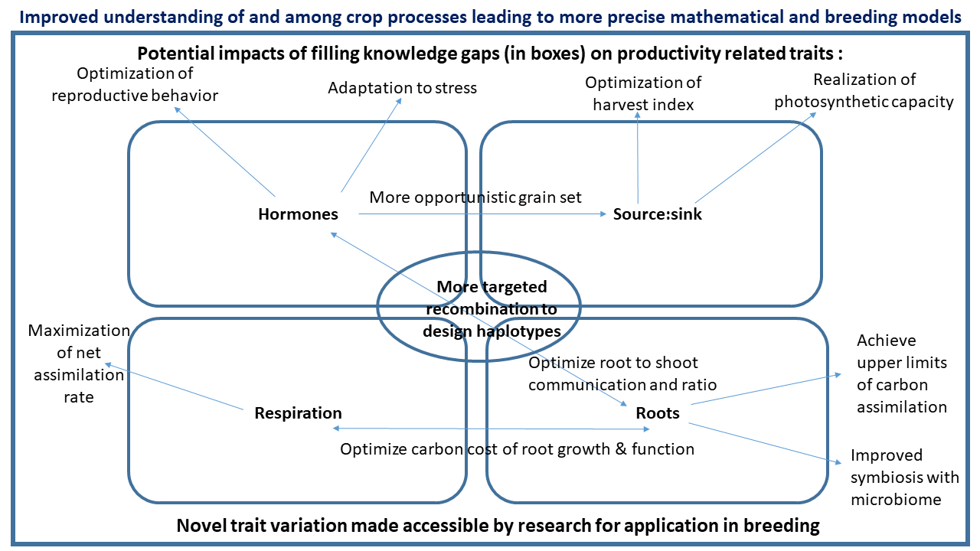
Figure 2. Current trait-knowledge bottlenecks and potential research outcomes on crop productivity

In the opinion of authors and other colleagues, some of the ‘best bets’ for achieving step changes in productivity across a broad range of crops include investment in: Root structure and function; Roles of Hormone Crosstalk; Efficiency of maintenance respiration; Increasing sink strength to boost carbon assimilation and yield, and Engineering meiotic recombination to harness genetic diversity. To illustrate how improved understanding of more basic science would create opportunities in crop improvement, two additional areas are reviewed: Exploration of genetic resources for pre-breeding, and Illuminating ‘black boxes’ in simulation modelling. Since authorship represents a range of scientific stakeholders from the public and private sectors, the topics are priorities in the ‘pre-competitive space’ as defined by the major seed companies involved in this exercise; in other words, areas with general benefit that if neglected potentially hold back progress for the industry.

Root Structure and Function
To aid foraging, root growth and development is responsive to abiotic and biotic signals in their local soil environment [11]. This highly adaptable behavior, termed developmental plasticity, offers breeders opportunities to create crops with ‘customised’ root system architecture (RSA) better adapted to forage for heterogenous resources in specific soil conditions [28]. For example, nitrogen (N) in the form of nitrate (NO₃–) is a particular challenge for root capture as it is highly mobile and leaches into deeper soil layers. To aid N capture breeders could exploit steeper root angle in brace and crown roots [29], elongation of lateral and seminal roots [30], reduced root length density near the soil surface and reduced numbers of axial roots [31]. These plastic traits would serve to increase exploration of deeper soil layers where N is more abundant. In contrast, phosphate (P) is available in an inorganic form that is highly immobile and concentrated in the topsoil [32]. To aid P capture, breeders could exploit increased numbers and lengths of roots in patches of high P availability [33], shallower root angle [32], increased numbers and lengths of root hairs [34] and cluster root formation [35]. In sorghum, genetic variation in root angle [36] enables the development of genotype x management technologies. Skip row systems can benefit from genotypes expressing low angles thereby increasing grain growth [36].
However, despite important advances in knowledge about crop roots over the past decade, major gaps remain. For example,
- Given the increasing impact of climate change there is an urgent need to determine how crop RSA is controlled by abiotic stress signals -often mediated by hormones- like aerial and soil temperature. Whilst aerial heat stress impairs wheat growth at any developmental stage, RSA traits such as greater rooting depth appear to help reduce its effects [37].
- How much carbon/biomass should crops invest in their root systems to maximize resource capture and sustainability, yet minimize its impact on yield? Surprisingly, some detailed studies on root system efficiency and CGM simulations (validated with reference to field data) predict ‘less is more’ where a lower density of longer lateral roots can be as effective at foraging for mobile resources [38]. In addition to RSA, anatomical scale traits like cortical aerenchyma can reduce root respiration by up to 50% [39], enabling crops to reinvest their C in roots or other organs.
- Despite growing recognition of the importance of the soil microbiome on crop RSA and vice versa [40], and development of a multi-billion $ industry selling microbiome-based seed coatings for crops, major gaps exist in our knowledge of the mechanisms integrating root and biotic signaling.
Studying crop RSA directly in field soil is arguably most relevant, but poses many practical challenges. Indirect approaches such as canopy temperature measurements [37] or determining water extraction profiles using electrical resistance tomography (ERT) and electromagnetic inductance (EMI) methods can be used to infer root architecture traits, but currently only at a relatively coarse resolution [41]. Invasive approaches such as soil coring and “shovelomics” have greatly facilitated the throughput of field root phenotyping [42]. However, destructive techniques can result in loss of finer scale features (e.g., lateral roots) and measurements give only a snapshot of root development. Non-destructive imaging techniques, such as agar plates, rhizotrons, paper-based and hydro/aeroponic systems, enable temporal changes to be observed throughout root development [11]. Non-destructive 3D RSA analysis is possible using transparent gels [43]. Whilst growing roots in non-soil based systems helps decrease experimental variability by reducing the impact of resource heterogeneity or microbial populations, the results are more difficult to extrapolate to field conditions. However, controlled environment phenotyping of root traits can be connected to field breeding experiments [iii]. Magnetic Resonance Imaging and X-ray Computer Tomography have been successfully used to non-invasively study 3D growth in soil [44,45]. Nevertheless, these techniques are expensive, relatively low throughput and not yet deployable in the field.
Understanding root responses to soil stresses is vital to develop novel crop varieties [46]. As topsoil dries there is a vertical gradient of water availability. Roots experiencing water deficit have been observed to increase their angle to reach deeper soil profiles [47]. Water deficit in upper soil profiles also suppresses lateral root and crown root growth in different plant species [48,49]. The few but long lateral RSA ideotype is suggested to be most efficient during water stress as resources are saved to extend the root system into deeper soil profiles. More research is indeed needed to create genotype x management technologies tuned to the TPE based on fundamental understanding of root traits [50].
Nonetheless, colonizing deeper soil profiles is challenging due to mechanical impedance [51]. Wheat roots growing at 90 cm are only found in macropores, suggesting their roots only grow by soil deformation in shallow un-compacted soil [52]. Interestingly maize and soybean roots preferentially grow towards macropores using a process termed trematotropism [53]. The ability to locate and grow through macropores could confer a deep rooting architecture and aid reaching water supplies. Instead the ability to deform strong soil is assumed to be the most important trait for deep rooting [54]. Despite the potential importance of either response, the mechanisms underpinning them remain unclear. The recent identification that the plant signal ethylene controls root responses to hard soil opens up new opportunities to select compaction resistant crop roots [55], some of the other impacts of hormones on root growth are presented next.

Roles of Hormone Crosstalk: Regulating Root Growth and Source-sink Relations
The role of individual hormones in determining plant growth and development is well documented. However, how hormones function interactively is still unclear. For example, an improved understanding of how hormone crosstalk regulates root growth and source-sink relations could be applied in crop improvement.

Root Growth
Dicotyledonous taproot systems and monocotyledonous fibrous systems, comprising primary and lateral roots are complex and heterogeneous. Multiple hormones and their synergistic or antagonistic interactions differentially regulate growth of different root types [56] (Box 1).
Ethylene-auxin crosstalk is the best established hormone interaction controlling primary root growth, with high concentrations synergistically inhibiting root elongation by modulating cell proliferation in apical meristems and cell elongation in the elongation zone [56]. Manipulating auxin transport can regulate root architecture, with large root angle (facilitating nutrient scavenging) resulting from a mutation in OsPIN2 [57], while decreased expression of the auxin transporter OsPIN5b enhanced root vigour and rice yield [58]. Deeper rooting (e.g., facilitated by the rice DRO1 gene – [59]) should enhance water uptake, boosting yields of cereal crops growing on residual soil water.
Tissue water status determines abscisic acid (ABA) effects on root elongation, with high ABA concentrations inhibiting root elongation at high water potentials, but endogenous ABA accumulation maintaining primary root elongation at low water potentials [56,60]. Thus constitutive ABA overproduction may constrain root elongation in moist soils, but facilitate it in dry soils. ABA regulates root elongation by modulating ethylene sensitivity [61] and auxin transport [62], but root ABA concentration was not correlated with genetic variation in maize root growth in dry soil [63]. Manipulating ABA enhances rice yield [64] and may affect root growth.
Cytokinins (CKs) inhibit Arabidopsis root elongation [56] but can promote crown and lateral root elongation in cereal and grass species [65]. Nevertheless, root-specific overexpression of cytokinin oxidase-dehydrogenase (CKX) genes increased root growth of both Arabidopsis [66] and Barley [67] without penalising grain yield.
Hormone interactions and regulatory hubs (Box 1) interactively determine tap vs. fibrous root growth. Understanding these genetic components may help identify alleles associated with favorable root phenotypes. Alternatively, applying deficit irrigation techniques with repeated drying and re-wetting cycles (alternate wetting and drying in rice; alternate partial rootzone drying in furrow-irrigated crops) can stimulate root growth via hormonal mechanisms [68].

Source and Sink Strength for Grain Yields
Hormones affect grain yields by regulating source and sink capacity or strength. CKs enhance sink strength by: 1) increasing the number or reproductive organs [69]; 2) positively regulating cell-cycle genes controlling cell proliferation in developing seeds [70]; and 3) increasing grain-filling rates, promoting assimilate supply to grains from source organs, especially in late flowering (inferior) spikelets [71,72]. Elevating endogenous CK concentrations genetically (by overexpressing ipt or downregulating CKX genes) altered carbohydrate assimilation and supply and increased plant productivity [69,73,74]. High ethylene levels can reduce grain yields by: 1) limiting source strength by accelerating leaf senescence; 2) inhibiting grain-filling rates by restricting assimilate partitioning to developing grains resulting in low starch biosynthesis and high accumulation of soluble carbohydrates [75,76]; and 3) reducing sink size by accelerating embryo and grain abortion [77,78]. Whereas low ABA levels correlate with poor grain-filling, high levels suppress sucrose transport to, and starch synthesis in, grains [79,80]. ABA/ethylene ratio is positively related to grain filling rate by regulating starch synthesis [81].
Manipulating CK, ABA, and ethylene levels / interactions may increase grain-filling rate and yield, perhaps by affecting sugar transporters and starch synthesis that regulate source-sink relations and sink strength during grain filling (Box 2; [82]).

Future Perspectives on Hormone Crosstalk
Mechanisms of hormonal regulation of root growth have mostly been elucidated with the simple, dicot taproot system of Arabidopsis, often in vitro (agar). Since this environment poorly simulates the biophysical conditions crop roots are exposed to, more systematic hormone phenotyping of relevant organs and tissues, at key/sensitive growth stages, is necessary in field-grown plants. Similarly, targeted gene editing [78] regulating hormone-sugar crosstalk and key molecular hubs controlling hormonal interplay will facilitate genetic improvement in grain yield by optimizing source-sink relations, as discussed below.

Increasing Sink-strength to Optimise Carbon Assimilation and Yield
Raising sink-strength during grain filling (given by the number of sinks and their activity) to increase partitioning of assimilates to harvestable organs is of paramount importance for crop productivity. Nonetheless, research to improve photosynthetic/source capacity tends to predominate. This is at least in part based on assuming that improved Radiation Use Efficiency (RUE) benefits grain yield. However, this assumption neglects that photosynthesis is responsive to sink demand: without adequate partitioning of assimilates to grain and other sinks, the source, or photosynthetic potential, will be underutilized (e.g., [83–87]).
Yield is the cumulative result of both source and sink strength over the course of development. Source strength is determined by both net photosynthetic rate and the rate of assimilate remobilisation from source tissues [88]. Sink strength is the product of the size, number and activity of sink organs; the latter refers to the specific uptake rate of resources. Although difficult to measure, methodologies are being proposed to estimate sink activity [89].
The concept of source or sink limitation is quantitative and the important question is to what extent source or sink limit yield realisation during seed set and filling. The source-sink balance during the time of economic sink development may be defined as the difference between the amount of assimilate available and the capacity to store it. Studies show source strength is in excess in both winter and summer cereals such as barley [90] wheat and barley [84], and maize [91]. This is consistent with the fact that: [i] yield tends to be far better related to the number than to the average weight of seeds [48 and references quoted therein [93]; [ii] seed weight tends to be insensitive or only marginally responsive to source strength per seed, during seed filling [14,93,94]; and [iii] photosynthesis and radiation-use efficiency are upregulated when sink strength is increased through breeding or treatments [83–85,95]. Sink-limitation during storage organ development is not limited to grain crops but also applies to tuber and root crops like potato or cassava [96,97].
The widespread sink-limitation for yield realisation during seed filling may reflect the evolutionary reward of modulating reproductive output through number rather than size [98]. This implies that stable seed size would have been adaptive [99], as size may have a marked effect upon fitness. Indeed, stabilising selection (natural selection force in a population towards a particular value) would reduce intra-specific variability of seed size towards an optimal seed size, balancing between survival of the individuals and number of progeny produced. As seed set precedes seed growth (even in indeterminate crops the overlap is small), plants have tended to be conservative to ensure reaching critical seed size for survival. This would explain why breeding has consistently increased yield through increasing sink strength (seed number or potential weight) in major grain crops, e.g., in wheat [14], rice [100] and maize [101] but not necessarily via increased leaf photosynthesis (e.g., [102]).
A solid proof of concept comes from the widespread boosts to yield of semi-dwarf cereals. The decrease in stem elongation increased partitioning of assimilates to the developing inflorescence, improving floret development and fertility and therefore increasing sink strength [103,104]. The resultant boost to harvest index [105–108] was likely the most important architectural change in crops for increasing yield. Improvements in harvest index have historically increased yield in major staple food crops [10] leading to broad economic gains for farmers. Complimentary to improved partitioning to the growing inflorescences, plant breeders may also seek to increase seed set per unit inflorescence [109].
Opportunities for increasing sink strength through modulating hormone cross talk have been presented (Box 2). Another may be to regulate the concentration of trehalose-6-phosphate (T6P), a metabolite involved in signaling the sugar status of plant tissue. This aspect can be utilized to enhance the partitioning of sucrose into e.g., inflorescences. Genetic and chemical intervention approaches have been used to modify the T6P pathway and improve performance of three food security crops: wheat (Triticum aestivum), maize (Zea mays) and rice (Oryza sativa) [110].
An alternative way to improve sucrose supply towards the economic sinks is via an increase in sucrose phloem loading [111–113]. The loading mechanism is conserved across most crops [96,113]. Increased sucrose transport capacity improved productivity in model crops [114,115] as well as in oilseed rape and wheat (Claus Frohberg, personal communication). Since many crops still seem to have sink limitation during seed filling, with implications for realizing not only current but also improved photosynthetic potential, breeders will need to keep improving sink strength. Priority traits to optimize source-sink balance are presented in Box 3.

Efficiency of Maintenance Respiration
While the role of photosynthesis in crops is reasonably well documented and has led to development of screening protocols with potential for routine application in field research such as chlorophyll fluorescence [116], the same cannot be said for respiration. This bottleneck in understanding is profoundly troublesome since many field data sets show that crop yields are significantly more influenced by night than day temperature [17,18], which could relate to effects on respiration and/or crop development.
A key approach to improving crop yields is through research targeting improvements in the efficiency with which intercepted radiation is converted into biomass [10], a trait that remains well below the theoretical maximum in elite crops (currently near 0.024, with potential to increase to 0.046-0.051; [117–119]). Along with efforts to improve photosynthesis [10], increases in biomass accumulation could also be achieved through research targeting variability in rates of respiration (Box 4). Each day, 20-70% of the CO₂ taken up by photosynthesis is released back into the atmosphere by respiration in shoots and roots [120,121]. Noting that: around half of daily whole-plant respiration takes place in above ground tissues [120]; that growth and maintenance account for similar levels of respiratory CO₂ release [122]; and, that the respiration rate of mature leaves is largely a reflection of the energy needs of maintenance processes – there is an opportunity to improve the Carbon Use Efficiency (CUE) of crops through screening for variability in rates of respiration in mature, fully expanded leaves (along with concomitant measurements of photosynthesis). Support for such an approach comes from past observations of a negative relationship between the rate of leaf respiration and growth and/or yield (e.g., maize [123], ryegrass [124] and canola [125,126]). The fact that respiration is temperature-sensitive and warming nights are leading to lower yields of rice [127] and wheat [128] is also consistent with a respiration-yield link, although other factors may also be at play (e.g., vpd [129]; hastened crop development).
Box 4 outlines the components via which decreases in the rate of respiratory CO₂ release can contribute to increases in CUE. So long as any decrease in respiration rate is coupled to increases in the efficiency of respiratory energy production and/or (ii) efficiency of respiratory energy use, then there is scope to achieve increased rates of biomass accumulation during growth (and thus yield) through screening for lines with reduced rates of leaf respiration in mature leaves – a proposition supported by the few studies available [123–126]. Despite this, relatively little attention has been given to screening for variability in leaf respiration rates in crops, or how it is linked to differences in crop performance. This is partly due to the small number of research groups who specialize in plant respiration, but also the low throughput capacity of commonly used methods such as portable infra-red gas analyzers (to measure respiratory CO₂ release) and Clark-type electrodes (to measure respiratory O₂ release). The inability to screen large numbers has meant that researchers could not exploit potential genetic variation in crop respiration. Further, while there is strong evidence that rates of leaf respiration are influenced by the environment (e.g., growth irradiance and temperature, soil moisture and nutrient availability [130–132]) in a duration-dependent manner, the lack of high-throughput methods for measuring leaf respiration has meant that the contribution of the environment to variations in leaf respiration of field-grown crops has not been established.
The development of high-throughput, fluorophore-based measurements of respiratory O₂ consumption in plant tissues [133–137] presents a game-changer for studies assessing the potential of variability in leaf respiration to influence crop growth and yields. Using an automated gas-phase method, changes in the partial pressure of O₂ through time are measured using a robotic system that quantifies the fluorescent emission from fluorophores that are in contact with air in closed vessels containing plant material [136]. This method has been used to characterize leaf respiration rates in a wide range of plant species, both under controlled environment and field conditions [133–137]. This approach has also enabled exploration of hyperspectral reflectance as a predictor of leaf respiratory O₂ uptake in near 1400 samples of wheat [135]. There is thus great potential for large screens of leaf respiration to be possible, either directly through use of the fluorophore approach, or through non-invasive, repeated measurements made using hyperspectral reflectance (either at the leaf level or in the future, using aerial or satellite platforms). The ability to screen variability in genetically diverse germplasm and breeding population will enable characterization of the genetic architecture of the trait and use of germplasm with reduced rates of leaf respiration in breeding.

Engineering Meiotic Recombination to Harness Genetic Diversity
Meiosis is a highly conserved cell division in plants, animals and fungi that generates haploid gametes required for sexual reproduction. During meiosis, homologous chromosomes become physically associated and undergo reciprocal recombination (crossover), which can create new combinations of genetic variation. Crop breeders rely on meiosis to create lines with novel trait combinations, where recombination is a vital tool [138]. However, breeders currently have little to no influence on the recombination process, and furthermore, the levels and patterns of crossovers along chromosomes can limit genetic improvement of varieties.
The major limitations facing breeders in terms of recombination are: (i) there are relatively few crossovers per chromosome per meiosis (typically 1 or 2), and (ii) large regions of crop chromosomes, usually flanking the centromere, can be potently suppressed for recombination [138]. This combination of factors means that breeders need to generate very large populations of plants to recover the desired recombinants, yet some critical crossovers are simply never achieved. As recombination similarly underpins genetic research into diverse traits, these limitations also slow down the identification of specific variants that cause phenotypes of interest. For example, enhanced recombination will help separate tightly linked QTLs with opposing effects that would otherwise be impossible to detect. A major challenge is using new insights into molecular control of meiotic recombination to develop technologies that allow precision control of recombination in plant genomes [138]. It is also important to consider that plant species vary enormously in genome size and ploidy, meaning that solutions from one genome may not translate easily to another.
Increasing global crossover numbers per meiosis has the potential to allow breeders and scientists to achieve recombinants of choice in smaller populations, which could significantly reduce time and costs (Box 5). Notwithstanding the importance of maintaining favorable haplotypes, modelling work indicates that elevated recombination can lead to substantial increases in genetic gain during recurrent selection [139]. Work in diverse eukaryotes has shown that despite there being few crossovers, there are many more initiation events with the potential to yield a crossover. For example, in most plants it is estimated there are between 100-1000 meiotic DNA double strand breaks (DSBs) per meiosis, of which approximately 10-20% are typically repaired as crossovers [140,141]. This means that there is a huge potential to increase crossovers, even without considering increasing DSB numbers. For example, manipulation of the two major crossover pathways in plants has already resulted in significant increases of recombination. In the recq4a recq4b, figl1 and fancm mutants Class II crossovers mediate the recombination increase [142–144] while overexpression of the Class I pathway protein HEI10 is also sufficient to globally increase recombination [145,146]. Furthermore, combination of recq4a recq4b and HEI10 leads to an additive crossover increase in Arabidopsis [146]. Research into these pathways may lead to more efficient molecular approaches in crops, although the figl1 mutation causes sterility in rice, pea and tomato [144]. Importantly, genetic mapping in wheat has revealed a novel helicase gene, RECQ7, that controls meiotic recombination [147]. These loci could potentially be combined with stress treatments, e.g., elevated temperature or chemicals, to increase global crossover frequency [148,149].
Unlocking recombination cold spots will have a significant impact on breeding (Box 5). Typically, large plant chromosomes show a pronounced bias of crossover frequency towards the sub-telomeres, with recombination suppression in the centromere-proximal regions [150,151]. Despite this, useful genetic variation can be found in the recombination-suppressed parts of crop genomes, which as a consequence may cause linkage drag during selection and thereby limit crop improvement [138]. As deleterious mutations tend to accumulate in low recombination regions [152], unlocking crossovers here would also allow breeders to purge unfavorable alleles. Many plant genomes show elevated levels of repeats and silencing epigenetic marks, including DNA methylation, in the regions surrounding the centromeres. Indeed, DNA methylation and H3K9me2 mutants in Arabidopsis have been observed to increase centromere-proximal crossover frequency [153]. Hence, disrupting these epigenetic marks in crop genomes may be one solution to unlock recombination. Indeed, Virus Induced Gene Silencing (VIGS) of MET1 and DDM1 in wheat caused a redistribution of crossovers along the chromosomes [154]. However, it is also important to note that structural polymorphism (for example, insertion-deletions, inversions and translocations) also suppress crossovers [155], which are more likely to occur in repetitive genome regions and in wide crosses.
Targeted meiotic recombination is the ultimate technology to precisely direct crossovers to loci of choice in plant genomes, and thus eliminating the need for numerous back crosses to remove linkage drag (Box 5). This has been successfully achieved in budding yeast, where tethering of SPO11, the protein which initiates meiotic DSB formation, is sufficient to create new recombination hotspots [156]. As the meiotic DSB machinery, including SPO11, is highly conserved across eukaryotes, tethering recombination factors is an attractive approach to be developed for plants. Further work will be required to determine which factor, or combination of factors, is sufficient to generate recombination hotspots at loci of choice in plant genomes. An alternative and related approach is to induce targeted recombination in somatic cells before forming the germline cells, for example via Cas9, which has been successful in tomato [157].
Solving the research bottlenecks described in other parts of this publication to model and create new combinations of traits and alleles, will be achieved faster and cheaper if we can control recombination. Pre-breeding will be the crucible that provides proof of concept for such models as discussed subsequently.

Leveraging Improved Understanding to Achieve Productivity Gains
Science breakthroughs coming from the topics discussed and their integration (Figure 2) can be translated into specific crop improvement technologies. These include improved CGMs that help prioritize research targets and their potential for scale-out based on simulations [23,158–160], and genetic improvement involving the identification of novel trait sources and their evaluation in a realistic breeding context, accompanied by improved crop husbandry.

Exploration of Genetic Resources for Pre-breeding
When lack of variation within extant breeding genepools limits the potential to make genetic gain, useful variation can often be found in progenitor varieties, landraces or crop wild relatives. The process of “pre-breeding” links trait discovery with variety development and involves identifying and introducing novel trait variation (NTV) from unadapted gene pools into elite breeding populations.
With an estimated 7M diverse accessions of crop genetic resources available in over 1,750 national and international ex situ collections worldwide and significantly more managed in situ, these underutilized resources represent significant opportunities to exploit almost any trait, and especially those which have been hitherto overlooked ([161]; http://www.fao.org/3/i1500e/i1500e00.htm]. Defining pre-competitive traits of interest to public- and/or private-sector breeders for a particular crop and TPE is the first step in a pre-breeding program.
Historically, resistance to pests and diseases, fertility traits (i.e., cytoplasmic male sterility), and abiotic stress tolerance have been targets of successful pre-breeding efforts [162,163] and there is increasing interest in pre-breeding to introduce trait combinations targeted to specific TPEs. Methods to increase genome-wide and local levels of recombination (discussed previously) are of great interest for accelerating the introgression process.
Reverse genetics approaches are valuable in cases where a major gene governing a trait of interest has been well-characterized; variants can be generated via TILLING [164] or introduced via genome editing [165] directly in breeding lines. This avoids linkage drag and shortcuts the backcrossing process, which typically requires 3-5 years, enabling evaluation of NTV to proceed rapidly in the context of the larger breeding program. Successful genome-editing has been reported in banana, tomato, potato, rice, wheat, maize, soybean, and several fruit crops [12,166–169], as well as de novo domestication [168] from wild crop relatives.
If the genetic architecture of a desired trait is complex but robust screening methods are available, backcrossing with unadapted sources may be effective [170–172]. Where trait inheritance is complex and precision phenotyping methods are not well developed, recurrent selection aided by predictive modeling and genomic selection (GS) is the most expedient way to integrate NTV into elite breeding material. This is time consuming and exploratory in nature; it requires the development of a training population, phenotyping for performance across years and environments, predictive modeling, and multiple generations of recombination and selection guided by GS, as discussed previously [171–173].
Among the traits most neglected in breeding (due to phenotyping challenges) but with high potential pay-off in terms of climate resilience is RSA. The rest of this section will discuss opportunities to improve RSA considering outputs from research in genomics and phenomics and how they may be used to explore genetic diversity.
Adaptive RSA -to withstand both drought and heat stress in the field, respectively- has been identified in wheat and other crops, indicating some common genetic basis [174]. The DEEPER ROOTING 1 (DRO1) gene [47,175] is a regulator of root growth angle. DRO1 orthologs exist in both monocot and dicot plant species [176] and experiments in rice, wheat [176], Arabidopsis and Prunus [177] suggest functional similarity with influence on root system architecture. It has not yet been determined whether orthologues of DRO1 underlie some of the major QTLs identified for rooting depth in maize [178], wheat [179], sorghum [180], barley [181], chickpea [182] and other crops. In addition to impacting root system architecture and drought tolerance, the DRO1 gene contributes to higher harvest index, nitrogen uptake, and flux of cytokinin from root to shoot during grain filling in paddy rice [47,183]. DRO1 carries a highly conserved EAR motif (ethylene-responsive element binding factor-associated amphiphilic repression motif; [184]) that serves as an important repressor of gene expression in response to abiotic stress, helping to limit cell damage [185].
Thus, variation in DRO1 represents an interesting target for breeders because it regulates both morphological and physiological responses to drought and has no demonstrated cost to plants under non-stress conditions. Natural variation at the DRO1 locus can be explored in diverse germplasm resources based on sequence data to identify potential donor lines carrying alleles of interest [185]. Subsequently, marker assisted selection or genome editing may be employed to introduce rooting depth variation into elite breeding backgrounds as part of the pre-breeding pipeline, followed by evaluation of the pre-bred lines for their response to drought tolerance in a TPE. Crop and breeding simulation in maize support this hypothesis [186].
Enhanced use of forward genetics approaches is also of critical importance. Tools that allow routine, non-invasive imaging of root systems in situ including X-ray computed tomography and magnetic resonance imaging [187,188] represent an opportunity to discover as yet uncharacterized NTV associated with root system architecture. This “phenotyping first” strategy makes no assumptions about the gene(s) involved and would revolutionize the study of root biology under field conditions. It could also accelerate breeding efforts to explicitly select for root parameters of interest, and would be applicable a wide array of species, including root and tuber crops [160, 161].
Canopy temperature is coupled to root water uptake via evaporative cooling from stomata [189] and their degree of coupling can be manipulated experimentally through modifying water regimes and atmospheric demand. Thus, canopy temperature offers a valuable screening tool for characterizing diverse donors and pre-breeding materials in terms of relative access to water, including those carrying known variants of target genes such as DRO1, ERECTA (ER) (a gene that exerts stomatal control over transpiration efficiency [190]), and/or Photosystem II Subunit S (PsbS) (a gene that regulates stomatal opening in response to light with demonstrated impact on water use efficiency in tobacco [191]), with demonstrated impacts on both drought tolerance and yield in bread wheat and maize [192,193].
Collectively, these approaches can accelerate pre-breeding efforts for enhanced climate resilience by a) using crop and breeding simulation to identity trait combinations of interest [186], b) using targeted genotypic and phenotypic screening methodologies, and c) employing genomics strategies to efficiently integrate NTV into elite breeding material. In concert with the development of predictions of potential trait targets to accelerate genetic gain for yield, such as those emphasized above, there is a need to advance predictive modeling capabilities to prioritize among the many opportunities for combinations of experimental evaluation strategies and ultimately to inject into breeding programs.

Illuminating ‘Black Boxes’ in Simulation Modelling
Improved soybean varieties [194] and drought tolerant maize, now grown in more than 20MM acres in the US, resulted from understanding how stomatal conductance responds to vapor pressure deficit [195] and designing breeding strategies [8,186] to exploit water conservation during vegetative growth to improve plant water status at flowering [23] and kernel set [196]. This is an example of targeted breeding to re-balance source:sink interactions (Box 3) to increase yield while recognising water availability in the TPE. Despite incomplete knowledge, using a CGM based on demand/supply concepts, sink strength based on number and growth rate of sink organs ([112]; Box 3), and competition among organs, it was possible to understand and model the emergence of phenotypes [159,196] to inform breeding [8,186].
Other black boxes are worth illuminating. Mass allocation among organs remains largely a descriptive exercise, while it has played a critical role in the long-term yield improvement in various crops [iii] [107–109,197]. In an iterative manner, maize breeders improved sink strength, agronomists increased plant population, and roots systems adapted to crowding and with enhanced efficiency [iii] [198]. This interplay of processes operating at different scales and organs is not captured in any modeling framework, with root/shoot resource allocation being one of the least known process in modeling. Emergent behavior due to competition among individuals in a crop setting is largely absent in CGMs. Developing views of hormonal cross talk in regulating root elongation, source-sink relations and grain set (Box 1 and Box 2) can help interpret how increased grain set in maize for example, may have resulted in root systems adapting to crowding, responding to the environment [44, 48, 49] and enhancing efficiency [iii] [198].
Advances in hormonal cross-talk networks (Box 1 and Box 2) offer an optimistic perspective to deal with such complexity and make informed selections based on root plasticity traits, and mass allocation once we encode this knowledge in crop models (Figure 3b). Combining high-throughput phenotyping, improved analytical techniques and CGMs, new knowledge will lead to a better utilization of existing crop genetic resources, and enable breeders to deal quantitatively with the complex regulatory networks from hormones, to organs, to communities of plants.
Most CGMs use the concept of radiation use efficiency [199] due in part to our limited understanding of regulation of maintenance respiration (m) and partitioning [151, 162] . Models based on RUE implicitly assume that ~20% of seasonal photosynthesis is used in maintenance respiration (Ng and Loomis (1984, cited in [200]). Advancing our understanding of the physiological and genetic determinants of m, and homeostasis to temperature [162] will enable the use of models to identify opportunities for the improvement of UE, thereby in crop yields (Box 4).
Crop growth and development models in combination with georeferenced databases allow prediction of performance of untested genotypes/traits across the broad TPE (Figure 3b). They also provide an avenue to structure dialogue between fundamental and translational research on trait relevance and the identification of bottlenecks for crop productivity [24,201]. Bayesian approaches further enabled integration of the quantitative genetics framework that underpins genetic gain in breeding with the physiological knowledge captured in CGMs(Figure 3c; [50,202]). In Gene-to-Phenotype (G2P) modeling, prior knowledge and beliefs translates into definitions of statistical priors for physiological traits, thus enabling modeling important breeding concepts such as trait breeding values and genotypic value of individuals (Figure 3c). The posterior distributions provide assessments of how much we really know given our available data and enable scientists to define the opacity of the black boxes by estimating the uncertainty in the parameters. This Bayesian-dynamic modeling framework provides the means to assimilate data collected within different stages of the breeding program ([202]; Figure 3). It includes the flexibility to use phenomics data [203] collected in time and derived from remote sensing and images of tissues, organs and plants [8,42,43,187] to estimate the rates $\frac{dy}{dt}$ of processes that give rise to the observed trait phenotypes ($y$). Increasing biological reality for processes described here and resulting from future research will inexorably expand the domain of application of CGMs, but more importantly, increase the capability of CGMs for ex-ante analyses and design approaches to tackle bottlenecks in crop improvement. Today, it is possible to use a CGM [196] to conduct a retrospective analyses of yield response to water deficit in gene-edited maize [78,204] but not prospective analyses on the manipulation of genes controlling hormone synthesis and their cross-talk effects on yield. The integration of cross talk hormonal networks (Box 1 and Box 2) within the Bayesian hierarchical framework (Figure 3) will fundamentally change the paradigm from descriptive to prescriptive crop modeling. Further understanding of these networks will improve the genetic models we can embed within CGMs (Figure 3c), yield prediction, our capability to explore opportunities for network optimization within the TPE, and design genotype x management technologies for cropping systems [50,205].
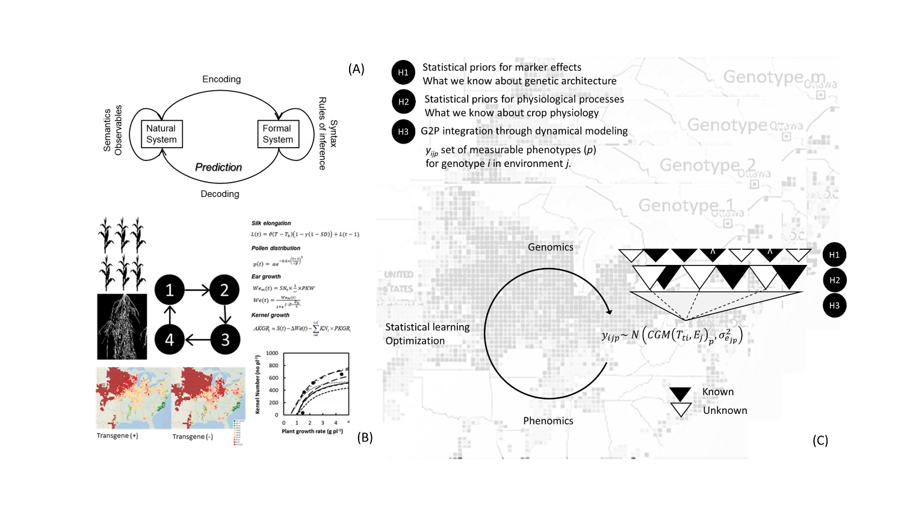

Figure 3. Illuminating black boxes could improve functionality and predictive skill through iterative model building (A), which is illustrated in panel (B), from model improvement (1) to spatial assessment of the trait (4). Hierarchical Bayesian dynamic modeling provides a transparent framework for knowledge and data assimilation to define the opacity of modeling boxes. Illuminating black boxes could be conducive to improve functionality and predictive skill. Prediction for various genotypes using Messina et al. [202] model and georeferenced environmental databases shown as background (C)

Conclusions
While other areas of crop science (e.g., carbon assimilation of non-leaf tissue and whole canopies, the genetics of wide adaptation etc., etc.) if adequately resourced could also fill important knowledge gaps (and merit review), the examples presented here provide a basis for targeted investigation, combining breakthrough technologies with proven ones. While the review tends to focus on opportunities for genetic improvement through crop breeding, increased knowledge integration within a modelling capability will create opportunities to improve crop adaptation through better targeted use of external inputs and design of genotype x management technologies [50]. Apart from modified planting and tillage systems, and precision applications of water and fertilizer, these could potentially include exogenous application of plant growth regulators to boost or protect growth at key phases of crop development, for acclimation to anticipated stresses, and to ameliorate the negative impact of unpredictable climate shocks.
Maximizing the impact of crop research requires a continuous cross-stakeholder interaction to share know–how obtained from discovery research in formats tailored to stakeholder use requirements [206]. Consensus among public and private crop scientists represents, if nothing else, provides a useful platform to begin discussing some of the obvious asymmetries in crop research that currently hold back genetic gains and yield gaps in a wide range of crops and environments. This aligns with society’s expectations that the academic, crop improvement and farmer communities ensure future food security in a generally less predictable if not harsher climate, and would lead to a more stable foundation for crop science to embrace increasingly realistic research scenarios.

Acknowledgements
Authors acknowledge the following scientists for helping achieve a consensus on research bottlenecks with significant implications for crop improvement: Yann Manes (Syngenta), Jeremy Derory (Limagrain), Bruno Marty (BASF) and Hans Braun (recent Director of the Global Wheat Program, CIMMYT. We acknowledge Renee Lafitte (Bill and Melinda Gates Foundation) for helpful feedback on the manuscript, and Fatima Escalante for valuable assistance in coordinating edits to the manuscript and its formatting. MPR acknowledges the International Wheat Yield Partnership https://iwyp.org/ for establishing a precedent of integrating different research strands in wheat for targeted pre-breeding, and the Foundation for Food and Agricultural Research (https://foundationfar.org/) for supporting a translational research and pre-breeding pipeline at CIMMYT to identify and stack climate-resilience traits in wheat.

Resources
^{i}Ritchie, H. and Roser, M. (2019) , Crop Yields. , Our World in Data. [Online]. Available: https://ourworldindata.org/crop-yields
^{ii}Fischer, R.A. et al. (2014) Crop yields and global food security. Aust. Cent. Int. Agric. Res.
^{iii}Messina, C.D. et al. (2020) Reproductive resilience but not root architecture underpin yield improvement in maize. bioRxiv DOI: 10.1101/2020.09.30.320937

References
1 Stewart, B.A. and Lal, R. (2018) Increasing World Average Yields of Cereal Crops: It’s All About Water. In Advances in Agronomy Volume 151 (Sparks, D. L., ed), pp. 1–44
2 Van Ginkel, M. and Ortiz, R. (2018) Cross the best with the best, and select the best: HELP in breeding selfing crops. Crop Sci. 58, 17–30
3 Singh, R.P. et al. (2015) Emergence and Spread of New Races of Wheat Stem Rust Fungus: Continued Threat to Food Security and Prospects of Genetic Control. Phytopathology 105, 872–884
4 Donatelli, M. et al. (2017) Modelling the impacts of pests and diseases on agricultural systems. Agric. Syst. 155, 213–224
5 Guzmán, C. et al. (2017) Genetic improvement of grain quality traits for CIMMYT semi-dwarf spring bread wheat varieties developed during 1965–2015: 50 years of breeding. F. Crop. Res. 210, 192–196
6 Juliana, P. et al. (2019) Integrating genomic-enabled prediction and high-throughput phenotyping in breeding for climate-resilient bread wheat. Theor. Appl. Genet. 132, 177–194
7 Araus, J.L. et al. (2018) Translating High-Throughput Phenotyping into Genetic Gain. Trends Plant Sci. 23, 451–466
8 Cooper, M. et al. (2014) Predicting the future of plant breeding: complementing empirical evaluation with genetic prediction. Crop Pasture Sci. 65, 311–336
9 Reynolds, M. et al. (2019) Translational Research for Climate Resilient, Higher Yielding Crops. Crop Breeding, Genet. Genomics 1:e190016,
10 Long, S.P. et al. (2015) Meeting the global food demand of the future by engineering crop photosynthesis and yield potential. Cell 161, 56–66
11 Morris, E.C. et al. (2017) Shaping 3d Root System Architecture. Curr. Biol. 27, PR919-R930
12 Gao, H. et al. (2020) Superior field performance of waxy corn engineered using CRISPR-Cas9. Nat. Biotechnol. 38, 579–581
13 Borrell, A. and Reynolds, M. (2017) Integrating islands of knowledge for greater synergy and efficiency in crop research. Food Energy Secur. 6, 26–32
14 Aisawi, K.A.B. et al. (2015) The Physiological Basis of the Genetic Progress in Yield Potential of CIMMYT Spring Wheat Cultivars from 1966 to 2009. Crop Sci. 55, 1749–1764
15 Reynolds, M.P. et al. (2007) Drought-adaptive traits derived from wheat wild relatives and landraces. J. Exp. Bot. 58, 177–186
16 Wilson, D. (1982) Response to selection for dark respiration rate of mature leaves in Lolium perenne and it’s effects on growth of young plants and simulated swards. Ann. Bot. 49, 303–312
17 Lobell, D.B. and Ortiz-Monasterio, J.I. (2007) Impacts of day versus night temperatures on spring wheat yields: A comparison of empirical and CERES model predictions in three locations. Agron. J. 99, 469–477
18 Shi, W. et al. (2017) High day- and night-time temperatures affect grain growth dynamics in contrasting rice genotypes. J. Exp. Bot. 68, 5233–5245
19 South, P. F. et al. (2019) Synthetic glycolate metabolism pathways stimulate crop growth and productivity in the field. Science 636, eaat9077
20 Shen, B.-R. et al. (2019) Engineering a new chloroplastic photorespiratory bypass to increase photosynthetic efficiency and productivity in rice. Mol. Plant 12, 199–214
21 Hammer, G.L. et al. (2019) Biological reality and parsimony in crop models – why we need both in crop improvement! in silico Plants 1, diz010
22 White, J.W. and Castillo, J.A. (1989) Relative Effect of Root and Shoot Genotypes on Yield of Common Bean under Drought Stress. Crop Sci. 29, 360–362
23 Messina, C.D. et al. (2015) Limited-Transpiration trait may increase maize drought tolerance in the US Corn Belt. Agronomy 107, 1978–1986
24 Messina, C.D. et al. (2020) Crop science: A foundation for advancing predictive agriculture. Crop Sci. 60, 544–546
25 Bagci, S.A. et al. (2007) Effects of zinc deficiency and drought on grain yield of field-grown wheat cultivars in Central Anatolia. J. Agron. Crop Sci. 193, 198–206
26 Cakmak, I. et al. (1996) Zinc deficiency as a critical problem in wheat production in Central Anatolia. Plant Soil 180, 165–172
27 Reynolds, M.P. and Borlaug, N.E. (2006) Impacts of Breeding on International Collaborative Wheat Improvement. J. Agric. Sci. 144, 3–17
28 Hodge, A. (2004) The plastic plant: root responses to heterogeneous supplies of nutrients. New Phytol. 162, 9–24
29 Trachsel, S. et al. (2013) Maize root growth angles become steeper under low N conditions. F. Crop Res. 140, 18–31
30 Gioia, T. et al. (2015) Impact of domestication on the phenotypic architecture of durum wheat under contrasting nitrogen fertilization. J. Exp. Bot. 66, 5519–5530
31 Zhan, A. and Lynch, J.P. (2015) Reduced frequency of lateral root branching improves N capture from low-N soils in maize. J. Exp. Bot. 66, 2055–2065
32 Rubio, G. et al. (2003) Topsoil foraging and its role in plant competitiveness for phosphorus in common bean. Crop Sci. 43, 598–607
33 Flavel, R.J. et al. (2014) Quantifying the response of wheat (Triticum aestivum L) root system architecture to phosphorus in an Oxisol. Plant Soil 385, 303–310
34 Bates, T.R. and Lynch, J.P. (2001) Root hairs confer a competitive advantage under low phosphorus availability. Plant Soil 236, 243–250
35 Shane, M.W. and Lambers, H. (2005) Cluster roots: A curiosity in context. In Root Physiology: from Gene to Function. Plant Ecophysiology, vol. 4. (Lambers, H. and Colmer, T. D., eds), pp. 101–125, Springer
36 Singh, V. et al. (2011) Genetic variability and control of root architecture in sorghum. Crop Sci. 51, 2011–2020
37 Lopes, M.S. and Reynolds, M.P. (2010) Partitioning of assimilates to deeper roots is associated with cooler canopies and increased yield under drought in wheat. Funct. Plant Biol. 37, 147
38 Postma, J.A. et al. (2014) The Optimal Lateral Root Branching Density for Maize Depends on Nitrogen and Phosphorus Availability. Plant Physiol. 166, 590–602
39 Zhu, J. et al. (2010) Root cortical aerenchyma improves the drought tolerance of maize (Zea mays L.). Plant Cell Environ. 33, 740–749
40 de la Fuente, C.C. et al. (2020) An extended root phenotype: the rhizosphere, its formation and impacts on plant fitness. Plant J. 103, 951–964
41 Whalley, W.R. et al. (2017) Methods to estimate changes in soil water for phenotyping root activity in the field. Plant Soil 415, 407–422
42 Trachsel, S. et al. (2011) Shovelomics: high throughput phenotyping of maize (Zea mays L.) root architecture in the field. Plant Soil 341, 75–87
43 Clark, R.T. et al. (2011) Three-Dimensional Root Phenotyping with a Novel Imaging and Software Platform. Plant Physiol. 156, 455–465
44 Mairhofer, S. et al. (2015) Extracting multiple interacting root systems using X-ray microcomputed tomography. Plant J. 84, 1034–1043
45 van Dusschoten, D. et al. (2016) Quantitative 3D Analysis of Plant Roots Growing in Soil Using Magnetic Resonance Imaging. Plant Physiol. 170, 1176–1188
46 Lynch, J.P. (2019) Root phenotypes for improved nutrient capture: an underexploited opportunity for global agriculture. New Phytol. 223, 548–564
47 Uga, Y. et al. (2013) Control of root system architecture by DEEPER ROOTING 1 increases rice yield under drought conditions. Nat. Genet. 45, 1097–1102
48 Sebastian, J. et al. (2016) Grasses suppress shoot-borne roots to conserve water during drought. Proc. Natl. Acad. Sci. U. S. A. 113, 8861–8866
49 Gao, Y.Z. and Lynch, J.P. (2016) Reduced crown root number improves water acquisition under water deficit stress in maize (Zea mays L.). J. Exp. Bot. 67, 4545–4557
50 Cooper, M. et al. (2020) Integrating Genetic Gain and Gap Analysis to predict improvements in crop productivity. Crop Sci. 60, 582–604
51 Valentine, T. et al. (2012) Soil strength and macropore volume limit root elongation rates in many UK agricultural soils. Ann. Bot. 110, 259–270
52 White, R. and Kirkegaard, J.A. (2010) The distribution and abundance of wheat roots in a dense, structured subsoil - implications for water uptake. Plant. Cell Environ. 33, 133–148
53 Colombi, T. et al. (2017) Artificial macropores attract crop roots and enhance plant productivity on compacted soil. Sci. Total Environ. 574, 1283–1293
54 Gao, W. et al. (2016) Deep roots and soil structure. Plant. Cell Environ. 39, 1662–1668
55 Pandey, B. et al. (2021) Plant roots sense soil compaction through restricted ethylene diffusion. Science In press,
56 Qin, H. et al. (2019) The Coordination of Ethylene and Other Hormones in Primary Root Development. Front. Plant Sci. 10, 874
57 Wang, L. et al. (2018) LARGE ROOT ANGLE1, encoding OsPIN2, is involved in root system architecture in rice. J. Exp. Bot. 69, 385–397
58 Lu, G. et al. (2015) OsPIN5b modulates rice (Oryza sativa) plant architecture and yield by changing auxin homeostasis, transport and distribution. Plant J. 83, 913–925
59 Kitomi, Y. et al. (2020) Root angle modifications by the DRO1 homolog improve rice yields in saline paddy fields. Proc. Natl. Acad. Sci. U. S. A. 117, 21242–21250
60 Sharp, R.E. et al. (2004) Root growth maintenance during water deficits: physiology to functional genomics. J. Exp. Bot. 55, 2343–2351
61 Thole, J.M. et al. (2014) Abscisic acid regulates root elongation through the activities of auxin and ethylene in arabidopsis thaliana. G3 Genes | Genomes | Genet. 4, 1259–1274
62 Xu, W. et al. (2013) Abscisic acid accumulation modulates auxin transport in the root tip to enhance proton secretion for maintaining root growth under moderate water stress. New Phytol. 197, 139–150
63 Leach, K.A. et al. (2011) Primary root elongation rate and abscisic acid levels of maize in response to water stress. Crop Sci. 51, 157–172
64 Miao, C. et al. (2018) Mutations in a subfamily of abscisic acid receptor genes promote rice growth and productivity. Proc. Natl. Acad. Sci. U. S. A. 115, 6058–6063
65 Debi, B.R. et al. (2005) Cytokinin inhibits lateral root initiation but stimulates lateral root elongation in rice (Oryza sativa). J. Plant Physiol. 162, 507–515
66 Werner, T. et al. (2010) Root-Specific Reduction of Cytokinin Causes Enhanced Root Growth, Drought Tolerance, and Leaf Mineral Enrichment in Arabidopsis and Tobacco. Plant Cell 22, 3905–3920
67 Ramireddy, E. et al. (2018) Root Engineering in Barley: Increasing Cytokinin Degradation Produces a Larger Root System, Mineral Enrichment in the Shoot and Improved Drought Tolerance. Plant Physiol. 177, 1078–1095
68 Dodd, I.C. et al. (2015) The importance of soil drying and re-wetting in crop phytohormonal and nutritional responses to deficit irrigation. J. Exp. Bot. 66, 2239–2252
69 Ashikari, M. et al. (2005) Cytokinin oxidase regulates rice grain production. Science 309, 741–745
70 Schaller, G.E. et al. (2014) Cytokinin and the cell cycle. Curr. Opin. Plant Biol. 21, 7–15
71 Roitsch, T. and Ehneß, R. (2000) Regulation of source/sink relations by cytokinins. Plant Growth Regul. 32, 359–367
72 Wilkinson, S. et al. (2012) Plant hormone interactions: innovative targets for crop breeding and management. J. Exp. Bot. 63, 3499–3509
73 Zalewski, W. et al. (2010) Silencing of the HvCKX1 gene decreases the cytokinin oxidase/dehydrogenase level in barley and leads to higher plant productivity. J. Exp. Bot. 61, 1839–1851
74 Peleg, Z. et al. (2011) Cytokinin‐mediated source/sink modifications improve drought tolerance and increase grain yield in rice under water stress. Plant Biotechnol. J. 9, 747–758
75 Valluru, R. et al. (2017) Phenotypic and genome‐wide association analysis of spike ethylene in diverse wheat genotypes under heat stress. New Phytol. 214, 271–283
76 Sekhar, S. et al. (2015) Spikelet-specific variation in ethylene production and constitutive expression of ethylene receptors and signal transducers during grain filling of compact- and lax-panicle rice (Oryza sativa) cultivars. Plant Physiol. 179, 21–34
77 Hays, D. et al. (2007) Heat stress induced ethylene production in developing wheat grains induces kernel abortion and increased maturation in a susceptible cultivar. Plant Sci. 172, 1113–1123
78 Shi, J. et al. (2015) Overexpression of ARGOS Genes Modifies Plant Sensitivity to Ethylene, Leading to Improved Drought Tolerance in Both Arabidopsis and Maize. Plant Physiol. 169, 266–282
79 Bhatia, S. and Singh, R. (2002) Phytohormone-mediated transformation of sugars to starch in relation to the activities of amylases, sucrose-metabolising enzymes in sorghum grain. Plant Growth Regul. 36, 97–104
80 Chen, T. et al. (2019) Abscisic acid synergizes with sucrose to enhance grain yield and quality of rice by improving the source-sink relationship. BMC Plant Biol. 19, 525
81 Wang, Z. et al. (2015) Abscisic acid and the key enzymes and genes in sucrose-to-starch conversion in rice spikelets in response to soil drying during grain filling. Planta 241, 1091–1107
82 Albacete, A.A. et al. (2014) Hormonal and metabolic regulation of source–sink relations under salinity and drought: From plant survival to crop yield stability. Biotechnol. Adv. 32, 12–30
83 Acreche, M.M. and Slafer, G.A. (2009) Grain weight, radiation interception and use efficiency as affected by sink-strength in Mediterranean wheats released from 1940 to 2005. F. Crop. Res. 110, 98–105
84 Serrago, R.A. et al. (2013) Understanding grain yield responses to source–sink ratios during grain filling in wheat and barley under contrasting environments. F. Crop. Res. 150, 42–51
85 Reynolds, M.P. et al. (2005) Sink-limitation to yield and biomass: a summary of some investigations in spring wheat. Ann. Appl. Biol. 146, 39–49
86 McCormick, A. et al. (2006) Sink strength regulates photosynthesis in sugarcane. New Phytol. 171, 759–770
87 Munier-Jolain, N. et al. (1998) Seed growth rate in grain legumes I. Effect of photoassimilate availability on seed growth rate. J. Exp. Bot. 49, 1963–1969
88 Smith, M.R. et al. (2018) Source-Sink Relationships in Crop Plants and Their Influence on Yield Development and Nutritional Quality. Front. Plant Sci. 9, 1889
89 Windt, C.W. and Blumler, P. (2015) A portable NMR sensor to measure dynamic changes in the amount of water in living stems or fruit and its potential to measure sap flow. Tree Physiol. 35, 366–375
90 Bingham, I.J. et al. (2007) Is barley yield in the UK sink limited?: I. Post-anthesis radiation interception, radiation-use efficiency and source–sink balance. F. Crop. Res. 101, 198–211
91 Bonelli, L.E. et al. (2020) Does the photo-thermal environment limit post-flowering maize growth? F. Crop Res. 252, 107805
92 Slafer, G.A. et al. (2014) Coarse and fine regulation of wheat yield components in response to genotype and environment. F. Crop. Res. 157, 71–83
93 Borrás, L. et al. (2004) Seed Dry Weight Response to Source–Sink Manipulations in Wheat, Maize and Soybean: a Quantitative Reappraisal. F. Crop. Res. 86, 131–146
94 Ordoñez, R.A. et al. (2018) Maize Grain Weight Sensitivity to Source–Sink Manipulations under a Wide Range of Field Conditions. Crop Sci. 58, 2542–2557
95 Reynolds, M.P. et al. (2001) Physiological basis of yield gains in wheat associated with the LR19 translocation from Agropyron elongatum. Euphytica 119, 139–144
96 Sonnewald, S. et al. (2020) The Cassava Source–Sink project: opportunities and challenges for crop improvement by metabolic engineering. Plant J. 103, 1655–1665
97 Oliveira, J. et al. (2016) An explanation of yield differences in three potato cultivars. Agron. J. 108, 1434–1446
98 Sadras, V.O. and Slafer, G.A. (2012) Environmental modulation of yield components in cereals: heritabilities reveal a hierarchy of phenotypic plasticities. F. Crop. Res. 127, 215–224
99 Sadras, V.O. and Denison, R.F. (2009) Do plant parts compete for resources? An evolutionary perspective. New Phytol. 183, 565–574
100 Horie, T. et al. (2003) Physiological traits associated with high yield potential in rice. In Rice Science: Innovations and Impact for Livelihood (Mew, T. W. et al., eds), pp. 117–145, International Rice Research Institute
101 Tollenaar, M. and Lee, E.A. (2006) Dissection of physiological processes underlying grain yield in maize by examining genetic improvement and heterosis. Maydica 51, 399–408
102 Evans, L.T. (1997) Adapting and improving crops: the endless task. Philos. Trans. R. Soc. London, B Biol. Sci. 352, 901–906
103 Hedden, P. (2003) The genes of the Green Revolution. Trends Genet. 19, 5–9
104 Ferrante, A. et al. (2020) Floret development and spike fertility in wheat: differences between cultivars of contrasting yield potential and their sensitivity to photoperiod and soil N. F. Crop Res. 256, 107908
105 Richards, R.A. (1992) The effect of dwarfing genes in spring wheat in dry environments. Aust. J. Agric. Res. 43, 517–527
106 Miralles, D.J. and Slafer, G.A. (1995) Yield, biomass and yield components in dwarf, semidwarf and tall isogenic lines of spring wheat under recommended and late sowing dates. Plant Breed. 114, 392–296
107 Sakamoto, T. and Matsuoka, M. (2004) Generating high-yielding varieties by genetic manipulation of plant architecture. Curr. Opin. Biotechnol. 15, 144–147
108 Khush, G.S. (1995) Modern Varieties-Their real contribution to food security and equity. GeoJournal 35, 275–284
109 Slafer, G.A. et al. (2015) Fruiting efficiency: An alternative trait to further rise wheat yield. Food Energy Secur. 4, 92–109
110 Paul, M. et al. (2018) The Role of Trehalose 6-Phosphate in Crop Yield and Resilience. Plant Physiol. 177, 12–23
111 Ainsworth, E.A. and Bush, D.R. (2011) Carbohydrate export from the leaf: a highly regulated process and target to enhance photosynthesis and productivity. Plant Physiol. 155, 64–69
112 White, A.C. et al. (2016) How can we make plants grow faster? A source-sink perspective on growth rate. J. Exp. Bot. 67, 31–45
113 Braun, D.M. et al. (2014) Understanding and manipulating sucrose phloem loading, unloading, metabolism, and signalling to enhance crop yield and food security. J. Exp. Bot. 65, 1713–1735
114 Wang, L. et al. (2015) Enhanced sucrose loading improves rice yield by increasing grain size. Plant Physiol. 169, 2848–2862
115 Xu, Q. et al. (2020) Carbon export from leaves is controlled via ubiquitination and phosphorylation of sucrose transporter SUC2. Proc. Natl. Acad. Sci. U. S. A. 117, 6223–6230
116 Murchie, E.H. and Lawson, T. (2013) Chlorophyll fluorescence analysis: A guide to good practice and understanding some new applications. J. Exp. Bot. 64, 3983–3998
117 Zhu, X.-G. et al. (2010) Improving Photosynthetic Efficiency for Greater Yield. Annu. Rev. Plant Biol. 61, 235–261
118 Long, S.P. et al. (2006) Can Improvement in Photosynthesis Increase Crop Yields? Plant, Cell Environ. 29, 315–330
119 Zhu, X.-G. et al. (2008) What is the maximum efficiency with which photosynthesis can convert solar energy into biomass? Curr. Opin. Biotechnol. 19, 153–159
120 Atkin, O.K. et al. (2007) Respiration as a percentage of daily photosynthesis in whole plants is homeostatic at moderate, but not high, growth temperatures. New Phytol. 174, 367–380
121 Gifford, R.M. (1995) Whole plant respiration and photosynthesis of wheat under increased CO2 concentration and temperature: long‐term vs. short‐term distinctions for modelling. Glob. Chang. Biol. 1, 285–396
122 Amthor, J.S. et al. (2019) Engineering strategies to boost crop productivity by cutting respiratory carbon loss. Plant Cell 31, 297–314
123 Heicherl, G.H. (1971) Confirming measurements of respiration and photosynthesis with dry matter accumulation. Photosynthetica 5, 93–98
124 Wilson, D. and Jones, J.G. (1982) Effect of selection for dark respiration rate of mature leaves on crop yields of Lolium perenne cv. S23. Ann. Bot. 49, 313–320
125 Winzeler, M. et al. (1988) Genotypic differences in dark respiration of mature leaves in winter wheat (Triticum aestivum L.). Can. J. Plant Sci. 68, 669–675
126 Hauben, M. et al. (2009) Energy use efficiency is characterized by an epigenetic component that can be directed through artificial selection to increase yield. Proc. Natl. Acad. Sci. U. S. A. 106, 20109–20114
127 Nagarajan, S. et al. (2010) Local climate affects growth, yield and grain quality of aromatic and non-aromatic rice in northwestern India. Agric. Ecosyst. Environ. 138, 274–281
128 Lobell, D.B. et al. (2005) Analysis of wheat yield and climatic trends in Mexico. F. Crop Res. 94, 250–256
129 Lobell, D. et al. (2013) The critical role of extreme heat for maize production in the United States. Nat. Clim. Chang. 3, 497–501
130 O’Leary, B.M. et al. (2019) Core principles which explain variation in respiration across biological scales. New Phytol. 222, 670–686
131 Atkin, O.K. et al. (2015) Global variability in leaf respiration in relation to climate, plant functional types and leaf traits. New Phytol. 206, 614–636
132 Rowland, L. et al. (2017) Scaling leaf respiration with nitrogen and phosphorus in tropical forests across two continents. New Phytol. 214, 1064–1077
133 Asao, S. et al. (2020) Leaf trait variation is similar among genotypes of Eucalyptus camaldulensis from differing climates and arises in plastic responses to the seasons rather than water availability. New Phytol. 227, 780–793
134 O’Leary, B.M. et al. (2020) Metabolite Regulatory Interactions Control Plant Respiratory Metabolism via Target of Rapamycin (TOR) Kinase Activation. Plant Cell 32, 666–682
135 Coast, O. et al. (2019) Predicting dark respiration rates of wheat leaves from hyperspectral reflectance. Plant. Cell Environ. 42, 2133–2150
136 Scafaro, A.P. et al. (2017) The combination of gas-phase fluorophore technology and automation to enable high-throughput analysis of plant respiration. Plant Methods 13, 16
137 O’Leary, B.M. et al. (2017) Variation in leaf respiration rates at night correlate with carbohydrate and amino acid supply. Plant Physiol. 174, 2261–2273
138 Taagen, E. et al. (2020) Counting on Crossovers: Controlled Recombination for Plant Breeding. Trends Plant Sci. 25, 455–465
139 Tourrette, E. et al. (2019) Assessing by modeling the consequences of increased recombination in recurrent selection of oryza sativa and brassica rapa. G3 Genes | Genomes | Genet. 9, 4169–4181
140 He, Y. et al. (2017) Genomic features shaping the landscape of meiotic double-strand-break hotspots in maize. Proc. Natl. Acad. Sci. U. S. A. 114, 12231–12236
141 Choi, K. et al. (2018) Nucleosomes and DNA methylation shape meiotic DSB frequency in Arabidopsis thaliana transposons and gene regulatory regions. Genome Res. 28, 532–546
142 Crismani, W. et al. (2012) FANCM limits meiotic crossovers. Science 336, 1588–90
143 Séguéla-Arnaud, M. et al. (2015) Multiple mechanisms limit meiotic crossovers: TOP3α and two BLM homologs antagonize crossovers in parallel to FANCM. Proc. Natl. Acad. Sci. U. S. A. 112, 4713–4718
144 Mieulet, D. et al. (2018) Unleashing meiotic crossovers in crops. Nat. Plants 4, 1010–1016
145 Ziolkowski, P.A. et al. (2017) Natural variation and dosage of the HEI10 meiotic E3 ligase control Arabidopsis crossover recombination. Genes Dev. 31, 306–317
146 Serra, H. et al. (2018) Massive crossover elevation via combination of HEI10 and recq4a recq4b during Arabidopsis meiosis. Proc. Natl. Acad. Sci. U. S. A. 115, 2437–2442
147 Gardiner, L.J. et al. (2019) Analysis of the recombination landscape of hexaploid bread wheat reveals genes controlling recombination and gene conversion frequency. Genome Biol. 20, 69
148 Higgins, J.D. et al. (2012) Spatiotemporal asymmetry of the meiotic program underlies the predominantly distal distribution of meiotic crossovers in barley. Plant Cell 24, 4096–109
149 Fuchs, L.K. et al. (2018) Anthropogenic Impacts on Meiosis in Plants. Front. Plant Sci. 9, 1429
150 Choulet, F. et al. (2014) Structural and functional partitioning of bread wheat chromosome 3B. Science 345, 1249721
151 Mercier, R. et al. (2015) The molecular biology of meiosis in plants. Annu. Rev. Plant Biol. 66, 297–327
152 Rodgers-Melnick, E. et al. (2015) Recombination in diverse maize is stable, predictable, and associated with genetic load. Proc. Natl. Acad. Sci. U. S. A. 112, 3823–8
153 Underwood, C.J. et al. (2018) Epigenetic activation of meiotic recombination near Arabidopsis thaliana centromeres via loss of H3K9me2 and non-CG DNA methylation. Genome Res. 28, 519–531
154 Raz, A. et al. (2021) Redistribution of Meiotic Crossovers Along Wheat Chromosomes by Virus-Induced Gene Silencing. Front. Plant Sci. 11, 635139
155 Rowan, B.A. et al. (2019) An Ultra High-Density Arabidopsis thaliana Crossover Map That Refines the Influences of Structural Variation and Epigenetic Features. Genetics 213, 771–787
156 Peciña, A. et al. (2002) Targeted stimulation of meiotic recombination. Cell 111, 173–184
157 Filler Hayut, S. et al. (2017) Targeted recombination between homologous chromosomes for precise breeding in tomato. Nat. Commun. 8, 15605
158 Asseng, S. et al. (2019) Model-Driven Multidisciplinary Global Research to Meet Future Needs: The Case for “Improving Radiation Use Efficiency to Increase Yield.” Crop Sci. 59, 843–849
159 Hammer, G.L. et al. (2010) Adapting APSIM to model the physiology and genetics of complex adaptive traits in field crop. J. Exp. Bot. 61, 2185–22002
160 Cooper, M. et al. (2021) Modelling selection response in plant breeding programs using crop models as mechanistic gene-to-phenotype (CGM-G2P) multi-trait link functions. in silico Plants 3,
161 McCouch, S. et al. (2020) Mobilizing Crop Biodiversity. Mol. Plant 13, 1341–1344
162 Mammadov, J. et al. (2018) Wild Relatives of Maize, Rice, Cotton, and Soybean: Treasure Troves for Tolerance to Biotic and Abiotic Stresses. Front. Plant Sci. 9, Article 886
163 Dempewolf, H. et al. (2017) Past and Future Use of Wild Relatives in Crop Breeding. Crop Sci. 57, 1070–1082
164 McCallum, C. et al. (2000) Targeting Induced Local Lesions IN Genomes (TILLING) for plant functional genomics. Plant Physiol. 123, 439–442
165 Van EcK, J. (2020) Applying gene editing to tailor precise genetic modifications in plants. J. Biol. Chem. 295, 13267–13276
166 Tripathi, J.N. et al. (2019) CRISPR/Cas9 editing of endogenous banana streak virus in the B genome of Musa spp. overcomes a major challenge in banana breeding. Commun. Biol. 2, 46
167 Oliva, A. et al. (2019) Broad-spectrum resistance to bacterial blight in rice using genome editing. Nat. Biotechnol. 37, 1344–1350
168 Lemmon, Z.H. et al. (2018) Rapid improvement of domestication traits in an orphan crop by genome editing. Nat. Plants 4, 766–770
169 Razzaq, A. et al. (2019) Modern Trends in Plant Genome Editing: An Inclusive Review of the CRISPR/Cas9 Toolbox. Int. J. Mol. Sicences 20, 4045
170 Reynolds, M.P. et al. (2017) Strategic crossing of biomass and harvest index—source and sink—achieves genetic gains in wheat. Euphytica 213, 23
171 Cooper, M. et al. (2014) Breeding drought-tolerant maize hybrids for the US corn-belt: discovery to product. J. Exp. Bot. 65, 6191–6204
172 Voss-Fels, K. et al. (2019) Accelerating crop genetic gains with genomic selection. Theor. Appl. Genet. 132, 669–686
173 Campos, H. et al. (2004) Improving drought tolerance in maize: a view from industry. F. Crop. Res. 90, 19–34
174 Pinto, R.S. and Reynolds, M.P. (2015) Common genetic basis for canopy temperature depression under heat and drought stress associated with optimized root distribution in bread wheat. Theor. Appl. Genet. 128, 575–585
175 Uga, Y. et al. (2011) Dro1, a major QTL involved in deep rooting of rice under upland field conditions. J. Exp. Bot. 62, 2485–2494
176 Ashraf, A. et al. (2019) Evolution of Deeper Rooting 1-like homoeologs in wheat entails the C-terminus mutations as well as gain and loss of auxin response elements. PLoS One 14, e0214145
177 Guseman, J.M. et al. (2017) DRO1 influences root system architecture in Arabidopsis and Prunus species. Plant J. 89, 1093–1105
178 Burton, A.L. et al. (2014) QTL mapping and phenotypic variation for root architectural traits in maize (Zea mays L.). Theor. Appl. Genet. 127, 2293–2311
179 Placido, D.F. et al. (2013) Introgression of novel traits from a wild wheat relative improves drought adaptation in wheat. Plant Physiol. 161, 1806–1819
180 Mace, E.S. et al. (2012) QTL for nodal root angle in sorghum (Sorghum bicolor L. Moench) co locate with QTL for traits associated with drought adaptation. Theor. Appl. Genet. 124, 97–109
181 Naz, A.A. et al. (2014) Wild barley introgression lines revealed novel QTL alleles for root and related shoot traits in the cultivated barley (Hordeum vulgare L.). BMC Genet. 15, 107
182 Varshney, R.K. et al. (2016) Fast-Track Introgression of “QTL-hotspot” for Root Traits and Other Drought Tolerance Traits in JG 11, an Elite and Leading Variety of Chickpea. Plant Genome 6, 1–9
183 Arai-Sanoh, Y. et al. (2014) Deep rooting conferred by DEEPER ROOTING 1, enhances rice yield in paddy fields. Sci. Rep. 4, 5563
184 Ohta, M. et al. (2001) Repression domains of class II ERF transcriptional repressors share an essential motif for active repression. Plant Cell 13, 1959–1968
185 Kulkarni, M. et al. (2017) Drought Response in Wheat: Key Genes and Regulatory Mechanisms Controlling Root System Architecture and Transpiration Efficiency. Front. Chem. 5, 106
186 Messina, C.D. et al. (2011) Yield-trait performance landscapes: from theory to application in breeding maize for drought tolerance. J. Exp. Bot. 62, 855–868
187 Bucksch, A. et al. (2014) Image-based high-throughput field phenotyping of crop roots. Plant Physiol. 166, 470–486
188 Jiang, N. et al. (2019) Three-dimensional time-lapse analysis reveals multiscale relationships in maize root systems with contrasting architectures. Plant Cell 31, 1708–1722
189 Amani, I. et al. (1996) Canopy temperature depression association with yield of irrigated spring wheat cultivars in a hot climate. J. Agron. Crop Sci. 176, 119–129
190 Masle, J. et al. (2005) The ERECTA gene regulates plant transpiration efficiency in Arabidopsis. Nature 436, 866–870
191 Głowacka, K. et al. (2018) Photosystem II Subunit S overexpression increases the efficiency of water use in a field-grown crop. Nat. Commun. 9, 868
192 Zheng, J. et al. (2015) TaER expression is associated with transpiration efficiency traits and yield in bread wheat. PLoS One DOI: 10.1371/journal.pone.0128415
193 Li, H. et al. (2019) A leucine-rich repeat-receptor-like kinase gene SbER2–1 from sorghum (Sorghum bicolor L.) confers drought tolerance in maize. BMC Genomics 20, 737
194 Sinclair, T.R. (2011) Challenges in breeding for yield increase for drought. Trends Plant Sci. 16, 289–293
195 Choudhary, S. et al. (2014) Hydraulic conductance in maize hybrids differing in breakpoint of transpiration response to increasing vapor pressure deficit. Crop Sci. 54, 1147–1152
196 Messina, C.D. et al. (2019) On the dynamic determinants of reproductive failure under drought in maize. in silico Plants 1, diz003
197 Hay, R.K.M. (1995) Harvest index - a review of its use in plant-breeding and crop physiology. Ann. Appl. Biol. 126, 197–216
198 van Oosterom, E.J. et al. (2016) Hybrid variation for root system efficiency in maize: potential links to drought adaptation. Funct. Plant Biol. 43, 502–511
199 Soufizadeh, S. et al. (2018) Modelling the nitrogen dynamics of maize crops – Enhancing the APSIM maize model. Eur. J. Agron. 100, 118–131
200 Loomis, R. and Amthor, J. (1999) Yield Potential, Plant Assimilatory Capacity, and Metabolic Efficiencies. Crop Sci. 39, 584–1596
201 Hammer, G.L. (2020) The roles of credibility and transdisciplinarity in modelling to support future crop improvement. in silico Plants 2, 1–3
202 Messina, C.D. et al. (2018) Leveraging biological insight and environmental variation to improve phenotypic prediction: Integrating crop growth models (CGM) with whole genome prediction (WGP). Eur. J. Agron. 100, 151–162
203 Reynolds, M.P. et al. (2020) Breeder friendly phenotyping. Plant Sci. 295, 110396
204 Shi, J. et al. (2017) ARGOS8 variants generated by CRISPR-Cas9 improve maize grain yield under field drought stress conditions. Plant Biotechnol. J. 15, 207–216
205 Hammer, G.L. et al. (2020) Designing crops for adaptation to the drought and high‐temperature risks anticipated in future climates. Crop Sci. 60, 605–621
206 Cornelissen, M. et al. (2020) Biotechnology for Tomorrow’s World: Scenarios to Guide Directions for Future Innovation. Trends Biotechnol. In press,
207 Chilley, P. et al. (2006) The POLARIS peptide of arabidopsis regulates auxin transport and root growth via effects on ethylene signaling. Plant Cell 18, 3058–3072
208 Liu, J. et al. (2013) Interaction of PLS and PIN and hormonal crosstalk in Arabidopsis root development. Front. Plant Sci. 4,
209 Yuan, T. et al. (2014) Glucose inhibits root meristem growth via ABA INSENSITIVE 5, which represses PIN1 accumulation and auxinactivity in Arabidopsis. Plant Cell Environ. 37, 1338–1350
210 Dello, R. et al. (2008) A genetic framework for the control of cell division and differentiation in the root meristem. Science 322, 1380–1384
211 Moubayidin, L. et al. (2009) Cytokinin–auxin crosstalk. Trends Plant Sci. 14, 557–562
212 Arite, T. et al. (2012) Strigolactone positively controls crown root elongation in rice. J. Plant Growth Regul. 31, 165–172
213 Hu, Q. et al. (2018) Strigolactones and interaction with auxin regulating root elongation in tall fescue under different temperature regimes. Plant Sci. 271, 34–39
214 Koren, D. et al. (2013) Strigolactone signaling in the endodermis is sufficient to restore root responses and involves SHORT HYPOCOTYL2 (SHY2) activity. New Phytol. 198, 866–874
215 Lambers, H. and Oliveira, R.S. (2019) Plant Physiological Ecology, Springer International Publishing.
216 Rey, M.-D. et al. (2017) Exploiting The ZIP4 Homologue Within The Wheat Ph1 Locus Has Identified Two Lines Exhibiting Homoeologous Crossover In Wheat-Wild Relative Hybrids. Mol. Breed. 37, 95

Boxes
Box 1. Hormonal Crosstalk in Regulating Root Elongation
POLARIS (PLS), encoding a 36–amino acid peptide, modulates both auxin transport and represses ethylene signaling to allow proper root elongation in Arabidopsis [207,208], and may be the cross point at which ethylene and auxin interact for root growth. ABA regulates root elongation by modulating ethylene sensitivity [61] and auxin transport [62,209] (Figure I). CK and auxin crosstalk controls root elongation of Arabidopsis via an auxin repressor gene, SHY2 (SHORT HYPOCOTYL 2); cytokinin-response transcription factor, ARR1, can directly bind and activate SHY2 which represses auxin signalling that negatively regulates auxin transporters, such as PIN and PAT [210,211] (Figure I). While the specific mechanism(s) by which strigolactones (SL) affect root growth have yet to be fully elucidated, they can positively regulate root elongation by promoting root meristematic cell division, potentially by suppressing auxin transport [212,213]. SL may induce SHY2 expression to inhibit auxin flux [214].

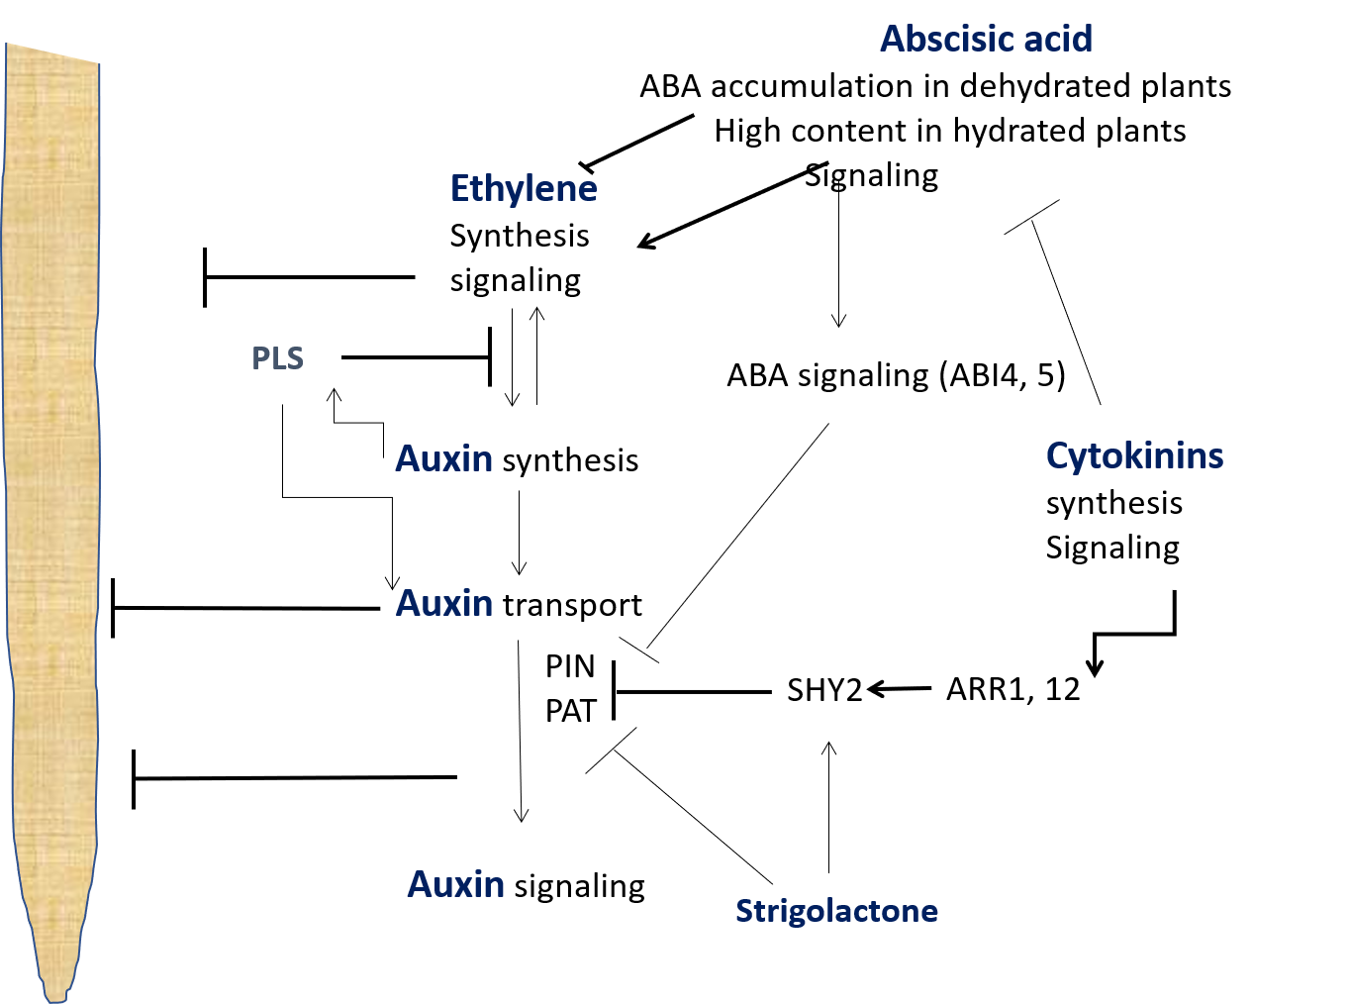
Figure I. Schematic pathways of hormonal crosstalk in regulating root elongation. Arrows indicate positive regulation and stop lines indicate negative regulation. ABI: ABSCISIC ACID INSENSITIVE for ABA signaling; ARR : A-type ARABIDOPSIS RESPONSE REGULATORS for cytokinin response; PAT: polar auxin transporter; PIN: PIN-FORMED protein as auxin efflux carrier; PLS – POLARIS peptide; SHY: SHORT HYPOCOTYL 2 as auxin repressor.
Box 2. Hormonal Crosstalks to Regulate Source-sink Relations and Grain sets
Effects of individual hormones (CK, ABA, and ethylene) on source-sink relations by controlling sink activity or sink/source size have been documented, as illustrated in Figure I. CK acts as a positive regulator for sugar transport from source to sink and starch synthesis involving enzymes, such as SuS, AGP, SSS in the sink tissue. ABA effects on sugar transport and starch synthesis in the sink tissue are dose dependent. Ethylene negatively affects seed sets by reducing source size by inducing leaf senescence, restricting source-sink sugar transport, and starch synthesis in the sink, as well as induction of grain abortion. Grain filling may be affected by the balance of ABA and ethylene. The interaction of multiple hormones, hormone-sugar crosstalk and key molecular hubs controlling hormonal interplay regulating source-sink relations are still unknown. Knowledge of such information will facilitate genetic improvement in grain yield.

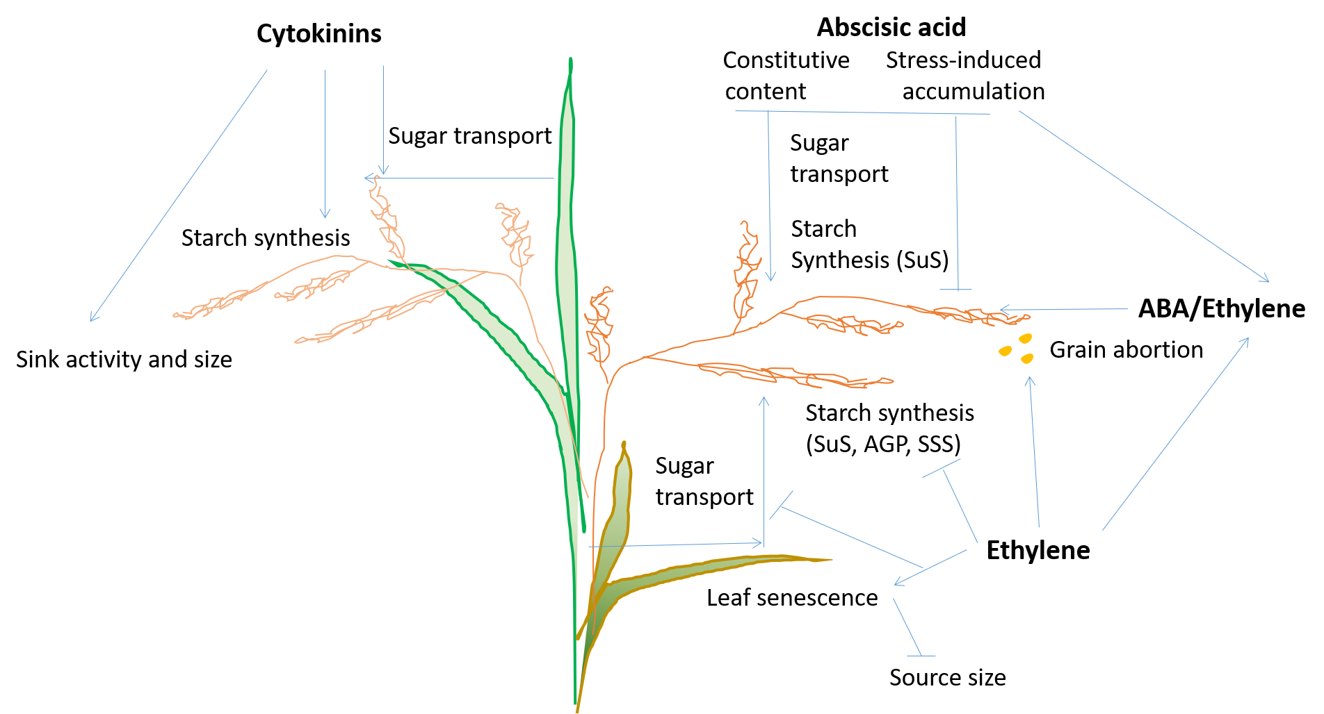
Figure I. Schematic pathways of hormonal crosstalk in regulating source-sink relations and grain sets. Arrows indicate positive regulation and stop lines indicate negative regulation. AGP: ADP-glucose pyrophosphorylase; SSS: soluble starch synthase; SuS: sucrose synthase.

Box 3. Priority Candidate Traits to Further Raise Sink-strength
In wheat, yield is mostly sink-limited during the effective period of grain filling (i.e. photosynthetic capacity exceeds the demands of the growing grains). Consequently, photosynthesis of leaves and spikes is down-regulated by lack of sink strength. Sink strength is set by the number of grains and their potential size, which are determined immediately before anthesis and depend on source availability (as resource allocation to inflorescences affects survival of developing florets and growth of ovaries). The concept that yield is limited by both source- and sink-strength therefore becomes clear when integrated over time (Figure I). While studies and funding have mainly focused on improving photosynthesis, sink-strength remains a critical research bottleneck. Increasing photosynthesis (e.g. during the stem-elongation phase, Figure I) will improve yield through increasing sink-strength (with the proviso that the partitioning towards the juvenile inflorescences is maintained). Traits that would improve yield with current levels of photosynthesis include:
- Increasing seeds set per unit inflorescence dry matter through hormonal regulation (see also a previous section on Roles of hormone crosstalk regulating root growth and source-sink relations)
- Improving floret survival through accelerating rates of floret development
- Setting larger grain weight potential
- Enhancing phloem loading

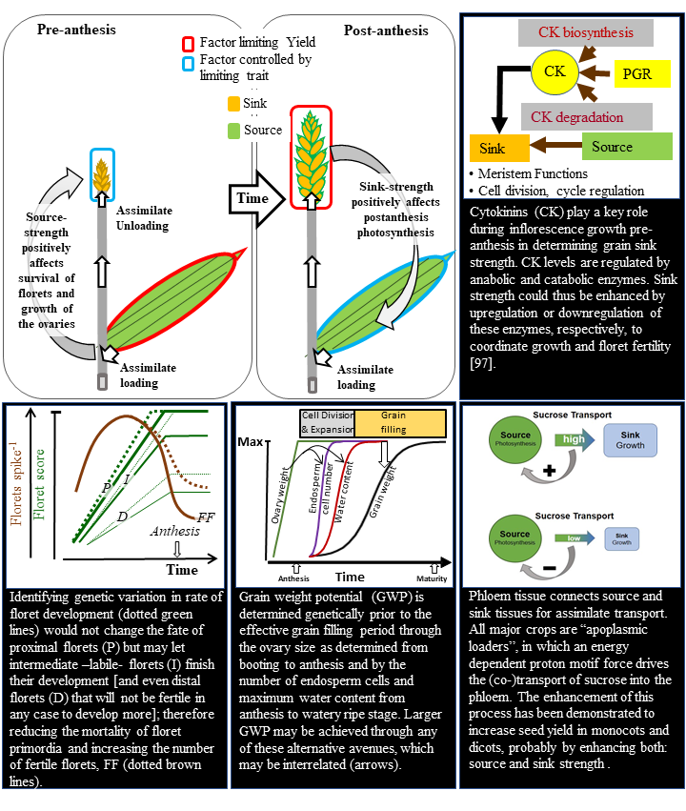
Figure I. Schematic diagram illustrating that in pre-anthesis of cereals source-strength determines the sink-strength during post-anthesis, which in turn may affect source activity during grain filling (top-left panel), and four candidate traits to further raise sink-strength.

Box 4. Respiration and Carbon Use Efficiency
One way to increase biomass accumulation and yields of key cereal crops is through reducing the respiratory CO₂ release relative to the amount of CO₂ fixed through photosynthesis (Figure IA). Respiration uses sugars produced by photosynthesis to produce the carbon skeletons, reducing equivalents (NADH and FADH₂) and ATP needed for maintenance of mature tissues and drive the biosynthetic processes that underpin growth and yield. Coupled to these processes is the uptake of O₂ and release of CO₂ by mitochondria, with (Figure IB) the balance between respiration and photosynthetic CO₂ uptake determining the CUE of plants. The greater the CUE, the greater the availability of carbon to be invested in new biomass and ultimately yield. While increases in CUE could (and are) being achieved through improvements in the efficiency of photosynthesis [10], they can also be achieved through (Figure IC) decreasing associated rates of respiratory CO₂ release. Key to any strategy targeting respiration as part of a novel approach to improving crop yields will be ensuring that reduced rates of respiration are linked to improvements in: (i) the efficiency of chemical energy production by respiration (i.e. increasing the amount of ATP produced per unit of CO₂ released and O₂ taken up) and/or (ii) increases in the efficiency of respiratory energy use. Factors that influence the efficiency of energy production include the fraction of mitochondrial electron transport occurring via non-phosphorylating pathways (e.g. NAD(P)H dehydrogenase bypasses of Complex I and the alternative oxidase) and the extent of proton leakiness through the inner mitochondrial membrane (e.g. protein movement through mitochondrial uncoupling proteins) [130]. A number of strategies are available to improve the efficiency of energy use, including reducing unnecessary turnover of proteins [200] and membranes, replacing energetically inefficient metabolic routes/reactions with efficient ones, suppressing futile cycles and reducing the ATP costs associated with ion transport [122]. The fact that CUE values are markedly higher in inherently fast-growing grasses compared to their inherently slow-growing counterparts [215] points to opportunities to screen for variability in CUE as part of novel screens to improve crop yields.

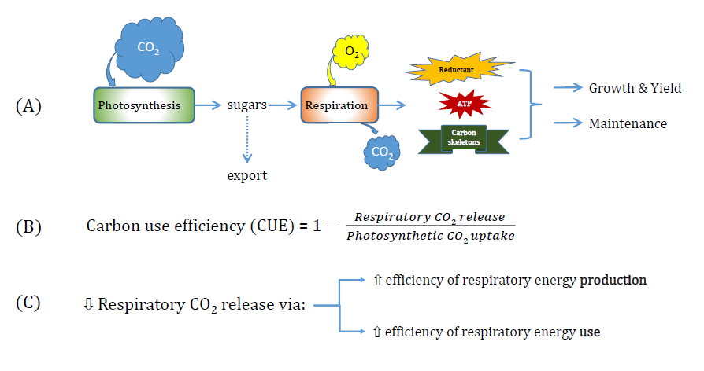
Figure I. Schematic showing: (A) links photosynthesis and respiration, the how the production of reductant (NADH and FADH2), ATP and carbon skeletons are used to support growth and maintenance processes; (B) how variations in the rate of respiratory CO₂ release per unit photosynthesis influences the efficiency with which fixed carbon can be allocated to growth; and, (C) how changes in efficiency of energy production (e.g. via changes in engagement of non-phosphorylating pathways of electron transport) and/or the efficiency with which respiratory energy is used (e.g. through reduced ATP requirements to support protein turnover) can influence rates of respiratory CO₂ release, and through it, the efficiency of the respiratory system.
Box 5. Strategies to Control Meiotic Recombination and Accelerate Crop Breeding
We consider a hypothetical crop with 5 chromosomes and two parental backgrounds (P₁ – red, and P₂ – blue) (Figure I). In this situation the breeder wishes to introgress a centromere-proximal target locus in P₁, located on the first chromosome, into an otherwise P₂ genetic background. We show the genotype of representative gametes produced from different generations during a hypothetical introgression experiment (Figure I). The parents are crossed to generate a P₁/P₂ F₁ hybrid, followed by repeated backcrossing to the P₂ parent, (e.g. BC₁ = backcross 1). In the wild type context, the desired introgression is not achieved until the BC₆ generation. We next show three contexts where the introgression has been accelerated by (i) unlocking centromere-proximal crossovers, for example by using DNA methylation mutants [153], (ii) promoting genome-wide hyper-recombination, for example via HEI10 or recq4a recq4b [144,146], or (iii) locus-specific targeting of meiotic recombination [157] (Figure I). When a target locus is closely located to an unfavorable allele, linkage drag may not be overcome even with repeated back crosses. In such cases, a targeted recombination approach may be the solution. Note also that the hypothetical crop represented here is a diploid species with 5 chromosomes (Figure I). The situation becomes more complicated when considering allo- and auto-polyploid species. For example, bread wheat is an allohexaploid where meiotic stability requires the Ph1 locus that includes the ZIP4 crossover recombination gene [216].

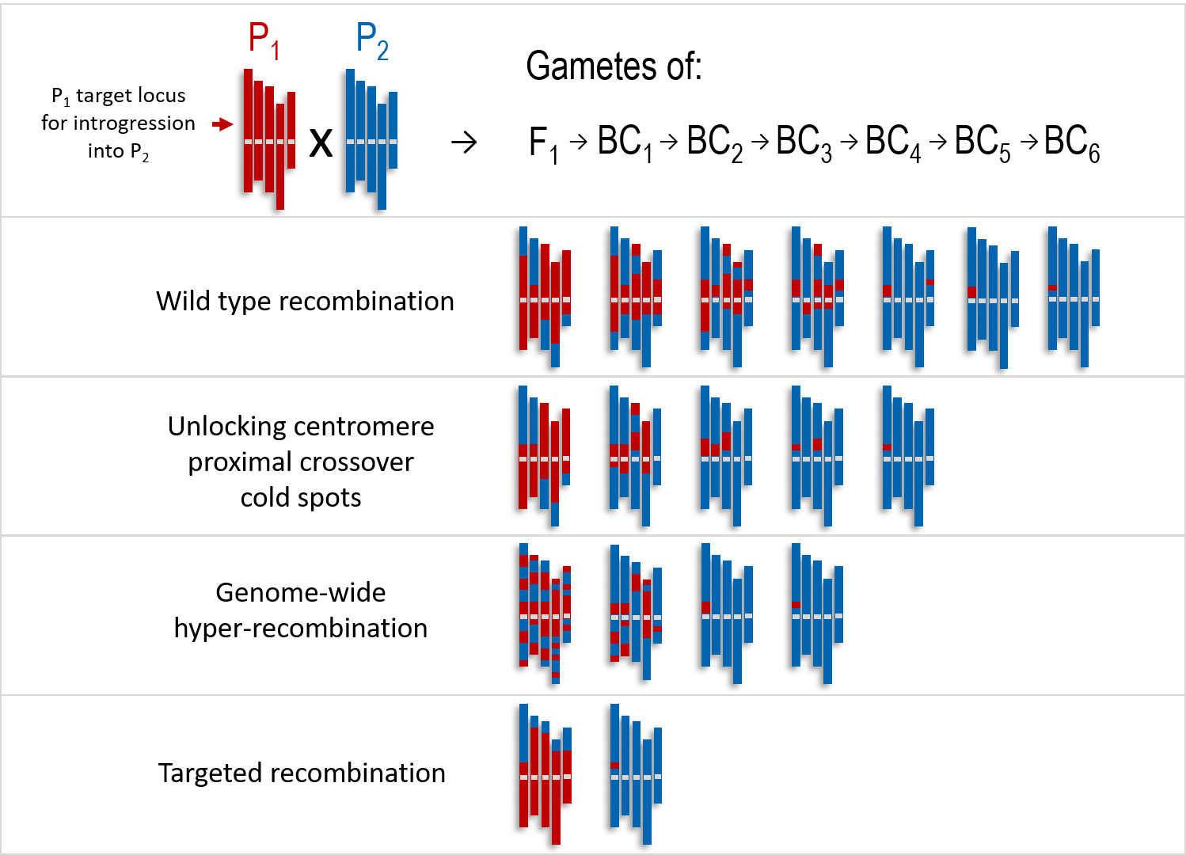
Figure I. Introgression of a target locus in wild type versus recombination-engineered backgrounds in a hypothetical crop species to accelerating research and utilization of improved traits

