Investigating the uptake and fate of poly- and perfluoroalkylated substances (PFAS) in sea ice using an experimental sea ice chamber.

Jack Garnett¹, Crispin Halsall^{1*}, Max Thomas², Odile Crabeck², James France^{2,3,4,}, Hanna Joerss⁵, Ralf Ebinghaus⁵, Jan Kaiser², Amber Leeson¹, Peter M. Wynn¹

1 Lancaster Environment Centre, Lancaster University, Lancaster, LA1 4YQ, UK
2 Centre for Ocean and Atmospheric Sciences, School of Environmental Sciences, University of East Anglia, Norwich, NR4 7TJ, UK
3 British Antarctic Survey, High Cross, Madingley Road, Cambridge, CB3 0ET
4 Department of Earth Sciences, Royal Holloway, University of London, Egham Hill, Egham TW20 0EX, UK
5 Helmholtz-Zentrum Geesthacht Centre for Materials and Coastal Research, Max-Planck-Straße 1, 21502 Geesthacht, Germany

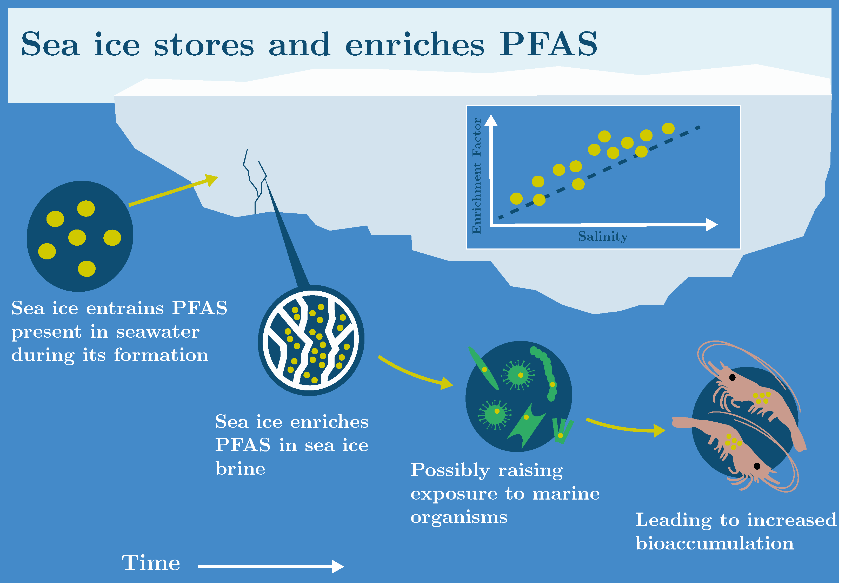

Abstract

Poly- and perfluoroalkyl substances (PFAS) are contaminants of emerging Arctic concern and are present in the marine environments of the polar regions. Their input to and fate within the marine cryosphere are poorly understood. We conducted a series of laboratory experiments to investigate the uptake, distribution and release of ten PFAS of varying carbon chain length (C₄ – C₁₂) in young sea ice grown from artificial sea water (NaCl solution). We show that PFAS are incorporated into bulk sea ice during ice formation and regression analyses for individual PFAS concentrations in bulk sea ice were linearly related to salinity (r² = 0.30 to 0.88, n = 18, p<0.05). This shows that their distribution is strongly governed by the presence and dynamics of brine (high salinity water) within the sea ice. Furthermore, long-chain PFAS (C₈ – C₁₂), were enriched in bulk ice up to 3-fold more than short-chain PFAS (C₄ – C₇) and NaCl. This suggests that chemical partitioning of PFAS between the different phases of sea ice also plays a role in their uptake during its formation. During sea ice melt, initial meltwater fractions were highly saline and predominantly contained short-chain PFAS, whereas the later, fresher meltwater fractions predominantly contained long-chain PFAS. Our results demonstrate that in highly saline parts of sea ice (near the upper and lower interfaces and in brine channels) significant enrichment of PFAS can occur with concentrations in brine channels greatly exceeding those in sea water from which it forms (e.g. PFOA = 10 ± 4). This observation has implications for exposure of biota to contaminants present in sea ice brine.

Introduction

Poly- and perfluoroalkyl substances (PFAS) are present in the Polar regions due to their long-range environmental transport (via atmosphere and ocean) and are considered “contaminants of emerging Arctic concern” (CEACs) ¹⁻⁶ The chemical structure of many PFAS consist of a hydrophilic moiety (e.g. COO–, SO₃–) along with a hydrophobic perfluorocarbon chain backbone of varying length which complicates the understanding of their environmental behaviour and fate. Perfluoroalkyl acids (PFAA) are one major sub-group of PFAS that have received considerable regulatory attention, with ‘long-chain’ perfluoroalkyl carboxylic acids (≥C₈, PFCA) and perfluoroalkyl sulfonic acids (≥C₇, PFSA) shown to bioaccumulate more than their ‘short-chain’ analogues and hence pose a greater risk to higher trophic level organisms and polar marine ecosystems ^{7, 8}.
PFAS have been observed in the sea-ice snowpack and in sea ice in the Arctic ² indicating deposition from the atmosphere with accumulation in the snowpack, as well as possible entrainment into sea ice from sea water during sea-ice growth in winter. Several studies have also observed some organochlorine persistent organic pollutants (POPs) in young or first-year sea ice ⁹⁻¹². Pućko et al, (2010a) measured the levels of α- and γ-HCH in first year sea ice in the Canadian Arctic and demonstrated significantly higher concentrations of these chemicals in the sea ice brine compared to under-ice seawater. Furthermore, they determined that their distribution and concentration in sea ice appears to be a function of circulating brine (a concentrated salt solution present within young sea ice). Recently, experimental studies in artificial sea ice also showed elevated levels of organic pollutants in brine and demonstrated their distribution in newly-formed bulk sea ice was primarily due to the movement of brine ¹³. Furthermore, α-HCH was released at a faster rate from melting sea ice compared to less soluble chemicals (i.e. BDE-47, BDE-99), suggesting that partitioning of chemicals between internal solid ice surfaces and liquid brine was also an important process. Due to their known surface acting properties, we anticipate PFAS to display partitioning within sea ice which could result in their enrichment, presenting a motivation to undertake similar experiments to investigate their behaviour during sea ice formation and subsequent melt.
During sea-ice growth, brine convection causes most salts and other solutes to be rejected into the underlying seawater (e.g. Notz & Worster, 2008; Thomas et al., 2020). This process, referred to as gravity drainage, is the dominant process causing desalination during sea ice formation ¹⁴. The relationship between salinity and other solutes present in sea ice is indicative of the way in which chemicals are entrained and rejected from sea ice. Salinity-normalised concentrations have been used to study the behaviour of nutrients ¹⁵, metals ¹⁶ and dissolved organic matter (DOM) ¹⁷ during sea ice formation and melt processes.
Understanding the behaviour of PFAS in growing and melting sea ice will allow better predictions of contaminant fate during winter (freeze) and spring (thaw) periods in polar marine environments, and hence the timing and extent of PFAS exposure to ice–associated biota. Undertaking process-based studies to resolve contaminant fate in natural sea ice is challenging. Therefore, we used an artificial sea-ice chamber to conduct controlled experiments to quantify chemical transfer between seawater and sea ice. We investigate the behaviour of several PFAS in sea ice during ice formation (freeze) and melt (thaw), testing the hypothesis that the uptake and distribution of PFAS (like like chloro- and bromo-POPs; see Garnett et al., 2019) in sea ice are controlled largely by the movement of brine.

2. Materials and methods

2.1. Experimental facility and conditions

The study was conducted in the Roland von Glasow Air-Sea-Ice Chamber (RvG-ASIC) at the University of East Anglia, UK ¹⁸. The facility consists of an insulated glass-walled tank (dimensions: height: 1.2m; width 1.2m; length 2.5m) located inside a refrigerated chamber (air can be chilled). Artificial seawater was made by dissolving NaCl in deionised water to a concentration of ~35 g L⁻¹ (all volume concentrations are reported for 20 ºC). A submerged pump was used to continuously mix the seawater throughout each experiment and a series of digital thermometers measured the in-situ sea-ice temperature profile and calculate the sea ice depth. Two freeze-thaw experiments, referred to as ‘Freeze–1’ and ‘Freeze–2’ hereafter, were performed at air temperatures of –18 ± 1 ºC and –35 ± 1 ºC, respectively.
A range of perfluoroalkyl carboxylic acids (PFPeA, C₅; PFHxA, C₆; PFHpA, C₇; PFOA, C₈; PFNA, C₉; PFUnDA, C₁₁; and PFDoDA, C₁₂), perfluoroalkyl sulfonic acids (PFBS, C₄; PFOS, C₈), and one n:2 fluorotelomer sulfonic acid (6:2 FTSA, C₈) were utilised in this experimental study (See Table S1 – S2). An ethanolic solution containing a mix of all the PFAS (individual chemical concentrations 0.21 to 0.46 μM) were introduced into the artificial seawater before first sea ice formation to give initial concentrations in seawater of individual PFAS between 0.06 and 0.14 nM.

2.2. Sampling procedures
Prior to the commencement of Freeze–1 and the introduction of the PFAS ‘spike’ solution into the chilled seawater, a short period (2 days) of sea ice growth at –35 °C was undertaken to obtain preliminary procedural blanks of seawater (0.2 L; n = 3) and bulk ice (3.5 L; n = 1) to determinine background PFAS contamination associated with the sea ice chamber. Once this initial sea ice had melted, the PFAS ‘spike’ was added into the experimental tank seawater. After mixing for 24 hours, initial seawater samples for Freeze–1 (0.2 L, n = 3) were collected with further seawater samples taken at the beginning of Freeze–2 (0.2 L, n = 4) and end of Freeze–2 (0.2 L, n = 4) as shown in Figure S1. Seawater was sampled via a pre-installed silicone hose (internal diameter: 8 mm) with an inlet set at 0.5 m above the base of the tank to avoid interference with any forming sea ice layer. All sample containers were made of polyethylene and pre-cleaned with methanol.

Bulk sea-ice samples were collected (n = 4) in Freeze–1 (depth = 0.26 ± 0.01 m) and Freeze– 2 (depth 0.17 ± 0.01 m) from across the tank area using techniques developed by Cottier et al., (1999) to limit brine loss. Samples were subsequently covered in polyethylene sheets and stored in a freezer (–40 °C) until further processing. Sea-ice samples were sectioned into horizontal layers (1 – 4 cm; see Table S3 – S4) using an electric band saw in a cold room (–25 °C) and transferred to individual polyethylene bags. Following melting at room temperature, sea ice samples were combined with adjacent sea ice layer samples ready for PFAS analysis. Frost flowers (0.2 L; n = 1) on the sea ice surface of Freeze–2 were carefully collected using a polyethylene spatula and stored in a freezer before melting for analysis.

2.3. Slow-melt experiment
An additional experiment to observe chemical dynamics during sea ice melt was conducted in order to assess chemical interactions with sea ice during thawing. Sea ice cores (n = 8) sampled from across the sea ice (Freeze–1) using a titanium corer (Kovacs, 75 mm I.D.) were sectioned to give a top (T) and bottom (B) section of approximate equal length (13 ± 1 cm), placed into separate polyethylene bags and melted at 0 ± 1 °C as described by Garnett et al.⁽¹³⁾ and others ^{11, 19, 20} ^{21, 22}. Meltwater fractions (n = 8) were then sequentially collected over a 48 h period in individual containers (0.1 – 2.5 L) and analysed separately to investigate chemical dynamics.

2.4. Chemical analysis and quality assurance
All sea ice samples were melted and the salinity of every sample was measured using a calibrated conductivity probe (Hach HQd40 logger with CDC401 probe). For PFAS, sample analysis followed established methods performed previously ^{23, 24}. Briefly, samples were loaded onto solid phase extraction cartridges (Oasis WAX, 3 cc, 150 mg sorbent, 30 µm particle size, Waters, USA) with subsequent instrumental analysis performed by HPLC-MS/MS, using an HP 1100 LC system (Agilent Technologies, USA) coupled to an API 4000 triple quadrupole mass spectrometer (AB Sciex, USA). A more detailed description of the analysis can be found in the supporting information. As part of the quality assurance, we added 100 μL of a solution (20 pg μL⁻¹) containing 6 mass-labelled PFCA (¹³C₄-PFBA, ¹³C₂-PFHxA, ¹³C₄-PFOA, ¹³C₅-PFNA, ¹³C₂-PFUnDA, ¹³C₂-PFDoDA) and 3 PFSA (¹³C₃-PFBS, ¹⁸O₂-PFHxS, ¹³C₄-PFOS) to each sample assess analytical performance (see Table S5). In cases where mass-labelled analogues were not available, a surrogate standard that was used (see Table S5). All PFAS concentrations reported in this study were recovery-corrected. Method detection limits (MDL) were calculated as the mean of procedural blank (n = 4) concentrations plus 3 times its standard deviation (MDL: c̅ _{procedural blank} + 3⋅σ _{procedural blank}). Samples were not blank-corrected as PFAS levels in the blanks were low (see Table S5). Mass-balance calculations were performed as a quality control measure to assess the recovery (e.g. loss of chemical through chamber-side sorption) of individual PFAS at two key points within this study. First, the ‘expected’ concentrations of PFAS in the experimental tank seawater (i.e. c_{expected seawater}) and the ‘measured’ seawater concentrations 24 hours after the addition of the ‘spike’ solution based on the known amount of PFAS added to the experimental seawater (i.e. c_{0 seawater}) were expressed as a fraction (%) to give the recovery during the experimental setup (i.e. r_{setup}). Second, the average ‘measured’ concentrations of PFAS in the experimental tank seawater before sea ice formation in Freeze–1 and Freeze–2 (i.e. c_{initial seawater}) were compared to the final seawater samples when all of the ice had completely melted at the end of Freeze–2 (i.e. c_{final seawater}) and expressed as a fraction (%) to show the recovery throughout the experiments (i.e. r_{experiment}). For more information, see Figure S1 and Table S6.

2.5. Data analysis
PFAS concentrations are used for further calculations of enrichment factors (see Table S7 – S16). However, bulk sea ice samples located at the bottom of the core were previously shown to suffer from a sampling artefact and were excluded from further calculations although concentration data are still reported (see Table S7). The method precision was given as the relative standard deviation (RSD) of initial experimental seawater samples (n = 7) and was included in uncertainty analysis for each individual PFAS. Enrichment factors (ε) were calculated using Equation 1 with mean subsurface seawater concentrations measured at the beginning of the experiments as the denominator (unless stated otherwise).

$${ε,}_{\text{ (e.g. bulk ice, frost flowers etc)}}=\frac{{\text{c}}_{\text{(e.g. bulk ice, frost flowers etc)}}(PFAS)}{{\text{c}}_{\text{ initial seawater}}(PFAS)} (1)$$
The ‘conservative mixing line’ (i.e. the predicted concentration of PFAS based solely on the movement of NaCl) was calculated by multiplying the ε, _{bulk ice} for NaCl in different sea ice layer samples by the initial measured subsurface seawater concentrations for each PFAS. We also calculated salinity-normalised enrichment factors, ε_{s}, for each PFAS using Equation 2 where S is the salinity (g L⁻¹) in a sample. ε_{s} = 1 represents conservative behavior, with respect to salinity. ε_{s} ≠ 1 denotes non-conservative behavior which corresponds to a specific depletion (ε_{s} < 1) or enrichment (ε_{s} > 1), respectively.
${ε_{\text{s, (e.g. bulk ice, frost flowers etc)}}}_{ }=\frac{{ε, }_{\text{(e.g. bulk ice, frost flowers etc) }}}{{S, }_{\text{ (e.g. bulk ice, frost flowers etc)}}/{ S, }_{\text{ initial seawater}}}$ $(2)$
Statistical analyses were performed on enrichment factor data using a significance level of α = 0.05. Normality was tested using the Shapiro-Wilk Test. Regression analyses were used to test for relationships between PFAS concentrations and bulk ice salinity. Significant differences in PFAS enrichment between groups of data were assessed applying the Welch’s t-test and student paired t-test. To test for significant differences in PFAS enrichment between sea-ice layers, a one-way ANOVA test was applied followed by a Tukey post-hoc test for multiple pairwise comparisons.

3. Results and Discussion

3.1. Uptake, rejection, and distribution of PFAS in growing sea ice

Low levels of PFAS were detected in procedural blanks ensuring that the method detection limits were well below the concentrations arising from the addition of the PFAS ‘spike’ to the seawater (see Table S5). Initial concentrations of PFAS in experimental seawater were comparable to those at the end of the study (see Table S6) demonstrating that PFAS loss from the chamber during the course of the experiments (e.g. vessel-side or glass-wall sorption artefacts ³¹) or addition through contamination artefacts were negligible. This ensured that the experimental system and the conditions of the sea ice chamber were suitable for conducting an investigation on the chemical fate of PFAS in sea ice. Low recoveries of some of the long-chain PFAS are discussed later.

Concentrations of PFAS in the different compartments of the experimental ice system are shown in Figure 1. Bulk sea ice were highest at the ice-air and ice-seawater interfaces, giving each chemical a ‘C’ shape profile. Salinity showed a similar ‘C’ shape, which is well documented in newly-formed sea ice and develops as salt is rejected from the ice matrix into the surrounding seawater, resulting from convective overturning of brine ²⁵. This process, known as ‘gravity drainage’, is the primary mechanism of desalinisation in sea ice and governs the incorporation and distribution of many dissolved metals ²⁶, nutrients ²⁷ and other dissolved constituents in seawater such as dissolved organic matter ²⁸.
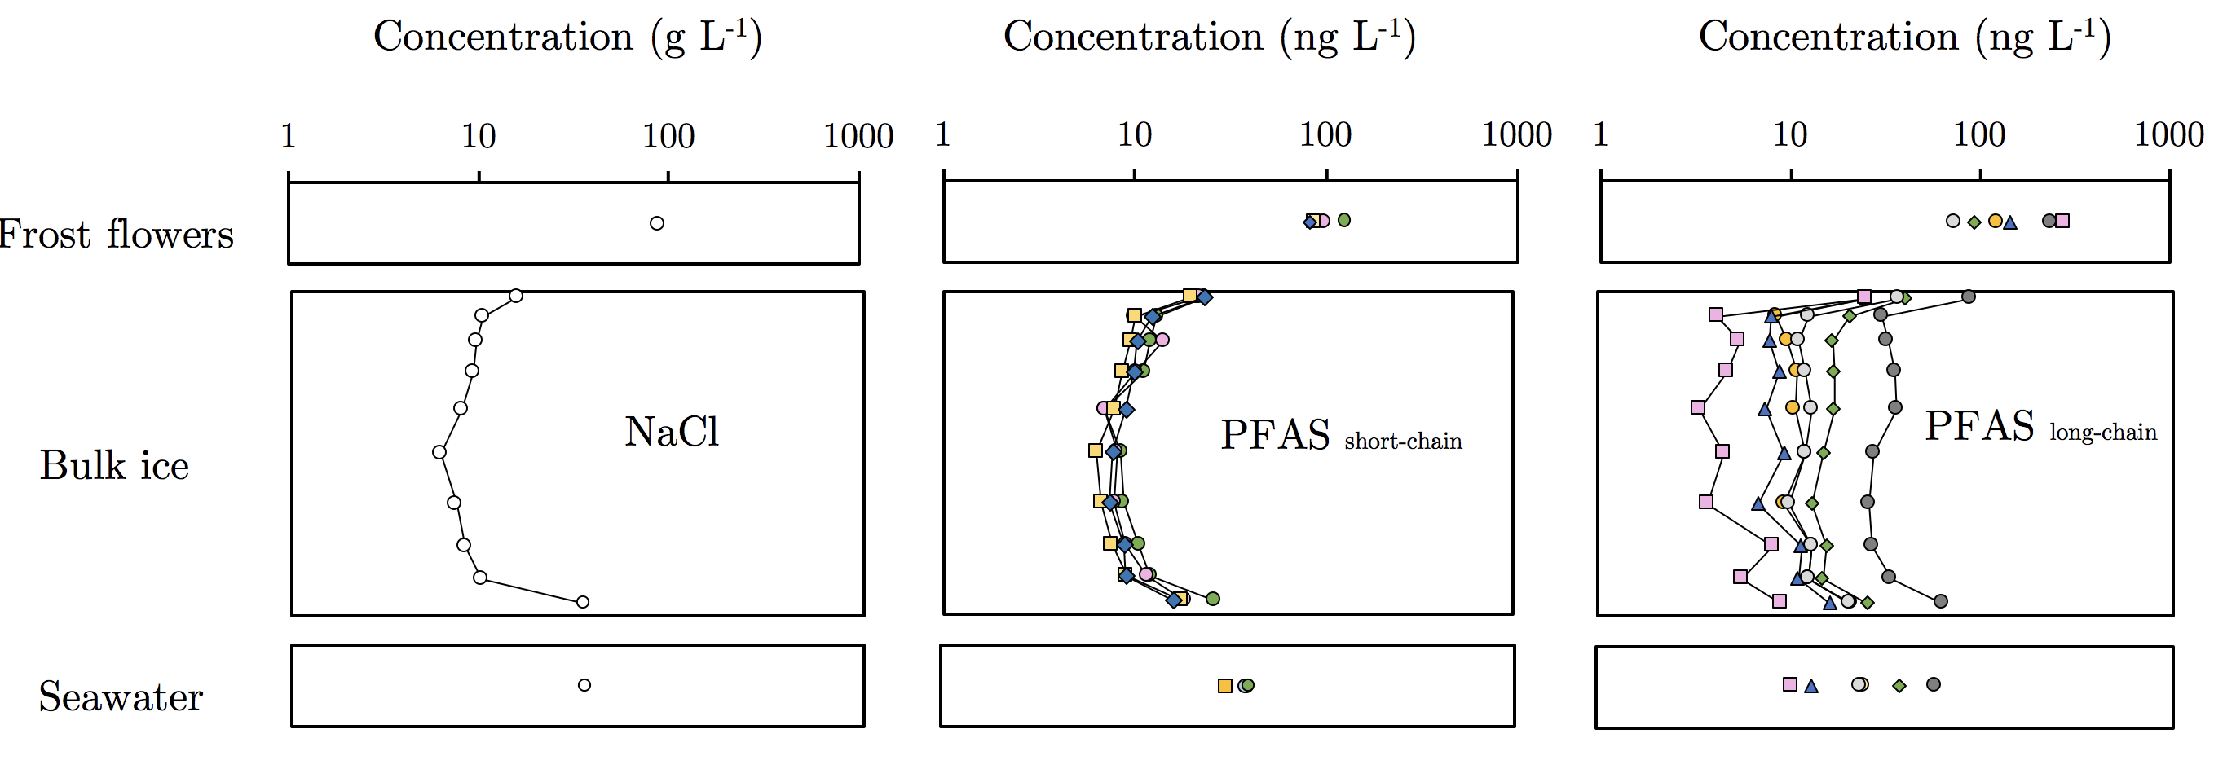
Figure 1: Measured chemical concentrations in different compartments of the experimental ice system during Freeze – 1 (NB: Frost flower data relates to Freeze – 2). A logarithmic scale was used on x-axis to allow the large range of measured concentrations to be illustrated. The y-axis on the bulk ice panel corresponds to ice depth with the upper most points corresponding to the layer of sea ice in contact with chamber air. The left, middle and right panels show NaCl, short-chain PFAS and long-chain PFAS, respectively. Short-chain PFAS include PFBS (C₄, green circle) PFPeA (C₅, pink circle) PFHxA (C₆, yellow square) and PFHpA (C₇, blue diamond). Long-chain PFAS include PFOA (C₈, green diamond), PFOS (C₈, yellow circle), PFNA(C₉, grey circle), PFUnDA (C₁₁, blue diamond) and PFDoDA (C₁₂, pink square) Although 6:2 FTSA (C₈, dark grey circle) is considered a precursor to short-chain PFAS ²⁹, its behavior in sea ice was more analogous to long-chain PFAS (see below) and so was grouped accordingly.
Figure 2 shows the relationship between measured concentration of PFAS and salinity in bulk ice samples collected from Freeze–1 and Freeze–2. The predicted concentration for each PFAS is also displayed (conservative mixing line). PFAS concentrations in bulk sea ice were positively correlated with salinity and regression analyses also showed that relationships were strong for short-chain PFAS (C₄ – C₇) with the data lying close to the conservative mixing line (r² = 0.68 – 0.94; p<0.05). Relationships for long-chain PFAS (C₈ – C₁₂) were weaker (r² = 0.29 – 0.57; p<0.05), but still significant and concentrations generally fell above the conservative mixing line (See SI for complete data). If the data for the two surface ice layers (uppermost ice) are removed then the correlations for the C₈ – C₁₂ compounds are not significant (p >0.05).
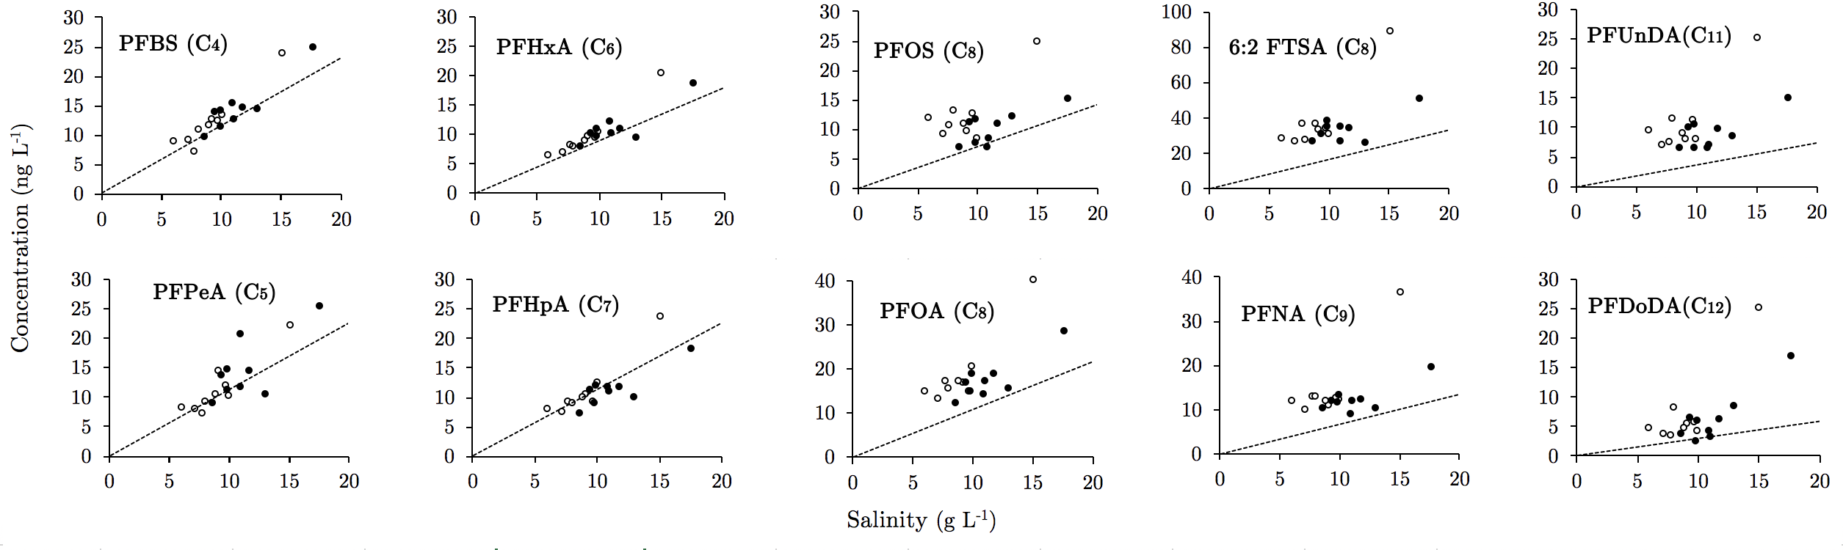
Figure 2: Concentrations of salinity (g L⁻¹) and PFAS (ng L⁻¹) in bulk ice samples. Open and closed symbols represent bulk ice samples collected from Freeze–1 (–18 °C) and Freeze–2 (–35 °C), respectively. Dashed line represents the conservative mixing line. Note that the two data points to the far right in each pane represent the surface ice layers (L1) (0-1 cm depth) in Freeze-1 and -2 experiments.
The qualitative similarities between PFAS and salinity profiles (Figure 1) combined with the quantitative agreement between the measured and conservative mixing lines (Figure 2) are strong evidence that brine dynamics determine PFAS concentrations in sea ice to a leading order. Measured concentrations of long-chain PFAS tend to be above the conservative mixing line which indicates that they are enriched in bulk sea ice by up to 3-fold (see Figure 3, upper left panel) and their chemical behaviour deviates to some extent from the behaviour of salt. This non-conservative behaviour suggests that other processes, such as diffusion within sea ice, heterogeneous ice nucleation or partitioning to solid ice surfaces, play an important role in retaining long-chain PFAS within the ice matrix.

PFAS, like most other dissolved solutes, are not expected to be incorporated within the ice crystal lattice due to their relatively large molecular size. Instead, they are incorporated in bulk sea-ice within interstitial brine channels. While studies have observed non-conservative behaviour of some dissolved organic components in sea ice ^{16, 28, 30, 31}, little is known about the mechanisms of enrichment (i.e. ε_{s} > 1). The enrichment of dissolved organic matter (DOM) may be related to differences in the diffusion rates of chemicals, which leads to the preferential rejection of small molecules as they diffuse at relatively faster rates in ice than larger DOM molecules ^{27, 32}. However, rhodamine 6G (a useful dye/tracer with a molecular mass akin to PFAS) did not noticeably deviate from conservative behaviour ³³. The presence of extracellular polymeric substances (EPS) in sea ice (high molecular mass gel-like organic material that is present in brine channels) can act as a sorbent for other chemicals ³⁴. However, in this study artificial seawater (NaCl dissolved in ultrapure water) was used with no EPS.

Enrichment of long-chain PFAS in sea ice may also be related to elevated concentrations in the sea surface microlayer (top 1000 μm of surface ocean), a phenomenon that has been observed in the environment ³⁵ and in experimental systems exploring enrichment of PFAS in sea spray aerosol ^{36, 31}. This behaviour of PFAS in the surface microlayer is likely driven by the presence of colloidal organic matter, although this is expected to have been absent in our experimental system but was not measured. Low recoveries for the long-chain PFAS (PFOA, C₈; PFOS, C₈; PFNA, C₉; PFUnDA, C₁₁; PFDoDA, C₁₂) were apparent in the seawater samples taken initially at the start of the experiment (see Table S6). Preferential partitioning of these long-chain compounds to a sea surface microlayer may then have occurred, resulting in elevated concentrations at the seawater surface where ice growth begins and thus leading to chemical enrichment in sea ice. However, the calculated concentrations of PFAS in sea ice based on the initial seawater concentrations that accounted for the unrecovered mass of PFAS using the assumption that they were transported conservatively with salt, were significantly higher (up to 50-fold) than measured concentrations in the sea ice (see Table S17 & S18). This indicates that most of the mass of PFAS that was not recovered in the initial sea water measurements was probably sorbed to the chamber surfaces (mainly glass) and hence was unlikely to play a role in the observed PFAS enrichment in sea ice. Volatilisation of PFAS to the overlying chamber air was another possible loss process but was considered to be insignificant. Perfluoroalkyl acids have relatively high aqueous solubilities, low volatilities and exist as their anionic form in seawater at pH ~8 with negligible water to air partitioning (dimensionless Henry’s Law constants, c_{gas} / c_{water} < 0.01)³⁷.
PFAS were particularly enriched in the surface layer (L1) of sea ice (ε_{s, L1} > 1) with values significantly higher (Tukey-HSD; p<0.01) compared to lower bulk ice layers in both Freeze–1 and Freeze–2 (see Figure 3; upper right panel). This was surprising given that solute rejection and accociated processes known to govern chemical distribution in forming sea ice are expected to occur relatively consistently throughout all stages of sea ice growth and suggests that a secondary selective process may be at play within the surface layer, or during the initial onset of sea ice formation. Garnett et al., (2019) observed relatively high concentrations for several hydrophobic POPs in surface sea ice, which were higher than those predicted using a 1D halo-dynamic model. Chemicals such as polybrominated diphenyl ethers (PBDEs) are hydrophobic and are not known, or expected, to partition to the air-water interface although have been shown to interact strongly with ice surfaces. The process of sea-ice growth begins at the surface of seawater with a layer of granular ice, proceeding with columnar ice as it thickens, as expected during both Freeze –1 and –2. Columnar ice also forms more slowly than granular ice, which proceeds through frazil ice accretion and is reported to be less effective at the rejection of impurities ²⁵. The higher bulk sea-ice salinities in surface sea ice layers formed when granular ice is dominant is in good agreement with these observations and may help to explain higher concentrations of PFAS in the surface bulk ice layer (L1). Alternatively, PFAS may serve play a role in heterogeneous ice nucleation during sea ice growth
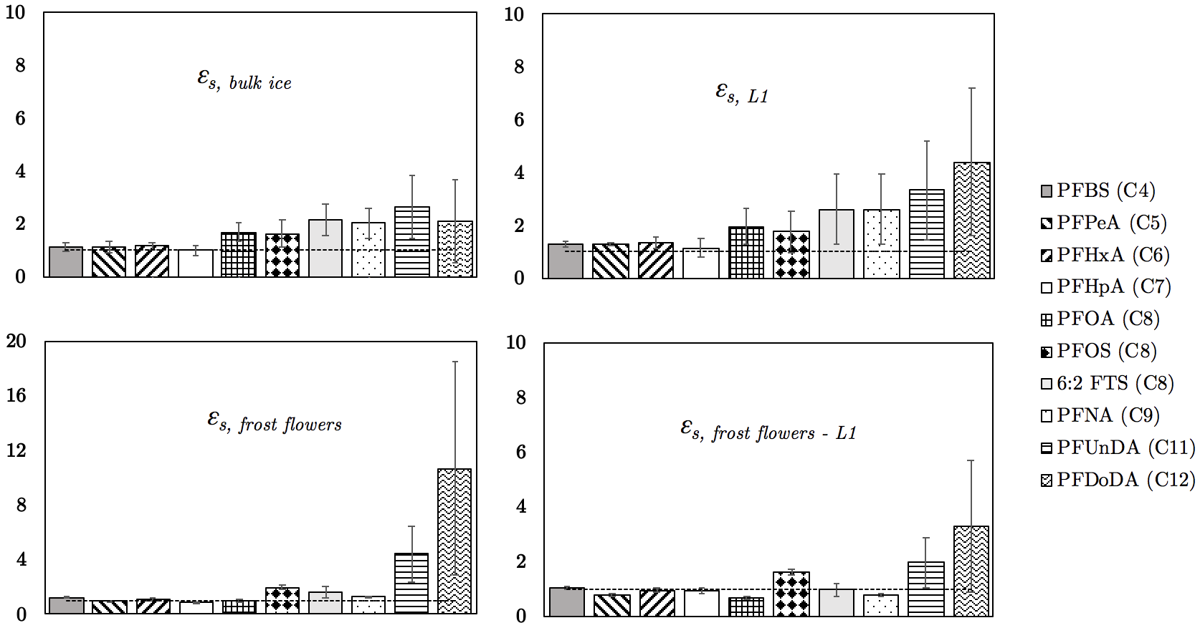

Figure 3: Salinity-normalised enrichment factors, ε_{s}, or key compartments of the experimental ice system. Mean values (± 1 s.d.) from Freeze–1 and Freeze–2. Calculated enrichment factors for frost flowers with surface sea ice layer (L1) were performed using samples taken during Freeze–2. Horizontal dashed line represents ε_{s} = 1.

We collected frost flowers during Freeze–2 which showed high concentrations with significant enrichment of PFAS, relative to the initial seawater concentrations (ε, _{frost flowers} = 2 – 27; see Table S7 – S8). Frost flowers are highly saline ice structures that develop under extreme cold, calm atmospheric conditions ³⁸. Brine and other solutes are ‘wicked’ from the surface layer (1 – 2 mm) by capillarity and concentrated on the ice structure. The presence of PFAS in frost flowers suggests they are also transported with brine. However, ε_{s, frost flowers} > 1 (up to 11) also indicates that other processes may contribute to the enrichment of PFAS in frost flowers (see Figure 3; bottom left panel). Garnett et al. (2019) saw a similar enrichment for a number of hydrophobic semi-volatile organic chemicals and postulated that their enrichment was due to evaporation and subsequent condensation on the frost flower ice crystal structure ³⁹. This study investigated perfluoroalkyl acids, which in their base form are effectively non-volatile and therefore evaporation is highly unlikely to play a role in the observed enrichment in frost flowers. Enrichment factors for PFAS in frost flowers were calculated in relation to the surface sea ice layer (L1) which is known to be the source of NaCl (and other solutes) in frost flowers as sea ice grows ³³. Values of ε_{s, frost flowers - L1} were much closer to 1 (Figure 3, lower right panel) which suggests the absence of a secondary fractionation mechanism that leads to significant enrichment specifically in frost flowers. Nonetheless, this result along with the high concentration of long-chain PFAS in frost flowers signify that PFAS concentrations at the air-ice interface are likely to be much higher than those measured in the surface bulk ice layer sample we collected during Freeze – 2 (L1 sample depth ~10mm). While the sample of frost flowers we collected is preliminary (n = 1), we highlight that these covered a large area of the sea ice in Freeze–2 (approximately 0.3 m² ). We therefore believe that high concentrations of long-chain PFAS in frost flowers is evidence that chemical sorption to ice surfaces plays a role in their enrichment (discussed further in Section 3.2). PFAS decoupling from convecting brine in this way could increase bulk sea-ice PFAS concentrations by preventing their rejection through gravity brine drainage. This does, however, demonstrate that our current understanding of the processes controlling chemical uptake during sea ice formation remains incomplete.

3.2. Rejection of PFAS during sea ice melt

The slow-melt experiment was designed to investigate chemical dynamics of PFAS during controlled sea-ice melt ²². The volumes of collected meltwater fractions varied from 0.2 – 2.5 L and displayed a wide range in salinity (2 – 58 g L⁻¹). Initial meltwater fractions were more saline and contained higher concentrations of short-chain PFAS than later meltwater fractions. In contrast, higher concentrations of long-chain PFAS were associated with the later meltwater fractions that were less saline. The total amount of NaCl and individual PFAS in the combined slow-melt samples were used to derive enrichment factors in each of the meltwater fractions (See Tables S13 – S16). Short- and long-chain PFAS displayed ε_{s,} _{meltwater} values that were ~1 and >1, respectively (Figure 4). This shows that short-chain PFAS (C₄ – C₇) were mainly ‘eluted’ in the first meltwater fractions and so behaved conservatively with respect to NaCl. Conversely, long-chain PFAS (C₈ – C₁₂) showed non-conservative behaviour and were preferentially retained in the melting ice being released in later meltwater fractions.
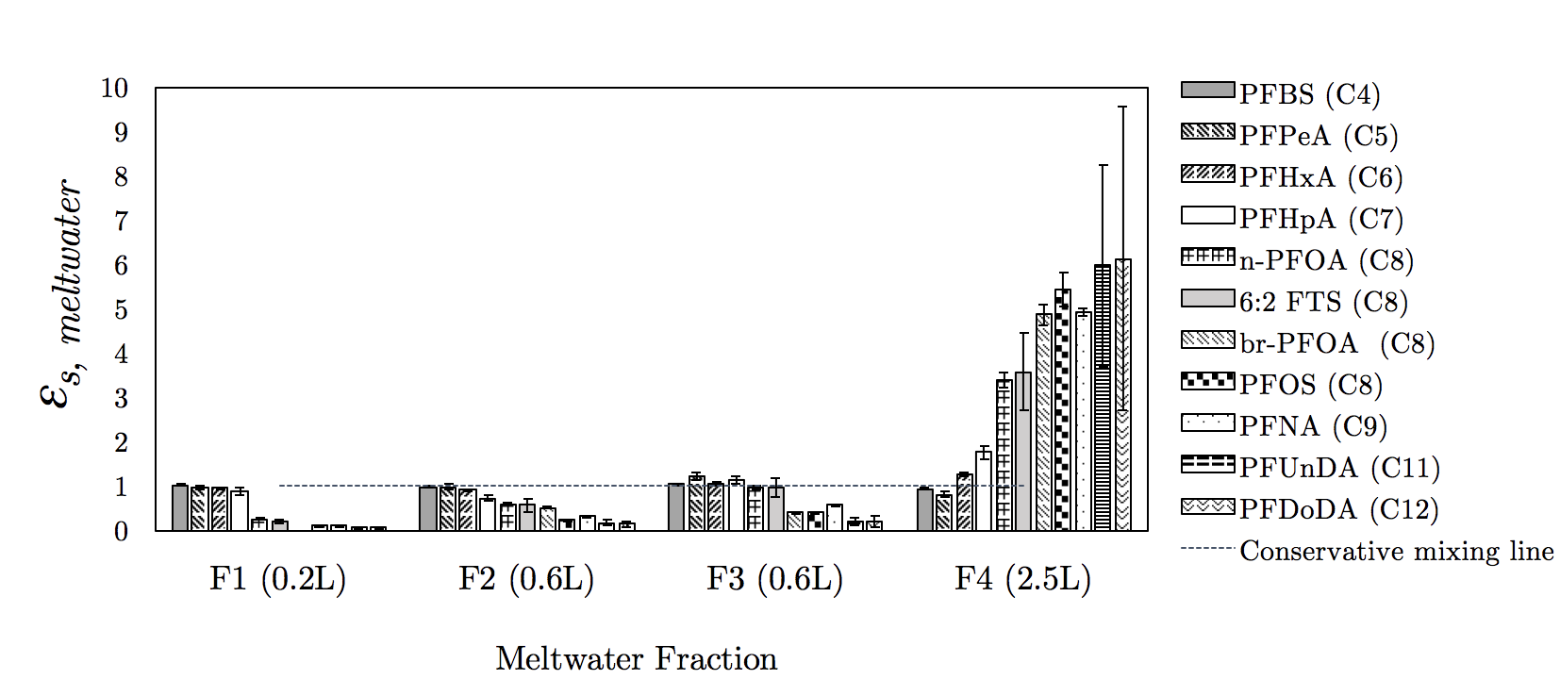
Figure 4: Salinity-normalised enrichment factors for PFAS in meltwater fractions, ε_{s, meltwater}, from melting sea ice. Linear (n-PFOA) and branched (br-PFOA) isomers of PFOA were included in this analysis. Dashed line is the conservative mixing line.

Sea ice is composed of a solid (fresh ice matrix) and liquid (brine) phases. The distribution of the PFAS between these two phases at equilibrium is expected to vary according to carbon chain length ⁴⁰. Long-chain PFAS have, in general, been found to partition more towards solid phases in sediments ²³ and in snow ^{40, 41}. Our results suggest PFAS behave analogously in sea ice and indicate that long-chain PFAS preferentially partition to solid ice surfaces, relative to short-chain PFAS. These findings are also supported by previous studies in sea ice which display similar findings for hydrophobic POPs of varying molecular mass and aqueous solubility ¹³. Partitioning of PFAS to ice surfaces can be linked to hydrophobic interactions, which increase with carbon chain length. Interestingly, differences were also observed between PFAS with the same carbon chain length (e.g. 6:2 FTSA, PFOS and PFOA) which shows that other physico-chemical properties also control the their behaviour in sea ice, such as the number of fluorine atoms and different functional groups. Hence, based on this evidence, we believe it is reasonable to assume that the non-conservative behaviour of long-chain PFAS, specifically, their enrichment is related to their tendency to interact with and partition to ice surfaces.

3.3. Environmental implications

Given the propensity of PFAS and other organic chemicals to sorb to ice surfaces, as indicated in the slow-melt experiment, it is possible that chemical partitioning to frazil ice during the onset of ice formation may be an important process controlling the uptake of dissolved chemicals into bulk sea ice. This may help explain why the enrichment of PFAS in the uppermost ice layers was significantly higher compared to the lower ice layers. Moreover, this is also supported by significantly higher enrichment factors (paired student t-test, p<0.001) in the surface layer of ice during Freeze–1, which formed at a slower rate due to a warmer ambient temperature (–18 ºC), compared to Freeze-2 (–35 ºC). This slower ice formation will have increased the contact time between ice cyrstals and PFAS during the initial ice growth stages of the experiment and this ‘concentrating effect’ has been observed for organic matter ⁴² and other components in seawater such as algae ⁴³.

The results demonstrate that PFAS are incorporated within sea ice during its formation and long-chain PFAS can be enriched relative to salt (NaCl) as well as short-chain PFAS. However, PFAS are included within the ice-brine network (i.e. distributed between sorbed internal ice walls and dissolved in brine) of sea ice, which represents a much smaller volume fraction of the total bulk sea ice. The salinity of ice-brine is governed by thermodynamic phase-changes, fluctuating in the environment according to diurnal and seasonal temperature changes (e.g. as temperatures decrease in sea ice brine salinity increases). Sea ice is considered to be porous when the brine volume fraction (V_{b}) reaches 5 % ⁴⁴. Above 5 % brine volume, ice-associated (sympagic) organisms can thrive in the brine network commonly observed on the underside of ice floes. Based on this, we performed a simple calculation (ε, _{bulk ice} divided by 0.05) to estimate the enrichment of PFAS for the in-situ sea ice brine and so assess the likely chemical exposure presented to brine-dwelling organisms. This approach indicates that the sympagic community may be exposed to individual PFAS concentrations that are more than an order of magnitude greater than those present in seawater (see Table S19). This enrichment of PFAS in ice-brine may result in significant exposure to the array of organisms situated at the base of the marine food web thereby exacerbating bioaccumulation of toxic contaminants particularly in brine-rich single season ice.

In the Arctic and other regions where sea ice is prevalent, the total burden of PFAS in sea ice will be a function of PFAS present in surface seawater, but also the amount deposited from the atmosphere with annual snowfall. Transfer of organic contaminants between the ice-rafted snowpack and sea ice has been observed in winter and during seasonal thaw ^{11, 12, 45-48}. Furthermore, sea ice is subject to various freeze-thaw cycles which could alter the distribution of chemicals in sea ice, compared to the controlled experiments in this study.

Acknowledgements
JG’s PhD (NE/L002604/1) was funded through NERC’s ENVISION Doctoral Training Centre. This work resulted from the EISPAC project (NE/R012857/1), part of the Changing Arctic Ocean programme, jointly funded by the UKRI Natural Environment Research Council (NERC) and the German Federal Ministry of Education and Research (BMBF). The authors are grateful to the British Antarctic Survey for providing funding (British Antarctic Survey Collaboration Voucher) to cover the running costs of the RvG-ASIC facility for the duration of the experimental period. This work has received funding from the European Union’s Horizon 2020 research and innovation programme through the EUROCHAMP-2020 Infrastructure Activity under grant agreement No 730997. The authors would also like to thank the two anonymous reviewers whose comments helped improve and clarify this manuscript.

4. References

1. AMAP AMAP Assessment 2016: Chemicals of Emerging Arctic Concern; -; -: Oslo, Norway, -, 2017; p 353.https://www.amap.no/documents/doc/AMAP-Assessment-2016-Chemicals-of-Emerging-Arctic-Concern/1624
2. Cai, M.; Zhao, Z.; Yin, Z.; Ahrens, L.; Huang, P.; Cai, M.; Yang, H.; He, J.; Sturm, R.; Ebinghaus, R.; Xie, Z., Occurrence of Perfluoroalkyl Compounds in Surface Waters from the North Pacific to the Arctic Ocean. Environmental Science & Technology 2012, 46 (2), 661-668;10.1021/es2026278
3. Casal, P.; Zhang, Y.; Martin, J. W.; Pizarro, M.; Jiménez, B.; Dachs, J., Role of Snow Deposition of Perfluoroalkylated Substances at Coastal Livingston Island (Maritime Antarctica). Environmental science & technology 2017, 51 (15), 8460;10.1021/acs.est.7b02521
4. Pickard, H. M.; Criscitiello, A. S.; Persaud, D.; Spencer, C.; Muir, D. C. G.; Lehnherr, I.; Sharp, M. J.; De Silva, A. O.; Young, C. J., Ice Core Record of Persistent Short-Chain Fluorinated Alkyl Acids: Evidence of the Impact From Global Environmental Regulations. Geophysical Research Letters 2020, 47 (10), e2020GL087535;10.1029/2020GL087535
5. Pickard, H. M.; Criscitiello, A. S.; Spencer, C.; Sharp, M. J.; Muir, D. C. G.; De Silva, A. O.; Young, C. J., Continuous non-marine inputs of per- and polyfluoroalkyl substances to the High Arctic: a multi-decadal temporal record. Atmos. Chem. Phys. 2018, 18 (7), 5045-5058;10.5194/acp-18-5045-2018
6. Muir, D.; Bossi, R.; Carlsson, P.; Evans, M.; De Silva, A.; Halsall, C.; Rauert, C.; Herzke, D.; Hung, H.; Letcher, R.; Rigét, F.; Roos, A., Levels and trends of poly- and perfluoroalkyl substances in the Arctic environment – An update. Emerging Contaminants 2019, 5, 240-271;https://doi.org/10.1016/j.emcon.2019.06.002
7. Tartu, S.; Gabrielsen, G. W.; Blévin, P.; Ellis, H.; Bustnes, J. O.; Herzke, D.; Chastel, O., Endocrine and Fitness Correlates of Long-Chain Perfluorinated Carboxylates Exposure in Arctic Breeding Black-Legged Kittiwakes. Environmental Science & Technology 2014, 48 (22), 13504-13510;10.1021/es503297n
8. Haukås, M.; Berger, U.; Hop, H.; Gulliksen, B.; Gabrielsen, G. W., Bioaccumulation of per- and polyfluorinated alkyl substances (PFAS) in selected species from the Barents Sea food web. Environmental Pollution 2007, 148 (1), 360-371;https://doi.org/10.1016/j.envpol.2006.09.021
9. Hargrave, B. T.; Vass, W. P.; Erickson, P. E.; Fowler, B. R., Atmospheric transport of organochlorines to the Arctic Ocean. Tellus B: Chemical and Physical Meteorology 1988, 40 (5), 480-493;10.3402/tellusb.v40i5.16015
10. Gustafsson, Ö.; Andersson, P.; Axelman, J.; Bucheli, T. D.; Kömp, P.; McLachlan, M. S.; Sobek, A.; Thörngren, J. O., Observations of the PCB distribution within and in-between ice, snow, ice-rafted debris, ice-interstitial water, and seawater in the Barents Sea marginal ice zone and the North Pole area. Science of the Total Environment 2005, 342 (1-3), 261-279;10.1016/j.scitotenv.2004.12.044
11. Pućko, M.; Stern, G.; Macdonald, R. W.; Barber, D. G., alpha- and gamma-Hexachlorocyclohexane Measurements in the Brine Fraction of Sea Ice in the Canadian High Arctic Using a Sump-Hole Technique. Environmental Science & Technology 2010, 44 (24), 9258-9264;10.1021/es102275b
12. Pućko, M.; Stern, G. A.; Barber, D. G.; Macdonald, R. W.; Rosenberg, B., The international polar year (IPY) circumpolar flaw lead (CFL) system study: The importance of brine processes for α‐ and γ‐hexachlorocyclohexane (HCH) accumulation or rejection in sea ice. Atmosphere-Ocean 2010, 48 (4), 244-262;10.3137/OC318.2010
13. Garnett, J.; Halsall, C.; Thomas, M.; France, J.; Kaiser, J.; Graf, C.; Leeson, A.; Wynn, P., Mechanistic Insight into the Uptake and Fate of Persistent Organic Pollutants in Sea Ice. Environmental science & technology 2019, 53 (12), 6757;10.1021/acs.est.9b00967
14. Notz, D.; Worster, M. G., Desalination processes of sea ice revisited. Journal of Geophysical Research: Oceans 2009, 114 (C5), n/a-n/a;10.1029/2008JC004885
15. Lannuzel, D.; Chever, F.; van der Merwe, P. C.; Janssens, J.; Roukaerts, A.; Cavagna, A.-J.; Townsend, A. T.; Bowie, A. R.; Meiners, K. M., Iron biogeochemistry in Antarctic pack ice during SIPEX-2. Deep Sea Research Part II: Topical Studies in Oceanography 2016, 131, 111-122;https://doi.org/10.1016/j.dsr2.2014.12.003
16. Janssens, J.; Meiners, K. M.; Tison, J.-L.; Dieckmann, G.; Delille, B.; Lannuzel, D., Incorporation of iron and organic matter into young Antarctic sea ice during its initial growth stages.(Report). Elementa: Science of the Anthropocene 2016, 4 (3);10.12952/journal.elementa.000123
17. Zhou, J.; Delille, B.; Kaartokallio, H.; Kattner, G.; Kuosa, H.; Tison, J. L.; Autio, R.; Dieckmann, G. S.; Evers, K. U.; Jørgensen, L.; Kennedy, H.; Kotovitch, M.; Luhtanen, A. M.; Stedmon, C. A.; Thomas, D. N., Physical and bacterial controls on inorganic nutrients and dissolved organic carbon during a sea ice growth and decay experiment. Marine Chemistry 2014, 166 (C), 59-69;10.1016/j.marchem.2014.09.013
18. Thomas, M.; France, J.; Crabeck, O.; Hall, B.; Hof, V.; Notz, D.; Rampai, T.; Riemenschneider, L.; Tooth, O. J.; Tranter, M.; Kaiser, J., The Roland von Glasow Air-Sea-Ice Chamber (RvG-ASIC): an experimental facility for studying ocean–sea-ice–atmosphere interactions. Atmos. Meas. Tech. 2021, 14 (3), 1833-1849;10.5194/amt-14-1833-2021
19. Fripiat, F.; Cardinal, D.; Tison, J. L.; Worby, A.; André, L., Diatom‐induced silicon isotopic fractionation in Antarctic sea ice. Journal of Geophysical Research: Biogeosciences 2007, 112 (G2), n/a-n/a;10.1029/2006JG000244
20. Nomura, D.; Takatsuka, T.; Ishikawa, M.; Kawamura, T.; Shirasawa, K.; Yoshikawa-Inoue, H., Transport of chemical components in sea ice and under-ice water during melting in the seasonally ice-covered Saroma-ko Lagoon, Hokkaido, Japan. Estuarine, Coastal and Shelf Science 2009, 81 (2), 201-209;10.1016/j.ecss.2008.10.012
21. Fripiat, F.; Sigman, D. M.; Fawcett, S. E.; Rafter, P. A.; Weigand, M. A.; Tison, J. L., New insights into sea ice nitrogen biogeochemical dynamics from the nitrogen isotopes. Global Biogeochemical Cycles 2014, 28 (2), 115-130;10.1002/2013GB004729
22. Miller, L.; Fripiat, F.; Else, B.; Bowman, J.; Brown, K.; Collins, R.; Ewert, M.; Fransson, A.; Gosselin, M.; Lannuzel, D.; Meiners, K.; Michel, C.; Nishioka, J.; Nomura, D.; Papadimitriou, S.; Russell, L.; Sørensen, L.; Thomas, D.; Tison, J., Methods for biogeochemical studies of sea ice: The state of the art, caveats, and recommendations. 2015,
23. Joerss, H.; Apel, C.; Ebinghaus, R., Emerging per- and polyfluoroalkyl substances (PFASs) in surface water and sediment of the North and Baltic Seas. Science of The Total Environment 2019, 686, 360-369;https://doi.org/10.1016/j.scitotenv.2019.05.363
24. Joerss, H.; Xie, Z.; Wagner, C. C.; von Appen, W.-J.; Sunderland, E. M.; Ebinghaus, R., Transport of Legacy Perfluoroalkyl Substances and the Replacement Compound HFPO-DA through the Atlantic Gateway to the Arctic Ocean—Is the Arctic a Sink or a Source? Environmental Science & Technology 2020;10.1021/acs.est.0c00228
25. Petrich, C. E., Hajo, Overview of sea ice growth and properties. In Sea ice (Third Edition), Third ed.; John Wiley & Sons: Chichester, U.K., 2017; pp 1-41.
26. Lannuzel, D.; Bowie, A. R.; van Der Merwe, P. C.; Townsend, A. T.; Schoemann, V., Distribution of dissolved and particulate metals in Antarctic sea ice. Marine Chemistry 2011, 124 (1), 134-146;10.1016/j.marchem.2011.01.004
27. Vancoppenolle, M.; Goosse, H.; de Montety, A.; Fichefet, T.; Tremblay, B.; Tison, J.-L., Modeling brine and nutrient dynamics in Antarctic sea ice: The case of dissolved silica. Journal of Geophysical Research: Oceans 2010, 115 (C2);10.1029/2009JC005369
28. Müller, S.; Vähätalo, A. V.; Stedmon, C. A.; Granskog, M. A.; Norman, L.; Aslam, S. N.; Underwood, G. J. C.; Dieckmann, G. S.; Thomas, D. N., Selective incorporation of dissolved organic matter (DOM) during sea ice formation. Marine Chemistry 2013, 155, 148-157;https://doi.org/10.1016/j.marchem.2013.06.008
29. Buck, R. C.; Franklin, J.; Berger, U.; Conder, J. M.; Cousins, I. T.; de Voogt, P.; Jensen, A. A.; Kannan, K.; Mabury, S. A.; van Leeuwen, S. P. J., Perfluoroalkyl and polyfluoroalkyl substances in the environment: Terminology, classification, and origins. Integr Environ Assess Manag 2011, 7 (4), 513-541;10.1002/ieam.258
30. Giannelli, V.; Thomas, D. N.; Haas, C.; Kattner, G.; Kennedy, H.; Dieckmann, G. S., Behaviour of dissolved organic matter and inorganic nutrients during experimental sea-ice formation. Annals of Glaciology 2001, 33, 317-321;10.3189/172756401781818572
31. Müller, S.; Vähätalo, A. V.; Granskog, M. A.; Autio, R.; Kaartokallio, H., Behaviour of dissolved organic matter during formation of natural and artificially grown Baltic Sea ice. Annals of Glaciology 2011, 52 (57), 233-241;10.3189/172756411795931886
32. Granskog, M. A.; Virkkunen, K.; Thomas, D. N.; Ehn, J.; Kola, H.; Martma, T., Chemical properties of brackish water ice in the Bothnian Bay, the Baltic Sea. Journal of Glaciology 2004, 50 (169), 292-302;10.3189/172756504781830079
33. Thomas, M.; Vancoppenolle, M.; France, J. L.; Sturges, W. T.; Bakker, D. C. E.; Kaiser, J.; von Glasow, R., Tracer Measurements in Growing Sea Ice Support Convective Gravity Drainage Parameterizations. Journal of Geophysical Research: Oceans 2020, 125 (2), e2019JC015791;10.1029/2019JC015791
34. Krembs, C.; Eicken, H.; Deming, J. W., Exopolymer alteration of physical properties of sea ice and implications for ice habitability and biogeochemistry in a warmer Arctic. Proceedings of the National Academy of Sciences 2011, 108 (9), 3653;10.1073/pnas.1100701108
35. Ju, X.; Jin, Y.; Sasaki, K.; Saito, N., Perfluorinated Surfactants in Surface, Subsurface Water and Microlayer from Dalian Coastal Waters in China. Environmental Science & Technology 2008, 42 (10), 3538-3542;10.1021/es703006d
36. Johansson, J. H.; Salter, M. E.; Acosta Navarro, J. C.; Leck, C.; Nilsson, E. D.; Cousins, I. T., Global transport of perfluoroalkyl acids via sea spray aerosol. Environmental science. Processes & impacts 2019, 21 (4), 635;10.1039/c8em00525g
37. Li, H.; Ellis, D.; Mackay, D., Measurement of Low Air−Water Partition Coefficients of Organic Acids by Evaporation from a Water Surface. Journal of Chemical & Engineering Data 2007, 52 (5), 1580-1584;10.1021/je600556d
38. Style, R. W.; Worster, M. G., Frost flower formation on sea ice and lake ice. Geophysical Research Letters 2009, 36 (11);10.1029/2009GL037304
39. Douglas, T. A.; Domine, F.; Barret, M.; Anastasio, C.; Beine, H. J.; Bottenheim, J.; Grannas, A.; Houdier, S.; Netcheva, S.; Rowland, G.; Staebler, R.; Steffen, A., Frost flowers growing in the Arctic ocean‐atmosphere–sea ice–snow interface: 1. Chemical composition. Journal of Geophysical Research: Atmospheres 2012, 117 (D14), n/a-n/a;10.1029/2011JD016460
40. Meyer, T.; Lei, Y.; Muradi, I.; Wania, F., Organic Contaminant Release from Melting Snow. 1. Influence of Chemical Partitioning. Environmental Science & Technology 2009, 43 (3), 657;10.1021/es8020217
41. Meyer, T.; Lei, Y.; Muradi, I.; Wania, F., Organic Contaminant Release from Melting Snow. 2. Influence of Snow Pack and Melt Characteristics. Environmental Science & Technology 2009, 43 (3), 663;10.1021/es8020233
42. Reimnitz, E.; Clayton, J. R.; Kempema, E. W.; Payne, J. R.; Weber, W. S., Interaction of rising frazil with suspended particles: tank experiments with applications to nature. Cold Regions Science and Technology 1993, 21 (2), 117-135;https://doi.org/10.1016/0165-232X(93)90002-P
43. Garrison, D. L.; Close, A. R.; Reimnitz, E., Algae concentrated by frazil ice: evidence from laboratory experiments and field measurements. Antarctic Science 1989, 1 (4), 313-316;10.1017/S0954102089000477
44. Golden; Ackley; Lytle, The percolation phase transition in sea Ice. Science (New York, N.Y.) 1998, 282 (5397), 2238;10.1126/science.282.5397.2238
45. Pućko, M.; Stern, G. A.; Barber, D. G.; Macdonald, R. W.; Warner, K. A.; Fuchs, C., Mechanisms and implications of α-HCH enrichment in melt pond water on Arctic sea ice. Environmental Science & Technology 2012, 46 (21), 11862;10.1021/es303039f
46. Pućko, M.; Stern, G. A.; Burt, A. E.; Jantunen, L. M.; Bidleman, T. F.; Macdonald, R. W.; Barber, D. G.; Geilfus, N.-X.; Rysgaard, S., Current use pesticide and legacy organochlorine pesticide dynamics at the ocean-sea ice-atmosphere interface in resolute passage, Canadian Arctic, during winter-summer transition. Science of the Total Environment 2017, 580, 1460-1469;10.1016/j.scitotenv.2016.12.122
47. Pućko, M.; Stern, G. A.; Macdonald, R. W.; Jantunen, L. M.; Bidleman, T. F.; Wong, F.; Barber, D. G.; Rysgaard, S., The delivery of organic contaminants to the Arctic food web: Why sea ice matters. Science of the Total Environment 2015, 506-507, 444-452;10.1016/j.scitotenv.2014.11.040
48. Pućko, M.; Stern, G. A.; Macdonald, R. W.; Rosenberg, B.; Barber, D. G., The influence of the atmosphere‐snow‐ice‐ocean interactions on the levels of hexachlorocyclohexanes in the Arctic cryosphere. Journal of Geophysical Research: Oceans 2011, 116 (C2), n/a-n/a;10.1029/2010JC006614

