New Waves, New Worlds: The Tempestuous Temporalities of Neo Rauch

Declan Lloyd

In the past decade or so the contemporary German painter Neo Rauch (b. 1960) has seen a seismic boom in popularity, his work frequently appearing in major exhibitions across the world. His paintings are marked by their distinctly surreal, dream-like aspect, which fuse together the disparate imagery, fashions, objects and artistic styles of vastly different time periods, depicting at once haunting visions of the past and offering glimpses of otherworldly futures. Rauch has never been more than fleetingly considered within the rubric of science fiction, yet his eerie, dystopian, highly narrativistic visions certainly bear a great many affinities with the genre, and particularly to the New Wave authors of the 60s and 70s; visions which similarly test and explore the limitations of genre, the flux of time and space, and shift focus onto the inner world of the psyche. Rauch’s paintings give us intimate insights into personal as much as cultural experiences, and so in them we see these wispy, ephemeral scenes and figures, a kind of mosaic of memories, of his time growing up in the strict confines of socialist East Germany, of the everyday life of his home in Leipzig, and even the tragic death of his parents in infancy. But such visions are often spliced and warped with the imagery from some infiltrative, alien future, and it is this convergence of time and space, of inner and outer world, which is so central to his artwork. Such intersectionalities are in many ways mirrored by the collision of ‘parallel worlds’ in the form of East and West Germany, whose opposing socialist and capitalist ideas are seemingly as cataclysmic and world-shaking as any alien invasion. Rauch spent his youth during the construction of the Berlin wall, and much of his best-known art appears after its fall, that seismic moment in German history. The collapse of the wall in many ways appears as a symbol of this dissolution of divisions and boundaries within his work. Rauch’s artwork explores the collision and insemination of worlds, times and ideas, and in them we see the fragmentary cerebral fallout which is left behind.

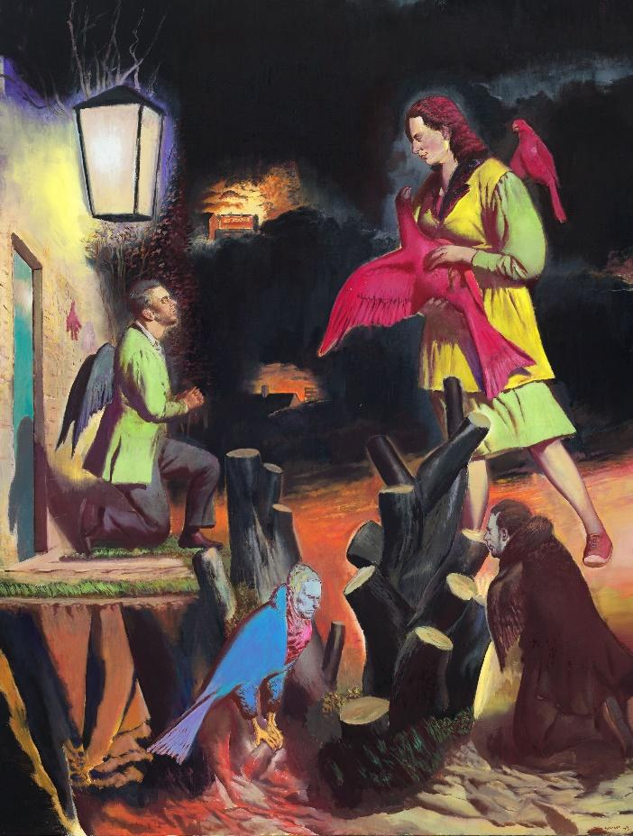
Neo Rauch Späte Heimkehr, 2013 Oil on canvas 280 x 210 cm © Neo Rauch / VG Bild-Kunst, Bonn Courtesy the artist, Galerie EIGEN + ART Leipzig/Berlin and David Zwirner

In many ways Rauch’s artworks can be viewed as painterly cousins to the literary works of J. G. Ballard, whose science fiction explored an ‘inner’ as opposed to ‘outer’ space. Ballard’s own dystopian imaginings similarly coalesce disparate temporalities and cultures, and are often set in times of war and social unrest, as seen in his Empire of the Sun (1984). In many of Ballard’s works we similarly see the unconscious mind bleeding into the waking world, into everyday reality, so that the sources of trauma, the obsessions, the festering fears, the buried instincts all come bubbling up to the surface with biting allegorical pertinence. Rauch, like Ballard, explores the liminalities of the man-made and the organic, the bodily and the mechanical warp and writhe, with an air of the biomorphic Surrealism of Francis Bacon and Richard Hamilton. The world of the worker is captured and contorted within Rauch’s paintings, as is the supremely concretized worlds their subjects inhabit. Those distinctly Ballardian views of reality, made up of endless motorways, shopping malls and tower blocks, depicted in works like Crash (1973), High Rise (1975) and Kingdom Come (2006) are echoed in Rauch’s works like ‘Weich’ (2005) and ‘Hohe’ (2004), wherein such architectures become alien and pervasive. Whilst Rauch’s ‘Späte Heimkehr’ (2013, shown above) undoubtedly calls to mind Ballard’s Surrealist rendition of his hometown of Shepperton in The Unlimited Dream Company (1979), in which the populace undergo a transformation into great birds much like those which appear within the paintings of Max Ernst: ‘all over Shepperton birds were appearing on the rooftops, raised by my cries from the sleeping minds of the people below, husbands and wives wearing their brilliant new night plumage’. A kind of temporal implosion also unites both of their work, in which we see a murky composite of past, present and the future, where wandering nomads gather, like wispy and ethereal shadows.

There are further affinities to be drawn with Rauch’s work and other tributaries of science fiction, in subgenres such as Afrofuturism and Steampunk, this in that his paintings evoke that same intersection of historic, culturally imbued past and unknown, vastly technologised future, often as a means of empowerment and historical confrontation. Resonances can be felt with classics like Octavia Butler's Kindred and Kurt Vonnegut’s Slaughterhouse Five, in the sense of their exploring some temporal rupture as a means of reapproaching and perhaps challenging some unsolved trauma from the past. Rauch has spoken of the therapeutic, cleansing power art wields, and the presence of this dimension within much of his own work. In Nicola Graef’s 2016 documentary ‘Neo Rauch: Gefährten und Begleiter’, or ‘Comrades and Companions’, Rauch speaks of the incapacity of earlier artists of pre-reunification East Germany to express themselves through their art, and how he was given ‘the grace of a late birth… someone perhaps two years older than me, had to maybe experience the drastic influence of the state on their art… [nevertheless] I still have this anticipatory mindset stored as a moment of horror that from childhood on was put upon us... Art has to function as a weapon in the social struggle’. He speaks too in the film of the quasi-mediumistic dimension to his art, utilised as a means to vanquish his own inner demons (Graef, 109.10). Once again there are echoes with Ballard here, who so often emphasised the therapeutic power of merging inner and outer worlds, this epitomised in the work of the Surrealists, whose ideological approach he viewed as so analogous with science fiction. Ballard often spoke of the affinities between Surrealism and science fiction, citing their influence by emergent scientific fields such as optics, photography, relativity and geometry, as well as the movement from which Surrealism takes its aesthetic cue: Freudian psychoanalysis. Ballard once elucidated that ‘what uniquely characterizes this fusion of the outer world of reality and the inner world of the psyche … is its therapeutic power’.

Surrealism and Science Fiction

But there are a great deal more affinities to be found between science fiction and Surrealism aside from their therapeutic capacity and scientific interests. At the most rudimentary level, science fiction and Surrealism share similar structures of a manifest and latent content: the latent, kernel idea - be it neurosis, obsession, repression, whether individual or societal - is hidden beneath a manifest ‘dream layer’ which gives us the notion of some lurking trauma. The process of ‘censorship’ is viewed as the primary role of the dream: that is, the abstraction or transformation of an underlying neurosis, anxiety, (etc.) into something unrecognizable, a construction of metaphoric-aesthetic veneer, as a means to protect the dreamer ‘from the shock of a disagreeable reminiscence’, as Carl Jung described it. In line with Surrealism, dreams are integral to Rauch’s own artistic process: ‘I’m interested in simulating the methods of dreaming’ he has expressed, and has playfully revised Descartes’ famous dictum to describe something of the nature and drive of his work, stating ‘I dream therefore I am’. Parallel to such Surrealist affinities, Rauch’s artwork undoubtedly brings to mind Darko Suvin’s well-known definition of science fiction as ‘the literature of cognitive estrangement’, which draws upon Bertolt Brecht’s Verfremdungseffekt in allowing us ‘to recognise its subject, but at the same time make it seem unfamiliar’ (Suvin, p. 6), a technique identifiable with the Freudian uncanny. Such a definition discloses the psychological underpinnings of science fiction, and moreover its links to Surrealist ideas, eminently visible. Like Suvin’s extrapolative models of SF which are ‘based on direct, temporal extrapolation and centred on sociological - that is, utopian and anti-utopian - modelling’ (Suvin, p. 27), Rauch's paintings are, as we know, a kind of skewed reproduction of reality which extrapolates ‘real-world’ elements. It is through such a dream-like process that science fiction too has the power to confront the issues, struggles and anxieties in wider society: what is Dystopia if not a dream (or nightmare) borne of anxieties for the future?

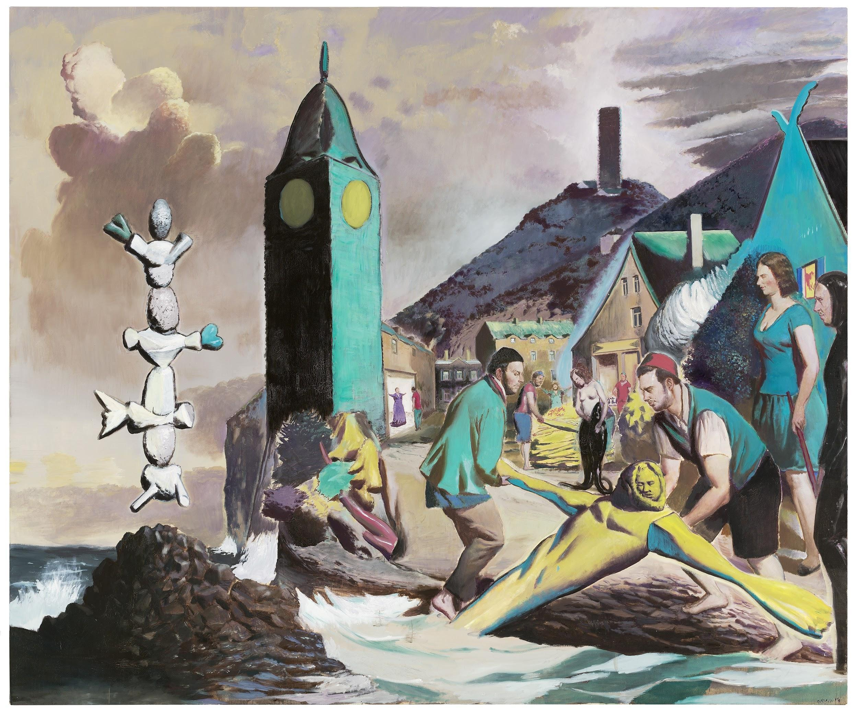
Neo Rauch, Marina, 2014 Oil on canvas 250 x 300 cm © Neo Rauch / VG Bild-Kunst, Bonn Courtesy the artist, Galerie EIGEN + ART Leipzig/Berlin and David Zwirner

It is perhaps unsurprising then that Surrealism is the movement with which Rauch is most often associated: regarded as something of a new-wave, post-Surrealist. In his work we see echoes of the twisted, temporally dislocated locales of Giorgio de Chirico and Paul Delvaux; we see the towering, teetering dream sculptures of Yves Tanguy; the esoteric clash and bustle of places and people and animals and dreams and reality to be found in paintings of Leonora Carrington; the hypnagogic landscapes of Salvador Dali and the eerie dislocation of objective reality in works by Rene Magritte. His Bacon-esque bodily grotesqueries, formed by cadaverous trickeries of paint, and the frequent warping of perspectival space which wrenches objective reality into painterly smears, these ‘punctum’ points (following Barthes) both draw the eye and challenge the imagination of the viewer, allowing their own notions to run wild. In line with the Surrealists, Rauch’s hypnagogic visions are infused by his own subjective experience, so that his haunting memories of the past coalesce with his worries of an unknown, alien future. Indeed, the present is almost entirely lost within his visions; evoked in nothing more than the very fixity of painterly form itself, the temporal ‘capture’ of the moment set before us. This is a present which has given way entirely to reminiscence, to the traumas of the past, to the anxieties of the future, to an echoing, paranoiac mosaic of fragmentary obsessions: these are Dystopias of the past and future. The infusion of subjective experience in Rauch’s work, and the utilisation of dream processes, no doubt owe a lot to his great early influence by Magritte and Dali (Lester interview), both of whom were exploring very different potentials offered by creating art using the properties of dreams and dream symbols. Affinities with Magritte are to be found in Rauch’s blurring of forms, his strange convolution of objects, his simply depicted, yet philosophically stimulating visions which often pose deep and penetrating questions. This epitomised in Magritte’s epochal ‘Treachery of the Images’ (i.e. ‘This is not a pipe’) which interrogated the shifting role of language when introduced into the visual realm of art. But there are more striking similarities to be found in contrasting his work with that of Dali.

Despite his zany and eccentric reputation, Dali’s artworks are highly theoretical and systematic, using a recurrent symbolic vocabulary made up of anthropomorphised crags, eggs, pomegranates, leonine heads, camembert clocks, colossal locusts, spindly-legged elephants and rhinoceri. Harnessing the recurrent images of his dreams, he placed himself ‘on the couch’ so to speak, painting a symbolic, ‘manifest’ rendition of his ‘latent’ emotional state. Once these private fantasies and visions of madness are deciphered - many of which are illuminated through his colourful retelling of his life in his autobiographical The Secret Life of Salvador Dali (1942) - there begins to emerge a very precise and evocative rendition of inner thought and feeling, many of which are so artfully elucidated. In Dali’s work we see, as with that of Rauch, fragments of the past, of impending war, of love and loss, in them we see a lucid and immersive iconography which powerfully evokes a state of mind. Dali termed this systematised approach to rendering dreams his ‘paranoiac-critical method’, a process which ‘organizes and objectivizes in an exclusivist manner the limitless and unknown possibilities of the systematic association of subjective and objective ‘significance’ in the irrational… it makes the world of delirium pass onto the plane of reality’ (‘The Conquest of the Irrational’ 1935). Harald Kunde has spoken of Rauch’s very similar methods of employing ‘certain motifs over and over again in a programmatic way. Internal cross-references and cyclical reprises in this world of motifs contribute significantly to the unique, self-enclosed nature of his art’. This fundamental process of recurrence in dreams, firmly held as a combative process, thus seems essential to Rauch’s own aesthetic hermeneutic. Such also further illuminates what is perhaps the most pressing point of unity between Surrealism and science fiction (and so art and literature more broadly speaking), in terms of the recurrent themes of science fiction, their manifest content, which, just like dreams, address some latent trauma of the times, whether that subjective or societal. Viewed as such, as megatext perhaps, science fiction emerges at once as both record and instrument of these ongoing historical latent fears and traumas.

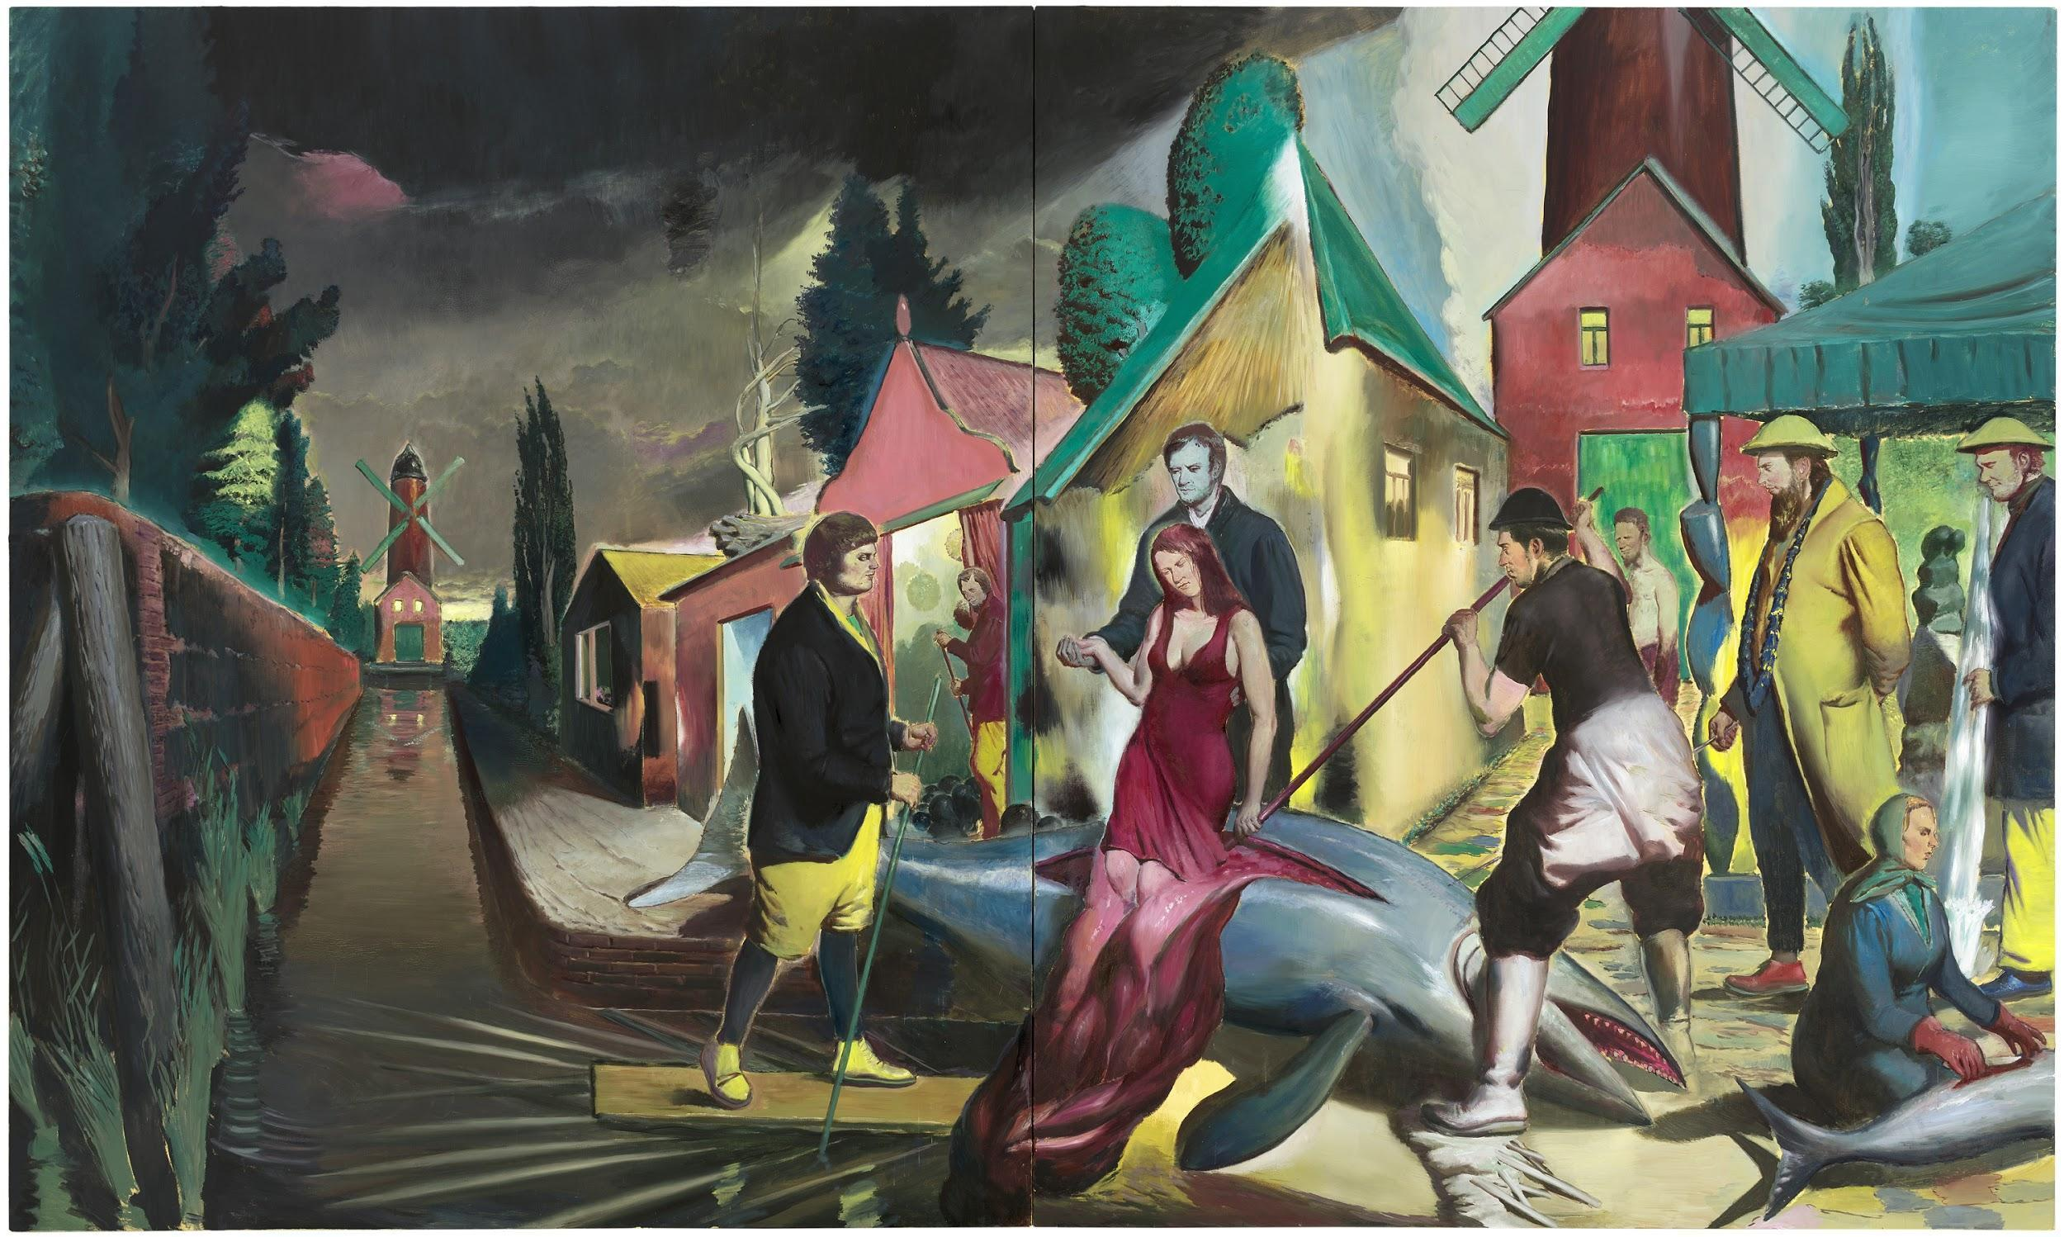
Neo Rauch, Der Blaue Fisch, 2014 Oil on canvas Diptych 300 x 500 cm © Neo Rauch / VG Bild-Kunst, Bonn Courtesy the artist, Galerie EIGEN + ART Leipzig/Berlin and David Zwirner

Rauch’s own sprawling, open landscapes of his native Leipzig, are often populated by drifting, phantasmal figures and eerily misplaced objects, architectures and scenes, all of which are certainly reminiscent of the dream-like Catalonia in the paintings of Dali. ‘Der Blaue Fisch’ (2014) is a particularly Dalinian work, in which an elegantly dressed woman emerges from the innards of a great fish, chaperoned by a ghostly suitor, the rippling shape of her blood-red her dress merging with its splayed entrails. The sense of ‘visceral’ grace evoked here seems to resonate with Marxist ideas of class alienation, a commonality within much of Rauch’s work: the idea of the debased, desubjectivised worker, alongside this contrasting almost ‘otherworldly’ sense of higher society. In Rauch’s richly satirical, metaphorical vision, the figures of the aristocracy so graciously emerge from the spilling viscera of a whale, which seems to represent the toil and labour of the working class. Indeed, the great many chimeras and animal-human hybrids which populate Rauch’s palimpsestic visions are redolent of Kafka in this respect, whose work similarly coalesced strange, dream-like worlds with familiar, mundane, everyday reality. Such liminalities appear in Kafka’s language to the same effect as Rauch’s visual imagery; their commentaries similarly wielding sociocultural bite and intent. The temporal drifters who populate these eerie, vacuous working environs (industrial estates, construction sites, lumberyards, concrete office buildings, diners, butchers, etc.) seem to have awoken, much like Gregor Samsa, into these new forms, into this new world where the surreal and the hypermundane are somehow harmonised (see ‘Bon Si’ (2006) and ‘Der Former’ (2015),for example). Such inhabited spaces and bodily metamorphoses speak above all to some inner change, one imposed by systemic powers and controlling forces; those which work at total and utter desubjectivisation.

Such narrativised inner changes are also crucial within Dali’s work, as can be seen in his iconic ‘Metamorphosis of Narcissus’ (1937) which contains the entirety of Ovid’s myth in a singular painted image. Like Dali’s painterly rendition of the Narcissus myth, in ‘Der Blaue Fisch’ there is a similarly reflective aspect, a duality or reciprocity to the buildings and figures, as if the painting is somehow split down the middle and parts of each side resonate with one another. Much like the central mirrored hand-body forms of Dali’s painting, which can be seen to represent at once Narcissus’ gazing into the water, and his reaching out from its depths upon falling in love with his own image, there is a sense of the infinite here, particularly through the red windmills, which recur off into the distance of the scene much like the hands in Dali’s work. Rauch’s aesthetic and ideological ties with Dali and other Surrealists are clear, particularly in terms of their engagement with the current upheavals in wider society, which acts as something of a fertiliser for their work. The events which weighed heavily on the unconscious (or mass unconscious) are manifested within their otherworldly, phantasmagorical visions. But despite his open acknowledgement to Dali’s early influence, Rauch has expressed some dissent at being bungled in with any one movement, an expression which is reflected by the assimilatory and boundary-breaking nature of his work. He is also averse to the idea of his art being seen as inherently political, and the emancipation from such confining categorizations clearly weighs heavily on his mind. This is no doubt why he is dismissive of the associations of his work with ‘post-socialist’ art or the New Leipzig school which confines his art to a political dimension, as a kind of caricaturist. Nevertheless, such a rejection of any individual artistic movement can also be seen to represent a crucial aspect of Rauch’s ‘science fictional’ presentation of time within his work.

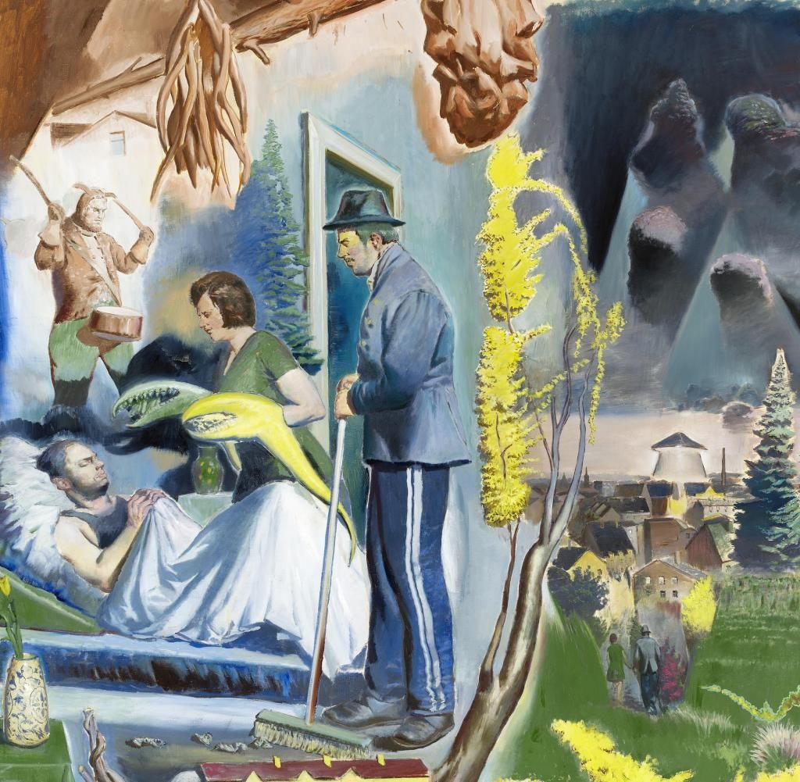
Neo Rauch, Hüter der Nacht, 2014 300 x 250 cm © Neo Rauch / VG Bild-Kunst, Bonn Courtesy the artist, Galerie EIGEN + ART Leipzig/Berlin and David Zwirner

Painting through the ages

Rauch once described his art as a ‘Peristaltic Filtration System in the River of Time’, an analogy which ties together the enormous presence of workers and machinery within his work to the apparitions which seem waylaid by some temporal tempest. But his work also acts as a kind of rift in timespace wherein the ever-shifting changes of art, artists and movements through the ages intercede and flow into one another like a great river of the imaginary. For in his painting we see the styles, imagery, scenes and architectures of the Old Masters of the Renaissance, of the Romantic era, of the Symbolists and of many more movements and artists of the bustling artistic decades of the early 20th century. There are elements of Expressionism, and especially Edvard Munch, and his dazzling and psychedelic-photonegative colourations, his sense of existential angst which warps his writhing figures. There are elements of Futurism, through the industrial bustle of his settings and working figures, which are jarringly placed alongside alien technologies and architectures. Of Cubism, and his contortion of objects in time and space, where all facets are simultaneously experienced; of Abstract Expressionists like Gerhard Richter; of later Neo-expressionists which dominate the art of Western Germany; of the comic-styles of Pop Art, marked by the alienated fashions and symbols of Westernised consumer brandings, and particularly the historical amalgams of Sigmar Polke. He has also often spoken of the prevalence of Socialist Realism growing up, the influence of which festers within his art, much like the propaganda-art of communist East Germany, which also bleeds into his uncanny visions. Rauch has expressed ‘I refrain from any hierarchisation and from a conscious evaluation of my pictorial inventory… Balthus Vermeer, Tintin, Donald Judd, Donald Duck, agitprop, and cheap advertising garbage can flow together in a furrow of my childhood landscape’ (Neo Rauch, p. 148). Crucial to his work then is this idea of assimilation: not only of time and space, but also of artists and art movements. Through Rauch we see how history is rendered through art and how seminal moments of history are echoed by the shifting, metamorphosing forms and techniques of art, and his own assimilatory processing of art throughout history serves to lay this mutability bare. This idea of art shifting with the times is what Alois Riegl termed the kunstwollen: that is, the artistic will, or what you might designate the aesthetic pulse of the times. Thus, in Rauch we have a ‘rhizomatic’, manifest surface, which collects the fragments of art and styles from different eras, beneath which is an assimilated latency of art through the ages. Indeed, one might regard this perennial problem of ‘fixity’ in painting, as the very driving force of art movements throughout history, the momentous drive of the kunstwollen, which appears by way of the ever-shifting nature of form. This is made especially evident in modernism and beyond, when perspective and subjectivity became so fundamental to art and literature. Rauch has called himself: ‘a child of modernism… but one who is gradually emancipating himself a little. One basic essence of modernism is doubt, that is, a mistrust of all laws, all aspects that are supposedly unavoidable, and this apparently inscribes itself into my pictures during painting’ (Neo Rauch, p. 360).

Rauch’s assimilatory blurring of historical imagery and artistic history serves a crucial function in the eye of the beholder, who cannot but impose their own insights, their own tangential connections and serendipitous significances (this once again, is a highly Surrealist tendency). All elements in this dreamspace are ripe for interlocution, but in particularly those which are related more by their abstractedness: for example the amorphous, bacterial masses, the geometric shapes and structures, the Biblical allusions, the oddly coloured objects, and all manner of other loose wires which begin to spark as they come into contact and attach the connective synapses in the viewer. Indeed, Rauch’s use of colour is almost as alien as his scenes, at once vibrant and yet somehow dissociative, a pallette seemingly more geared at generating a sense of time and place, or provoking correlations between scenes and objects. Rauch has spoken of colour as a ‘lubricating film through which our emotions are transported onto the canvas… in terms of the capacity to release memories, it is less strong than the sense of smell, but very much related’. Thus, for Rauch even colour is utilised to tamper with temporal fixity - these chromatic configurations a way of provoking our personal associations with certain colourations, of tapping into our own past and recollections. This mnemonic semblance of colour and smell is perhaps related to their innate abstraction from language, and their being of a different sensory order, and so more readily attached to memory only when the sensation is revisited within the sensory realm (when one walks past a place they used to frequent, or smells a food they ate in childhood etc.).

Time, memory and the illusion of continuity

Experiments with colour and imagery which are distinctive of different specific time periods and movements demonstrates Rauch’s interest in exploring how to render time in the visual world. For Rauch’s medium allows him to relinquish the temporal limitations imposed by the linearity of language, of memory as ‘flowing’ backwards, or ‘forward thinking’ (literature necessitates some measure of forward progression), or being confined to one fixed moment in time (as with sculpture). Instead painting can encapsulate many times, and all the disparate components of time can appear in a singular image. A painting can converge past, present and future, as well as inner and outer worlds: in painting one can contort the very fabric of spacetime. Rauch’s art seems to relish in exploring how time and space are represented in the immediate visual world. Our memories, our recollections and conceptions of the past, those fleeting and ephemeral scenes and figures, those nostalgic instances, those traumas and hauntings, those ephemeral flashes and flickerings of vision which invade the present: these are all fundamentally visual in nature. We do not remember in words, rather, we remember in images. Just as we do not imagine the future in words, we ‘imagine’ it in images. Rauch is clearly keen on elucidating the visual nature of the mind, how the visual world relates to memory, and can invoke different temporalities, can take us back, or even forward, in the aesthetic representations of futurity popularised by science fiction. He is thus keenly aware of the versatility of spatiotemporality in the visual realm, of time as perspective. The sense of mnemonic rupture within Rauch’s work, which depicts memories (both personal and collective) of the past alongside worries about the future in a singular moment, results in a seismic clash which threatens the very stability of the present. In line with such, the many interlocking narratives within Rauch’s paintings provoke a frantic overactivity of logic-seeking in the viewer, and this is a process which transcends time. Indeed, time becomes nullified in the sense of the viewer being more concerned with finding out what unifies these moments: they are incessantly searching for that tranquil, blissful illusion of continuity.

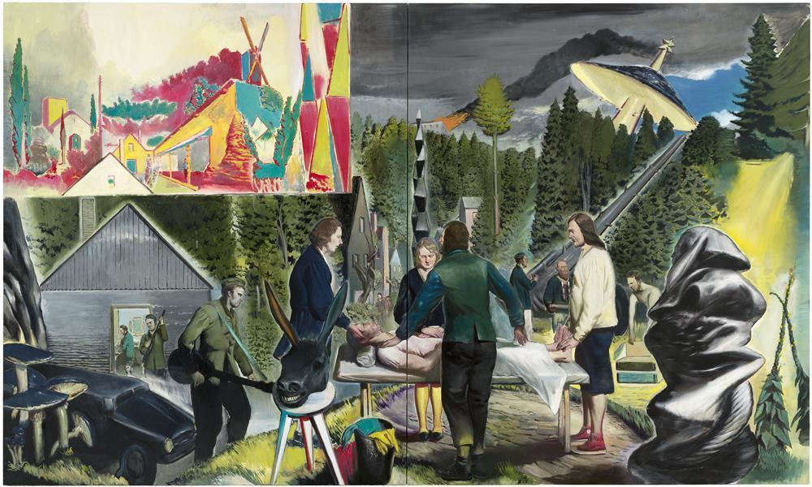
Neo Rauch, Heillichtung, 2014 Oil on canvas Diptych 300 x 500 cm © Neo Rauch / VG Bild-Kunst, Bonn Courtesy the artist, Galerie EIGEN + ART Leipzig/Berlin and David Zwirner

Rauch’s Heillichtung (2014) is particularly lucid in depicting these clashing visual icons of temporality, in coalescing tangential narratives, in utilising colours and symbols which speak to memories of the past, and contorting them with inklings of the future. His process of artistic assimilation can be evidenced here once more: a Brancusi-style sculpture appears in the centre, whilst on the front-right appears a material-covered mass reminiscent of Magritte’s veiled faces as seen in ‘The Lovers’ (1928); a work which produces a heightened sense of intimacy through the very emergence of this partition, veil or covering. The intimations of war are ubiquitous in this vision: a wounded man appears at the center, surrounded by sombre figures; there are armed soldiers (one wielding a guitar); a building burns off in the distance; an anti-aircraft gun (or is it a telephone post?) is arced towards the upper-right corner. But if this is indeed a scene of war, it is a war which transcends time. For there also appears an armoured car, and a Wellsian craft of some kind which looms in the background with a beam of light close by as if intimating an abduction (the craft also mirrors the shape of the mushrooms in the lower-left corner, expressing a connection to earthly environment). The effect of this is a something of a warped amalgam of Renaissance military art and 60s sci-fi movie posters. Biblical imagery also presides here: looking closer at the figures surrounding the central bed, there appears a Converse-clad Christ-like figure who stands at the feet of the injured man, as if about to lay on his healing hands. As if to support this image, the anti-aircraft gun in the background is angled so that it almost seems to rest on ‘Christ’s’ shoulder, perhaps symbolising his carrying of the cross. Then there is the grinning head of a donkey which seems to further reinforce this Biblical aspect to the image, or rather, further extend upon the endless chain of logic-seeking, for this is a journey in which one actively takes part (perhaps, then, this is the grin of a knowing creator?). This religious imagery is enforced by the very title of the work, which roughly translates to ‘healing’ or ‘holy’ glade or clearing. Thus, here is a vision which, much like a dream, is ultimately motivated by recuperation; be it psychological or spiritual. Something particularly distinctive about this painting is the portal-like image in the upper-left section of the painting, which shows us an alternate view of this world, an idyllic, perhaps utopian vision, which is bright and vibrant, and which in some sense works to render this ‘other’ scene as Dystopia. Such readings are perhaps inevitable within Rauch’s work, but they also serve not only to expose the great affinities of his artwork within the rubric of science fiction, but they also allow us to see how his imaginings can bring about all new insights to the genre.

***

Bibliography:

Salvador Dali, The Secret Life of Salvador Dali (New York: Dover, 1993)

J. G. Ballard, A User's Guide to the Millenium: Essays and Reviews (London: Flamingo, 1997)

J. G. Ballard, The Unlimited Dream Company (London: Harper Perennial, 2008)

Nicola Graef (dir.), Neo Rauch: Comrades and Companions, Lona Media 2016.

Carl Jung, Marie Luise von Franz (ed), Man and His Symbols (London: Picador, 1978)

‘Neo Rauch: “A painting should be more intelligent than its painter”’. Interview of Neo Rauch by Paul Lester for Conceptual fine arts, 7/11/2019: https://www.conceptualfinearts.com/cfa/2019/07/05/neo-rauch-interview/

Darko Suvin, The Metamorphoses of Science Fiction: On the Poetics and History of a Literary Genre (New Haven: Yale UP, 1979).

Neo Rauch, eds. Hans Werner Holzwarth, Wolfgang Büscher, Harald Kunde & Tinterow, Gary. Neo Rauch (Köln: Taschen, 2012)

Alison M. Gingeras, "Neo Rauch, A Peristaltic Filtration System In The River Of Time", Flash Art Vol. XXXV No. 227, November-December 2002.

‘Neo World Disorder: The Artistic Journey of Neo Rauch’, interviewed by Diana d’Arenberg Parmanand for Hong Kong Tatler, 27/11/2015. https://hk.asiatatler.com/life/neo-world-disorder.

J. G. Ballard, The Unlimited Dream Company (London: Harper Perennial, 2008) p. 57.
Nicola Graef (dir.), Neo Rauch: Comrades and Companions, Lona Media 2016.
J. G. Ballard, A User's Guide to the Millenium: Essays and Reviews (London: Flamingo, 1997) p. 84.
Carl Jung, Marie Luise von Franz (ed), Man and His Symbols (London: Picador, 1978) p. 52.
‘Neo Rauch: “A painting should be more intelligent than its painter”’. Interview of Neo Rauch by Paul Lester for Conceptual fine arts, 7/11/2019: https://www.conceptualfinearts.com/cfa/2019/07/05/neo-rauch-interview/
Darko Suvin, The Metamorphoses of Science Fiction: On the Poetics and History of a Literary Genre (New Haven: Yale UP, 1979).
Neo Rauch, eds. Hans Werner Holzwarth, Wolfgang Büscher, Harald Kunde & Tinterow, Gary. Neo Rauch (Köln: Taschen, 2012) p. 227.
Alison M. Gingeras, "Neo Rauch, A Peristaltic Filtration System In The River Of Time", Flash Art Vol. XXXV No. 227, November-December 2002, p. 66.
‘Neo World Disorder: The Artistic Journey of Neo Rauch’, interviewed by Diana d’Arenberg Parmanand for Hong Kong Tatler, 27/11/2015. https://hk.asiatatler.com/life/neo-world-disorder.

