Predictions of macroscopic mechanical properties and microscopic cracks of unidirectional fibre-reinforced polymer composites using deep neural network (DNN)
Xiaoxuan Ding ª, Xiaonan Hou ^{a,*}, Min Xia ª, Yaser Ismail ^{b}, Jianqiao Ye ª
ª Department of Engineering, Engineering Building, Lancaster University, Lancaster, LA1 4YW, UK
^{b} Groundforce Shorco, Gildersome, Leeds, LS27 7HJ, UK
* Corresponding author. Email address: x.hou2@lancaster.ac.uk; Tel: +44 (0)1524 593314

Abstract
Fibre-reinforced polymer (FRP) composites have been widely used in different engineering sectors due to their excellent physical and mechanical properties. Therefore, fast, convenient and accurate prediction tools for both macroscopic mechanical properties and failure of the composites are highly demanded by industry and interested by academia. In this study, two back-propagation deep neural network (DNN) models are developed. The first model is a regression model for predicting macroscopic transverse mechanical properties of FRP laminae, which is based on a data set generated by Discrete Element Method (DEM) simulations of 2000 Representative Volume Element (RVE) with 200 different sets of fibre volume fractions and fibre radii. The second model, which is a classification model based on the results of 1600 DEM simulations of RVEs with a fixed 45% fibre volume fraction and $3.3 μm$ fibre radius, is developed for predicting microscopic crack patterns of the FRP laminae. The results show that the two developed DNN models are able to predict both the macroscopic transverse mechanical properties and the microscopic cracks of the RVE accurately.
Keywords: Deep neural network (DNN); UD FRP lamina; Discrete Element Method (DEM); mechanical behaviours; data-driven prediction.

1. Introduction
Fibre-reinforced polymer (FRP) composites have wide applications in different engineering sectors due to their excellent physical and mechanical properties such as lightweight, high strength, high stiffness, and corrosion resistance, etc. Laminated FRP composites are among the most commonly used FRP composites that consist of several unidirectional (UD) FRP laminae. However, predicting mechanical properties and damage progression of UD FRP composites at laminae scale with high accuracy is still a challenging problem as the damage evolution and failure mechanism are obviously far more complex than those of monolithic materials. One of major concerns in the use of UD FRP composites is their susceptibility to damage resulting from transverse loading, which results in transverse cracking and fibre-matrix debonding. They are complex processes developing simultaneously on all internal length scales, i.e., from micro to macro scales.
One way to study mechanical behaviour of a UD FRP lamina is to conduct experimental tests. However, these tests are normally costing and the results from the tests may not be reliable due to the limitations in implementing realistic environment and loading conditions, and the complex and random nature of damage progression. Alternatively, analytical micromechanics models have been used to predict mechanical properties of FRP composites. Typically, in an analytical micromechanics model, both fibres and matrix are assumed homogeneous, linearly elastic and isotropic [1]. More recently, computational modelling using finite element method (FEM) has been employed for micromechanical analyse of composite laminae, for instance, to predict failure path and damage evolution [2-4] using a Representative Volume Element (RVE). The RVE based FEM analysis investigated the influences of matrix and interface properties on their stress-strain response, failure strength, ductility and the corresponding failure modes [5], and the effects of fibre–matrix debonding and thermal residual stress on the transverse damage behaviour of UD carbon fibre reinforced epoxy composites [6]. Besides the FEM model, Yang et al. [7, 8] used a Discrete Element Method (DEM) model to simulate transverse cracking and interfacial delamination in cross-ply laminates under transverse loading, and predict cracking density and stiffness reduction. Ismail et al. [9, 10] studied microscopic behaviour of UD FRP composite laminae under different loads through analysing an RVE by the DEM model. The DEM results showed a good agreement with experimental tests, and revealed advantages in both predicting mechanical properties and studying crack evolution of composites, though it is more computational expensive and practically less user-friendly to be used in engineering design.
In recent years, a rapid development of data science and machine learning (ML) techniques has helped new engineering applications due to their high efficiency, great potential in dealing with big data and accurate prediction ability. Consequently, data-driven computational mechanics [11] have been employed to study composite materials and structures [12]. Based on the data-driven computing, Xu et al. [13] proposed a data-driven multiscale finite element method (data-driven ${FE}^{2}$) for structural analysis. Huang et al. [14] combined Micro-CT and data-driven ${FE}^{2}$ in a multiscale analysis of FRP composite structures. For the applications of ML in the investigations of mechanical behaviour, researchers began to use neural networks to predict mechanical behaviours of different composite materials, such as predicting initial failure of woven composites [15], strengths of particulate reinforced metal matrix composites (PRMMCs) [16], the interfacial shear strength of carbon nanotube (CNT)-reinforced composites [17] and FRP-concrete interfacial bond strength [18]. In addition, the study on the determination of the macroscopic mechanical properties of UD FRP laminae combined with ML has showed its desirability. Pathan et al. [19] combined principal component analysis (PCA) and the Gradient Boosting Regressor (GBR) to predict mechanical properties of a UD FRP composite by training the data from numerical micromechanics (FEM) simulations of computer-generated microstructures. However, there was no comparison conducted among the prediction results obtained from the ML approach and the existing micromechanics analytical models. In addition, the study on the application of ML in predicting fracture process of composite materials is still at its very early stage and hardly found in the literature. ML approaches have been used to predict fracture process of brittle materials, which includes the studies on predicting fracture evolution in concrete by using simulation data from combined Finite-Discrete Element Method (FDEM) [20-22] and fracture patterns in crystalline solids based on the data from molecular simulations [23]. However, one or several pre-set initial cracks must be introduced to ensure the accuracy of the ML predictions. Besides, these approaches are merely applicable for when the materials are assumed homogenous. Thus, an accurate and more realistic prediction of crack initiation, propagation and failure of anisotropic medium using a ML approach still remains as a challenge that demands urgent attention.
As a powerful ML method, artificial neural network (ANN) is capable of addressing some complex issues occurring in modelling composite materials, such as in capturing and establishing the interaction between inputs and outputs. These advantages assign ANN the ability to predict mechanical behaviours of UD FRP composite laminae when consider their microstructures. Finally, a trained ANN can be used to replace the time-consumed computational simulations and labour-intensive experimental tests. However, to the authors’ best knowledge, there are no ML based studies on the stiffness, strength, and fracture of UD FRP composites with consideration of randomly distributed fibre position, varying fibre volume fraction and fibre radius available in the literature. In this paper, two deep neural network (DNN) based data-driven predictive models are developed to predict transverse mechanical properties and crack path of UD FRP composite laminae, respectively. All the data used for the predictive models are obtained from an experimentally validated DEM model. After training and testing, the prediction results, and the performances of the two DNN models are analysed and discussed.

2. Computational micromechanics analysis of mechanical behaviour of UD FRP composite laminae

2.1. 2D RVE based DEM model
To investigate the mechanical behaviour of a UD FRP composite lamina subjected to transverse loading, a 2D plane strain computational micromechanics DEM model is used in this study. DEM was proposed by Cundall, P.A. in the context of rock mechanics and has been implemented in many fields [24, 25]. In a typical DEM analysis, particles with mass are used to discretise the domain of a material and are bonded together at the contacts. The particles are usually assumed rigid and of circular or spherical. The particles interact with each other through contacts and separate when the contact strength or fracture energy is exceeded. When the internal forces are balanced, the interaction between the particles is considered a dynamic process with equilibrium. Subjected to external loading, the motion of all the particles is governed by Newton’s second law. To describe the mechanical behaviour of two rigid particles at the contact, bonding models based on force-displacement law are used. The calculation cycle of DEM is between the application of Newton’s second law of motion on each particle and one of the force-displacement laws for contacts between particles. There are several bonding models available in the literature. Two of them will be used in the DEM model in this paper, which will be described in detail later in Section 2.2.
A $50 μm × 50 μm$ RVE of the cross-section of the laminae, which contains 43 circular fibres of radius R = $3.3 μm$ randomly distributed in the matrix (as shown in Figure 1(a)), is chosen to be analysed. The material properties of fibre, matrix and fibre-matrix interface for the FRP composite lamina are shown in Table 1. The approach proposed in [26] is employed to construct the RVE and achieve randomness and the required fibre volume ratio. It has been validated that this square RVE is reliable to represent the macroscopic properties of a UD composite lamina [5]. The RVE is subjected to periodic boundary conditions and the process of the RVE generation is implemented by the DEM software ‘PFC2D’ [27]. In the RVE shown in Figure 1(a-b), fibres and matrix are colored by yellow and blue, respectively, and are all discretised with particles by the hexagonally packing arrangement, as shown in Figure 1(c-d), which requires three types of bonds of contact. i.e., contact bond of two fibre particles, contact bond of two matrix particles and the contact bond between a fibre particle and a matrix particle.

2.2. Contact models of DEM model
In the DEM simulation, particles of fibres and matrix are bonded at contacts by parallel-bonds and their behaviours are analysed by parallel bond model [25]. A parallel-bond of two contacted particles can be regarded as a set of springs with constant normal and shear stiffness uniformly distributed over a circular or rectangular cross-section lying on the contact plane and centred at the contact point that both forces and moment can be transmitted on. The force-displacement laws of the parallel bond model for the normal and shear behaviours are shown in Figure 2.
Particles of fibre and matrix interface are modelled by displacement-softening model [27], whose principle is similar to cohesive model [29]. The curves of the displacement-soften model are shown in Figure 3. Damage initiation starts when the force in the contact reached the peak contact strength. After the peak contact strength, the force in the contact reduces as a linear function of the displacement. The bond strength decreases to zero when the displacement reaches the maximum that is related to the fracture energy release rate G. The debonding between fibre and matrix may behaviour as mode I, mode II or mix mode according to the progression of the damage. In this study, the macro fracture energy (shown in Table 1) of the respective modes I and II were used to define the maximum displacement. The interface strength used in the displacement-softening model was taken as the value of the cohesion yield stress calculated using Mohr-Coulomb criterion [5, 9]. The parameters for Mohr-Coulomb criterion are the angle of internal friction $θ= {15}^{°}$and the matrix tensile strength $σ_{mt}= 60 MPa$ (given in Table 1). Therefore, the corresponding cohesion is $39.1 MPa$, which gives the fixed normal interface strength of $39.1 MPa$. More details about the two contact models can be found in [9, 10, 27].

2.3. Calibration of the DEM model
The micromechanical properties that characterize DEM model should be calibrated by the macroscopic properties of each constituent of the composite that are obtained from experimental tests. It is assumed that both the fibres and the matrix are isotropic in the DEM model. For the hexagonal packing arrangement, the contact stiffness can be expressed explicitly as functions of the respective Young’s modulus and the Poisson’s ratio of fibres and matrix [30]. It was found that the relationship between the macro strength of the material and the micro strength of the bonds between material particles was linear, and a linear coefficient of 1.7 was determined from the parametric studies in [9]. The micro-contact tensile strength of the matrix bond is therefore computed as 1.7 times of the macro strength of the material, which is 105 MPa. In this study, it is assumed that when the material is under transverse tension, there is no fibre damage. Thus, for convenience, the micro-contact tensile strength of the fibre bond is set as a very large value. For the micro-contact strength of the fibre-matrix interface, the cohesion model shown in Section 2.2 is used.

2.4. Simulation result of the 2D RVE based DEM model and validation
To study the macroscopic transverse mechanical behaviour of the UD FRP composite lamina, a constant tensile velocity of 5 mm/s is applied simultaneously on the particles located at both the left and right boundaries of the RVE. For the purpose of validation, DEM simulations are firstly carried out for two commonly used UD FRP laminae, i.e., AS4/3501-6 epoxy and E-glass/MY750 epoxy [31]. Using the material properties given in [31], RVEs of $50 μm × 50 μm$ containing randomly distributed fibres of 60% volume fraction are constructed for the two UD FRP laminae. Due to the randomness of DEM model for generating RVEs, for each type of laminae, 8 RVEs with constant fibre volume fractions of 60.7% and 59.6% are generated and then simulated, respectively. The DEM approach for the RVE generation can accurately achieve the fibre volume fractions of the two laminae (60%). A total of 16 DEM simulated stress-strain curves are shown in Figure 4, from which the transverse Young’ modulus and the transverse tensile strength of the two types of laminae are evaluated by taking the respective average, as shown in Table 2. The experimental results from [31] are used for validation (see Table 2). It can be seen that the predictions based on the DEM models agree well with the experimental tests. In addition, the good capability of the DEM model in predicting the local damage initiation and progression of transverse cracks of UD FRP laminae subjected to static transverse tension was demonstrated in [9] by comparing the crack patterns with the in-suit microscopic test [32]. Therefore, it can be concluded that the DEM model can provide accurate and reliable simulation results for both macroscopic properties and microscopic cracks and can be used reliably to generate required data for data-driven predictive models.

3. Data-driven deep learning models
In this section, deep learning models, which are the deep neural network (DNN) models for both regression and classification applications, are developed to predict, respectively, the macroscopic transverse properties of a UD FRP lamina and crack development of the UD FRP subjected to transverse tension. The deep learning is based on the data generated from the microscale RVE based DEM model that has considered the microscopic properties at constituent level.

3.1. DNN predictive model for the macroscopic transverse properties of UD FRP composite laminae

3.1.1. DoE sampling and data generation
This paper mainly focuses on studying the mechanical properties of the lamina, which are affected by their volume fractions, radii and random distribution of fibres. Therefore, design of experiment (DoE) is employed to select a sufficiently large number of sampling points defined by two independent variables (fibre volume fraction and fibre radius) within the ranges specified in Table 3, which has covered the most commonly-used UD FRP composite laminae [31, 33]. The sampling technique, Latin Hypercube sampling (LHS), which was proposed by McKay et al. [34], is implemented to generate 200 evenly distributed data points in the problem domain.
For a chosen combination of the volume fraction and fibre radius, 10 RVEs with different fibre distributions are generated. A total of 2000 RVEs are then simulated using the 2D DEM model described in the previous sections. The material properties of fibre, matrix and fibre-matrix interface used in the models are shown in Table 1. The transverse tensile strength and Young’s modulus are extracted from the DEM simulation output file. To minimize the variations of mechanical properties caused by different random fibre distributions, the average values of the two mechanical properties from every 8 out of 10 samples that have the same fibre volume fraction and fibre radius (by removing the maximum and the minimum values of the 10 samples) are calculated. The average tensile strength and the average Young’s modulus of every 10 RVEs that have the same volume fraction and fibre radius but different fibre distributions are plotted in Figure 5, where the variances of the respective averages are also shown. It can be seen that the variance of tensile strength is relatively larger than that of Young’s modulus, which suggests that fibre distribution may have greater influence on the tensile strength than the Young’s modulus of the composite. The 200 sets of fibre volume fraction and fibre radius selected by the DoE and their predicted average strength and stiffness from the DEM simulations are used then as the input data and output data to be trained by deep learning.

3.1.2. Data pre-processing
Before determining the structure of the DNN predictive model, data pre-processing is carried out. It is one of the essential steps in developing data-driven models as the quality of the data of representative features directly determines the performance of a machine learning model. Data pre-processing includes data set partition and data normalization.
To improve the model performance, three different groups of data which are processed by a 3-fold cross-validation and implemented in Python, are used for training and testing the predictive model. In each group of the data, 80% of data points in the data set (160 data points) are used in the training process and the rest 20% of data points (40 data points) are used in the testing process.
As the magnitudes of the input features and the output are at different scales, it is crucial to apply a data normalization method to convert the magnitudes of data to a same scale. There are two common methods, namely min-max normalization and Z-score normalization, to bringing different features into the same scale [35]. Between them, Min-max normalization rescales the range of features to [0, 1] by the formula below:
$x_{i_min_max}^{'}= \frac{x_{i} - x_{min} }{x_{max} - x_{min}}$ (1)
where $x_{i }(i=1,2,…,n)$ is the original value of a specific feature in the training set, $x_{i}^{'}$ is the normalized value, $x_{min}$ and $x_{max}$ are the minimum and maximum values of a feature in the training set, respectively.
Z-score normalization rescales the data to the normally distributed data with a mean of 0 and a standard deviation of 1 by the formula below:
$x_{i_z_score}^{'}= \frac{x_{i} - μ}{σ}$ (2)
where $μ$ and $σ$ are the values of the mean and the standard deviation of a specific feature in the training set, respectively. Both the methods mentioned above are used in this analysis to compare their performances in the predictive model.

3.1.3. Configuration of the DNN predictive model for the macroscopic transverse properties
Deep neural network (DNN) that is inspired by the biological nervous network, is a robust and promising deep learning approach in modelling mechanical behaviour of materials due to its powerful nonlinear mapping ability. Figure 6 shows a simplified structure of a general neuron network, which forms a single-output predictive model. The model is composed of a multi-input layer, one hidden layer and a single-output layer. The multi-inputs denoted as $x_{i} (i=1, 2, …, n)$, consist of the input layer. As discussed in Section 3.1.2, fibre volume fraction $V_{f}$ and fibre radius $R_{f}$ are the two input features in the input layer. There are weights in between each layer in order to make connections with the layers. Each individual layer needs an activation function $f$ that makes the dot product of the two inputs and their corresponding weights. Then a set of bias is required to add to the dot product of the two inputs and their corresponding weights, which finally calculates the value of the single-output $y$. The transverse tensile strength and Young’s modulus, are the two target outputs in the output layer, respectively.
In this study, a DNN model with a back-propagation learning algorithm is used to predict two macroscopic mechanical properties, namely, the transverse tensile strength and Young’s modulus, which allows forward signal transmission and error back propagation simultaneously during the training process. To ensure that the DNN model can have a sufficient accuracy, a set of trials by using the models with different numbers of hidden layers and different numbers of neuron are made. It is found that the predictions by using DNN models containing less than four layers with less than 80 neurons in each layer are ‘under fitting’, which means the DNN models do not learn well in the training process. It is also found that the predictions by using the DNN models containing more than four layers with more than 80 neurons in each layer are ‘over fitting’, suggesting that the DNN models learn very well in the training process due to the powerful nonlinear mapping capabilities, while may not give accurate predictions in the testing process. Therefore, as shown in Figure 7, the DNN regression model with back-propagation, consisting of four hidden layers with the same neuron number of 80 in each layer, has the best nonlinear mapping capabilities in this case. The activation function used from the input layer to the first hidden layer and between any two hidden layers is the rectified linear activation function (ReLU) and is defined as:
$f\left(x\right)=\left\{\begin{aligned}0, if x≤0 \\ x, if x>0\end{aligned}\right.$ (3)
The Sigmoid function is used between the last hidden layer and the output layer and is defined as:
$f\left(x\right)= \frac{1}{1+ e^{-x}}$ (4)
The generated DNN predictive model is implemented by using Keras functions of the TensorFlow package in Python [36, 37].

3.2. DNN predictive model for crack path of UD FRP composite laminae

3.2.1. Data generation and pre-processing
Unlike the data set generated for predicting the macroscopic properties (tensile strength and Young’s modulus) which contains 2000 samples with different fibre volume fractions and fibre radii, the data set generated for predicting the microscopic behaviour (crack path) contains 1600 2D RVE samples of $50 μm×50 μm$ with a constant fibre volume fraction of 45% and fibre radius of $3.3 μm$. When a RVE is generated, a constant tensile velocity is applied simultaneously on the particles located at both the left and right boundaries of the RVE. The loading velocity applied in all the DEM simulations is 5 mm/s. The crack paths of all the 1600 RVE samples are recorded, when the stress is about 70% of their tensile strength.
After that, a selection of input features is carried out. The input features for crack prediction need to contain important geometrical information, i.e., spatial distribution of fibres in the RVE, which are critical to potential crack initiation and propagation. The origin or a geometric reference point of the RVE is firstly chosen (see the bottom-left corner in Figure 8(a)), such that all the considered features can be related to the origin to uniquely define the geometry of the RVE. Given the positions of the randomly distributed fibres, for instance, ${(x}_{f_{1}}, y_{f_{1}})$ and ${(x}_{f_{2}}, y_{f_{2}})$. As shown in Figure 8(a), two types of features, namely the distance to the origin (denoted ${dist}_{f_{1}}$) and the corresponding angle with the $x-axis$ (denoted $θ_{f_{i}}$), are used to represent the relative spatial positions of the randomly distributed fibres in the RVE. And the distances from each fiber to the origin are set in an order of the nearest to the farthest. The distances and angles are computed as follows:
${dist}_{f_{i}}= \sqrt{{{(x}_{f_{i}}-0)}^{2}+{{(y}_{f_{i}}-0)}^{2}}$ (5)
$θ_{f_{i}}=arcsin⁡(\frac{y_{f_{i}}}{{dist}_{f_{i}}})$ (6)
where $x_{f_{i}}$ and $y_{f_{i}}$ are the $x-$ and$y-$ coordinates of the centre of fibre $i$. It is worth stressing that there are at most 53 randomly distributed fibres in the generated RVEs with the fibre volume fraction of 45% and the fibre radius of $3.3 μm$. If the number of fibres is less than 53 due to the random fibre distribution, it will be assumed that fibres are replenished to the corner opposite to the origin. In this way, the distances of the fibers to the origin are the length of the diagonal of the RVE plus the radius of the fibre, and its corresponding angle is ${45}^{°}$. Therefore, the numbers of the input data in each generated RVE are the same for the predictive model.
To predict occurrence of cracking, the RVE is divided into subareas, as shown in Figure 8(b), where a (7 × 7) division is adopted. If there is at least one crack in a subarea, the subarea will be classified as having an output of 1. Otherwise, the subarea will be classified as having an output of 0. Tests on using different divisions were performed to choose a division, from which a reasonably accurate prediction can be achieved without demanding excessive computational cost. The tests have shown that an increase of the subareas from (7 × 7) would not improve the accuracy significantly. Thus, (7 × 7) subareas were used in all of the following simulations. Therefore, in the classification model, 53 pairs of 2-dimensional feature vectors are identified as the 53 2D input features in the input layer and in the output layer there are 49 outputs in a vector, which are either 1 or 0.
After selecting the features, 80% of the data (extracted from 1280 DEM model simulations) are used as training data for the DNN predictive model and the rest 20% of the data (extracted from 320 simulations) are used as testing data. Finally, to ensure that all the features are of the same scales, Min-max normalization is used to rescale the features in the training set and the testing set independently.

3.2.2. Configuration of the DNN predictive model for crack path
The configuration of a DNN classification model with back-propagation is constructed as shown in Figure 9. The 53 pairs of 2D feature vectors discussed in Section 3.2.1 are in the input layer and to be trained to predict cracking as multi-outputs in the output layer. There are four hidden layers in the DNN model with the same neuron number of 530 in each layer. The activation function used from the input layer to the first hidden layer and between every two hidden layers is ‘ReLU’. The activation function used between the last hidden layer and the output is ‘Sigmoid’. The generated DNN classification model is implemented also by using Keras functions in the TensorFlow package through Python [36, 37] that has been used for the DNN regression model in Section (3.1.3).

4. Results and discussion

4.1. Results of the DNN predictive model for macroscopic transverse tensile strength
Figure 10 and Figure 11 show the transverse tensile strength of the UD FRP obtained from the DEM simulations and the DNN predictive model and their comparisons using, respectively, the Min-max normalization and the Z-score normalization methods to process the input and output data. The validation of the training results of the DNN model on the three cross-validation groups of data are shown in Figure 10(a-c) and Figure 11(a-c). In the training process, all the points from the DEM and the DNN predictions are scattered around the diagonal line (indicating 100% agreement). The results on the three different groups of data in the testing process of the DNN model using the two data normalization methods are presented in Figure 10(d-f) and Figure 11(d-f), respectively. Similar conclusions can be made based on the comparisons. The DNN predictive model is sufficiently accurate in predicting the transverse tensile strength of the UD FRP with a range of fibre volume fractions and fibre radii. Though Figure 10(d-f) and Figure 11(d-f) show a slightly more scattered pattern, all the points are still within a reasonably close range of the diagonal.
To assess the accuracy and effectiveness of the machine learning predictive model, R squared ${(R}^{2})$, as shown in equations (7), is used also as a performance indicator for both the training and the testing processes.
$R^{2}=1- \frac{\sum_{i=1}^{n}{{(y_{i}- \dot{y_{i}})}^{2}}}{\sum_{i=1}^{n}{{(y_{i}- \overline{y})}^{2}}}$ (7)
where $y_{i}$ is the result from the $i-th$ DEM simulation, $\dot{y_{i}}$ is the $i-th$ predicted value by the DNN model and $\overline{y}$ is the mean value of the DEM results. $R^{2}$ represents the proportion of the variance for the target output in the DNN model. From the equation for the $R^{2}$ indicator, a value closer to 1 suggests a better prediction. The comparisons of the performance indicator of the DNN model in predicting tensile strength of the UD FRP in both the training and testing processes are presented in Figures 10 and 11, respectively, for the Min-max and the Z-score normalizations. The comparisons show that for both training and testing Min-max normalization performs better than the Z-score normalization.

4.2. Results and verification of the DNN predictive model for macroscopic transverse Young’s modulus
The results of training and prediction of the developed DNN model on the three cross-validation groups of data for transverse Young's modulus are shown in Figure 12 and Figure 13, respectively. As shown in Figure 12(a-c) and Figure 13(a-c), the training results of the three different groups using the Min-max normalization and the Z-score normalization are both very close to the DEM model results. The comparisons demonstrate that the accuracy of the training process is very high. The transverse Young’s modulus predicted in the testing process of the DNN model are shown in Figure 12(d-f) and Figure 13(d-f), respectively, for the two normalization methods and compared with also the DEM results. In more details, the performance indicator $R^{2}$ of the predictions are all very close to 1. It can be concluded that the DNN model works efficiently and accurately in predicting transverse Young’s modulus of the UD FRP composite laminae.
To further verify the DNN predictive model, the transverse Young’s modulus predicted by DEM and DNN are also compared with two existing analytical micromechanics models, i.e., the Slab model and the Halpin-Tsai model, the details of which are summarized in Table 4. In Table 4, $E_{T}$ is the transverse Young’s modulus; $E_{f}$ and $E_{m}$ are the transverse Young’s modulus of the fibre and matrix, respectively; $V_{f}$ and $V_{m}$ are the respective volume fractions of fibre and matrix. The ratio, $a/b,$ is the cross-sectional aspect ratio of the reinforcement. Figure 14 presents the transverse Young’s modulus calculated by the two analytical models, the DEM simulations and the DNN predictions based on 40 RVE samples over the whole range ($40\%-60\%$) of fibre volume fractions considered in this paper. It can be seen from Figure 14 that the Slab model gives the lowest value of Young’s modulus. The DNN predictions show a similar form of non-linearity as the DEM model. Compared to the Slab model, the Halpin-Tsai model is more comparable to the DEM and DNN predictions. In general, the DEM and DNN predictions are lower than the predictions from the Halpin-Tsai model when the volume fraction is below 48% and higher when the volume fraction is over 48%. Apart from the various assumptions that were introduced to derive the analytical, numerical and machine learning models, factors that attribute to the discrepancies between the DNN and the analytical models include the impact of the randomly distributed fibres and their diameters that were not considered in the analytical models, but have been properly modelled in the DEM model and, subsequently, reflected in the DNN model.

4.3. Results of the DNN predictive model for predicting cracks
To demonstrate the accuracy of the DNN model, we divide the composite material into a number subareas and study the likelihood of crack occurrence within each of the subareas. Both the validated DEM model and the trained DNN model are used to predict the occurrence of cracks of 1600 samples with the same material composition but randomly distributed fibres. For each of the subareas, the number of time it is predicted to crack by both models is counted, respectively. The respective total occurrence of cracking of each subareas is divided then by the total number of the samples to give the predicted probability of cracking of each of subareas (locations) of the material for both models. Figure 15 presents the comparison of the above defined crack probabilities from the DEM results and the DNN predictions. It is evident that the probabilities of cracking at different locations (subareas) obtained from the DNN predictions are close to those from the DEM model. In addition, the density of cracking of the 1600 RVE based DEM simulations is calculated and compared with the density of cracking obtained from the DNN predictions. The density of cracking is computed as the total number of cracked subareas of the RVE samples divided by the total number of subareas of the RVE samples, which describes the extent of cracking coverage in each RVE sample. The densities of cracking based on the 1600 DEM and DNN simulations are, respectively, 0.3325 and 0.3288, which shows a very high consistency between the two results. It can be concluded that the trained DNN model can satisfactorily predict the locations of cracking and the overall crack density of the material.
Based on the ‘0’ and ‘1’ classifications, three representative DNN prediction results of cracking are shown in Figure 16 - 18, respectively. Figure 16(a) shows a RVE generated by DEM with random fibre distribution. The cracks, marked by A and B, are the initial cracks predicted by the DEM, both of which are located at the centre of the RVE. The damage in the RVE starts at the stress of 56 MPa and these initial cracks show an early stage of failure (at the stress of 61 MPa). It can be seen that the initial cracks appear at the locations where fibres are close to each other. This confirms that the locations of initial cracks are closely related to the overall and the local properties of fibre distributions of the RVE. To be specific, it is usually deemed that these areas contain a high fibre and matrix stiffness ratio, which results in significant stress concentration [9]. As the tensile loading velocity of 5 mm/s is continuously applied, the initial cracks grow inside the RVE. Figure 16(b) shows the DEM simulation result of crack growth within the RVE when the stress is about 70% of the tensile strength. In Figure 16(b), crack propagation in the matrix starts to appear. There are four short cracks in the matrix at the upper middle part of the RVE and one long crack through the matrix between five pairs of relatively close fibres, which cause the final failure of the RVE. The yellow areas in Figure 16(c) are the cracked subareas predicted by the DNN, which are compared with the DEM simulations in Figure 16(d). It can be found that almost all the cracked areas are predicted correctly by the trained DNN model. There are 3 mis-predicted crack areas, as shown more clearly by the DNN outputs classifications in Figure 16(e-f). The two red ‘0’ represent that these two cracked subareas are not correctly predicted by the DNN. The red ‘1’ area has cracked in the DNN prediction, while has not according to the DEM simulation.
In Figure 17(a), the damage in the RVE starts at the stress of 38 MPa from the simulation and the initial cracks are generated at the stress of 42.5 MPa. Similar to the initial cracks of the RVE in Figure 16(a), the initial cracks of the second RVE also occur at the region where the inter-fibre distance is small. However, unlike the way of the long crack propagation in the RVE in Figure 16(b), the cracks in Figure 17(b) extend upward through the region where the fibres are located relatively sparsely. In Figure 17(c), the cracks predicted by the DNN model show a similar pattern. The comparison in Figure 17(d) demonstrates that the DNN has satisfactorily predicted the crack propagation. Again the output classifications of the DNN model are shown in Figure 17(e-f). There are four areas that are wrongly predicted as cracked. However, these four subareas are all close to the correctly predicted crack areas, which is reasonable because the DNN model considers the probability of the crack in vicinity of an existing crack is high.
Figure 18(a) shows the third RVE with several isolated cracks at early stage of failure (at the stress of 56.5 MPa) from the DEM simulation. Compared to the crack paths of the first two RVEs, the damage of the third one consists of several short and medium length cracks, as shown in Figure 18(b). The short cracks occur between two adjacent fibres firstly and then propagate in the matrix. Then, some of the initial cracks connect with each other. From Figure 18(c-f), it can be observed that the accuracy of the crack prediction by the DNN is less satisfactory compared to that of the first and second RVEs. The purpose of selecting this RVE is to demonstrate a typical error of the DNN prediction. However, as shown in Figure 18(d), most of the cracks on the right-hand side of the RVE are predicted correctly, which cause the ultimate failure of the RVE according to the DEM simulation. In addition, the subarea having one short crack, labelled by C in Figure 18(d), is not predicted as a crack area by the DNN. Instead, three subareas, labelled by X in Figure 18(d), with a relatively dense fiber distribution are identified as cracked. Crack C is short and does not eventually propagate or merge to a longer one leading to the ultimate failure (see Figure 18(b) and (d)). Thus, it appears that when the current DNN model is used to predict short and isolated cracks, it may not have the same accuracy as it is used to predict growing cracks, as shown in the previous two RVEs. Nevertheless, it can be concluded that the DNN model can successfully predict most of the cracks and the major crack evolution with full consideration of fibre random distribution.

5. Conclusion
In this paper, two multi-layer DNN models with back-propagation are developed based on the results of DEM simulations for the predictions of two transverse mechanical properties (tensile strength and Young’s modulus) of a FRP composite lamina at the macroscopic level, and the crack patterns at the microscopic level, respectively.
By considering two features related to the fibre distribution, a DNN regression model containing fully connected five-layers (input layer excluded) is developed to predict both tensile strength and Young’s modulus. The data for the training process and the testing process in the predictive model is obtained from DEM simulations of a large amount of RVEs which is pre-processed by the Min-max normalization method and the Z-score normalization method respectively. All the testing results are validated by using 3-fold cross-validation. It is found that better performance, which is indicated by the higher $R^{2}$, in predicting tensile strength is obtained by applying the Min-max normalization method. On the other hand, the performance in the prediction of transverse Young’s modulus, as indicated also by the $R^{2}$ values, is not affected significantly by the use of normalization methods. Moreover, the verification of the DNN model for the Young’s modulus shows that the DNN model have its superiority when compared with existing analytical models, as the impact of the randomly distributed fibres and their diameters can be considered in the DNN model.
For the prediction of the crack pattern of UD FRP composite laminae, a DNN multi-output classification model containing fully connected five layers is generated. By training the DNN model, crack patterns at failure can be predicted successfully. It can also be concluded that the DNN model is capable of predicting both occurrence of local cracks areas of the RVE sample with full consideration of fibre random distribution. In addition, the DNN model has the power to capture the complex intrinsic relations between the inputs and the outputs and learn the likely positions of cracking without imposing any assumptions or simplifications for such a complex and difficult prediction problem to initiate cracks.
The work reported in the paper represents a pioneer investigation on prediction crack patterns in materials of random anisotropy. It is expected better predictions can be achieved when more input data, from either numerical or experimental means, are added in the training process.

Data availability
The raw/processed data required to reproduce the two DNN predictive models cannot be shared at this time as the data also forms part of an ongoing study.

References
[1] Ye J. Laminated composite plates and shells: 3D modelling: Springer Science & Business Media, 2002.
[2] Ye J, Zhang D. Prediction of failure envelopes and stress–strain curves of fiber composite laminates under triaxial loads. Journal of Composite materials. 2012;46:2417-30.
[3] Zhang D, Xu L, Ye J. Prediction of failure envelopes and stress–strain curves of fiber composite laminates under triaxial loads: Comparison with experimental results. Journal of Composite materials. 2013;47:763-76.
[4] Zhang Y, Xia Z, Ellyin F. Nonlinear viscoelastic micromechanical analysis of fibre-reinforced polymer laminates with damage evolution. International journal of solids and structures. 2005;42:591-604.
[5] González C, LLorca J. Mechanical behavior of unidirectional fiber-reinforced polymers under transverse compression: microscopic mechanisms and modeling. Composites Science and Technology. 2007;67:2795-806.
[6] Vaughan T, McCarthy C. Micromechanical modelling of the transverse damage behaviour in fibre reinforced composites. Composites Science and Technology. 2011;71:388-96.
[7] Yang D, Ye J, Tan Y, Sheng Y. Modeling progressive delamination of laminated composites by discrete element method. Computational Materials Science. 2011;50:858-64.
[8] Yang D, Sheng Y, Ye J, Tan Y. Dynamic simulation of crack initiation and propagation in cross-ply laminates by DEM. Composites Science and Technology. 2011;71:1410-8.
[9] Ismail Y, Sheng Y, Yang D, Ye J. Discrete element modelling of unidirectional fibre-reinforced polymers under transverse tension. Composites Part B: Engineering. 2015;73:118-25.
[10] Ismail Y, Yang D, Ye J. A DEM model for visualising damage evolution and predicting failure envelope of composite laminae under biaxial loads. Composites Part B: Engineering. 2016;102:9-28.
[11] Kirchdoerfer T, Ortiz M. Data-driven computational mechanics. Computer Methods in Applied Mechanics and Engineering. 2016;304:81-101.
[12] Yang J, Xu R, Hu H, Huang Q, Huang W. Structural-Genome-Driven computing for composite structures. Composite Structures. 2019;215:446-53.
[13] Xu R, Yang J, Yan W, Huang Q, Giunta G, Belouettar S, et al. Data-driven multiscale finite element method: From concurrence to separation. Computer Methods in Applied Mechanics and Engineering. 2020;363:112893.
[14] Huang W, Xu R, Yang J, Huang Q, Hu H. Data-driven multiscale simulation of FRP based on material twins. Composite Structures. 2021;256:113013.
[15] Liu X, Gasco F, Goodsell J, Yu W. Initial failure strength prediction of woven composites using a new yarn failure criterion constructed by deep learning. Composite Structures. 2019;230:111505.
[16] Chen G, Wang H, Bezold A, Broeckmann C, Weichert D, Zhang L. Strengths prediction of particulate reinforced metal matrix composites (PRMMCs) using direct method and artificial neural network. Composite Structures. 2019;223:110951.
[17] Rahman A, Deshpande P, Radue MS, Odegard GM, Gowtham S, Ghosh S, et al. A machine learning framework for predicting the shear strength of carbon nanotube-polymer interfaces based on molecular dynamics simulation data. Composites Science and Technology. 2021;207:108627.
[18] Zhou Y, Zheng S, Huang Z, Sui L, Chen Y. Explicit neural network model for predicting FRP-concrete interfacial bond strength based on a large database. Composite Structures. 2020;240:111998.
[19] Pathan M, Ponnusami S, Pathan J, Pitisongsawat R, Erice B, Petrinic N, et al. Predictions of the mechanical properties of unidirectional fibre composites by supervised machine learning. Scientific reports. 2019;9:1-10.
[20] Moore BA, Rougier E, O’Malley D, Srinivasan G, Hunter A, Viswanathan H. Predictive modeling of dynamic fracture growth in brittle materials with machine learning. Computational Materials Science. 2018;148:46-53.
[21] Hunter A, Moore BA, Mudunuru M, Chau V, Tchoua R, Nyshadham C, et al. Reduced-order modeling through machine learning and graph-theoretic approaches for brittle fracture applications. Computational Materials Science. 2019;157:87-98.
[22] Schwarzer M, Rogan B, Ruan Y, Song Z, Lee DY, Percus AG, et al. Learning to fail: Predicting fracture evolution in brittle material models using recurrent graph convolutional neural networks. Computational Materials Science. 2019;162:322-32.
[23] Hsu Y-C, Yu C-H, Buehler MJ. Using deep learning to predict fracture patterns in crystalline solids. Matter. 2020;3:197-211.
[24] Cundall PA, Strack OD. A discrete numerical model for granular assemblies. geotechnique. 1979;29:47-65.
[25] Potyondy DO, Cundall P. A bonded-particle model for rock. International journal of rock mechanics and mining sciences. 2004;41:1329-64.
[26] Ismail Y, Yang D, Ye J. Discrete element method for generating random fibre distributions in micromechanical models of fibre reinforced composite laminates. Composites Part B: Engineering. 2016;90:485-92.
[27] Itasca C. PFC2D (particle Flow Code in 2-dimensions), Version 3.10. 2004.
[28] Yang L, Yan Y, Liu Y, Ran Z. Microscopic failure mechanisms of fiber-reinforced polymer composites under transverse tension and compression. Composites Science and Technology. 2012;72:1818-25.
[29] Xie D, Waas AM. Discrete cohesive zone model for mixed-mode fracture using finite element analysis. Engineering fracture mechanics. 2006;73:1783-96.
[30] Kačianauskas R, Vadluga V. Lattice-based six-spring discrete element model for discretisation problems of 2D isotropic and anisotropic solids. Mechanics. 2009;76:11-9.
[31] Soden PD, Hinton MJ, Kaddour A. Lamina properties, lay-up configurations and loading conditions for a range of fibre reinforced composite laminates. Failure criteria in fibre-reinforced-polymer composites: Elsevier; 2004. p. 30-51.
[32] Gamstedt K. Fatigue damage mechanisms in polymer matrix composites: Luleå tekniska universitet, 1997.
[33] Thomason J. The influence of fibre length, diameter and concentration on the modulus of glass fibre reinforced polyamide 6, 6. Composites Part A: Applied Science and Manufacturing. 2008;39:1732-8.
[34] McKay MD, Beckman RJ, Conover WJ. A comparison of three methods for selecting values of input variables in the analysis of output from a computer code. Technometrics. 2000;42:55-61.
[35] Raschka S. Python machine learning: Packt publishing ltd, 2015.
[36] Langtangen HP, Langtangen HP. A primer on scientific programming with Python: Springer, 2011.
[37] Gulli A, Pal S. Deep learning with Keras: Packt Publishing Ltd, 2017

Figures:

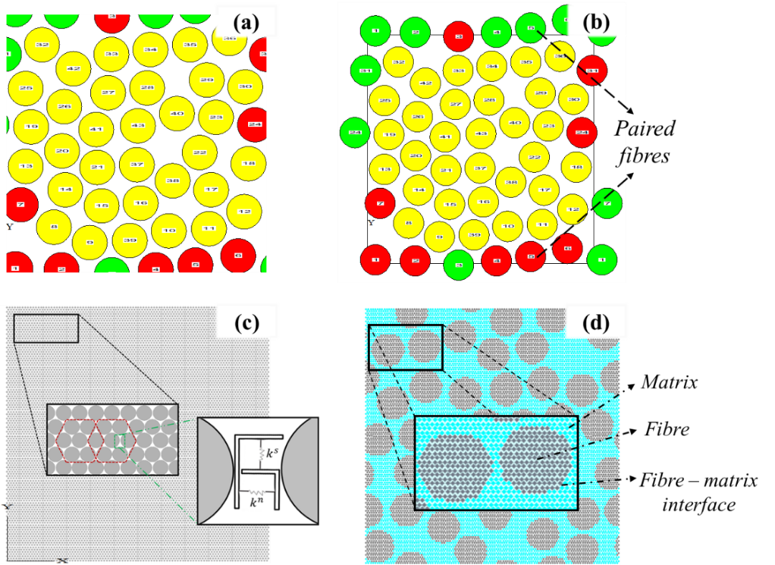
Figure 1: RVE with randomly distributed fibres and discrete element discretisation. (a) Random fibre distribution in an RVE. (b) Paired fibres on the boundaries of an RVE. (c) Discrete element discretisation using hexagonally packing arrangement. (d) An RVE sample of the DEM model.

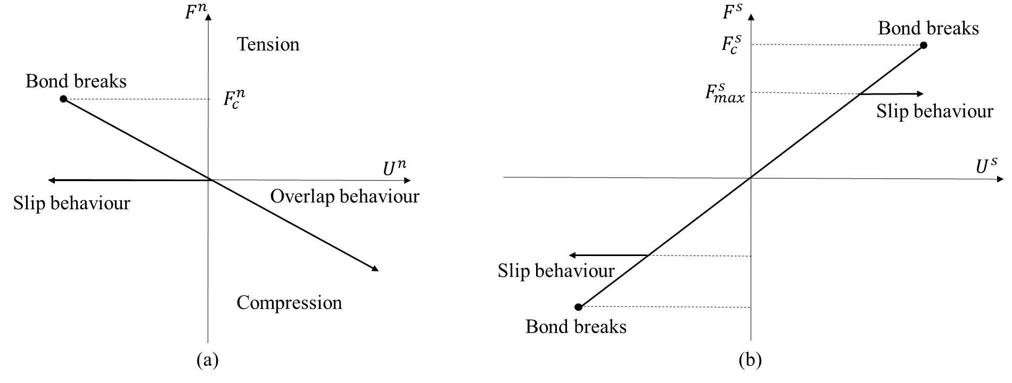
Figure 2: Force-displacement laws of the parallel-bond model. (a) Normal behaviour. (b) Shear behaviour.

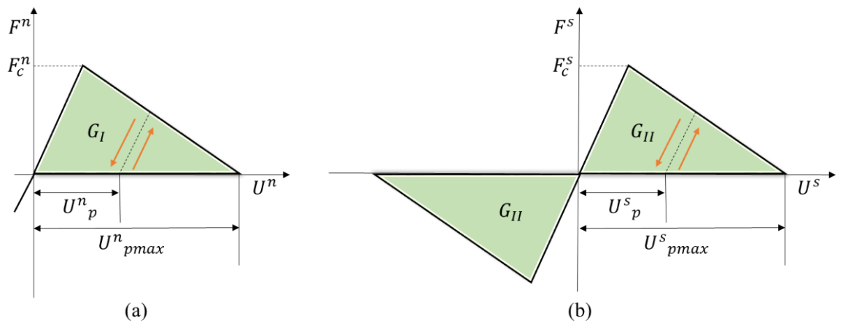
Figure 3: Force-displacement laws of the displacement-softening model. (a) Normal behaviour. (b) Shear behaviour.

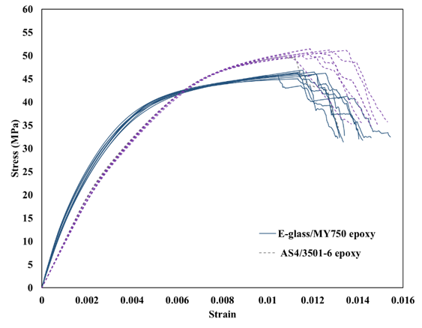
Figure 4: DEM simulated stress-strain curves of AS4/3501-6 epoxy lamina and E-glass/MY750 epoxy lamina.

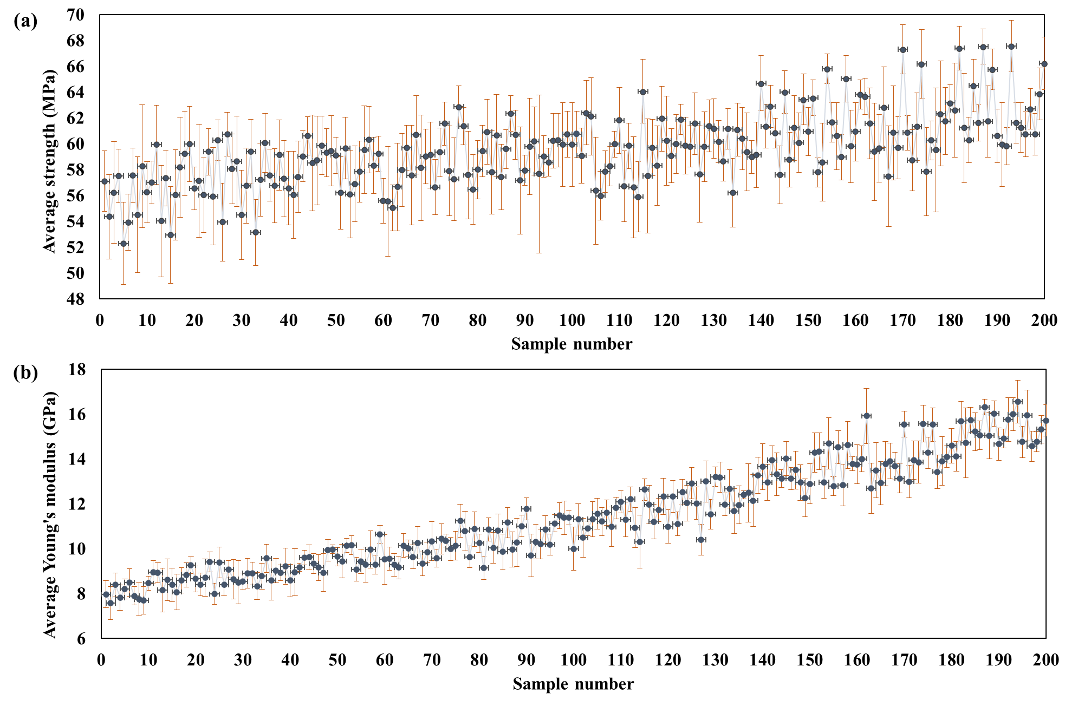
Figure 5: Variance plot for (a).the average tensile strength and (b).the average Young's modulus.

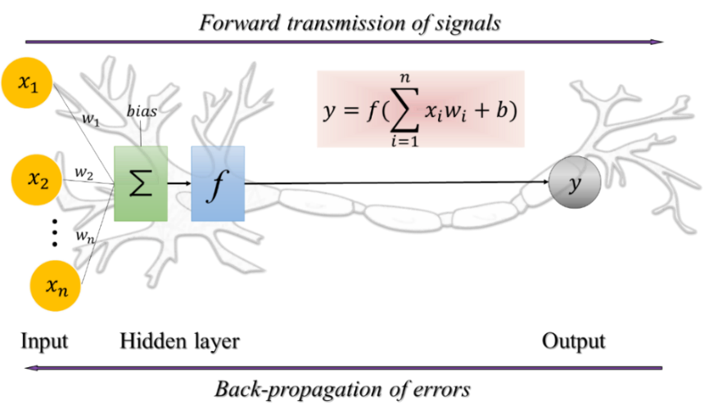
Figure 6: Architecture of a simplified artificial neuron network with back-propagation feedback.

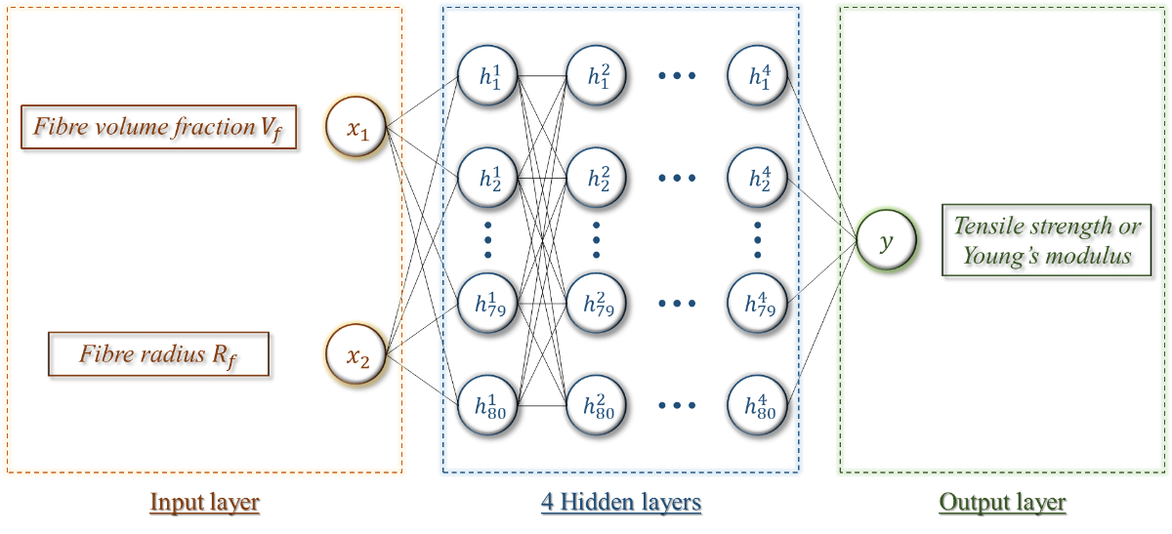
Figure 7: A multi-layer DNN model for the predictions of the transverse mechanical properties.

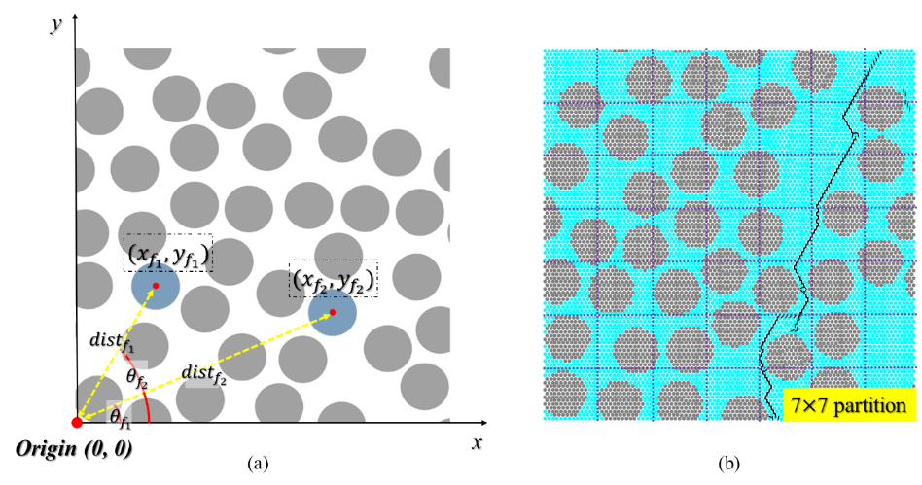
Figure 8: Data pre-processing based on the generated RVE. (a) Feature selections. (b) RVE partition.

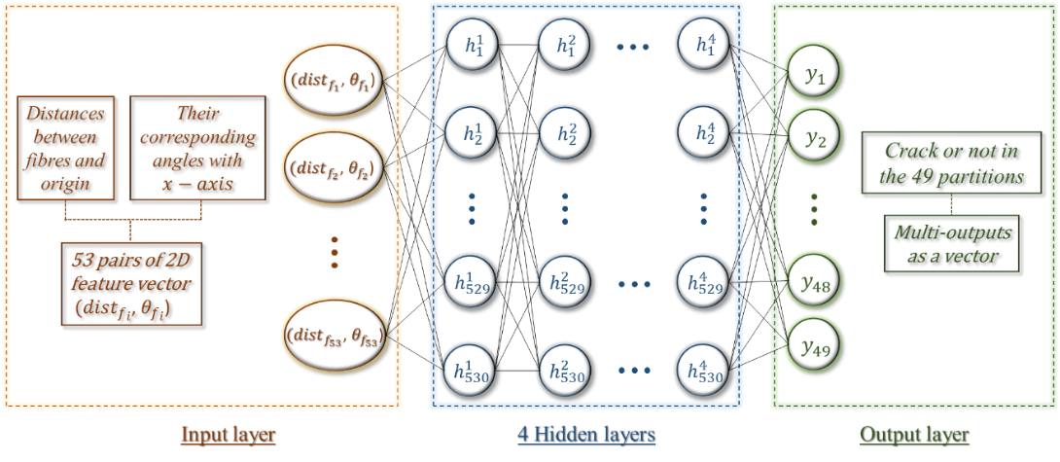
Figure 9: A multi-layer DNN model for the predictions of crack path

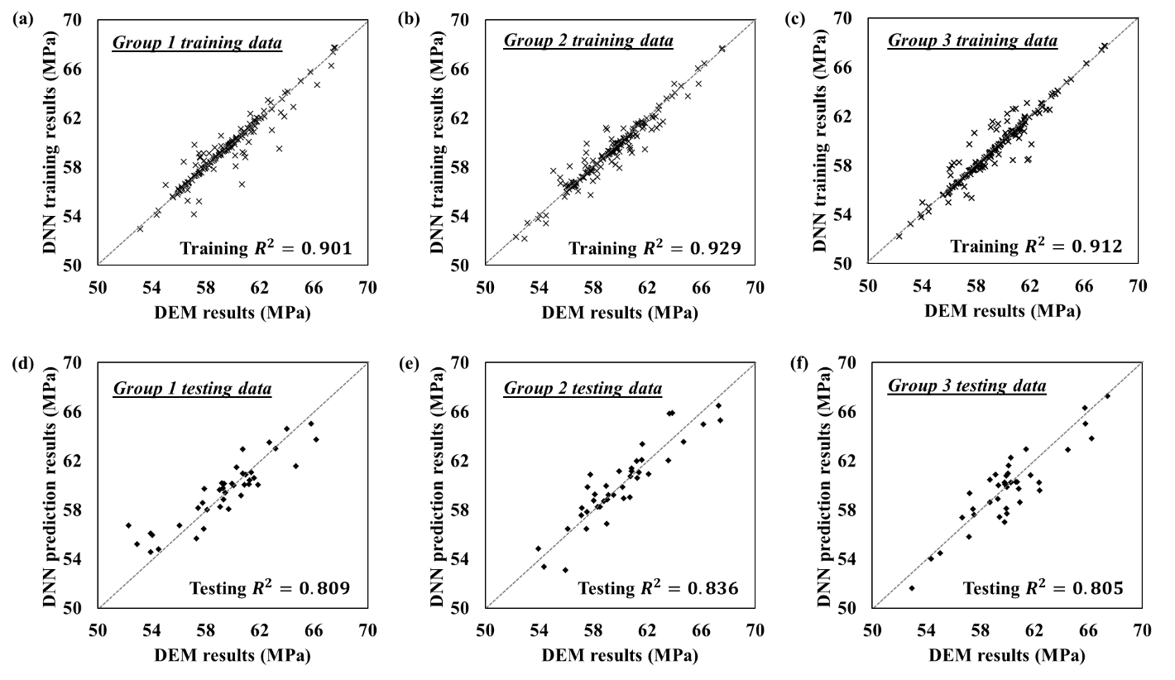
Figure 10: Comparison of the training results and prediction results for the transverse tensile strength using 3-fold cross-validation and Min-max normalization method. (a-c) Training results of Group 1, Group 2 and Group 3. (d-f) Testing results of Group 1, Group 2 and Group 3.
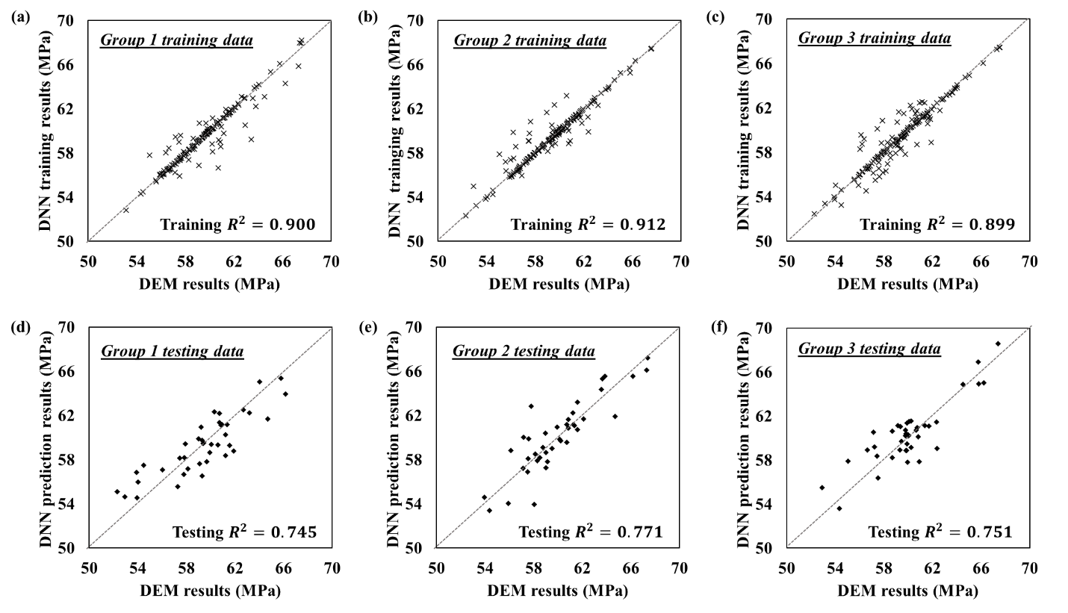
Figure 11: Comparison of the training results and prediction results for the transverse tensile strength using 3-fold cross-validation and Z-score normalization method. (a-c) Training results of Group 1, Group 2 and Group 3. (d-f) Testing results of Group 1, Group 2 and Group 3.
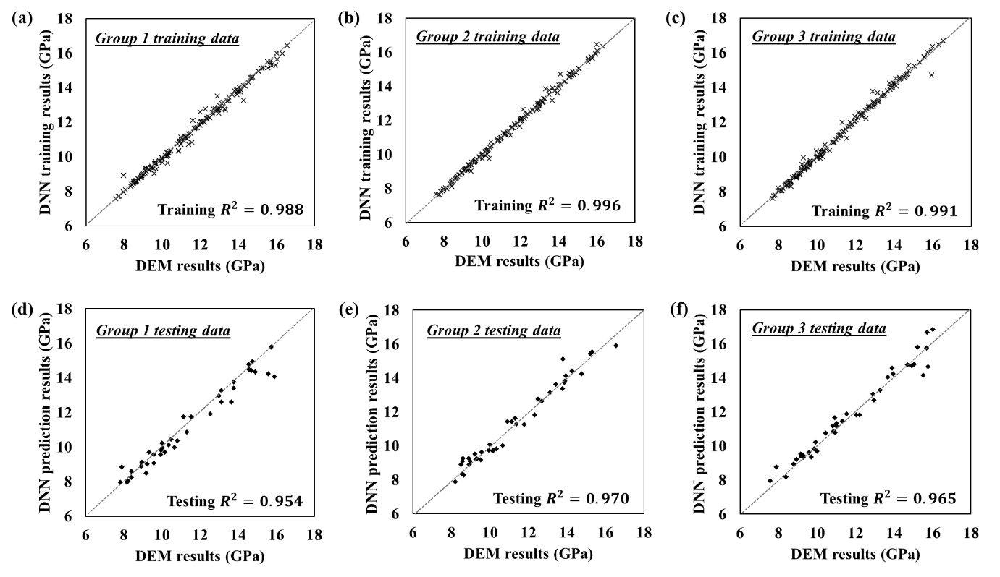
Figure 12: Comparison of the training results and prediction results for the transverse Young's modulus using 3-fold cross-validation and Min-max normalization method. (a-c) Training results of Group 1, Group 2 and Group 3. (d-f) Testing results of Group 1, Group 2 and Group 3.
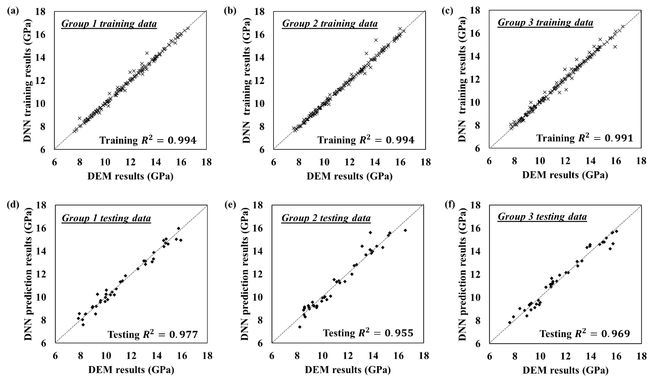
Figure 13: Comparison of the training results and prediction results for the transverse Young's modulus using 3-fold cross-validation and Z-score normalization method. (a-c) Training results of Group 1, Group 2 and Group 3. (d-f) Testing results of Group 1, Group 2 and Group 3.

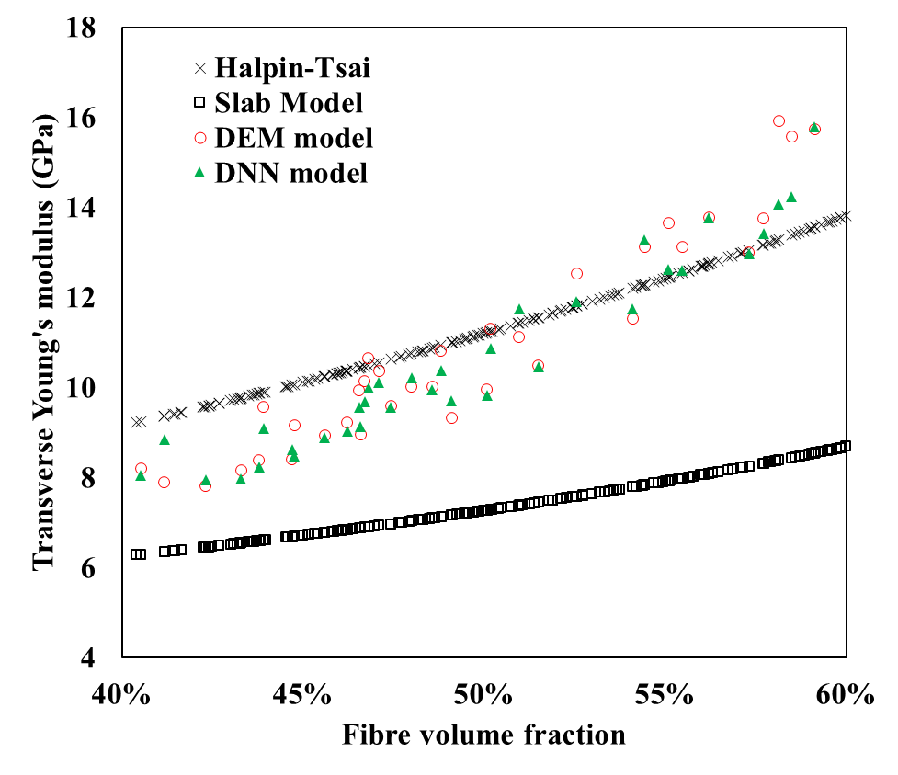
Figure 14: Comparison of transverse Young's modulus determined by two analytical models, the RVE based DEM model and the DNN predictive model.
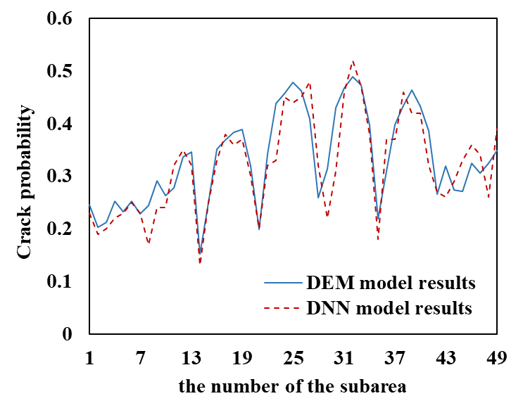
Figure 15: The crack probabilities based on DEM model results and DNN prediction results.

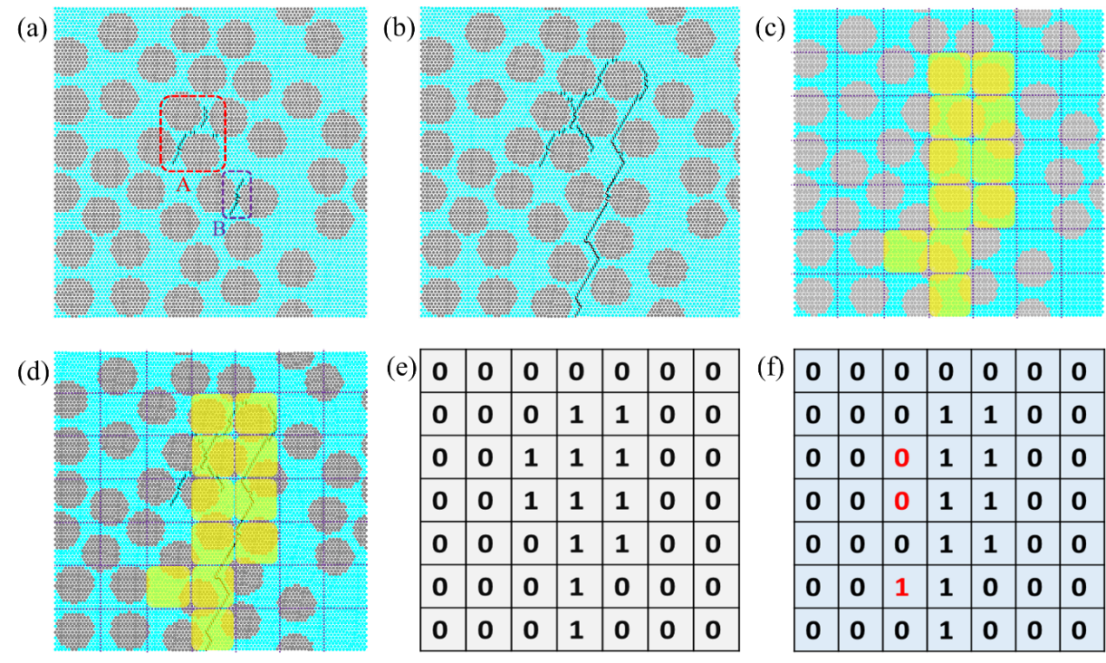
Figure 16: (a) Initial cracks in the first RVE simulated by DEM model. (b) DEM model simulation of the crack path. (c) DNN prediction of crack path. (d) Result combined with DEM simulated cracks and DNN predicted crack subareas. (e) Table of results of crack path from the DEM simulation. (f) Table of results of crack subareas from the DNN prediction.
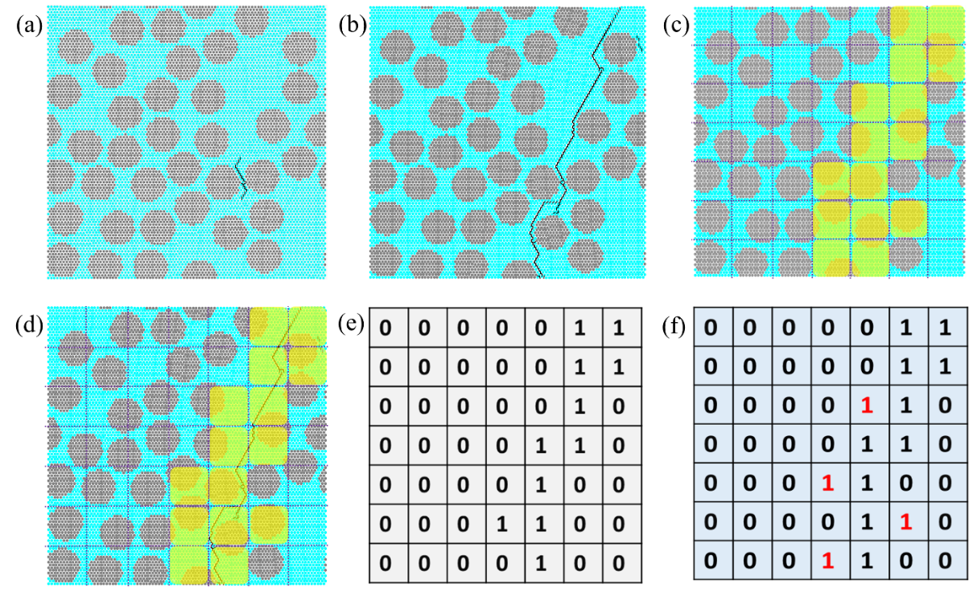
Figure 17: (a) Initial cracks in the second RVE simulated by DEM model. (b) DEM model simulation of the crack path. (c) DNN prediction of crack path. (d) Result combined with DEM simulated cracks and DNN predicted crack subareas. (e) Table of results of crack path from the DEM simulation. (f) Table of results of crack subareas from the DNN prediction.

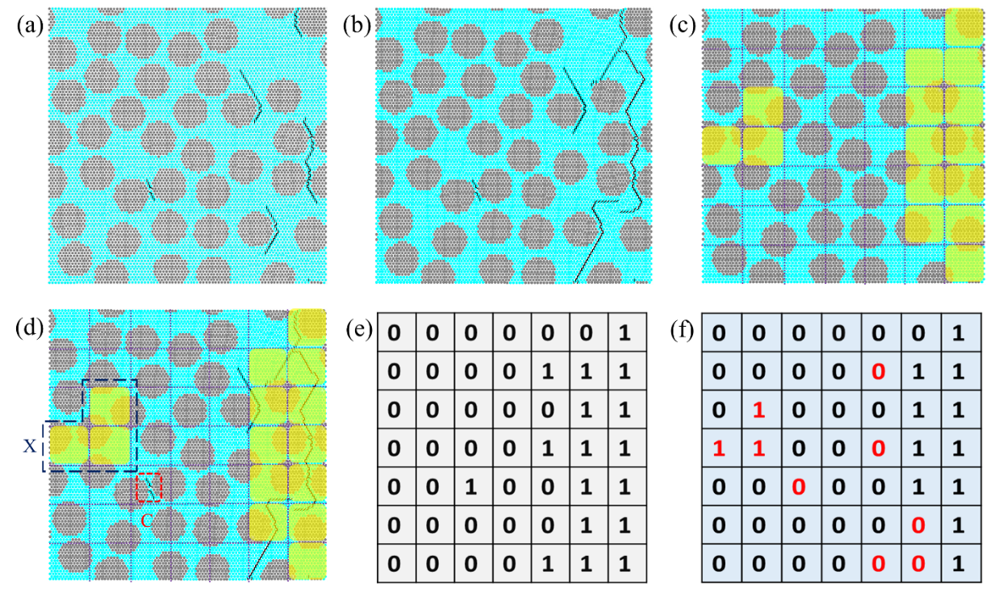
Figure 18: (a) Initial cracks in the third RVE simulated by DEM model. (b) DEM model simulations of the crack path. (c) DNN predictions of crack path. (d) Result combined with DEM simulated cracks and DNN predicted crack subareas. (e) Table of results of crack path from the DEM simulation. (f) Table of results of crack subareas from the DNN model.

Tables:

Table 1: Material properties of fibre, matrix and interface [28].
Fibre | Transverse modulus, $E_{f} (GPa)$ | 40
 | Poisson’s ratio, $V_{f}$ | 0.25
Matrix | Modulus, $E_{m} (GPa)$ | 4
 | Poisson’s ratio, $V_{m}$ | 0.35
 | Tensile strength, $σ_{mt} (MPa)$ | 60
Interface | Interface strengths,$σ_{max} (MPa)$  Facture energy, G (J/m²) | 39.1  10

Table 2: Transverse modulus and transverse tensile strengths obtained by DEM model and experimental test for two UD FRP laminae.
 | AS4/3501-6 epoxy |  | E-glass/MY750 epoxy
 | DEM | Experiment [31] | DEM | Experiment[31]
Fibre volume fraction | 60.7% | 60% | 59.6% | 60%
Transverse modulus $(GPa)$ | 10.1 | 11 | 15.8 | 16.2
Transverse tensile strength $(MPa)$ | 50 | 48 | 44 | 40

Table 3: Two variables in DoE and their lower and upper bounds.
Parameters (DoE) | Lower Bound | Upper Bound
Fibre volume fraction, $V_{f}$ | 40% | 60%
Fibre radius, $R_{f}$ ($μm$) | 3 | 5

Table 4: Two analytical micromechanics models for transverse Young’s modulus.
Model | Transverse Young’s modulus
Slab model | $\frac{E_{T}}{E_{m}}= \frac{E_{f}}{V_{f}E_{m} + V_{m}E_{f}}$
Halpin-Tsai Equations | $\frac{E_{T}}{E_{m}}= \frac{1+ {ξηV}_{f}}{1-{ηV}_{f}}$, where $η= \frac{\frac{E_{f}}{E_{m}}-1}{\frac{E_{f}}{E_{m}} + ξ}$ and $ξ=2(a/b)$

