The impact of field margins on biological pest control: a meta-analysis.
Abstract
Floral field margins are known to benefit invertebrate species diversity and abundance within agricultural landscapes, but variation in success limits widespread uptake. Understanding of variation within floral field margins and margins can affect certain entomological groupings is lacking but would allow for a more individualised design of margins to enhance biological control. This meta-analysis aims to answer the question; do floral field margins benefit biological pest control over grassy field margins? Finding that floral margins significantly benefit the natural enemy community and biological control services, relative to non-floral grass margins. We confirm that field margin type is linked to higher abundance and diversity of natural enemies, lower numbers of herbivorous invertebrate pests, and reduced crop damage. We consider whether specific characterisations of natural enemies and pest communities vary between these margin types; finding key differences in the abundances of aerial and epigeal enemies, the diversity of parasitoid and predatory enemies and pest abundances found in naturally regenerating and sown floral field margins. The finding here cements the implementation of floral field margins as a legitimate control method for crop pests in the face of pesticide losses and highlights design and management considerations for the success of floral margins.
Keywords
Biological control, floral field margins, natural enemies, ecosystem service, natural regeneration.
Statements and Declarations
The authors confirm that there are no interests that are directly or indirectly related to the work submitted for publication.
Introduction
Over recent years, pest control in agriculture has become a growing concern. The decline in available forms of chemical pest control, through legislation and declining efficacy, has led to a rising reliance on biological control services provided by the local ecosystem (Chaplin-Kramer et al. 2011). Although, the long-term overreliance on chemical control and widespread monoculture systems have caused considerable degradation to these services (Bommarco, Kleijn & Potts, 2013). Ecosystem services, the beneficial services obtained by humans from the environment, have significantly diminished as a whole within agricultural landscapes, due to habitat loss and fragmentation, and intensive agricultural production (Holland et al. 2017; Albrecht et al. 2020). Additional concerns over biodiversity declines on a larger scale have led to the promotion of Integrated Pest Management (IPM), which promotes sustainable, ecosystem-based pest control systems, that focus on long-term results, through the combination of multiple pest control techniques (Barzman et al. 2015). Such techniques include the promotion or restoration of diverse hedgerows, the creation of semi-natural habitats, crop rotation, the development of pest and disease-resistant varieties (Rusch et al. 2013; Ramsden et al. 2015; Montgomery, Caruso & Reid, 2020). Such pest control techniques are classified as conservation biological control; a broad definition for techniques that reduce reliance on pesticides through promoting beneficiary invertebrates (Begg et al. 2017).
Establishment of floral field margins; linear areas of uncultivated herbaceous habitats, established between crops and field boundaries; is a widely implemented technique that has been identified as a successful approach to combat local biodiversity losses and preserve and restore associated ecosystem services (Marshall & Moonen, 2002; Bianchi & Wäckers, 2008; Bommarco et al. 2013; Albrecht et al. 2020). In the UK, maintaining uncultivated ‘green cover’ (i.e. grass margins) between boundary habitats or structures (e.g. hedgerows) and the cultivatable area, is incorporated within Cross Compliance; the rules farmers must stay within the receive rural payments (Ernoult et al. 2013). Such grass margins are commonly characterised by low floral diversity, potentially including some species considered agricultural weeds, such as docks (Rumex spp.), nettles (Urtica spp.) and thistles (Cirsium spp.), and a high abundance of competitive grasses (Marshall & Moonen, 2002). Grass field margins support essential resources required by naturally occurring enemies of crop pests, beyond those supplied by the crop (Ramsden et al. 2015; Bishoff et al. 2016). Such resources include shelter (over winter and during times of agricultural activity), oviposition or nesting sites to promote reproduction and food resources (Shackelford et al. 2013; Ramsden et al. 2015; Holland et al. 2016; Albrecht et al. 2020). Floral margins have been highlighted as a prospective option to increase the quantity and diversity of such resources (Karp et al. 2011).
Understanding the effectiveness of floral field margins and the mechanisms by which they contribute to the biocontrol of crop pests is a complex task but can lead to improvement in the establishment and management of future margins (Chaplin-Kramer et al. 2011), as well as adding to our understanding as to why sometimes conservation biological control measures fail (Karp et al. 2018). Consideration can be made to the nature of establishment and continuous management of floral field margins: i) sown to promote diversity or ii) managed to promote diversity, often termed “naturally regenerated” or “weedy margins”. A wide array of seed mixes are available commercially which allows quick establishment of floral field margins, and may be specifically designed to provide diverse floral resources over a long flowering period. Though these mixes can be effective in doing so, they can also introduce non-native species (Garland & Wells, 2020). An alternative method to increased diversity is to develop an appropriate management regime for an existing margin to foster the seed bank and increase species diversity, such as limiting grazing pressure and removal of annual cuttings (Fritch et al. 2011).
Another factor influencing the efficacy with which field margins support biological control is the assemblage of natural enemies delivering pest control. The natural enemies involved may constitute a relatively diverse suite of organisms with differing resource requirements. Within this group, functionally important subdivisions may also be formed depending on factors such as mode of action (pathogens, parasites and parasitoids, and predators), dietary specialism, and guild. The members of each of these groupings depend on different resources, over different timeframes, within the wider ecosystem. Thus, tailoring floral field margins to particularly effective groups, in terms of biocontrol, could be advantageous. Pathogens are microorganisms that cause disease, increasingly utilised by application for biocontrol, much like a pesticide (Lacey et al. 2015). While these organisms are likely to already be present in the environment, floral field margins have the potential to act as a refuge for pathogens, providing alternative hosts to promote continuous infection and a stabilised local microclimate (Baverstock, Clark & Pell, 2008). Many parasitoid adults require pollen and nectar resources for survival and reproduction, meaning the provisioning of a high quantity of quality open floral resources is imperative to promote their associated services (Ramsden et al. 2015). Dietary specialism refers to the broadness of a given species' diet/host range; generalist natural enemies will rely on a myriad of food resources, while specialists will have a narrower diet/host range, utilising a smaller group, or even a singular species (Hsu, Ou and Ho, 2021). Authors disagree with the labelling of some families as distinctly specialist or generalist, a general consensus can be found based on the majority of that group, though outliers may be included. Finally, the guild is a term here used to describe the area in which an arthropod carries out the majority of its activity; aerially (flying) or epigeal (on the soil surface; Martin et al. 2012).
Invertebrate pest species can also be categorised in several functionally relevant ways: for example, based on which life stage causes damage, the mode of feeding, or the morphological development pathway. Here, we use the classifications of endopterygota and exopterygota, reflecting morphological development characteristics. Endopterygota species are those that go through distinct larval, pupal, and adult life-cycle stages, characterised by changes in morphology and behaviour. Invertebrate orders that fall into this grouping include Coleoptera, Diptera, Hymenoptera, and Lepidoptera. In contrast, exopterygota closely resemble adults throughout their life, with small, gradual changes occurring between life stages (Wilby & Thomas, 2002). Hemiptera and Thysanoptera are key orders within exopterygota. The differences between these groupings may be important in terms of biological pest control; endopterygota may occupy entirely differing niches throughout their life cycles, thus there could be a different natural enemy assemblage associated with distinct stages (Strand & Obrycki, 1996; Bernays, 1998). It has been predicted that a greater diversity of natural enemies may be required to provide full control of endopterygota, in comparison to exopterygota, which utilise similar resources throughout their life cycle (Wilby & Thomas, 2002).
Recent meta-analyses confirm that specifically designed floral field margins can positively influence biological control as a whole (Dainese et al. 2019; Albrecht et al. 2020). In this meta-analysis, the addition of categorisation of natural enemies, crop pests and field margin type, will enable a more nuanced understanding of the ways in which floral margins influence the local invertebrate population. The main research question in this meta-analysis is: do floral field margins benefit biological pest control over grassy field margins? This will first be accessed using the abundance and diversity of the local arthropod natural enemy community, the abundance of invertebrate pests and crop damage. The following questions aim to further elucidate the role of field margins: (1) Do floral field margins benefit dietary specialist or generalist natural enemies?; (2) Do floral field margins affect natural enemies of differing guilds differently?; (3) Do floral field margins promote pest control services in the local landscape?; and (4) Do floral field margins best promote control of endopterygote or exopterygote herbivorous pests?

Materials and Methods
Literature search
Studies were selected based on a search of scientific articles in Web of Science Core Collection using the following search terms; (“biological control” OR “biocontrol” OR “pest control” OR “natural enem*” OR predator* OR parasite*) AND (“floral field margin*” OR “field margin*” OR “field border*” OR “field boundar*” OR “field edge*” OR “insectary strips” OR “field strip*” OR “wildflower strip*” OR “flower strip*” OR “grassy strip*”). The search was limited to the last 20 years (2000-2021). Additional searches were done of reference lists to ensure no appropriate studies were missed. Studies were included if they complied with the following criteria: i) made a comparison of species abundance and diversity of invertebrate natural enemies and/or pest species in field margins or adjacent crop, ii) used grass field margins as the control for comparison, iii) had a minimum of two replicates per treatment, and iv) reported test statistics, means and standard error or sample sizes needed to calculate test statistics, for comparative analysis (Pastor & Lazowski, 2017). These criteria were necessary to remove studies that did not fit the topic being reviewed (see Supplementary Figure S1). Where possible additional test statistics or necessary information was collected on crop damage and yield. Authors of studies that did not report all necessary information were contacted for the original data sets, if data sets were provided the study was included within the study. The search terms produced 556 results (as of 11/02/2021). A total of 171 test statistics were identified from 40 studies that met all criteria for analysis of the influence of field margin composition on pest and natural enemy communities. Studies could produce multiple test statistics if multiple response variables were measured. Three studies produced six test statistics of crop damage, and three studies produced four test statistics of yields (see Supplementary Table S1).
Statistical analysis
As is common practice (Shackelford et al. 2013; Dainese et al. 2019), for each study, Pearson's correlation coefficient r was calculated based on reported test statistics, or means, samples sizes and standard deviations, using the formulas found in Lipsey and Wilson (2000) and Borenstein et al. (2009). This was used to provide a standard unit for comparison to be input into the model. This analysis was conducted using the metafor package (Viechtbauer, 2010) in R 4.0.3 (R Core Team, 2021). This package was chosen due to its ability to conduct meta-analyses and moderator (predictor variable) analyses, giving it the ability to fit meta-regression models using continuous or categorical predictor variables. Within metafor, the Pearson’s corelation coefficient r values were transformed once more using Fisher’s z-transformation (z’ = 1/2ln[(1+r)/(1-r)]; Hedges and Olkin, 1985) so that the data set was normally distributed. Fisher’s z-transformation was selected in favour of Hedges’ d, due to the potential bias associated with the latter (Hamman et al. 2018). This transformation function provided the Fisher’s z value and a measure of the corresponding variance, based on sample size, to assign a weighting of precision to each study. Test statistics were split by response variable: natural enemy abundance, natural enemy diversity, pest abundance, crop damage, yield.
The meta-analysis was conducted using a random-effect meta-regression (rma function), with a restricted maximum-likelihood estimator to estimate heterogeneity (Viechtbauer, 2005). When testing the influence of predictor variables, a mixed-effect model was utilised (with study as the random effect), to account for multiple test statistics coming from the same studies, and the Wald χ² test was used, as a single model was being tested. For each response variable, the model was fit, and then each predictor variable was tested separately. For the classifications of species features in the included studies see Supplementary Table S2.
A test for heterogeneity was conducted to establish variance across all studies; a diagnostic Baujat plot was used to visualise any particular studies influencing the overall heterogeneity, using diagnostics for checking the quality of regression fits. The included studies were reviewed for potential outliers and extreme outliers were removed from the analysis (Baujat et al. 2002; see Supplementary Figure S2). To assess publication bias, a funnel plot was generated to visually highlight any apparent bias, this visualised standard error against the correlation coefficients (Peters et al. 2008; see Supplementary Figure S3). Two tests were conducted to test for bias: regression test for funnel plot asymmetry and rank correlation test for funnel plot asymmetry, both giving non-significant results: p = 0.609 and p = 0.608, respectively, suggesting low publication bias.
Results
Natural enemy abundance
A total of 92 test statistics reported the difference in the abundance of natural enemy communities between grass and floral field margins. Overall, there was a significant difference in the abundance of natural enemies between grass margins and the floral margins (z=8.71, P<0.001). In the predictor variable analysis, natural enemy type, dietary specialism and floral margin type were found to have no significant influence on the difference found between floral and grass margins. However, the natural enemy guild classification (aerial versus epigeal species), was found to be a significant predictor of the difference between natural enemy abundances (χ²=12.921, df=1, P<0.001; see Figure 1 and Table 1). Although floral strips show higher abundances of both guilds, the difference is significantly greater for epigeal compared with aerial natural enemies.
Natural enemy diversity
Overall, the results of the random-effect model (n=24) showed that there is a significant difference in the species diversity between the grass control treatment compared to the floral field margin treatment (z=8.07, P<0.001). The predictor variables of natural enemy diet, guild, and type of floral margin showed to have no significant influence on the variability seen between the grass control margin and the floral margin treatments. The diversity of differing natural enemy type groupings did, however, account for some of the variability found (χ²=5.952, df=1, P=0.015; see Figure 2 and Table 1). Both parasitoid and predatory species diversity was higher in floral margins compared to grass margins. Though, the greatest difference was found in species counts of parasitoid species.
Pest abundance
Forty test statistics were generated based on the difference between pest abundance in floral and grass margins. Overall, there was a significant difference in pest abundance between areas associated with grass margins and floral margins (z=4.53, P<0.001). The abundance of individuals in the pest community was assessed using the predictor variables; morphological development (χ²=1.484, df=1, P=0.223) and the margin type (sown or regenerated; χ²=20.748, df=1, P <0.001, see Figure 3 and Table 1). The type of floral field margin (sown to regenerated) accounted for the largest variation found in pest abundances, with regenerated margins contributing slightly more to this variation found between the grass control than sown margins. This result is one of the key results in terms of farmer and grower interest; a reduced number of pests within crops associated with the establishment of both types of floral field margins, and specifically regenerated margins, continuously managed to promote diversity.
Crop damage
Analysis of crop damage was limited due to sample size (n=6). Thus, no predictor variable analysis was conducted. Overall, there was a significant difference in crop damage associated with grass (control) field margins and floral field margins, as a whole (z=3.63, P<0.001), being lowest when the field margins were floral. As with pest abundance, this is another key metric for farmers and growers, confirmation that floral margins benefit the control of damage in the crop in comparison to grass field margins is imperative for the continuous establishment and management of floral margins.
Discussion
This analysis of published studies demonstrates a conclusive positive response from biological control services based on the establishment of floral field margins, relative to standard grass margins. We conclude that floral field margins are associated with a significant increase in abundances and species diversity of natural enemies of crop pests, as well as a significant decrease in pest abundance and crop damage. This confirmation that the establishment of specific non-crop habitats increases biological control services is hugely important, not only for farmers and growers in terms of yield quantity and quality but also as a broader incentive to manage habitats in a wildlife-friendly way to benefit ecosystem services (Chaplin-Kramer et al. 2011; Albrecht et al. 2020; Hatt et al. 2020).
Natural enemy communities
Both abundance and the species diversity of the natural enemy community were found to be significantly greater in areas associated with floral field margins compared to grass field margins. This result supports the thought that floral field margins are able to better support beneficial arthropod communities through greater resource provisioning and the creation of stable micro-ecosystems within an unstable landscape (Gardner et al. 2021). It is important to note that a more diverse community can benefit a community’s adaptive capacity in the face of local environmental change (i.e. agricultural activities; Hellmann et al. 2016). This is due to a greater number of niches fulfilled, with species that can each tolerate a differing variety of environmental conditions (Tilman, Lehman & Bristow, 1998). Previous meta-analyses highlight the wider local landscape heterogeneity as a key consideration when evaluating the success of floral field margins. Complex agroecosystems offer a higher abundance and diversity of habitats and therefore resources and can act as a source for rapid migration of beneficial invertebrates to new habitats (Shackelford et al. 2013; Holland et al. 2017).
The predictor analysis results concluded that grouping the natural enemy community by enemy type (predator or parasitoid) and guild (aerial or epigeal) can aid us in understanding how natural enemy communities respond to the establishment of floral field margins. In terms of natural enemy abundance, epigeal natural enemies benefitted more than aerial, though both were significantly more abundant in association with floral margins compared to grass. This was unexpected, given aerial enemies largely encompass parasitoid wasps which directly benefit from increased floral diversity (Lavandero et al. 2006; Géneau et al. 2012). However, both ground beetles and spiders, two of the largest groups of epigeal natural enemies, are known to significantly benefit from increased plant diversity, with the benefits being based more on microclimate, vegetation structure and ease of mobility, over nectar and pollen resources (Meek et al. 2002; Ditner et al. 2013).
For natural enemy diversity, the enemy type classification was a significant predictor of the difference between floral and grass margins, with the difference being found in parasitoid (rather than predator) species diversity. Our understanding of the reasoning behind parasitoid diversity benefiting more so from an increased floral diversity is relatively straightforward; a large proportion of this grouping requires pollen and nectar resources in their adult stage to power reproduction and maintain fitness (Lavandero I et al. 2006; Wäckers and van Rijn, 2012). Thus, greater abundance and diversity of floral resources equates to greater resource variability and availability (Ramsden et al. 2015). The predictor variables dietary specialism and floral margin types did not significantly describe any of the difference found between floral and grass margins. It appears that both specialist and generalist natural enemies are significantly supported by floral margins of any kind (McCabe et al. 2017).
Pest abundance & crop damage
Counts of pest abundance were found to be significantly different between grass field margins and floral field margins, with floral margins playing host to fewer individual pests. Likewise, crop damage was shown to be significantly reduced in association with floral field margins, though the limited number of studies that assessed crop damage prevented further analysis of predictor variables. Both pest abundance and cop damage are key for farmers and growers when considering the effectiveness of a control measure; here we can successfully say that floral field margins can benefit biological control services, through the reduction in pest counts and crop damage, more so than standard grass field margins (Letourneau et a. 2011).
Predictor variable analysis found that the type of floral field margin was a significant influence on arthropod pest responses. Of the two types of floral margin, the naturally regenerated margins were shown to support fewer individual pests than sown margins. The reason for this finding could be two-pronged: 1) naturally regenerated margins support more natural enemies and so manage the number of pests, and/or 2) sown margins support more pest species than regenerated, though still fewer than grass margins (Letourneau et al. 2011). There is evidence that herbivorous pests can benefit from the increase in floral species diversity, in much the same way as natural enemies would, as there is some overlap in resource requirements (Winkler et al. 2010; Wäckers and van Rijn, 2012; Karp et al. 2018). Though the predictor variable of morphological development proved to be non-significant, that overall significant increase in both natural enemy abundance and diversity might shroud this result.
Knowledge gaps
The data set collated here was distinctly biased towards predator natural enemies, over parasitoids and pathogens. This imbalance could be due to differences in the ease of surveying and identifying predators, and the total abundance of predators and parasitoids over known beneficial pathogens. The analysis of existing studies identified several areas where more research is needed; studies that included information regarding crop damage and crop yield were generally lacking. The failure to measure these outcomes of increasing local floral diversity highlights the redirection needed in future research, as these are the variables that quantify the effectiveness of floral field margins and increased implementation by persuading farmers and growers (Chaplin-Kramer et al. 2011; Albrecht et al. 2020). The addition of such data into the academic and public sphere will only continue to increase our understanding of floral field margins, and their ability to promote local biological control services. Though one size may never fit all when it comes to cultural biological controls, increasing and collating our knowledge in such ways as this meta-analysis will allow us to understand our failures and develop a reliable methodology to establish floral field margins for biological control.

References
Albrecht, M., Kleijn, D., Williams, N. M., Tschumi, M., Blaauw, B. R., Bommarco, R., Campbell, A. J., Dainese, M., Drummond, F. A., Entling, M. H., Ganser, D., de Groot, A., Goulson, D., Grab, H., Hamilton, H., Herzog, F., Isaacs, R., Jacot, K., Jeanneret, P., Jonsson, M., Knop, E., Kremen, C., Landis, D. A., Loeb, G. M., Marini, L., McKerchar, M., Morandin, L., Pfister, S. C., Potts, S. G., Rundlöf, M., Sardiñas, H., Sciligo, A., Thies, C., Tscharntke, T., Venturini, E., Veromann, E., Vollhardt, I. M. G., Wäckers, F., Ward, K., Westbury, D. B., Wilby, A., Woltz, M., Wratten, S., Sutter, L., 2020. The effectiveness of flower strips and hedgerows on pest control, pollination services and crop yield: a quantitative synthesis. Ecology Letters. 23(10), 1488-1498.
Barzman, M., Bàrberi, P., Birch, A. N. E., Boonekamp, P., Dachbrodt-Saaydeh, S., Graf, B., Hommel, B., Jensen, J. E., Kiss, J., Kudsk, P., Lamichhane, J. R., Messéan, A., Moonen, A-C., Ratnadass, A., Ricci, P., Sarah, J-L., Sattin, M., 2015. Eight principles of integrated pest management. Agronomy for Sustainable Development. 35, 1199-1215.
Baverstock, J., Clark, S. J., Pell, J. K., 2008. Effect of seasonal abiotic conditions and field margin habitat on the activity of Pandora neoaphidis inoculum on soil. Journal of Invertebrate Pathology. 97(3), 282-290.
Baujat, B., Mahé, C., Pignon, J-P., Hill, C., 2002. A graphical method for exploring heterogeneity in meta-analyses: application to a meta-analysis of 65 trials. Statistics in Medicine. 21(18), 2641-2652.
Begg, G. S., Cook, S. M., Dye, R., Ferrante, M., Franck, P., Lavigne, C., Lövei, G. L., Mansion-Vaquie, A., Pell, J. K., Petit, S., Quesada, N., Ricci, B., Wratten, S. D., Birch, A. N. E., 2017. A functional overview of conservation biological control. Crop Protection. 97, 145-158.
Bernays, E. A., 1998. Evolution of feeding behavior in insect herbivores. BioScience. 48(1), 35-44.
Bianchi, F. J. J. A., Wäckers, F. L., 2008. Effect of flower attractiveness and nectar availability in field margins on biological control by parasitoids. Biological Control. 46(3), 400-408.
Bischoff, A., Pollier, A., Lamarre, E., Salvadori, O., Cortesero, A-M., La Ralec, A., Tricault, Y., Jaloux, B., 2016. Effects of spontaneous field margin vegetation and surrounding landscape on Brassica oleracea crop herbivory. Agriculture, Ecosystem & Environment. 223, 135-143.
Bommarco, R., Kleijn, D., Potts, S. G., 2013. Ecological intensification: harnessing ecosystem services for food security. Trends in Ecology & Evolution. 28(4), 230-238.
Borenstein, M., Hedges, L. V., Higgins, J. P. T., Rothstein, H. R., 2009. Introduction to meta-analysis. United Kingdom: John Wiley & Sons, Ltd.
Chaplin-Kramer, R., O’Rourke, M. E., Blitzer, E. J., Kremen, C., 2011. A meta-analysis of crop pest and natural enemy response to landscape complexity. Ecology Letters. 14(9), 922-932.
Dainese, M., Martin, E. A., Aizen, M. A., Albrecht, M., Bartomeus, I., Bommarco, R., Carvalheiro, L. G., Chaplin-Kramer, R., Gagic, V., Garibaldi, L. A., Ghazoul, J., Grab, H., Jonsson, M., Karp, D. S., Kenndey, C. M., Kleijn, D., Kremen, C., Landis, D. A., Letourneau, D. K., Marini, L., Poveda, K., Rader, R., Smith, H. G., Tscharntke, T., Andersson, G. K. S., Badenhausser, I., Baensch, S., Bezerra, A. D. M., Bianchi, F. J. J. A., Boreux, V., Bretagnolle, V., Caballero-Lopez, Cavigliasso, P., Ćetković, A., Chacoff, N. P., Classen, A., Cusser, S., Da Silva E Silva, F. D., De Groot, G. A., Dudenhöffer, J. H., Ekroos, J., Fijen, T., Franck, P., Freitas, B. M., Garratt, M. P. D., Gratton, C., Hipólito, J., Holzschuh, A., Hunt, L., Iverson, A. L., Jha, S., Keasar, T., Kim, T. N., Kishinevsky, M., Klatt, B. K., Klein, A-M., Krewenka, K. M., Krishnan, S., Larsen, A. E., Lavigne, C., Liere, H., Maas, B., Mallinger, R. E., Pachon, E, M., Martínez-Salinas, A., Meehan T, D., Mitchell, M. G. E., Molina, G. A. R., Nesper, M., Nilsson, L., O’Rourke, M. E., Peters, M. K., Plećaš, M., Potts, S. G., Ramos, D. L., Rosenheim, J. A., Rundlöf, M., Rusch, A., Sáez, A., Scheper, J., Schleuning, M., Schmack, J. M., Sciligo, A. R., Seymour, C., Stanley, D. A., Stewart, R., Stout, J. C., Sutter, L., Takada, M. B., Taki, H., Tamburini, G., Tschumi, M., Viana, B. F., Westphal, C., Willcox, B. K., Wratton, S. D., Yoshioka, A., Zaragoza-Trello, C., Zhang, W., Steffan-Dewenter, I., 2019. A global synthesis reveals biodiversity-mediated benefits for crop production. Science Advances. 5(10), eaax0121.
Ditner, N., Balmer, O., Beck, J., Blick, T., Nagel, P., Luka, H., 2013. Effects of experimentally planting non-crop flowers into cabbage fields on the abundance and diversity of predators. Biodiversity and Conservation. 22, 1049-1061.
Ernoult, A., Vialatte, A., Butet, A., Michel, N., Rantier, Y., Jambon, O., Burel, F., 2013. Grassy strips in their landscape context, their role as new habitat for biodiversity. Agriculture, Ecosystems & Environment. 166, 15-27.
Fritch, R. A., Sheridan, H., Finn, J. A., Kirwan, L., Ó HUallacháin, D., 2011. Methods of enhancing botanical diversity within field margins of intensively managed grassland: a 7-year field experiment. Journal of Applied Ecology. 48(3), 551-560.
Gardner, E., Breeze, T. D., Clough, Y., Smith, H. G., Baldock, K. C. R., Campbell, A., Garratt, M. P. D., Gillespie, M. A. K., Kunin, W. E., McKerchar, M., Potts, S. G., Senapathi, D., Stone, G. N., Wäckers, F., Westbury, D. B., Wilby, A., Oliver, T. H., 2021. Field boundary features can stabilise bee populations and the pollination of mass-flowering crops in rotational systems. Journal of Applied Ecology. 58(10), 2287-2304.
Garland, L., Wells, M. J. 2020. Native planting versus non-native planting: the state of the debate. In Douglas, I., Anderson, P. M. L., Goode, D. Houck, M. C., Maddox, D., Nagendra, H. and Tan P. Y. The routledge handbook of urban ecology. 2nd ed. Routledge: United Kingdom. pp. 1051-1061.
Géneau, C. E., Wäckers, F. L., Luka, H., Daniel, C., Balmer, O., 2012. Selective flowers to enhance biological control of cabbage pests by parasitoids. Basic and Applied Ecology. 13(1), 85-93.
Hamman, E. A., Pappalardo, P., Bence, J. R., Peacor, S., D., Osenberg, C. W., 2018. Bias n meta-analyses using Hedges’ d. Ecosphere. 9(9), e02419.
Hatt, S., Francis, F., Xu, Q., Wang, S., Osawa, N., 2020. Perennial flowering strips for conservation biological control of insect pests: from picking and mixing flowers to tailored functional diversity. In Gao, Hokkanen, H. M., Menzler-Hokkanen. (eds) Integrative biological control. Pp 57-71. Cambridge: Springer.
Hedges, L. V., Olkin, I., 1985. Statistical methods for meta-analysis. London: Academic Press.
Hellmann, J. J., Grundel, R., Hoving, C., Schuurman, G. W., 2016. A call to insect scientists: challenges and opportunities of managing insect communities under climate change. Current Opinion in Insect Science. 17, 92-97.
Holland, J.M., Bianchi, F., Entling, M.H., Moonen, A.C., Smith, B.M., Jeanneret, P., 2016. Structure, function and management of semi‐natural habitats for conservation biological control: a review of European studies. Pest Management Science. 72(9), 1638-1651.
Holland, J. M., Douma, J. C., Crowley, L., James, L., Kor, L., Stevenson, D. R. W., Smith, B. M., 2017. Semi-natural habitats support biological control, pollination and soil conservation in Europe. A review. Agronomy for Sustainable Development. 37(4), 31-54.
Hsu, G-C., Ou, J-A., Ho, C-K. 2021., Pest consumption by generalist arthropod predators increases with crop stage in both organic and conventional farms. Ecosphere. 12(7), e0325.
Karp, D. S., Chaplin-Kramer, R., Meehan, T. D., Martin, E. A., DeClerck, F., Grab, H., Gratton, C., Hunt, L., Larsen, A. E., Martínez-Salinas, A., O’Rourke, M. E., Rusch, A., Poveda, K., Jonsson, M., Rosenheim, J. A., Schellhorn, N. A., Tscharntke, T., Wratten, S. D., Zhang, W., Iverson, A. L., Alder, L. S., Albrecht, M., Alignier, A., Angelella, G. M., Anjum, M. M., Avelino, J., Avelino, J., Batáry, P., Baveco, J. M., Biachi, F. J. J. A., Birkhofer, K., Bohnenblust, E. W., Bommarco, R., Brewer, M. J., Caballero-López, B., Carrière, Y., Carvalheiro, L. G., Cayuela, L., Centrella, M., Ćetković, A., Henri, D. C., Chabert, A., Costamagna, A. C., De la Mora, A., de Kraker, J., Desneux, N., Diehl, E., Diekötter, T., Dormann, C. F., Eckberg, J. O., Entling, M. H., Fielder, D., Franck, P., Frank van Veen, F. J., Frank, T., Gagic, V., Garrett, M. P. D., Getachew, A., Gonthier, D. J., Goodell, P. B., Graziosi, I., Groves, R. L., Gur, G. M., Hajin-Forooshani, Z., Heimpel, G. E., Harrmann, J. D., Huseth, A. S., Inclán, D, J., Ingrao, A. J., Iv, P., Jacot, K., Johnson, G. A., Jones, L., Kaiser, M., Kaser, J. M., Keasar, T., Kim, T. N., Kishinevsky, M., Landis, D. A., Lavandero, B., Lavigne, C., Le Ralec, A., Lemessa, D., Letourneau, D. K., Liere, H., Lu, Y., Lubin, Y., Luttermoser, T., Maas, B., Mace, K., Madeira, F., Mader, V., Cortesero, A. M., Marini, L., Martinez, E., Martinson, H. M., Menozzi, P., Mitchell, M. G. E., Miyashita, T., Molina, G. A. R., Molina-Montenegro, M. A., O’Neal, M. E., Opatovsky, I., Ortiz-Martinez, S., Nash, M., Östman, Ö., Ouin, A., Pak, D., Paredes, D., Parsa, S., Parry, H., Perez-Alvarez, R., Perović, D, J., Peterson, J. A., Petit, S., Philpott, S. M., Plantegenest, M., Plećaš, M., Pluess, T., Pons, X., Potts, S. G., Pywell, R. F., Ragsdale, D. W., Rand, T. A., Raymond, L., Ricci, B., Sargent, C., Sarthou, J-P., Saulais, J., Schäckermann, J., Schmidt, N. P., Schneider, G., Schüepp, C., Sivakoff, F. S., Smith, H. G., Whitney, K. S., Stutz, S., Szendrei, Z., Takada, M. B., Taki, H., Tamburini, G., Thomson, L. J., Tricault, Y., Tsafack, N., Tschumi, M., Valantin-Morison, M., van Trinh, M., van der Werf, W., Vierling, K. T., Werling, B. P., Wickens, J. B., Wickens, V. J., Woodcock, B. A., Wyckhuys, K., Xiao, H., Yasuda, M., Yoshioka, A., Zou, Y., 2018. Crop pests and predators exhibit inconsistent responses to surrounding landscape composition. PNAS. 115(33), 7863-7870.
Lacey, L. A., Grzywacs, D., Shapiro-Ilan, D. I., Frutos, R., Brownbridge, M., Goettel. M. S., 2015. Insect pathogens as biological control agents: back to the future. Journal of Invertebrate Pathology. 132, 1-41.
Lavandero I, B., Wratten, S. D., Didham, R. K., Gurr, G., 2006. Increasing floral diversity for selective enhancement of biological control agents: A double-edged sward? Basic and Applied Ecology. 7(3), 236-243.
Letourneau, D. K., Armbrecht, I., Rivera, B. S., Lerma, J. M., Carmona, E. J., Daza, M. C., Escobar, S., Galindo, V., Gutiérrez, C., López, S. D., Mejía, J. L., Rangel, A. M. A., Rangel, J. H., Rivera, L., Saavedra, C. A., Torres, A. M., Trujillo, A. R., 2011. Does plant diversity benefit agroecosystems? A synthetic review. Ecological Applications. 21(1), 9-21.
Lipsey, M. W., Wilson, D., 2000. Practical meta-analysis. SAGE Publications, Inc. California, United States.
Martin, E. A., Reineking, B., Seo, B., Steffan-Dewenter, I., 2012. Natural enemy interactions constrain pest control in complex agricultural landscapes. PNAS. 110(14), 5534-5539.
Marshall, E. J., Moonen, A. C., 2002. Field margins in northern Europe: Their functions and interactions with agriculture. Agriculture, Ecosystems & Environment. 89(1), 5-21.
McCabe, E., Loeb, G., Grab, H., 2017. Responses of crop pests and natural enemies to wildflower borders depends on functional group. Insects. 8(3), 73.
Meek, B., Loxton, D., Sparks, T., Pywell, R., Pickett, H., Nowakowski, M., 2002. The effect of arable field margin composition on invertebrate biodiversity. Biological Conservation. 106(2), 259-271.
Montgomery, I., Caruso, T., Reid, N., 2020. Hedgerows as ecosystems: Service delivery, management, and restoration. Annual Review of Ecology, Evolution, and Systematics. 51, 81-102.
Pastor, D. A., Lazowski, R. A., 2017. On the multilevel nature of meta-analysis: a tutorial, comparison of software programs, and discussion of analytic choices. Multivariate Behavioral Research. 53(1), 74-89.
Peters, J. L., Sutton, A, J., Jones, D. R., Abrams, K. R., Rushton, L., 2008. Contour-enhanced meta-analysis funnel plots help distinguish publication bias from other causes of asymmetry. Journal of Clinical Epidemiology. 61(10), 991-996.
R Core Team., 2021. R: A language and environment for statistical computing. R Foundation for Statistical Computing, Vienna, Austria. URL https://www.R-project.org/.
Ramsden, M. W., Menendez, R., Leather, S. R., Wäckers, F., 2015. Optimizing field margins for biocontrol services: The relative role of aphid abundance, annual floral resources, and overwinter habitat in enhancing aphid natural enemies. Agriculture, Ecosystems & Environment. 199(1), 94-10.
Rusch, A., Bommarco, R., Jonsson, M., Smith, H. G., Ekbom, B., 2013. Flow and stability of natural pest control services depend on complexity and crop rotation at the landscape scale. Journal of Applied Ecology. 50(2), 345-354.
Shackelford, G., Steward, P. R., Benton, T. G., Kunin, W. E., Potts, S. G., Biesmeijer, J. C., Sait, S. M., 2013. Comparison of pollinators and natural enemies: A meta-analysis of landscape and local effects on abundance and richness in crops. Biological Reviews. 88(4), 1002-1021.
Strand, M. R., Obrycki, J. J., 1996. Host specificity of insect parasitoids and predators. BioScience. 46(6), 422-429.
Tilman, D., Lehman, C. L., Bristow, C. E., 1998. Diversity-stability relationships: statistical inevitability or ecological consequence? The American Naturalist. 151(3), 277-282.
Viechtbauer, W., 2005. Bias and efficiency of meta-analytic variance estimators in the random-effects model. Journal of Educational and Behavioral Statistics. 30(3), 261-293.
Viechtbauer,W., 2010. Conducting meta-analyses in R with the metafor package. Journal of Statistical Software. 36(3), 1–48.
Wäckers, F. L., van Rijn, P. C. J., 2012. Pick and mix: selecting flowering plants to meet the requirements of target biological control insects. In Biodiversity and insect pests: key issues for sustainable management. Eds Gurr, G. M., Wratten, S. D., Snyder, W. E. and Read, D. M. Y. Chapter 9. United Kingdom: Wiley-Blackwell. pp. 139-165.
Winkler, K., Wäckers, F. L., Termorshuizen, A. J., van Lenteren, J. C., 2010. Assessing risk and benefits for floral supplements in conservation biological control. BioControl. 55, 719-727.
Wilby, A., Thomas, M. B., 2002. Natural enemy diversity and pest control: patterns of pest emergence with agricultural intensification. Ecology Letters. 5(3), 353-360.

Figure captions
Figure 1. The effect estimates of the fixed-effect predictor variables on natural enemy abundance. Estimates were calculated using Fisher’s z-transformation, with 95% confidence intervals (CI). An effect estimate is significantly different from zero if the associated CI range does not include zero. The model estimate (diamond symbol) is based on the random-effect model, comparing grass and floral field margins. Additional values are the model degrees of freedom, the test for heterogeneity, random-effect model significance value, tau² value (model generated estimate of total heterogeneity) and I² value (model generated total heterogeneity).
Figure 2. The effect estimates of the fixed-effect predictor variables on natural enemy diversity. Estimates were calculated using Fisher’s z-transformation, with 95% confidence intervals (CI). The model estimate (diamond symbol) is based on the random-effect model, comparing grass and floral field margins. Additional values are the model degrees of freedom, the test for heterogeneity, random-effect model significance value, tau² value (model generated estimate of total heterogeneity) and I² value (model generated total heterogeneity).
Figure 3. The effect estimates of the fixed-effect predictor variables on pest abundance. Estimates were calculated using Fisher’s z-transformation, with 95% confidence intervals (CI). The model estimate (diamond symbol) is based on the random-effect model, comparing grass and floral field margins. Additional values are the model degrees of freedom, the test for heterogeneity, random-effect model significance value, tau² value (model generated estimate of total heterogeneity) and I² value (model generated total heterogeneity).

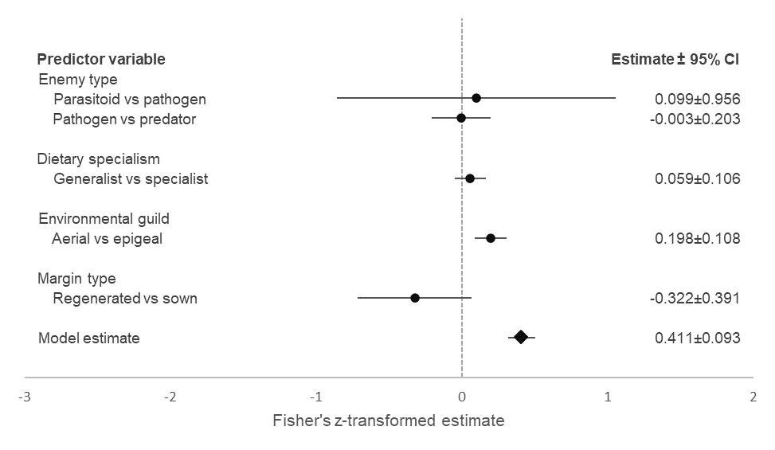
Q(91)=422.58, p<0.0001, tau²=0.15, I²=79.16%

Figure 1. The effect estimates of the fixed-effect predictor variables on natural enemy abundance. Estimates were calculated using Fisher’s z-transformation, with 95% confidence intervals (CI). An effect estimate is significantly different from zero if the associated CI range does not include zero. The model estimate (diamond symbol) is based on the random-effect model, comparing grass and floral field margins. Additional values are the model degrees of freedom, the test for heterogeneity, random-effect model significance value, tau² value (model generated estimate of total heterogeneity) and I² value (model generated total heterogeneity).

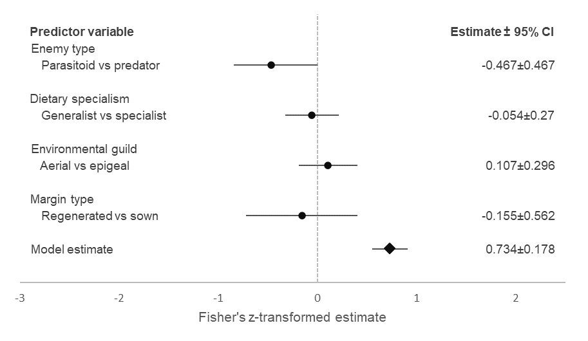
Q(23)=115.53, p<0.0001, tau²=0.15, I²=80.2%

Figure 2. The effect estimates of the fixed-effect predictor variables on natural enemy diversity. Estimates were calculated using Fisher’s z-transformation, with 95% confidence intervals (CI). The model estimate (diamond symbol) is based on the random-effect model, comparing grass and floral field margins. Additional values are the model degrees of freedom, the test for heterogeneity, random-effect model significance value, tau² value (model generated estimate of total heterogeneity) and I² value (model generated total heterogeneity).

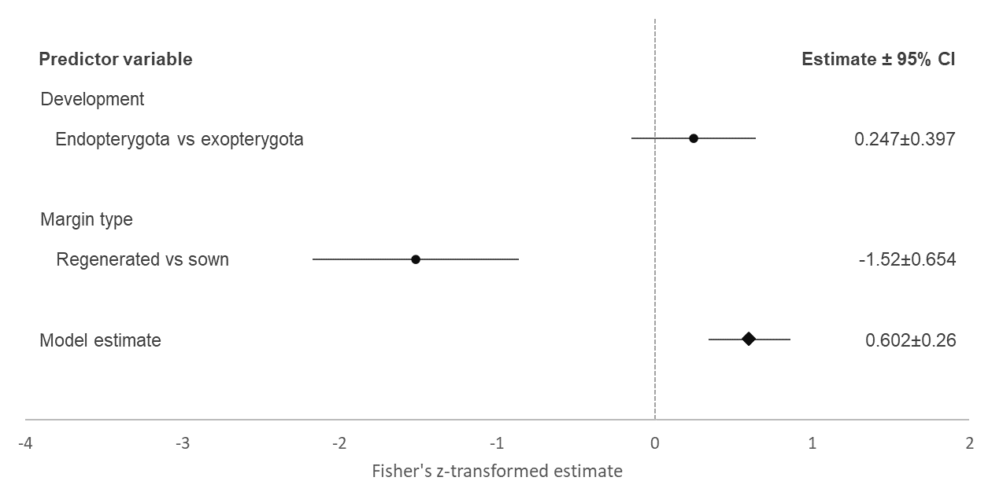
Q(39)=581.18, p<0.0001, tau²=0.64, I²=93.81%

Figure 3. The effect estimates of the fixed-effect predictor variables on pest abundance. Estimates were calculated using Fisher’s z-transformation, with 95% confidence intervals (CI). The model estimate (diamond symbol) is based on the random-effect model, comparing grass and floral field margins. Additional values are the model degrees of freedom, the test for heterogeneity, random-effect model significance value, tau² value (model generated estimate of total heterogeneity) and I² value (model generated total heterogeneity).

Table 1. Results of the test of moderators within the mixed-effect meta-analysis model, for each measure of effect. χ² indicates the results of the Wald-type χ² test. Significant p values are shown in bold.
Measure | Predictor | Test of moderators
 |  | df | χ² | p
Natural enemy abundance | Type | 2 | 0.045 | 0.978
 | Diet | 1 | 1.18 | 0.277
 | Guild | 1 | 12.921 | <0.0003
 | Margin | 1 | 2.599 | 0.107
Natural enemy diversity | Type | 1 | 5.952 | 0.015
 | Diet | 1 | 0.154 | 0.694
 | Guild | 1 | 0.507 | 0.476
 | Margin | 1 | 0.292 | 0.589
Pest abundance | Development | 1 | 1.484 | 0.223
 | Margin | 1 | 20.748 | <0.0001

