Understanding Solid-state Photochemical Energy Storage in Polymers with Azobenzene Side Groups
Callum Wallace,¹ Kieran Griffiths,¹ Benjamin L. Dale,¹ Stuart Roberts,² Jonathan Parsons,² John M. Griffin,^{1,3}* Verena Görtz¹*
¹Department of Chemistry, Lancaster University, Lancaster, LA1 4YB, United Kingdom
²Jaguar Land Rover Research, International Digital Laboratory, University of Warwick, CV4 7AL, United Kingdom
³Materials Science Institute, Lancaster University, Lancaster, LA1 4YB, United Kingdom

ABSTRACT: Solar thermal fuel (STF) materials store energy through light-induced changes in the structures of photoactive molecular groups, and the stored energy is released as heat when the system undergoes reconversion to the ground state structure. Solid-state STF devices could be useful for a range of applications; however, the light-induced structural changes required for energy storage are often limited or prevented by dense molecular packing in condensed phases. Recently, polymers have been proposed as effective solid-state STF platforms as they can offer the bulk properties of solid materials while retaining the molecular-level free volume and/or mobility to enable local structural changes in photoresponsive groups. Light-induced energy storage and macroscopic heat release has been demonstrated for acrylate polymers with photo-isomerisable azobenzene side groups. However, the mechanism of energy storage and the link between the polymer structure and energy density and storage duration has not yet been explored in detail. In this work, we present a systematic study of methacrylate- and acrylate-based polymers with azobenzene side groups to establish the mechanism of energy storage and release, and the factors affecting the energy density and reconversion kinetics. For polymers with directly attached azobenzene sidegroups, the energy storage properties are in line with previous work on similar systems, and the photoisomerisation and reconversion properties of the azobenzene side groups mirror those of molecular azobenzene. However, the inclusion of an alkyl linker between the azobenzene side group and the backbone significantly increases the photoswitching efficiency, giving almost quantitative conversion to the Z isomeric state. The presence of the alkyl linker also reduces the glass transition temperature and leads to faster spontaneous thermal reconversion to the E isomeric form, but in all cases half-lives of more than 4 days are observed in the solid state which provides scope for applications requiring daily energy storage-release cycles. The maximum gravimetric energy density observed is 143 J g^{–1} which represents an increase of up to 44% compared to polymers with directly attached azobenzene moieties.

KEYWORDS: solar thermal fuel, azobenzene polymer, energy storage, solar energy, energy conversion, energy materials, photoresponsive polymer

INTRODUCTION
The development of technologies for solar energy conversion and storage is crucial to support the global move towards renewable energy sources. One class of materials that attracts increasing attention is solar thermal fuel (STF) energy storage materials, which use photoactive molecules to convert photon energy to thermal energy through reversible isomerization between ground and metastable isomeric states.^{1,2} A wide range of photoactive molecular systems have been studied for this purpose, including norbornadiene−quadricyclanes,^{3,4} fulvalene diruthenium,^{5,6} arylazopyrazoles,^{7–9} and azobenzenes.^{10–14} Of these, azobenzenes have received particular attention due to their high quantum yields, high-fatigue resistance and appreciable energy separation between the ground-state E and metastable Z isomers.¹⁵ However, in their pure solid form, the photoisomerisation of azobenzene derivatives and other photoswitches is often limited due to dense crystal packing. A number of strategies have been proposed to address this problem, including templating azobenzene functional groups on nanotubes^{10,11,16} and graphene,^{17–19} incorporation into frameworks,^{13,14,20} and the introduction of bulky functional groups to increase the free volume and prevent crystallisation at ambient temperature.^{12,21} Another promising method is the attachment of azobenzene functional groups to polymers.^{22–25} This approach can offer access to photoswitchable solid state materials with greater processability for coatings and devices, while retaining comparatively high densities of photoactive groups and therefore high energy densities.
In a proof-of-concept study, Zhitomirsky et al. demonstrated that a simple methacrylate polymer with azobenzene sidegroups can store and release up to 104 J g^{–1}.²⁶ The polymer was shown to be solution processable into a uniform film coating for which a thermally-triggered macroscopic energy release was demonstrated, resulting in a 10 °C temperature increase compared to an unirradiated film. However, to date, there has been limited fundamental insight into the mechanisms of photothermal energy storage in azobenzene-based polymers or the dominant factors in controlling the energy densities. In addition to spatial and steric considerations for allowing photoconversion between isomers, the degree of photoconversion to the metastable state is also a key factor. For azobenzene, overlap of the π–π* absorption bands for the E and Z isomers means that the photostationary state (PSS) is limited to approximately 78% under 365 nm irradiation.²⁷ One way to increase the intrinsic PSS is to incorporate functional groups which alter the electronic structure to increase the absorption band separation for the E and Z isomers. This has been demonstrated for ortho-functionalised azobenzene derivatives for which the n-π* absorption bands are well separated for the E and Z isomers, leading to quantitative photoisomerisation at visible wavelengths.^{28–30} However, while this approach can lead to more efficient photoisomerisation, it can also reduce the energy difference between the ground and metastable states, thereby reducing the energy density of the STF material.
A further consideration is the stability of the metastable isomer. Azobenzene-based photoswitches will undergo spontaneous thermal reconversion from the metastable state to the ground state isomer, typically via first-order kinetics controlled by the activation energy barrier between the two isomeric states. The rate of spontaneous thermal reconversion at ambient temperature (or equivalently the half-life of the metastable state) in the dark needs to be sufficiently long for the desired STF application. This will necessarily depend on the context in which the STF is to be used, but typically half-lives of at least several hours would be required for daily repeat cycles. Therefore, the structural design of STF materials needs to balance multiple factors regarding both spatial and electronic considerations to maximise the conversion to the metastable state as well as the energy density. This must be based on a detailed understanding of the photoisomerisation properties and thermal energy storage and release mechanisms.
In this work, we present a systematic study of methacrylate- and acrylate-based polymers with azobenzene functional side groups as potential STF materials. We evaluate the absorption and photoisomerisation properties of a set of 6 model polymers to understand the factors that control the photoisomerisation efficiency, Z isomer stability and the resulting energy density. We find that the inclusion of an alkoxy linker between the azobenzene side group and the backbone significantly increases the photoisomerisation efficiency, giving almost quantitative conversion to the Z isomeric state. The presence of the alkoxy linker also reduces the glass transition temperature and leads to faster spontaneous thermal reconversion to the E isomeric form, but in all cases half-lives more than 4 days are observed in the solid state. The increased photoconversion in polymers with alkoxy linkers increases the energy density by up to 44% compared to polymers with directly attached azobenzene moieties. This is found to be primarily due to the increased absorption band separation of the ground and metastable isomeric states that results from this chemical modification, while structural effects including the reduced glass transition temperatures may also contribute to a lesser extent.

RESULTS AND DISCUSSION
Structural design of photochromic polymers. The structures of the polymers studied in this work are shown in Figure 1. The basic polymer comprises an azobenzene side-group directly bonded to either a methacrylate (1a) or acrylate (1b) backbone via the ester functionality.
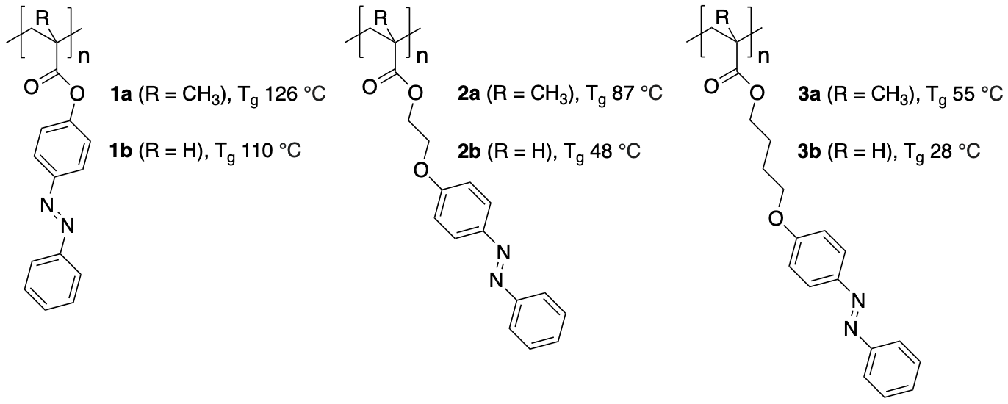
Figure 1. Structures and glass transition temperatures T_{g} of (meth)acrylate-based polymers investigated in this work.
To systematically investigate the influence of side-chain structure on the photoisomerisation, we prepared analogues with flexible alkoxy linkers of varying length between the azobenzene group and the polymer backbone (2a,b; 3a,b). All polymers were synthesised by free-radical polymerisation in solution from monomers prepared in one step from 4-phenylazophenol, following slightly modified previously reported methodologies.^{26,31,32} The as-prepared polymers’ glass transition temperatures are shown in Figure 1. Detailed experimental procedures and further analytical data, including polymer molecular weight data, can be found in Section 2 of Supporting Information.
In side-chain functional polymers such as 1a, the glass transition temperature, T_{g}, which is a measure of polymer chain segment mobility, depends on the backbone structure, the size and nature of the attached side-chain functional groups, and on the distance between these side-chain groups and the backbone, i.e., the length and structure of any linking groups present. Equally, the local mobility of the polymer can influence the ability of azobenzene functional groups to switch between the E and Z isomeric forms, which may also depend on the distance of the photochromic units to the backbone.²³ In each polymethacrylate/acrylate pair a/b, the methacrylate derivatives a have the higher T_{g}. In both the series of polymethacrylates 1a - 3a and the series of polyacrylates 1b - 3b, T_{g} drops with increasing linker length. The combined effects of a removal of the methyl group and a successive increase in linker length result in a drop of T_{g} from 126 °C in 1a over 48 °C in 2b to 28 °C in 3b.
Photoisomerisation in solution. To separate intrinsic molecular properties from any effects arising from solid-state morphologies, we investigated the UV-vis absorption and photoisomerisation of the six polymers in solution. UV-vis spectra of dichloromethane solutions of the as-prepared polymers are shown in Figure 2. NMR analysis confirmed that all, or at least the vast majority of, azobenzene chromophores are in the E isomeric state under these conditions for all six polymers. Both 1a and 1b (Figure 2a,b) exhibit a strong π-π* absorption band at 325 nm and a weak n-π* band at 440 nm. The close similarity in absorption behaviour between 1a and 1b is not surprising given that the only structural difference, the backbone methyl group, is minor and distant from the azobenzene moiety. The absorptions are also very similar to those obtained for both monomers and azobenzene itself, recorded under the same conditions (see Supporting Information), suggesting that attachment to the polymer backbone does not significantly affect the absorption properties of the azobenzene moiety.
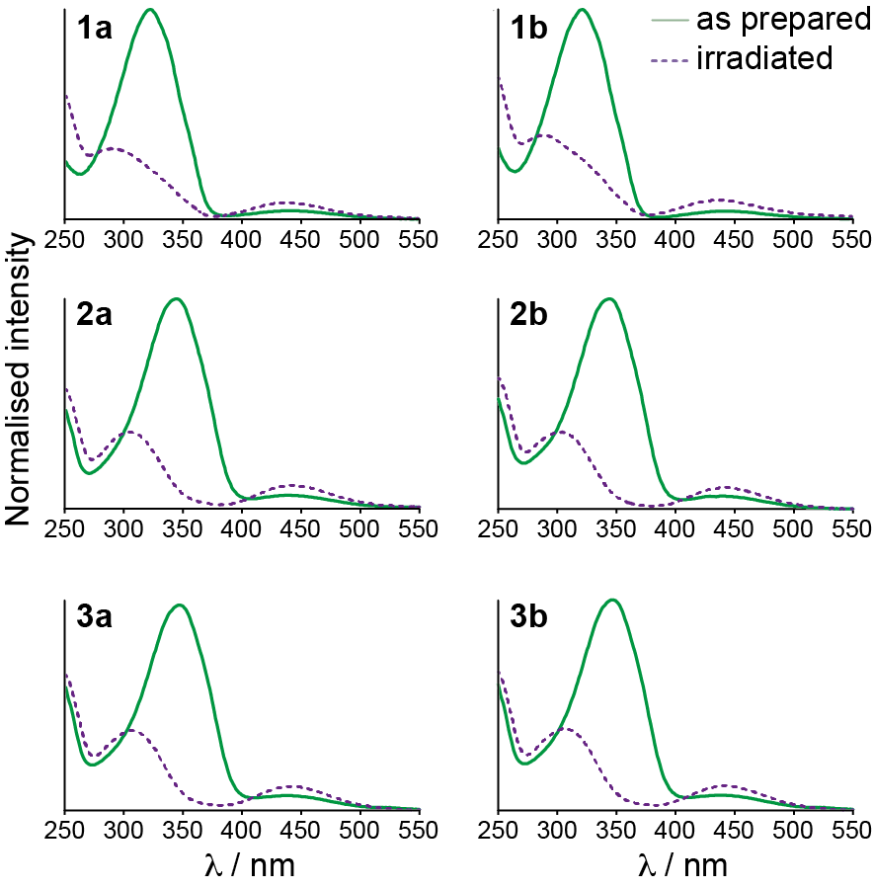
Figure 2. UV-vis absorption spectra before and after irradiation with 365 nm light. All spectra were recorded in CH₂Cl₂. Spectra for each polymer are normalised to the maximum intensity of the as prepared polymer (see Supporting Information section 3.1 for extinction coefficients ε at λ_{max}).

However, for 2a,b and 3a,b (Figure 2), a significant shift of the absorption maximum for the π-π* transition from 325 nm to around 345 nm is observed. The same shifts are observed in UV-vis spectra of the corresponding monomers (Supporting information section 3) showing that this effect is a property of the side groups rather than the polymers. We attribute this bathochromic shift to the donation of electron density into the azobenzene moiety from the adjacent ether oxygen atom connected to the alkyl spacer.^{27,33} Conversely, in 1a and 1b this oxygen is part of an ester group, therefore donates instead towards the more electron deficient carbonyl carbon, and no significant shift in the π-π* transition relative to azobenzene is observed.
After irradiation with 365 nm light for 5 minutes, we observed a hypsochromic shift and reduction in intensity of the π-π* absorption peak for all six polymer solutions, (Figure 2 and Table 1), whereas the n-π* absorptions remain at approximately the same wavelength and increase in intensity. For many azobenzene chromophores, this behaviour is characteristic of isomerization from the E to the Z isomer, for which the π-π* transition band is weaker, but the n-π* transition band stronger.^{27,34,35} Similarly to the absorption spectra of the as-prepared polymers, the π-π* absorption maxima for the irradiated polymers are observed at longer wavelengths (around 305 nm) for the polymers 2a,b and 3a,b compared to polymers 1a and 1b (around 290 nm).
Thus, the π-π* absorption maxima for both the as-prepared and irradiated polymers 2a,b and 3a,b are bathochromically shifted because of the introduction of the linking group, although the shift is far less pronounced for the irradiated polymer solutions. Therefore, the introduction of the linking group increases the separation of the E and Z π-π* absorption bands.
Table 1. λ_{max} values for the π-π* and n–π* absorptions observed for as-prepared and irradiated polymers 1 - 3 in dichloromethane solution.
 | As-prepared |  | Irradiated 365 nm
Polymer | λ_{max}^{π-π*} / nm | λ_{max}^{n-π*} / nm | λ_{max}^{π-π*} / nm | λ_{max}^{n-π*} / nm | ∆λ_{max}^{π-π*} / nm
1a | 322 | 439 | 296 | 440 | 26
1b | 321 | 441 | 290 | 438 | 31
2a | 344 | 441 | 303 | 443 | 41
2b | 344 | 438 | 304 | 440 | 40
3a | 347 | 438 | 307 | 442 | 40
3b | 347 | 438 | 307 | 441 | 40

To quantitatively follow the photoisomerisation in solution, we recorded ¹H NMR spectra at 15-minute intervals during exposure to 365 nm light (see Supporting Information Section 4). Figure 3a shows an example of the changes observed in the NMR spectrum of 1a. Figure 3b shows the population of Z isomers calculated from the NMR spectra as a function of irradiation time for all polymers studied. Polymer solutions 1a and 1b reach respective photostationary states (PSSs) of 77% and 75% Z isomer after approximately 30 minutes total irradiation time. The PSS we observe for 1a and 1b is comparable to the PSS we measured for the monomer M1a, and to the PSS reported for azobenzene itself when irradiated with 313 nm light.²⁷ Therefore the PSS for 1a and 1b does not appear to be influenced by any steric effects from polymer attachment and is instead a result of the considerable overlap of the π-π* absorption bands of the E and Z isomers. For azobenzene-based polymer STF materials, this incomplete conversion to the Z isomeric state represents a significant limitation on the energy density since, even under optimum conditions of light absorption, around 20-30% of azobenzene groups remain in the E isomeric form, which do not contribute to energy storage and hence impact negatively on the gravimetric energy storage density.
Figure 3b also shows the growth of the population of Z isomers as a function of irradiation time for 2a/b and 3a/b. While the kinetics of photoisomerization are similar to 1a and 1b, the Z isomer population at the PSS is significantly increased for this set of polymers. In fact, with PSSs of around 98% Z isomer, we observed almost quantitative E to Z conversion, which we attribute to the increased separation of the E and Z π-π* absorptions resulting from the incorporation of either the C₂H₄ in 2a,b or the C₄H₈ linker in 3a/b. The irradiation wavelength of 365 nm is closer to the shifted absorption maximum for the E state, whereas it remains on the edge of the weaker Z absorption, thereby significantly reducing the propensity for back conversion to the E state during irradiation. This contrasts with polymers 1a and 1b where the irradiation wavelength is on the edge of both the E and Z absorptions, leading to greater back conversion. The increased PSSs for polymers 2a/b and 3a/b mirror observations on similar alkyl-substituted azopolymers,²³ as well as for fluorine-substituted azobenzene derivatives and arylazopyrazoles which switch quantitatively between E and Z isomers due to increased separation of the absorption bands.^{28,36}

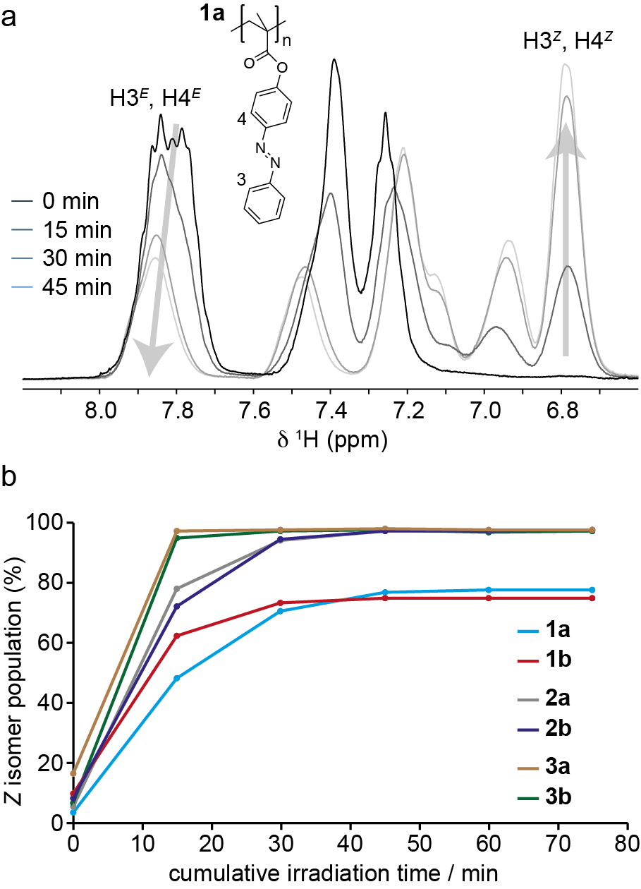

Figure 3. (a) Aromatic regions of ¹H NMR spectra of 1a in dichloromethane solution irradiated with 365 nm light for durations between 0 - 105 minutes. Changes in the intensities of the H3 and H4 resonances for the E and Z isomeric states are indicated by arrows. (b) Plot of Z isomer populations as a function of cumulative duration of 365 nm irradiation in dichloromethane solution for all polymers studied.

Photoisomerisation in the solid state. Films of the as-prepared polymers were prepared by spin-coating at a concentration of 25 g L^{–1} from toluene solution, which produced films of an approximate thickness of around 5 µm (see Supporting Information section 6). In contrast to films spin-coated from dichloromethane, films spin-coated from toluene had a smooth and homogenous appearance in optical microscopy and AFM. To investigate the E to Z photoisomerisation in the solid state and quantify the conversion, individual films were irradiated at 365 nm for different lengths of time, dissolved in dichloromethane, and solution ¹H NMR spectra recorded (Supporting Information section 6). Figure 4 shows the Z isomer population calculated from the NMR spectra as a function of irradiation time for all polymers studied.
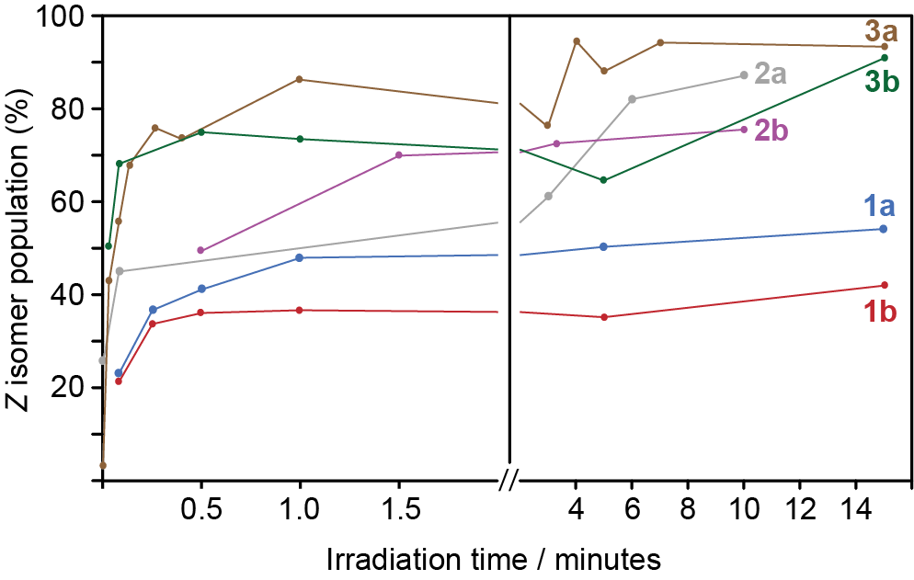
Figure 4. Change of Z isomer fractions in solid-state spin-coated films of polymers 1a/b, 2a/b and 3a/b as a function of duration of irradiation with 365 nm light. Each data point corresponds to a unique film.
Interestingly, the build up of Z isomers happens on an even faster timescale than in solution (c.f. Figure 3), with polymers reaching PSSs within approximately 2 minutes of irradiation. The precise timescale is likely to be influenced by the film thickness and light intensity, so the specific kinetics observed here are unlikely to be a general case. However, the deposition of polymer films does not appear to significantly reduce the timescale of switching - and indeed in this case even appears to hasten it. After 15 minutes, the solid-state films of 1a and 1b show conversion to 56% and 43% Z isomer, respectively. The values are significantly reduced compared to the solution-state PSS values of 77% and 75% (vide supra). For 2a and 2b, significantly higher PSSs of 85% and 80% Z isomer are observed, and for 3a and 3b the solid-state PSS values after 15 hours irradiation were found to be 97% and 96% Z isomer, which is equal to the solution-state. These results suggest that the inclusion of the alkoxy linker in 2a/b and 3a/b has a marked effect on the PSS achievable under 365 nm irradiation. This may be attributed to the increased π-π* band separation in 2a/b and 3a/b which leads to better penetration of 365 nm light through the film because far fewer E isomers remain in the irradiated portion of the film, and the Z isomers that are formed under irradiation do not significantly absorb at 365 nm. However, the reduced T_{g} values for the linker-containing polymers may also contribute by imparting more local mobility to the sidegroups. Indeed, there appears to be a trend of increasing PSS in the solid state with decreasing T_{g}; expected in so much as a lower T_{g} value reflects the increased mobility and free volume a linker of increasing length imparts. The polymers 2b (T_{g} 48 °C, PSS 80%) and 3a (T_{g} 55 °C, PSS 96%) do not follow this trend, which could reflect T_{g} being determined by overall chain-segment mobility, rather than the mobility and free volume of the azobenzene side groups alone. We note that there are significant variations in the measured Z isomer populations over the irradiation period, particularly for 3a and 3b. For each data point in Figure 4, a separate spin-coated film was studied. However, for each polymer, the spin-coated films were deposited from the same solution. Therefore, we attribute the observed variations in Z isomer populations to variations in film thickness between samples and/or inhomogeneities resulting from the spin coating process. However, the results show that despite these factors, it is possible to achieve high photoconversion for polymers containing linker groups, and for 3a/b the photoconversion is not limited by the film thickness.

Solid-state thermal reconversion kinetics. The required lifetime of the metastable state in a STF material depends upon the specific application; however, lifetimes of at least tens of hours or days would be desirable for applications involving daily repeat energy storage-release cycles. The energy storage lifetime of a STF device can be parameterised by the spontaneous thermal relaxation rate of the metastable state when stored at ambient temperature in the dark. To a first approximation, the thermal relaxation behaviour would be expected to follow first-order kinetics described by Eq. 1,
ln(I(t)/I₀) = k_{rev}t (1)
where I₀ is the initial Z isomer population, I(t) is the Z isomer population at time t, and k_{rev} is the first-order rate constant describing the thermal reconversion process. To quantify the reconversion, irradiated solid state samples were kept in the dark at room temperature, portions of the sample taken at specific times, dissolved in dichloromethane, and a solution ¹H NMR spectrum recorded (see Supporting Information section 5).
Figure 5 shows ln(I(t)/I₀) measured by ¹H NMR as a function of time for all polymers studied as well as the corresponding half-lives, t_{1/2}. Good agreement with first-order kinetics is observed, and the polymers 1a and 1b show similar half-lives of 7.0 and 6.7 days, respectively. There does not appear to be a correlation between the reconversion kinetics and molecular weight. In the synthesis of this series of polymers, different molecular weight averages were observed for the methacrylates compared to the acrylates, with the methacrylates showing somewhat higher molecular weight averages than the acrylates as expected (Supporting Information section 2.2). For polymers 1a/b and 3a/b, the methacrylates show faster reconversion but for polymers 2a/b, the acrylate shows faster reconversion, so there is no trend in molecular weight reflected in the reconversion data. However, the introduction of the C₂H₄ linker increases the rate of spontaneous thermal reconversion, reducing the half-lives for 2a and 2b to 5.2 and 5.9 days, respectively. The introduction of the C₄H₈ linker further reduces the half-lives of 3a and 3b to 3.6 and 3.3 days, respectively. This suggests that the presence of the linker lowers the activation energy barrier for Z to E reconversion, and increasing the length of the linker lowers it further. In line with the solid-state irradiation results, it is noteworthy that 2b (T_{g} 48 °C) has a significantly longer half-life than 3a (T_{g} 55 °C), showing that the T_{g} of the unirradiated polymers does not directly correlate with the reconversion kinetics. This implies that the backbone mobility of the polymer is not a primary factor in determining the reconversion kinetics whereas the local mobility and free volume of the azobenzene side group (influenced by the linker length) has the overriding influence.
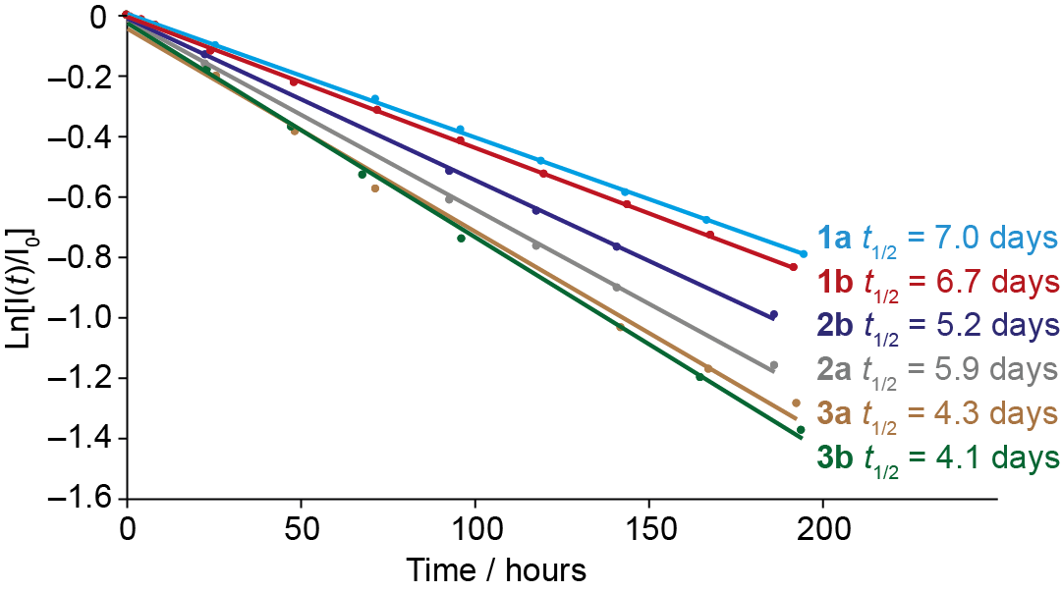
Figure 5. Reconversion kinetics of solid-state samples of 1a/b - 3a/b stored at ambient temperature in the dark.

Thermal properties. We investigated the thermal properties of the six polymers by differential scanning calorimetry (DSC) in the as-prepared state and after 365 nm irradiation in solution. T_{g} values for the as-prepared samples are reported in Figure 1 and Table 2 (see Supporting Information section 7). For the DSC investigations of irradiated solid-state polymer samples, samples of as-prepared polymers were dissolved in dichloromethane and irradiated with 365 nm light for 60 minutes to reach the PSS before the solvent was removed under vacuum at ambient temperature in the dark. The resulting solids were transferred to DSC pans for analysis. Figure 6 shows heating and cooling thermograms of each irradiated polymer sample. On the heating step, broad exothermic thermal features are observed between 60 °C and 130 °C for each polymer, which we attribute to the thermally driven Z to E isomerization of the azobenzene sidegroups.²⁶ No exothermic features were observed in subsequent heating steps, although glass transitions were observed at temperatures consistent with unirradiated samples indicating complete reversion of the sidegroups to the E isomeric state. ¹H NMR spectra of irradiated samples after the DSC measurement also confirmed that all side groups had reverted to the E isomeric state. The enthalpies associated with the observed exotherms for each polymer are summarised in Table 2. Also recorded in Table 2 is the Z isomer population in irradiated polymers at the beginning of each DSC measurement, which was separately determined by solution ¹H NMR on a small fraction of the sample. In general, the Z isomer populations in the DSC samples are slightly lower than the PSS values in solution. This is partly attributed to the 1 - 2 hour duration of the drying process, during which some reconversion to the trans isomer will have taken place.
For 1a, the gravimetric enthalpy of 99 J g^{–1} we measured in our DSC experiments is in good agreement with the value of 104 J g^{–1} measured by Zhitomirsky et al. Considering the molecular mass of the repeat unit and the Z isomer population of 64%, the measured enthalpy corresponds to an isomerisation enthalpy of 41.2 kJ mol^{–1}. This value is in line with experimental isomerisation enthalpies of between 41 - 49 kJ mol^{–1} reported for molecular azobenzene.^{37–39} For 1b, a higher gravimetric enthalpy of 135 J g^{–1} was measured, which is expected given that the removal of the methyl group in 1b leads to a reduction in molar mass. This value corresponds to a molar enthalpy of 46.5 kJ mol^{–1}. The origin of the difference in molar isomerisation enthalpy for 1a and 1b is not clear; based on the structures, the isomerisation enthalpy of the azobenzene sidegroup would be expected to be comparable in both polymers. While glass transitions for the irradiated polymers were typically not discernible in the DSC traces, we note that the unirradiated form of 1a shows the highest T_{g} of 126 °C which is at the high-temperature limit of the observed exotherm in the DSC thermogram. If the T_{g} for irradiated 1a is lower than this temperature (which would be expected from published data²³ and due to increased free volume of Z isomer sidegroups), the glass transition may occur within the exotherm which could influence its magnitude. In contrast, T_{g} values for all other unirradiated polymers are either within or below the temperature range of
Table 2. Summary of photochemical and enthalpic properties of polymers studied in this work.
Polymer | T_{g} / °C | Normalised energy density† / kJ mol⁻¹ | PSS₃₆₅  (%, solution) | Z isomer population at beginning of DSC measurement (%) | Measured energy density  / J g^{–1} (DSC)
1a | 126 | 41.2 ± 3.6 | 77 ± 0.2 | 64 | 99
1b | 110 | 45.9 ± 3.6 | 75 ± 0.2 | 73 | 135
2a | 87 | 43.8 ± 1.9 | 97 ± 0.5 | 92 | 130
2b | 48 | 46.7 ± 1.5 | 97 ± 0.5 | 91 | 143
3a | 55 | 45.1 ± 2.5 | 98 ± 0.5 | 88 | 122
3b | 28 | 46.5 ± 1.7 | 98 ± 0.5 | 95 | 135
†Normalised by Z isomer population at beginning of DSC measurement.
the exotherm, suggesting that glass transitions for the irradiated forms of these polymers would not coincide with the exotherm.
For 2a and 2b, the thermal analysis yields gravimetric enthalpies of 130 J g^{–1} and 143 J g^{–1}. These values are significantly higher than that measured for 1a and comparable to that measured for 1b, despite the increased mass of the repeat unit due to the presence of the C₂H₄ linker group. The reason for this is the higher population of Z isomers at the beginning of the experiment (92% and 91%), which means that a larger proportion of the sidegroups in the sample contribute to the exothermic process. The molar enthalpies of 2a and 2b are also very similar to 1b, confirming that the intrinsic isomerisation enthalpy is very similar. The gravimetric enthalpies of 3a and 3b (88% and 95% Z isomer populations) that contain C₄H₈ linkers are 122 J g^{-–1} and 135 J g^{–1}, respectively. These polymers also reach high Z isomer populations, and similar molar enthalpies are obtained, but the gravimetric enthalpy is now reduced slightly by the increased mass of the
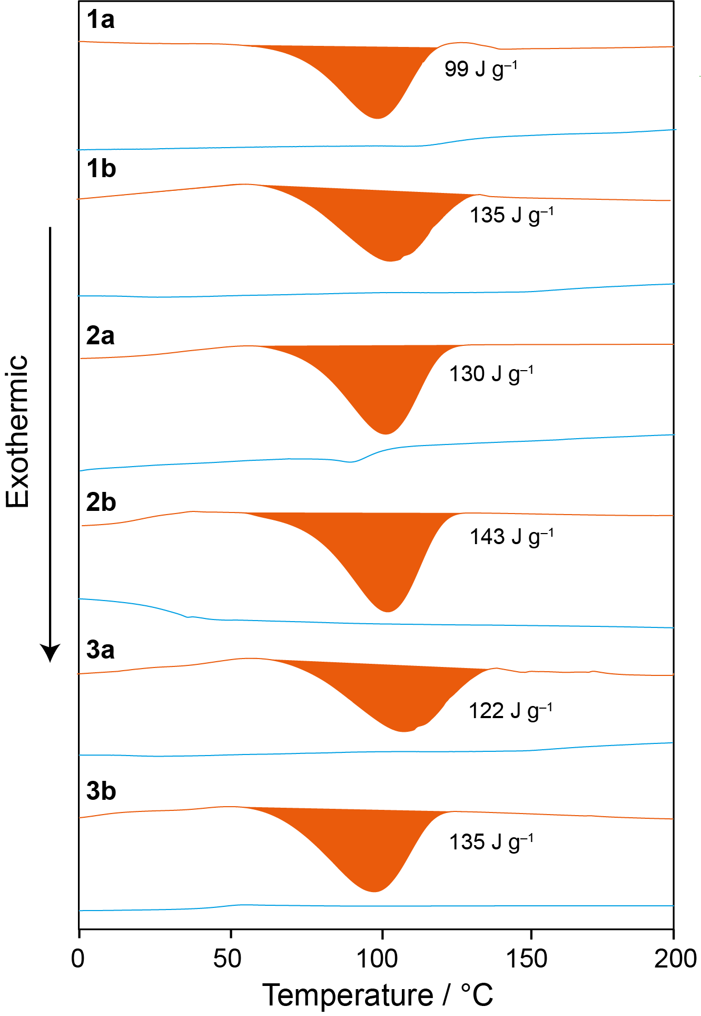
Figure 6. DSC traces for irradiated polymers between 0 - 200 °C recorded with a heating rate of 10 °C min^{–1}. Heating curves are shown in orange and cooling curves are shown in blue. Magnitudes of exotherms observed during heating are indicated for each polymer.

longer C₄H₈ linker. ¹H NMR spectra of the polymers recorded after a full heating-cooling cycle showed almost complete absence of Z isomers, confirming that isomerisation of the side groups to the ground state E configuration in these polymers is not limited by any packing effects in the solid state. Instead, the molar enthalpies suggest that the observed thermal energy release is dictated largely by the intrinsic energy difference between the Z and E isomers.

CONCLUSIONS
This work shows that the STF properties of acrylate-based polymers with azobenzene sidegroups can be significantly enhanced through judicious choice of the structural units. Characterisation of the basic acrylate and methacrylate polymers with directly attached azobenzene sidegroups shows that the photoswitching properties mirror those of molecular azobenzene, which has a photostationary state of below 80% Z isomer under 365 nm irradiation. The molar energy density during thermally driven reconversion to the ground state E isomer agrees with the reconversion enthalpy for molecular azobenzene, showing that inclusion within the polymer does not significantly affect the photoswitching properties. Separation of the azobenzene moieties from the polymer backbone via an alkoxy linker group separates the π-π* absorption bands of the E and Z isomers leading to almost quantitative photoisomerisation. Although the molar Z→E reconversion enthalpy remains similar to that of molecular azobenzene, the increased PSS significantly increases the gravimetric energy density by up to 44% compared to polymers with directly attached sidegroups. Experiments on polymer films suggest that the increased absorption band separation may also give a greater light penetration depth which would be beneficial for energy storage in macroscopic films and coatings. The inclusion of the alkoxy linkers also reduces the glass transition temperatures of the polymers, which leads to somewhat faster spontaneous thermal reconversion; however, half-lives of the Z isomeric states remain more than 4 days, providing scope for applications with storage-release cycles on timescales of up to several days.
EXPERIMENTAL SECTION
Materials and reagents. All reagents and solvents used in the synthesis of the monomers were readily available commercially and used as supplied without further purification. Reactions were monitored by thin-layer chromatography (TLC) using Merck silica gel 60 F254 plates (0.25mm). TLC plates were visualized using UV light (254nm) and/or by using the appropriate TLC stain (Cerium Molybdate stain). Flash column chromatography was performed using silica gel (VWR) 40-63 μm in collaboration with a solvent system specified in the procedure. Reactions under anhydrous and inert conditions were conducted in oven-dried glassware under an atmosphere of argon.
Polymer molar mass distributions. Triple detection Gel Permeation Chromatography (GPC) was carried out on a Shimadzu GPC/SEC set up using a Shimadzu RID-20A, with both a Wyatt Technologies miniDAWN Treos and a Wyatt Technologies Viscostar II viscometer detectors. The mobile phase was HPLC grade tetrahydrofuran. Samples were run on a Phenomenex Penogel 5μm Linear (2) column in conjunction with a guard. All data obtained from chromatographic traces were analysed by ASTRA 6 software from Wyatt technology. The molar mass distribution of a particular polymer was determined from the retention volume of the chromatographic peak maximum and the retention volume range of the peak, respectively. Samples were prepared in the mobile phase at a concentration 1 mg mL^{–1}.
UV-vis absorption measurements were carried out using a Cary 60, in a 1 cm pathlength quartz cuvette. The UV-vis spectra were collected between 200 nm – 800 nm at 200 nm min^{–1} using Cary WinUV software. Samples were prepared in dichloromethane, unless stated otherwise, to a concentration around 3.91 x 10^{–3} g L^{–1}. Precise concentrations were obtained by weighing the sample on a Mettler Toledo XPE205 DeltaRange balance and diluting using volumetric flasks with a resulting error of ±0.015 x 10^{–4} g L^{–1}.
Sample irradiations were carried out with an OmniCure® LX500 Ultra-compact UV LED spot curing system. Irradiation was performed at 10 mm from the 365 nm UV LED spot curing head equipped with a 12 mm focusing lens.
Optical microscopy was performed on a Zeiss Axio Scope.A1 microscope and used in conjunction with a Canon 700D digital camera.
Scanning electron microscopy was performed on a JEOL JSM 7800F, with samples mounted on ITO coated glass slides. Refractive index values were measured using an ABBE 5 refractometer alongside an acetone standard. Measurements were made for azobenzene-based polymers films coated using a deposition concentration of 25 mg mL⁻¹. Preliminary contact profilometry surface data were recorded using an SJ-400 surface profilometer. Measurements were made for azobenzene-based polymers films coated using a deposition concentration of 25 mg mL⁻¹.
Any errors reported are the standard deviation of repeat experiments unless otherwise stated, in such circumstances the error relates to the systematic error inherent to the preformed experimental method where error analysis has been undertaken.
SUPPORTING INFORMATION
Materials and methods, synthetic procedures, additional characterisation details and data.
ACKNOWLEDGEMENTS
We acknowledge Jaguar Land Rover Ltd for funding this work.

REFERENCES
(1) Kucharski, T. J.; Tian, Y.; Akbulatov, S.; Boulatov, R. Chemical Solutions for the Closed-Cycle Storage of Solar Energy. Energy Environ. Sci. 2011, 4 (11), 4449–4472.
(2) Baroncini, M.; Canton, M.; Casimiro, L.; Corra, S.; Groppi, J.; La Rosa, M.; Silvi, S.; Credi, A. Photoactive Molecular-Based Devices, Machines and Materials: Recent Advances. Eur. J. Inorg. Chem. 2018, 2018 (42), 4589–4603.
(3) Dreos, A.; Wang, Z.; Udmark, J.; Ström, A.; Erhart, P.; Börjesson, K.; Nielsen, M. B.; Moth-Poulsen, K. Liquid Norbornadiene Photoswitches for Solar Energy Storage. Adv. Energy Mater. 2018, 8 (18), 1703401.
(4) Gray, V.; Lennartson, A.; Ratanalert, P.; Börjesson, K.; Moth-Poulsen, K. Diaryl-Substituted Norbornadienes with Red-Shifted Absorption for Molecular Solar Thermal Energy Storage. Chem. Commun. 2014, 50 (40), 5330–5332.
(5) Boese, R.; Cammack, J. K.; Matzger, A. J.; Pflug, K.; Tolman, W. B.; Vollhardt, K. P. C.; Weidman, T. W. Photochemistry of (Fulvalene)Tetracarbonyldiruthenium and Its Derivatives: Efficient Light Energy Storage Devices. J. Am. Chem. Soc. 1997, 119 (29), 6757–6773.
(6) Lennartson, A.; Lundin, A.; Börjesson, K.; Gray, V.; Moth-Poulsen, K. Tuning the Photochemical Properties of the Fulvalene-Tetracarbonyl-Diruthenium System. Dalton Trans. 2016, 45 (21), 8740–8744.
(7) Gerkman, M. A.; Gibson, R. S. L.; Calbo, J.; Shi, Y.; Fuchter, M. J.; Han, G. G. D. Arylazopyrazoles for Long-Term Thermal Energy Storage and Optically Triggered Heat Release below 0 °C. J. Am. Chem. Soc. 2020, 142 (19), 8688–8695.
(8) Xu, X.; Wu, B.; Zhang, P.; Xing, Y.; Shi, K.; Fang, W.; Yu, H.; Wang, G. Arylazopyrazole-Based Dendrimer Solar Thermal Fuels: Stable Visible Light Storage and Controllable Heat Release. ACS Appl. Mater. Interfaces 2021, 13 (19), 22655–22663.
(9) Gonzalez, A.; Odaybat, M.; Le, M.; Greenfield, J.; White, A.; Li, X.; Fuchter, M.; Han, G. Photocontrolled Energy Storage in Azobispyrazoles with Exceptionally Large Light Penetration Depths. J. Am. Chem. Soc. 2022, 144, 19430–19436.
(10) Kolpak, A. M.; Grossman, J. C. Azobenzene-Functionalized Carbon Nanotubes As High-Energy Density Solar Thermal Fuels. Nano Lett. 2011, 11 (8), 3156–3162.
(11) Kucharski, T. J.; Ferralis, N.; Kolpak, A. M.; Zheng, J. O.; Nocera, D. G.; Grossman, J. C. Templated Assembly of Photoswitches Significantly Increases the Energy-Storage Capacity of Solar Thermal Fuels. Nat. Chem. 2014, 6 (5), 441–447.
(12) Cho, E. N.; Zhitomirsky, D.; Han, G. G. D.; Liu, Y.; Grossman, J. C. Molecularly Engineered Azobenzene Derivatives for High Energy Density Solid-State Solar Thermal Fuels. ACS Appl. Mater. Interfaces 2017, 9 (10), 8679–8687.
(13) Griffiths, K.; Halcovitch, N. R.; Griffin, J. M. Long-Term Solar Energy Storage under Ambient Conditions in a MOF-Based Solid–Solid Phase-Change Material. Chem. Mater. 2020, 32 (23), 9925–9936.
(14) Griffiths, K.; Halcovitch, N. R.; Griffin, J. M. Efficient Solid-State Photoswitching of Methoxyazobenzene in a Metal–Organic Framework for Thermal Energy Storage. Chem. Sci. 2022, 13 (10), 3014–3019.
(15) Dong, L.; Feng, Y.; Wang, L.; Feng, W. Azobenzene-Based Solar Thermal Fuels: Design, Properties, and Applications. Chem. Soc. Rev. 2018, 47 (19), 7339–7368.
(16) Jiang, Y.; Huang, J.; Feng, W.; Zhao, X.; Wang, T.; Li, C.; Luo, W. Molecular Regulation of Nano-Structured Solid-State AZO-SWCNTs Assembly Film for the High-Energy and Short-Term Solar Thermal Storage. Sol. Energy Mater. Sol. Cells 2019, 193, 198–205.
(17) Feng, Y.; Liu, H.; Luo, W.; Liu, E.; Zhao, N.; Yoshino, K.; Feng, W. Covalent Functionalization of Graphene by Azobenzene with Molecular Hydrogen Bonds for Long-Term Solar Thermal Storage. Sci. Rep. 2013, 3 (1), 3260.
(18) Feng, W.; Li, S.; Li, M.; Qin, C.; Feng, Y. An Energy-Dense and Thermal-Stable Bis-Azobenzene/Hybrid Templated Assembly for Solar Thermal Fuel. J. Mater. Chem. A 2016, 4 (21), 8020–8028.
(19) Zhao, X.; Feng, Y.; Qin, C.; Yang, W.; Si, Q.; Feng, W. Controlling Heat Release from a Close-Packed Bisazobenzene–Reduced-Graphene-Oxide Assembly Film for High-Energy Solid-State Photothermal Fuels. ChemSusChem 2017, 10 (7), 1395–1404.
(20) Yu, F.; Liu, W.; Li, B.; Tian, D.; Zuo, J.-L.; Zhang, Q. Photostimulus-Responsive Large-Area Two-Dimensional Covalent Organic Framework Films. Angew. Chem. Int. Ed. 2019, 58 (45), 16101–16104.
(21) Masutani, K.; Morikawa, M.; Kimizuka, N. A Liquid Azobenzene Derivative as a Solvent-Free Solar Thermal Fuel. Chem. Commun. 2014, 50 (99), 15803–15806.
(22) Wang, D.; Wang, X. Amphiphilic Azo Polymers: Molecular Engineering, Self-Assembly and Photoresponsive Properties. Top. Issue Polym. Self-Assem. 2013, 38 (2), 271–301.
(23) Zhou, H.; Xue, C.; Weis, P.; Suzuki, Y.; Huang, S.; Koynov, K.; Auernhammer, G. K.; Berger, R.; Butt, H.-J.; Wu, S. Photoswitching of Glass Transition Temperatures of Azobenzene-Containing Polymers Induces Reversible Solid-to-Liquid Transitions. Nat. Chem. 2017, 9 (2), 145–151.
(24) Sun, S.; Liang, S.; Xu, W.-C.; Xu, G.; Wu, S. Photoresponsive Polymers with Multi-Azobenzene Groups. Polym. Chem. 2019, 10 (32), 4389–4401.
(25) Wu, S.; Butt, H.-J. Solar-Thermal Energy Conversion and Storage Using Photoresponsive Azobenzene-Containing Polymers. Macromol. Rapid Commun. 2020, 41 (1), 1900413.
(26) Zhitomirsky, D.; Cho, E.; Grossman, J. C. Solid-State Solar Thermal Fuels for Heat Release Applications. Adv. Energy Mater. 2016, 6 (6), 1502006.
(27) Bandara, H. M. D.; Burdette, S. C. Photoisomerization in Different Classes of Azobenzene. Chem. Soc. Rev. 2012, 41 (5), 1809–1825.
(28) Bléger, D.; Schwarz, J.; Brouwer, A. M.; Hecht, S. O-Fluoroazobenzenes as Readily Synthesized Photoswitches Offering Nearly Quantitative Two-Way Isomerization with Visible Light. J. Am. Chem. Soc. 2012, 134 (51), 20597–20600.
(29) Beharry, A. A.; Sadovski, O.; Woolley, G. A. Azobenzene Photoswitching without Ultraviolet Light. J. Am. Chem. Soc. 2011, 133 (49), 19684–19687.
(30) Samanta, D.; Gemen, J.; Chu, Z.; Diskin-Posner, Y.; Shimon, L. J. W.; Klajn, R. Reversible Photoswitching of Encapsulated Azobenzenes in Water. Proc. Natl. Acad. Sci. 2018, 115 (38), 9379–9384.
(31) Georgi, U.; Reichenbach, P.; Oertel, U.; Eng, L. M.; Voit, B. Synthesis of Azobenzene-Containing Polymers and Investigation of Their Substituent-Dependent Isomerisation Behaviour. React. Funct. Polym. 2012, 72 (4), 242–251.
(32) Moniruzzaman, M.; Sabey, C. J.; Fernando, G. F. Synthesis of Azobenzene-Based Polymers and the in-Situ Characterization of Their Photoviscosity Effects. Macromolecules 2004, 37 (7), 2572–2577.
(33) Chen, S.; Zhang, Y.; Chen, K.; Yin, Y.; Wang, C. Insight into a Fast-Phototuning Azobenzene Switch for Sustainably Tailoring the Foam Stability. ACS Appl. Mater. Interfaces 2017, 9 (15), 13778–13784.
(34) Forber, C. L.; Kelusky, E. C.; Bunce, N. J.; Zerner, M. C. Electronic Spectra of Cis- and Trans-Azobenzenes: Consequences of Ortho Substitution. J. Am. Chem. Soc. 1985, 107 (21), 5884–5890.
(35) Vetráková, Ľ.; Ladányi, V.; Al Anshori, J.; Dvořák, P.; Wirz, J.; Heger, D. The Absorption Spectrum of Cis-Azobenzene. Photochem. Photobiol. Sci. 2017, 16 (12), 1749–1756.
(36) Weston, C. E.; Richardson, R. D.; Haycock, P. R.; White, A. J. P.; Fuchter, M. J. Arylazopyrazoles: Azoheteroarene Photoswitches Offering Quantitative Isomerization and Long Thermal Half-Lives. J. Am. Chem. Soc. 2014, 136 (34), 11878–11881.
(37) Corruccini, R. J.; Gilbert, E. C. The Heat of Combustion of Cis- and Trans-Azobenzene. J. Am. Chem. Soc. 1939, 61 (10), 2925–2927.
(38) Dias, A. R.; Minas Da Piedade, M. E.; Martinho Simões, J. A.; Simoni, J. A.; Teixeira, C.; Diogo, H. P.; Meng-Yan, Y.; Pilcher, G. Enthalpies of Formation of Cis-Azobenzene and Trans-Azobenzene. J. Chem. Thermodyn. 1992, 24 (4), 439–447.
(39) Cammenga, H. K.; Emel’yanenko, V. N.; Verevkin, S. P. Re-Investigation and Data Assessment of the Isomerization and 2,2′-Cyclization of Stilbenes and Azobenzenes. Ind. Eng. Chem. Res. 2009, 48 (22), 10120–10128.

Table of contents graphic

