# Appendix O

# Screenshots of phishing emails sent to participants during office simulation study

1)

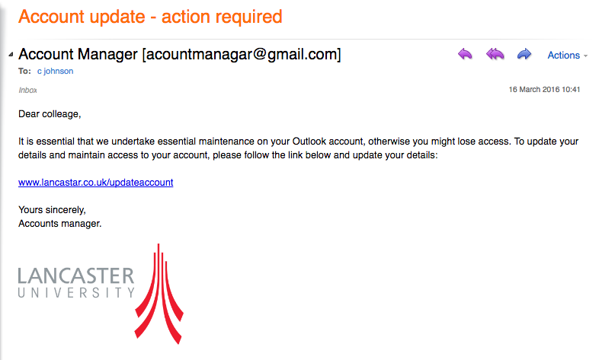

2)

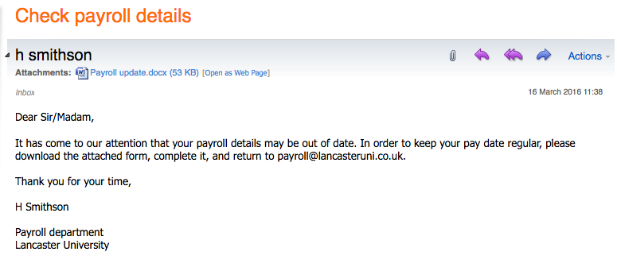

3)

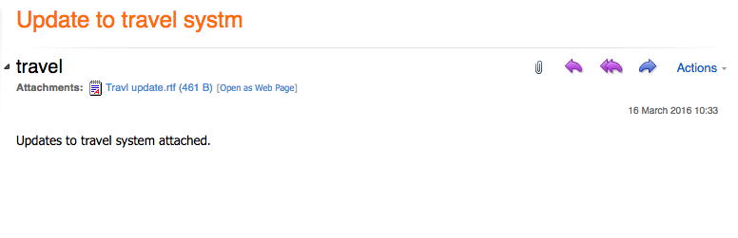

4)



5)

