Dr Bela Chatterjee is sometimes located in Lancaster. If we were going to be precise, we would observe her co-ordinates as 54.0491° N, 2.8063° W, 6°C, Wind NE at 22 mph (35 km/h), 49% Humidity. A short bio? At 5’2” it’s all relative but she can see the horizon from here as her office is on the 3rd floor and she stands on the shoulders of giants. You may like to visit sometime – C63 Bowland North, Lancaster LA1 4YN. You can bring your own records as Dr Chatterjee likes these, as well as army surplus, tea, vintage hi-fi, fine art and architecture - but not necessarily in that order. Her record player was never the same since she dropped it on the way to her office, but the rather mushy acoustic resulting is both surprising and pleasing. She rescued the record player from a skip – it’s amazing what you can find.
Her last decade has been spent encloistered in the University of Lancaster, seemingly rising at Matins to deliver lectures on the law of Torts, interspersing these with matters of Gender and Intellectual Property at Prime, Terce, Sext and Vespers. As far as copying the requisite manuscripts goes, she considers herself academically as ‘a snapper-up of unconsidered trifles’, her work including aspects of architecture, cryptography, digital media, gender and sexuality &c, &c. And law, we suppose, but again, not necessarily in that order. Although her work often considers digital culture, we could note with some irony that the increasing digitisation of the world greatly distresses her. She prefers to travel with a 1960s AA Gazetteer of Great Britain and Surrounding Isles, this being far more enlightening and challenging than satnav. If we were to consider her long term plans, we would note her aim for the next decade as being to exist (insofar as it is possible to do so) spiritually and practically in the 1940s, but without tea on ration.
Communiqués are always acceptable – digitally (if we must) we could try b.chatterjee@lancaster.ac.uk. But an exquisitely handwritten note on fine vellum would really get her attention...

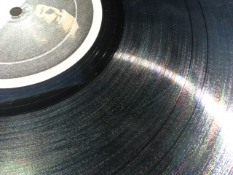
And Churchill says: Do your worst and we will do our best!

