East Meets West: Painting, Calligraphy and More by Gu Feng and Pip Dickens

Public Lecture b y Pip Dickens and Demonstration by Gu Feng
Confucius Institute 28 November 2013 11:00 to 14:00
The Education Room, The Stanley & Audrey Burton Gallery, University of Leeds

Pip Dickens Public Lecture Notes with Powerpoint

ORIGINS

When I was invited to join Chinese artist, Gu Feng, in a celebration workshop and talk organised by the Business Confucius Institute at the University of Leeds two things struck me instantly about how to best compare and contrast our quite distinct artistic practices. The first was a realisation that both of us are almost the same age – born in the early 1960s the world we entered was one of the Space Age, the Cuban Missile Crisis, the building of the Berlin Wall, the mini skirt and assassinations of Martin Luther King and JF Kennedy. I should note that these socio-political timelines are ones from the perspective of my location in the West. I wonder, therefore, how distinct our view on the world was in those first few years and whether either of us, who had no knowledge of one another, knew that our lives would be driven by a passion and dedication to the practice of Fine Art.

EPIPHANY

My second observation, when reading Gu Feng’s biography, brought a smile of acknowledgment – that both of us had undergone an epiphany within our artistic practice. For Gu Feng this took the form of seeing an exhibition by Fan Zeng in 1986. Fan Zeng was a master of calligraphy and painting and his work made such an impression on Gu Feng that he committed to study the techniques and themes of this artistic tradition leading him to, in 1995, abandon oil painting and take up a new dedication using the ancient materials of ink, silk, paper and brush.

My epiphany came somewhat later, recently in fact, whereby I cut loose the troublesome and insoluble questions of how my paintings slotted into the contemporary art world of the West and its markets. I cast my mind back over my artistic career and asked two simple questions: ‘What are you doing?’ and ‘Why are you doing it?’ The answer to the first question re-affirmed my childhood dreams – that of space exploration. I had wanted to join Neil Armstrong on the moon, I had wanted to ‘go where no man had gone before’ and learn all that could be known about everything. As a painter I explore space not as an astronaut but in the second dimension often testing its boundaries and seeing if it can yield to the third, or possibly the fourth dimension even if this is merely illusory. Moreover, most memorable to me is the American mythographer, Joseph Campbell, defining Armstrong’s moon landing in this way – “the point is, he saw no horizons” - a myth for contemporary society if ever there was one. Armstrong also found himself distanced from his point of origin – looking at the sphere of planet Earth, his physical home. There were no boundaries.

The answer to the second question is, in many ways, answered by the first – why paint? Because it allows me to explore everything and anything – it is my teacher; it is my education. Once more, there are no boundaries.

Similarly, there is an honesty and a humility in Gu Feng’s submission to the knowledge of a Master of Art whose work he admires – he chooses to learn from him and the great wealth of other skilled art-scholars he has been drawn to, and they have shown him the way.

My practice comprises never-ending cycles of trial and error, of ‘terrible beauties’ and ‘clumsy discoveries’. Occasionally, through committed exploration, something is discovered that is of real merit and it shows me the way. The foundations of success are, however, built upon many, many failures. These failures I embrace for without them progression is impossible. Within a painting practice rehearsal and repetition leads to aptitude and skill. However, all the skills in the world won’t necessarily produce a painting that generates its own qualities, on its own terms.

RHYTHM

Most artists, be they from the West or East, acknowledge being conscious of the rhythm, the ‘music’, that follows them when they are in the moment of painting. Some call it ‘the zone’, a state in which a painter is so absorbed in the act of painting that they are not conscious of anything other than the unified choreography of mind, eye and hand working as one. One reality is replaced with another. Gu Feng’s works physically evidence what is described as ‘rhythmic vitality’ and are ‘profound and natural’. His works are also ‘of the moment’. He states that through his art he is seeking peace, dignity and serenity. When one studies traditional Chinese ink paintings all seems dignified and peaceful: the human figure sits happily amidst a natural landscape, surrounded by flora and fauna, mountains and streams. Scale seems to bow to the figure – the vanishing point is vanished. All is in concord, all is balanced - all is well with the world.

In September 2013, an article by Kate Kellaway (The Observer) ‘Unscrolling the history of China’s art’ relates to us her trip to China preparing for the V&A’s Masterpieces of Chinese Painting: 700-1900 Exhibition (London: 26 October 2013 – 19 January 2014). Whilst in Hangzhou, Kellaway visited pupils studying traditional Chinese art: “When 22 year old Li Jinrui is asked what calligraphy means to her she describes calligraphy as if it were a religion that has changed her life. She was a restless child until calligraphy calmed her. Her boyfriend is a calligraphy convert too”.

This rhythmic concentration, therefore, is not only about discipline and focus within the act of art but also about states of inner calmness – that ‘serenity’ Gu Feng speaks of.

Many of my paintings utilise brush, plenty have been wrought through use of dysfunctional or old brushes, pieces of comb, discarded plastic packaging, fingers and other tools. Obtaining a unique and useful mark from something deemed unworthy, or discarded, is a secretive joy. A series of ‘Black/Phenomena’ Paintings made between 2000 and 2002 heralded a new-found interest in both the importance of the tool and also a rhythmic manner of working. In the painting ‘Don’t Believe in Signs, Comma’ (oil on canvas, 122cm x 122cm, 2002, (c) Pip Dickens) a 4ft sq canvas is coated in hand-mixed black oil paint, tinted with enough blue to be perceived, rather than seen. From the centre of this canvas the smallest brush available is taken and a wavy line is drawn, spiralling out from the centre. At a certain juncture the brush is replaced with a larger brush which continues the journey, which is then replaced with a larger brush and so on and so forth. This continues to the edges of the canvas. The painting is an exercise in rhythm and also control. It is important to relax and breathe correctly. The painting is produced as one act. However, in reality, it has been rehearsed, abandoned and re-started many times. The final painting, therefore, is the sum of many months work. Its thick, impasto brush marks catch the light and refract it, creating a painting that – like a pool of water – shimmers and changes according to the play of ambient light. This is a painting that breathes, as I breathed making it. There is an innate sense of transfer.

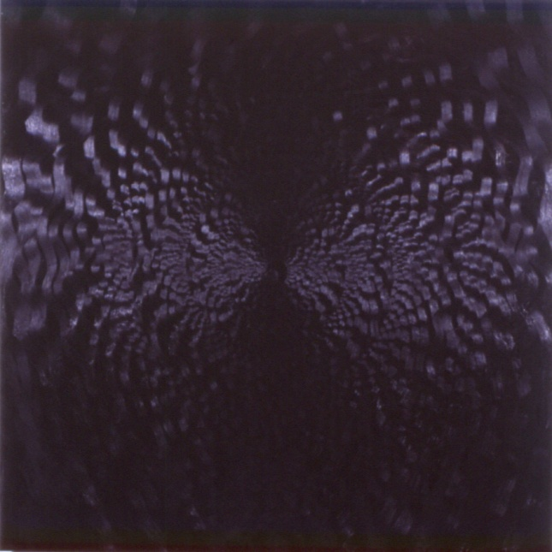

Don’t Believe in Signs, Comma (c) Pip Dickens

CONTRASTS & INFLUENCES

Paintings such as the ‘Black/Phenomena’ series are characteristic of a parallel interest in, or empathy, with Chinese and Japanese art. I am an extractive artist – I do not mimic, emulate or simulate the works of other cultures but through looking, and reading, aspects chime with specific concerns – concerns about light and shadow, colour, rhythm, pattern, about objects. All of these, and more, draw me back time and time again. Of course, light and shadow, colour, rhythm, pattern and other objects exist in the West. So what is it, as presented through the art of the Far East that captures my interest? I think the answer to this resides in a single word - sensibility. It is a philosophical and visual recognition, a perspective that I seem to align with. I seek, nor give, further explanation.

One final contrast, or comparison, which raised yet another smile of recognition when reading Gu Feng’s biography was in his description of ‘the sketch’ :

“a mutualism of ‘to be’ and ‘not to be’ in traditional Chinese culture...a high level realm, which is just the painter’s perception of ‘to be’ and of ‘not to be’ and the reflection of his understanding and self-cultivation to the deep accumulation of heaven and earth, the beginning and ending of all kinds of objects.”

BEING AND NOT BEING

The painting Between Wu and Yu (oil on canvas, 152.5 cm x 152.5 cm, 2006, © Pip Dickens) borrows words from Taoist philosophy ‘yu’ meaning being and ‘wu’ meaning non-being. These words seem perfect for the speculation of painting in general – for what is a painting but a physical object (being) yet it also depicts an abstract view (non-being), or idea, of the world?

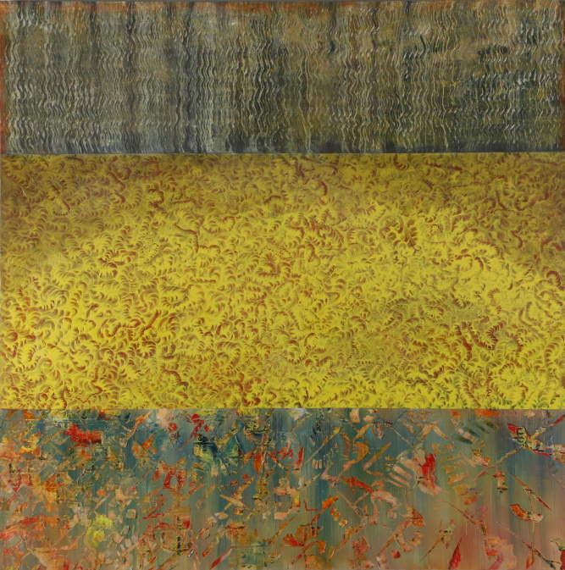

Between Wu and Yu, oil on canvas, © Pip Dickens

In this painting, the colours red and yellow are, literally, central to the painting. They sit in the middle of three panels. Their selection was fundamental for both are auspicious colours in Chinese culture. Red represents joy and good fortune which, in this painting, is over-painted with Yellow - the most prestigious colour - and one which also represents freedom from earthly concerns.

In essence, Between Wu and Yu is a form of abstract ‘landscape’ – an ‘other-worldly’ place imbued with exotic and intense colours, marks, textures and contrasts. It is a painting about ornament but also about escape.

We covet beauty and beautiful things because they transport us; they take us away from the mundane, the discordant and disorientating aspects of everyday life. A painting is not only an aesthetic concern, it is also an escape for the eye and mind – somewhere to shift our gaze but also drift, intellectually and emotionally. So perhaps Between Wu and Yu is my “land—escape”: a place I feel exists albeit in my mind’s eye. We all have such places and even though they do not exist in reality, they are frequently the things that keep us both enchanted, grounded and sane…they lie, perhaps, somewhere between heaven and earth, and in the realm of Mr Gu Feng.

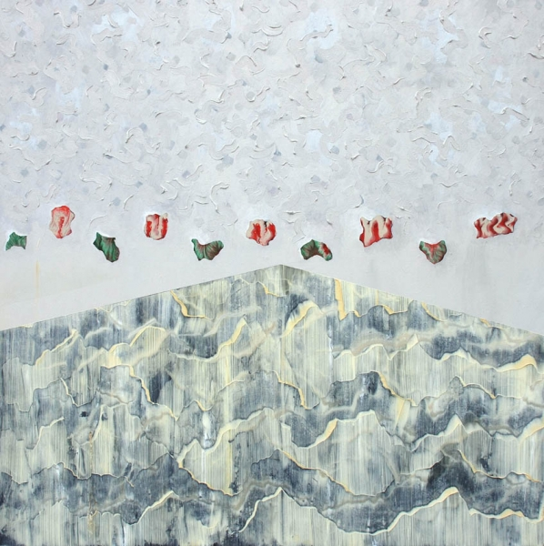

Heaven & Earth, oil on canvas, © Pip Dickens

Pip Dickens is a Fine Art Lecturer in Painting at Lancaster University and co-author of ‘Shibusa – Extracting Beauty’ with Professor Monty Adkins. This book celebrates a number of artistic endeavours: music, painting and the skill of making in general with particular reflection upon Japanese aesthetics.

-ends-

