Participant Information Sheet

Smart Energy Monitor (SEM) Study

Dear Participant,
Thank you for taking the time to take part in my Dissertation Research Study, it is greatly appreciated and as a little thank you for your participation a gift will be given to you at the end of the study.

What will the study involve – Summary

Free use of a Smart Energy Electricity Monitor for one month
- Writing seven Diary entries (a paragraph each) on your attitudes and experiences with the Smart Energy Monitor
- A post study interview lasting less than an hour on your experiences with the SEM.
The Details

Background

The UK government aims to give the option for all UK households to receive a free Smart Energy Monitor through your energy provider by 2020. This research aims to see what your thoughts, feelings, opinions and experiences are towards the monitors and this scheme and what effects (if any) these monitors have on your energy behaviours and awareness and whether the scheme needs improving or will be a success.

The study timeline

- Installation of the Smart Energy Monitor (SEM) into your home – To help speed up the set up process it would be great if you could find out your electricity tariff in advance (this can normally be found on your electricity bill under unit rate of pence per kWh e.g. 10.969p per kWh).
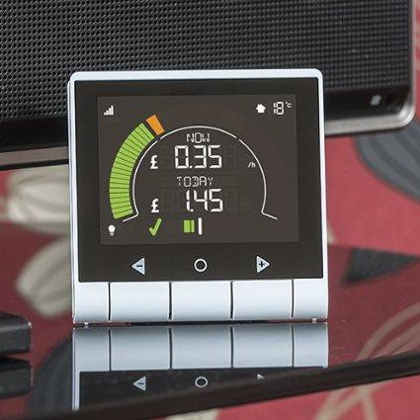
- I will then show you how your Smart Energy Monitor unit fully works and all its features which you can use during the study (for reference this is also provided in the “Instructions” and “Features” pages below and above in Fig.1)
Fig.1 – The Smart Energy Monitor (SEM) that will be provided for you (GEO, 2015).
Summary Features
- Shows you your real-time electricity usage in £, kWh or Kg CO₂ per hour
- Also shows you your historic consumption (e.g. your electricity usage from yesterday, this week, last week, this month and last month.)
- Speedometer to show current energy use
- Budget bar to help keep track of costs

- You will then need to fill out a participation consent form and questionnaire (the whole set up and form filling should take no longer than 15-30 minutes)
- I will then leave you with the monitor for just over 1 month and let you fill in your 7 diary entries (see details below about what to include in these)
- After the 1 month study period I will then come back and collect the monitor from you – (I will ring you a week in advance to organise a day and time that suits you best for this).
- At the end of the study period I will also conduct a post study interview on your experiences with the SEM (and/or other members of the household if you want) that will last under an hour and collect the diaries from you.

Diary Entries
- The aim of using diaries in this research work is to try and get a more in depth insight into your thoughts, feelings, opinions and experiences with the Smart Energy Monitor (you can write positive, neutral and critical or negative things about the smart meters if you wish)
- I appreciate that writing a diary takes time and effort, and I do not expect you to write in it every day of the study but would ask you if you could kindly write 7 entries (around a paragraph for each entry, on the things mentioned below) on different days through the 1 month study period – The diary will be provided for you.
- If you would like to write more entries feel free to do so on the spare pages at the end of the diary (the more in-depth the diaries are, the better for my study)
- Please make sure the same person from the household writes each of the 7 diary entries.

Possible things you could write about in your diary

- Your (and other members of the households) thoughts, feelings and opinions around the Smart Energy Monitor being in the home – (you can write positive, neutral and critical or negative things about the smart meter if you wish)
- Some of your everyday energy behaviours and their energy requirements.
- Note down what you are doing as a result of the energy monitor being in the home – i.e. Any energy behaviour changes or actions that are different from the normal household daily/weekly routine or has the household daily/weekly energy routine pretty much stayed the same?
- Have you talked to others about the monitor/study/scheme, and if so about what?
- You can pretty much write anything you want in your diary entries as long as it is related to energy, the monitors or the roll out scheme.
If you have any problems or questions regarding the study at any time please do not hesitate to ask me;

Mobile Phone:

Email:
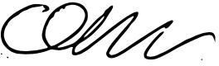
Thank you once again for your time and effort in taking part in my research. Yours Sincerely

Christopher Brown (Researcher)
BSc Earth and Environmental Science Undergraduate – Lancaster University

