Example Hand-written participant Diary

Environment
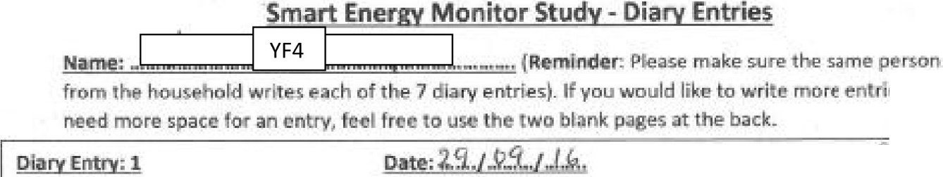
C,entre

01

Time:•. •· r,i...

*·
c..,_ <'I
(,.._iJ,,
b......k

Date 0.3.J.JQ../J. .
t.5
l-
w d
i 2f2f )
J
+ 'o-j -r...;
bj
6 f· r
J
c.
CP-,,,..
.
!I,
'
.J
.t.
)
tu tu
\..J
'Si -vP-L- (
5-lhl\ CO'VI. "::, ""-t: v-i , {\'n,;, .

Wt. i1.9 t'-.li"r
. >:,,1j, - tl"V-s •

rv.o,u -

1Fl,,...L - - "'-"'-"--
.S!i , t-

tr'-

1.,,.).a
' '1 ..·..

4-..a. ,, ,:J .

.......-.e l .t
,+.,

"' y m,,. - ,..

