Interview #4 Transcript: Senior Lecturer and Programme Leader (31.07.17) (University A)

Interviewer (I): Okay so, as a senior lecturer and a programme leader, what would you consider to be your main responsibilities?

Participant (P): I think I’m – the two of them are quite different roles, so senior lecturer is – that’s kind of, like, that’s my job title, so that involves a combination of teaching at all levels, of the administrative work that goes with that and also with, kind of, research activity and publication. The programme leader side is programme leadership of our English undergraduate programmes, so that’s English single honours, English and Creative Writing, English and History, English and Journalism and Drama and English [laughing] it’s got quite a few to remember and English and Creative Writing is new, although there is someone else who’s doing programme lead for that one and so, that’s really looking after – I suppose in a way it is looking after the student experience, but it’s making sure that the programme’s run smoothly, so it’s making sure that the right number of option modules are made available for the students and that the processes are followed, it’s liaising with external examiners, it’s completing the annual monitoring report and thinking about NSS statistics, National Student Survey statistics, so it’s, kind of, like, the day-to-day running of the course really. So, it’s – although I would be a port of call for students, they would usually go and see one of their year tutors about the day-to-day questions that they have and I’m more to do with the, kind of, behind the scenes rather than necessarily, kind of, seeing the students not in teaching on a daily basis.

I: Okay. How many undergraduates do you personally teach in a term, roughly?

P: So, I was teaching three groups, three groups – three to four groups in a semester, and there’s 18 students in a group. At that point, I was sharing programme leadership and I’ve just taken it on as a role just as me. And so, at the moment, that’s gone down to two seminar groups a semester, for undergraduates.

I: What about lectures? Do you…?

P: Lectures, usually about – I’d say maybe three to four a semester.

I: Okay. So, is that a manageable number in your opinion?

P: Yeah, I think that’s a manageable number. I think in comparison to other places I’ve worked, that’s a really [laughing] light load. So [laughing] I think it’s really good.

I: [laughing] Okay. What meaning does the word engagement have for you?

P: What meaning does that have? That’s a really tricky one, and even though I’m in English, I feel like I can’t come up with – I suppose it’s, kind of, like, it’s tricky to try and think about, kind of, synonyms for that. I think engagement, it’s obviously, it’s about being engaged so I think it’s about – I don’t know I guess in the first place, being made aware of something, being engaged, I think it indicates some, kind of, active participation in something so, rather than being passive. Engagement… yeah, I think that, kind of – yeah, being aware, participating. I think as well, there’s also something there that must suggest some, kind of, interest as well, that there’s some level of interest in the thing, otherwise it’s very difficult to be engaged with it. Yeah and a sense that engagement, also I think suggests something that’s quite, kind of, lively and dynamic as well.

I: Yeah. Okay. So, using what you’ve just said, how do you attempt to engage your undergraduate students in your teaching?

P: Oh [laughing]. Well, [pause] I suppose that there’s a difference in [sigh] – that’s a huge question. Okay so different kinds of teaching I suppose and thinking about… thinking about seminars, especially at the start of a semester, I do give thought to – there are, kind of, waves, or patterns, that students go through within a semester, probably, like, staff as well, to be honest. So, there’s the first bit where you go into a seminar group and they’re not quite sure, they’re not quite sure what to expect from the module, they might not know each other and so that’s, kind of, like, making sure all of the basics are covered so, setting up, kind of, you know, ground rules for how the seminar is going to work, what’s expected from them, what they can expect from me, doing a bit of ice breaker stuff so they get to know each other. So then as the weeks go forward, they feel comfortable enough to talk to each other because I think, the most important point about a seminar is that it should be – they should be engaged with it! Which really means that they do need to participate. I think that obviously students will learn in different ways, but – like, everyone talks about various studies about participating in something means that it embeds much more deeply, so there’s part of that within seminars, I’d always try to make sure that we’re talking a lot and the emphasis is on the students talking, rather than on me. So, it’s not about me, kind of, giving opinions or giving lots of information. For that reason, I tend not to use things like PowerPoints in seminars, I know some colleagues who do, but to me, then that becomes more of a lecture, so the only time that I’d use PowerPoint is if I particularly want to show them, kind of, like, a set of images that speak to the text that we’re studying, or something like that. And then I do a lot of small group work as well because I think that – I think students can feel a lot of pressure when they’re – even in a seminar environment of only, kind of, you know, 15 to 18 people, you know, a lot of, kind of, anxiety and pressure about talking, and getting it right and the problem is that with English is [sic], it’s not about getting it right, it’s about putting forward an idea, providing evidence for that idea. So, small group work, asking them to get into pairs and to think about a set of questions in detail, or to do some close reading of a passage. Other things that I’ve also started to do later in the semester, once the students have settled in and become more comfortable, is to set them preparation work that puts more emphasis on them, kind of, leading the discussion, than on me. So, two of the things that I do, particularly with novels, is ask them to identify two short passages from a text and explain why they’ve chosen it, and then read out the passage and then everyone talks about it. So, we do a, kind of, one person, sort of, leads a, kind of, close reading of part of a text, or to prepare two questions on a novel to then put to the rest of the group, so rather than me asking the questions, it’s actually them coming up with the questions, and that I think actually works really well. I think that it makes them feel a little bit nervous, but it means that they get used to, I guess, kind of, taking ownership of what it is that they’re learning about. And then I think when it comes to other things, like lectures, then I really would use PowerPoint because I think it’s very hard – I think, you know, you can only maintain a decent pitch of attention for, without break, for something like, it’s unbelievably short, like, 20 minutes or half an hour or something, and the lectures are 50 minutes, so make sure there’s, kind of, visual cues on the screen to, kind of, give them, kind of, hooks to work out what it is that I’m actually talking about. And occasionally to do interactive stuff in lectures. I used to do that a lot in the past at other institutions and I tried it once here, to our second year group, and it was only my second week of teaching here so I hadn’t, you know, worked out all of the patterns and things, and I asked them what I thought was a really simple question, and there was just absolute silence when I was trying to get responses, it was like pulling teeth, it was dreadful, and I did ask afterwards, like, “What happened? Why did no one speak?” and someone said, “Although they might be used to being asked questions and then talking about it among themselves in a lecture, they would never be asked to feedback as a big group” so that was something I learned. So, if I do that again, I’m going to have to make sure that I, you know, it’s a heads up at the beginning, “I am going to ask you to do this, be aware!” But that was a shame, because I thought that was quite a good way of making sure that they’re staying engaged, so rather than sat listening to something, they’re actually taking on – you know, responding to a question before then we move onto another point, so I’m going to try that again, but it has worked better at other institutions, where the students are more used to that, kind of, interactive lecture. And then another aspect of teaching is probably the, kind of, assessment and feedback, so I probably tend to be, kind of, more encouraging in the style of, kind of, feedback that I give, and I think that it’s to do with, kind of, informal, ongoing feedback, so, you know, responses in seminars and things like that, as well as the formal feedback that you get for an essay. And then trying to be clear in feedback about, you know, what works and what doesn’t and how to improve for future assignments. Something else that I always try to do as well, is always bring in, in lectures and seminars and other, kind of, teaching formats, is my research as well, so the areas that I teach on, I’m very lucky in that they really are the areas that I research on. So, I work in the 19th Century and really, the majority of my teaching is 19th Century, long 19th Century, so that’s brilliant because I can bring in some of the authors that I work on, I can think about, even if it’s not the same authors, the same kinds of texts and the things that I’m interested in and the things that I observe, and ask them to – yeah so, I think that helps students think about texts in a slightly different way. And I’ve also got my own option module coming up this semester, which really is driven by my research, so that’s really exciting.

I: [laughing] Okay. What are your thoughts on the concept of the student as consumer in higher education?

P: Bad thing [laughing]. I think the idea of student as consumer, or student as client, is antithetical to the way that a university should work. I think that both of them are words that – yeah, the idea of consumer makes the student a client, which would suggest that a university is a mill, or a shop, you can go in, you pay for what you want, and you’d get that result. It’s, kind of, like, the idea, you know, the idea that you can pay for your degree and therefore, you will get it. What you’re paying for is the privilege of the education and the learning opportunities that you get. The degree that you get is really down to what you put into it as a student, so I hate the idea of student as a consumer [laughing].

I: [laughing] Fair enough. Do you consider students to be customers in any sense?

P: I think that [pause]. I think that the way in which they are customers is that, institutions, universities provide a particular set of services, and I think that those services, some of those services include, kind of, things like facilities, a minimal amount of, maybe, like, kind of, contact time, the opportunity to speak to members of staff. I think it’s to do with setting up, kind of, expectations, that there are expectations that students should know will be met, because they have engaged with a contract with the institution. At the same time though, I think the idea that [pause] students feel somehow entitled to, and therefore able to comment on, the, kind of, I suppose the, kind of, the pedagogical quality, of their experience, I think that’s tricky because I think the problem is, because they’re on the receiving end, this is the only, usually the only, degree that they have done, and they don’t always necessarily understand the methods that are used for teaching and the reason, the good, sound reasons, that are often behind it. That’s not to say that everyone is necessarily always going to do an equally good job, you will get, you know, some members of staff will do things in very different ways, but [pause] yeah, and I think at the same time, the idea that everyone that they are engaged with should be doing their best, you know, if a student, for example, complains about a member of staff who isn’t, I don’t know, seems uninterested in teaching for example, or is not a good teacher, I think that’s a tricky one. I think staff should have some degree of training about how to teach because being a good researcher doesn’t necessarily make you a good teacher. But at the same time, if the student doesn’t do well in a course, that isn’t necessarily the fault of the member of staff so, yeah…

I: Yeah. Okay, in your opinion, how prevalent, if at all, is the concept of the student as consumer, in the university’s attempts to engage its undergraduates?

P: It’s a tricky one because, I remember looking up Student Collaboration [policy name changed] when I came to [University A] and I remember thinking that it was a really exciting thing. It’s not something that I’ve heard much about since I’ve actually been here. The way that I tend to think about it, is not in terms of a specific project, where something is clearly set up with a view to making a student work with a particular member of staff on that thing and both engaged in research together, those, kind of, projects might work, but they would also seem quite artificial as well. So, the way that I understand it more, is in terms of a, kind of, ethos [pause] and I suppose it is to do with trying to make students feel engaged and also feel that they are participating in a culture of scholarship and of research through all of the work they do, rather than on a given project. So, the idea that they are producing knowledge themselves, through their assignments, and often as well I guess through some of their, maybe their, kind of, extracurricular activities, so some of the things that the English society might put on, or some of the, kind of, you know, research seminars or reading groups that take place within the department, that kind of thing. So, there’s opportunities to, kind of, get involved in that way and to [pause] to feel that they are part of that production of knowledge. Yeah.

I: Okay. In your opinion, are there elements of the student consumer concept apparent in your interactions with undergraduates? So, do you ever get a sense of them feeling as though they’re customers when you interact with them?

P: It’s something that tends to come through much more in, like, kind of, feedback – I can’t think of the word – kind of, like, NSS and module feedback surveys, things like that. I mean largely, largely I think the students feel satisfied, it only ever seems to come up when students feel dissatisfied with something, that then it seems to become an issue. I have occasionally heard other, kind of, colleagues and academic acquaintances, say things about, you know, how someone has said, “Well, I pay your salary” or something like that, as a, kind of, idea, that well then, “So you should be doing more for me”. And I think well, you know, that’s annoying but what it also suggests is a lack of understanding about what it is that they’re paying for, and also where that money goes as well. [pause] So I suppose it doesn’t come up [pause] doesn’t often come up, it’s usually – yeah, if students are dissatisfied with something, occasionally that might be in relation to, kind of, resources, English as a subject, in every institution I’ve worked at, always has a slight problem with library resources because there’s, you know, there are a lot of books and they’re very expensive for libraries to buy. Occasionally contact hours, that sometimes comes up as a question at Open Days and things like that, because the pattern of contact hours works very differently for Humanities, in comparison to how it would for, you know, a science-based subject where you might have lots of lab time or something like that, or heavy lecture-based, you know, information-dissemination-type sessions, whereas the emphasis in the Humanities, and in English especially, is much more on the individual doing their own work. So not that often, not that often.

I: Okay. In your opinion, do you think the introduction of fees has given them a greater sense of entitlement to higher grades?

P: [laughing] [pause] I don’t think it’s given them a sense of entitlement about getting higher grades. I think it probably makes students feel greater pressure about wanting to get a higher grade, because they – because it feels like it costs so much more. [pause] I wouldn’t say so, I mean I’ve never heard any, kind of, study on this, but in my experience, from when students were paying less cost of the course, so when the fees were, kind of, three as opposed to nine thousand, I haven’t seen much difference in, for example, the number of students taking resits, or deferring, or withdrawing. So, I guess that’s answering your question by looking at completely the other end of the spectrum. Yeah.

I: Yeah, okay. Okay, so moving onto learning now then. In your opinion, are lectures useful for engaging undergraduates?

P: [pause] I think that’s a hard question because I think they are necessary for undergraduate learning. Lectures I think will usually tend to be less engaging than seminars, because they aren’t interactive, because the tendency is for students to sit there passively for 50 minutes. But I certainly think there’s still a place for lectures, I certainly wouldn’t want to move away from lectures as one of the, kind of, modes of learning. What was the question again?

I: Are lectures useful for engaging undergraduates?

P: I think lectures serve a purpose, they are a means of giving out information and that – and so in terms of engagement, that might be different kinds of information, that could be information about – and, kind of, notices, it could be information about assessment, so often a lecture slot will be given over to talk about assessment, and students get very, very anxious about assessment and so, using a lecture for that I think can be quite useful. But also, as well, disseminating the, kind of, basic information that they need, so, kind of, context for example, if you’re doing a period module, to give them a sense of what is going on. What are the debates with which this text is engaging or choosing to avoid? What’s happening at the same time? So, I think in that sense, they’re, kind of, valuable. Whether they’re engaging, I think that probably depends on the lecturer, the type of content that it is [pause] yeah… And I suppose as well, the style, the amount that the lecture has to cover so, the content, I think the content and the delivery depends on the extent to which it’s engaging, yeah.

I: Yeah, okay. Okay, so in the same vein, are seminars useful for engaging undergraduates?

P: Absolutely. In feedback, seminars tend to be the part of the course that students say they feel most engaged with because I think, that it’s more about participation, that’s the opportunity to, kind of, test out ideas, to ask questions, that’s more of the – not one-on-one time – but it’s more of the, kind of, personal contact time where they can ask things if they aren’t clear. But yeah, so, kind of, to share those ideas, but also to learn from each other, as well so it’s not just about that, kind of, the top-down dynamic of the lecture. Seminars, I think, are and should be, much more open and it’s just as much about, or if more, about, kind of, peer learning, rather than that idea of, kind of, teacher-student that happens in lectures. Yeah, and I think the more students talk and the more they think about the questions, they think about the text and they come up with responses, I think the more engaging they are. So, there’s definitely more space for that in seminars than lectures.

I: Okay, what about one-to-one sessions being useful for engaging undergraduates?

P: I think it depends on what the one-to-one session is about and when it happens. So typically, our one-to-one sessions are likely to be a, sort of, essay tutorial and whether or not that – the student, kind of, engages with that, depends I suppose in the same way for seminars, on the amount of preparation they’ve done. If the student hasn’t prepared anything, there’s very little to respond to, so there’s very little that – kind of, advice that you’re able to give, that they can then engage with and take forward. So, because the pressure is on in a one-to-one session, I think yeah, it really is about the student’s level of preparation, and I suppose what they have come to the session with. There’s only so much you can do as a tutor, if the student hasn’t thought about the question or, kind of, isn’t prepared with something to give, that you can then talk about, yeah.

I: Okay. Which of the above teaching methods do you think undergraduates find the most engaging?

P: Seminars. Definitely.

I: Okay. Is there anything you think is particularly good about the style of learning that takes place at university, as opposed to compulsory education?

P: [laughing] Well [pause] I think compulsory education has its place, because you’re learning some of the basics, but I think education at university is hugely different. I think the benefits of it are: the student has chosen to be there, to be here, and so there’s an emphasis on them taking responsibility for their own learning. This is their choice and they’re adults, so it really is up to them, you know, we can, you know, we will keep records of attendance and completion in terms of marks, of modules, but the actual, the hard bit of the learning is, kind of, up to them. I think that it also gives them much more freedom and flexibility to follow the things that they’re interested in, in a particular course or in a particular module, it gives them opportunities to make connections across, and between modules as well, so that they’re building a much more varied, and much more, I suppose a, kind of, dynamic picture of the subject in comparison to school and college. In a subject like English as well, it’s much less about hitting the right points, so there’s that flexibility in, you know, coming up with your own argument, rather than – sometimes compulsory education for English feels a little bit like ticking boxes to make sure you’ve made particular points about a text. I remember for my AS in English, I got 100% for one of the units, or for the – no I think it was for the – anyway, I got 100% which just seems really wrong because this is English and it’s not about hitting those marks and doing a tick off, which is exactly what I did, whereas at university it’s much more about establishing your own position, providing your interpretation of a text, analysing it and providing evidence to support that view, showing that you can situate your voice alongside other critical voices as well, and so that you’re aware of the, kind of, debates that are taking place. And so, I think that makes it much more exciting, it’s something then that’s always, kind of, evolving, it’s not end stopped, it’s, kind of, open-ended as a learning process, so and of course, it doesn’t stop, you know, staff are still engaged in exactly the same process as the students are, they’re just doing it perhaps at a, kind of, higher or more sustained level. And [pause] and I think as well, the, kind of, sense of the transferrable skills that students learn at university as well, even just from things like, that, sort of, independence, they’re away from home, usually for the first time, so they’re learning to, kind of, manage their money, they’re probably in, you know, different kinds of social situations, they’re learning, kind of, you know, presentation skills and improving their literacy and able to think, you know, analytically and critically. So, there’s a whole combination of things that they’re, kind of, developing as well as that, kind of, knowledge in their subject. So yeah, definite advantages I think in the university level education.

I: Okay. You mentioned this being a choice for undergraduates. Do you think the government’s focus on employability and widening participation has had any impact on undergraduate – on it being a choice for undergraduates as it used to be?

P: [pause] I think that there is a clear link between employability – yeah, I think the emphasis on employability is good, I think what that does is it focuses on a, kind of, on some, on, kind of, generic skills that you can learn across – like across disciplines. So, for example, you’re likely to gain a lot of the same skills within a Humanities subject, and some of the skills that you learn in English might be the same skills that you learn in History for example, so that’s quite useful, because the idea then that they are transferable, that they are then applicable, not only within the subject, but in other subjects and also, by extension, to the wider world of work as well. Widening participation, I think is a very good thing. [pause] What was the question again?

I: So, the government’s focus on employability and widening participation, do you think it’s had an impact on students choosing to go to university? You mentioned it being their choice and so their responsibility.

P: I think it’s hard to say, I mean I think, a university degree is always something that is going to be valuable and so I think that as a, kind of, standard of achievement, that that has, kind of, stayed solid. I think that because of the employability agenda, it’s becoming increasingly recognisable as something that applies beyond the subject. I think, I don’t know whether it’s had an effect or not [long pause] yeah, I suppose it’d be hard to say.

I: Okay. [laughing] From your own experience of teaching, is there anything you would change to improve student learning, in terms of either your own teaching, the resources you have access to, curriculum and assessment, or anything else?

P: [pause] God. Not off the top of my head. I suppose that we’re all very used to being in a, kind of, in a, kind of, pattern, the annual pattern of teaching and so I guess it’s, kind of, hard to think beyond that. [pause] I wish there was a way of making sure that students always did the preparation for seminars [laughing] so I always try and – I write – I do preparation questions for students, and then I think that’s a tricky thing because I have colleagues that don’t do it and I do do it, but then I worry that sometimes the students are relying on those questions, rather than using them as a, kind of, foundation or a springboard to then do their own work, so I’m not – so it’s hard to tell whether or not I think that works. But it at least gives me peace of mind that I have – you know, I couldn’t have done more to tell students, you know, how to get the most out of their preparation for a seminar. Maybe more interactive elements in lectures. I think lectures – lectures can be tricky, it is hard to sit there and listen for an hour, but the, kind of, information that you’re trying to deliver in a lecture, it doesn’t always necessarily lend itself to being interactive I guess, and they are, you know, potentially such big groups of students, that it – how do you manage an interactive element when you’ve got, you know, 150 students in a room? But yeah, off the top of my head, I don’t think there’s necessarily anything. [pause] Yeah, not that I can think of really, not off the top of my head.

I: Okay. Okay so policy now then. I sent you the document that refers to the university’s teaching and learning strategy. I have it here [rustling paper].

P: Great.

I: So, do you think this strategy is successful for engaging undergraduates?

P: [pause for reading over document] Yes. [laughing]. Yes, I think that – I think that as a strategy, it’s absolutely, kind of, fit for purpose. I think that because it’s an institution-wide strategy, it’s very, very open, but then I think that it has to be because of the different, kind of, ways in which the student experience might differ across different colleges and departments. I think that – so some of these, for example, aren’t really applicable for English so, the second paragraph, the first part about work placement consultancy and consultancy project, projects, design and development of work for external clients, none of those are things that – I don’t know how our students would be able to do that, it’s just not something that we could really offer. But participating in creative arts projects and engaging with matters of interest to our local community, that’s yeah, and issues of worldwide importance, yeah, I think that’s certainly something that our students do. I think that’s something that they do through the study of their subject, but also as well, through some of the additional things that are offered as part of their time at university. So, things like reading groups, you know, visits by, like, visiting scholars or, research seminars that are open to everyone, things like that.

I: Okay. And I sent you the document that refers to the Student Collaboration [policy name changed] policy. How would you say you implement the aims of this approach, if at all, in your interactions with students?

P: [pause for reading] Well, I suppose one of the ways that I’ve been thinking about it is through my option module, which really is driven by my research interests, and is linked to the, kind of, research that I have been, am, and am continuing to undertake. So, by discussing the kinds of ideas that my research has thrown up with the students, that will then feed back into my own work and they’ll be participating in that, and also thinking about some of the most recent debates in the field as well. So, they are, kind of, in that sense, they really are participating in something that is – I hate the term cutting edge, but that is new, is recent, is something that is ongoing and developing. The field that I work in is [removed for confidentiality]. So, I suppose in that way. There are also opportunities for students to – so is this research-engaged teaching or… I suppose also, participation in research events, so things like research seminars, or Symposia, for example, so things that are arranged, kind of, both within the institution and outside the institution as well so, something that is for external visitors but also things that are designed for our own students, for example, like our MA symposium. So, we might often have undergraduates coming to listen to some of our MAs talk about their research, as well as to staff talking about their research as well, so the idea that it is a, kind of, continuous backwards and forwards at all levels. I suppose those are some of the ways, yeah.

I: Okay. In your opinion, should undergraduate students have greater control over, or input in, the curriculum and/or assessment design or their chosen courses?

P: I think the students should always have a voice and should always be listened to, particularly – more I would think to do with assessment. I think in terms of curriculum design, that’s a tricky one [pause] because I think before students have studied things, how can they know whether or not it would work or would be appropriate? And as well, the content of much of the curriculum is driven by the research interests of staff so, particularly for option modules – excuse me – so, there is a, kind of, good reason often for that, kind of, content. In terms of the – in terms of assessment, I think that it is good to listen to students. There are some changes that we’re making recently, so one of my modules, we are moving away from a form of assessment to do something else, in part in response to student feedback, because they felt that it wasn’t a very effective mode of assessment. I think, though, that [pause] because the students might feel that they have such a vested interest, or that it might make a personal impact on them, they might choose to do things that they like, as opposed to things that actually accurately reflect their learning. So, for example, I know that most students would prefer not to take exams, but there are reasons to have exams as one of many methods of assessment. Certainly not lots of exams, but, you know, the occasional one can be quite useful. I think that it would be very boring, for example, and not a very good indicator of a student’s learning, if the only way that they were assessed was through a series of essays, so including diverse assessment methods I think is quite important. So, listening to the students and their views is something that we always do, and we often, we often take them into account. But I think at the moment there is quite a good balance between a, kind of, I guess, sort of, a logic for having particular types of assessment or content in a module. And students’ voicing their views on it as well through the feedback and things like that.

I: Okay. Okay. In recent government policy on higher education, students have been placed at the heart of the system. In your opinion, to what extent are undergraduates positioned centrally within this university?

P: Very much so, I think they really are [pause] which I think is a good thing, I think that – I think that students should be. If the students weren’t here, there wouldn’t be a university, so that whole point is of, you know, continuing to, continuing to – continuing that exchange of knowledge that is part of the learning process. So, I think that actually [University A] is very good at that and in a lot of meetings that I’m in, a lot of discussion about policy documents, students are always really at the heart of it, so it’s certainly something that I think is very evident here.

I: Okay. Do you think positioning students centrally works to separate them at all from other members of the university, such as the academics?

P: [pause] I don’t think so. I’m not [pause]… There is inevitably going to be a division [pause] but I don’t get a sense in [University A] that there is a, kind of, barrier between staff and students [pause]. Yeah, I don’t think so.

I: Okay. What meaning does the word relationship have for you in the context of interacting with undergraduates?

P: [laughing] Okay what was the question again?

I: What meaning does the word relationship have for you in the context of interacting with undergraduates?

P: Relationship? I suppose that’s a tricky one. You always have a relationship with your students. The question is, I suppose, is the, kind of, relationship you have, or whether not it’s a good relationship. I’m not entirely sure what makes a good relationship. I think that would differ from – for different members of staff. Some members of staff will be much more, kind of, jokey and informal with their students, whereas some will maintain more of a, kind of, sense of hierarchy. I’m not – I don’t think necessarily that either style is less effective or more effective than the other, because I think it differs according to, probably according to personality. I think it’s to do with – relationship? What does a relationship mean in that context? I think it’s to do with the – maybe to do with the sense of, kind of, being on a journey together? I know that sounds really corny, but that idea that, you know, “Okay, we’re together on this module. These are the things that we’re going to be talking about, and there are some things that I am going to be telling you, and you will be learning from me, but there are other things that, kind of, we’ll be doing together”. So, I think it’s that idea maybe, of a relationship. But it does sound a bit – yeah it does sound really corny [laughing].

I: Okay [laughing]. What do you consider to be the main purpose for building a relationship with undergraduates?

P: Oh well I suppose to make sure that they’re engaged, to make sure that they stay interested. Also, as well to make sure that, kind of, like, they trust that you are there because you have their interests at heart, that this is, you know, that because as a tutor, as a teacher, as a lecturer, you care about your students’ progress, and you want them to know that because, you know, it’s, kind of, like, you feel invested in them, you want them to do well. And also, as well, you want to share with them some of your sense of your enthusiasm and excitement for your subject as well, you know, you want to say, “This is amazing! This is great, isn’t this really interesting?!” So, I suppose the benefits yeah, kind of, it puts the student at ease, it makes them feel that they are – that they’re part of the institution, that they’re more than, kind of, just an anonymous cog in a wheel [pause]. But I think, you know, I suppose, you have 12 weeks really to, kind of, cultivate that relationship with students and sometimes, you might not then teach that particular student again for quite a while. So, the personal tutor role I think is really important. Students hopefully have quite a good relationship with their personal tutors because that’s often their first port of call if they run into any problems. Yeah so, I do think it helps, a good relationship does, I think, help students to get the most out of their – out of their experience in a, kind of, acknowledgement that, I guess it goes both ways. Yeah.

I: Okay. To what extent is that purpose fulfilled do you think?

P: [pause] I think it’s very hard to say overall. Do you mean with me personally? Or within the institution?

I: Yeah, with you personally.

P: I suppose it differs from student to student. [pause] I’m always very aware that I try to make the students that I teach, to make sure that they’ve got all of the right information, so on things like assessments, because I know that that always stresses them out, so to make sure that they feel that they have been given the time and they’ve had enough time to ask the questions and things like that. I think as well, for – I’m not exactly a disciplinarian, so the way that I teach is, I suppose, fairly informal. And I do tend to be quite encouraging [knock on the door].

[Conversation between participant and visitor]

P: ….and, yeah so, I think a, sort of, kind of, about being approachable so that students feel that they can ask me questions if there’s anything that they’re not clear about. But also, as well, encouraging about the ideas that they have, so, you know, I hate, and will do everything I can to avoid telling a student, “No”, like, “That’s wrong” or, you know, “You haven’t got it right” because I, kind of, think it is about interpretation and sometimes when they’re testing out an idea, that’s a nerve-wracking thing to do, so yeah. I’m not sure if that really answered your question, but… [laughing].

I: [laughing]. Okay, can you describe to me a typical face-to-face encounter with a student? So, if they come and meet you to discuss an assessment or something?

P: Yeah so, we’d probably be meeting in my office. So they’d come in, have a seat, I’d ask them what they wanted to talk – we’d, kind of, do a bit of chit chat probably, I’d ask them what they wanted to talk about, and then they’d explain what it was, and either, probably ask me to maybe explain a grade, where they don’t feel that the feedback’s been very clear, or they might ask something, I don’t know, about revising for an exam say, to check over whether what they were doing was right, or maybe to talk through a plan for an essay, and then, you know, I can talk through their ideas, make sure that they’re – you know, give them maybe some recommendations for additional reading, or new directions that they might want to take, if they hadn’t considered them already, that kind of thing I suppose. We do have weekly office hours where students can drop in and see us, so yeah.

I: Okay. Do you ever notice any implications of a hierarchy in your interactions?

P: At first a little bit, though just in really small ways, like, you know, students calling me Dr [name removed] and it was like, “No, no, no please call me [name removed], that’s, kind of, very, very formal”. Not really, I mean I think it’s also, it’s just something that I don’t – I think especially in a seminar environment, that, kind of, hierarchical sense isn’t very useful. With hierarchy, do you mean between tutor and student?

I: Mmmhmm [agreement].

P: Yeah. So, I think it’s something that I, kind of, try to avoid. That might be different in a lecture, but then the setup of a lecture is very different anyway. But, you know, in a seminar, I will never have the room in, kind of, lines with me at the front, it’s always a circle. Or little clusters of groups and I’ll move between them so… [pause] So I suppose where I do get a sense, I – the times where I think it’s most noticeable are when students haven’t done the work and so, there’s that, kind of, thing about they’re apologetic or defiant and nervous depending on the kind of student they are, and then you’re having to, kind of, work out how to deal with that and largely, dealing with that is to do with the implications for the rest of the group. You know, if half the group haven’t done the reading and the preparation that you’ve planned for the group depends on them having read to the end of the text, then I suppose that, kind of, that might reinforce the fact that there’s a hierarchy because it makes it very clear that you’re the tutor and they’re the student. But generally, in seminar discussion, I would say not very much. I would say that, kind of, sense of hierarchy is there as a, kind of, as a, sort of, safety net and students will often, you know, look – kind of, suggest an idea and, kind of, look for that affirmation of, “Did I get it right?” Or “Am I along the right lines?” and, you know, they’ll often say something like that, “I don’t know, but is it this?” And so then, kind of, giving that affirmation and saying, “Yes absolutely, you’re right. So, if that’s the case then how about so and so?” So, I suppose there is a hierarchy in the sense that in a tutor – in a seminar, as a tutor, you’re facilitating the discussion, but I think the more that the students are taking responsibility for facilitating their own discussion, the better, because it’s about their learning experience. You might have certain things that you want to make sure are covered in the seminar, but you don’t want to be too rigid and inflexible in how you’re going to go about it.

I: Yeah, okay. Can you think of any particularly good relationships, without giving away their identity, with any undergraduates?

P: [pause] I think often those relationships come with students that are, I suppose there are two different ways. The first is when a student is having particular problems and so, you end up seeing them quite a lot. They will often come to you for help or advice, or they might come to – even if it’s, like, to explain absences or, to do catching up or something like that. So, it’s to do, I think it’s often to do with that, kind of, contact time and that moves into the second one, which is those students that are very, very engaged, very active in their learning and, kind of, you know, the ones that do extra reading or the ones that talk a lot in a seminar or always want to come up to you at the end because they read something interesting and want to talk to you about it. So I suppose those are the kinds of, in a way, strangely because they’re, kind of, really different but often they’re the better relationships you have with students, really just because you see them more, because they are – they’re, sort of, part of – you’re aware of them in a much more conscious way I suppose and, you know, everyone’s had those students who are God sends in seminars and just so good, and always get it really quickly and always have lots to say and have always done extra reading and it’s just, like, you know, and that’s exciting because it’s rewarding when you have a student like that, because you think, “Yes, this student is really getting it!” But then at the same time, a student who might have been struggling, might have been disengaged at the beginning of a module, and by the end, you know, they’re, kind of, really on solid ground, they feel like they’ve had a breakthrough with the material, they’re opening up more in seminars, and contributing more, that is also a really, kind of, rewarding experience and you feel that you get a good relationship with those students as well, so strangely the two opposite kinds of student, yeah.

I: Okay, now’s the fun bit everyone loves [laughing]. Can I get you to draw your conception of a good relationship with a student?

P: [laughing].

I: It can be anything you like [laughing].

P: Oh my God. To draw a conception of a good relationship with a student [laughing]. Okay. [pause for drawing]. These people have really long bodies and really short legs [laughing]. Okay, so that’s a book and that’s a book, and okay… conceptual… and so like that, and we’ve also got, kind of, okay, kind of, in different, like, kind of, circles. So, this is… the big circle is where we all, kind of, interact and then we’ve all got other things as well and then we’ve both got things to say, equally and so the idea is, there’s a, kind of, equal thing here and we’re happy [laughing]. This is really weird and really hard [laughing]. Good relationship with a student [laughing] I think that’ll do, is that enough?

I: Yeah course.

P: Okay. [writing] There you go.

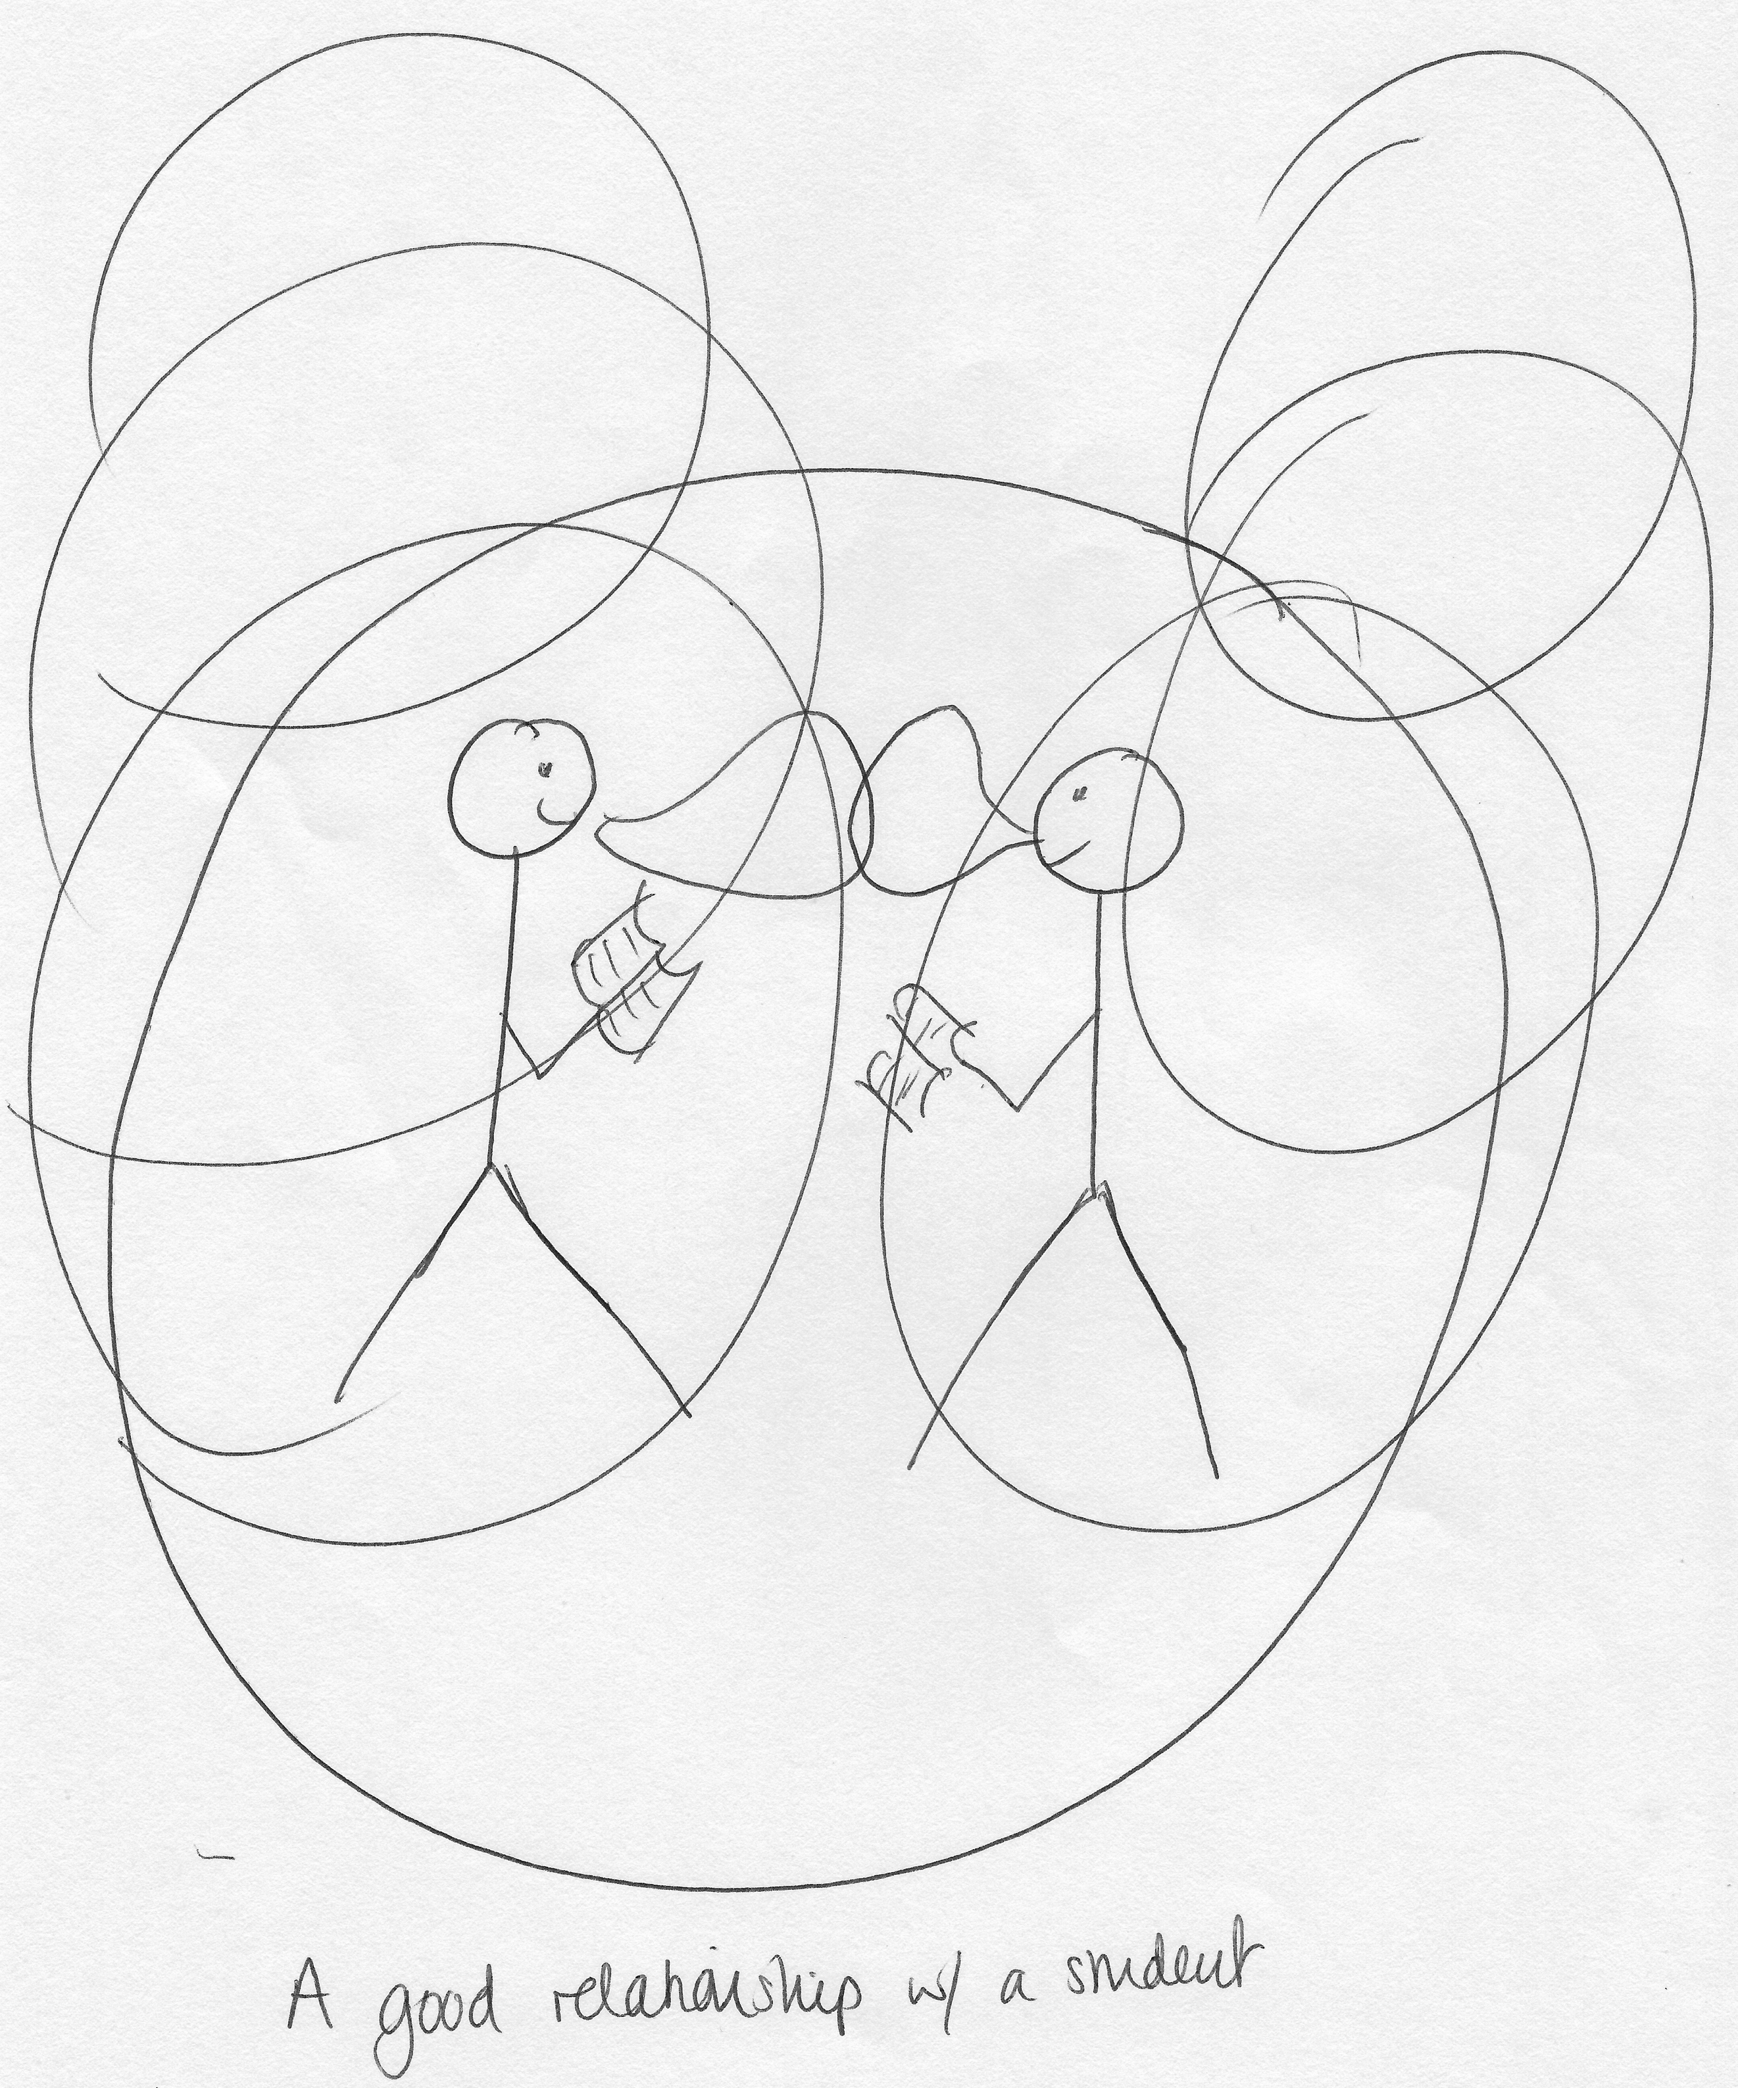

I: Okay, brilliant. Thank you. Now can I ask you to draw the opposite, so a bad relationship? [laughing]

P: Oh [laughing] Yeah okay. Bad relationship with a student… Okay so clearly, my thinking about this relationship is now all about, this is all about communication [laughing] I think that’s what my idea has come down to. So, okay. [pause for drawing] Oops, I don’t know how to draw… [continues drawing] Okay that’s meant to be a wall [laughing] although it kind of looks like a net [laughing] but it’s definitely a wall. Yeah, so I suppose it’s to do with – this is not… yeah. So, we’ll have to do different circles. So I suppose it’s to – yeah, it’s to do with, you know, the kind of lack of engagement, lack of communication so lack of anything, kind of, being shared, a, sort of, disinterest and lack of awareness of the other, not doing the work and getting frustrated, not engaged with other people so, maybe kind of, if not – because I tend to find that the students that – students that make little friendship groups in seminars, even if it’s only for the space of the seminar, feel like they tend to get more out of it, which is why I do the ice breakers at the beginning. The student that comes in, always sits by themselves and doesn’t contribute, I think makes it much harder and so it’s how to get that relationship with that student when they don’t have a relationship with the group and they don’t have a relationship with you, so it’s very difficult to, kind of, bridge that gap then [pause] Yeah… yeah [laughing].

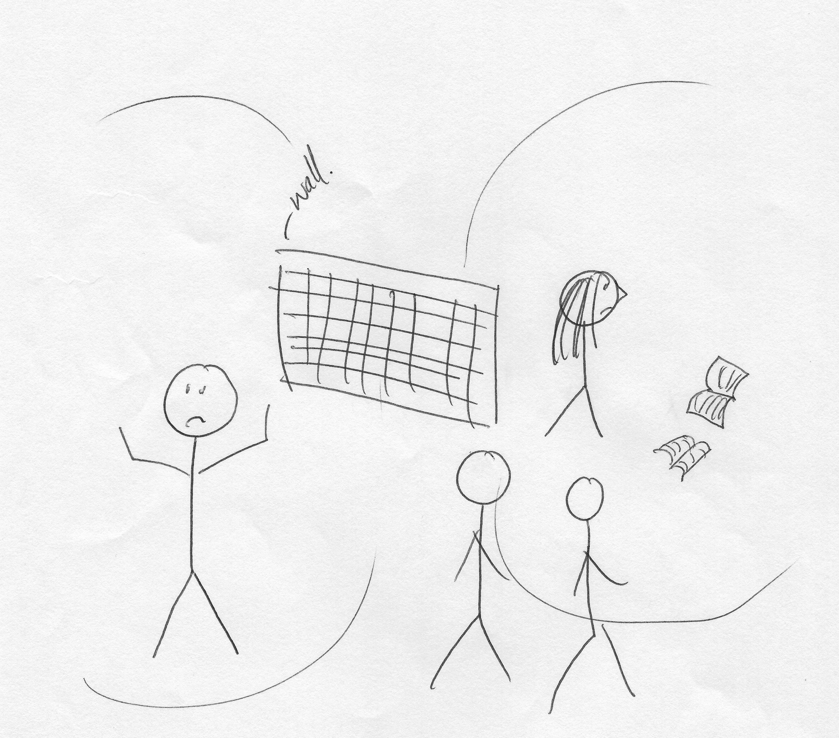

I: Okay brilliant, thank you very much. There’s no more drawing now don’t worry [laughing].

P: [laughing] That was quite fun.

I: You’re the first person that’s thought it was fun [laughing].

P: [laughing].

I: Okay, there’s often a lot of encouragement for undergraduates to engage with different experiences that the university offers, such as joining societies, volunteering, getting involved with the SU. What are your thoughts on this?

P: I think that’s a very good thing. I think that – I think that being at university is about more than just the subject that you’re studying, it is a much more, kind of, sort of, diverse, varied, kind of experience, where the student – you know, it’s as much about the students, kind of, learning about themselves as much as it is learning about the subject, you know, it’s a, kind of, for many students, it’s a, kind of, process of becoming an adult, so, you know, they – the literal educational side is, I think, a big part of that, but the other things that they might be engaged with are important as well, and I think especially in the, kind of, first year when students are settling in, students that feel isolated or disengaged from their studies often, or those that have come to see me, often don’t feel like they have that, kind of, friendship group, don’t feel like they’ve settled properly, aren’t, you know – don’t necessarily participate in some of the other things that the university offers. So, I do think it’s quite important, as long as students can manage their time properly, obviously that’s down to the individual but, overall yeah, I think it’s a really good thing.

I: Okay. What are your thoughts on the Student’s Union in terms of engaging undergraduates?

P: I have really very little to do with the Student Union. I mean I think the fact that they have such, you know, huge range of clubs and societies and things like that, is fantastic. But I know relatively little about it. Yeah.

I: Okay. Do you think the undergraduates value the Student’s Union as a space dedicated to them?

P: I hope that they do. I think some do more than others. There was a bit of a thing that happened last year, [removed for confidentiality]. At the same time though, I think there may be a sense that, well, you know, a Student Union is something that’s always there and so, students don’t have to participate in it, but they do know that it’s always there for them. So, I think it’s difficult to tell really.

I: Okay. What are your thoughts on the university’s attempts to engage its current and prospective undergraduates?

P: I think it seems to do a pretty good job. [pause] I mean there are lots of projects, for example, that the institution is engaged in, in the local community. I think as well, it really helps having facilities like the [removed for confidentiality] on campus, so that is a, kind of, it’s on the university, but it’s also [removed for confidentiality]. And there’s [removed for confidentiality] and things like that. [pause] Yeah, I suppose I don’t know what else… What kinds of things, do you have any view on what kinds of things that might include?

I: So well for the current students, what you said is pretty – yeah hit the nail on the head. With prospective, I guess the marketing techniques the university uses? That sort of thing.

P: I mean I think it seems to be quite good. I was involved in something in the last year which is 60 second seminars, which are little, kind of, video clips that are particularly aimed at, I think, kind of 15 to 16 year olds, so people that, you know, when they’re thinking about coming to university, on a, kind of, like, little snapshot on a really small subject. So, I did one on [removed for confidentiality] and that was sent out to, I think, kind of local schools or… in the Humanities subjects. So, initiatives like that, that I think are actually quite good, but I think, you know, it does quite a good job.

I: Yeah, okay.

P: … And good, kind of, glossy brochures and stuff. We’ve spent a lot of time on the brochures recently, so I think they’re kind of, you know, they’re quite good, they’ve got a lot of information in I think, so that helps.

I: Okay. Do you – this is the last question – do you think the university relies on individual departments and/or individual staff members, to maintain levels of engagement once undergraduates have begun their studies?

P: [pause] I don’t think so. I don’t think it’s that, kind of, divided. I mean I would say that, for our own students, for students in English, quite often we are – we put up information on like Blackboard, our virtual learning environment thing, to notify students of events that are coming up that they might be interested in, or members of staff might put up things of interest in their folders for particular modules, if not to the whole cohort, you know, and that might include things like, you know, “There’s a TV programme coming up that might interest you”, “This is coming on at the theatre if anyone’s interested”, “There’s a talk happening this Friday if you’d like to come”, so things like that. And that’s often done by different members of staff. We do have, kind of, officers or representatives that take charge of particular things, so we’ve got – we’ve got an employability tutor, who is in charge of things like our [removed for confidentiality]. But generally, I think it’s something that staff across the department will do, rather than it being for one particular person.

I: Okay, well thank you very much. Is there anything you’d like to add that we haven’t discussed?

P: No, I don’t think so, that was quite a lot of stuff [laughing].

I: [laughing] Okay well thank you very much.

P: That’s okay!

I: That was really valuable.

[End of Recording]

