Interview #5 Transcript: Third Year Male English Student (07.02.18) (University A)

Interviewer (I): Okay, so why have you chosen to do an English degree at this particular university?

Participant (P): [laughing] Okay. English was because I wasn’t 100% sure what I wanted to do with my career and there were several subjects that I was quite good at in school, but English I felt, sort of, kept my options open, and I really enjoyed it, doing it at A-Level, so I thought, “Carry on doing it at university, hopefully I’ll decide what I want to do for my career”, and [University A] in particular, it was actually my second choice university but what appealed to me about it was just the city in general, I have an older sister who went here so I already knew the city and how much its university’s growing as a whole, and yeah, I enjoyed the – when I went to an Open Day, I liked the sound of the course, yeah.

I: Okay, what does value for money mean for you, and is it important that you get it from your university?

P: Value for money. I feel like probably as an English student, probably get less value for money than many other courses, especially when you think, you know, like, the Science courses, you think they use all this expensive equipment and our main equivalent to equipment is books, and we have to pay for them ourselves. Yeah, it’s – I think I don’t – realistically, I don’t think we get our money’s worth with an English degree.

I: Okay. Okay, do you agree with paying fees?

P: [pause] These are hard questions [laughing]. I think in general yes, but I think the system is flawed in how it, you know, how it helps people with loans and whatnot, you know, I’m one of those people that are, sort of, in the middle. So, my family, we’re not very well off that I don’t need the money that loans can give, but we’re not really poor so we get all the money, and I’ve known people that have had excess, far excess of what they’ve needed, and I’ve also known people that are rich, but they’re self-employed so they’re, like, builders and they can fiddle it so that they’re on low income and they get extra money. So, it is flawed, but I think realistically, yes, I think there does need to be some, sort of, fee, as long as it doesn’t stop people from being able to go to university.

I: Okay, what does being a university student mean to you?

P: It means that I feel like I’m an academic? It feels like it, sort of, helps shape me as a person and sets me up for future life.

I: Excellent. What do you think being a university student means to people that don’t go to university, or have never been to university?

P: [pause] I think it’s quite often perceived as, sort of, a waste of time and money, and I can sometimes see where they come from when, you know, they – I’ve known people that have gone straight into work and, you know, they’re on a decent salary, they’re earning money, you know, they’re putting money away for a house, or going on these holidays and I’m paying for education, and I’m not really – any income that I’m coming [sic] isn’t enough to cover accommodation, so yeah.

I: Okay, what meaning does the word engagement have for you?

P: I think interaction between two people. It can’t just be a one-way channel, it has to be open both ways.

I: Yeah, okay. In what ways do academics attempt to engage you as a student?

P: Academically, I think that’s obviously the main one. I feel like as a university, it’s quite open and forward thinking, so it, sort of, elements, and I suppose it’s probably true for most courses, that, sort of, challenge your way of thinking.

I: Do their, like, techniques to engage you differ in lectures and seminars?

P: Yes. As you know lectures tend to be more just one person talking and it’s, sort of, there are some lectures where you just go and you just think, “I’ve just made notes, that hasn’t really done anything” but there’s others where you go, “Wow, that was really interesting and thought-provoking”. But then seminars, most tutors try to get you to interact with them, answer questions, think for yourself and come up with your own answers.

I: Yeah, okay. What are your thoughts on the concept of student as consumer in higher education? Are you familiar with this concept? [participant shakes head]. Okay, so it’s really born out of the introduction of fees, and it’s a concept that basically means that the students are now considered more consumers rather than students. So, universities frame them as customers as opposed to students. So, has this impacted on your experience at all? Have you noticed this, or…?

P: No, I haven’t really felt that myself. No. I’ve actually had a bit of a unique experience that I’ve studied abroad in America during my degree and I felt that was a lot more consumer-like than it is over here.

I: Yeah, okay. Do you consider yourself to be a customer in any sense?

P: [pause] No.

I: Okay. Do you think paying fees gives you more entitlement as a student, and if it does, what kind of entitlement does it give you?

P: Yeah, I think it does. I think – now I feel like I have to backtrack on what I said earlier [laughing]. Yeah because you’re – as a way – I personally don’t consider myself as a customer, but in that, sort of, model, you are paying for a service, you’re, you know, paying for more than just, you know, a sheet of paper at the end of the day. I’m trying to remember now, where is it recently where the university lecturers are going on strike for a few weeks? I came across that recently in the news, and the students are saying, “We want some of our money back”. So, you know, yeah.

I: Tricky one. So, as a – when you said, you’re paying for a service, in your mind, what service is that? What are you paying for?

P: [pause] To be educated? I don’t know, to be – to become a student of the university. [pause] I feel very strongly that part of the university experience isn’t just, you know, the academic studying and the qualification, I feel a lot of it is how you, for most people, it’s the first time moving away from home and living for yourself, by yourself and I feel like that’s really part of the experience. So, I think – but then you don’t really pay the university for that, in a way. [pause] I don’t know.

I: [laughing] That’s a hard one. So, do you think there would be a difference if, say you’d paid for this experience or if you paid, I don’t know, if you did Open University and you paid for a degree that way? Is there any difference in the service you’re getting, or…?

P: Well, I don’t really know a whole lot about Open University, but from what I gather, this would be, sort of, more personal? In a way, it’s, sort of, yeah there’s more interaction maybe. Certainly I think more face-to-face interaction. Yeah.

I: Yeah, and do you think that’s important – an important part of your studies?

P: Yeah, yeah.

I: Okay. So, moving onto learning. How engaging and/or useful for learning do you find lectures, if you do at all?

P: I think, yeah, they are useful. I think they’re, sort of, they’re a good way to lay the groundwork for what you’d study that week, or in that module, or whatever. But, sometimes it doesn’t really work that way because they’ll have the seminar before the lecture, so, you know, we’ve already covered a lot of it and I feel like a seminar, naturally, is better than a lecture. But, then, you know, you probably won’t get as much information, and as much quick, needed understanding that you can get from a lecture.

I: Okay. Okay then, how engaging and/or useful for learning do you find seminars?

P: Yeah, I think they’re the best aspect of the learning experience, especially since most of the time, they’re quite small seminars. If it was, like, a classroom of 30 people, then I think you’d lose a lot of that, and, you know, there are times when I come away from a seminar thinking, “Oh, I wish that went on another hour”, or, “I wanted to talk about this and didn’t get a chance” and I rarely come away from a lecture thinking, “Oh I wish that went on a bit longer”, you know?

I: [laughing] Okay. Where do you choose to sit in seminars and lectures, like, at the back, front, middle, or do you not care?

P: I just sort of – just not at the front really.

I: Yeah, why not at the front?

P: I don’t know, I don’t know, I just don’t like being at the front, being at the forefront I suppose.

I: Yeah, okay. What about in seminars, or does that…?

P: Well, I’ve recently realised – I have a seminar that’s an hour and a half – and I’ve recently realised how annoying it can be if you’re sat sideways, and the screen is there, and you’re turning your neck for an hour and a half. So, I think recently I’ve, sort of, decided to try and be straight on [laughing]. Somewhere in the middle.

I: [laughing] Okay. How engaging and/or useful for learning do you find one-to-one sessions with tutors, if at all?

P: I find it rare that I experience one-to-one, you know, about, sort of, that isn’t just, you know, a check-up of how you’re doing or, you know, like, progress report or, you know, something about, talking about a completed essay or a due essay. I have been offered to just come in and just talk about a text or talk about, you know, whatever you want about the module. I feel like that would be good, but probably at the same time, quite intimidating because, you know, they’re – the lecturers they’re, you know, supposedly experts in their fields and you’re still, sort of, learning, and it would, sort of, be like, “Oh what about this?” and they’ll know everything about it already.

I: Okay. Do you find like – do you go and see your tutors for essay feedback, face-to-face?

P: I normally haven’t done, I’m pretty bad for essay feedback [laughing]. I hate looking at my old work and, sort of – I always think, “God, that’s awful”, you know, “What did I write?” I don’t want someone else to tell me it’s awful when I know it’s awful, so…

I: [laughing] Okay. Is there anything you particularly like about the learning style of universities, compared to compulsory education?

P: I feel like it’s more of a sense of freedom, you know, you get more of a choice of what you want to learn, how you want to learn it, and it’s far more relaxed, it’s so far, you know, there’s not – I feel like school it’s always a lot more pressure of you, you know, even at GCSE’s, which in the end don’t really matter that much, you know, like, you have to perform, or the Mock exams, you did poorly in the Mock exam, so you’re going to have to…you know, and here it’s, like, this is what you can improve on, you know, this is what’s important, it’s, sort of, it’s a process rather than – yeah, I just think it’s better than school, yeah.

I: Yeah, okay. Okay, do you always understand what your teachers are explaining to you, or the material you’re set to read?

P: The material, yes. But, there are sometimes where the tutor, or whatever, will go off on a long, sprawling question or something, and I’m like, “What’s the little nugget? What’s the little, you know, the three words that underlined what you want me to respond to this”. So, I think yeah, sometimes when they want feedback or, sort of, interaction from other students, it could be simpler.

I: Yeah, okay. Is it more to do with the content of what they’re saying, or the language that they use?

P: I think language, yeah.

I: Yeah, okay. From your own experience, is there anything you would change to improve your own learning. In terms of teaching, resources you have access to, curriculum and assessment, or anything else you consider important?

P: I’d maybe say, sort of [pause], sort of, maybe something to maybe help attitude of, sort of, learning, of – because I personally have struggled, and I know a lot of people do, with motivation, and completing dead – you know, sometimes, I think everyone does all-nighters at some point in their degree, and, you know, little things – I’ve, sort of, discovered along the way that I do work much better when I’m in the library, when up, I’m dressed, I’m not in my room where I sleep, you know, that, sort of, thing, it’s just – and maybe just little techniques that can help you, sort of, get through.

I: Yeah, okay. Okay, I sent you the document that refers to the Student Collaboration Policy [policy name changed], have you heard of this policy before I sent it to you?

P: I don’t think so, no.

I: No, fair enough. Okay, so yeah, I mean just a brief outline, it’s – it’s meant to be that student – undergraduates students – here are encouraged to be more than just passive learners, and they take responsibility for their own learning and they produce new work that helps advance their discipline. So, instead of just being told what to learn and then reproducing it in essays and getting a grade for it, they help contribute to knowledge, to new knowledge. So, that’s the idea behind it. So, is it evident in your experience of being a student here?

P: I feel like it would be definitely more evident in an English degree, or a creative degree. I have no real experience of something like Law, so I don’t know how – how, like, new they can produce, you know, laws, I don’t know how it works, but certainly yeah, I feel like you, sort of, you know, you get a reading list and all the suggested reading list but then it’s, go off on your own, sort of, find, you know, there’s books in the library but there’s online resources I suppose you can order in, you know, a lot of the time you’re just free to answer the questions you want to.

I: Yeah, okay. Okay, so I also sent you the document that refers to the Student Charter, have you seen this document before?

P: I don’t think so either, I think I’ve probably flicked through it at some – actually I’ve probably flicked through it, but it’s probably one of those Terms and Conditions things that you, sort of, discard.

I: [laughing] Yeah, so this is technically your contract with the university in less formal terms. So, are these values and these beliefs evident being a student here?

P: [pause] I feel like they’re definitely – it’s, sort of, I can imagine them printing these on, sort of, like, an Open Day, you know, sort of, entice – “We [removed for confidentiality]”, “We share a responsibility”, you know, they’re little catchphrases and whatever, but overall I feel like yeah, they’re probably true. How much length they go to try and achieve these values, I don’t know. It seems that that is the community that we have.

I: Yeah. Do you think this is an important policy document for you, or…?

P; [makes face] No. No.

I: No? [laughing] Fair enough. Okay, in your opinion, should undergraduates have greater control over, or input in, the curriculum and/or assessment design of their chosen courses?

P: [pause] To a certain extent. I mean you – when you’re choosing a course or whatever, before applying for university, you don’t go, “I –”, you know, you look at what they’re offering, you know? It’s not what – in some ways, it’s not what you want to do, it’s, like, would you like what they’re offering? [pause] I feel like there are improvements or suggestions that students can make, but I don’t feel they should have, like, the ultimate say. Yeah, and a lot of – and obviously the staff have their own areas of expertise and interests, then, so if you really want to do a module on, or you want there to be a module on, whatever I don’t know, you know, some weird example, then it’s probably not going to happen.

I: Yeah. Okay. What about if, like, undergraduates were in, say, like, an open dialogue with academics to discuss different options, so they didn’t just say, “We want this, give it to us”, but they would have, like, a constant dialogue with teachers to talk about possible texts, or possible assessment designs and they worked through it together?

P: Mayb – I feel like some of that can be done retrospectively, you know, when you get, sort of, like, feedback forms at the end of a module. But, going into a module, I don’t really feel – because [pause] because you’re, sort of, you’re learning in the module, unless you’ve studied it before, you might not know what the important texts are, or what’s the important themes to look at, or the areas to focus on, but they do, and they can say, “Look, this is what’s important, this is what we need to look at”. So, before you, you know, you know anything about it, you can’t really say, “It needs to be this, this and this”.

I: Yeah, okay. Okay, in recent government policy on higher education, students have been placed at the heart of the system, which is their wording. How central or important do you think students are in this university?

P: [long pause] Yeah, I feel like they’re important, yeah, yeah definitely. Yeah.

I: Would you say they’re the most important part of the university, or, would you say the tutors are more important…?

P: I think probably the students, or at least, I think I would hope so. Yeah.

I: Yeah. So, you think they should be the central part?

P: Yeah.

I: Okay. What meaning does the word relationship have for you, in the context of interacting with academics?

P: I think it can, sort of, mean you have a, sort of, history with certain staff, you know – for instance, my personal tutor that I have for third year now, I had her for a module in first year, she was the coordinator that I was – when I did my study abroad, so, you know, we’ve interacted, we know each other a bit, you know, I feel like she, sort of, knows me and I feel like those, sort of, relationships that you build between staff and students are good and, like, sort of, needed.

I: Okay. What do you consider to be the main purpose for building a relationship with academics?

P: So that they can help you, and guide you, yeah.

I: Oaky. Academically, or just overall in general?

P: Yeah, overall I feel, again, I had a – I’m in a weird situation because in my second year, I had to interrupt part-way through for health reasons and so, you know, when I was struggling and not able to go to lectures or whatever, all the staff were really understanding, they were really, sort of, “How can we help you?” you know, and that was really good back then, yeah.

I: Okay. Do you consider there to be a link between the relationships you build with academics and your levels of engagement as a student?

P: [pause] Maybe? I mean, the only way I can think of that is, if there are certain tutors or professors or whatever, that you don’t like or are scared of, you know, so maybe you’re less likely to get involved, but…

I: Do you enjoy the classes with the tutors that you get along with more, that you have a better relationship with, or does it not matter?

P: Well I think foremost it’s probably their ability, but then yeah definitely, you know, if they come across a bit hostile or intimidating, then yeah, it will probably be a bit – even if they’re, you know, they’re making really good points and they’re clever and whatnot, it would still be a negative effect.

I: Okay. Okay, so can you describe to me a typical face-to-face encounter with an academic. So, if you go and see them to discuss an essay, or something like that. How does that interaction play out, what actually happens?

P: Greet each other, just the typical, “How are you?”, “Okay, how are you?”, “Okay”, you know, that. Yeah and then straight onto, sort of, the point of the meeting really. I don’t really know how else to…

I: Does it take – where does it take place?

P: Normally in their office, or in a room booked for that, yeah.

I: Do you normally make an appointment, or, do you just turn up?

P: Yeah, most times I’ll email ahead and say, you know, like, “Oh, can we meet?” Or, you know, they’ll say, “We need to meet” or whatever. So, normally takes a few emails to organise a time and a place.

I: Yeah, okay. Are you ever aware of a hierarchy when you interact with them like that?

P: As in a hierarchy between the student and an academic?

I: Yeah.

P: [pause] I think I’m aware of, sort of, that they’re, I don’t know, sort of, the leader’s not the right word, but they’re in more control than I am. It’s, sort of, it’ll be typically me asking for help or me getting guidance, and obviously the person that can give that, is the person more in power.

I: Yeah, okay. Can you think of any particularly good relationships, without telling me who they are, with any academics, and tell me why you think it’s good?

P: [pause] Yeah, I think, like I said, it’s, sort of, based on a, sort of, a history and the, sort of, number of interactions, you know, there’s some staff members where, maybe outside a lecture or a seminar, I’ve barely spoke to, and there’s others where, you know, I turn up for a seminar, say I’m a bit early, sit down and just talk, not even about anything about the seminar, you know? And it’s, sort of, the – it’s not like a friendship, it’s a friendliness, outside of just the student-staff relationship, and a, sort of, feeling of, you know, like, trust, and, sort of, knowing that you can be open and they won’t judge you or…

I: Yeah, okay. Do you find it quite hard to build, like, relationships like that with staff because of the turnover of how many you see?

P: Yeah, there aren’t many staff members I would say I’ve had – I would call have a relationship with, you know, if it’s just they’ve – I’ve been to their lectures, I wouldn’t call that, I know them, or, you know, we’ve got a relationship, you know, I – you know, if I had to email them, it would be, “Dear”, you know, rather than “Hi”.

I: Yeah, okay. Okay, can I get you to draw your conception of a good relationship with an academic?

P: Oh dear.

I: So, it can be anything you want, it can be stick people, abstract, whatever, however you visualise it. It doesn’t have to be good [laughing].

P: Oh dear, okay. I can’t draw a circle. Okay [pause for drawing]. Okay.

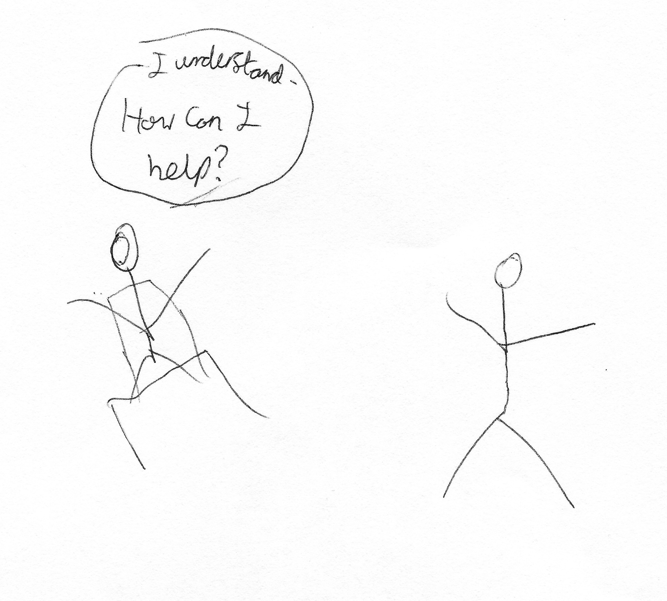

I: Okay, so what’s this then?

P: It’s a staff member sat behind a desk, me meeting them and they’re going, “I understand, how can I help?” and I feel like that’s one of the main purposes of academic staff outside of learning, is, sort of, helping you.

I: Mmhmm, yeah, like, a supportive role?

P: Yeah.

I: Yeah, okay. Now can I get you to draw a bad relationship? [laughing]

P: [pause for drawing] I’m interested, do you get some really, like, artistic drawings?

I: No, everyone I’ve interviewed has said, “I’m not an artist” before they start [laughing]. There’s been a lot of stick people [laughing].

P: [pause for drawing] Okay. So, this is interaction between the staff member, student, could be anywhere and simple message, “You’re wrong”, and I feel like, you know, this could be in a seminar, you know, where someone presents an idea or, you know, say, “Oh I think this is about that” or – and I feel like that’s always the worst response to get is not, you know, or that, you know, like, “Look at it this way” or, you know, like, “That’s interesting, how about this?” But the flat-out rejection of, “You’re wrong”, you know, like, what you’ve just contributed doesn’t matter, it’s not important.

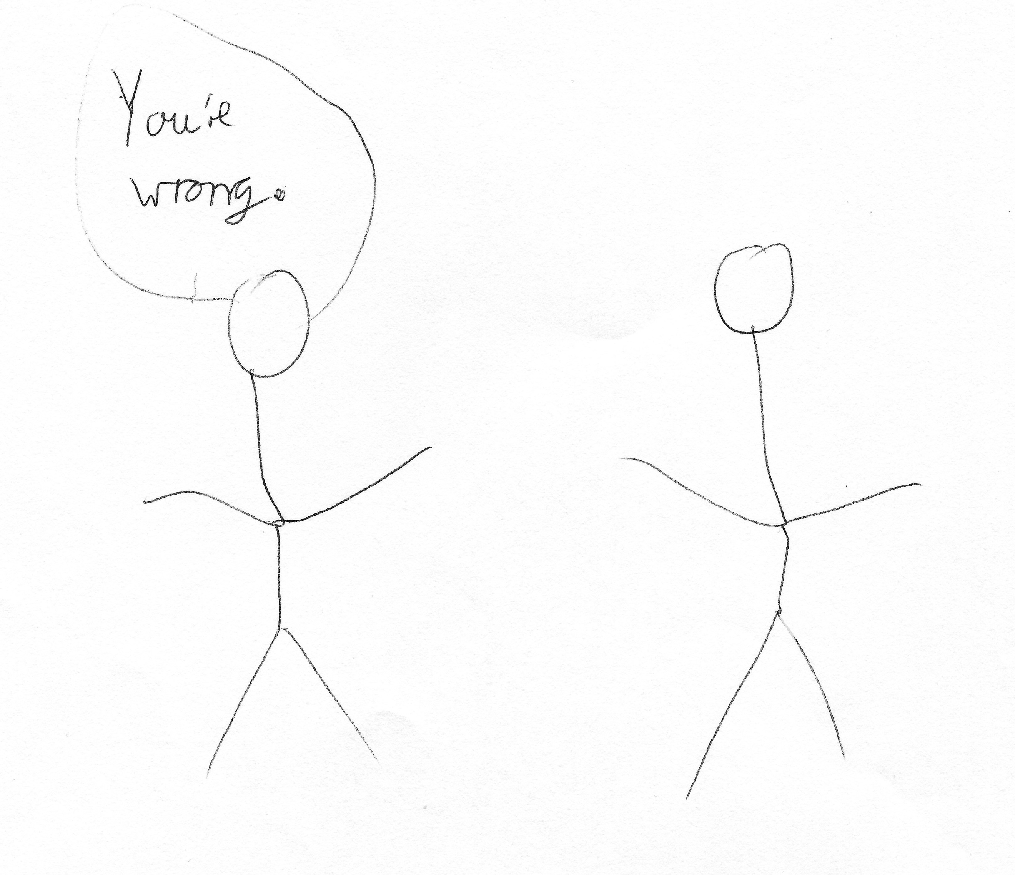

I: Yeah, okay. Have you ever had that experience?

P: I’ve seen it happen.

I: Have you?

P: Yeah.

I: Okay. Okay, so this is the last drawing I promise [laughing]. Can I ask you to draw your conception of your relationship with the university as a whole?

P: [pause] Oh dear [pause]. [sigh] I really don’t know what to put for this [pause].

I: It can just be, like, when you think about the university, what comes to mind, or what’s the most important part of the university to you?

P: [pause] Ah! [pause for drawing] Okay, it’s meant to be graduation.

I: Okay, cool.

P: That isn’t what I feel like is, like, the most important part, but for me, it is the end goal, it is ultimately what you are here for university to gain [sic], and certainly it helps motivate me to think, “This is what I’m going to get from the university, I’m going to get my degree. I’m going to get that great day of graduating, like, feeling of, sort of, proud – pride and achievement”.

I: Yeah, okay, brilliant. Thank you very much for doing that, there’s no more I promise.

P: Burn them, burn them!

I: [laughing] Okay, so there’s often a lot of encouragement for undergraduates to engage with different experiences that the university offers, such as joining societies, volunteering, or getting involved with the SU. So, what are your thoughts on this?

P: Yeah, I think they’re positive. Yeah, I think, sort of – pardon me – I think it’s important to have more than just, “I went to university and I got a degree”, you know, it’s not just for yourself, as personal development, but also for your CV and for future jobs and certainly, you know, things like societies or whatever, they can help build friendships and relationships, and in other ways, you know, they can be really meaningful and, sort of, give back to the community or the university.

I: Yeah. Okay, so when you say they’re important for your CV, is this something that – because this has cropped up a few times, is it something that the university tells you when you start, that you need more than just your degree?

P: Yes, that’s what it seems to be, and certainly it seems everyone tells you, “You need more, everyone’s got a degree, everyone’s got at least a 2:1, you need something about you that stands out, that is different on your CV”, so even if, you know, people doesn’t – even if someone hasn’t met you and doesn’t know what you’re like, they can read you on paper and say, “That’s different”.

I: Yeah, okay. What are your thoughts on the role of the Student’s Union, in terms of engaging you as an undergraduate?

P: I don’t really, sort of, see how the Student’s Union affect academically. They’ve given me, personally, a lot of support when I was going through my interruption, so that side of it, certainly useful and it’s certainly, I suppose without the Student’s Union, there wouldn’t be societies and some events, and you know, like, nights out. So, I think they’re important to the university. I think I wish I’d see them, sort of, get involved more, maybe academically?

I: Yeah, okay, in what ways?

P: Maybe just offering more guidance, more opportunities to learn maybe, you know, maybe like, “Oh you do an English course, but you know, we’ve got this voluntary course on Spanish” or something, you know, like, stuff like that.

I: Yeah, okay. Do you consider yourself to be a member of the Student’s Union?

P: Technically yes, as a student, unless you tick the box saying you don’t want to be, you are a member. Don’t really feel that involved with the Student’s Union though.

I: Yeah, okay. Okay, last question. How much of a valued member of the university do you consider yourself to be?

P: I consider myself valued in, sort of, like, my little world of the university. I know, you know, if I walk into, you know, a Science building, it doesn’t matter. But I feel like – not that I’m, like, a big shot or anything, you know, not in that way, but just, sort of – there are people that care about me, care about how I’m doing and that I do matter.

I: Yeah. So, would you say it’s more department-based, than the institution?

P: Yeah, yeah.

I: Yeah, okay. Okay, well thank you very much for all of your answers, really valuable. Do you have anything that you want to add about your student experience or interactions with academics that I didn’t cover?

P: No, I just – I feel like I’d like to stress just how helpful, and how really nice the staff have been in my experience of having to stop because of health reasons and helping me back in, and I feel like – I feel like it’s happening more and more to students now, that they’re struggling with health and more and more students are stopping, you know, I know others that have had to interrupt and things similar to that, and it’s nice to see that the staff do care more than just your grade.

I: Yeah, okay. Okay, brilliant, thank you.

[End of Recording]

