Interview #6 Transcript: Second Year Male English Student (21.03.18) (University A)

Interviewer (I): Okay, so why have you chosen to do an English degree at this particular university?

Participant (P): This particular university? Well, this was actually my insurance choice. I had – my first choice I think was at [removed for confidentiality], but then I didn’t get the grades that I should have done, I got two B’s and a C, and they were pushing for, like, A’s so… But I’m really happy I came here. English in particular, probably because I wanted a lot of options when I leave, I mean I didn’t really come into this with any fixed purpose, you know, I want to come out with a teaching degree or something like that, no, I just want to keep my options open as much as possible.

I: Are you the first in your family to go to university?

P: I am, they’re all farmers. All of them [laughing].

I: [laughing] Okay, what does value for money mean for you and is it important that you get it from your university?

P: Well, it is incredibly important, I mean, every day I think about the – what is it, £9,250 I’m paying, and, you know, the quality of teaching I’m getting here, is it worth it? I mean, I’m sure my opinion will come up later on about that [laughing].

I: Yeah, okay. Do you think – do you get value for money from this university?

P: I mean, I’m doing well, you know, my marks are showing that I think it is value for money, I’m getting good marks so far. Their particular methods and dealing with certain situations I think they could be doing better. I think – what am I trying to say here? Interacting with the students, I think they could probably improve on a bit.

I: Okay. Do you agree with paying fees?

P: Do I agree with paying fees? [pause] I mean, this is – I always try and, sort of, stay out of this whole thing. [pause] I mean part of me wants to say yes, but the amount that we do have to pay, I think, is a little ridiculous for the – yeah, for the teaching that we’re getting.

I: Yeah, so a smaller fee?

P: A smaller fee, yeah. I don’t – yeah, I wouldn’t say that we should be getting this, that, you know, that I should be getting this for free at this stage, but yeah smaller fee.

I: Yeah, okay. What does being a university student mean to you?

P: It means I’m doing something other than being a farmer [laughing]. No, I’m pleased that I got this far, it means that I’m, you know, I’m working towards having lots of opportunities in the future. And it, you know, makes my parents happy.

I: [laughing] Opportunities in terms of your career?

P: Yeah, yeah.

I: Okay, what do you think being a university student means to people outside of the university, or who have never been to university?

P: I think it’s – so for people who, yeah, just haven’t been to university? What do they think of people who – I don’t – I hope they don’t think of us as snobs. I know my mates who was at sixth form [sic] and they’re doing apprenticeships right now, they don’t look up to us very well [laughing]. But I mean, I think that they should see it as, like, a pathway to, like, a much more fruitful career I think, you know, if they decide that they really want to go and push for something else, that, you know, university would be a good choice.

I: Yeah. Do you think they do see it like that? Or they should see it like that?

P: I mean, like, I know I’ve just talked about my friends in apprenticeships who – [laughing] I like to think it’s mixed. I think there are people out there because I work in – at an Oxfam at the moment and everyone likes to know what I’m doing right now, and I always say, “I’m at university” and they, you know, they’re always really positive about it. So, I think it – yeah, I think it depends, might be mixed, I think, yeah.

I: Yeah, okay. What meaning does the word engagement have for you?

P: [pause] What meaning does the word engagement… [pause] Everyone is on the same level of understanding, ready to co-operate with each other, yeah, engagement [laughing].

I: Okay. Okay, so in what ways do academics attempt to engage you as a student?

P: Oh boy [laughing]. They do it in a number of ways, some that I don’t really like. So, there are – I had a tutor last year called [name removed], I had him for my Victorian Studies, very nice chap, he would go in and the first thing he would do before any module is he would, he’d just have a general chat, make everyone feel comfortable, you know, because for me on a 9am on Monday, no one is comfortable, no one wants to be there, they’re all sleepy. But, the first thing he does is just has a general chat, bit of banter, you know, gets everyone relaxed, and then he’ll go into group work, so he’ll get everyone into very small groups, and we can converse, because I know a lot of people on this course are incredibly anti-social, I am [laughing] myself. So, no one wants to speak, you know, be the first person to speak out loud in a big class, so getting into small groups, you talk, you know, to fewer people, at first anyway, and then he would come round to each group, say your thoughts, he’d have another bit of general chat, make us feel really nice, happy, positive, then we’d all come back together. I’m sure you know of this, you know of this way of teaching. And then we’d relate back to the class, to all the other groups. That’s what I see as a positive engagement. Negative engagement, what I’ve had more recently over the last year as well, is that the tutor would start off talking about the subject and then we’d all be in, you know, just in one horse-shoe shape, and then they’d ask a question and then if no one answers, then nobody else answers for, like, the next 2 minutes and the tutor will wait and he will sit, he or she will sit, and wait for as long as it takes for someone to speak up and in their mind that’s probably thinking, “Okay, well, they’re going to crack, you know, this is going to help them to be more confident” but really it’s just worsening everything because the longer the silence goes on, the longer no one, you know, no one wants to speak. That’s not engagement for me, at all. And that’s, sort of, it’s not happening in all my modules, but it’s just, like, particular modules I see this happening and I don’t know whether it’s happening for other courses, but it’s not great, is it? Doesn’t sound, you know, when you come to university, it’s not really what you picture, just sitting around in silence waiting, you know, it just doesn’t really help.

I: Okay. Does the types – do the types of engagement differ for lectures and seminars, the way that they try and engage you?

P: Lectures are very different. Lectures you sit there and they will relay information and you write it down and then you go back, and you look over it, and that’s it.

I: Would you say that lectures are engaging?

P: Lectures can be engaging, I think it all depends on the mode of presentation, the way lecturers present. If they are just behind their little plinth, reading off a script, you know, no I think people – a lot of people switch off. It always helps to have a presentation for something to look at, so you have a few notes on a PowerPoint that you can jot down and then you can also jot down points that are not on the PowerPoint so, I think both help.

I: Yeah, okay. What are your thoughts on the concept of student as consumer in higher education? Are you aware of this concept? Have you heard of it before?

P: What was that again, sorry?

I: The student as consumer?

P: Student as consumer, I haven’t heard of that.

I: So, it’s being discussed a lot in higher education academia, and what it basically entails is that universities are treating their students more as customers, as opposed to students or conventional students. So, there’s a big focus on student satisfaction, pleasing the student, etc., etc. So, what do you think about that?

P: I mean, what I’ve just been talking about, the seminars that I don’t like, that I don’t think are engaging enough. You don’t really feel like a student, you don’t really feel like the tutors are there, sitting in front of students wanting to help them to learn, you feel like you’re, sort of, a person that has paid to come to this place and they’re just, sort of, giving you these questions and yeah, it does feel different. Yeah, whether a customer, I’m not sure if that term is right, but you do definitely feel different when you’re in that situation to then just being a student, definitely.

I: Okay. Do you consider yourself to be a customer in any sense?

P: Like I said, I don’t think that term is very good but yeah, like I just said, sometimes you do feel like a student here, with people who do really want to help you learn and to help, you know, and to engage, and then yeah, there are some where you just feel like they’re there because they have to be there, you’re there because you have to be there because you’ve paid and that’s how it is sometimes.

I: Okay. Do you think paying fees gives you more entitlement as a student?

P: [pause] Paying fees gives me more entitlement… Could I have that rephrased?

I: Yeah, so, the fact that you’re paying money for your education, does that give you more of a right to involve yourself in that educational process –

P: Oh, I see.

I: So right to complain, or to change things or…?

P: Oh definitely, yeah. I think if I was, you know, I think if there were no fees, I mean at this establishment I think we should still have that – those rights to voice ourselves, definitely. I don’t think that should be based on how much we pay or anything. No.

I: No, okay. Okay, so moving onto learning. How useful for learning do you find lectures?

P: Very useful. Like I said it does depend if they, I mean, if they have a nice PowerPoint presentation it really does help. Other than that, yeah, I would say very much so.

I: Okay. How engaging and/or useful for learning do you find seminars?

P: [laughing] I think you know [laughing]. Yeah, again, it all depends.

I: Depends on the tutor?

P: Yeah pretty much.

I: Okay. Where do you choose to sit in seminars and lectures? Like, at the back, front, middle, or do you not really care?

P: Is this in lectures, just specific, lectures?

I: Lectures and seminars.

P: Oh, lectures and seminars, okay. Lectures I do tend to sit off to the side, mainly because, I don’t know, I don’t really like to sit in the middle. I like to sit off to the side where I can just see, I don’t know, that’s just what I’ve always done. And then seminars, you don’t really have, I mean there’s no real choice because it’s in a horse-shoe, so it doesn’t really matter where you’re placed. I think that’s the whole point…

I: Yeah, okay. How engaging and/or useful for learning do you find one-on-one sessions with tutors?

P: The one-on-one sessions I have got have been incredibly helpful because the tutors that I have, or I haven’t talked about specifically and I won’t, but, you know, the ones that don’t engage properly, you really do see them change in terms of, like, personality as soon as they are out of that room and they are in their office, just with you in a one-on-one and it does feel a lot more personal and it is, it’s good. The ones I’ve had, they’ve really helped.

I: Okay. Do you ever find them intimidating?

P: Intimidating [laughing]. There’s definitely a few that, yeah, I’ve had. I wouldn’t say, like, really bad to the point that I really don’t want to be in their presence, it’s – no, it’s more of a joke thing. Some of them look intimidating but then they turn out to be nice. So, no I don’t.

I: [laughing] Okay. Is there anything you particularly like about the learning style of universities, compared to compulsory education?

P: You do get – they do allow you to have a lot more choice and freedom with, you know, what you can say and what you can do in your seminars, and I think even the way they’re set up, that you don’t – it’s not, well it is compulsory for you to go to seminars and you will be marked absent if you don’t go, but they’re not going to yell at you if you do miss, you know, the odd one or two. I think that does really help with, you know, satisfaction and positivity.

I: Yeah, okay. Do you always understand what your teachers are explaining to you, or the material you’re set to read?

P: Again, this comes – I mean, if this was in a lecture, usually, you know, obviously in English we get a book to read and you have to read it beforehand, so that always helps if you’ve read the book. If you haven’t read the book, then you may as well just not turn up to the lectures or seminars because you’re just not going to understand a thing. But in the certain lectures where lecturers won’t have a PowerPoint slide or anything, they’ll be reading off a piece of paper, they’re obviously a lot more comfortable because they’re just staring down at a piece of paper and they’ll just go on and on and on, just going through it and you’ll find it – you’ll find it difficult to keep up, with trying to jot down notes. So, that way it’s not very good. Seminars are good though, seminars are fine.

I: Okay. Do you think, if you ever have a lack of understanding, is it to do with the content of what they’re saying or is it the language that they’re using to explain it?

P: I [pause] I don’t think I’ve ever had an issue with – if it’s their language, and if it ever has been, someone would just ask, you know, what that means. So, it’s probably more content-based, because a lot of the books we’ve had to read I know are, well, they’re quite difficult for me anyway. So, sometimes it’s a little difficult, content-wise.

I: Okay. From your own experience, is there anything you would change to improve your own learning, in terms of either teaching, resources you have access to, curriculum and assessment, or anything else?

P: Teaching I would, yeah, I would change definitely, seminars-wise. I’d like for, yeah, seminar tutors to rethink the way they, yeah, do their seminars. And to maybe think that, “Maybe at this – the way I’m doing it right now, just sitting down, asking questions and just literally waiting for someone to answer maybe isn’t the best way to engage with these students. Maybe I should try to actually get more involved, you know, with them and yeah I’ll look at other ways of conducting them”.

I: Okay. Do they ever, like, do you – how do you feel about them calling out people, like –

P: It’s never nice, is it? I don’t think anyone likes a person who does that. I mean you get that all the way through High School and College or Sixth Form, and it’s never nice and again it’s – it, sort of, keeps you ready, you know, on your toes because you know that your name could be answered, it doesn’t help though for mental state, knowing, you know, knowing that it’s just, yeah, again I, sort of, get why they do it, but it’s, yeah, it just doesn’t sit well with students, and then that just brings down the vibe and it makes it more negative.

I: Yeah. Do they do that fairly often here, or…?

P: No, they sit in silence until someone says something. So, I don’t know which one’s worse actually [laughing].

I: Okay [laughing]. Okay, so I sent you the document that refers to the Student Collaboration Policy [policy name changed]. Have you ever heard of this policy?

P: I haven’t, no.

I: Okay, so, I’ll give you a little bit of background then. This is an institution-wide policy here and it’s really unique, and it was basically set up as an opposite to the student as consumer ethos, and what it aims to do is to ensure that students and academics are both in the pursuit of knowledge, so there’s not so much of a divide in, one being a learner and one being a teacher, so it’s all about bringing them together in the pursuit of knowledge together. So, that being said, is it evident in your day-to-day experience of being a student here? Do you feel like that’s what your tutors are doing, or… not?

P: This back to, like, goes back to the question of whether the student is a consumer, do I feel that, again, yes and no. It literally all just falls down to how, you know, specific tutors interact with their students. If they don’t interact well then, I definitely because, yeah, definitely feel like less of a student. But then, I think that’s why the one-to-one sessions really help because in those situations, you don’t feel like you’re talking to a tutor and you don’t feel like you’re a student, you feel like you’re two, almost, I don’t want to say colleagues, but, you know, you’re two people who are in the same field, on this module, and you can just discuss backwards and forwards your own ideas and it’s just much better that way.

I: Yeah, so that’s exactly what this policy wants to foster, so would you say that’s not really happening in your seminars or your lectures?

P: No not in the lectures, no, it could be happening more.

I: Okay. Okay, so I sent you the document as well that refers to your Student Charter, have you seen this document before?

P: I may have glanced. I mean, I may have glanced at it [laughing].

I: [laughing] It’s quite a long Student Charter.

P: Yeah, no I think I do remember reading this. Yes, I think so.

I: Yeah, okay. So, is this policy evident in your day-to-day experience?

P: [pause] Give me a quick summary of the [laughing] –

I: [laughing] Okay. So, basically the Student Charter is, like, your contract with the university. So, the university says what its values are and what it promises to deliver for the student, and then it gives the student a set of expectations that the university wants them to abide by. So, it’s a lot of nicely packaged language –

P: The university gives you, to say, yeah –

I: Yeah, that sort of thing, you know, those headings and then they’ll give you more detail.

P: Yeah, I mean it’s a selling point, isn’t it? I mean, some of it, I do think they do well. A lot of it, well not a lot of it, but I do think some could, they could be actually living up to a little better.

I: Mmhmm [agreement]. Which ones?

P: The treat each other with dignity and respect, I do agree with that, I think they do do that. I haven’t seen, you know, been in the presence of a single lecturer or tutor who has, you know, insulted or offended someone, a student, so, yeah, that’s always good. The [removed for confidentiality] learning, again, back to – you know what I’m going to say, some of them feel like they really do want to engage properly and help you, and then there are ones that just, you know that they’re here because they have to be. And share the responsibility [removed for confidentiality], I think that’s where the, you know, the one-on-one sessions come into play a bit more, and then work together to support the university’s [removed for confidentiality] [pulls face] yeah [laughing]. That’s – yeah.

I: [laughing] Okay. Do you think it’s important to have this Student Charter, for you, or would you not notice if it wasn’t there?

P: I mean I – it’s a nice thing to always get, isn’t it? And to look back to see if they are actually living up to it. So, in that case, I guess, I do like to have it because then it’s, sort of, a reminder of what they should actually be doing, you know, for the points that they’re not, so…

I: Okay. Okay, in your opinion, should undergraduates have greater control over or input in the curriculum and/or assessment design of their chosen courses?

P: I think they should definitely have the option to, yeah. I think it’s – yeah, definitely. I don’t see what’s wrong with, you know, speaking out and just putting your voice out there about something, you know, you are paying for this at the end of the day and I think you should be able to voice your opinion.

I: Yeah, what, kind of, like, input do you think students should have, like, to what extent should they be involved?

P: They should be able to, you know, at least have their voices heard by the Head of that, you know, the course department, in some way or another. I don’t know how they would go about that but, it should definitely be a thing that – it should definitely be a thing.

I: Yeah. Do you think they do that at all here at the moment or…?

P: Usually if you do have an issue and you want your voice heard, emails – they’re not really that responsive on emails, really at all. There are the student reps, the only problem with that is I don’t actually think half of the students on this course know who the student reps are [laughing]. Honestly, I don’t think there’s any easy way to do it, you’d either have to find a course rep and then go through them, or you could go through emails and wait an eternity to actually get the answer you want.

I: Okay. Okay, so in recent government policy on higher education, students have been placed at the heart of the system, which is their wording. So, how central or important do you think students are in this university?

P: [pause] I mean they like to make us think that we are, you know, very important, and I like to think that that’s what they – yeah, that’s what they look at it [sic] – that’s how they look at it, yeah. I think there’s always, you know, with big universities, they’ve also got to keep in mind, money’s also always going to be, you know, something that they’re always going to, sort of, think separately but yeah, I’d like to think so.

I: Yeah. Do you think students are being put, like – are being focussed on because of the money that they bring into universities, or do you think students should just be the centre of the university?

P: I think students should be the centre of university, that’s why the, you know, that’s what this whole thing’s for, that’s what university’s for. But, if it was just for money then that would be – that wouldn’t be very good, it would be very negative. But of course, you know, we don’t know that, but again, I like to think that it’s just about us and our education and not about the money we give them, so…

I: Okay. What meaning does the word relationship have for you, in the context of interacting with academics?

P: Relationship. I guess it goes back to, you know, friendly engagement. If you can really get on well and see your seminar tutors, not as tutors but more as, you know, friends who are there to help you with your course modules, then yes that’s a good relationship. If you can – if you go into a seminar room and you really do see a divide between the students and then the person who is just teaching you the stuff you need, that’s not a very good relationship.

I: Okay. What do you consider to be the main purpose for building a relationship with academics?

P: It just, you know, for wellbeing. No one comes here to be unhappy and so to have that positive relationship, it’ll just help in so many ways in general, you’ll feel a lot more positive about your course, about your studying, because that’s another big issue here, people being so anti-social because they don’t feel like they can, you know, really reach out to the tutors who don’t, you know, then they fall into a, you know, depression [laughing].

I: Okay. Do you find that you’re getting those kinds of relationships here, or is that just, like, the ideal that you’d want from a tutor?

P: It’s what I want, I am getting it, you know, I am getting it from some tutors. Some tutors I get on incredibly well with and it’s those ones that I’ve mentioned that really do just try and get to know you and really help you out and, yeah. So, I think it’s – I think it’s 50/50 at the moment. I think a lot of – I think a lot of the tutors overall that I’ve had since I’ve been here, have mainly just been, you know, “If you have a problem, email me” that’s it really [laughing], “Come in, we’ll have a 5 minute chat”, yeah.

I: Do –

P: Ju –

I: Oh, sorry go on.

P: No, no, no, no.

I: So, do you think it’s important for tutors to treat you as individuals, as actual – like, get to know you as a person, rather than just see you as another student?

P: Oh yes, no definitely. I think it very much helps, to just really get to know them, because it breaks that barrier between just being a student and a tutor. That’s when you can really, you know, become more than that and you can become friends and then, it’s just a lot easier, it’s a lot more relaxing.

I: Okay. Can you describe to me a typical, or the most common, face-to-face encounter with an academic member, so if you went to speak to them about an essay or something, your one-to-one, what actually happens?

P: What actually happens?

I: Yeah, like, exactly. Play by play.

P: Okay, well because there’s – we go through a lot of tutors, there’s not a lot, well they don’t, you know, really stick around for you to get to know them enough, so – because obviously we have a different tutor for every single module and then, we move onto the next module and they’re gone. All of the ones, meetings, I’ve gone to about essays, most of them, you go in, you don’t really know the tutor, they don’t really know you, they just know you by name, you sit down, they’ll have your essay, either on the table or on the computer, they’ll just go through it step by step of what, you know, what you’ve done wrong, what you’ve done well and then you’ll say, “Thank you very much” and you’ll leave. They’ll give you some tips on, you know, how you can improve, but again, it’s – it literally just feels [indicates place with hand] student, [indicates place opposite with hand] person who is telling you what’s right and wrong. Whereas in my – my first year was the best, I had a lot of – I keep saying a lot, but I had, like, four modules so, but I had, like, two – yeah, two tutors in my first year who were really, really good. I would go into their classrooms, or their offices, and they would sit down with me and before we even got onto the essay, they would tell me – they would ask me, you know, “How’s the course going? How are you finding the module?” They would, you know, asking all of these questions [sic] and it would just – it would just really relax me, especially if it was an essay for, like, an exam or for coursework, very important thing that you’re going to be incredibly stressed about. So, they really did, yeah, try to just get you more relaxed. And then they would go into your essay and they would do it step by step, and again, they would be asking you questions like, “What did you think about this line that you’ve written here, what were you thinking when you wrote this?” Instead of just saying, “This is wrong, this is alright, this is what you need to do”, do you see what I mean? It’s just – there’s a lot more communication, and then, yeah, they would ask about, you know, “How’s life?” And I’d do the same. Found out one of my tutors last year played at the same tennis club, that I didn’t even know about, so that was funny [laughing]. And then another one of my tutors found it – I don’t know why, but they found it so funny that I lived on farms my whole life when I told them what background I was from, I guess I just don’t look like a farmer [laughing] so… But, you know, those were the good – those were the best, yeah, times I had with tutors.

I: Okay. Are you ever aware of a hierarchy in your interactions with academics?

P: Whether they definitely feel, like, as powerful as they are, and you feel as small as you are, sort of thing? [interviewer nods] I do yeah, with the ones who just say, “This is right, this is wrong”, you really do feel their dominating presence, so yeah, some.

I: Okay. Can you think of any particularly good relationships with any academics and tell me why you’d characterise it as good?

P: I, kind of, I guess I’ve just answered that –

I: Yeah.

P: – with the meetings I’ve had with tutors, those are the best interactions I’ve had with them.

I: Yeah, so there’s no, like, stand-out ones?

P: The one about the tennis was pretty funny. [pause] Other than that, I have had a tutor this year, I don’t want to side-track from the question, but I did suffer from depression really bad last year, I still do now, it’s something that doesn’t go away, but I had a tutor who – I think it was, it was either late last year or early this year, I think it was before Christmas, I would go to her and she would really try and, you know, break everything down and try to get to the root of why I was depressed, and then, you know, she would ask if it was due to the course or anything like that, and that was really nice, that would be – because in that one moment, she was not a tutor, she was just a friend who was looking out, you know, so I’d guess that’s a stand-out one because no other tutor’s done that really. So, yeah.

I: Okay.

P: Sorry did that answer the question, I sort of…?

I: Yeah, no definitely, yeah. So, you’d say, like, why it was good was because she was, like, a caring, supportive role?

P: Yeah, because she got – she wanted to get to know me and she wanted to know why I, you know – down to the feelings so, yeah, so it was good.

I: Okay. Okay, so now, can I get you to draw your conception of a good relationship with an academic?

P: Draw?

I: [laughing] Yeah.

P: Oh boy! [laughing]

I: So, you can do – it can be anything you want, it can be abstract, it can be stick people, it can be whatever.

P: Just wait, so…

I: Just a good relationship with an academic, what pops into your head when you think of a good relationship with a tutor?

P: What do I think, what pops… [laughing] Being put on the spot like this. I failed at Art GCSE I’ll have you know.

I: [laughing].

P: Hmm, okay. [pause for drawing] This is where I take, like, an hour to draw and just completely waste your time [laughing]. This just popped into my head so… [pause for drawing].

I: Okay! That’s absolutely fine, it can be anything you want.

P: [pause for drawing] Yeah, I think that’s decent.

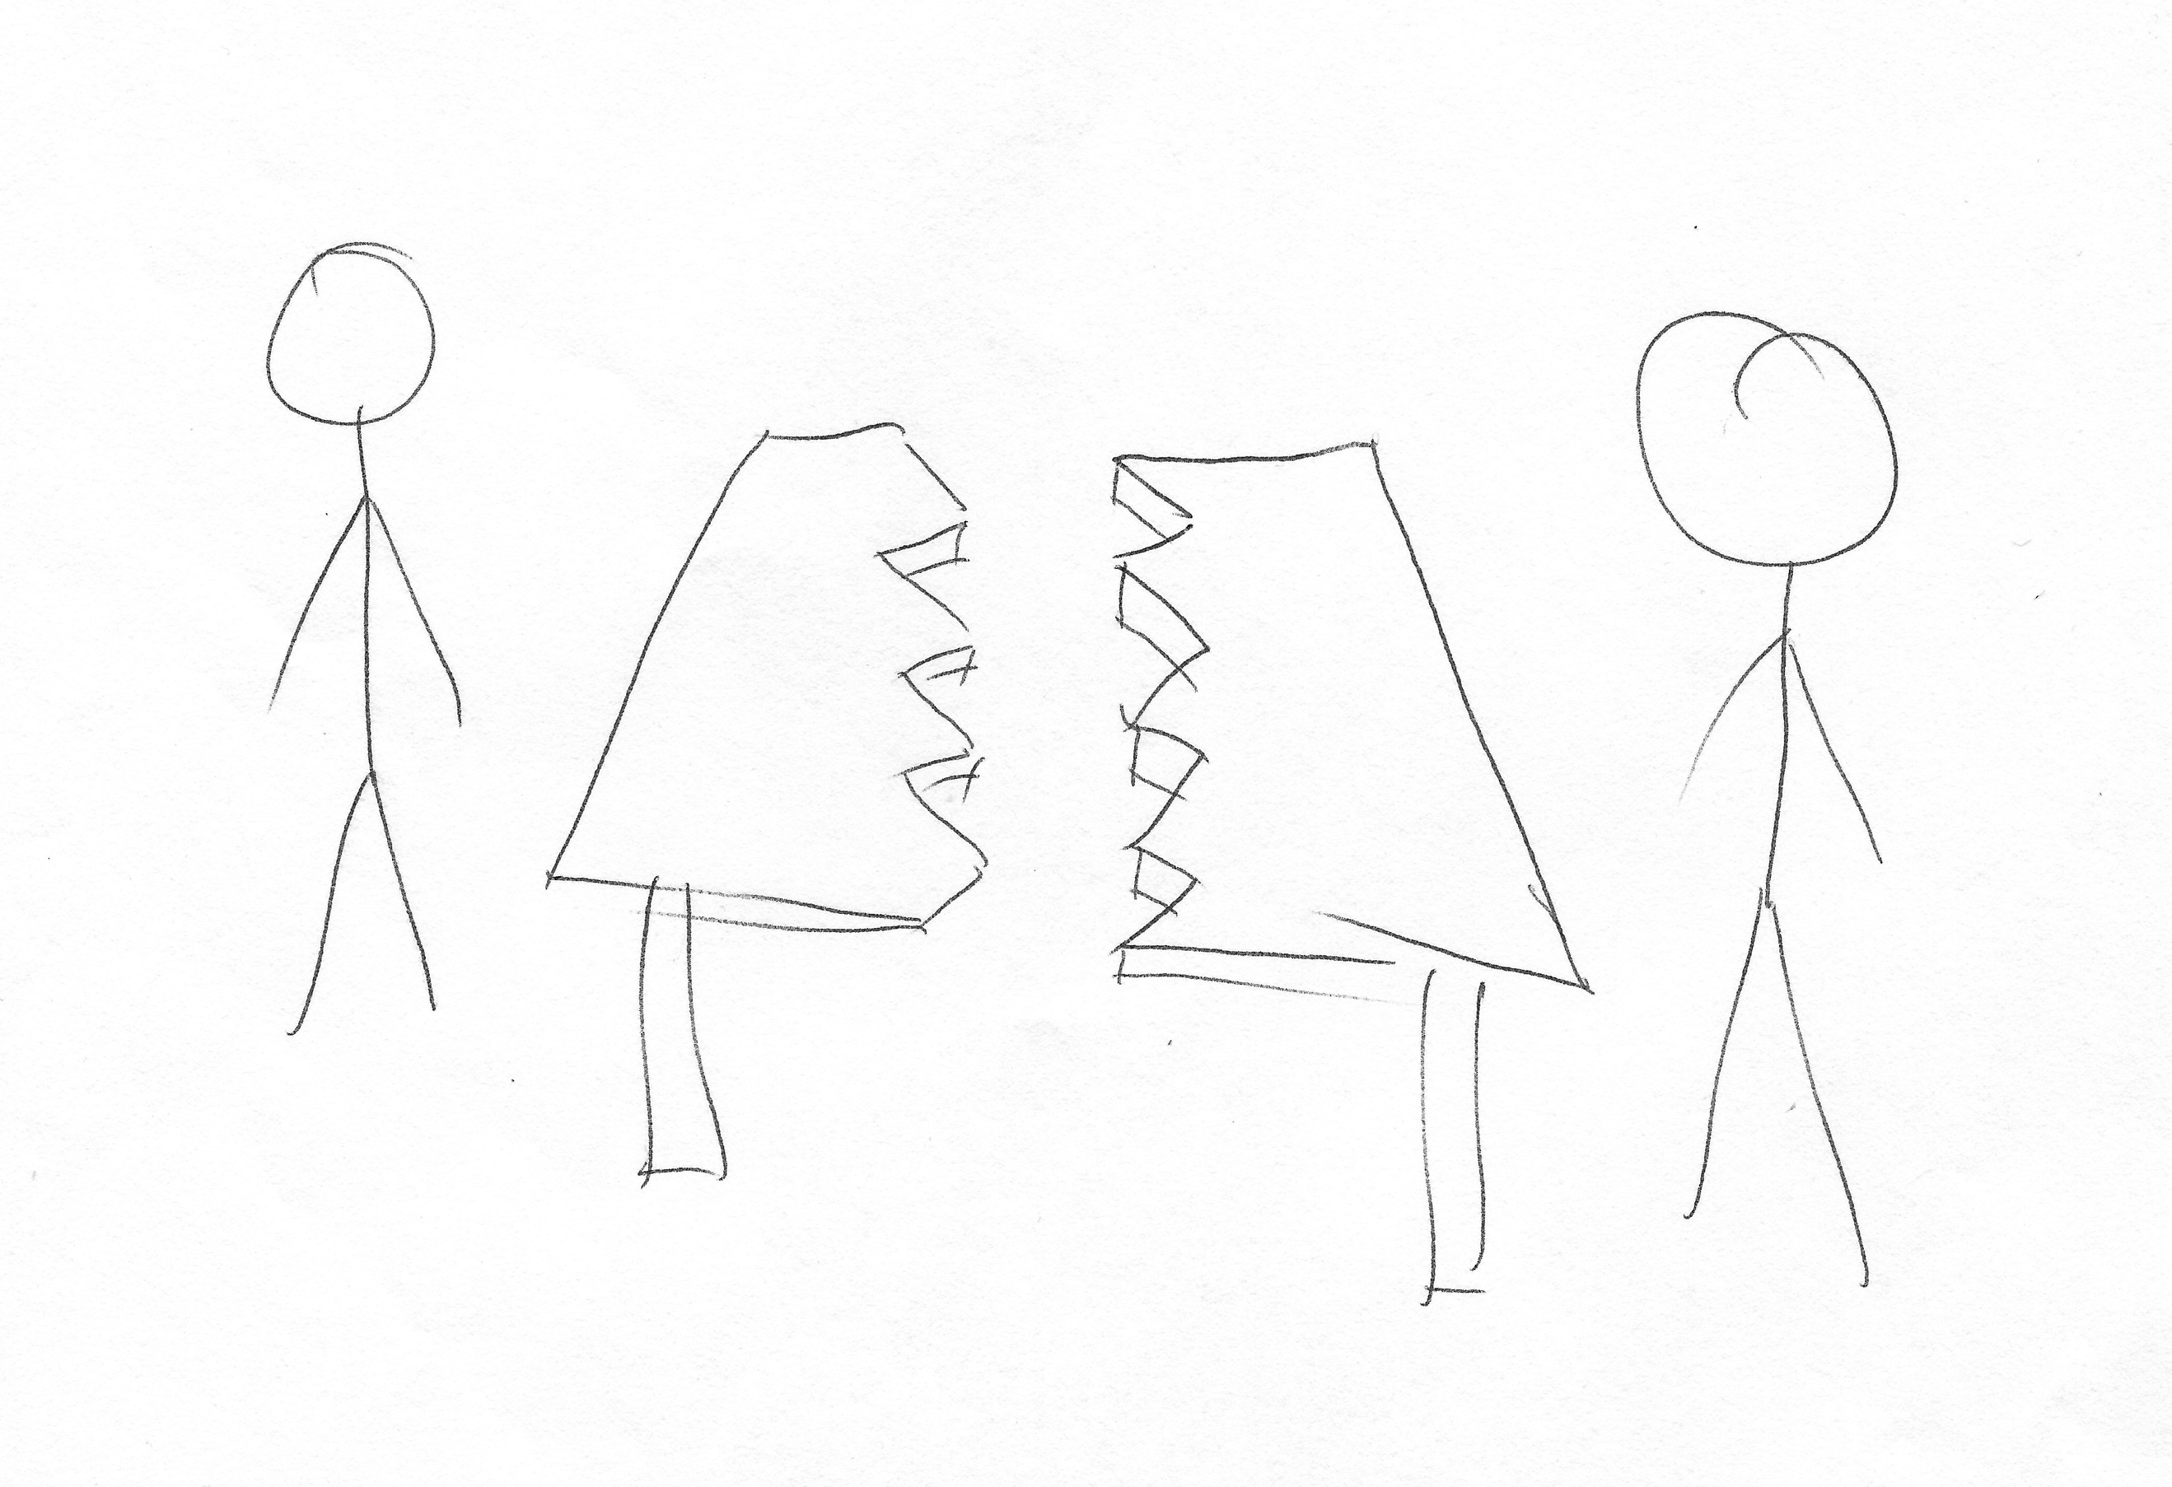

I: Okay, brilliant, so why have you drawn this?

P: Well, usually in, you know, encounters between tutors, it’s usually, you’re at one end of the table and they’re at the other end of the table, doesn’t really help. I like to think that a good relationship with a tutor, it would feel like that table isn’t there, or it’s broken.

I: Ahhh! Nice! I like it. Brilliant, thank you very much.

P: Frame that.

I: [laughing] Okay now, can I get you to do a bad one?

P: Okay. I won’t just do a whole table then [pause for drawing]. Simple.

I: Okay great, what do we have here?

P: Reviewing an essay, you don’t feel like you have any, sort of, you know, way to express your own opinions on your work, you’re sat there, they’re telling you what’s wrong and what’s right about it. And they are the bigger person in that situation.

I: Yeah, brilliant. Thank you very much. There’s one more drawing [laughing]. It’s the last one. Can I get you to draw your conception of your relationship with the university as a whole?

P: University as a whole… [pause] How – my true, honest opinions about the university right now?

I: Yeah.

P: Or just the course?

I: The whole university.

P: The whole university… Okay. [pause for drawing] The suspense [laughing] [pause for drawing] I guess that was meant to be a pound note. I just – I think I said it at the beginning, I see it as a, sort of, means to more options in life, a larger pathway to whatever you want to be. At the same time, I do think they focus on the money aspect, and I like to think they do focus on – more on the students’ education as well.

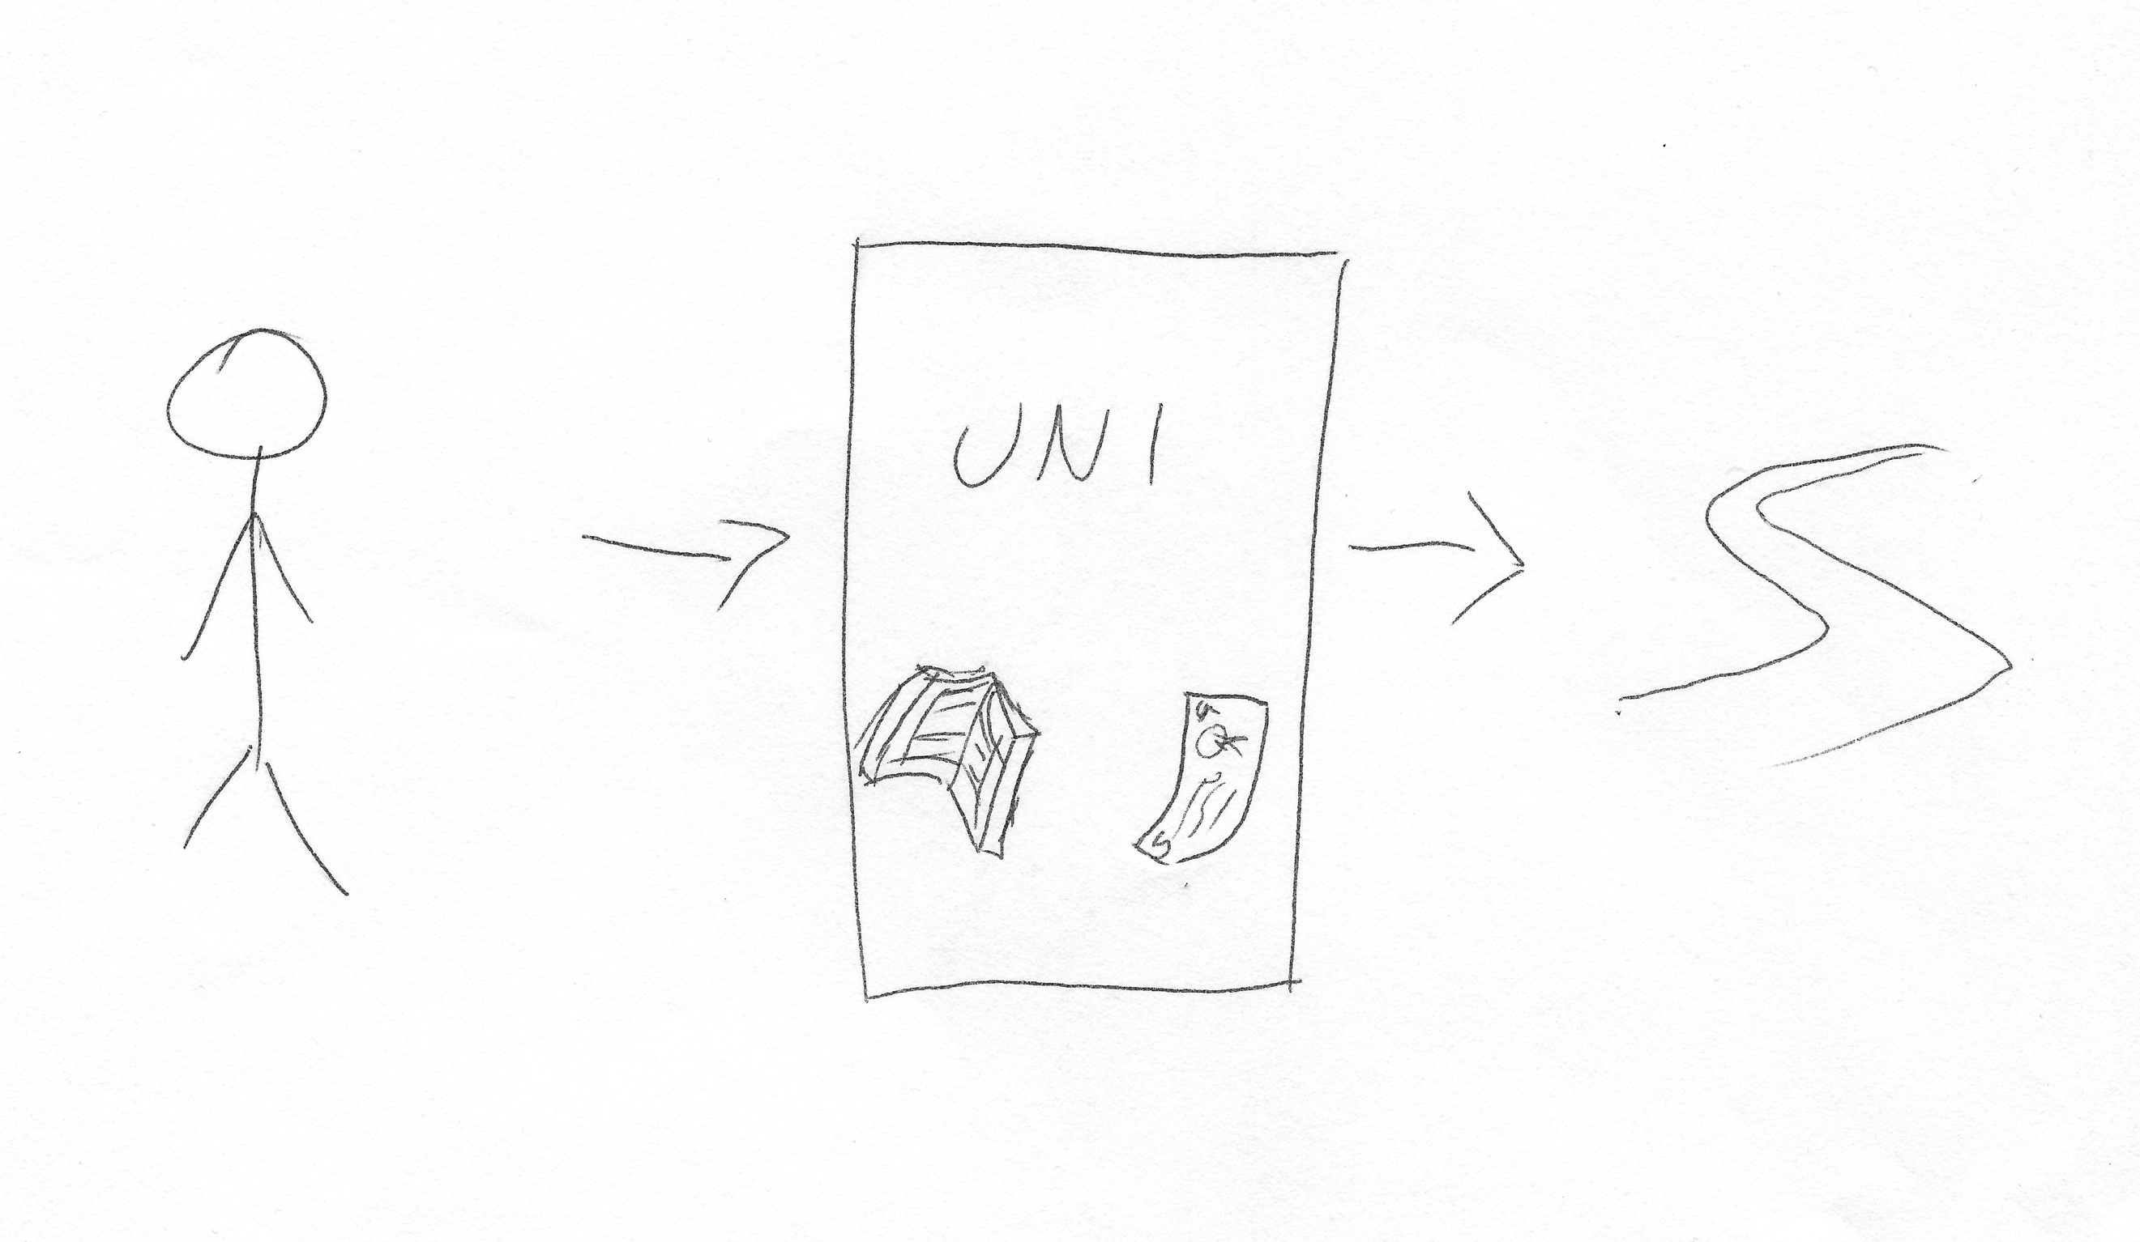

I: Okay, brilliant, thank you very much! There’s no more drawing, don’t worry [laughing]. Okay, so last couple of questions then. There’s often a lot of encouragement for undergraduates to engage with different experiences that university offers, such as joining societies, volunteering, or getting involved with the SU. What are your thoughts on this?

P: Very good, yeah, I think it helps with self-esteem and I think it is a positive thing to do, especially for people who are away from home because I know, you know, a lot of students here will be able to either live in the city, or they will be able to go home every day, which obviously helps, but a lot of students have to stay and, you know, move far away from their homes, so it’s – I don’t think it’ll be very positive for them if all they’re doing is, day in day out, come to the uni [sic], study, go back to their apartment or something. So, societies really help to just make new friends and yeah, it’s a very positive experience.

I: Okay. What are your thoughts on the role of the Student’s Union in terms of engaging you as an undergraduate?

P: The role of the Student’s Union [pause]. Sorry, could I have that question again?

I: Yeah, so what do you – what are your thoughts on the Student’s Union? Is it important? Do you see it as valuable, do you engage with it, do they engage with you?

P: The Student’s Union. Not really, if I’m honest. You see them at Open Days and Fresher’s Weeks because you can’t get away from them, they’ll have flyers everywhere, but I think – and they are, you know, they are the way you get into societies and know about societies, so that’s a good thing. But then as soon as you're in societies, you don’t really – you don’t really deal with them, or at least I haven’t had to anyway. I’m sure there are people who do confer with the Student’s Union, do have a, you know, who are regulars, but I think – I mean is this for more, like, support? Or…

I: Just for everything that they do.

P: Just everything they do. No, I don’t [laughing] no.

I: [laughing] Fair enough. So, do you consider yourself to be a member of the Student’s Union?

P: No, I’m a member of my societies, but not, no, the SU.

I: Okay. Last question then. How much of a valued member of the university do you consider yourself to be?

P: I like to think anyone who comes to this university is a, you know, a valued – valued member. And so, yeah, I like to think so. I don’t, like, you know, if I didn’t then I’d feel like I’m getting left out or something, so no.

I: Do you think your value comes more from your department, or from the university as a whole? Or both?

P: I would say more from the department, that’s what, you know, that’s what I’m getting out of this, more of, than the, yeah, the actual university. The university, you know, the facilities are great, and I know that’s – I’m getting value for that, I’m getting the great library and, you know, the spaces to learn, so yeah. But I think more the department [inaudible].

I: Okay. Okay, brilliant, well thank you very much for your answers, I’ve got some really valuable stuff. Do you have anything you want to add that we didn’t talk about?

P: [pause] No, I don’t think so. Their wellbeing could be better, the health and support wellbeing because they’re crap – sorry, can’t [laughing]. I didn’t know if I can – yeah, they’re not good, so they could be improved.

I: Okay, are they just not particularly supportive, understaffed, or what would you say?

P: You know, you go there and they are supportive and then, they don’t – nothing really happens after that, especially, you know, a lot of people go there for, you know, low state of mind, like, depression or something and they will give you tips and things, but then they won’t make it their mission to actually follow up to see how you are, they’ll just, sort of, leave you to their own devices [sic]. So maybe that could be improved, I don’t know. Yeah, other than that, nothing.

I: Okay, well brilliant, thank you.

P: That’s okay!

[End of Recording]

