Interview #8 Transcript: Second Year Male English Student (19.04.18) (University A)

Interviewer (I): Okay, so why have you chosen to do an English degree at this particular university?

Participant (P): Well for me, it was actually a really, it was, kind of, a last-minute thing. So, I applied to go to other universities because I’m from [location removed], I actually live at home, and I applied to go to other universities, and the one that I wanted to go to in [location removed], I was looking at prices for, like, halls and I was like, “I don’t want to be eating pot noodles for 3 years”, I’d rather just, like, have my bath and, like, stay at home so, yeah, I just chose to stay at home in the end and save money so, and it was – I didn’t even look, I didn’t even look at the course specification or anything, I just, sort of, winged it and applied and then, it turned out okay in the end so [laughing].

I: Okay, why’d you choose English?

P: It was just a subject that I always really enjoyed, and it was one of the ones that I was just naturally good at so, it seemed like a natural fit and for a long time I was really interested in Drama, and then that just, sort of, shifted and I, sort of, grew up a little bit.

I: [laughing] Okay. Are you the first in your family to go to university?

P: Yes.

I: What does value for money mean for you, and is it important that you get it from your university?

P: I think, well value for money is getting as much out of the university experience as I possibly can so, you know, having the contact with tutors and having them be interested in contacting you, because sometimes I feel like that’s not the case. I think value for money as well is having resources, like, available and things, yeah, things being ready for us to use so that we’re not, you know, waiting around and missing out on learning better by people being unorganised. So, organisation probably would be the word.

I: Okay. Do you think you get it from this university?

P: On the whole, yeah. There’s, like, there’s been a couple of occasions where I’ve had a bit of a tiff with tutors but [laughing] we’ll ignore that.

I: Okay. Do you agree with paying fees?

P: I do, yeah, I do, because for me, I actually had this conversation the other day [laughing], for me, I see university as investing in my own future so, I, kind of, think, “Why should someone else have to pay for that?” I don’t agree with how much it is, like, I think it should be significantly reduced, but I do think I should have to pay to be at university, because I see it as a privilege not a right, and I think university people – people work hard to get to university, but it’s a choice at the end of the day, it’s not a concrete path for everyone, and not everyone would suit it, so I think if I was – if I was to go and do an apprentice, apprenticeship, I wouldn’t have someone else paying for me to do that, I would be working and being paid for my work, so…

I: Okay. What does being a university student mean to you?

P: [pause] [laughing] I don’t really know. I think [pause] I think it means taking, like, investing time into something I enjoy learning about, and I think for – I don’t know if I can speak for everyone, but for me, I’m at university because I enjoy learning, not because I think – I mean, investing in future is part of it, but ultimately for me, it’s because I enjoy learning and I have a real issue with people who say, “Well, what are you going to get out of it at the end? What’s the, like, what’s the reward afterwards?” and I’m like, “Well, the reward is learning and having a bit more knowledge about something that I enjoy” so for me, like, being a student is just pursuing an interest, yeah.

I: Okay. What do you think being a university student means to people outside of the university, or who have never been to university?

P: [laughing] I think it probably – to them, I think it probably – I mean, like, my dad would be, like, a good example. I think a lot of people think that university is just somewhere that you go when you don’t really know what you want to do with your life, and it buys you another 3 years, and then when people do a Masters, that’s another year, apparently! And I think people perceive – well not everyone, but I think some people perceive of university as being, sort of, a 3 year party, when that’s not really the case, and I think if you haven’t been, you don’t know how hard it actually is – and when people say, like, “Oh, like, it’s so hard at uni [sic]”, I’m like, “Well it’s supposed to be hard, it’s higher education, like, if it was easy, everyone would go” [laughing].

I: Okay. What meaning does the word engagement have for you?

P: In terms of from tutors, or from students, or just overall?

I: Just overall, yeah.

P: I think, like, being interested, either in terms of, like, a tutor, engaging with your students and taking an interest in either their research interests or their study, and being there to offer the support that they need so, yeah, I think from a tutor’s perspective, engagement would be taking that interest in students and wanting to do everything you can to help them progress. And then from a student’s point of view, would be engaging with the material and engaging with the subject because, at the end of the day, like, awkward seminars when they’re sat there and they’re asking questions and everyone’s just, like, looking down and don’t know what to say, it’s just horrific [laughing]. It’s usually me that ends up speaking, and they’re just like [sigh], “Oh, not again”.

I: [laughing] Okay. Okay, so using what you’ve just said, in what ways do academics attempt to engage you as a student?

P: Well, I’m always getting emails about, like, research, like, seminars and stuff like that, that you can go to, they’re always sending out extra secondary material and quite a lot of the tutors offer – I mean they have their office hours, but quite a lot of them will just be like, “Pop by whenever you feel the need” because I think – sorry could you repeat the question? Sorry.

I: Yeah. In what ways do academics attempt to engage you?

P: So, I think, yeah, as well, like, in seminars they’ll sometimes, if no one is talking, they’ll just pick people and say, like, “Right, what do you think? What do you think?” and then it obviously becomes clear when someone hasn’t done the reading and they don’t know what to say, and they’re like, “I don’t know”. But they, yeah, I think they push for engagement because, at the end of the day, if no one’s going to take part, then it, kind of, all falls apart, yeah, so.

I: Yeah, okay. What are your thoughts on the concept of student as consumer in higher education? Have you heard of this concept?

P: Yeah so, that’s about, the student is basically, like, receiving a product from the uni [sic]?

I: Yeah, so, it’s, like, engaging a student as, like, a customer rather than a student, yeah.

P: [pause] I think I have – well I have two sides to my opinion about it. On the one hand, I think, like, yes the university is providing a service and that service is an education, and we’re paying for that and so, in terms of, like, the student as a consumer, we – because we’re paying for it, we would then expect the [pause] I don’t want to say product, but the tuition that we receive to be of a good standard because we’re paying for it, and I think if we weren’t paying for it, then we wouldn’t be able to argue, when it’s not up to standard, “Well, I’m paying for this”. But, then on the other hand, I think that universities should not see students as customers, but see them as students, you know, they’re there to learn, they’re not there to make the university money and I think when it becomes completely money-oriented, then things, kind of, lose all their soul a little bit, don’t they? [laughing] And it just becomes a bit cold [laughing].

I: Have you – has this idea of the student as consumer impacted on your experience here at all? Have you noticed it or…?

P: Only from – I would say only from my perspective because, again when I was saying about – about how because we’re paying, we can argue that, “I’m paying for this, so why is it not good enough?” So, there was one instant when [laughing] a tutor – for the module, they were supposed to print readers for us that had all the readings in for the module, and we were, sort of, 4 weeks in and hadn’t got them yet, so I went to the module coordinator’s office and asked if I could have one and she was like, “Well, they’re not ready yet. Why have you come here? They’re not ready yet” and I was like, “ Well, why are they not ready? I’m paying you £9,000 for it, why are you not ready?” [laughing] and she, yeah, she wasn’t very happy. But I think, like, it’s true, like, you know, be organised, you run the same module every year, so, I don’t know if that answered the question.

I: Yeah, no definitely, yeah. Okay, so do you think paying fees gives you more entitlement as a student then?

P: In – more entitlement to, like, tutors’ time, or…?

I: Just more entitlement, like, whatever, kind of, entitlement you think it might give you, so, the right to complain, or entitlement to more time with tutors…?

P: I think even if I wasn’t paying, I think I’d have the right to complain [laughing] because I think, at the end of the day, like, where students are here investing their time in the university and it all, sort of, works together so, without the students, the university can’t progress and thrive, and obviously [University A] has, like, [University A] has moved up significantly in the, sort of, the past 10 years and really progressed, and ultimately, that’s because students are investing their time here. So, I think, regardless of whether you’re paying for it or not, you have a right to call tutors to account and say, you know, “I’m not happy with this, why is it – ?” you know, and question, why something might not be right or how you think it should be, and obviously, like, there will be some students who just, like, throw their toys out the pram for everything because they’re not happy but, I think – but then I think, on the other hand, like, again, we’re paying so, you know, and some people, you know, some people, like, pay their fees upfront so – the rare occasion, but some people do, and, you know, like, I think if that was me and I was feeling as though I wasn’t really getting my value for money, I would be a bit annoyed, I’d be like, “No, I paid for this” [laughing] so…

I: Okay. Okay, moving onto learning. How engaging and/or useful for learning do you find lectures, if you do at all?

P: I find lectures a lot more useful, just for my style of learning, I find them a lot more useful than seminars because, for me, I, sort of, I find it more useful to take information in than to sit and share ideas, because when I think back to, like, essays I’ve written, I’ve not once written anything that I’ve, like, discussed in a seminar because I think a lecture, for me, just lays out the information quite plainly and, you know, so that I can understand it and then that allows me to then go in my own time and form my own opinions and, like, I understand the purpose of a seminar is to, sort of, bounce those ideas off of the students, but then when no one talks, it’s not very useful so, yeah, I’d probably say lectures are my most useful thing.

I: Okay, so the next question was, how engaging and/or useful for learning do you find seminars? [laughing] So…

P: Yeah, so seminars. It honestly depends on the tutor and it depends on the students that are in the seminar and on the topic as well, so if it’s something really dull, and then the tutor’s really dull and the students are all really dull, then it’s horrific [laughing]. But, I don’t know, like, I think for certain topics, seminars are particularly useful so, we did a module called [removed] last semester, which was all, you know, difficult theory and the only way that we would have understood it is by sitting and running through it with a tutor and having them explain it to us, and us discussing it as a group, whereas other modules, I don’t know, like, modernism – I had a tutor who just, like, he was so eccentric that he literally, I didn’t even feel as though I’d been in there for an hour because he’d just talk about something completely other [laughing] and by the end we were, like, “What is modernism? No one knows” [laughing].

I: [laughing] Okay. Where do you choose to sit in seminars and lectures, like, back, front, middle or do you not really care?

P: I usually – well in a seminar, I usually retreat to a corner, me and my – we usually go in, like, a group of two or three to seminars and we always, sort of, retreat to the same corner and then in lectures, we always sit in the same row near the back, so…

I: Why do you sit near the back in lectures?

P: I don’t know [laughing] I don’t know, I feel, probably because I feel less exposed? I don’t know, like, just retreat to the back and then I can, sort of, just sit behind my laptop and type.

I: Okay. How engaging and/or useful for learning do you find one-on-one sessions with tutors?

P: I don’t know because – well, again, it depends so, sometimes, and I hate to say it, sometimes I just switch off. So, like, I’ll – and it’s so bad because I do it all the time, like, I’ll ask a question and then they’ll just talk for, like, 5 minutes and I’ll find myself just, like, thinking about complete different things and then I leave and I’m, like, “Wait, what did they just say? I can’t even remember” but, I think, when there are things that I particularly don’t understand, or especially, like, for getting feedback on essays, and to be fair that’s probably – essay feedback is probably the only time really that I do go and see tutors. I think there’s been a couple of occasions where I’ve been about the material, but rarely, because I, kind of, just like to figure it out and do my own reading, because I don’t want to waste their time by switching off [laughing].

I: Okay. Do you ever find it intimidating meeting them one-on-one?

P: Mmm [agreement]. Only because some of them are, like, I think because some of them are, like, so intelligent, that I just feel like anything I’m going to say they’re going to be, like, “Really? Really?” I think I had one essay and he wrote in the margin next to it, “This is stupid” [laughing] so, I mean he gave me a First, but it was just really, like, yeah, just wrote “This is stupid” [laughing] so…

I: [laughing] Fair enough, so do you think it depends on the person then whether they’re intimidating?

P: Yeah, I think, you know, like, there are some tutors that, you know, I’ve been taught by every module since – well every semester since the start of first year so, I know them very well, they know me, they know how I work, so I have a good relationship with them, whereas there’s other tutors who, maybe I’ve had them for one module, not really known them, turned up to, like, four seminars [laughing], and then yeah, I’ve gone to the feedback and they’ve been like, “Hi…” I don’t really know.

I: [laughing] Okay.

P: I don’t do that often [laughing].

I: [laughing] Okay, is there anything you particularly like about the learning style of universities compared to compulsory education?

P: [pause] In terms of seminars, I think it’s nicer to have a smaller group, so I remember in school, it’d be maybe a class of, like, 30 sometimes. So, it’s nice to have, you know, maybe 10, 12 people because then, not only are you more likely to talk because you have chance to because there’s not as many people fighting to talk, but I think it’s just easier to, like, engage with, like, the material because you’re, yeah, you’re just – it’s a smaller group. That wasn’t a very good answer, but, like, you know what I mean, like, because it’s a smaller group, it’s easier to have those conversations with the tutors because they’re not distracted by trying to get around everyone and it’s not – yeah, it’s a bit more intimate.

I: Yeah, okay. Do you always understand what your tutors are explaining to you, or the material you’re set to read?

P: [laughing] No. Did you say the material that we’re set to read?

I: Yeah.

P: No. I think, yeah, because again, this tutor who was very eccentric, he – honestly, like, I don’t even, like, he must, yeah, I don’t know [laughing]. We’d leave the seminar and by the end of it, we’d just be like, “What’s just happened? What just happened?” [laughing] No, I think – I think it’s important to have material that we understand, but then obviously, like, we’re not going to understand it all because it’s hard, but then that’s where the seminar comes in and you can ask the questions that you don’t understand and try and engage with it. But, like, even now there’s still modules where I, sort of, leave and I’m like, “I don’t really know what I’m doing” [laughing] and I’m doing an essay now and literally I’m like, “I don’t even know what I’ve just learnt on that module, I don’t know what that was about” [laughing].

I: [laughing] Okay, would you say your lack of understanding is, like, more to do with content or the language used to explain it, or, like, a bit of both?

P: I think a bit of both. I think sometimes the content is particularly difficult but then if you’ve got a tutor who doesn’t really explain it in a way that – because some of the tutors are very intelligent, I think they explain it in a way that they would explain it to someone who is on the same level as they are, you know, having, like, two Masters and a PhD or something and we’re undergraduates, and then I think some tutors get frustrated that you don’t understand because they’re like, “How can you not understand?” like, so yeah.

I: Okay. From your own experience, is there anything you would change to improve your own learning? So, either in terms of teaching, the resources you have access to, curriculum and assessment, or anything else?

P: [pause] For me, probably I would say, less seminars and more lectures but I don’t know, I don’t know if that would be the same for everyone, and I know there are some – like, some of my friends at other universities have said, like, they don’t have seminars, they just have solid lecture-based teaching and I don’t know, I think I would find that more useful because I like, you know, just going and getting the information and then leaving and going home and understanding it, and I think sometimes seminars try and force an opinion out of you, or force a – force you to think, and sometimes that’s not necessarily useful because I think it doesn’t, it then doesn’t – I don’t think it helps you understand the topic more, it just makes you look like you’ve – makes you feel as though you’ve said something. So, yeah, if I was to change something, it would be more lectures and less seminars to be honest.

I: Okay. Okay, so I sent you the document that refers to the Student Collaboration Policy [policy name changed]. Have you heard of this policy or seen this policy before?

P: No.

I: No? Okay so, fair enough, most students haven’t. So, I will just give you a brief background then. So, it was set up as, sort of, a counter to the student as consumer ethos and what it basically entails is that students and academics collaborate together to produce knowledge, rather than the student is just passively consuming knowledge from the tutor. So, that’s what it was set up as, now it’s an institution-wide policy here at [University A]. So, that being said, is it evident in your day-to-day experience of being a student here?

P: No. No, well I didn’t know what it was so… [laughing].

I: Yeah, true. Do you not find your tutors try and, like, collaborate with you to produce knowledge, or do you just find they’re just teaching at you?

P: [pause] Again, I think it depends on the tutor. I think a lot of, you know, a lot of the time, I think I had one seminar where I said something, and he was like, “I’m going to write that down” [laughing] and I was like, “Okay”. But yeah, on the whole, I feel as though it’s very much student and teacher and there’s that separation, you know, and the – I don’t think, like, personally, I don’t think there’s anything wrong with that because they’re more educated than we are, and they’re there to teach us. But, then I think the notion of working collaboratively sounds a lot nicer, but then I don’t know how that would work really, because we’re not on the same level, yeah, I don’t really know. I think, I wouldn’t – I mean, I would see myself as a student, I wouldn’t see myself as a researcher or a [removed for confidentiality] because I’m here to get the grades and pass, I’m not here to [removed for confidentiality] – well obviously by writing essays you’re doing research and [removed for confidentiality] but, I think those two things are a world away from each other because I have, you know, I know people who, someone who has just finished her third year and she, while she was doing her undergrad studies, she was also being paid by the university to research because that’s what she enjoyed to do, like, liked to do. But I don’t think every student is like that, I don’t think every student would want to invest all their time into research, so yeah.

I: Yeah, okay. So, I also sent you the document that refers to the Student Charter. Have you seen this document before?

P: Yeah, yeah.

I: Yeah, okay. So, this is your contract with the university. So, is this – are these values evident in your experience of being a student here?

P: I think definitely – well, treating others with dignity and respect, I see, like, that is definitely something that the university gets really right, you know, before university I don’t think I’ve ever been to a more diverse place and, like, people’s, like, different identities are just not relevant because it’s about the learning, and the research, which I think is a really good thing. But, the only instance where I would probably say that I don’t feel that all the criteria is followed – so, it says, [removed for confidentiality] or [pause] [removed for confidentiality] so, that part, different people bring different ideas, the only instance where I can think where that’s not really been understood would be – well, not understood but, like, sort of, taken into account. I personally don’t think lecturers should have – profess political opinion so, for me, I voted Conservative in the election but, in lectures, it’s sometimes very evident that lecturers see you as, sort of, like, “Why would you do that?” So, I think there was one where literally the lecturer just went for Margaret Thatcher and I was, like, “That’s fine” but, like, I, kind of, feel like that’s a bit un-PC, I don’t know, because I think in – for me, university is supposed to be about having your own opinion and everyone’s opinion being valid, but then I feel as if, if I was to stand up in a seminar and say, “I voted Conservative”, I feel like everyone would go for me because so many people are left-wing, which is, you know, completely – you know, everyone is allowed their opinion and I think that that’s a good thing, but I don’t think it works both ways a lot of the time, so I don’t know, that’s the only instance where I’d be like, “I don’t think it’s that”.

I: Yeah, okay, cool. Okay, in your opinion, should undergraduates have greater control over, or input in, the curriculum and/or assessment design of their chosen courses?

P: [pause] No, I don’t, because – well in terms of terms of the assessment criteria, at the moment we’re having – sorry – for one of the modules that we’re doing, there’s an interview, which forms 50% of the assessment grade, of the final grade, and I think if students had the control to be able to stop that from happening, then we wouldn’t have a diversity in assessment, like, methods. So, you know, if some people had it their way, it would be an essay for every single module, they wouldn’t ever have to speak to anyone, they wouldn’t ever have to, you know, they can just sit in their room, in a dark room with the curtains shut and type, and that would be it. And, you know, as much as I don’t, you know, I enjoy not having to talk to other people and just sitting and doing my work, I think it’s important that we are forced to do other types of assessment, like, I think it’s important to do those interview things, or presentations, or group work because at the end of the day, like, that’s the real world, like, if we were to – you know, people, in the real world, people don’t just sit in a dark room and write, like, people, you know, people talk to other people, and collaborate with other people and so, as much as, you know, as much as we all don’t like it sometimes, I think it’s good that we’re forced to because it forces you to then build on skills that you might not necessarily build otherwise. And in terms of the curriculum, again, like, I think, you know, all that would happen was people would just get rid of things that they don’t really enjoy [sic], and that doesn’t necessarily – like, just because we don’t enjoy it doesn’t make it’s any less important, it just is something that’s not as fun. So, modernism, everyone hated it, everyone hated that module, but it’s important that we did it, because then we don’t have a full view of the topic, of the subject, and there’s going to be bits that people don’t enjoy, you can’t just get rid of them.

I: Okay. What about, like, more choice in, say, what you write your assessment on? So, like, normally you get essay questions given to you, is that right?

P: Yeah.

I: So, what about more, like, choice about where your research interests lie? Because sometimes they might not account for a particular interest with the questions you’re given, so, would you support that idea?

P: I think, well, so [lecturer’s name removed] module last year, well not last year, last semester, I did her medieval module, and she didn’t set essay questions, she said, “Here’s some, like, sort of, directions that you could go in, but I want you to form your own thesis, I want you to do your own research, present something that interests you”, which was great because it was different, whereas, you know, I think people – we all, like, we’re all guilty of it, we like just having a set question and being able to say, “Right, I’ll do that one, that’s all I have to research and that’s it” and, you know, it’s easier because it means that, you know, you’re a lot more direct in your approach to an essay but, again, it’s not – then they just get, you know, 100 essays that are all the same and, you know, if we’re all writing about the same book, the same questions, then chances are we’re going to write about the same things, which, you know, is fine because at the end of the day, they have to assess us and they have to have some, sort of, criteria for doing that and the easiest way to do that is probably to have everyone do the same thing, but then I think that is the only sense where university, sort of, becomes a conveyor belt of students. At another – a friend I have at a different university has said that, they go to a much smaller university, and they said that there, they are not usually given essay questions, they’re usually just told, like, “Write an essay about this topic, but you can form your own ideas about it” and I think, a bit more of that would be useful because thus far, [lecturer’s name removed] is the only tutor that’s done that, and I think ultimately, like, that helps with your dissertation in the end because you have to write a dissertation on something that you are interested in, and you have to research it, you’re not given a question, so you need practice.

I: Yeah, okay. Okay, so in recent government policy on higher education, students have been placed at the heart of the system, which is their wording. So, how central or important do you think undergraduates are in this university?

P: I think massively important because, at the end of – like I said before, earlier, undergraduates are ultimately what makes the university progress, without – if the university didn’t have students, then the university can’t grow and it can’t develop, and I think as well for [location removed] as a city, students have massively, you know, endorsed [location removed] and brought a lot of money into [location removed] and development, and the university’s really helped with that. But yeah, ultimately, like, the students are the foundation of all of that, and if you don’t have students coming here, then you can’t improve the uni so…

I: Yeah, okay. What meaning does the word relationship have for you, in the context of interacting with academics?

P: Mutual respect, probably, so them understanding that you’re – well, I understand, like, I understand from an academic point of view, from their point of view, that it can be frustrating when you have students who aren’t interested, like, I do, I really do understand that because I think if it was me, and I’d spent my whole life, you know, learning about, like, medieval literature, and then I had a student who just didn’t really care and was just there because they had to be, I’d get frustrated. But, in terms of relationship between the two, I think it’s important that both sides respect each other, both sides value each other’s opinion and not, you know, like, not necessarily know you very well, but have that relationship where you can talk about complex ideas and ideas about the subject without feeling uncomfortable or [pause] yeah, without feeling uncomfortable.

I: Okay. What do you consider to be the main purpose for building a relationship with academics?

P: I think it ultimately helps you to learn better. The purpose of having a good relationship, it means that you can then, when you don’t understand things, you can feel more comfortable asking questions, which then means that you’re going to understand more, which then means ultimately, you’re going to do better. I think if you don’t have any kind of relationship with your tutors, then, you can’t learn properly because if they don’t – I think last year, there was one student who, they’d never turned up to a seminar, and they handed an essay in at the end and the tutor was like, “I don’t even know who that person is, but I’m going to mark it anyway” because they had to. But, like, I think by having a relationship and, you know, we handed in our dissertation proposals, last week I think it was, and I won’t say which tutor it was, obviously it doesn’t matter anyway, but, like, they basically told me that it was a load of rubbish, but I appreciated that opinion because I know them well and because I’ve been taught by them all the way from the beginning, I know them well and I value their opinion and I know that their input would only be for the best, whereas if I was to have that from a tutor who I’d never met before, and didn’t know anything about me, I’d be like, “ Sorry, like, who are you?” so…

I: [laughing] Yeah. Okay, so there’s, like, more honesty and more trust?

P: Yeah, more honesty in it, yeah.

I: Okay. So, do you find this actually happening with your tutors, or is that just, like, what the ideal would be?

P: I’d say with one or two tutors, definitely, but not with many, no. I think there’s probably – I could probably count on one hand the amount of tutors that I would go to and speak to if I had an issue or, well, one of them would be my personal tutor because obviously, we have regular meetings, just about university in general, and then there’s that same tutor who I’ve been taught by since the beginning, who knows me better than anyone else, any of the other tutors anyway, so – but then, generally, I wouldn’t say that that’s the case in every other module, I, sort of, go to the class, do the work and leave, I don’t really, I don’t engage with them outside of that, so…

I: Okay, why do you think it’s only with a few tutors, do you think there’s, like…?

P: I think just because we know each other better.

I: Is that because you’ve seen them more, or because of their personality?

P: Yeah, I think we – so again, that same tutor who – we’ve had a class with each other every single semester since the start of university, so they know me, I know them and they know my learning style, they know how I work, I know how they work, they know the work that I can produce so, you know, when I go for essay feedback with them, even if they give me a First, they’ll say, “I know you can do more than that” because they know that they can push me further, whereas, you know, from – if there was a tutor who I’d maybe done one essay for, one class with, and then they said to me, “You can do better than that”, I’d be like, “How do you know that? You don’t know”.

I: Yeah, okay. Okay, can you describe to me a typical face-to-face encounter with an academic? So, if you go and see someone for, like, essay feedback, what exactly happens in that interaction?

P: Okay so, well, do you mean from, like, a specific tutor, or just generally?

I: Just, like, generally, like, how – the most common, like, does it – what happens normally?

P: Okay so, well, from a tutor that I don’t know well, which is usually the case, we’ll go, we’ll knock on the door, and they’ll say, “Come in” and then they’ll be like, “Name?” [laughing] sometimes they will, sometimes they won’t, but if they don’t know your name, then you’ll obviously just tell them your name. I usually crack a joke, so break the ice [laughing] and then I’ll just sit down and then they’ll get up on the screen, like, they’ll have this long list of names, scroll through and find the, like, yours and then they’ll just, like, get the essay up and be like, “Oh, I remember marking this, like, 5 years ago” [laughing] and then, I think what quite often happens is, well it depends on the module as well because if it’s a core module that everyone has to do, then they have a lot more essays to go through, and especially if they peer mark, well they do peer mark as well, then they have two sets of classes to mark, so they’ll go through, find yours, and then they’ll have a brief scant through of what they’ve said and be like, “Oh yeah, I remember, I remember what this was about” and, sort of, re-cap what they had said, so then they can give the feedback. But then – and then they just, sort of, say, “Any questions?” And that’s about it. But then, if it was someone that I know, then, you know, it’s a lot more chatty and a lot more personal and, you know, we’ll sit down and they’ll go through it, like, line by line and say, you know, “You do this every time because you handed in an essay before where I’ve seen this, you need to stop doing this”, and I think one thing that I always get is about the passive voice and I don’t even know what that is, and they’re always like, “You use the passive voice”, I was like, “I don’t know what it is though” [laughing], yeah.

I: Okay, okay. Are you ever aware of a hierarchy when you interact with academics?

P: Between students and the academics?

I: Yeah.

P: Yeah [laughing]. yeah, I wouldn’t say that we’re – well, we’re not on the same level, we’re not, you know, intellectually we’re not equal because they have PhDs and higher qualifications and so, I think – there have been a couple of occasions where – English is a subject where there is no right or wrong answer, and sometimes I, like, begrudge that and wish, “Oh, why can’t I just do Maths where the answer is just the answer?” But, there have been a couple of occasions where they’ve been like, “No, I don’t think – like, that’s not, no I don’t think that’s the case”, I’m like, “Well, that’s my opinion” so, in terms of a hierarchy, I’d say there are occasions when tutors would say that their opinion is more valid, but not necessarily all the time.

I: Okay. Can you think of any particularly good relationships, without telling me who they are, with any academics and tell me why it’s good?

P: So, again, going back to that tutor who I’ve known since the beginning, well that would be the first thing, like, it’s good because we’ve known each other since – I think it was actually, I think they actually started at the university at the same time, so I think our first year was also their first year here, so it was, sort of, their first run of students and, as I say, we’ve worked together in every single module since then so, I think it’s probably good because we know each other, they know how I work, I know how they work and I think because we can, you know, I can take the criticism from them and know that it comes from the right place, not, you know, to just be harsh [laughing] and because they expect more from me, or know that I can do better, and I value that. Whereas, if it was from a tutor who I didn’t know, again, I’d just be like, “Who are you?” [laughing]. So, sorry, what – could you say the question again?

I: So, yeah, a good relationship with an academic and why you’d say it’s good?

P: Yeah, so, again, yeah just because we’ve known each other for so long – I say so long, it’s only been, like, year and a half, but in terms of, like, with tutors, that’s a long time, and yeah I think – and because I think they, because they know the level that I work at, and they know that the work that I can produce, they then, in seminars and stuff as well, they, sort of, value my opinion and want to hear from me.

I: Yeah, okay. Okay, so now, can I get you to draw your conception of a good relationship with an academic? [laughing] So, it can be – it can be anything you want, it can be stick people, it can be abstract, just whatever comes to mind when you think of a good relationship with an academic.

P: I’m [inaudible] [laughing]. Okay [pause for drawing]. I’ll draw arrows, so you know what each thing is [laughing] essay [laughing] [pause for drawing] tutor. Yeah, I think that’s it.

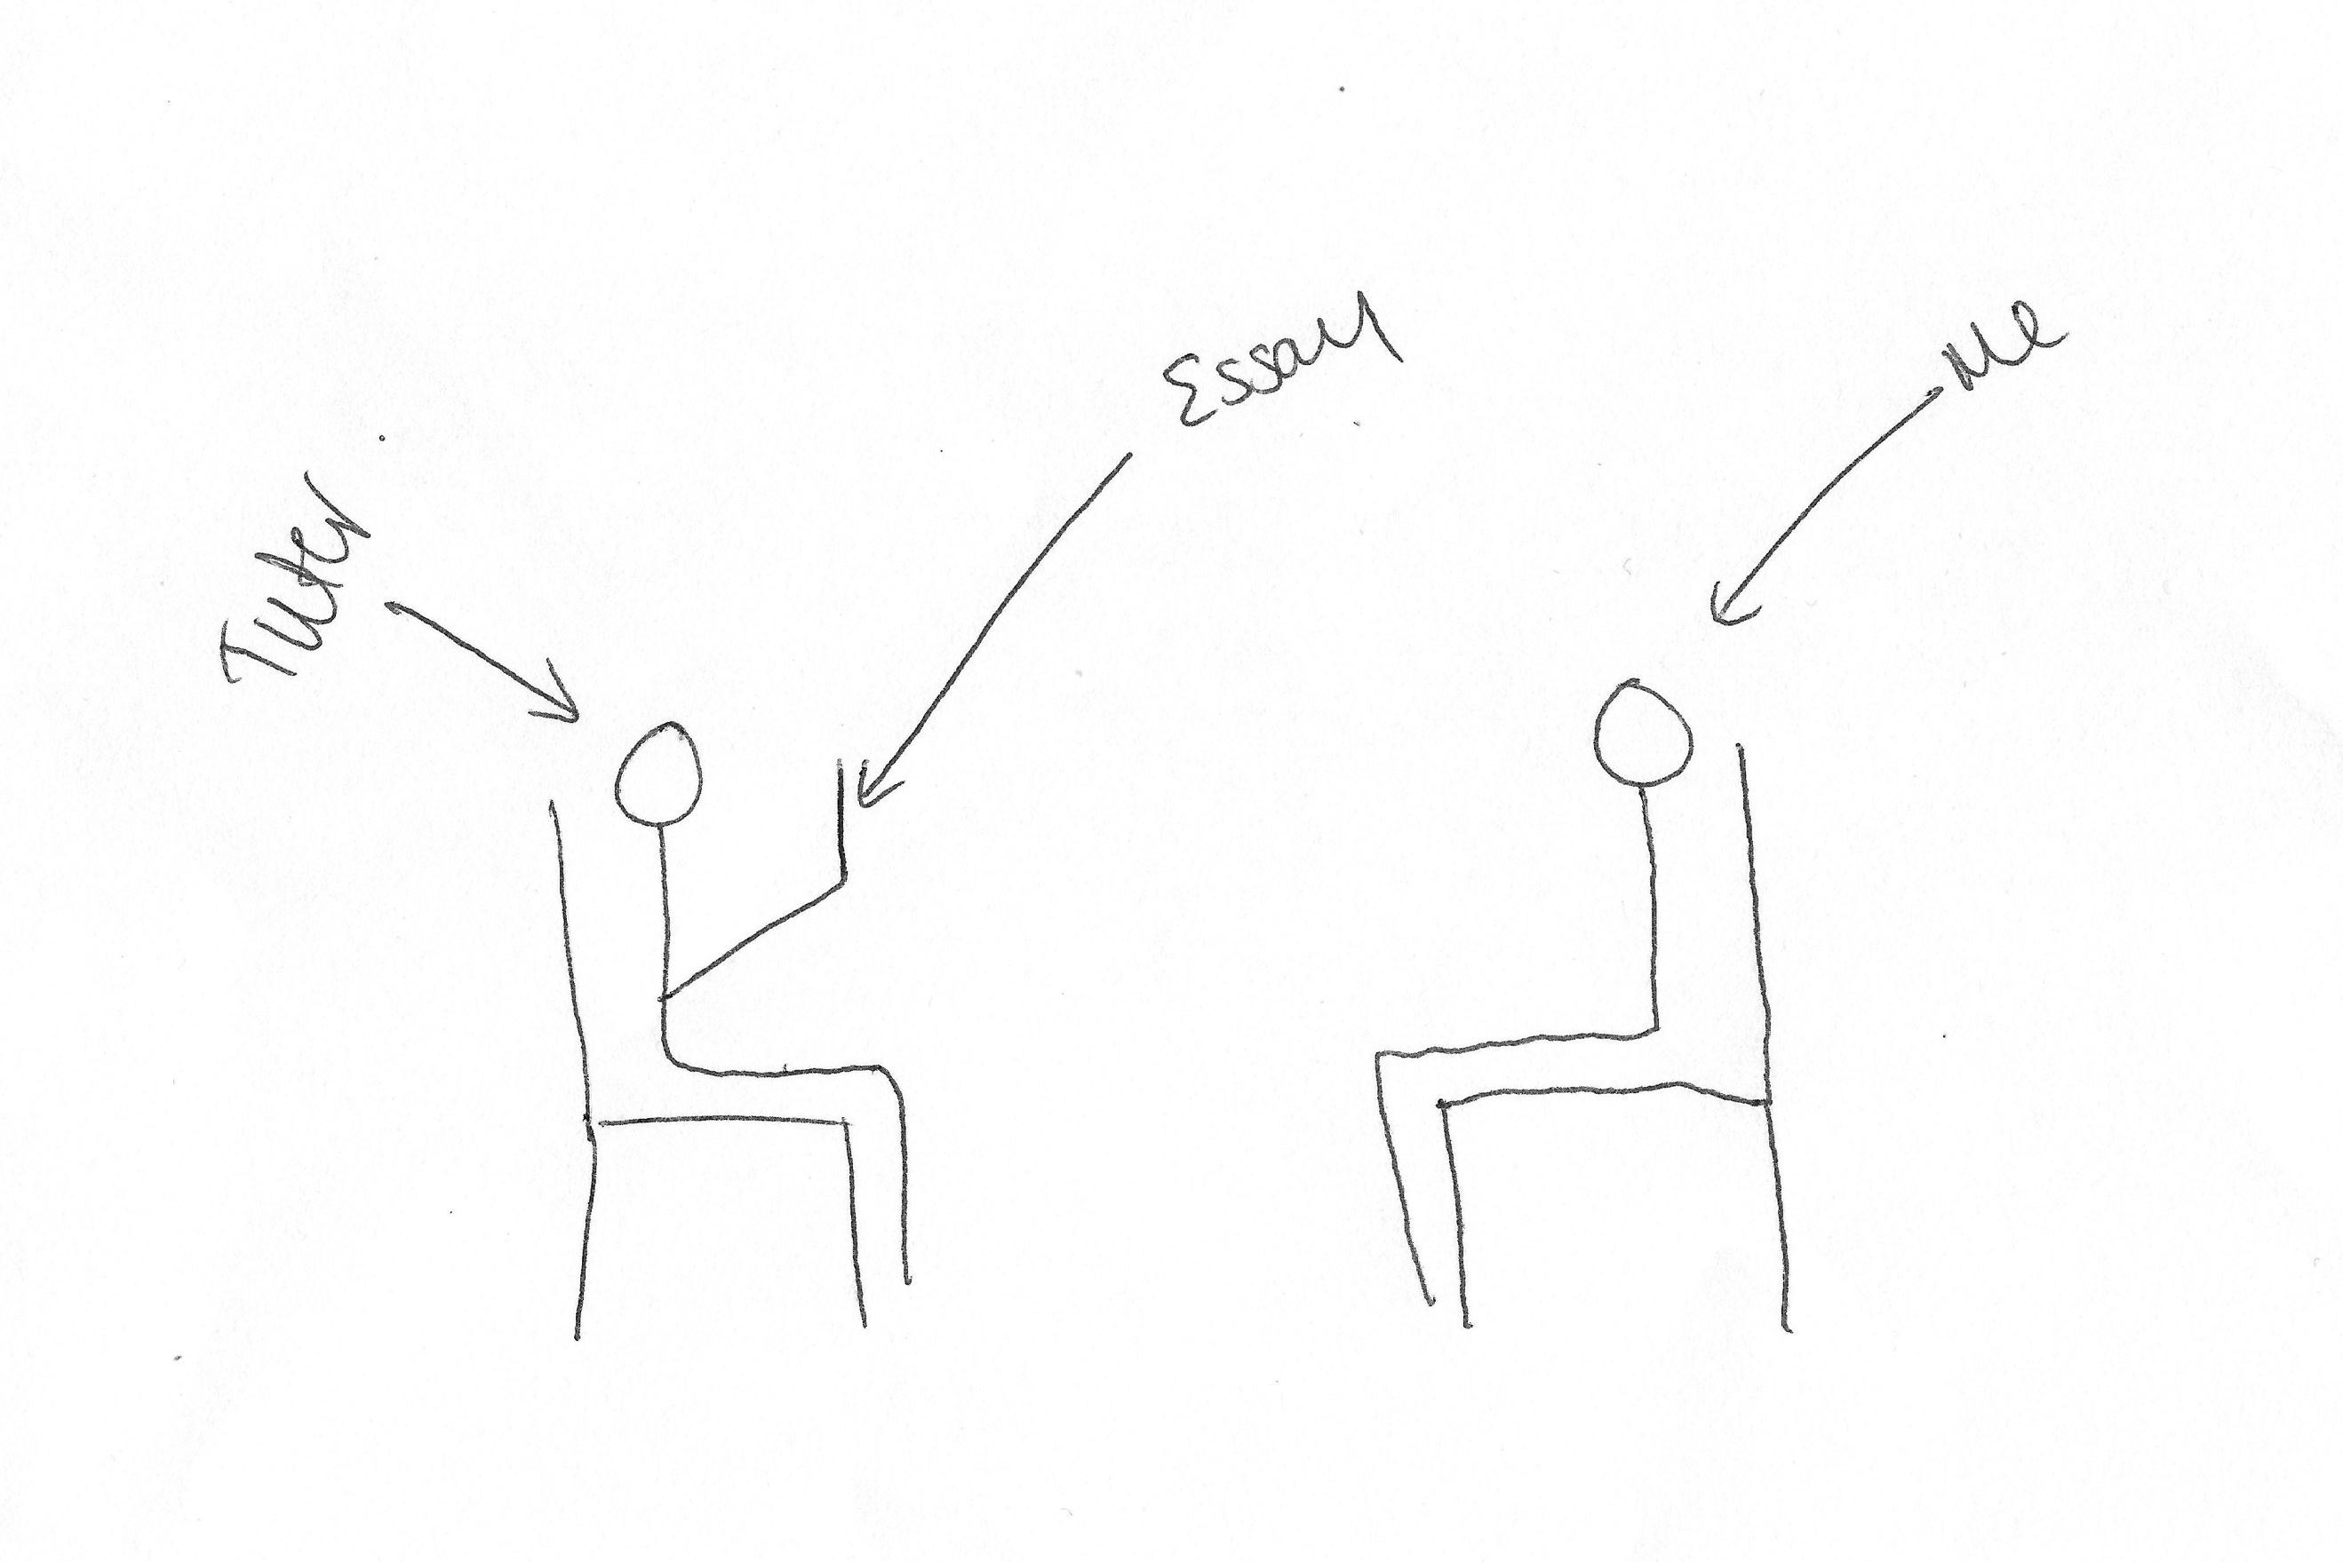

I: Yeah, okay, so what have you drawn here then?

P: So, just informally talking about the work, so not, you know, I think the environment that you talk in is, quite often, has a big impact so, if you go in, and there’s a desk separating you, and they’re sat on one side and you’re sat on the other, it’s, like, having an interview, whereas if you’re sat just having a chat and you’re just sat on chairs opposite each other, and they’re sat with your work and, you know, going through it with you and being able to relax, I think is the main thing, because yeah, like I said, like, a desk is very intrusive, it just gets in the way and it’s not – it seems a bit chilly, do you know what I mean?

I: [laughing] Yeah, okay, brilliant, thank you very much. Can I get you to draw the opposite, so a bad relationship? [laughing]

P: Okay [pause for drawing]. This chair is very out of proportion [pause for drawing].

I: Okay, brilliant, so what have you drawn here?

P: So, the desk that I was talking about. So, if you’re, you know, physically – it’s almost like, I don’t know, it’s almost, like, segregation, like, you know, they’re like, “Stay away from me, you’re a horrible student, I’m an academic”. Yeah, I think it just seems a bit cold, and then in that situation as well I’d probably find myself switching off because I wouldn’t be able to engage with what they’re saying because they’re so far away.

I: Yeah, okay. So, is this just them talking at you?

P: Yeah and, like, they’ve got the essay on the desk and they’re not really looking at me, they’re just looking at the essay, and I’m just, like, there, like, “Please be nice to me”.

I: [laughing] Okay, brilliant, thank you. This is the last one I promise [laughing]. So, can I get you to draw your conception of your relationship with the university as a whole?

P: [pause for drawing] This might take a little while.

I: [laughing] That’s fine.

P: [pause for drawing] Yeah, you get the idea. Crowd of students [pause for drawing] Yeah.

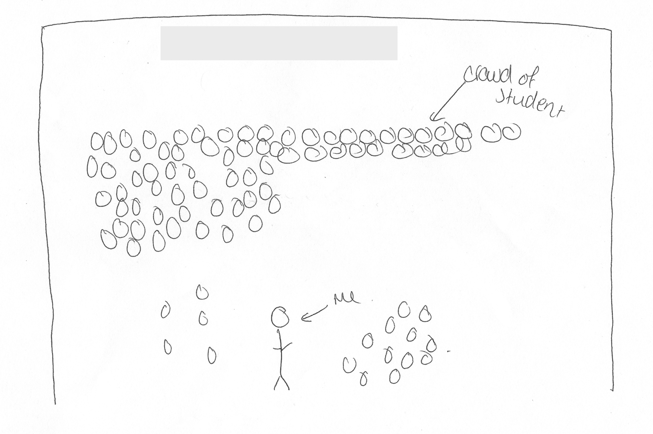

I: Okay, brilliant, so what have you drawn?

P: I think I’m just one in the masses so, yeah, I wouldn’t – I don’t know, like, I think the university, so if I was to go and speak to the Chancellor, they wouldn’t know who I am, or if I was to go and speak to the more, you know, any of the senior management, they would not have a clue who any of us are, because we’re just the students, we pay the tuition and go there, and I think even within the English faculty, if I went to the Head of English, [they] wouldn’t know who I am, and obviously that’s a much smaller group of students as well, I think there’s maybe 100 of us, well on our year, there’s maybe 100 of us. So, I think in terms of relationship with the university, I think the university probably just sees me as another student, it’s not really, they don’t know me.

I: Okay, brilliant, thank you very much. Okay, so last couple of questions. There’s often a lot of encouragement for undergraduates to engage with different experiences that the university offers, such as joining societies, volunteering, or getting involved with the SU etc. So, what are your thoughts on this?

P: I think it’s a good thing. I think to join societies – I mean I’m not in any societies but, especially if you’re moving away from home, it’s a good way to engage with people and meet new people and do things that you enjoy. I think – and, like, in terms of other opportunities, so working for the SU, or doing volunteer work, I’m forever getting emails through about, like, vacancies for this or “Have a go at this” or – but then, I don’t know if that’s because I’ve subscribed to those emails or not, I don’t know if everyone gets those. But then I think in terms of the course, so in terms of, you know, English as a faculty, I think it’s important that, and I agree, like, they would say, “Your main focus is your study, so it’s alright to do those other things as long as you have that as your solid foundation”, and, you know, I think I remember in one, we had, like, a personal tutor session, but again, they call it a personal tutor session but it was in a group, so we were – but the group is very small, there’s about 8 of us I think, and we were, like, she was asking, and then we have one-to-one meetings as well as that, and she was just asking about, “Oh, is anyone, like, is anyone doing anything, like, extra-curricular or – because it’s good to do that to get your mind off of study” but then, I think the reality for a lot of students is that a lot of students work to support themselves while they’re at uni [sic] so they don’t have time to do societies and other things, but I think the university, yeah, they value it and I think they push it as much as they can so…

I: Yeah, okay. What are your thoughts on the role of the Student’s Union in terms of engaging you as a student?

P: Well the Student Union [pause] in terms of engaging me as a student? [pause] I wouldn’t – I wouldn’t say the Student Union plays a role in engaging me in study, so the Student Union puts on, like, you know, they have their – well there’s two every week, but they have their, like, nightclub that everyone goes to on a [removed for confidentiality], and in terms of student as in a student experience, like, they’re good for that because they provide that and they do, they run events and, you know, they’ll have, like, dogs in the Student Union to make you happy or whatever, they’ll have, like, a big sign like, “Come and meet some dogs and cheer up”, or something like that. But then, in terms of, like, a student, like, a studying student, they don’t really impact that to be honest, so…

I: Okay. Do you consider yourself to be a part of the Student’s Union?

P: I think what’s good about university is it’s very much a community vibe so, you know, you very much feel as though you’re part of the [University A] community and therefore, part – well, as a consequence of that, part of the Student Union, and, you know, the Student Union are the ones who ask you to evaluate your modules and – which then obviously helps you to engage with the university because you’re providing your opinion and your feedback about particular modules. Did that answer the question?

I: Yeah, yeah. Okay, so last question. How much of a valued member of the university do you consider yourself to be?

P: [pause] I think, again, going back to that particular tutor, for them, I would say they do see me as a valued member and they, you know, they value my work and my input in classes and I mean they’re forever asking me to – well not forever, like, they asked me to do a couple of extra things, like, you know, meeting with visitors and stuff like that because they know, because they said that I represent the university well, so obviously in a roundabout way that’s, I think that’s them saying, “I think you’re a good student”. But then, for other tutors, who I don’t really know, I’m just another student going through the process, and they wouldn’t – I don’t think they’d be able to distinguish me in a crowd or, distinguish my work in a crowd, so yeah, I think it depends on the tutor really, I’d say.

I: Okay, so the value comes more from the department, rather than the university?

P: Yeah, definitely, I wouldn’t, like, the university doesn’t know who I am so, you know, and I think – sometimes I think that that, again, is a little cold, but then obviously there’s a lot of students, you know, there’s – I think there’s getting on 15,000 students at [University A] so there’s no possible way that they could know everyone. But yeah, I think in terms of the faculty, the English faculty, like, yeah, I think there are members who appreciate us and to be fair to the university, like, we have had emails from, you know, the Vice-chancellor and others key figures who say, you know, “We value our students, our students are what make [University A]”. So, I guess they, sort of, do, but not on a personal level.

I: Yeah, as a body?

P: Yeah.

I: Okay, brilliant, well thank you very much for your answers. Is there anything you want to talk about that we didn’t cover?

P: Not particularly, unless there’s any other questions you have.

I: No, no, that’s it, that’s it. Okay, brilliant.

[End of Recording]

