Interview #9 Transcript: Second Year Female English and History Student (18.10.18) (University A)

Interview (I): Okay, so why have you chosen to do an English degree at this particular university?

Participant (P): Okay so, this particular uni was just because it was convenient, I’ve lived here for however many years now and didn’t really want to go elsewhere. I chose English, well I’m doing English and History, I chose that because it was interesting to me. So, English is – I thought would open more avenues for me. I want to go into teaching, so I thought that would be a pretty broad one for me. History is basically just tacked on because I’m interested in it [laughing] so yeah.

I: Okay, brilliant. Are you the first in your family to go to university?

P: I am yes, so bonus points for the youngest daughter [laughing]

I: [laughing] What does value for money mean for you? And is it important that you get it from your university?

P: Yes. So, there were a few occasions, specifically last year, it hasn’t happened this year yet, but there were a few times where, you know, we’d walk into a lecture hall and no one would turn up and we were like, “Okay great, I’m paying, like, £9,000 a year for you to not turn up, that’s smashing!” But that was an issue with communication and scheduling and stuff, so the professors literally didn’t know they were supposed to be there, so that was a bit annoying, but then they got it sorted out pretty quickly when we all emailed in in a rage so, it’s – yeah, if I’m paying a lot of money to be here and I’m going to be in a lot of debt for a very long time to be here, I do, kind of, want to get the most out of it, yeah [laughing].

I: Okay. Do you agree with paying fees?

P: Yes in a way. I think that it’s – given how much – it’s a bit of a double-edged sword for me, I’m a bit to-ing and fro-ing because, on the one hand, given how much everyone pushes, kids especially, to go into uni – I mean I didn’t go straight from school so, you know, but I remember being sat in sixth form and every single person would be like, “You have to go to uni” so, you know, there’s that pressuring people into it and saying, “You need a degree for all these jobs and everything” which says, “Why are you charging us so much for it then?” But on the other hand, they don’t – the tuition fees don’t really scare me at all because they’re, kind of, pointless because they just get wiped if you can’t pay them back and it’s a bit like, “What’s the point? [laughing] We’re not paying for it” so it’s – I do to and fro with it because it all just seems a bit backwards, but then so does everything at the minute so [laughing].

I: What does being a university student mean to you?

P: That’s, I think, difficult because it’s hard for me to put a pinpoint on that because obviously I’m surrounded by, like, 19, 20 year olds who have come straight from school because they didn’t have anything else to do so it’s a bit frustrating when I’m sat here knowing, like, “Okay but we can’t do this again, you know, like, this is – well you can if you want but”, but you know, like it’s, for me, it is the step to getting a career so, it’s really important to me, so I spend a long time, like, every day working and reading and yeah, it’s important to me. I think that I’m here for a purpose, I’m here for a reason, not to, kind of, mess around with it. Obviously have fun, but, you know, it’s important to me I think.

I: Okay. What do you think being a university students means to people outside of the university, or who have never been to university?

P: For a lot of people I think that is just a lark, you know, my grandparents, that generation, they say, “How long are you there for?” and I say, “Oh, I’ve got 8 hours contact time” and they say, “Wow really? Do you actually do anything?” [laughing] They don’t seem to understand the structure, I think that it’s all very closed off, because even when, again thinking back to being at school and being told about uni and everything, you don’t really get an idea of, like, how much work there is and how much people – even with regards to the tutors, you don’t know how much all of these people are actually working so, it does seem like quite a, like, a closed off thing, like, you have to, kind of, experience it to actually understand what’s going on. So I do think a lot of people who don’t experience it just have no idea what’s going on in here.

I: Yeah, okay. What meaning does the word engagement have for you?

P: Participation? More than anything, like, if someone says that they require a certain amount of engagement from me, I’m going to, you know, actually take part [laughing]. But I guess as well just, kind of, being present and yeah, that one stumped me [laughing].

I: [laughing] I know, it’s something you never really think about.

P: Yeah!

I: You hear it all the time though! Okay, so in ways then, do academics attempt to engage you as a student?

P: I think with – having spoken to friends from school who have done other courses, there seems to be a lot more, kind of, personal engagement with their tutors so, one of my friends did Business and he was basically always with a tutor, whereas what I’ve noticed, in English particularly, is it’s very much, “Come to the lectures, we’ll chat for a bit in the seminar and then, off you go, do your own thing” and it’s similar in History as well. I know you’re not doing History, but it is very independent and then we’ll get the odd email saying, “Hey if you want to come for a chat at any point, my door’s open these hours” so, they seem to try I think with the engagement and, kind of, I think a lot of my – this year, a lot of the English tutors in lectures have been fantastic, like, because that’s obviously the most information that I take, so most of them that I’ve had this year have been absolutely amazing and getting so much information from them. Last year wasn’t as good but, I think it just depends on the person. They try [laughing].

I: Okay, what are your thoughts on the concept of student as consumer in higher education? Have you heard of this?

P: No.

I: No? Okay, so this is basically come out when the fees have started to increase [sic] and what it is, is a lot of people are saying that now, because students are paying so much money that the universities are starting to treat them as customers and as customers, they expect certain things and they have to treat them differently, especially with the Consumer Rights Act because legally now you are a customer of the university so, having said that, has this impacted at all on your interactions or have you noticed this at all within the institution, or with individuals?

P: I mean I haven’t noticed that but I suspect that it’s been like that since I started. I haven’t noticed a change in the way that we’re interacted with or anything like that. Now that you’ve said that, I do wonder if we weren’t customers, if things would be perhaps better or not because, I don’t know, I’m just wondering if there would be a different, kind of, interaction with our tutors if they looked at us, not as customers but as, you know, people who want to learn, who are here to learn, not to buy a product sort of. I don’t know, oh you’ve made me think! [pause] Yeah.

I: So, nothing’s obvious then?

P: I mean in my personal experience, no. I managed to attend one entire personal tutoring session last year because of scheduling clashes. He seemed to treat us as individuals rather than – because I don’t know, because I work in retail, I see customers as just blank faces. Oh God, is that how they see us? Oh no [laughing].

I: I don’t know, that’s why I’m asking [laughing].

P: I mean I suppose it’s difficult because there’s however many thousands of students pass by them every day, so maybe there is that level of, you know, that lack of personal connection, which at the same time, ties, kind of, in to what I was saying earlier about – there’s so many people going to university, so many people that they’re just churning them out so, I suppose it would be nicer if it was, well I say nicer, it would be different if there was that more personal aspect to it, like, “I genuinely care about you specifically and what you’re doing”, kind of like what you get in primary school [laughing], you know, but I suppose we can’t all have primary school teachers teaching us all the time but, yeah.

I: Okay. Okay, do you consider yourself to be a customer in any sense?

P: I mean I hadn’t [laughing] [pause] I suppose yeah, in a way, now that it’s, kind of, more clear to me. I’m really sorry, I did glance over everything, it’s just… you know, now that I, kind of, have been made aware of that, it’s a bit like, “Am I just a blank face to you?” because I mean even in seminars, you’ve got upwards of 10, 15 people in any given seminar and it’s still pretty early on in the semester, so everyone’s just, kind of, sitting there silently. It’s a bit awkward, but yeah a bit. Not in a negative way, just in, kind of, a – because [sigh] I don’t know how to say this without sounding like I’m slating it but, it hasn’t negatively impacted my time here I don’t think, but without having experienced, again, that more personal interaction [pause] I’ve gone completely blank, but yeah, I don’t know. I don’t think – I don’t feel like a customer [pause] until I think about the amount of money I’m spending, but… I’m a bit all over the place I’m really sorry [laughing].

I: [laughing] No, that’s fine, that’s fine! Okay, do you think paying fees, paying money, gives you more entitlement as a student?
P: [pause] No because, you know, I feel like we all, I don’t know, because is there anyone who doesn’t? Because we all, we all pay the money, don’t we? So, on a sense of, like, I don’t feel any better or, I mean I don’t feel any better than anyone anyway because I’m not particularly vain or whatever but, you know, like, no.

I: What about in terms of what you feel you should be getting from the university? As in an entitlement to expect?

P: Ah! Yes, yes, because, again, despite the fact that if I don’t earn a certain amount of money, that’s not going to be there, you know, I’m, like, I am a customer, you know, like, you walk into a shop, if you pay money you expect a certain service so, if we are, in fact, all consumers and customers then, you know… And, like I said before, when – the first time – one of my very first lectures, in my first year, I was frantically trying to get there because the traffic was absolutely appalling, because I commute in everyday, traffic was appalling, I had a 9am lecture, I was panicking because my phone wouldn’t work when I was trying to pay for parking and I sprinted into the lecture hall, my friend had saved me a seat, we sat down and a man came in and said, “Oh hey, this lecture’s been cancelled” and I was like, “Oh, great, okay. Fantastic!” So, I mean that was a History one, again [mumbling] but, again, there was that, kind of, sense of, okay: one, I’ve completely wasted my morning because that was the only thing I had to go in for, so I’ve completely wasted my morning, completely wasted my money parking because there is no parking facility, I’ve – and there is the fact that a portion of my over £9,000 has gone to this lecture and it doesn’t exist. So – and it was a case of he, uploaded the lecture slides but, the lecture slides didn’t have, like, a lot of information on because it was a lecture, so they only had their points, so it was, kind of, trying to piece together what he was going to say with no knowledge whatsoever on what the lecture was going to be about. So yes, in – I ramble, I’m sorry [laughing] but there is that, kind of, sense of, like, if I’m paying however much money, that I’m going to have to pay back eventually, and I’m not getting everything that I possibly can from it, then what’s the point? I could have taught myself all of that stuff on Wikipedia or YouTube you know? So yeah, yeah.

I: Okay. Okay, so moving on to learning then. How engaging and/or useful for learning do you find lectures, if at all?

P: Lectures depend on the lecturer. I personally find them really good. I hate it when you walk into a lecture and it’s a Word document on the front and he just stands and reads from it. It drives me insane. There is one man in particular who does this and every single time, I’d sit there and think, “I’m literally just here for the attendance percentage”. But, there are others who are absolutely amazing. Am I allowed to mention names, as a good thing?

I: Yeah you can, I’ll just edit it out.

P: It’s not going to go? Whatever, [name removed], good, old [name removed]. His lectures are always really, really interesting. He packs information in. There’s another couple who have a really nice storytelling vibe as they’re lecturing, so it’s – and I take everything down on my laptop so it’s just fingers frantically flying across keys. Yes, lectures are, I think, really informative, sometimes more informative than the seminars themselves because, again, everyone just sits there in silence so you don’t really get anything, but yeah, I think lectures are A*.

I: [laughing] Okay. How engaging and/or useful for learning do you find seminars then?
P: Seminars, I think, it depends on the group. So, sometimes there’s nothing that a tutor can do [laughing]. If no one feels like talking, then they’re not going to talk and it’s that tricky thing of finding the balance because obviously I’m there and I don’t mind talking, I’ll talk to anyone in front of anyone so – but it’s that fine line of being like, “Am I talking too much?” Because, again, I ramble. So, it’s – I think they can be useful if you get a really good conversation going. Last year, in my Edwardian and Victorian seminar groups, I mean they probably do it in loads of them, but he would split us into groups and we’d just sit in tiny little groups, which makes people feel a lot more comfortable when they’re talking, and we – they’d just wander and there were times when I was talking to my little group and my seminar tutor at the same time and we’d be just, ideas flying and we’d all be going, “Oh yeah, okay, well what about this?” and it was – if you get the right people and the right tutor all combined, and something that we’re all interested in, it’s a really, really good place to spark ideas and share ideas. But if it is that really awkward environment where no one wants to talk, then it’s an absolute pain for 50 minutes of just sitting there in silence, or having the tutor basically give you a lecture while you’re sat in there, and it’s like, “This is supposed to be an interactive environment”. I appreciate they launch information at us in a lecture because that is what that is there for, but in a seminar it’s supposed to be more interactive and just, sometimes, that doesn’t happen, but I don’t think that’s anything to do with the tutor, I do think that is just a student thing [laughing] of not wanting to – I don’t know, it’s almost, like, they think they’re going to sound stupid? But that’s what we’re there for, you know, we’re there to bounce ideas off each other and learn from each other and stuff I guess so, yeah, it really does depend on the students.

I: Where do you choose to sit in seminars and lectures? Like at the back, front, middle, no preference?

P: In lectures, it’s always within the first three rows [laughing] on the left hand side if you’re looking at the chairs [laughing]. We have, like, me and my friends always sit in the exact same space, in the exact same seats because, multiple reasons: if you sit at the back, you’re surrounded by, a) all the people who don’t really want to listen and are just there to sign the register, and b) heat rises, so you get way too hot and it’s difficult to see and hear and it’s just easier if you’re sat up front and you can 100% focus on what’s going on with your tutor. Seminars, I basically sit anywhere. I do tend to go towards, like, like if the tutor is stood at, like, the front with the board and everything, I’ll try and go, like, off to the side but towards the back because we sit in, like, a little circle. Yeah, just somewhere nice and tucked out of the way where I won’t get too many glares for talking too much [laughing].

I: [laughing] Okay. How engaging and/or useful for learning do you find one-to-one sessions with academics, if at all?

P: I can’t say that I’ve ever had one. Oh wait, have I? Oh, I’ve had one, which was to discuss the results of my poetry essay, which was actually quite useful, at the [sigh] can’t speak. At first, when we got the email saying, “Oh, your – you have to collect a paper copy of your essay instead of it just being uploaded onto Blackboard” I was a bit like, “Why are you doing this?” But actually it was really useful. She gave me tons of information about what she’d thought about what I’d written and why she’d given me, you know, certain marks here and there and why she hadn’t given me as many in this place and bla bla bla. So that was really helpful actually and she pointed out a lot to do with the way that I write, because I have a tendency to write the way that I talk [laughing]. But she was really helpful actually and, in a broader sense than just about poetry as well, which I appreciated because I hate poetry, but yeah, so that was actually really helpful. It would probably be helpful if we had more, but again, you know, there are so many of us, I appreciate that they don’t have the time to have one-on-one with everyone because it would – they would just never leave. So, I do appreciate that but, I know that, again, personal tutoring, I haven’t had very many, I think I’ve only actually had one, but that was down to scheduling issues so my next personal tutoring is when a History lecture is and it’s just a disaster. But, in that, there was maybe 3 of us on that occasion, so not one-on-one but he still took the time to talk to each of us individually, that was quite helpful as well, you know, he was nice, not that you need to know about him specifically but, you know, but yeah, I think if there was more personal tutoring, it would probably be helpful, but at the same time I don’t feel the need to seek it. I didn’t mean personal tutoring, I meant one-on-one interactions, yeah.

I: Okay, do you ever find those interactions intimidating?

P: Personally no, but I know that there are a lot of people who would. But the work that I did before I started uni, kind of, made me immune to feeling nervous in front of people. Yeah, I don’t tend to feel nervous because, at the end of the day, regardless of the way that they view us, or anything like that, they are there to help us and, despite potentially seeing us as blank faces or anything like that, I know that if I go to someone, they’re going to help me. And I know that from emailing them, you know, I’ve emailed a couple of them saying, “Hey, what do you think about this? or, “Can you help me with this?” and they’ve, you know, it’s maybe taken a little bit of time, but they have emailed back. So I know that they do care so, I wouldn’t feel nervous about asking for one-on-one time with any of them, and I, again, didn’t feel nervous sitting there talking about my poetry essay, even though it was terrible [laughing]. But, you know, I don’t – yeah, things like that don’t bother me personally, but I can understand how it might intimidate other people.

I: Why do you think that is?

P: I think it’s a mixture of just anxieties in general about being in that, kind of, position – a person of authority, and also if – because a lot of the times when I’ve heard about the one-on-one situations, it’s been, kind of, in, like, a criticism context so, one of my friends took an essay draft, not like a full draft, but like a basic plan, and she came out an absolute frazzled mess because she’s not very good at taking constructive criticism so, I think that’s probably something that’s holding people back because they think that they’ve done a really good job and they’re scared that they’re going to get told, “No, actually, this is bobbins”. So, I think that’s probably one of the main things. That, and just being in front of a person who is a lot smarter than you [laughing] and has the power to give you really rubbish grades or whatever, I don’t know.

I: Yeah. Okay. Is there anything that you particularly like about the learning style of universities, compared to compulsory education?

P: I like the independence. I absolutely hated being spoon-fed information at school because a lot of the time I didn’t agree with it [laughing]. I was sat there thinking, “Yes okay, but you’re reading this and I’m reading this” and there was no argument about it, there was no, kind of, alternate readings or anything like that to what you were reading. There’s – whereas in first year, just as an example, there were a few times in my Edwardian seminars where I would say something about the way that I’d read a passage of text or whatever, and my tutor would go, “Oh! Oh, I haven’t thought about it like that before. Yeah, good!” and then we’d talk about it. So, I like the fact that I can go off, do my thing, get what I get, and then come back and we all come together and share ideas, rather than it being a teacher stood at the front saying, “This is what this means and you will agree with me, or you will fail” [laughing]. So, it is much more, it’s much more difficult, but it’s also at the same time, a lot more laid back, and I think that encourages that, kind of, freedom of thinking that you just didn’t get in school, which I really appreciate [laughing].

I: Okay, brilliant. Okay, is there anything you would change to improve your own learning? So, in terms of either the teaching you receive, the resources you have access to, curriculum and assessment, or anything else?

P: [pause] I am sometimes not a person who learns well when I don’t have the opportunity to, kind of, interact with something. So, for all that I love lectures because I get tons of notes down, I then have to go home and force that information into my head, desperately trying to memorise it, and a lot of the time, I will go home and I will, like, write things on flashcards, write things on postcards, postcards? Postcards isn’t right – post-it notes is what I meant! And I’ll stick them all over the place trying to – trying to force the information into my head because when someone is talking at me, it doesn’t go in. Obviously, cohesive and detailed notes are great when you’re just looking at writing an essay, but for actually learning, sometimes it’s a bit difficult. I’m not sure how that could be changed. Obviously the seminars, building on what we’ve learned in the lectures, are useful. One thing that we did sometimes in History last year, and I think there’s a couple of podcasts on Blackboard for English as well, is they would put videos on, so they would say, “Watch this video from such and such talking about whatever” and that was – that went in a little bit more. Rather than saying, “Read this article on Marxism”, I don’t know, we’re doing Marxist at the minute [laughing] so, I think readings – obviously I know that’s a really stupid thing to say because I’m doing English, but when they say, “Read – again, just for an example – the Communist Manifesto”, I’m sat there going, “I don’t like the way he speaks” so I went off and YouTubed – what is it called, those YouTube videos that – it’s like, “How it’s done” or something like that? Or like, “Easy Learning” or something and it’s literally, like, bite sized videos where they explain something in brief terms. It’s basically like GCSE-level stuff but, that – they use the visuals and everything, so I think that having more visual stuff that they tell us to do and give us access to, because sometimes it’s really difficult to find things. I’ve not done this very coherently. Readings sometimes don’t go in and I don’t remember it, so having the more visual and interactive styles of things that are available on, again YouTube’s just an example, but they’re all over the place, would be more helpful for me if they provided those or gave us some – a general direction to point in. Seminars, I think, are good when they are interactive. I have a seminar for a module this year where it is just my tutor sat in the middle and he basically lectures, which, again, is fantastic for notes, but they don’t go in. So, having the seminars remain as an interactive thing, instead of just an additional lecture tacked on to the one we’ve already had, would be more beneficial I think. That was really, really, really messy, I’m so sorry. My ideas were all, like [motions chaos with hands] but yeah, just having more interactive things made available to us. I don’t expect them to bring, like, a giant mat of, I don’t know, Snakes and Ladders or whatever and have us, “Okay, and you’re this character, and you’re – ”. I don’t expect that, but maintaining and encouraging that interaction between us. I don’t know how they would do it, it’s very mean of me to suggest it, but just finding some way to make people feel comfortable with talking about things would be really helpful, because I know that not everyone likes talking in front of people, but you know, sometimes it does, kind of, drag a seminar down [laughing].

I: Yeah, okay. Are you happy with the amount of contact hours you have?

P: Yeah. Simply, yeah. I think that there is, again, one of the things that I really like about it, is how independent it is so, I have the time to go away and read [removed for confidentiality].

I: [laughing] You need time for that.

P: Yeah, it’s so hard [laughing]. But, I think that if they tried to cram more contact hours in, I would just be – my mind would melt because, again, it’s that freedom of being able to create a schedule for myself that suits me, fits around the rest of my life. Also, the low contact hours means that I can work [laughing] so, you know, there’s benefits. But yeah, I think that introducing more contact hours would just be an absolute disaster because there’s not really much more that they can do, I don’t think. I don’t think it would be beneficial to have – I mean I’m already struggling with a seminar that is an hour and a half, it’s [sigh], “Come on guys! What more do we have to discuss?” Yeah, I’d say that the contact hours are alright, I think.

I: Okay. So, I sent you the document that refers to the Student Collaboration Policy [policy name changed]. Have you ever heard of this policy?

P: I have not.

I: You have not. You’re not alone. So, basically this policy was introduced by one of the lecturers here and it was in response to the student as consumer idea because [they] hated that idea, as do many academics. So [they] set it up, so basically the premise of it is that students and academics are both equally involved in the pursuit of producing knowledge. So, it’s not about just giving students knowledge, so that they can get their degree, it’s about a collaboration between the two to produce new knowledge. So having said that, is it evident at all in your interactions with academics? That kind of idea?

P: My personal interactions, no. I don’t feel that we are at a high enough level to, kind of, add to what they already know and a lot of my tutors will talk about what they’re doing at the minute, which is really interesting, but doesn’t really affect us [laughing] and a lot of the things that they talk about, we’re just, kind of, sat there thinking, “What does that mean?” [laughing] We’re not high enough yet. So, I personally don’t feel like I am contributing as a [removed for confidentiality], but I would say that it seems likely that maybe at a higher level, so maybe at, like, a Master’s level or something like that, it could be something that those students would be capable of. But at our current level, we get all of our information from them and from the library, which they have access to, and they give – I said before that they don’t spoon-feed us but they, kind of, do in a way. They provide us with everything that we need, and anything that we are capable of finding, isn’t something that they haven’t already found. So, you know, like, someone last year went to [pause] I can’t remember where she went, but she went to a museum or something like that and she was like, “Oh I found this!” and the tutor was like, “Oh yeah, hey I’ve seen that” and it’s like, “ Oh okay” but yeah, I don’t feel like, as BA students, we are capable of – this is personally – that we are capable of being producers. Maybe back when unis first, kind of, became popular, maybe that was more of, kind of, a thing but at this point, I think that there’s so much information, that we’re just – we can’t contribute to it. I don’t think. At this level [laughing].

I: Okay, brilliant. So, I also sent you the document that refers to the Student Charter. Have you ever seen this document before?

P: I’ve heard of it vaguely.

I: Okay. Do you know the purpose of it? Or…?

P: It was a long time ago, I’m sorry.

I: No, that’s fine, that’s fine. So basically this is your contract with the university so, this sets out basically what they expect of you and what you can expect of them. So, yeah, I mean they have to legally write it down now but, this is what, you know, this is how your relationship with the university works basically. So, is this policy, or the ideas in this policy, are they evident in your experience of being a student here? Do you notice them, or does this document mean absolutely nothing to you?

P: Dignity and respect is something that’s been evident recently. Again, it’s to do with History, I’m really sorry. But, without getting into too many specifics, [removed for confidentiality] I’ve noticed this more with the student reps, who have been really good with, kind of, trying to deal with it. But again – and it’s also been evident in English actually, now that I think about it. [removed for confidentiality]. So, probably not evident in my experience there. Responsibility for learning, I would say that’s definitely there because, you know again, they provide everything that we need and it’s our problem if we’re not going to take the time to actually acknowledge what they’ve done for us. [pause] I did glance over this by the way, but my niece was screaming at the same time [laughing]. [pause for reading] I would say that the staff members, yeah, I would say that they really do provide a hell of a lot of information, like, beyond what they’re teaching us in contact time. So, there’s a lot of emails and notifications through Blackboard that say, “Hey, if you want, there’s additional information that you can find here” so there’s a lot of – they basically give us everything that we need for essays, which is why it really winds me up when people don’t have secondary sources because there’s giant sections on Blackboard that say, you know, under learning materials, that say, “This would be really useful if you’re talking about this” and so, you know, they really do go full pelt with giving us what we need. And again, about their research, they do tell us about their research so – one of them actually made me very angry because he’s doing a book or something about [removed for confidentiality] and he was telling us about how [removed for confidentiality] and [mumbling] I was sat in the middle of a lecture just absolutely raging, like “[name removed] stop telling us about this!” But, you know, it is really interesting to hear about what they’re doing, but again, it doesn’t really have any impact on us, it’s just, you know, curiosity more than anything. Responsibility for learning, again, students don’t always take that responsibility, which I think comes from what I mentioned before about being spoon-fed in school. It is difficult to, kind of, I expect, to get out of that, kind of, mentality of, “You should be providing me everything I need to know, and it should all be in front of me in pretty colours so that I can take it immediately, rather than looking for it” because it is all there, if they would just – but it’s fine. So yeah, other than that one negative thing, well, those two negative things about dignity and respect, I appreciate it’s difficult, especially with, you know, the current state of things in the world, [removed for confidentiality] It’s rocky, but at the same time, you know, I feel like administration should be, well, treating people with dignity and respect more than anything [laughing]. Yeah.

I: Okay. Okay, do you think it’s important to have that document? Or do you – would you not really notice it if it wasn’t there?

P: I can’t say that I’ve ever noticed it before, and I would suspect that very few students have ever gone out of their way to look for it. I would also suspect that were some of these things mentioned to some of the students that have put in complaints and whatnot, they would be very, very upset. Yeah, it’s a bit of a touchy, a touchy subject but it does need addressing beyond just, “Hey, we have this document to protect you, but we’re not going to do anything about your issues” you know, so, it’s difficult yeah.

I: Okay. Okay, so in recent government policy on higher education, students have been placed at the heart of the system, which is their wording. So, how central or important do you think undergraduates are in this university?

P: [pause] In the sense that we make up the majority? Then yeah, we’re pretty important [laughing]. I’m not sure how many, like, what the numbers of undergrads and Masters and everything there are but, I would say that in terms of pure numbers, we are pretty, you know, central. I’ll be honest, I’ve never really given much thought to, kind of, how important they see us, other than, again, like, we’re the ones that, kind of, keep everything ticking over because we’re the ones that are here [laughing]. Yeah, I’ve never really given much thought to it. I wouldn’t know…

I: Do you think, like, just walking around the university, or being in the university, do you get a sense that they do things aimed at undergraduates, or do they aim it at, I don’t know, postgraduates, or researchers, or academics, or…?

P: I would say probably yes, us. I haven’t seen, I’m a little bit unobservant, but I haven’t noticed anything specifically catered towards researchers or anything like that. Obviously we do get emails and whatnot saying, “Hey can you help this researcher?” so, and you know, there have been things where we have been, kind of, providing, like this for example, we’ve been providing information to other people. But again, that does seem to be more centred around them needing us, more than the other way around. In terms of Masters students, I haven’t noticed really anything to do with them. But again, like, we get cut off from all of the higher level emails and everything so – we do still get all of the emails for the Freshmen, it’s a little bit annoying! But, yeah, I would say – I would say that we are pretty central, us, 3 years are the standard – it does seem like we are the standard, like, everything is catered towards us because we are the mass so, yeah.

I: Okay. Do you think that undergraduates should be the central part of a university?

P: Mmm [pause]. Yes, but at the same time, it’s important not to alienate anyone else. But, thinking about keeping people here, and keeping people in education, things do need to be catered towards us, about those other things that you can do in academics. So, encouraging third year students to stay on for later years and to go on research things… so far beyond me [laughing]. Yeah, I would say that it’s, again, in terms of just how many of us there are, it’s important for us to, kind of, be the main focus, but without ostracising anyone else.

I: Yeah, okay. Okay, what meaning does the word relationship have for you in the context of interacting with academics?

P: [pause] Again, with tutors and everyone, they’re, kind of, [pause] relationship between them is, kind of, non-existent between us and them. Again, purely because of numbers. There are just too many of us to build that, kind of, rapport that you maybe had with teachers when you were younger. I feel like if you were working in more of, like, a close-knit group with, like maybe – I think, one of my friends, she did Drama, and she did, like, a little research thing over the summer, so she built, like, a really good relationship with her tutors because she was with them all the time and they were working together. I think that – having that, kind of, close-knit thing would be more beneficial towards making a relationship but, again, I don’t see – I didn’t even know what one of my tutor’s faces looked like because, even from the third row, she was just a splodge [laughing], a face-coloured splodge in the distance so – and then it wasn’t until I ended up serving her at work and I was looking at her and I was, like, “Oh hey, you teach me! Awesome!” So yeah, it’s – relationships with the people that are teaching us is pretty non-existent. With academics itself, like, as a thing, I guess it’s either a love it or hate it type-thing. I personally love it but, you know, I like learning so… yeah [laughing]

I: Okay, do you think it’s important to have a relationship with your lecturers, or does it not really matter to you for your learning?

P: For my learning, I, like, for basic learning as in just getting by, probably not massively important. If, at any point, I was struggling, then I would definitely attempt to cultivate a better relationship with a tutor who could help, be that like the module leader or personal tutor or whatever. I know that my friend’s personal tutor, she went to him when she – this is English, so it was an English tutor – she went to him because last year, about half way through, she didn’t want to be at university anymore. She went to him and he sat down and talked to her for ages, they were there for, like, 2 hours, he gave up 2 hours of his time just to talk her through everything and to listen to her. So I think that it is possible to, kind of, cultivate those relationships if necessary, but personally, I don’t feel that it’s necessary for me and my learning and my experience at uni.

I: Okay. Okay, can you describe to me a – well, I mean you’ve only had one so, the typical, just face-to-face one-on-one encounter with a lecturer? So, what – how does it work? What goes on?

P: Okay. In the one that I had [laughing], we received an email that literally just had, like, time slots on it. Again, this was a pick-up of an essay so we all had to go to it, many people didn’t but, whatever, and we got given a time slot, we walked into the room, she had a giant TV with, like, our essays on it which was cool but, kind of, pointless because she also had it printed so I was very confused, but it was fine. Yeah, and then it was a case of, she asked me how I felt it went and I said, “Pants” and she said, “Okay, well it doesn’t show” so – and then she, kind of, just walked me through the entire essay from start to end and she gave me a lot of helpful points. I know that, from receiving emails from tutors who have just not filtered their emails and said, “Oh, for my tutor group, or whatever, you can come and see me at these times” and whatever, so they basically just say, “I have these time slots for these people” and then, presumably you just shimmy your way over there, I don’t know. But, again, I’ve only had one because I haven’t really had any need to have any others, so I’ve not requested any. I was considering whether or not to email my personal tutor and say, you know like, “There’s a bit of a schedule class – class – clash – is there any other time that you can do for me?” But then I, kind of, thought, “Well, do I need to talk to a personal tutor because, like, I’m not having any issues so I don’t want to waste his time” so I guess that is one thing about being concerned about with, like, if I don’t have an issue and I ask for your time, am I just wasting your time? And I don’t want them to be angry [laughing], I don’t want him to, like, say goodbye to me and be like, “Well, that was a waste of time” so, yeah. That did not answer your question, I’m really sorry [laughing].

I: [laughing] No, it’s fine. Okay, so, can you think of any particularly good relationships with any staff, without telling me who they are, and why you would characterise it as good?

P: My relationship last year with the guy who is my personal tutor but was also my [removed for confidentiality] seminar tutor, he was brilliant. I’d class it as good because he was very enthusiastic in his seminars, so anything you – anything that you could say, he’d be like, “Yes! Good” and would encourage – he was brilliant at getting people to come out of their shells because he would just be dancing around the room and talking about his ideas and asking us what we thought about certain things. He was interesting to listen to as well, but at the same time, he had that perfect line of strictness and firmness and fun. So, the first seminar I walked into I was really scared because he stood there and went, “If you haven’t read the book, don’t bother coming” and we were like, [puts on high pitched nervous voice] “Okay” and then, the next breath he was like, “Okay, so who enjoyed this?” and it was just really interesting to talk to him and interact with him, and then on the one occasion that I did go to personal tutoring, he had a lot of time for the three of us and was really interested about everything that we had to say, so it was very nice, none of us felt like it was a transactional interaction, it was very much – there was a girl next to me who didn’t really know what she wants to do and he was just like, “Okay, well I mean, you know, you could do this, you could do this, bla bla bla, bla bla” and he really took the time to, kind of, talk to each of us. Yeah, that was – he was good.

I: Okay, awesome. Okay, so now is a little, slightly different part. Can I get you to draw your conception of a good relationship with an academic? How you – however you would see it in your head as being good with a lecturer. It can be anything, it can be abstract, it can be stick people, it can be whatever.

P: It’s not not going to be stick people I can tell you that. Okay, well, I’m bad at drawing [laughing].

I: That’s okay.

P: This is [drawing] he has very short arms and very short legs. This is tutor man [pause for drawing]. This is lots of different people [pause for drawing] [laughing]. I mean, it’s supposed to be, like, a little group of people all talking and him interacting with us as well, rather than just being – so, some of the seminars that I’ve been in, have been us all in groups and then a tutor just, kind of, stood floating at the front, and floating between us sometimes and asking questions, but not really, kind of, getting involved in what we’re talking about. So, the guy that I just talked about, and my Edwardian tutor last year, both of them would be floating around groups but, sitting down with us. I can’t draw chairs [laughing], but sitting down with us and actually getting involved in our discussions and questioning our discussions and questioning our reasoning for it so, [drawing] just draw a little piece of paper, whatever. That’s his notes.

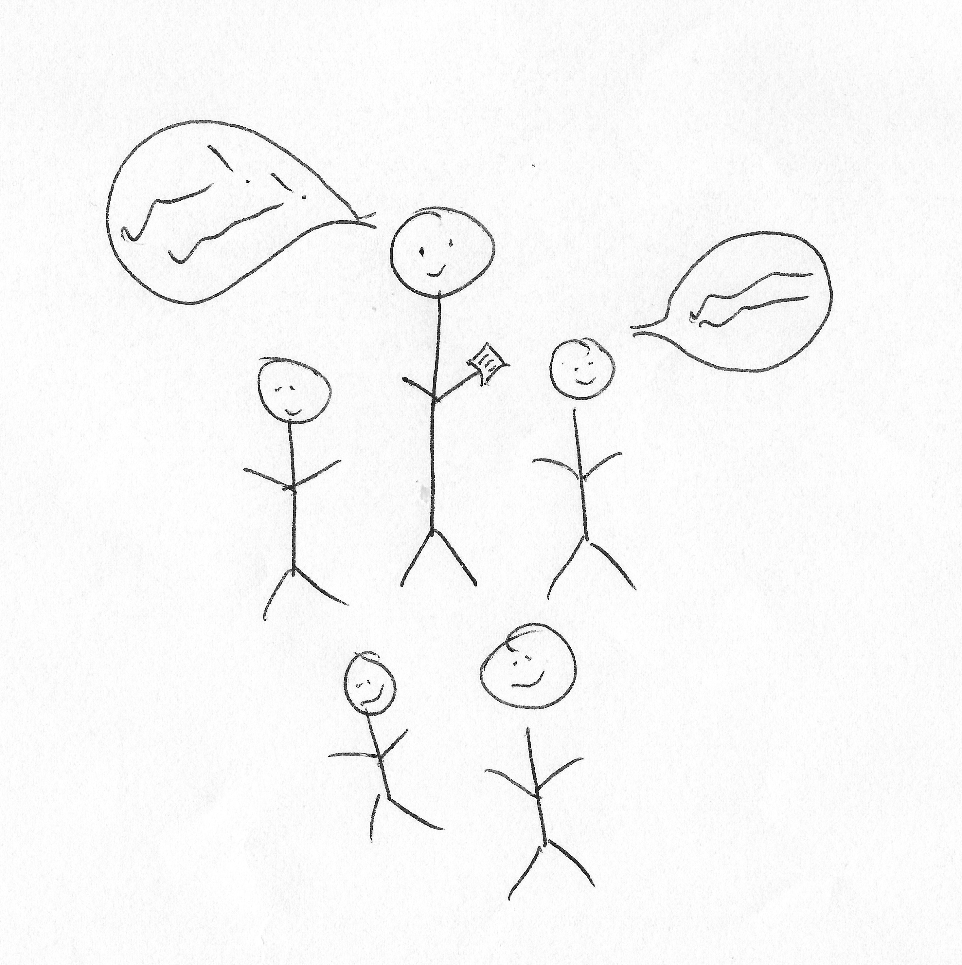

I: Awesome, brilliant.

P: [laughing] It truly is a work of art as you can see. There you go [laughing].

I: [laughing] Thank you very much! Can I get you to do the opposite, so what you would consider a bad relationship?

P: Okay [drawing]. If I draw faces on this one here, and then this is [drawing]. He’s facing that way [drawing] and this is the rest of us [laughing] just, kind of, sat around, not really knowing what’s going on. He is silent [drawing]. So, one particular seminar group that I have, he – this isn’t English, but it’s just an example, he will stand at the front, in the middle of our little circle, and if no one responds to his question, he’ll just stand there, he won’t, kind of like, give us any ideas or, like, tease people, tease, like, thoughts out of anyone, he will just stand there for ages. He won’t say anything, and I’ve timed him before and it took him, like, 3 minutes, an entire 3 minutes of silence, and I was sat there thinking, “Okay, I would say something because this is painful but I don’t know the answer. So what do you want from me?” and then he’ll just go, “Woo hoo” and it’s like, that doesn’t encourage anyone to talk, that just makes people feel nervous! So, either that or just blatantly – I’ve had someone just, like, we’ve all been sat in groups and they’ve been just facing another way [laughing] and you’re like, “What is the purpose of this?” like, we can talk as much as you want us to, but we might be talking about the wrong thing, you know, so, yeah.

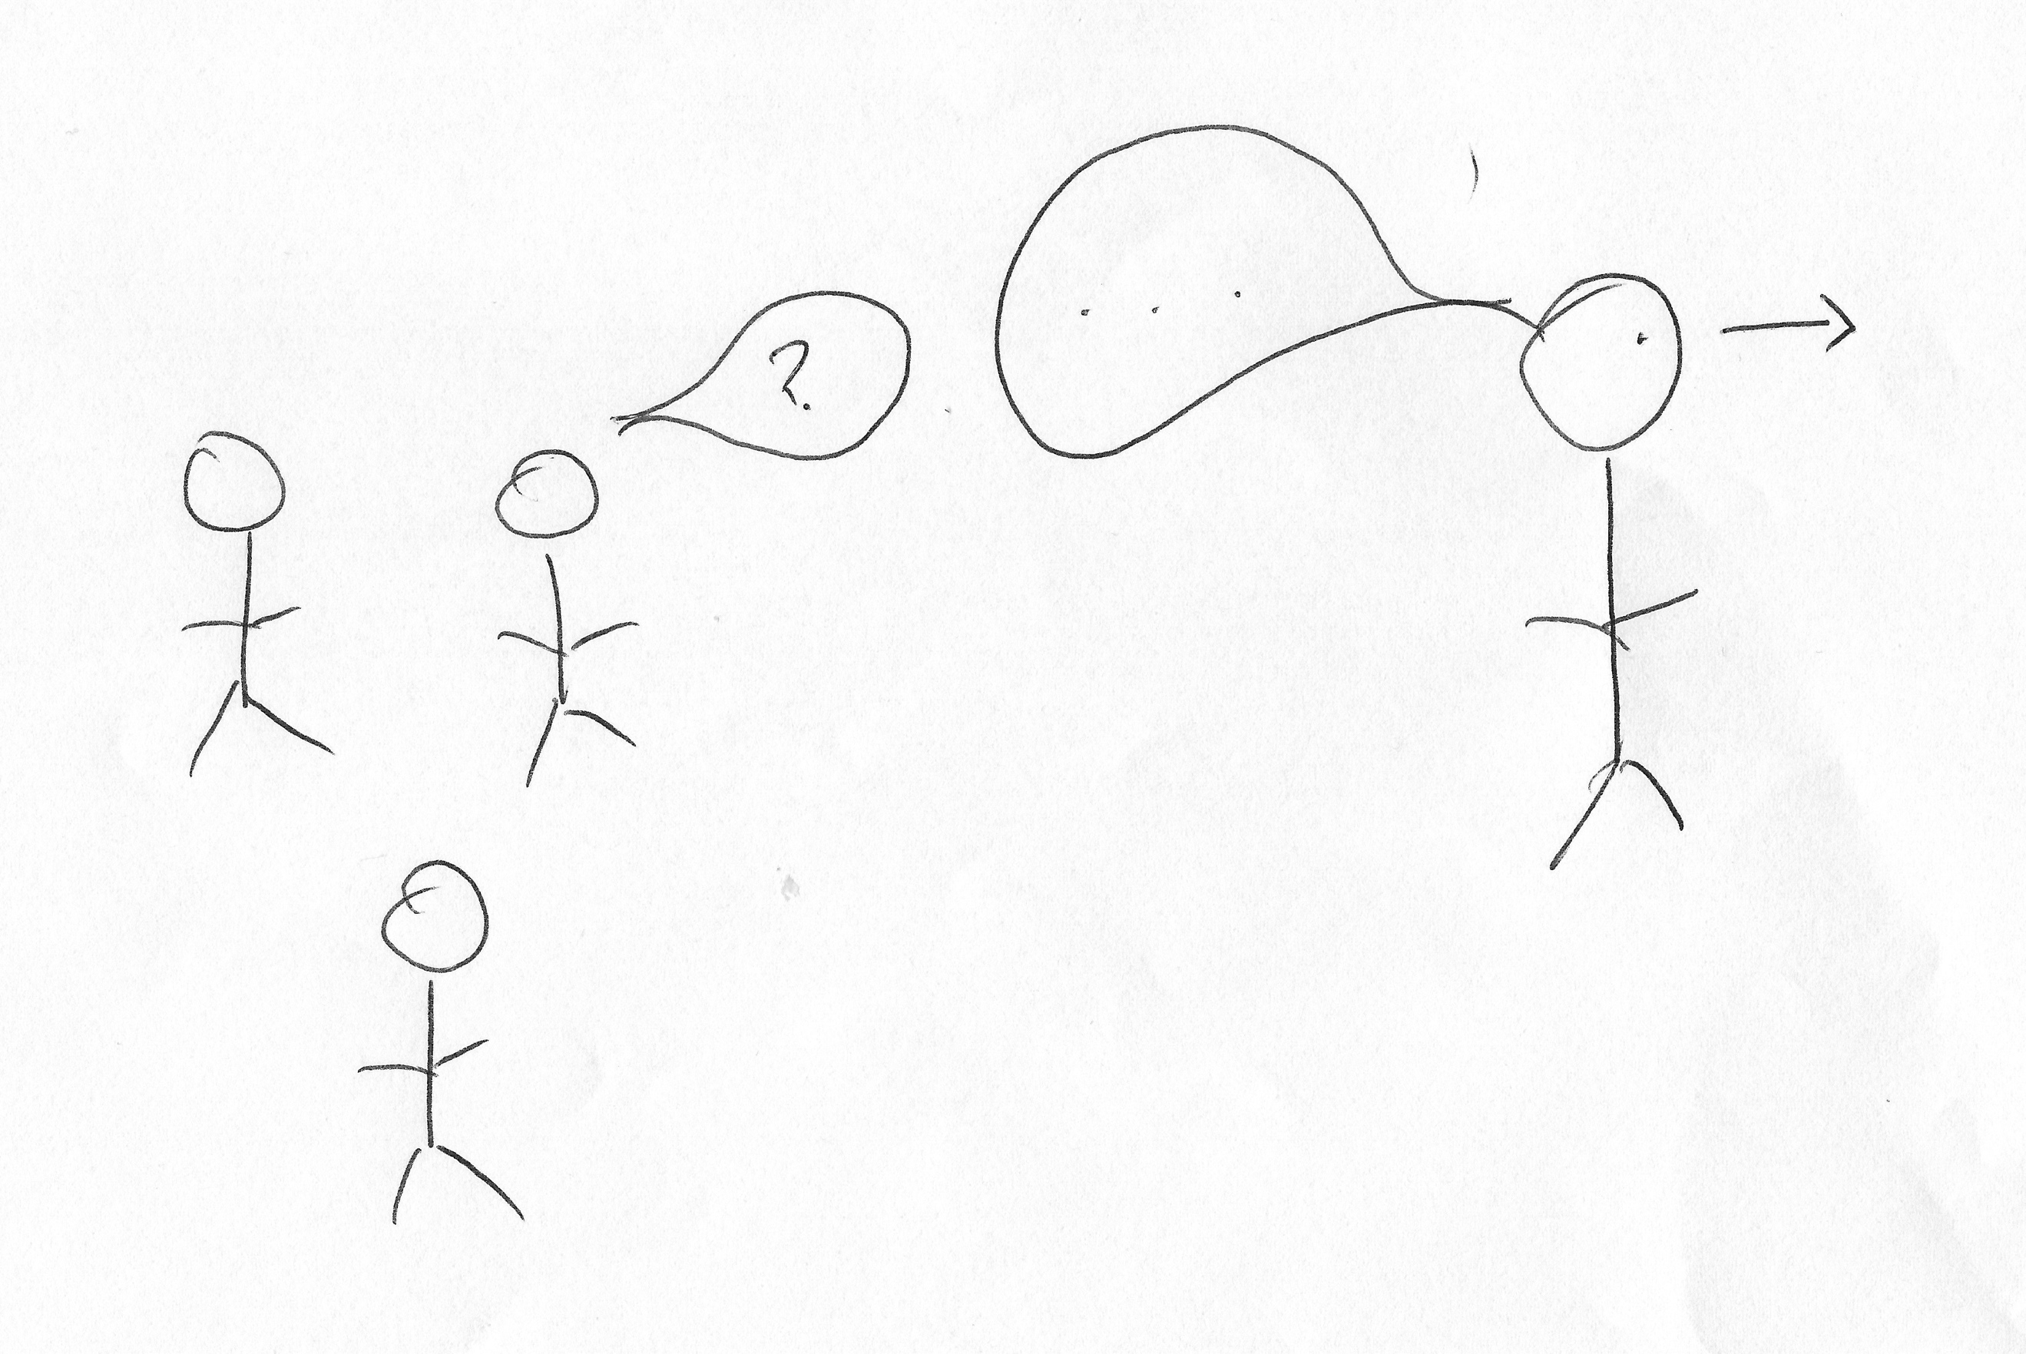

I: Okay, cool. So one more, and this is, this is – can you draw your conception of your relationship with the university as a whole?

P: Okay [drawing]. This is going to come across as really, really negative, but I don’t mean it that way, I’m quite happy with it [drawing]. Just lots and lots and lots of people, all blank faces, this one’s me. Just another face in the crowd. Again, I don’t see that as a negative thing, I’m quite happy for that anonymity, I don’t need to be, kind of, recognised or pointed out by tutors, I’m quite happy just being just another body filling a seat, and just another name on the register, I’m perfectly happy with that. So yeah, either that or a number, so [drawing] that’s also me. But it’s the number sign, not the hashtag sign.

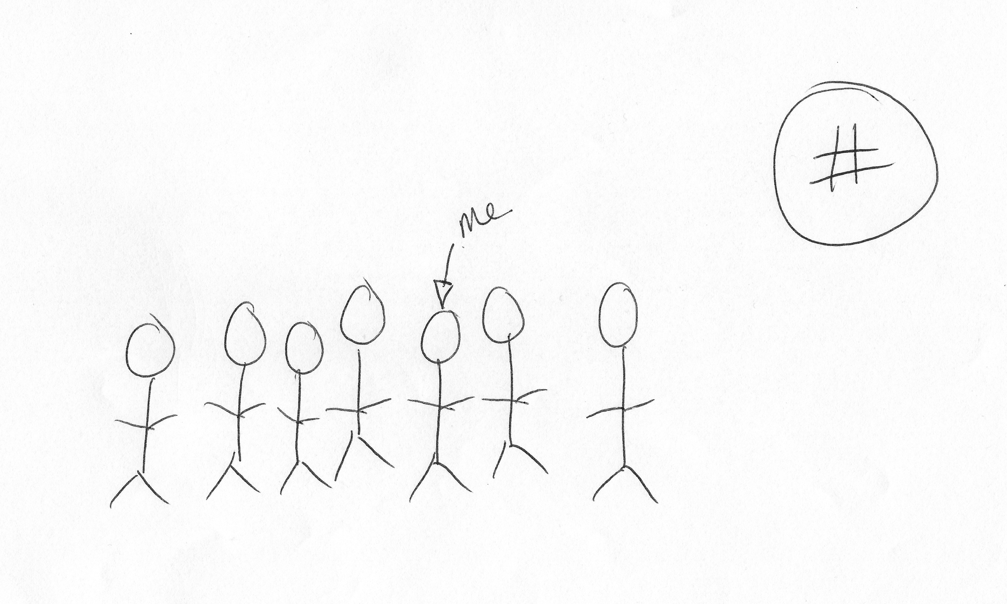

I: Okay, brilliant. Thank you very much. Well that’s the end of the drawing don’t worry [laughing].

P: [laughing] They are truly works of art.

I: [laughing] Okay, so there’s often a lot of encouragement for undergraduates to engage with different experiences that the university offers, so joining societies, volunteering etc. What are your thoughts on this?

P: I think it’s great, I think it’s really useful to have those different places that people can go to make friends and to gain different experiences. I am part of the yoga society which is really helpful for me because it’s nice to just go and actually have someone there to lift your back if you’re doing the wrong thing or anything like that, and me and my friend go and it’s just a really nice, calm environment. I know a lot of people who have found passions in various things, so various sports and stuff like that, that they maybe wouldn’t have previously, like, they went on a whim and just, they found that it was fun. I went to the [removed for confidentiality] society last year, which was fun, wasn’t really my thing, despite loving the books or whatever, but, you know, it was nice to, kind of, have somewhere outside of uni but still within uni so, people who understand the pressures of upcoming deadlines and stuff like that to talk to. Sometimes people who have been, like, people who were a couple of years above you but in the same course, who can say, “Oh yeah, hey, I did that. This is what I thought about it” just to, kind of, spark ideas. The amount of cool experiences that they offer as well, is really, really interesting. So, the other day we had a girl come into our lecture with a bunch of flyers to go to, I want to say Africa, so it was, like, you spent 2 weeks there and 1 week was, kind of, volunteering to help with animals and, kind of, nature reserve and stuff like that, and the week after that was just hang out with animals and it sounded awesome. So, it is really cool that there’s all these people who are interested in pushing you into, like, cool new experiences, and, like, studying abroad sounded really awesome, I personally can’t do it, but, you know, it would have been really, really cool and I know a lot of people who have done it who have really enjoyed themselves. The societies again are really, really useful just as ways for people to, kind of, get more active or get more involved in other people and stuff like that. Yeah.

I: Okay. Brilliant. What are your thoughts on the role of the Student’s Union in terms of engaging you as an undergraduate?

P: They like to – I haven’t really engaged a whole lot with them, because, for me personally, my purpose of being at uni is to learn and, kind of, get my degree and then off I go, but I know a lot of people appreciate them, and we get emails and people coming to talk to us all the time about voting for Student Union reps and whatever. As I understand it from what I remember from their personal introductions when we first started, they all seem really nice and they all seem to have different roles within the Union, couldn’t tell you what they are, but you know. I think there was one of them who specialised in being, kind of like, a point of contact for international students, which was pretty cool to hear about. Yeah, I haven’t really interacted, I haven’t voted or anything like that because I’m like, “Well I don’t know you people so I’m not – ” and it doesn’t affect me personally so I feel like I don’t really have a place to do that, but you know, it’s cool that they’re there, and if I ever needed anything – I mean, they wouldn’t be my first port of call, but I could probably go to them. So yeah, they’re just, kind of, there for me in the peripheral [laughing] yeah.

I: Okay. Okay, last question then. How much of a valued member of the university do you consider yourself to be?

P: [pause] I don’t think I am a valued member, I think I am just a member, just, kind of, another person who is here. That’s not necessarily anything that they’ve done or anything like that, that’s just the way it is. Again, I think there’s just too many of us who aren’t doing anything extraordinary to, kind of, be classed as, like, or like be recognised by anyone so, I don’t expect at any point to hear my name in, like, any kind of exceptional discussions or anything like that. I’m just, kind of, there. Yeah. I appreciate – but again, that isn’t a negative thing, that is just the way it is. I wouldn’t change it because I’m just here, like, I’m getting what I want from it so, it doesn’t feel like a bad thing, yeah.

I: Okay, brilliant. Okay well, thank you so much for your answers, they’re really, really interesting and really useful. Is there anything that you want to add that we didn’t talk about that you think’s important, or – ?

P: Not really. I would just like to apologise because I ramble a lot [laughing].

I: [laughing] Don’t be silly, it’s all great, I’ve got some really, really good stuff, so thank you so much!

[End of Recording]

