Interview #10 Transcript: First Year Female English and Creative Writing Student (18.01.19) (University A)

Interviewer (I): Okay so, why have you chosen to do an English degree at this particular university?

Participant (P): I’ve always liked writing, probably since I was a kid, I still, like, I journal a lot and I have been since I was quite young, but I, kind of, chose this university because my boyfriend’s here [laughing] so, but other than that, I actually did come – because he’s in second year, so I came up and visited him and I did peek into a few of the lectures whenever I was up here, and I realised, kind of, I liked the professors and I’m glad I came here because I do, like, I trust my professors and I do like them and I actually enjoy their lectures and their workshops and their seminars, it’s not something where I just want to, kind of, zone out, like, I’m here and I actually do want to learn. So, yeah.

I: Okay, cool. Are you the first in your family to go to university?

P: No.

I: Okay. What does value for money mean for you? And is it important that you get it from your university?

P: [pause] Value for money? I don’t know, do you think you could elaborate on that really quick?

I: Yeah, so, you have to pay – obviously you’re paying fees now so, there’s a certain expectation that you’d receive a certain amount of value that corresponds with the amount that you’re paying. So, in terms of going to university and paying for university, what does that equate to for you? Value for money, what does that mean for you, for a university degree?

P: Okay. Well, I chose to come to university and I know, kind of, the debts that I have and what I have to pay at the end, when I earn a certain amount. So, at this stage, like, if I don’t go into my classes or my seminars it’s, kind of, a waste on me because I’m the one – it’s coming out of my pocket at the end of the day for however long, but yeah, if I don’t go into classes I’m not going to get anything out of it because I’m not actually there to pay attention, and I’m not learning and it’s just I think, I did, to scare myself into going to classes when I didn’t want to, I’d be like, “I’m spending about £50, like £50 on this one lesson, so I might as well go in”.

I: Yeah, okay. Do you think that the lecturers and the university in general provides valuable lectures and seminars and – ?

P: Yeah, I think they do yeah. Yeah, I do enjoy them so I like them.

I: Okay, cool. Do you agree with paying fees?

P: No [laughing] not really. I think education is something – well, to a certain degree I think we have all, like, the we need resources and stuff but, at the same time it’s knowledge that I want, like, I mean I could learn it from the internet and stuff, but at the same time, I just – it’s a lot of money for something I do want to do, if that makes sense? [sigh] I don’t know, it’s very confusing because, like, I’ve had conversations like this before where I’m like, “I wish I didn’t have to spend like, £15,000 on just one year from, like, tuition fees to, like, my maintenance loan”. I wish it’s something that we didn’t have to do but, it is necessary I guess but…

I: Okay. What does being a university student mean to you?

P: [pause] I feel like there’s a – I guess there’s a sense of freedom that I’ve got since I’ve been here, I mean I’ve only been here about 4 or 5 months now but, I don’t know, I’ve had a lot of – I’ve gained a lot of memories from being here and it’s not just, like, university – my parents were always like, “If you’re going to uni, concentrate. Focus on your studies and whatnot” but, like, I think I did that for the first, like, month or two and it just, kind of, drained me a little bit and I was – I, kind of, put myself under pressure and I just felt like, “Oh, I probably need to lay back a bit”. My boyfriend was like, “You should probably start coming out a little bit more” and so I had a sense of freedom and like, I was responsible for what I’m doing and no one else is going to, like, take responsibility for my actions because I know what I’m doing but, like, I learnt that you have to, kind of, balance it out, but, like, a lot of sense of freedom in the fact that I can do what I want when I want it, so yeah.

I: Okay. What do you think being a university student means to people outside of the university, or who have never been to university?

P: I think the, like, the stereotype that you get is students that are going to uni, but they’re, kind of, going for the experience because, obviously my boyfriend, he’s in the year above and he would always come back home with stories, and he’s like, “Oh, I’ve done this, I’ve done this” and it’s all, like, brand new things and I’m like, “Wow, that’s going to be great for me” but then I realised, like, I came here myself and I was like, “This isn’t how he said it was going to be”. It’s a lot more stress. It’s a lot more anxiety and a lot of, like, my time and my mind is just focussed on, like, my work all the time now, like, I want to improve. But I feel like, for some people who have never been, they just see it as, like, just like, university students going out drinking every night, or, kind of like, not paying attention but, at the end of the day, like, I’ve met students that love what they do and then, it’s not really the case.

I: Okay. What meaning does the word engagement have for you?

P: Reacting, kind of, taking part in something. Yeah.

I: Yeah, okay. Okay, so in what ways, then, do academics attempt to engage you as a student?

P: I think the seminars are a big part of that because I obviously have to do the reading and then go back in the, like, the next week and talk about it and that’s a lot of, it’s a lot of, kind of – it’s a group activity because, like, everyone’s talking, everyone’s putting in their notes and that, like, their own interpretations of, like, the different – one piece of text. But, like, that’s like – when I hear engagement, I think of seminars, I don’t really think of lectures. Lectures I’m, kind of, just sitting there and taking in all the information, whereas with a seminar I’m, kind of, you know, just like, throwing suggestions and stuff in there and I guess workshops are, kind of, the same thing as well because you do talk quite a lot, obviously you’re interacting and you’re getting responses from other, like, classmates so, yeah.

I: Okay, cool. What are your thoughts on the concept of student as consumer in higher education? Have you ever heard of this concept?

P: No.

I: Okay, so when the fees started, there was – it basically started because students started paying fees, so this idea of the student as consumer came about and it basically means that students are now being thought of as consumers rather than students. So their needs as a consumer are being put above their needs as a student, and it’s all about satisfying the consumer and stopping complaints, etc., etc. So, what do you – what are your thoughts on that in a university, and have you noticed it at all? Do you feel like a customer, etc., etc.?

P: I think maybe, to a sense, no, but then again, yeah. I feel like, when I think about money, I think about going out and just doing a lot of stuff and I feel like I’ve put a lot of money into, like, groceries and, like, drinking as well, like, events and things. But, I’ve never really seen it as, like, I’m a customer, I just see it as, like, I’m going out, I’m, kind of, having an experience that I haven’t had before. But yeah, I’ve never really seen it as, like, “Oh, I’m a customer, I’m, kind of, paying my dues” other than, like, actual tuition fee and all that. But yeah…

I: Okay. So, it doesn’t really relate, you don’t think?

P: No. I don’t think so.

I: Okay. And do you think students should be positioned as consumers by universities?

P: No. I don’t know, I don’t think that will have, like, the greatest response from, like, from any uni student because, like, we all have our own opinions but I feel like there will be a very big negative feedback from everyone because I don’t think they want that, kind of – they don’t want the label where they’re – it looks like they’re, kind of, wasting their money, I guess because money, at the end of the day, is never really ours, it’s, kind of, we always – we take it out and then we use it for something else, so we never really have it ourselves so I don’t think we’d want that, kind of, label on us.

I: Okay. Do you think paying fees gives you more entitlement to complain, or to have more of a say in how the university’s run at all?

P: To an extent, yeah, when it comes to, I guess, living situations, if there’s a problem I think I should be able to go to someone about it and talk and hopefully get it resolved but, it’s like, I don’t know, I can’t really think of any, like, big problems or situations that I’ve either heard of or come across myself. But to an extent yes, because I’m being here, I’m getting the support but I also, kind of, need, like, if I need the extra, I want to know that I have it. But, I don’t think that we should be, like, spending money on just things that we don’t need.

I: Okay. Okay, so moving onto learning then. How engaging and/or useful for learning do you find lectures, if at all?

P: Lectures, I like them and then I don’t like them, it depends on my mood for the day. I’m not – I can sit there and listen to someone for about an hour but, like, an hour is it, like, if I had, like, a two-hour lecture, I think I’d – oh I don’t know, I’d probably go crazy or insane within, like, the first 20 minutes. But I do like them, I have some really, like, interesting and very quirky I guess, like professors so it’s not always boring. I do like going in and, like, seeing them but sometimes, I’m just not in the mood. But no, I do actually like my lectures, they’re quite alright.

I: Okay. Okay, so in the same vein, how engaging and/or useful for learning do you find seminars, if at all?

P: I like seminars, probably because we’re just, it’s constantly talking about what we just learned and I, kind of, like gaining new information from other people. I like listening to a new interpretation because it puts me in, like, a different perspective so, I do like seminars a lot too [inaudible].

I: Okay, cool. Where do you choose to sit in seminars and lectures, like at the back, front, middle, or do you not really care?

P: It depends because, last semester, one of my lectures, it was, like, because I do joint so, the – yeah joint honours have, like – English and Creative Writing, there’s, like, about 30, 40 people but the [removed for confidentiality] module, that was joint and single honours, so that was, like, 200 people so, like, it, kind of, depends where there’s space [laughing]. But, usually if it’s, like, the smaller lectures, I’ll have, like, middle towards the back, kind of thing, and then at the big lectures, it’s always in the back [laughing].

I: Okay. How come?

P: I don’t, kind of like, I don’t like being the first to be seen by someone else, it’s just I feel more comfortable in the back, like, secure and protected by everyone else.

I: [laughing] Okay. How engaging and/or useful for learning do you find one-on-one sessions with tutors, if at all?

P: The one-on-one sessions I do, I think they’re important. I feel like if you have, if you have, like, just one in the whole term you should go to it just because it gives you the chance to talk about things you might not feel comfortable talking about to, like, friends or, like, even parents. So, like, personal tutor, they’re there to help and just, like, to give you advice when you need it and just support so, I think it is quite important that students should go to see their personal tutor and, like, that should be their – not their number one, but, like, a back-up plan if they don’t have anyone else to talk to.

I: Yeah. Okay. Have you ever had any one-on-one sessions with tutor that aren’t your personal tutor, just general academic tutors?

P: No. No, I haven’t.

I: Do you think you would go and speak to them about essays and – ?

P: Yeah, if it’s, like – if I’m writing a certain essay I’ll talk to, like, the teacher that I’m doing the module for, but I think for advice, I’ll just go to my personal tutor or, like, the well-being centre.

I: Okay. Do you ever find them intimidating, being in a one-on-one with tutors?

P: First time yeah, because I wasn’t – I was very unsure how the, like, how they interact with and what they say to me, but I think after probably about 5, 10 minutes I was all fine.

I: So just, like, the fear of the unknown?

P: Yeah [laughing] basically.

I: Okay. Is there anything you particularly like about the learning style of universities compared to compulsory education?

P: [pause] No, nothing really comes to mind. It’s just – no I don’t really have anything in mind for that one.

I: No? Okay. Okay, from your own experience, is there anything you would change to improve your own learning? So, in terms of the teaching you’re getting, the resources you have access to, curriculum and assessment, or anything else?

P: I wish we had more, kind of like – I used to hate exams but, like, coming to uni and doing, I think this semester, my first year, just pure coursework, I do wish we had, like, regular exams, like, just one at least because I’m not a big fan of writing essays anymore so, I’d rather just do an exam and, kind of, work from a paper and have, like, set questions for me instead of just one big question, where I have to work on the idea myself but, yeah.

I: Okay. Okay so, I sent you the document that refers to the Student Collaboration Policy [policy name changed]. Have you ever heard of this policy before?

P: No, not until you sent me the document, no [laughing].

I: No, fair enough, most students haven’t. So, just to recap then, the Student Collaboration Policy [policy name changed] was introduced as a way of combatting the idea of the student as consumer so, it’s a way of making undergraduates more involved in teaching and research. So, it was set up with the idea that undergraduates would work with academics on research projects and they’d become more involved in what the university does, rather than just being taught and getting their degree and then leaving. So, that was the idea of it. So that being said, is it at all evident in your experience of being a student here?

P: [pause] Oh yeah, there was, kind of, a little incident that happened I think October time, where students, kind of, had an opinion on this one [removed for confidentiality].

I: Oh, I heard about this.

P: A lot of students had a lot of opinions and, I don’t know if you heard, but there was, like, a – one of my classmates in my English and Creative Writing course, he wrote, like, a letter on behalf of all us, like, all the English students saying, like, “We want this sorted out. [removed for confidentiality]” and all this, and it was, kind of like, we can’t do much, like, all we can do is react to what he said and just go about it, and, like, just leave it alone, it’s not our business. But at the same time, it was, like, it’s affecting our teaching [removed for confidentiality]. So, it was quite intense and it did, it did, like, bring up a meeting where we had to talk to the Head of English and I was at that meeting because [removed for confidentiality] so I think, yeah, it is quite important because I just – there was, a lot of people have said that it really just, it affected what they wanted to do [removed for confidentiality] yeah, it really affected them so, it was quite…

I: Did it get resolved?

P: Yeah, [removed for confidentiality] so…

I: Right, okay. Fair enough. Okay, fair enough. So, I also sent you the document that refers to the Student Charter. So, the Student Charter basically is your contract with the university, it’s what you agree to do and it’s what they agree to do in return. So, how evident is this policy in your experience of being a student here? Do they uphold what they say they’re going to do, and all of that?

P: [inaudible] over these again, sorry [pause]. Yeah, going back to that story I think, yeah they do, but at the same time, I feel like there was, well basically there was a response to it by the Head of English and a lot of students were still, like, kind of, unhappy with what he said so, it meant there was a meeting where we would, like, talk and we would tell him and it was, like, obviously it was resolved but he just, [removed for confidentiality] But I think they do uphold their values and what they actually say they want to do. But, I guess, like, each to their own, obviously, they all have their own opinions about certain things but we can’t necessarily change their mind, we just, kind of, have to either deal with it or just put it aside.

I: Okay. Do you think it’s important to have this contract in, like, a written contract between you and the university?

P: [pause] I feel like some of them yeah, but, kind of, some of them you think it’s just, kind of, basic common, like, just common sense no offence but, like, kind of, we treat each other with dignity and respect you, kind of, as a human you think you just get that anyways. It’s, kind of like, it’s a part of just being a nice person, you don’t really need a written contract for that bit, but everything else I do agree with. Things like the university’s strategic plan and our responsibility for, like, learning, that’s, kind of, on us as well but, with their help, except for just this first bit. Yeah I think that bit you just don’t really need, but I do think sometimes we do need, like, a written contract to, like, just refresh ourselves every once in a while.

I: Yeah, okay. Okay. In your opinion, should undergraduates have greater control over, or input in, the curriculum and/or assessment design of their chosen courses?

P: I think so yeah, so say if I, like, I think it would be important for, like, the year that’s about to graduate to talk about what they’re putting in the curriculum for next, for the next year. I feel like if there’s a wider gap, there’d, kind of, be a gap in, kind of like, I guess like, current content that’s already out there or what’s going on with politics and stuff because, like, right now I think we’re doing – this semester, I’m doing [removed for confidentiality] and a lot of it’s, kind of, centred on, like, [removed for confidentiality] and everything is quite, like, now-ish [sic] so I feel like when it comes to curriculum, like, if it’s, like, a [removed for confidentiality] thing maybe have, like, one say in what we can do. But I feel like we should stick to basics, like, Gothic Literature and all this but – and assessments, other than, like, just the one exam that I want, that’s probably – I’m fine with it as it is with coursework so…

I: Okay. What are your thoughts on the idea of students as partners in the learning experience? So where, like, if you’re partnered with an academic, or with your academics, then you, like, co-create the curriculum and you co-create the assessments and so you work alongside academics to do everything basically.

P: I feel like probably as an undergraduate student, not right now. I don’t think I could hold that responsibility because that is quite a lot to, kind of, take on, like, I’m designing an entire, like, syllabus for the future student and what if they don’t like it? What if they don’t want to do, like, particular subjects that I have an input in? So, I think right now if I were to do it, I probably wouldn’t, like, if I had the choice. But I think if I was, like, a Master’s student I probably will because it’s quite, it would be a fun experience I guess, like, to be able to really, like, be like a TA and help them out and things but, I feel like right now, no [laughing].

I: Fair enough. Okay so moving onto interactions. In recent government policy on higher education, students have been placed at the heart of the system, which is their wording. How central or important do you think undergraduate students are in this university?

P: I think, yeah, I think they’re quite important. I guess because they’re, like, I feel like, I guess for us first years especially, it’s, kind of, everything’s just brand new and you go into, like, the first week and everything’s just, kind of, thrown at you and it is quite overwhelming a little bit. But, at the same time it’s just, I don’t know, it was – I got the support where I needed it and when I needed it but, yeah, I don’t know what else to say about that [laughing].

I: Fair enough. What meaning does the word relationship have for you, in the context of interacting with academics?

P: I think, kind of, having, like, I guess maybe, like, not like a one-to-one but an understanding of, like, they – the teacher, kind of, notices your face or your name or something. If you had, like, a problem you wouldn’t – I wouldn’t feel, kind of, like, embarrassed to go up to them. I feel like it’s good to, like, establish a positive relationship and a positive attitude as a teacher so you’ll seem more approachable because, obviously, as a first-year, everything is quite overwhelming and, as you say, like, intimidating a little bit so, I would just yeah, I think I’d definitely – sorry, could you repeat the question, I’m, kind of, like flanking out, sorry.

I: No, that’s fine. What meaning does the word relationship have for you?

P: Yeah, yeah establishing a foundation between the student and the teacher where, kind of, you know the basis, like, I have the, I have – one of my workshop teachers he, like, there was a time where I just, kind of, didn’t go in, like, for a certain amount of weeks and he was always like, “Oh, is she okay? Is everything okay?” and when he first started, he was a new teacher but he, kind of, like, in our first lesson he, kind of, set his, kind of, like, how he works as a teacher and it was, like, if like, he was like, “I’m going to know your name, and I do want to know who you are and I want to know your style of writing and all this, but, like, if you’re ever in trouble, like, I’ll notice” like, he always, he, kind of, checks attendance and stuff and if he notices that you’re not interacting, like, with the uni and the fact that you’ve gone to the library because you have to swipe your card to check in to, like, to go into the library, so if you haven’t, like, done that or, attended any other classes he’ll, kind of, he’ll contact you, like, email you or go through Blackboard and message you there but, yeah, there’s quite – some teachers are quite good at that, like, being able to be approachable and, like, I’ve seen, like, students freely go up to teachers and say, “Hi” and I guess it’s nice. Yeah, I think it’s important to have somewhat of a good foundation, yeah.

I: Okay. So what do you consider to be the main purpose for building a relationship with academics?

P: Main purpose… I think it’s just to get a better understanding of each other, in a sense. I feel like if you don’t, like, if I don’t know my teacher well enough, I probably wouldn’t be interested in what they have to say and I just won’t learn anything if I don’t so, I think it is quite important, especially if you, I guess, like a certain module you, kind of, want to know what the teacher likes, like, if they like your, kind of, gothic literature or if there’s an American rendition or whatever but, yeah, to an extent yeah, it’s quite important.

I: Okay. Okay, can you describe to me a typical face-to-face encounter with an academic. So, for example if – when you go to speak to your tutor, how – so what actually happens? What do you do?

P: It’s usually just, like, it depends on the situation. I feel like if I have a question, it’s quite straightforward, they don’t really, yeah, so dawdle about with what they’re saying. So, it’s quite straightforward if I , like, if I want to – if I have a certain question, like, an essay or an assignment, but if it’s, kind of, like, more personal, they’d probably sit me down, like, they’d sit me down in their office and, like, in an enclosed area where no one else can hear and it’s just confidential between me and them. Yeah, that’s usually the other typical, like, situation I get.

I: Okay. Are you ever aware of a hierarchy when you interact with academics?

P: Like, I know who, like, the main lecturers are and the Head of English just because I have [them] for quite a lot of my classes, but ones that you, kind of, like, senior lecturers or, like, new ones I don’t really, I don’t really notice I don’t think, no. I feel like you just, well, you know the Head of English just because, like, [they’re] the Head of English, it’s, kind of, like, [they’re] the go-to person if you have, like, a main problem about the course. But I feel like I don’t see a hierarchy, I don’t see rankings and things, no.

I: What about a hierarchy between you, as a student, and them as an academic?

P: Yeah I feel like it’s a bit more different because I’m learning from them and I’m respecting them and they’re giving me the same respect back but they have more knowledge and I’m trying to learn from them so, I notice that, but it’s not, like, a big thing because I’m treated like an adult, so...

I: Okay, so would you say it’s quite a natural hierarchy then?

P: Yeah.

I: Okay. Can you think of any particularly good relationships, without telling me who they are, with any academics and why you would characterise it as good?

P: I guess I, kind of, told you one: the teacher that, kind of, checks up on everyone, yeah because, like, questioning my mental – it’s, like, [inaudible] my father, I don’t have, like, the best mental stability and health at the moment, like, before I came to uni, there’s a lot of checking up and stuff. I do get quite, yeah, like, I think they sent out either automated text messages or, like, text messages if you haven’t been in for a certain amount of time and I have gotten a few of those in the past few months but that’s one teacher that knows, and they’re quite, like, he interacts with you and, even if you’re not asking for help, he’s offering it. Same goes for another one of my teachers, he – I guess it came out in my writing, and he saw my writing and just questioned, like, it was a different teacher, but he just double checks, he always asks if I’m okay and whenever I see him it’s always, like, a “Hi” or a smile or something, so it’s quite, yeah, it’s quite straightforward, but it’s nice, it’s not, like, too overwhelming it’s just – it feels, it’s a good one.

I: Yeah. So just a caring feeling?

P: Yeah, like, it feels like they do care and they do understand if you have a problem and if you can’t, like, if you can’t help it, they’ll be understanding and they’ll try to help you as much as they can, without, like, overstepping boundaries and if it has to be, like, a – I guess if it meant, like, I had to go see a Doctor, like, someone has to go see a Doctor or they have to refer someone, like, they have to refer to someone else because they can’t do it themselves, then they probably will, but I haven’t seen that happen.

I: Okay. Okay, so now can I get you to draw your conception of a good relationship? So, however you would visualise it in your head, it can be whatever you want, it can be stick people, abstract, doesn’t have to make sense, whatever comes to mind when you think of a good relationship.

P: [pause for drawing] Student [mumbling], teacher’s up here [pause for drawing].

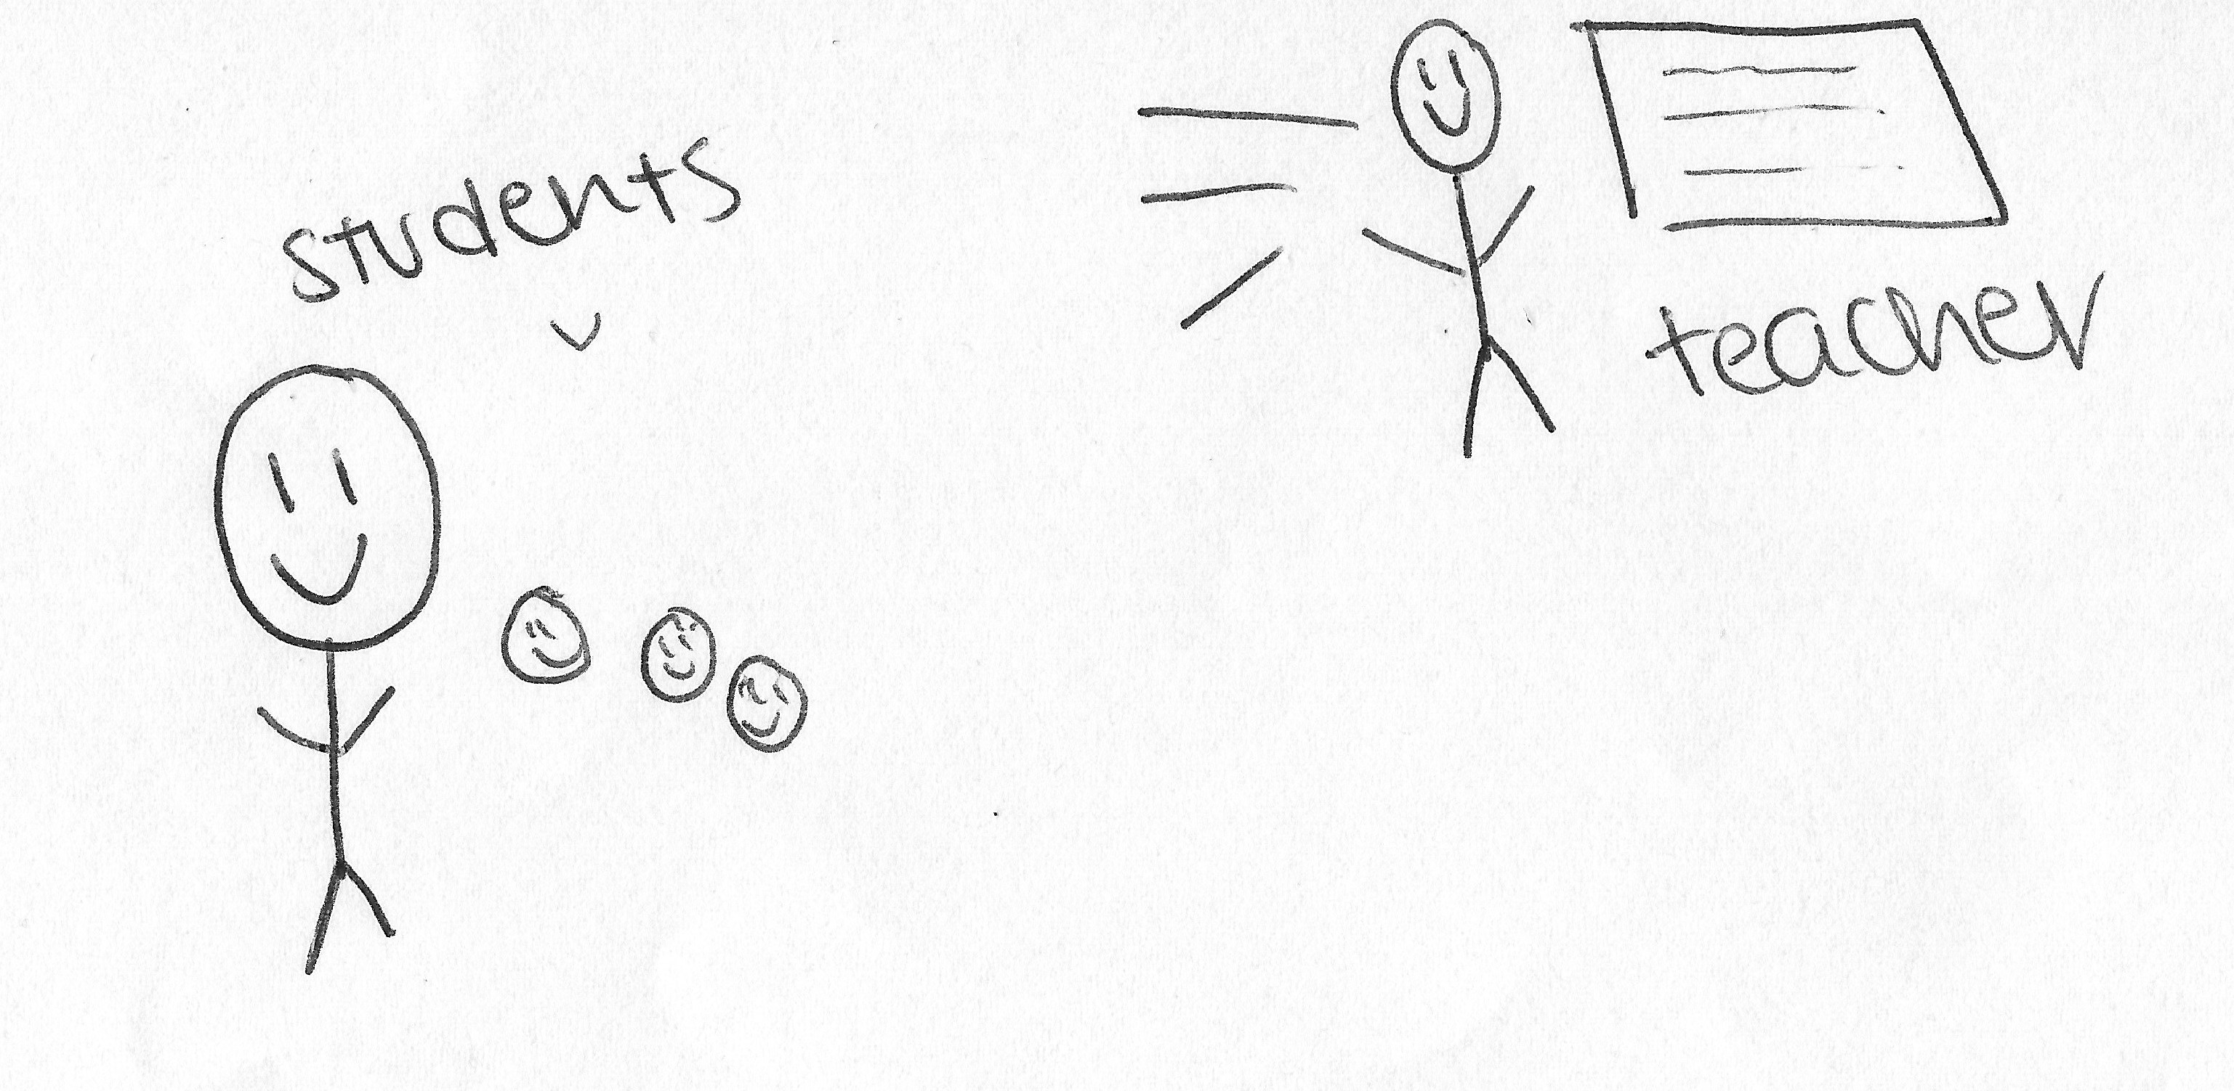

I: Okay cool, so what have you drawn?

P: So, this would be students, this would be me. This would be the teacher and it’s constantly talking, and engaging, and asking questions. Sometimes they don’t really get a response, it’s just awkward silence but, they make up for it anyways and it’s quite, you can see that they’re trying so it’s quite, it’s good, it’s a very – yeah, it’s a good, like, relationship.

I: Okay awesome. Cool, so can I now get you to do the opposite? What do you think of as a bad relationship with an academic?

P: [pause for drawing] Yeah.

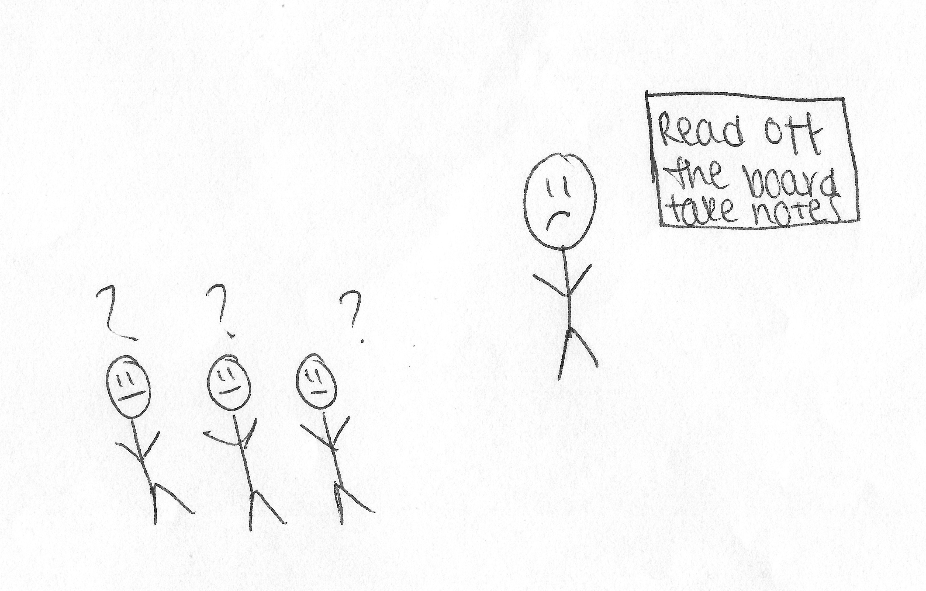

I: Cool, what have you drawn?

P: This is just, kind of, a teacher that’s not really participating at all, not really engaging with the students, not talking, not elaborating on what they’re saying or asking questions. It’s quite just, like, “Read off the board and take notes”, that’s it. Yeah.

I: Okay, awesome. Okay, this is the last one. Can I get you to draw your conception of your relationship with the university as a whole?

P: [pause for drawing] Okay.

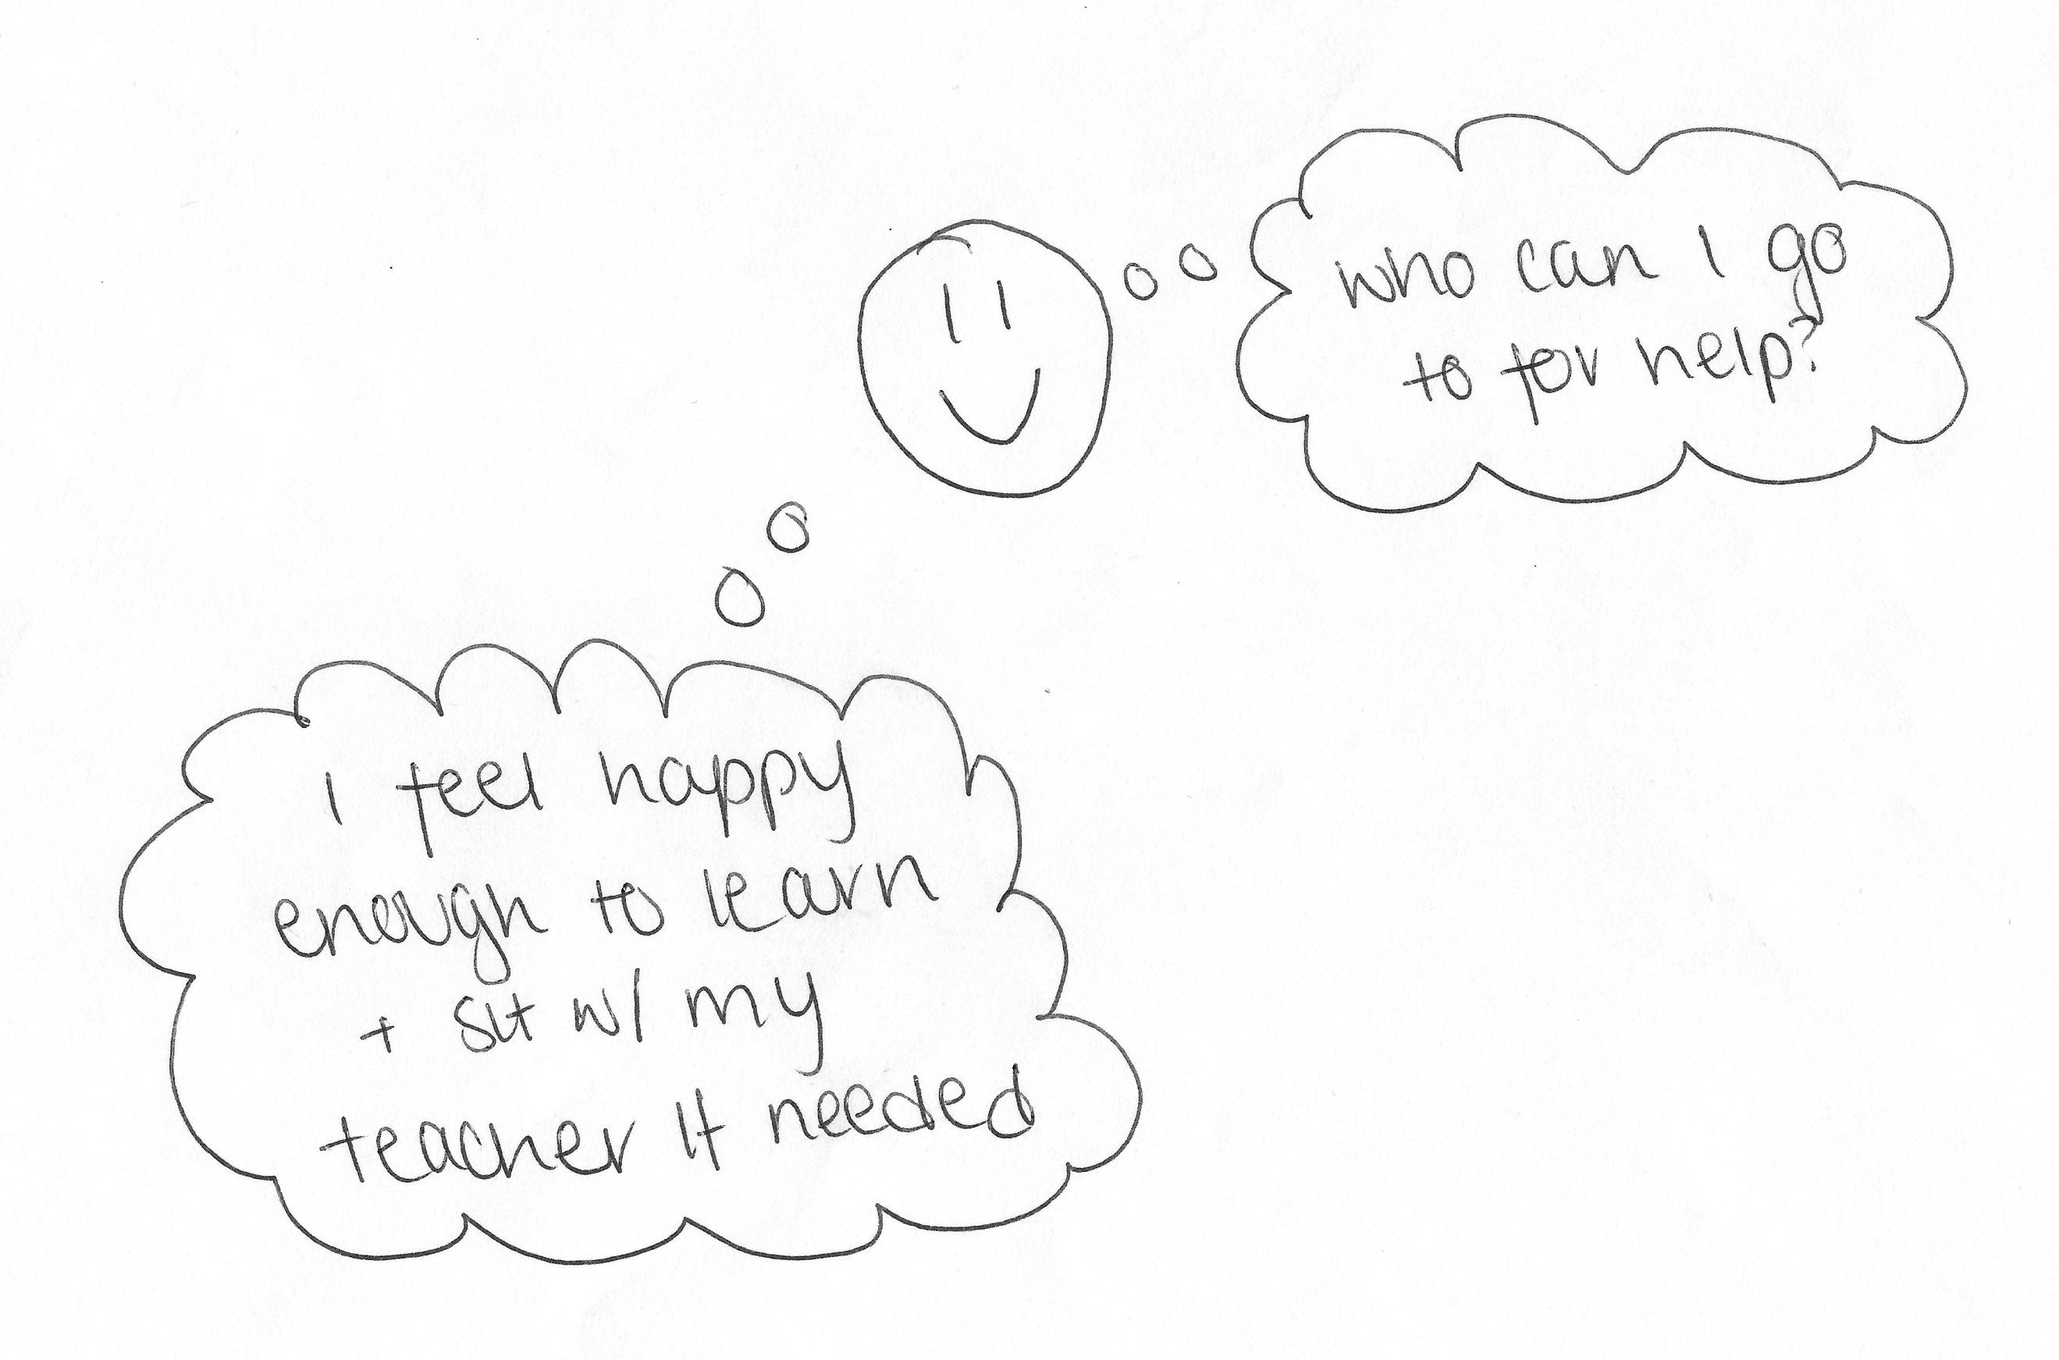

I: Cool.

P: It’s, kind of, like, bubble thoughts but I feel, like, with what I’ve gotten so far, I’m quite happy with the way that teachers handle situations and I don’t feel, like, I should be – I guess, like, as a first-year, like, my first month was quite scary because I wasn’t – I was very unsure of, like, who to go to and where to [inaudible] if I did need help but, over time I’ve learnt that the teachers are there to help and there is, like, different kinds of support; there’s, like, medical support so I’ll go to the wellbeing centre if needed, there’s a, like, on-campus Doctor, like Doctor service, NHS, so I can always go there if I need it. Yeah, there’s always someone to talk to and yeah, I’m not complaining but, yeah, I don’t have, like, a massive, like, compliment to say but with what I’ve got so far, I’m really happy with it.

I: Okay. Awesome. Okay, no more drawing. Okay, so last few questions then. There’s often a lot of encouragement for undergraduates to engage with different experiences that the university offers, such as joining societies, volunteering, getting involved with the SU, etc. What are your thoughts on this?

P: I feel like if you’ve got the time and you’re responsible enough to be handling classes, coursework and societies, I feel like go for it. My mum always says, like, “The more you take part, kind of, the more you gain out of things and you always meet new people and you’re never really alone” so if you can do it, do it. I mean, I haven’t joined a society yet, but I probably will next year. This year I’m, kind of, still settling in, like, settling in a bit but I have this one friend, she has, like, she’s in, like, two or three societies but she’s, like, on top of her work all the time and I just see her as, like, the best student in the world. I can’t, I don’t know how she handles it. I text her over the holidays and was like, “Are we starting to go to the gym as a New Year’s Resolution?” and she was like, “Yeah, we’re signing up for Pure Gym” and I’m like, “Okay”. So, yeah, I feel like it depends on the student and the person, if they’ve got good habits and they can keep a solid routine like that, I feel like yeah, anyone should go for it.

I: Okay. What are your thoughts on the role of the Student’s Union in terms of engaging you as an undergraduate?

P: They’re quite good, they do listen. I feel like you’ve got, like, the welfare, the international, the education and just the overall president and, going back to that little story [removed for confidentiality], they were there for some of the meetings, like, I assume that although they’re the Student’s Union, they were there to, kind of, talk to us and get questions because, I think there was, like, the education, kind of, like, bit of it, they were there and they came and they talked and they asked questions on, like, how they can help because, like, they were offering support as well because there was quite a few distressed students. So, yeah they do interact with the students quite well and it’s not just, like, social media posts, like, I feel like students know them by their names and they, like, go out, like, you can hang out with them at, like, [removed for confidentiality], which is the [removed for confidentiality] and stuff. But yeah, I think it’s a good relationship.

I: Okay, cool. Do you consider yourself to be a part of the Student’s Union?

P: I take part in all their events, if it’s, like, an event in [removed for confidentiality] or at home, I’m usually going with, like, a big group of friends. But I feel like, overall, I’m just, kind of, there to take part in the event, I’m not there to, like, organise or anything like that, I’m just there as a participant.

I: Okay. Okay, final question. How much of a valued member of the university do you consider yourself to be?

P: Valued… I don’t know, there’s a lot of people at this uni, so I don’t think, like, not a little amount to the extent where I’m nothing, but it’s not, like, I’m very important, like, I’m not president of the SU or anything so, I don’t know, I feel like it’s a balance of, like, I feel like teachers know me enough and they care about, like, my learning and they do have and they want to, but at the same time, it’s not, like, I’m the only person that they do that too, there’s other students too but it’s not, like, I feel small or anything. It’s quite good.

I: Okay, cool. Okay brilliant, thank you very much. Is there anything you want to add that we didn’t cover?

P: No, I’m good, I think I’m satisfied, yeah.

I: Okay well, I’ll stop recording then.

[End of Recording]

