Interview #1 Transcript: Faculty Director of Learning and Teaching for the Arts and Humanities (05.06.17) (University B)

Interviewer (I): So, as the faculty director of learning and teaching, what would you consider to be your main responsibilities?

Participant (P): I think there’s strands of them. The first strand is to the centre of the institution to ensure that central policy process, updating of ideas around how curriculum is designed and delivered get translated into our faculty environment, so I have a kind of diagonal line of responsibility to our centre and a department called [removed for confidentiality]. Secondary to that, I have a direct responsibility to the faculty to ensure that they are up to date with, I suppose, contemporary ideas around the delivery of learning and teaching and to make sure that they’re thinking constantly about the student experience and about really crucial matters, such as recruitment, retention, continuation and success. And I’d say that I’ve got another role, so there’s this role of kind of action planning and business planning and making sure we do what we’re supposed to do at a faculty level and then I’ve got another role which is developmental, so I put faculty members through the process of achieving the portfolio to achieve higher education fellowship, the HEA and also run various different enhancement, developmental activities, bespoke targeted activities so I’ve got a really broad remit [laughing].

I: [laughing] Okay. How many undergraduate students do you teach in a term, roughly?

P: Right, well I don’t, well, so – it’s complicated for me in my role. Faculty Directors of Learning and Teaching have a portion of their contract that they – that means that they’re expected to teach within, but it’s actually quite small. I teach, and have taught, over this year, students on our foundation year, which is a level 0 entry year into a 4-year degree pathway rather than a year degree pathway and that has roughly 50 students in it, and I’ve taught across the academic year in different modules and have mostly programme management, strategic management, of that programme but I do have face-to-face contact with those students.

I: Okay. What meaning does the word ‘engagement’ have for you?

P: I think, I think it’s really very much about the idea of the relationships that you have with students so on two different levels: first of all, this institution has a strategy which means that we [removed for confidentiality], so at one level in the way that the programme is managed, we construct activities in that programme management context which means that we have student reps, students have an opinion, they contribute to the way that a programme is delivered, we review programme delivery every year, based on students’ commentary at staff-student liaison committee meetings for example. A second area would be the way in which we engage students around the process of evaluation, that’s just on going but after every module. And then thirdly, in that context of students as partners in learning, we run, in this faculty, several student engagement projects which is where we have a specific problem that we take to a group of students and we say, “We want to design an intervention”. It might be in curricula or extracurricular, which is to do with some aspect of the student experience. We partner up with the students and we ask them to co-design or design with a brief, those interventions, and then deliver them with students, which is really – and we’ve had a number, in our faculty, of very successful interventions. We’ve had one which has run across faculty for 2 years which is [removed for confidentiality]. And we do that also in relation to strategic themes, so we try to use student engagement in a way that connects up to where we need to be working strategically as a faculty, so around equality and diversity for example, we’ve got one around sustainability. And then I think that the fundamental there, in student engagement, comes in the way that lecturers interact with their learners, so for me that’s really crucial. I’ve worked in higher education for 20 years and I’d say the strongest feature of a student cohort and happy students and successful students is when they feel that they can talk to you, they can come to you with their problems, they can see you at the end of a lecture, you’re available, and that you develop in your role as a lecturer, a social interaction with them and a kind of – you know, a really caring interaction within the context of a structure. So, you know, you want to feel that you’re approachable really.

I: So, using what you’ve just said, how do you personally attempt to engage your undergraduate students in your teaching?

P: Well, first of all, because I think subject specificity is really important, so I think all subjects have a specificity and a way in which they would naturally design student, you know, experiences that were right for their subject, so this is a, you know, a media, a kind of arts and humanities faculty and in the context of the programmes that I’ve taught on, it would be very much with that sense of well, if students are studying the arts and humanities, and my specialism is [removed], I would make sure that the first way that I was engaging with them is in the way that I design lectures and seminars and choose learning and teaching methods that are appropriate for those types of subjects, which means, you know, a very, very big, [removed for confidentiality] to the way that I’m delivering the curriculum because at, you know, at kind of a fundamental level, if you’re not doing that, in my mind, you just turn a load of people off because they’re Arts, they’re into the Arts, they’re into History, they’re into, you know, Broadcasting, whatever it is and they need to get the sense of how the theory applies to practice, so for me, it’s always about making sure that those relationships are there. I think the second thing that I tend to do is to have a very, very, un-hierarchical and relaxed communication style with students, so there are boundaries and generally, I would construct a set of kind of expectations and conditions or boundaries that the students help me create at the start of an academic year, but that enables the students to interact at all times in the course of any type of learning activity, so that sense of hierarchy is disbanded a bit and they feel that they are equals in the learning space. And then I think the third way that I do, I teach through facilitation and so, it’s very rare that I would be in a situation where I would be standing in front of a room and saying, you know, “You’re not allowed to interrupt” and so, I really do believe that it’s about how you create a kind of persona around who you are as an academic that enables the students to engage.

I: Yeah, okay. Thank you. What are your thoughts on the concept of the student as a consumer in higher education?

P: Well, actually, that’s a really, a hugely moot point at the moment. I have got background whereby I – although I had higher education and postgraduate studies, [removed for confidentiality] so the concept of consumerism and that idea of people having expectations around the value of their experience is not new to me and it’s been relatively easy for me to transfer that into a higher education context, because I can see quite clearly that students would be [pause] I suppose questioning the value of their experience. Although what I do have to say is that most students are – would be happy being taught in a shack and paying nine grand if they feel that their interaction and the quality of the learning experience that they got with the people that teach them is good. So, I think that there’s some issues around marketisation, such as, you know, resources, spaces, you know, cafes, coffee shops, sandwiches, you know, those kind of ideas of value for money which, to me, yes, we do have to provide them as an institution but, I think that students can be very happy with very little providing the interaction is good. Although I do have to say that academic communities really struggle with the concept of the marketisation of higher education and I think many lecturers that I work with in this faculty do not see themselves as being there to perform that kind of role and do not see the student as a consumer.

I: Do you consider students to be customers in any sense?

P: Yeah, I do actually, I really do believe. I believe that we have a duty of care to students, I believe that we have a duty of responsibility, I believe that – I mean I’m a university complaints investigator, I believe that we should have – we should hold our hands up and say, “Sorry” if we’ve done something wrong. I believe that we should create opportunities to make things right for students. I believe that, you know, we should give the student the benefit of the doubt – I, yeah, and I don’t actually know whether or not, you know, I’ve taught in higher education before the fee system came in and I still did that kind of thing, I just think it’s a way of interacting with the people that are studying with you. Does that answer your question or not?

I: Yes [laughing]. In your opinion, how prevalent, if at all, is the concept in the university’s attempt to engage its undergraduate students?

P: As consumers?

I: Mmhmm

P: [pause] Well, we consult with our students so I think that says something about engagement so, for example, we are moving to a semesterised model of delivery in the next academic year, we have consulted with our students as we’ve consulted with staff around their ideas, around the planning for that, as well as the implications for them. We send out very specific sets of communications to students in the context of our marketing information to ensure that what’s on our website, for example, and the kind of communication that we send out to existing students in the university is very tailored and they’re separate to the comms [sic] that we would send to our academic staff or that are internally facing comms [sic]. I think that, you know, there are other questions that we’re starting to think about now, to do with, the idea of, say the offer of options, so if your student is a consumer, should they – should they have tighter rules and regulations and options around their choices? Or should there be – should they have more say in what they can have? I think that other than that, there’s no real direct sense of interacting with students in that way, other than through NSS, for example. So, we really encourage our students to complete NSS and UKES for example, I think it’s really important that institutions do support students and students do complete those sorts of survey. That is a sign in itself, that we care about how the student has perceived their experience. I think with the TEF, there’s going to be more and more focus on how students engage with the NSS and it will really be down to the institution to take responsibility for that. Not in this institution, but in other institutions – so I worked in higher education, further education, for a long time and we would actually get all the students into a room and say, “Here’s a bank of computers. We’re really interested in your opinion; can you please do the NSS with us?” And I’d buy biscuits and we’d kind of talk to the students about what it meant for them to fill out that form, how the changes that they suggested or the feedback that they gave NSS and USS and all those other things, how we would then act on that, so I think a lot of programmes, for example, have a kind of “You said, we did” policy now where on their VLE or in some kind of way at an institutional level will communicate with students to say, “Actually, you know, what you’ve said has made a difference and we’ve changed something as a result of it”.

I: In your opinion, are there elements of the student consumer concept apparent in your interactions with students. So, do you get a sense of them perceiving themselves as customers?

P: Yeah… I think – I think what that boils down to is sometimes a sense of them feeling that we owe them something. That might be quite subtle through the way that they might have an expectation that we would chase them, rather than them be autonomous and take responsibility for something. It’s quite subtle, but I’ve seen that quite a lot. I think another way that students have that expectation is in the timeliness that it takes for us to respond to an enquiry. So it’s partly to do with the fact that they have our emails and we, you know, say as somebody who’s responsible for a programme, I will say to a student, you know, “I will try to get back to you within 12 hours of you emailing me” for example – excuse me – and I’ll take a kind of line which says, I will be as immediate as I can because I know there is that expectation of immediacy but I think that’s generally a cultural expectation in the use of email. So, I think those kind of senses of the student as consumer have changed. I think that students have – with the, you know, the CMA coming in and that sense of a student being given the correct information, I’ve seen more and more and I know that I manage programmes and I’m very conscious of being sure that the information that I’m giving the student is not mis – going to misguide them and that it’s correct. So, we do a lot of work, for example, in our marketing information to make sure that around specifically regulations to do with assessment or re-assessment, we’re very, very clear and concise. And that’s because of the fact that I think the knock on institutional effect that the student sees themselves as a consumer comes in in the types of student complaints that are formal and the numbers of student complaints and the types of things that students are complaining about.

I: Okay, so we’ll move on to learning now. So, in your opinion, are lectures useful for engaging undergraduate students?

P: This is a really, really, hot, hot potato of a subject at the moment and we’ve recently had somebody in our faculty, you know, big up and stand up for the traditional lecture as still being a valid and useful teaching tool. I also consider that in a context, it’s extremely valid and useful, but I don’t think what we do enough of is develop lecturers to know how to deliver a lecture in a way that’s going to enable students to, kind of, pay attention for 50 minutes and to take the things in that they’re being taught. I don’t think it’s worth much if that’s the only way that you’re being taught, I really feel that it’s really important that if you’re doing – I wouldn’t really call it a lecture, I’d say that there’s sometimes in all module deliveries, a bit where there’s, you know, they’ve got to know something, so that content is delivered through a lecture, it might be through an enhancement like flipped activity where that lecture is recorded and they watch it digitally before they come to a seminar, there’s a bit that’s about that but then it has to be backed up by some sense of ensuring that the student has engaged with that material, understood it, thought through it at their level, so thinking about a student in level 4 for example, compared to a student in level 6, will have a really different sense of understanding how to use a lecture and how to, how to, how to make notes and how to, kind of just absorb the content.

I: Okay. So, in the same vein then, are seminars useful for engaging undergrad –

P: Oh, definitely I would say so. But again, I think that – I’m responsible in my Faculty Director of Learning and Teaching role to deliver staff development activity around how to design and deliver small group activities, so again, I think that the institution has to do some work in supporting the development of staff to ensure that they know how to create seminar activity which is, you know, meaningful and not too difficult and challenging. I mean when I was a student and I used to go to seminars it was an absolutely terrifying experience at university and, you know, the person in charge of the seminars wouldn’t necessarily really understand the function of the seminar and I don’t think I did either. And again, I think for students when they start university, it’s about saying, “Well, this is a seminar and this is a lecture. This is, you know, this is how these things work”, and so, if you’re responsible for delivering seminars, you kind of have to train the students up to know how to work with you in that situation or context.

I: Are one-to-one sessions useful for engaging undergraduates?

P: Absolutely. I mean, I think that – so at our university, we have a system, [removed for confidentiality] which is where a member of staff is kind of set up as responsible for that student’s overarching, kind of, you know, big picture progress over an academic year. I think, sometimes, students don’t – what we say is, you know, “Here’s your tutor, there’s office hours, come along” – that doesn’t work. I – in our foundation year we run our [removed for confidentiality] as scheduled and timetabled activities within [pause] within the curriculum. We don’t have office hours because we, we, we have an entirely open-door policy and there’s also that sense of the fact that we would expect that other tutors delivering modules, would still see students one-to-one too. I think that there’s, and this is probably my background as a developer in professional and third sector contexts, is that I see the one-to-one role with a student as being, yes to track academic progress, to provide students with ideas, you know, “Go and look at that book”, or inspiration, encouragement, there’s a little bit of it that’s pastoral. There’s a lot of it which is about, you know, the way in which you can engage with those students and ask the right sorts of questions that encourage them to be more reflective about their own development and sometimes, you know, to be very straight with a student. And quite often I’ve said to a student, you know, in a one-to-one, “You’ve sat here all year, kind of, asked you several times, how’s it going and you’ve nodded your head yes, but I can tell your whole body language is saying no”, and so the one-to-ones I think are a great way of encouraging, particularly over 3 years of study, a relationship with that student and a sounding board so the student comes away with a good sense of realism of where they need to work to, to improve.

I: Yeah, okay. In your opinion, which of the above teaching methods do you think undergraduate students find the most engaging? Which one would you say…

P: What –

I: From the students’ perspective, which one do you think they find –

P: What, lectures, seminars, or one-to-ones?

I: Yeah.

P: Well, do I have to answer one?

I: No, you don’t.

P: Well, I think actually that – I don’t think a student – I think they would be unlikely to say that they have a – I’m not sure actually. I don’t think they have favourite [pause] favourite methods of learning and teaching, I think they have favourite lecturers.

I: Yeah [laughing]. Fair enough.

P: [laughing]

I: Is there anything that you think is particularly good about the style of learning that takes place at universities?

P: I think it depends on what you see the function of university to be. If you are comparing what goes on at a university to a vocational programme of activity, or a higher apprenticeship, I think there is something very much of value of [pause] the experience of work in a learning context. I think what is of value at university are the things that, I suppose, keep the idea of a university alive, you know, the concept of kind of criticality, the idea of, you know, pushing thinking or the horizons of thinking, the idea of the way in which you might see the function of the university to [pause] to kind of build our tomorrow for, kind of, society in a different way to other sorts of learning universities and, it’s just a great way to learn how to be an adult, you know, so the function of a university is – it is about knowledge, passing on knowledge, but I think it’s really also, for a lot of people, learning how to be a person.

I: Yeah. From your own experience of teaching, is there anything you would change to improve student learning in terms of either your own teaching, the resources that you and students have access to, curriculum, assessment, or anything else?

P: [pause] I think for a lot of students, they – so that idea of starting university and induction, for example, I think induction really helps improve student learning, but it needs to be long and thin over a year and then you need to kind of think, “Well actually, I might need to re-induct those students in Level 5, for example, back into university again and then support them to transition out of a level and into the next level” and so, that’s going on around the curriculum. I think that the curriculum itself has to be challenging, inspiring, you know, engaging, future thinking, you know, those sorts of things and I think also the programme has to be managed in a way that keeps the programme sustainable, i.e., you know, with the right levels of staff, the right mix of staff, with the right levels of administration and support, you know. It’s that kind of – there’s that behind the scenes stuff that is really, really crucial. Although, again, saying all that and I just – knowing this because I set up our foundation year 2 years ago here, and we had 3 weeks to go before the start of term and we were told that it had to run. And I didn’t have an administrator and I didn’t have a programme team and we had no nothing. In actual fact, I think that one of the things that really helps things go on in a university and in a programme, is the goodwill of the people who are working together to make things happen and I thought in that year as long as there’s a lecturer in a room with students and they’re – the students are getting something good, then all the behind the scenes stuff will fall into place eventually.

I: Yeah. Good. So, we’ll have a look at policy now. So, the document that refers to the teaching and learning strategy…

P: Yes.

I: So how does this strategy impact (if at all) on your interactions with students? Do you want to have a look or…?

P: No, I know it off by heart [laughing] I helped write it.

I: [laughing].

P: [laughing] Oh well, for me hugely, so a bit of background about the strategy is it’s been kind of in place now for nearly 2 years and we did some work when we were writing it to consult with professional academic and student community. And one of my roles since that strategy has come into play is to continue to run developmental activity with academic teams in the faculty around principles in the strategy as themes. So, if I take one, for example, [removed for confidentiality]; part of my work is to sit down with programme teams before they develop a new programme and have it validated for example, to say, “Right, let’s use our curriculum design for transformation tool that enables us to think through at a more strategic level around what we are designing” and, for some programmes, that means inviting students into that conversation as well. I think other ways that we work with students are particularly, and some are related to the theme of your questionnaire, so student engagement, students as partners in learning is a principle of the learning and teaching strategy. So, naturally, throughout their experience of being a student, they will have opportunities to work with us and feedback to us. I think that things like [removed for confidentiality] for example, that – that’s a principle of the strategy that’s joined together with [removed for confidentiality] for example. Some students still don’t have as many opportunities as others to experience [removed for confidentiality] as part of their student experience because, the programmes haven’t been designed in that way and that means that another bit of my job is to slowly dig away at programme teams to say, “Well, actually we do have a facet of the strategy which talks about [removed for confidentiality] so where does that appear in your curriculum and how can we embed that further?” So, I think that more naturally there are things at the centre of the learning and teaching strategy, such as assessment and feedback and excellence in learning and teaching that students would have more opportunity to experience on a day-to-day basis than some other things that are at the edge and we know institutionally we’ve got to kind of push towards. Our students have actually, and it’s interesting, we did a piece in the last academic year which was a student engagement project about learning and teaching strategy. So, we got a group of students together and it was managed through [removed for confidentiality] and they interrogated the strategy, wrote a translation of it for students and blogged about it and presented it – about it at our [removed for confidentiality] last year. So, I think that’s quite interesting because, you know, our students do ask our lecturers, “So how has the experience of a lecture connected to the learning and teaching strategy?” And sometimes that’s quite a challenging question, and that’s where we see the student as a consumer.

I: Yeah. Okay. I sent you the document that refers to the Student Charter [name changed], so how would you say you implement the aims of this approach (if at all) in your interactions?

P: Well, as I said, you know, in that sense of the fact that, it’s programmed into how a programme is managed, you know, so there’s an automatic sense of that structure, there’s an automatic sense in the way that I deliver learning and teaching, to always look for feedback anyway. And then there’s this other way that I work with students which is around doing these kind of special, extracurricular student engagement projects. I wouldn’t say that everybody does that, I do that. But I think that’s because as a Faculty Director of Learning and Teaching, with a remit to deliver curriculum as well, if I didn’t do it and exemplify that then there would be a big problem in trying to persuade other members of the academic community to do that.

I: In your opinion, should undergraduate students have greater control over, or input in, the curriculum and/or assessment design of their chosen –

P: Oh yeah definitely. Definitely. I think actually, the interesting thing about the Arts for example, is that, I’ve often run sessions where, you know, I’ve done something and said to the students at the end of the session, “Next week, you know, what do you think you’d like to watch? You know, you can suggest something”, or, there’s that sense of it being a kind of, conversation that goes on in the learning environment about how students experience things and interact with things and what they’d like to look at as an example of, going back to that idea of theory to practice. So, I think, I think offering choices to students, obviously within a certain limit, is a really positive – sorry I’ve forgotten, ask me the question again?

I: Should they have greater control or input in their curriculum or assessment design?

P: Oh yeah. Well, so, with respect to assessment design, it’s interesting, there are institutions that I have worked for that have offered students a choice of redesigning assessment activities, or being part of the redesign of assessment activities through things like, I don’t know if you’ve heard of [removed for confidentiality] which is, it’s like, a kind of, a closer student survey tool to enable programme teams to look at the experience of assessment and feedback that students have had much, much more – at a much more granular level. So, you basically select a programme for this exploration and you set it up with students that they will be surveyed with a facilitator and there’ll be like a kind of focus group and other sorts of quantitative data measurement about their experience of assessment and feedback and their suggestions, and then out of that comes a kind of report and a set of recommendations that the students have participated in to actually change possibly aspects of their experience of assessment and feedback. So that’s a very structured way of doing that, that does happen here, it’s happened in other institutions that I’ve worked in. I think that another way that students do have that is through the way that we have set up a feedback deadline, so, you know, we say, “In 15 days, or whatever it is, you will get feedback”. You know, so we’ve kind of surveyed students and asked them about their experience of feedback and timeliness of feedback and also, the forms in which they’d like feedback in. And so, I think there’s plenty of things that you can kind of like shift around the student having an opportunity to be part of making changes which mean that you don’t have to make a minor modification or a major modification to a module, it’s possibly shifts in how those things are managed. I do know, for example, with technology to enhance learning, that in other institutions that I’ve worked in, that – where students have requested a move to, say, complete their assessed activity as a blog rather than an essay, their student levels of satisfaction have gone up to 100% because the form of assessment is one that the students have actually suggested, buy into and they want to do that.

I: Yeah okay. So, in recent government policy on higher education, students have been placed ‘at the heart of the system’. In your opinion, to what extent are undergraduate students positioned centrally within this university?

P: Massively. I mean, we have what’s – although we’re getting rid of, well not yet but I think it’s coming, we have the [removed for confidentiality], which is a scheme by which most of our undergraduate programmes are delivered through. Most of our – so even if you start from the experience of fresher’s week, you know, it’s obviously tailored to, kind of, you know, undergraduates, the whole student union experience is very much – our support services very much also tailored to the undergraduate experience. I think actually it’s interesting, you know, the postgraduate experience can be entirely different and I think that – I know that we, as an institution, are looking to review our postgraduate experience and I think one of the ways in which that perhaps, we do, we do need to do some work is the expecting and believing that if a student is a postgraduate student, they kind of know what they’re doing and they don’t need support, I think actually it’s the opposite. Or, in fact that we should be looking at building and developing tailored support systems to the type of student profile that sits inside both of those areas. Although we, at this institution, we’re – I suppose, we call ourselves a widening participation institution so, because of that, we have a huge range of student profiles which are more vulnerable in higher education. At undergraduate level, highly vulnerable and at postgraduate level too and that’s because of this part of [location removed] partly and our market and profile of students, so I think that we do focus a lot to undergraduate because we can see that our students are coming in from further education, you know, they’re not coming in from high-flying grammar school kind of backgrounds, their parents may not have been to university themselves. We have, very often, a higher degree of black minority or ethnic students who are travelling from [removed for confidentiality] to study, so we have lots and lots of vulnerable student groups.

I: Yeah, okay. Do you think, at all, that positioning students centrally works to separate them from other members of the university, like academics or administrators?

P: I think it’s really interesting, I think that the silos that are naturally in higher education, you know, between students and academics and administrator are quite difficult to break down really. I think sometimes, I think this is possibly my view, which wouldn’t be shared by everybody and it’s probably because of the way that I entered into working in higher education, I don’t have a PhD for example, I don’t have a kind of sense of [pause] my academic authority as being higher or separate and I think that some people who come to work in universities are imagining that they’re coming to work in an institution that was kind of like universities 50 years ago – it’s not. And so, there’s maybe some people that believe that the students are not equal and also, administration teams are not equal and I think that that’s another interesting point: I’ve had roles in this institution which are professional service roles and coordinatory [sic] and administrative as well as being academic and I can see across those areas and see the complex ways in which they need to interact and interrelate to enable student, staff and administrators to have a good experience of work. I think unfortunately, and all too often, the mix isn’t particularly encouraged.

I: Okay. What meaning does the word relationship have for you in the context of interacting with undergraduate students?

P: I think it’s – I think it’s quite interesting, I think that students who I’ve taught, not here because I haven’t really been here for long enough but in other institutions, that I’ve worked with, I still see now, 10 or 15 years later. And, you know, I don’t see them very frequently but, they socialise with me and we stay in touch and, over the course of the 3 years, we’ve become in, as a professional way as possible, friends and co-producers of understanding and learning. And that’s how I see my role, I’m there to support, I’m there to educate, I’m there to encourage, I’m there to give advice, I’m there to do all sorts of things that I would do with a friend in a scaffold. And also, I think I’m very much there to challenge and to support the idea of attainment, so for me I think that the interesting experiences that I’ve had around friendship with students, is that – a good example, [removed for confidentiality] so that all sounds a bit garbled but I do really believe that, you know, you can be a friend to students and also help them to make the most of their talents.

I: Yeah, okay. What do you consider to be the main purpose for building a relationship with undergraduate students?

P: Get them to attain. I think, you know, for me, it’s about keeping them here, not because I want a bum in a seat, you know, I think sometimes students really, really, want to do something and they really need a lot of help to make what they want to do, happen. And to make what they can’t see in themselves, but we can see in them happen as well.

I: Okay. To what extent do you think is the purpose fulfilled?

P: Not all – not all the time. Not all the time. I mean I think that there’s some students that you try as hard as you can, that you can’t help. And on the foundation year, we’ve got a really, really kind of very, very hands on retention strategy which is that, you know, leading into this period of the academic year, for example, when we know that there’s some students who’ve got a high number of resits, maybe 80 credits, which is a lot between now and August to fill, we run resits surgeries, for example, and the way that we decided to manage those was to actually, obviously advertise them, but to phone the students up from home and say, “Don’t forget, did you know you’ve got your resit surgery tomorrow morning, you know, come on, get your arse into gear, and come in and give it a go!” And actually, they’ve rocked up. And sometimes, you need to show belief in students to help them believe in themselves, but some students still wouldn’t necessarily engage.

I: So, do you think there’s a link, then, between the relationships that students build with tutors and their levels of engagement?

P: Hugely, yeah. I think that if a student thinks their lecturers don’t care, they won’t care.

I: Mmm, yeah. Okay, so using what you’ve said, can you describe to me a typical face-to-face encounter with a student? So, if they come and meet you to discuss an assessment or something like that.

P: Oh well usually it would start with – because I’ve known the student in their journey into the institution through interviewing them and through initial personal academic tutorials and subsequent one-to-ones, it would usually start with, a kind of, just a general – I mean I don’t know how granular you want this to be – it’s a general, “How’s it going?” make a joke, you know say, I tend to, kind of, try to use the model – which seems a bit naff but – of Johari Window, which is a kind of developmental model which helps people to be more self-aware. So a lot of my interactions with students on a one-to-one after through questions, or jokes, or kind of, disarming bits of conversation initially to allow them to relax and then I tend to ask sets of questions around what it is we’re there to focus on, that help them to answer the – answer the situation that they’re finding themselves in, so if they’ve struggled with assessment or if they’ve failed, I would not be telling them, “This is what you did and this is why you failed”, I would be asking them question sets that would support them to think that through for themselves and then to think through the ‘what next’?

I: Yeah. Okay. Do you ever notice any implications of hierarchy in any interactions with stu –

P: Oh yes. I think sometimes they’re really scared [laughing]. I mean I know that people say that I’m like really scary and some of the students that I’ve taught in other institutions used to have a joke and call me [name removed] [laughing]…

I: [laughing]

P: … like from [reference removed]! But not in a bad way, just in a way that I’m very kind of driven to make sure that they succeed, I won’t let go, you know…

I: [laughing]

P: … but I think that, you know, that – I think you have to be aware when you are a lecturer or in a managerial role, about how students will perceive you and how scary it must feel for them to be sitting there.

I: Okay. Has the dynamic, or the relationship, between you and students changed at all throughout your career –

P: Oh God, hugely. Hugely. I think when I started, I can remember my first role as a – full-time role as a lecturer – and it was in higher education/further education and the guy who was my boss said, “Just don’t forget [name removed] that the most important thing you do is take the register”. And I was always so anxious about, you know, delivering content and that my planning and structure had happened, that I’d always forget to do the register. And then I think what happens, over, you know, the first 4 or 5 years of you teaching is that you do all your – you do all your fundamental design and you work through the kind of problems and the anxieties of delivering learning and teaching, which is just simple things like, you know, you’re standing in front of 100 people, or actually you’ve had a really shit day at home and then you have to come to work and pretend that it’s all okay or, you know, and I think you go through phases where you become a little bit more congruent with yourself and you become more natural. So, I did – I think it was very useful for me – [removed for confidentiality] which was promoting, amongst other things, the concept of authentic self, which I feel that I’m more able to be in this environment and with students. So, I think, you know, at the start of your learning and teaching career, you’re kind of worried about looking like a serious academic, you know, and slowly, I’ve sort of dropped a lot of those masks and layers and, you know, I think that that can be helpful for lecturers, and students really appreciate that authenticity as well.

I: Yeah. Can you think of any particularly good relationships, but don’t give away their identity, with any undergraduate students?

P: Yeah! You know, well, in this institution, I work with our foundation year students and, you know, they go on and they go into their degree pathways, and I still see them around the campus and they’re like, “Oh, hello” [high-pitched voice] and they will come back to me if they have any questions, or difficulties, and I think that’s really positive. And as I’ve said, other relationships that I’ve still got with students when they’ve left higher education or they’re in the other institutions that I’ve worked in over the last 15/20 years and I think that’s just about their – the ex-student or the student feeling that they can still interact with you in some kind of way. But I think that’s because when I studied in higher education and further education, my lecturers were very much from a particular period in time where they kind of did socially engage and so I think what you do, is you end up as a lecturer, doing the similar kind of thing to your own student – kind of, your own student experience. So, I think I passed that on, but that’s a particular time period in higher education and I think other students wouldn’t necessarily experience that similar kind of sense of – sense of freedom to be in contact with lecturers.

I: Yeah, okay. Okay, do you have a pen?

P: Yeah.

I: You do. Can I ask you to draw your conception of a good relationship? So, it can be anything, it can be abstract or stick men or whatever.

P: My goodness me, that is the most interesting thing I’ve ever…

I: [laughing]

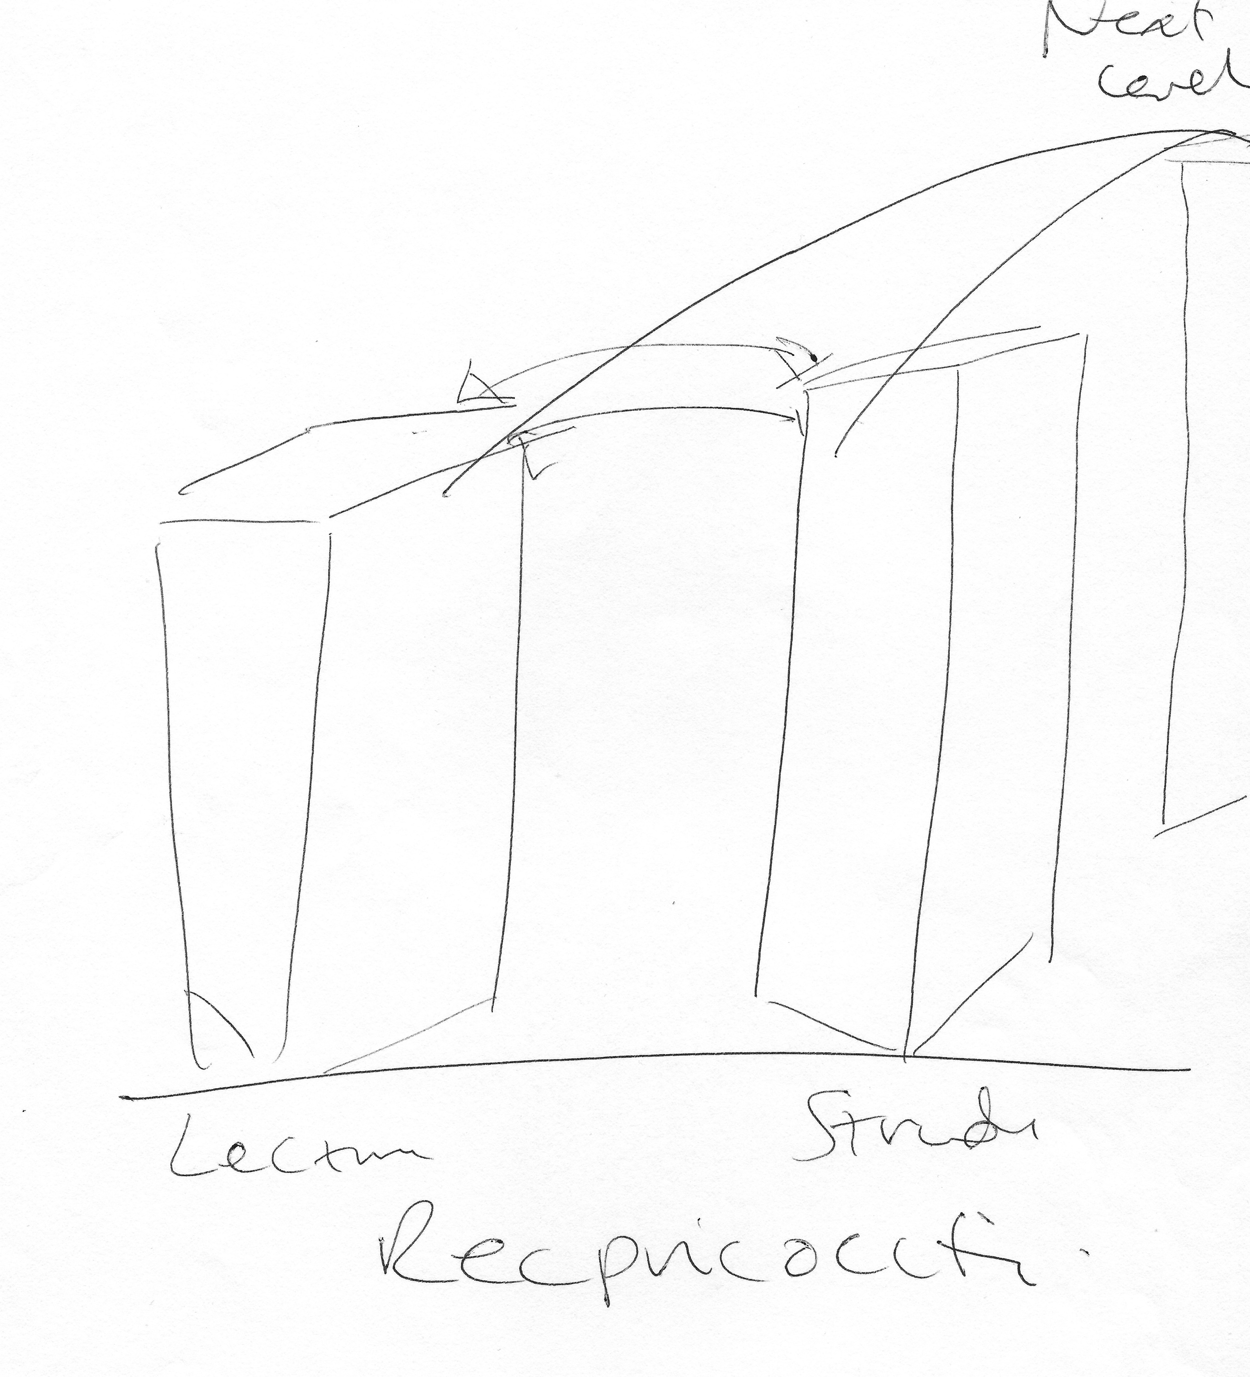

P: [starts drawing] Okay, now I’m going to talk you through this. I don’t know why I’ve kind of come up with this, but [pause] it looks a bit like the twin towers which isn’t that great an analogy…

I: [laughing]

P: [continues drawing] … but if that’s the lecturer and that’s the student, we start from the same level, and what we’re both looking for, is a kind of two-way conversation, that helps me and them get to the next level. So, I think, you know, for me, it’s all about, how do you move forward? How do you move to improvement? How do you move upwards? How do you move to where you want to be? Or how do you progress? And about that, relationship being about an equal, reciprocal – something that’s reciprocal, so it’s equal and the conversation is two-way. That’s pretty much as I can do [laughing].

I: Yup. Okay, now can you draw –

P: I’ll write reciprocal down.

I: Okay. And can you draw your conception of the opposite of that relationship? So, a bad relationship?

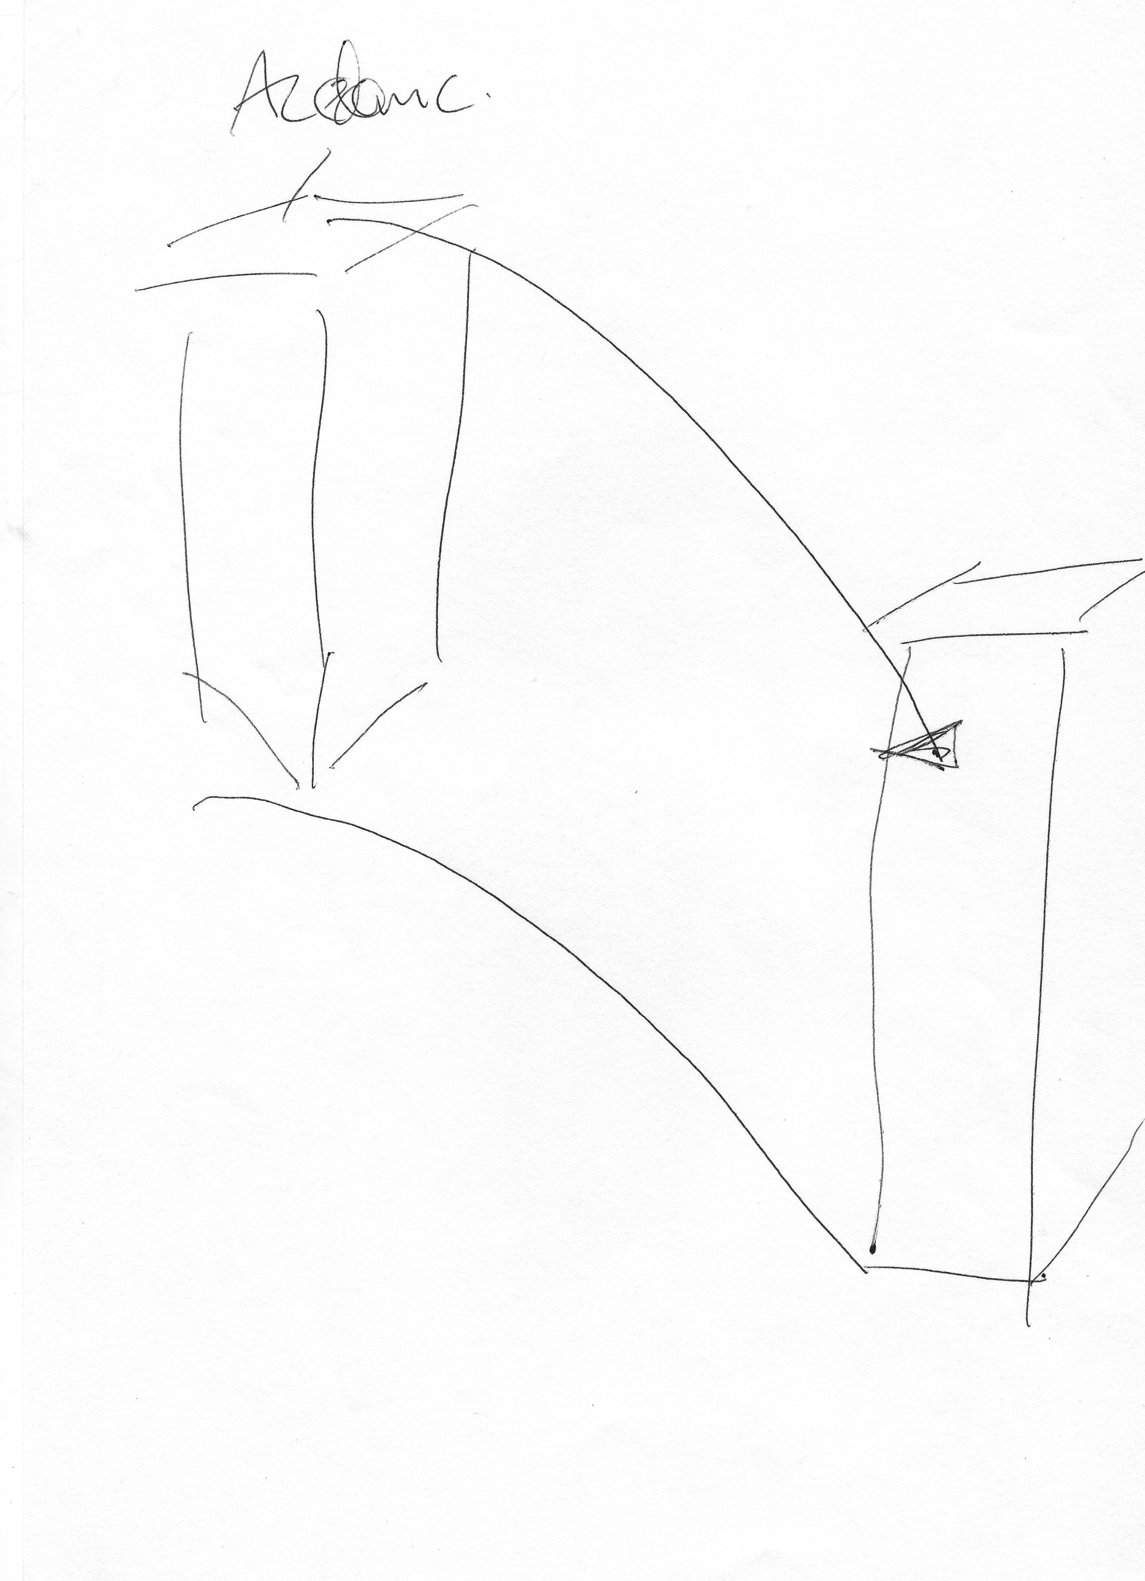

P: Mmm, yeah so [starts drawing] if – if the tower block, the academic is here and they see the student [finishes drawing and hands to interviewer] that would be the opposite.

I: Okay, so they see the student as lower than them?

P: Yeah.

I: Right, okay. Thank you. There’s a lot of encouragement for students to engage with different experiences the university offers, such as societies, getting involved with the Student’s Union, etc., what are your thoughts on that?

P: I think the Student Union has a really, really important place to play in students being part of the broader community of – yeah but I think it’s really interesting, when you are a student and I – and when I was a student it was just about cheap booze and somewhere to go pool really, and I never joined any societies because I thought they were for geeks and [pause] but I do recognise how I think Student Unions have got more of a role in supporting the students and, in fact, I’ve done a lot of work with our Student Union in other developmental roles to look at different ways of inducting, for example, sabbatical officers into post that get them to think about what they’re doing for a year and how they’re there to represent the student body, but actually, they’re also there to represent the institution in some way and I think there’s a kind of complexity about the relationship that the Union has with the institution that, you know, needs a lot of support and thinking through and fostering because, actually, they have got a really important part to play. So, for example, if you think about how sports – groups of sports players might have a kind of sense of ‘lad’ culture or something like that, you know, the Student Union can do a lot of work to break down and kind of, you know, get under the skin of some of that negative behaviour that students display towards one another, as well as supporting the students.

I: Okay. What are your thoughts on the university’s attempts to engage its current and prospective students?

P: Well, I think it’s really interesting, we put a lot of effort into our website and our prospectus and I think that, you know, as an institution, there’s a lot of tension now around what you say a course is going to offer because of CMA, and that changes the way that you might engage with marketing and I think our marketing activity is very owned by marketing – the central team because they kind of streamline the look of pages and they streamline content, and they check it to make sure that, you know, it’s not making any kind of false promises. [pause] And I think that that’s changed something about the way that we interact and market our programmes. I – so another interesting and moot point that I think’s coming forward now is the way programme teams are also getting more involved in what I would call outreach activity, so we might recruit students by going into schools and/or other types of institutions and that’s really interesting because if you’re in that role, and I’ve done outreach work before, is that you, you know, you’re the face of the institution in another kind of context and you have to do everything, you have to inspire, you have to encourage the student to think that that programme is right for them, you have to do a number of different things. I don’t think all academics ever thought that they would be in a role where they would be involved in recruitment and marketing.

I: Yeah. Okay. Do you think the university’s attempts to engage undergraduate students differ from the departmental attempts?

P: Yeah they do because what the departments and schools might try to do is personalise, so we have a school, for example, who has a policy whereby [removed for confidentiality] it’s about trying to build up that relationship with the student right from the start and to make them feel that they – that the institution isn’t a machine, if you see what I mean. And I think that that works very well for some programmes in encouraging the students to make their – make offers, actually they decide on this institution because of that. Not everybody does that. More and more programme teams are though, that’s just one example.

I: So, the university’s obviously quite successful in engaging its undergraduate students, but there’s probably more that could be done. So, I wonder whether you have any comments around how the university could broaden its engagement across the student body?

P: Well I think that [pause] we haven’t done it at this institution yet, but so, let me just try and think of the way to phrase this so, if we think about the way that we are using technology to enhance learning, we’ve just developed our ETAL strategy, which is very much about promoting the use of technology to enhance learning in ways which are to do with offering blended activities to offer students the capacity to be part of discussion, online discussion forums, but that’s within the context of the curriculum. But I also know that other institutions that I have worked for, they do other things, which is, for example, to develop a course blog and the blog is, you know, kind of something that all the students have to take part in because they all have to have a blog and part of their assessed activity is to blog and the tutor blogs back, and so there’s this kind of online community of engagement as well as when you put your foot through the door of the institution so I kind of feel that, you know, I think universities have to start to walk through that door of thinking about how they can use technology to enhance student engagement, you know, I think that’s one way. I think another way is to, at an institution level, for institutions to kind of say, “Well, if it is our strategy to engage students, then how are we – how are we giving students something back for that engagement?” So, you know, for some of our partners in learning projects where the students deliver elements of the curriculum or their involved in designing something, we pay them to do that. That, I suppose, isn’t sustainable, because, you know, we have a 3-year project that’s run, in actual fact, I suppose, you can’t pay students all the time to engage, but how else can you give them a sense of the fact that they’ve done something which shows them to be – what am I trying to say? On their higher education achievement report, a student gets a line to say you’ve done a degree. At this institution, we offer them a chance to get an additional line on their higher education achievement report which is, you have done a [removed for confidentiality], which means that you’ve volunteered, you’ve engaged in reflective activity with our student development team, you’ve done a range of other developmental activities. We’re changing that now to include other projects like the one that I told you about in this faculty, [removed for confidentiality] so that students who sign up to be engaged in that way will get another line on their higher education achievement report to say, actually, you did this, which is a significant thing that supports other students and the university. And I think that that’s, you know, part of the thing, is that we’ve got to think about ways to, you know, if we can’t pay students, we’ve got to give them something back.

I: Yeah, okay, well thank you very much –

P: Is that it?

I: Yeah –

P: Bloody hell – [laughing]

I: That is it. [laughing] Thank you very much.

[End of Recording]

