Interview #4 Transcript: Principal Lecturer (12.10.17) (University B)

Interviewer (I): Okay, so as a principal lecturer, what would you consider to be your main responsibilities?

Participant (P): [laughing] There’s lots of them. My main ones are to be knowledgeable about my subject and teach it well and to research in the same area and to have a, kind of, symbiotic relationship between teaching and research.

I: Okay. How many undergraduate students do you teach in a term, roughly?

P: Well it’s been changing because we semesterised so… And it’s also got less because of a range of factors. So, at the moment, undergraduates did you say?...

I: Yeah.

P: …It is about 40. But it’s been double that, you know.

I: Okay, so is that a manageable number in your opinion?

P: Yeah.

I: What meaning does the word engagement have for you?

P: In this context?

I: Yeah.

P: Okay, lots of possibilities. Do you mean student engagement?

I: Yeah, so what – how would you conceptualise student engagement?

P: So traditionally there’s a big problem with poor attendance. Maybe about a third of people don’t come regularly, traditionally. That has been improving and I think the sort of impetus around retention, which is driven by financial anxiety I think, but nevertheless, is a good thing because it means we are coming up with better ways to keep students engaged when there are forces acting against them, like money or accommodation or anxiety, that kind of thing.

I: Okay, so using what you’ve said, how do you attempt to personally engage your undergraduate students in your teaching?

P: Firstly, just by being as good as I can be, so try to be interesting and to be up to date and to have a mixture of lectures and workshops and seminars, which appeal to different students, you know, some people don’t like being asked to discuss and other people can’t wait and, you know, I try to give everybody a bit of everything. And also, being freely available, which is something that – I mean, we’ve had email for about 20 years now so, that makes me very available to all but the most reticent students, of whom there are a few, and we’ve always had a culture in the department of, you know, kind of, open door attitude; people can come and see me whenever they want and I try to be as empathic as possible when – because it’s quite difficult to remember what it’s like to be 19 and away from home and all of that so, try to remember that and respond in a way that makes sense to the students.

I: Okay. What are your thoughts on the concept of student as consumer in higher education?

P: You’re probably not surprised to learn that I really hate it. I get it, they pay fees and this is what they get in return for their fees but, it’s not a good analogy because there’s lots of things in life where you give money up in return for something but you’re not always thought of as a customer, like taxes, and although it’s couched in the terms of a fee that is then repaid, it isn’t actually, because you’re not chased by bailiffs or whatever. It is, in effect, graduate tax, which you only pay when you can afford to pay it and all the rest of it and, you know, we can quibble about the terms and obviously it would be nicer if it was free, but even under the current system, it’s not like buying a television or a car and so the idea that students are customers can prompt us to be better because we – there’s a feeling that one has to give value for money and also one doesn’t want to have complaints that, “I paid £9,000 and I’m not getting what I thought I was going to get”. On the other hand, it’s unhelpful because it creates a, kind of, service model where students are – have misunderstood the nature of learning sometimes.

I: In your opinion, how apparent is the concept of student as consumer in the university’s attempts to engage its undergraduate students?

P: It’s probably split where most lecturers – you said, “How far…” Sorry say that again?

I: How prevalent is the concept in the university’s attempts to engage –

P: Yup, yup. This idea of students as consumers. So yeah, it’s probably split where lecturers don’t like to think of it that way and managers do like to think of it that way and so that leads to, sort of, tetchy meetings and so on, but I think I wouldn’t want to be too impatient with that because if I was a manager, I’d be thinking that way too, probably, because of the imperatives, you know, about recruitment, that surround recruitment and I just did an Open Day and, you know, we’re like, you know, you’re like the showman selling medicine in the Wild West sort of thing, you know, you’re just, you’re teeth and smiles sort of thing, really trying to get people to love the place so they’ll come and I believe in the product in inverted commas, but it’s a – yeah, it’s a shame that we have to sell it and, of course, once upon a time that wasn’t the thing. I mean when I first started here, there was no – we didn’t do any recruitment. They just came, in a different world, but you know, we’re not in that world now.

I: Okay. In your opinion, are there elements of the student consumer concept apparent in your interactions with undergraduates? So, do you ever get a sense of them feeling as though they’re customers when you interact with them?

P: Not as much as you might fear, I think. But that might be to do with how I teach and how I talk to them, I don’t know. But certainly, I was a programme director for undergraduates for 4 years, and then before that, at MA level for 8 years and when I was programme director, you see it a lot more because you’re the person they come to when they’re angry or disappointed or have difficulties and there – I mean I can’t actually recall anyone saying, “I’ve paid £9,000 for this” but I think there was sometimes a sense that people were grieved that they weren’t getting what – the product that they thought they’d bought.

I: Okay. In your opinion, do you think the introduction of fees has given them a greater sense of entitlement to higher grades?

P: [pause] No. I don’t think so. I think you – I think students will be more disappointed if they don’t succeed because they’ve wasted a lot of money, which they will have to repay at some – you know, in some degree at some point in their lives, whether or not they get a degree, so… But on the other hand, it might give students, you know, a sense of mission which might help them! I remember before fees came in, years ago, teaching a class and it was – I remember it very distinctly, it was the novel, [removed for confidentiality], which is a great novel, you know, it’s kind of, really good and loads of people hadn’t read it and I was trying to work out why they hadn’t read it and part of the mix in my mind was I think that no one had paid, and so it was free so, you know, you could do it or not do it, and there was no sort of sense that you were losing out if you didn’t do it. Whereas now, I think, it might be one element that is driving – I’ve certainly found this year, everybody seems to be very engaged and that might be one of the factors.

I: Okay. Okay, so moving on to learning. In your opinion, are lectures useful for engaging undergraduate students?

P: Are lectures? As in formal lectures? Are they good for engaging undergraduate students…? We don’t do many lectures and where we do, they sort of slide in and out of being lectures, because we don’t – we no longer do these big, 150 people in a room things, I mean it will be 40 people at most probably. And so, if people look a bit glassy-eyed, I’ll just come out of lecture mode and ask them a question and tell them to talk to their neighbours for 5 minutes and then have them do – be more discursive, so I, kind of, try to be quick on my feet. So, I guess that means the answer is, at least that it’s problematic because it’s so passive. However, some students, particularly foreign students, I’ve got students from France who have told me this term already that they are not used to being asked to contribute and that their model of teaching is entirely passive and they sit there and they get lectured at and they write it down and then they go away and do work afterwards. So that – sorry that was a long sentence, but some students want to be lectured at because they feel – it makes them feel safe because they’re being told what it is they need to know and then, they like to go away and think about it and do some work rather than being put on the spot. Particularly if you’re shy, you don’t want to be in a, whichever – people have a perfect right to be shy and, you know, they shouldn’t have to be put on the spot in front of 20 people they don’t know very well, if they don’t want to be, I mean you could argue about that, that’s transferable skills and all that, but – so anyway, I think there’s a place for it, but you have to use it in a mix.

I: Yeah, okay. So, in the same vein, are seminars useful for engaging undergraduates?

P: Again, there’s pluses and minuses. Yes, it’s discursive, it’s good for their debating skills, it puts them on the spot, it makes them think. The way I do it, I do try to ensure that everybody takes part, just by – you know, some people will try, will sort of dominate, so I have to try and keep those people – I sort of say, “Okay, wait a minute. Wait a minute” and then with the brilliant strategy of just calling out people’s names, you know, which turns out, someone who never says anything, if you just say, “[name removed] what do you think?” turns out she’s got plenty to say, she just didn’t want to put herself forward, so that’s normally what happens. So that’s good, but also, of course, it can, you know, if a student comes up with something that’s completely off pieced and a bit bonkers, on the one hand, you don’t want to embarrass them and you have to be polite and sort of bring whatever they’ve said into the discussion in some way, but on the other hand, you don’t want to send everyone else away with some crazy idea that, in fact, isn’t rooted in anything correct, so – but that’s just, kind of, fun. I treat that as a, kind of, game, to try and handle those situations. So yeah, again, pluses and minuses.

I: Okay. So, what about one-to-one sessions then, are they useful for engaging undergraduates?

P: Oh, they’re fantastic, but it’s just, you know, you need a lot of resource to do lots of one-to-one sessions because it takes longer. But they are. I mean the people I see most, one-to-one, at undergraduate level are year three dissertation students and when you get a student who’s fully engaged with that, that goes very well and I think it can be the part of their studies that they find the most exciting and interesting and so on. But it also puts a lot of pressure on the individual student and you – every year if I’ve got four people doing a dissertation, one or two of them at least will, sort of, hardly ever show up and, you know, I can understand that they don’t relish the prospect of, kind of, being shut in a room with just this tutor who puts them on the spot and there’s no escape. So…

I: [laughing] Okay. So, in your opinion, which of those three teaching methods do you think undergraduates find the most engaging?

P: Can I say there is a fourth?

I: Yeah.

P: Have you got others? Or is that it?

I: No, they’re the only –

P: I mean I do another thing which is called workshop, which is, kind of, halfway – I mean it’s, kind of, a seminar but I give students, in an hour, a very specific task to do. So I’ll give them a handout with a critical essay extract on this handout, relating to a text we’ve been studying and ask them to do something very specific like, summarise each paragraph in as few words as possible, identify the examples which illustrate the points, so it’s a way of developing their knowledge of the text, but also developing their knowledge of the art of writing a good essay, because I try and find extracts that aren’t just great, sometimes it’ll be extracts that are nonsense and, you know, I try and encourage them not to accept everything they read, just because it’s in an academic journal, it might still be rubbish and, you know, so we do that. So, it’s not really a seminar, it’s not really a lecture, so I do that too.

I: Okay, so which of those four teaching methods then, do you think undergraduates find the most engaging?

P: It really depends on the undergraduate. As I say, some people like to be lectured and don’t like being put on the spot, some people can’t wait to get talking, some people like to do a task which is very, sort of, contained and, you know, the outcomes are very clear. Traditionally, the subject has been taught by chatting and when I was an undergraduate, it was really aimless chatting and I often came away thinking, “Well, you know, what was that?” you know, and so I think my teaching developed in reaction to that experience. But, you know, the way I classically now teach an undergraduate module is with – each week there’ll be an hour that’s a lecture, an hour that’s a workshop and an hour done twice because there’s two groups, that’s a seminar.

I: Yeah. Okay. Is there anything you think is particularly good about the style of learning that takes place at university compared to compulsory education?

P: Yes. The analogy I always use at Open Days is that when you’re at school, there’s this, kind of, confined – no, hang on that’s not the word – discreet body of knowledge that’s, kind of, in a box and the teacher opens the box and invites you to have a look in the box, and at university, there’s no box. I mean there is, particularly with first years in that you’re just trying to get them off the ground, sort of thing, with basic knowledge but, it – you know, I think most of the people, or all of the people, in our team are teaching in areas that they research in and so, if I have just written an article about something and start teaching in the light of that article, then I’m going to be teaching stuff that isn’t in the box, to return to the metaphor you know, we can – and students sometimes say things that I haven’t thought of and it’s more democratic and more open to insight and also, our criteria when we assess are looser I think than A-Level criteria and GCSE criteria. So, it – those school level criteria, you know, you’ve either done it or you haven’t done it and so you either get an A or you don’t get an A and I mean, I don’t know, you’re probably going to ask me about assessment later, are you? But I think we strike a balance between doing that, and having a general sense of a student’s capacity to think critically and creatively.

I: Yeah, okay. Okay, from your own experience of teaching, is there anything you would change to improve student learning, in terms of, either your own teaching, the resources you and undergraduates have access to, curriculum and assessment, or anything else?

P: Hang on, let’s do that bit by bit. There’s some really practical things like we’ve had a real problem with rooms over the years and that’s catastrophic, I mean really, really bad. I mean it’s difficult to express how naff it is to be trying to create – you know, you’re doing all your hard work to create a, sort of, a group feeling and a body of learning taking place in this thing, and you’re in a different room every week. One week it’s in a port-a-cabin and one week it’s up at the library and I got to the point where I was – I would print out little credit card sized piece of paper and give one to each student with all the rooms, because it was so complicated and, I would email people every week saying, “This week it’s here” to try and overcome it. That seems to have been more or less fixed or maybe I’m just lucky this year that my stuff is all in good rooms and it doesn’t keep changing. So that was a massive problem, sorry what was the list again?

I: Your own teaching, resources you and undergraduates have access to –

P: Alright, stop, stop, stop because I – yeah, so that was resources. Other resources – library’s fine, it was a little college library and it’s taking time to grow but, you know, we get a small sum of money every year to add to the stock of books and we do that, it would be nice if it was more, but it’s alright, you know, and so that’s that. Great online resources and, you know, Blackboard and all the online databases that we can use are a massive help. We used to do a lot of photocopying and having folders stuck on your office door for people to come and collect things and so on, and so all of that’s gone now, so that’s really good and Turnitin I guess is a resource in terms of teaching, which is also, I think, on the whole, apart from not wanting to spend my whole life looking at a screen, is good and having got rid of all the, you know, piles and piles of paper essays everywhere and all that, is great and I think it means we turn around – the marking happens more quickly as well, because there’s less passing of envelopes, no passing of envelopes, and all that stuff. So that’s all good. So that was, kind of, resources. What was the next one?

I: Curriculum and assessment.

P: Oh yeah, so we’re always changing the curriculum. It’d be nice to settle down for a bit but, you know, we do minor modifications and so on, so the curriculum’s good and you know, for example, when a new colleague joins the team, they’ll come from some other university where they can’t understand why we’re doing it – this happened with [name removed] who you spoke to who, you know, came with [pronoun removed] ideas about what a first-year curriculum should look like and, we’d been doing it the way we’d been doing it for about 10 years previous and I think that’s when I was programme director and I thought, “Great, you know, over to you. You know, change it. I mean, you know, I don’t really actually mind how you change it, just change it, you know” and [pronoun removed] had it, obviously I trusted [pronoun removed] not to come up with something rubbish, and now it’s organised on completely different lines to the way it was before and it works really well and – if only that it’s fresh and you know, we had to sort of re-imagine, re-do things, throw away our yellowing notes and all that, you know, it was good. So that’s curriculum, what was the other one?

I: Assessment.

P: Oh yeah, assessment. I think we’re really good at assessment. We’ve got a tradition of doing quite fulsome feedback, written feedback. We don’t have a form where we tick boxes or put scores for, you know, quality of English or whatever, we don’t do that. There’s – I think there’s no appetite to do that in our subject, I know they do it, I think, in [removed for confidentiality] and other disciplines. But I think it’s a tradition in our discipline just to, with the criteria in mind, to write a fulsome response, I mean it might be, I don’t know, 200 words or something like that, in the feedback box on Turnitin and a mark and that’s it and there’s no other things, like charts or whatever, and that’s how we do it and our external examiners always pick it out as something that we do well and, so long as we turn it around in the required time which we almost always do unless someone has some particular problem so that students get it before they’ve forgotten what it was they’d written, then it works well yeah.

I: Yeah. Okay. Okay, so moving on to policy then. I sent you the document that refers to the university’s teaching and learning strategy, let me just grab it here, refresh your memory. There it is.

P: Okay yeah.

I: So, how does this strategy impact, if at all, on your interactions with students?

P: Well, I don’t sort of read it at the start of the year and think, “I must do all of these things” and it’s easy to be dismissive about this kind of document, and that’s probably my first instinct, is to say “Ah, you know, some people have sat in a room and come up with this. It doesn’t have any relationship to what I actually do” but I thought about it, and that’s not actually true. I do still feel a bit of ire about the amount of time and effort that was – and the amount of hours, if you added up everyone involved, that was spent producing a document that is full of, mainly platitudinous statements that no one could disagree with, you know. But I think it does filter down, I think that this document is produced and then Deans have ways – or they should do, and I think ours did, of ways of, sort of, sending that down the waterfall or whatever, cascading it down and things happen at my level, which I may not realise are part of the learning and teaching strategy, but they are. So, the impetus to, for example, the getting work back to students in a good period of time, we sort of, were a bit annoyed about it because it made some – particularly if you’ve got lots of students on a module, it’s quite hard to do – but it’s clearly, if you can do it, it’s clearly a good thing. But also, the knock on of that was that it became unacceptable for staff to be given a pile of marking that couldn’t be turned around in that time, which was not previously the case so, in fact, it rolled on and had a series of impacts so that’s just one example where it’s probably this that sends a chain of events – sets it off. Does that make sense? I really hate the vision statement, which I read, because it doesn’t make sense. It’s grammatically incoherent – I don’t know if you’ve read it – it’s a very long sentence that’s extremely difficult to understand. I mean you get the gist, you know, but yeah, I’m not sure what a vision statement is for, it’s like a mission statement isn’t it? But at the very least, they could just split it up into two sentences so that it makes sense. I also felt – there’s [removed for confidentiality] sections, they seem to, kind of, overlap quite a lot, you know, and I wondered if it had to have quite so many bullet points and overlapping of things, you know. I mean if I look at the [removed for confidentiality] seems quite a lot to me, if you’re trying to be succinct, you know[removed for confidentiality] would be good or something like that, but what’s the – yeah [removed for confidentiality] they’re all, sort of, bound up with each other, but okay, I guess you’ve got to try and set it down somehow [muttering]. Oh one – there’s a few little things that, sort of, made me bridle a bit which is, for example, the stuff about technology, where – I mean there was something about “where appropriate” or whatever, but there is a pressure to deploy technology because we’ve bought it and I’m a big fan of Blackboard and I think it’s great, but there’s other stuff where I really can’t be bothered and it doesn’t – I can’t, you know, I’m not a luddite so, for example, I think the university would like us to tweet and I do have a Twitter account and I gave it a go to just find out what it was and how it worked and so on and it’s the emperor’s new clothes, it’s nothing. And there are people who spend hours and hours of the week tweeting and doing tweeting and they get – they sit in meetings, I’ve seen this, they’re in a meeting with a laptop, you know, pretending to look at the papers and they’ve got Tweetdeck open on their laptop and they’re managing several Twitter accounts on this thing called Tweetdeck, and it’s got no discernible outcomes as far as I can see, it’s fun but – well I don’t think it’s fun but anyway. And I might be wrong about that, still every time – I’ve got a colleague who does lots of tweeting and every time I see her I say, “You know, what’s going on in the Twittersphere? What’s it all about? Talk me into it, you know, I’d love to do it if I could see a point!” So that’s, anyway, just one example of how getting carried away with technology and feeling that it can, sort of, be the answer to questions that haven’t been asked… yeah. I’m a big fan of this internationalisation thing but, the international office has got a very poor reputation amongst academics I think and I’ve got various students on my course this year, from France and America and Holland, and they just appeared. I didn’t know they were coming, I didn’t have a list, I haven’t been told how I’m meant to assess them, no one’s got in touch with me. That’s really, really poor and they come to me and say, “What am I meant to do?” and I say, “Well, in previous years, it’s been, you know, this, so it will probably be that but I haven’t heard what I’m meant to do with you yet” so that could be better. But there are various initiatives afoot because of the research that shows that if our students go abroad at any point, for any amount of time, it’s kind of transformative and – so we’ve got this [removed for confidentiality]. Is that enough?

I: Yeah! That’s great.

P: Good.

I: So, looking at the other document I sent you, which is the –

P: Contract!

I: …Student Charter [name changed]

P: Sorry, Student Charter [name changed], yeah.

I: …Yeah, so how would you say you implement the aims of this approach, if at all, in your interactions with students?

P: The aims of this approach? Wait, do you mean how do I implement these things?

I: Yeah, if you do at all.

P: I don’t. I mean, it’s in – except implicitly – it’s in our programme handbook as the first page after the cover, I think. So, students should be aware of it and presumably their attention’s drawn to it outside of the programme as well, I assume, by the Student’s Union perhaps. I agree with everything on it, I think. It’s probably a good idea to have it boldly stated like this so that students get this sense of a, kind of, a two-way relationship which is good. I’m not crazy about the language, [removed for confidentiality] does sound a bit business-y, like customers and all that, but you know, that’s just a quibble. And if I look at the bit that I’m responsible for, it says that the university [removed for confidentiality], well, so I’m responsible for one part of that as the tutor, and opportunities in relation to learning, well that’s me, and the wider experience of the university, that’s not me I guess, is how I see that. So again, it just brings me back to my core job of knowing what I’m doing, subject-wise, and teaching it properly and I mean I guess, last year I did the – I got [removed for confidentiality], which is the equivalent of a, kind of, teacher training type thing, but done through different means and again, there were things about that that were irritating because of the kinds of language you get encouraged to – that you’re encouraged to use, but it was a good thing. Made me think, after 20 odd years of teaching, to sort of take stock and ask myself what it was that I did and how I did it and why I did it that way and I read some books on teaching theory and I can’t say I had any great revelations but, you know, I thought, “Oh yeah, yeah I do that, but I could do it slightly differently” that kind of thing. So, all of that, and the university basically forcing us to get that [removed for confidentiality], or strongly encouraging us through appraisals, meant that I engaged with this, you know, that was the university’s mechanism I guess, to get me to do this and it worked. And what’s the other bit, support, advice, guidance, yeah within our programme, we’re big on support and guidance yeah, I think, and all the stuff about what we value, I like to think comes out in my seminars, my modules. Is that enough?

I: Yeah. Do you think that partnership agreement is a successful one for engaging undergraduate students?

P: I suspect they don’t read it, but something I could do, and never have done, is draw their attention to it in seminars but then again, I’m busy teaching, you know, [removed for confidentiality] or whatever. It’s like when I’m encouraged to talk about employability in seminars, which we’re probably going to come on to but, I sort of feel like I’m, kind of, busy doing this other stuff that’s my subject and, you know, similarly evaluation, if I give up 20 minutes to an evaluation exercise, well that’s 20 minutes when I could have been teaching something so, there’s always a, sort of, play-off or whatever. But I’m assuming that outside of the programme, their attention is drawn to it and that they glance at it and even if they haven’t read it carefully, they’re aware of its existence and that probably helps.

I: Okay. In your opinion, should undergraduates have greater control over, or input in, the curriculum and/or assessment design of their chosen courses?

P: Sorry I zoned out, say that again.

I: [laughing] Should undergraduate students have greater control over, or input in, the curriculum and/or assessment design of their chosen courses?

P: No. I mean they have some. Not greater. But yeah, I approve of their involvement, of course, but it seems about right to me.

I: So, at the moment, is it module feedback?

P: So yeah, module feedback, we’ve got student reps who feed back to us, they’re as probably as important as anecdotal staff, now when we do Open Days for example, we have students with us on those Open Days as, kind of, ambassadors of the programme and we – that’s probably where I get to chat to students the most, where we’re sat there all day and in between talking to prospective students, we talk. So, that kind of thing, and of course, the [removed for confidentiality], sorry what’s it called? It’s called something better than that. I think it’s just called the [removed for confidentiality], put the students first. And then when we do re-validate, they’re also – there’s a formal role for some students in that, where they take part so that all seems about right to me, yeah.

I: Okay. So, what are your thoughts on the idea of students as partners in the learning experience? Have you heard this concept that’s rolling out at the moment?

P: Is that this? [gestures towards the policy document] Student Charter [name changed]?

I: No, so, students as partners is basically where – it’s a concept in which students are seen as having just as much to give from their perspective as a student as an academic would have in creating the learning – modules and, you know.

P: Okay. I guess I’m aware of the idea, I wasn’t aware of the language. And I guess in some – I guess in a respect it’s true, but obviously not in terms of the subject, where you know, I’ve been studying the subject for, like, 30 years so I know a lot more. So, in terms of fundamentally designing curriculum and deciding what should be in the degree, that’s the lecturer’s job. But, if we’re talking about ways of learning and also, kind of, generational cultural differences, you know, which, you know, I’m getting middle-aged now and I’m probably out of touch, you don’t think you’re going to get out of touch, but you do get out of touch and you know, it’s a different world for those kids now. So that’s probably essential, yeah, that is essential to have them contribute in that way. Is that what it means?

I: Yeah. Yeah. Okay, so in recent government policy on higher education, students have been placed at the heart of the system. In your opinion, to what extent are undergraduates positioned centrally within this university?

P: That really annoyed me, when they said that, like we’d all been doing something else for the last 50 years or whatever. They were at the centre, they are at the centre, they’re at the centre! They are. I mean particularly here, I mean, maybe that statement was aimed at Russell Group universities, where there is a, you know, a sort of, anecdotal history of lecturers not being interested in undergraduates because they’re basically researching, and then they grudgingly show up and do some lectures. And that happened to me actually, I was a student at [removed for confidentiality] and my very first seminar, I think it was, that’s how I remember it anyway, was on Jane Austen’s Pride and Prejudice and the tutor had been, sort of, told he had to teach this module and he just grumbled, and said, you know, “I don’t know anything about Jane Austen, does anyone else – anyone else got anything to say?” and, that might be why I’m a lecturer [laughing] that sort of feeling that this isn’t right and I could do this much better. But – so that might be where that statement came from, but as far as this programme is concerned, you know, apart from one colleague, [name removed], I’m the one who’s been here the longest, yeah, it’s always been the case. They’re our bread and butter, you know, 90% of our income, if we want to be brutal about it, comes from undergraduate students as well and yeah, I can’t think of any sense in which they’re not in the centre of everything.

I: Okay. So, do you think positioning students centrally works to separate them at all from the academics, in that some people have said that the university gives too much attention to students and not enough to its academics?

P: Oh, I see. Oh yeah, okay. I mean I don’t think of it as an either/or proposition, but sometimes it comes out that way and I can think of one very good example, which was I went to a workshop about the turnaround time for essays, the what do you call it? [removed for confidentiality], so this was before it came in, it’s now 15 working days, I think it is, 3 weeks, and I, in this workshop, made the point in those days, sometimes it’s very hard to do it in 3 weeks because if you’ve got x number of 2,000 word essays and you’ve really only got 2 weeks because the second marker needs a week and, if the second marker’s in London and you have to post them and la da da and you just can’t do it! And somebody else, who I won’t name, but a senior, sort of, adminis – bureaucratic person, who’s been in the university for many decades, sort of said, “Well I think if you’re paying – as it probably was then – £3,000 a year, you know, the least you can expect is to get your essay back in 3 weeks!” And so, he wasn’t listening to me and it was entirely about satisfying a perceived student need and he wasn’t interested in hearing what problems that might create for me and, it was only a perceived student need because, you know, I’m not sure where 3 weeks came from, it seems like an arbitrary period of time to me, and I’ve always argued that what’s important is that students get the feedback back in time to learn from it before their next assignment, that’s the crucial thing. The sooner the better obviously but sometimes, what if it takes 4 weeks, I can’t see that that’s a catastrophe and yet, if we have a situation where it does take 4 weeks, you know, we have to fill in a form and explain what we did and why it wasn’t possible and all the rest of it, maybe that’s necessary in programmes that have got a poor history of returning stuff on time, but we haven’t. Anyway, sorry, that wasn’t the question but, yeah, so sometimes there’ve been instances in the past where it has sounded like academics are the, sort of, the donkeys that make the wheel of the mill go round and managers are just trying to, kind of, give us a little whip, whips rather than carrots – sticks rather than carrots, so that, you know, students are – students’ needs are met. But I have to say, that was some time ago now, few years ago now, that anecdote and, it doesn’t feel that way now. In the School of Humanities, which I can’t remember how long we’ve been in this arrangement, 3 years maybe? It’s a good balance I think, you know, there’s a recognition that we have to have study leave sometimes, and we have to write our books but, a recognition that that will make us better teachers and will make us more highly regarded in our fields and therefore more opportunities will come our way, in terms of conferences and publications, and that will increase the stock of the School and that will mean we’re more attractive to undergraduates. So, it’s all related and in the bad old days, research was something you did in your own time, you know, if you were really driven, and there was no time for it in the curriculum. When I first started here, I had 21 hours of teaching a week, so that was 7 different courses going simultaneously, and now I’ve got 2 simultaneous courses, amounting to [muttering] something like 6 hours a week. I’m 0.8 though so, it would probably be like 8 hours a week, or something like that now, so times have changed.

I: Okay. What meaning does the word relationship have for you in the context of interacting with undergraduates?

P: I don’t know. That’s really vague. We obviously have a relationship. Supportive? Is that the kind of thing you’re looking for?

I: Yeah, yeah!

P: So, there is a way of speaking about students that people, lecturers, sometimes fall into that’s pejorative, you know, “Can’t believe this student didn’t show up”, “Can’t believe they can’t write a grammatical sentence”, “Why haven’t they read the book?” or “They’ve read the book but they don’t seem to have understood it” you know, and then you can get into a, kind of, grumble zone about students and I have certainly been in that zone, in my time, but I’m never in it now because – maybe it’s to do with getting older – but you know, I just – it’s very easy to remember what it is to be 19 and to have all the difficulties of being 19 on top of having to do all this stuff and, sometimes I might get out an essay I wrote when I was 19 just to remind myself how little I knew and how little I’d read and so on so, [pause] that is something I say whenever the grumble stuff comes up and, yeah, so supportive is what we are.

I: Okay. What do you consider to be the main purpose for building a relationship with undergraduates?

P: The main purpose? [pause] So that they have a really good university experience! They learn stuff, those – I mean it seems to be that there’s an epidemic of anxiety among young people, for all kinds of reasons, it’s probably a combination of fees, Isis, you know, I mean I know someone who’s 13 who basically thinks about Isis every day, you know, because of the, you know, – it’s a terrible world we’re in sort of feeling, you know, anyway whatever. Lots of anxiety so yeah, the relationship is there to reassure, to encourage them to step out of their comfort zone, to learn, to grasp opportunities, to read critically.

I: Okay. Do you think there is a link between the relationships undergraduate students build with their tutors and their levels of engagement?

P: Do I think there’s a link? Yes, but it’s also self-fulfilling because the people who – I mean you can’t tell which way round it is. The people who engage the most might also be the ones who come and talk to their tutors the most and build the best relationships with them and the people who fall by the wayside through non-attendance and you can email them as much as you like, and they’ll say they’re coming and then they don’t come, it’ll be because they’re suffering from depression or anxiety, or something’s going on in their lives, or their partner’s just left them or, you know, or they hate the house they live in, or they’re homesick, you know, and it’s very difficult as an academic to, you know, apart from offering – telling them where to get help, to engage with all of that stuff, but – so as I say, it’s difficult to tell which way round it is, but definitely the ones who have the strongest relationship with lecturers are the ones who achieve the most.

I: Yeah okay. Can you describe to me a typical face-to-face encounter with a student? So, if they came to discuss an essay with you or something, how would that interaction play out? Typically.

P: I mean, they sit in the chair, we chat, I try to put them at their ease, we – I’m very careful not to, sort of, talk over their heads in any way, or use any language that they might not understand, or if I need to use language that they might not understand, I’ll make sure that I use some synonyms so that it’s clear what I’m talking about. Listen to them. Something I often ask is – students, for example, if they have to write a dissertation, they’ll come, [starts talking very quickly] “Well okay, it’s going to be, this is the structure, it’s going to be in three parts and part one is this, part one that, part one…” and I’ll say, “Well, slow down, you know, don’t impose a structure on it before you know what it is you want to argue” because there’s this anxiety, “I’ve got to get going here, I’ve got to design it” you know, and the question I’ll then ask is, “Why did you choose this? What’s enthusing you about this particular topic? You know, forget academia, just tell me about why you love this” and sometimes they can’t and then I say, “Well, you’ve chosen the wrong topic” you know, “What do you care about?” Sadly, the answer’s quite often, Harry Potter, which you know, it is a thing, people have written doctorates about Harry Potter but, you know, it’s not really my cup of tea. I don’t want to be snobbish or anything but it’s not proper literature. Anyway, but yeah, so I’ll try and work from where they are up as it were, although it’s patronising to say up, but I think I’ll stick with that, rather than, sort of, you know, talk as though I would talk to a colleague and leave them, kind of, leaping to try and catch hold of something. Yeah, that’s the ideal. It may not always go that well, you know, but that’s the ideal.

I: Okay. Do you ever notice any implications of a hierarchy in your interactions?

P: With students? Oh yeah. What, like I’m more important than them, kind of thing?

I: Yeah, sort of.

P: Yeah.

I: How is it apparent? In what ways?

P: Well, you know, students are – well actually, I was going to say students are deferent and they are in different ways. So, some would always call me, “Dr [name removed]” which is charming and I never called any of my tutors by their first names, it just wasn’t conceivable. Although that said, I don’t think I called them anything, I mean, we never really had that kind of interaction, but, anyway that’s nice – but even the ones who send me emails going, “Hiya” you know, which to me feels a bit inappropriate, I understand that it’s not how it feels to them and generally, they’re deferential. Some students are – there are some students who are more, sort of, demanding and if, for example, a student has failed a module and, they feel like they’re not being supported enough – this happened to me last year – you know, they can get a bit angry or whatever, but then we just talk and normally, it’s resolved and it’s fine, you know, they’re angry because they’re nervous not because they’ve got any, sort of, real causes, they’re just upset about having to, you know, about the embarrassment of failing and all that stuff.

I: Do you ever find that students aren’t initially comfortable talking to you about their ideas? Do you ever find you have to pull them –

P: Yeah, definitely yeah.

I: And do you think that’s linked to a hierarchy? Or…?

P: Well it makes sense that they are, sort of, taking their first steps – not first steps but anyway, in relation to me, earlier steps and if they have an idea, they might feel anxious about expressing it in case it’s stupid or wrong and, of course, I will, you know, encourage them to say it and then, if it turns out that I think it’s not a strong idea, that’s fine, you know, I’ve got ways of saying that without, sort of, crushing them, you know, “That’s interesting, but, have you thought about connecting if with this?” or “Why don’t you go away and read this and come back?” you know, try and do it constructively, yeah. But I think there’s a hierarchy and I think there has to be, you know, and it’s interesting, the students – I think students feel there should be because in the past, where I’ve – I think there was a point where I tried to sit in a circle in seminars and no one wants to sit next to me, you know, or if we’re sitting around a square of tables, the students will put themselves around the three sides that I’m not sat on so that I’m the teacher and I say, “You know, you can sit here” and people laugh but they don’t, because they don’t want to, because it undermines that hierarchy.

I: Yeah, okay. Can you think of any particularly good relationships, without giving away their identity, with any undergraduate students? Past or present, any ones that stick out in your mind as being particularly good, and why you’d say they were good?

P: Wow. Well if I try and think of a specific person, who’s an undergraduate, fairly recent, no that’s quite hard to do. If I sort of, if I really wanted to do that, I’d have to get my register out and look at names and try to remember – try and remember, you know, specific instances but [pause] but the strongest relationships do come with year 3 students doing their dissertations because you just talk to them one-to-one more than anyone else. And with years 1 and 2, it will probably only be when you have an essay tutorial week where people can come and talk to you one-to-one where you get to do that, where you get a stronger sense of who the person is and so on. Some students will – I normally make, you know, unless I have to rush off, I hang around at the end and if someone wants to talk to me, they do and so, someone did that this week and we chatted about [removed for confidentiality] in the corridor and that, you know, that – so now I know, I’ve got a clear sense of that student and that’s a second year student, so I’m aware that that person will – you know, is interested in this subject and they might want to do a dissertation in this area and I might be their supervisor and then that – and if that happens then there’s a sort of relationship there, and then sometimes people go on and do the MA and then you actually know them for 4 years of their lives and that’s – yeah those are the ones.

I: Okay. Okay so, now is the fun bit, everyone really loves doing.

P: How are we doing by the way? Are we on schedule or am I taking too long?

I: No, no, there’s only a few questions left.

P: So, you’re not worrying that we’re… I’m fine, timewise.

I: No, no. Okay, so this bit, can I ask you –

P: A blank sheet of paper [laughing].

I: It is [laughing]. Can I ask you to draw your conception of a good relationship with a student…?

P: [laughing] No…

I: …So you can draw whatever you want.

P: …What do you mean? What does that mean? Do you mean like a – no! Can you give me a clue about what…?

I: So, a lot of people draw stick people and they normally draw themselves and then the student in relation to them and whatever else they think goes into a good relationship with a student. I don’t want to lead you too much [laughing] because I want you to think about what makes a good relationship at university.

P: I mean I’m going to draw two stick people sitting in chairs next to each other.

I: Okay that’s fine.

P: Is that it?

I: As long as you can say why –

P: Wait I want to see if I can think metaphorically about this… [pause] because [laughing] then I thought, “Should I draw a shepherd and a sheep” you know, but is that too hierarchical, you know? And also, the shepherd doesn’t teach anything to the sheep, he herds the sheep, that’s not right, that’s not right at all. Well, I mean, you know, I’ll try and draw a picture of me sat on a chair, wait no, I’ll be leaning forwards probably. I’ll be holding a book, that’s always important, got my glasses on, and then, yeah, I’m not artistic. And then the student will be there and they will have, probably a notepad and a pen, that’s a pen, and I’ll probably do this, I’ll put this in the background, “Screen off”, something that bothers me about modern life is the ubiquity of screens, which draw the eye, but then I can go like that [moves mouse attached to computer] and it will, or that [presses the power button], I forget which one it is now, depends what I’ve done, it will come back on and then, if we need to look at the library catalogue or whatever, we do, but I save that for the end. I’m also going to say that this is the nicest office I’ve ever – this is about my sixth office I think and, fifth or whatever, and it’s the nicest one so I would say that that’s important, so I’m putting a window there to indicate that we’re in a nice, well lit room and – oh! See once you start you get thinking about it, I’m also going to put my bookcases here, these are my books, because I think it’s important that the student comes into a space that belongs to the lecturer – this is me defending the notion of lecturers’ offices instead of having some open plan thing which has been spoken about in the past, so that we can talk in the context of the books around me and I can reach for books and I can recommend books and if I’ve got something that I can’t quite remember I can find it in a book and so on. And clearly, people who like to use space efficiently would, so you know, apart from – this office is empty a lot of the time because I’m either teaching or I don’t have to be here and I may not be here, so it seems like a bit of a waste of space, but yeah, I would defend the environment of entering the lecturers’ offices as I think part of the learning process and it wouldn’t be the same if we were in hot desks. Is that enough? That’s my picture.

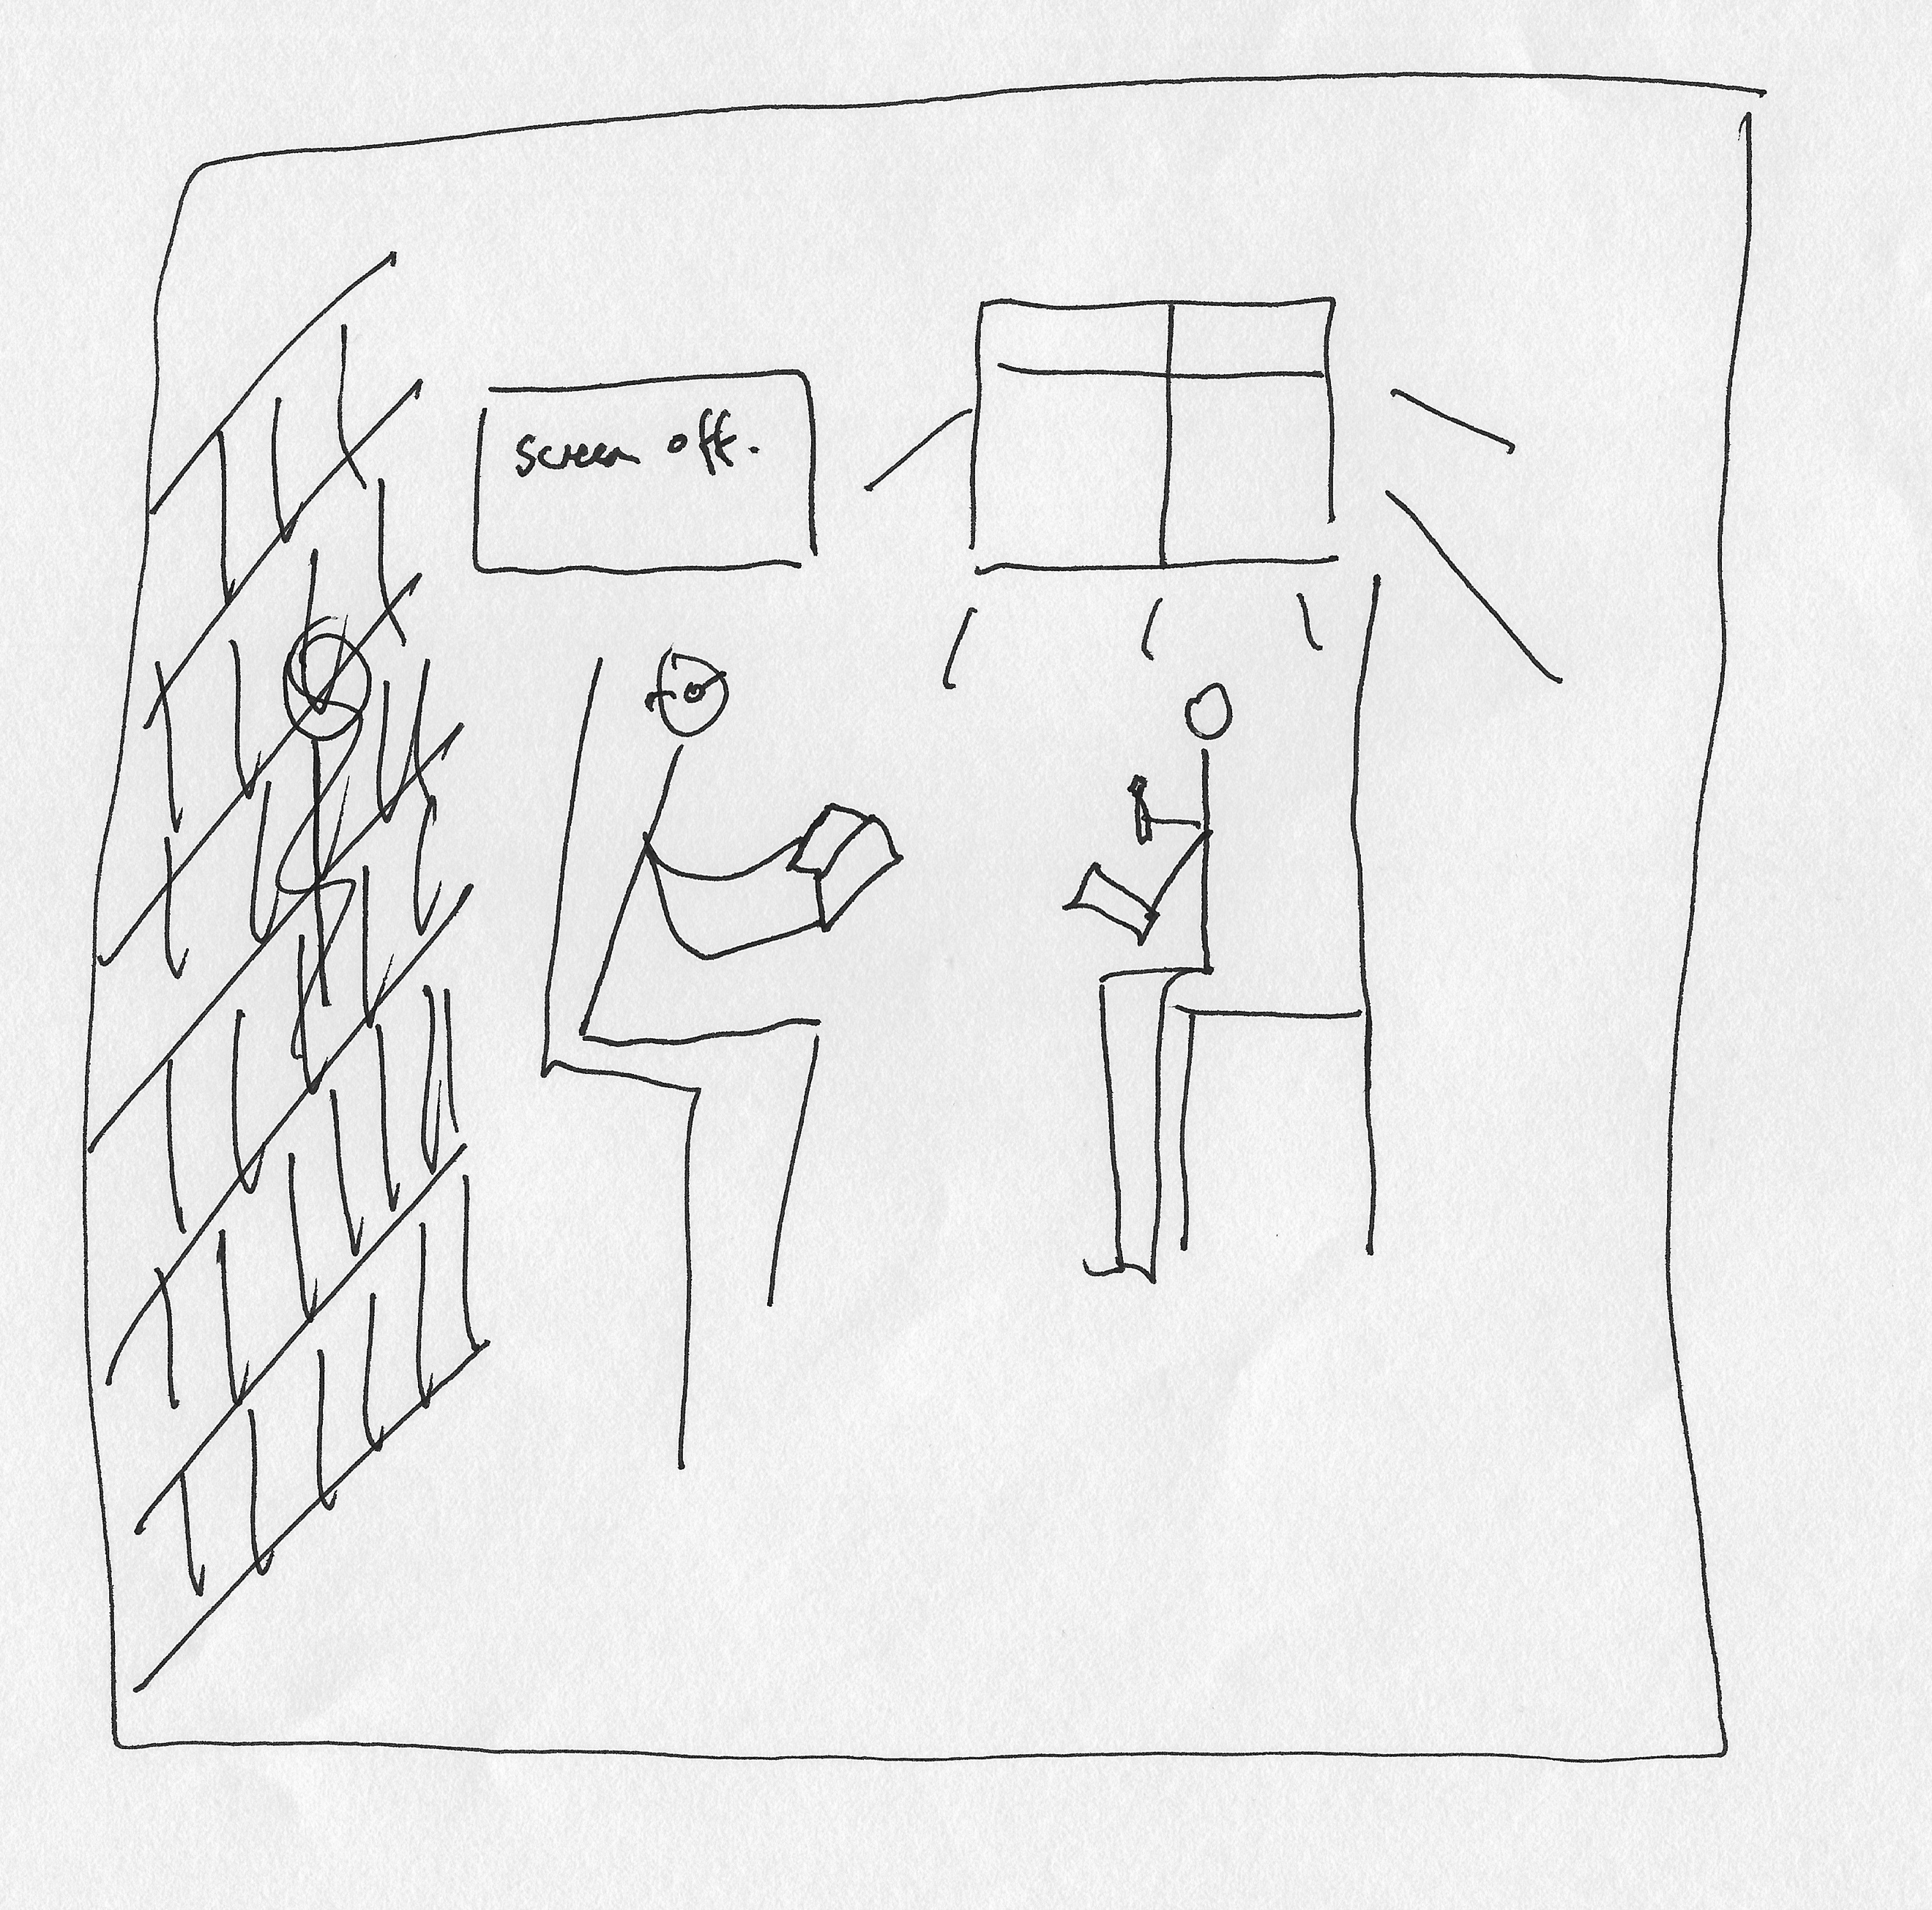

I: Yeah brilliant. That’s really good.

P: Couldn’t think of anything else – pictures. I’ve got pictures [gestures to pictures pinned to the board]. They’re educational aids, they show what my areas of research are.

I: Okay, so now, can you draw the opposite? [laughing]

P: Oh crikey! A bad one?

I: Yeah.

P: Alright, well that’s good. So, it’s a hot desk. I’ll just – I’ll do some cubicles, these are cubicles, and we are here, there’s me – oh and the other thing is, my very first office, you couldn’t sit and talk to a student without your knees touching, it was so small, which is, of course, totally inappropriate so we’re jammed together, there’s a screen that’s on, I’m writing “On” on the screen, oh and we are using e-readers instead of books, those are screens like that, and there’s other people who we can overhear in all these other cubicles, these are people and they’re all talking, “Talk” “Talk”, so we can’t really concentrate and it’s all just strip lighting with no windows.

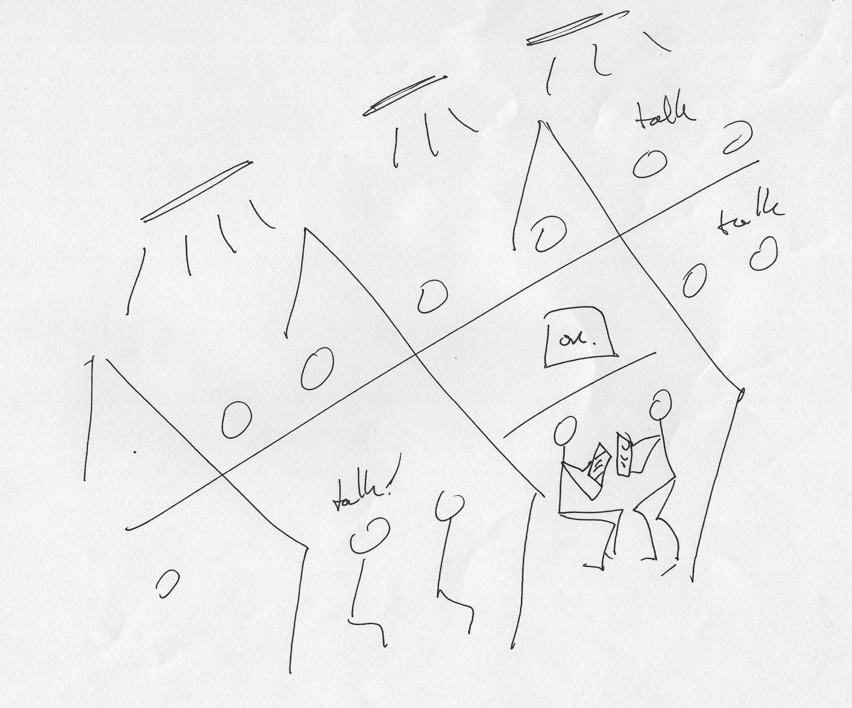

I: Okay brilliant.

P: And it’s cold.

I: [laughing] Okay, very interesting. Thank you for doing that. Okay so last couple of questions then. There’s often a lot of encouragement for students to engage with different experiences that the university offers, such as joining societies, volunteering or getting involved with the Student’s Union. So, what are your thoughts on this?

P: It’s really important, I think if a student’s away from home for the first time and they don’t join a club of some kind or whatever, that’s going to make it much, much more difficult for them. Yeah.

I: Okay, do you ever find any issues concerning balancing extracurricular with –

P: Yeah. I had a student who was in the rugby team that played every Wednesday I think it was and our seminar was on a Wednesday morning and the game was on Wednesday afternoon, but if it was an away game, he didn’t come because he had to get on the coach or whatever and it definitely had a negative impact on his studies. But he loved rugby and I get that, you know, he really wanted to be in the rugby team. So yeah it can do. That’s quite rare.

I: Okay. What are your thoughts on the role of the Student’s Union in terms of engaging undergraduates?

P: So yeah, we don’t have an awful lot to do with the Student’s Union, apart from this [removed for confidentiality] thing which I don’t, well that’s a whole other subject, I mean I did get nominated once but, you know, whatever. Anyway, apart from the [removed for confidentiality], we don’t – you know, apart from seeing the logo and stuff, we don’t have anything to do with them and they don’t have anything to do with us, but apart from when there’s a problem. So, if a student’s accused of plagiarism, or some kind of misdemeanour, then the Union will maybe represent them. But it’s kind of second hand, seems to me it’s really – for example, the way it appears in this document, Student Charter [name changed], you know, it seems like a positive force. I’m not sure if the students – do you interview students as well? I’m not sure if the students, how strongly they feel a member of the Union, on a scale of 1 to 10, if you know, is it…?

I: A lot of them don’t really know what it is, they think it’s a bar.

P: Oh right, they’re not aware that it’s a Union, as in a Union, yeah.

I: No, they think it’s just, they offer societies and discounts for food and drink and stuff. So yeah there’s a lack of understanding a little bit there.

P: So that’s a shame because it’s a real – it could really support people in difficulties and then they may not think to turn there, yeah.

I: Yeah. What are your thoughts on the university’s attempts to engage its prospective undergraduate students?

P: What do I think of what we do?

I: Yeah.

P: So, we’ve got an outreach team, is that the kind of thing you’re talking about, yeah? Yeah so, the outreach team is fantastic, in my dealings with them, they go out and talk to people who are as young as 12 I think and plant the idea of going to university into the heads of people who might not otherwise think of it, which is fantastic. So, outreach, particularly in that, kind of, I’m not sure if it’s still called this, but widening participation agenda is good. Sorry was your question particularly about widening participation or was it just any schools?

I: It was just about the way the university engages prospective undergraduates.

P: Yeah right, right. Yeah so that side of it is good but then obviously we also are attempting to engage everybody, not just those people in those participating schools and we have Open Days which have got more and more sophisticated and impressive, and there was one last weekend and it seemed really good, it was great, except that it was on a Sunday and I had to give up my Sunday, but apart from that it was good. And I quite enjoyed it. So that’s all good and then there’s a lot online that I don’t look at because it’s not my business to look at it but I know it’s there for people to – apart from our own pages I look at, but you know, to find out more about the university and that seems pretty good. [removed for confidentiality]. And then prospective students who’ve applied, are you including them? I mean, you know, again it’s not something I was involved with, but there’s this whole student journey thing, it used to be awful, just breathtakingly awful about, you know, students applying and then not hearing anything, or you know, not knowing what day to show up and all of that, and so that was one of the things, one of the few things, the previous Vice Chancellor did [removed for confidentiality] was to set up a group to sort that out and I think it’s probably much – it is – much, much better than it used to be. What other problems, I can’t think of any other problems, but then it’s not, if I was still a programme director then I might know more about it…

I: Okay. Do the university’s attempts to engage undergraduate students differ from the departmental attempts, or personal attempts to engage students?

P: Hmm [pause] what happens at a university level to engage students? I mean I sort of feel like that’s all delegated to us, but that’s because I may not see the other stuff. So, we do a lot to engage and to follow up when people are missing sessions and so on. If there’s, you know, things going on outside to encourage people to take part in extracurricular activities, and the volunteer thing that they do where they get points or credits or something for doing volunteer work, maybe that’s part of it? Don’t know. So, yeah, I’m not sure about that one.

I: Okay. So, last question then. The university’s obviously very successful in engaging its undergraduate students, but there’s probably more that could be done, ways in which it could broaden engagement across the student body. So, I wonder if you had any comments around this?

P: How to improve engagement?

I: Yeah.

P: [pause] [removed for confidentiality].

I: Yeah, it is quite far.

P: [removed for confidentiality] it will all be different so…

I: Okay well thank you very much for taking the time to talk to me. I got some very insightful and valuable comments so thank you. Is there anything you want to add about interactions with students that we haven’t covered?

P: [pause] Wait let me just think for a minute.

I: Okay.

P: Just to say, I mean this conversation happened the other day, which, I took part in with some students, in fact, at the Open Day, where they said that in their year in English Literature, there was a – no one really knew anyone and there wasn’t a sense of a group community feeling and so on, and we do try to create that but clearly not, in everyone’s minds, successfully. And it would be great to have that taken care of, as it were, in some way and I think part of the problem is, [removed for confidentiality]. So yeah, that’s all I can think of.

I: Okay well, thank you very much. I can send you a draft of my initial analysis if you’re interested in having a look at my findings.

P: Yeah! Yeah, great.

[End of Recording]

