Interview #6 Transcript: Professor (28.11.17) (University B)

Interviewer (I): Okay, so as a professor of [removed for confidentiality], what would you consider to be your main responsibilities?

Participant (P): So, obviously from an undergraduate perspective, it’s teaching them. Actually, my notion of what it is I do is probably, obviously it’s broader than that, but it’s probably different from theirs in the sense that I think undergraduates do – they think the role of any of their lecturers is to teach them and to prepare them for assignments. My understanding would naturally be different, it’s actually that I’m contributing to, and furthering, a discipline, that I am trying to get them to participate in that discipline, so if we see it as a spectrum that begins with their undergraduate studies and then moves up to, if you like, or through different layers until you’ve reached the, sort of, [inaudible] of professor and that’s how I see it, as a, kind of, continuum where everybody is participating in learning, we are trying to engage with literature, history, culture, whatever it happens to be at different levels and in different ways. So, I think that’s one really clear difference in perspective but also there’s a leadership responsibility, obviously, that comes with a professor role and that is partly to do with actually my colleagues instead of the students, which is another thing, of course, that students may not think about, especially with the fees being what they are, of course, it tends to be in their mind that it’s all very – university is about students. Well actually, if there was no discipline and if there was no sensible infrastructure, there would be nothing to teach them anyway and you know, the student experience would be terrible so, it is also about [inaudible] I’m the subject lead for creative writing, so it’s about managing that programme, checking that my colleagues are happy and in extremis, it would be about checking that they’re doing what they’re meant to be doing [laughing]. Actually, I never really need to do that because they do what they’re meant to do, so that side of it is very easy, and then there’s the, you know, that side of my role involves sitting in meetings and doing all the other things that we all complain about and wonder why we’re doing [laughing].

I: Okay. So how many undergraduate students do you teach in a term, roughly?

P: Obviously it varies. Undergraduates… So, my creative writing teaching is normally in the first year and it’s single honours so it might be around 20-25 in that group and the rest of my teaching is postgraduate anyway. So, I don’t actually teach that many undergraduates, although I do supervise final year dissertations as well, so I might be doing 2 or 3 of those.

I: Okay. Okay what meaning does the word engagement have for you?

P: I think, for me, it’s very much about something reciprocal. I know I’ve said often that I’m engaged and as engaging as the students are prepared to be, and that’s really, really true because I think in any academic job, yet another thing the students don’t see, actually we are all working above hours inevitably, we’re – but also because the definition of the job is quite flexible, once all the admin and the stuff that’s going to be noticed, is done and out of the way, there’s a pull between research and teaching and if I’ve got a group of students who are really keen to learn and asking me questions and they’re engaged themselves, that’s when I’m likely to come out of a seminar thinking, “They’ve asked a really interesting question, I’d like to know the answer myself, I know, I’ll go and look that up for them, I’ll find out this and that, I’ll make my next seminar really good on the back of it”. If I’ve just spent 2 hours being stared out in a slightly hostile way by people who are clearly half asleep [laughing] the temptation to go and do a bit of my own research instead is probably going to win out. That’s just the reality.

I: Yeah. Okay. Okay, so using what you’ve said, how do you attempt to engage your undergraduate students in your teaching?

P: Some of it is quite simple and it’s probably not specific to teaching. Eye contact. Humour. I mean I don’t mean I go in, you know, saying, “A funny thing happened on the way here this morning”, but, I will use little injections of humour to lighten the atmosphere, particularly in a creative writing course because students doing that may feel very vulnerable, may feel exposed, so I might use self-deprecating humour. Teaching [removed for confidentiality] courses, maybe slightly less so, but the – but again, [removed for confidentiality] reading can feel quite heavy to them sometimes, so something that will lighten it up, and sometimes if I’m drawing on [removed for confidentiality] examples, or I’m teaching [removed for confidentiality], I might look for the modern parallel. So, if I’m looking at representations of gender, I will – I mean it’s a really easy win this, I just bring in a copy of the Daily Mail and a [removed for confidentiality] and say, “Can you tell the difference?” Generally, no, except the [removed for confidentiality] is often slightly more [laughing] liberal and a bit more intelligent [laughing]. So, I think there are strategies, and also, it’s, maybe, knowing that group. If actually, they’re going to find it too difficult to go and read [removed for confidentiality] in a week, then we’ll do it over 2 weeks. If I’ve really got a group – and this can happen in creative writing, where I’m asking them particularly to read [removed for confidentiality] texts, they don’t see the point of it, they want to be focussed on their own writing, they don’t see it as being – “I don’t think I should do any reading”, I’ll select key scenes and we’ll read them aloud, because it’s a [removed for confidentiality] to do, it makes people read differently when they read it aloud from how they’d read it silently, but it’s also, and I keep this bit quiet when I’m talking to them, it’s also a way of making sure they’ve actually read the key scenes that I need them to read, or there’s not going to be a seminar at all.

I: Yeah. What are your thoughts on the concept of student as consumer in higher education?

P: The whole idea makes me feel physically ill [laughing]. Yeah, I find that whole notion so repellent, I can’t begin to tell you how much it disturbs me. But from the student perspective, I think it’s also a real shame, because when I want to consume something, I go into McDonalds and I ask for a burger [laughing] I would no more go into McDonalds and say, “I would like the opportunity to discuss the constitution of a burger and to interact with it so that I can learn from it” [laughing] than I would expect a student to do – well sadly I’m now expecting students to come into a seminar with that approach, but I think it’s very damaging for them, partly because it really does destroy the relationship between students and lecturers because if they think they’re buying something then I sometimes remember how many hours I’m actually being paid for and what they have a right to expect and what they don’t [laughing] which is, you know, there’s sometimes quite a big gap there. But the other thing is, it’s very passive, that notion of consuming, the idea is that, “I will come in and I will pay for this and I will get that”, actually, what we want students to do is to come in and participate, and engage and learn, and to take opportunities and have to create opportunities for themselves. None of that is really covered by a consumerist model.

I: Okay. Okay, do you consider students to be customers in any sense?

P: No!

I: Okay! That was easy [laughing]. In your opinion, how prevalent, if at all, is the concept of student as consumer in the university’s attempts to engage its undergraduates?

P: It’s been insidious, this one. Academics are fighting it, but I think we’re slightly fighting looking over our shoulders now. There are support departments that don’t have that on-the-ground interaction with students, so there was a support department, I saw an email come in and the signature said something about providing a high model of customer care or something, again, made me feel quite disturbed [laughing] for several days. So, there is a sense that we’re fighting a bit of a rear-guard action on that one. But yeah, I think we’ll go down fighting [laughing].

I: Okay. Are there elements of the student consumer concept apparent in your interactions with undergraduates? So, are you ever aware of them feeling, or being customers when you interact with them?

P: One or two of them are very keen to tell me that they’re customers, but then I very swiftly just abuse them [laughing] for that idea. Where I am conscious of the legalities I suppose, which is slightly different, with the CMA requirements of what we can say and what we can’t, I’m much more careful in not making claims. So, for instance, we were making a promotional video about why students should come here and I said, “Well, it’s a stone’s throw from [removed for confidentiality]” and [inaudible] of the camera was stopped and I was reminded that I couldn’t throw a stone from here to the [removed for confidentiality] which seemed extreme but I took in on board [laughing]. I think I’m aware that while I know a student isn’t a customer, that doesn’t always help if they don’t know it too, and some of them can be slightly litigious, so I keep [fire alarm goes off]. That happens sometimes. [fire alarm goes off]. Yeah, I’m more conscious that I used to, perhaps, of keeping emails and not saying things that I wouldn’t want repeated, I’m very conscious of the social media context as well, which isn’t quite the same, but it’s, you know, related to that.

I: Yeah. Okay. Do you think the introduction of fees has given students a greater sense of entitlement to higher grades?

P: Yes. Absolutely, without a doubt. They will say, some of them, with no sense of irony, “I am paying this and I want a First” [laughing] as if there were some strange connection between the two.

I: Okay. Okay, moving onto learning then. In your opinion, are lectures useful for engaging undergraduates?

P: I think they can be, actually, because I know that some people are very wary of lectures being passive but, they don’t have to be, they can be slightly interactive and certainly if I’m giving a lecture to a group, you know, that’s small enough for me to do this, I will stop from time to time and say, “What do you think about that?” and even if they don’t answer, there’s a slight prompt implicit in that, “I am expecting you to be paying attention to what I’m saying”, and it’s a chance for them to speak if they want to. It also means that we are getting a certain amount of substance across, because I’m very big on group learning, partly because I teach a lot of creative writing, and a lot of group discussion, but equally I want them to participate, I want them to stimulate each other, there are times when I’m going to know more about something than they do and I want to make sure that gets across, so a lecture does allow that to happen, without me butting into a discussion and correcting all the time.

I: Yeah, okay. In the same vein, are seminars useful for engaging undergraduates?

P: Again, it varies tremendously, depending on the group. One or two students can make a real difference, either for good or evil [laughing] I have to say. Yeah, I think they are, maybe especially if they’re not too big. I think when we start getting into the, sort of, 25 people in a room, it is really tricky. The best seminar size, for me, I would say is around 15, 10-15 and we don’t normally get that, because there’s cost implications and it just doesn’t usually happen but sometimes in the option modules, if only 10 or 15 choose that then yeah, I think I do see a difference, because it’s just, it’s small enough that they don’t feel intimidated and they can’t hide, but it’s big enough to have a range of opinions.

I: Yeah, okay. Are one-on-one sessions with undergraduates useful for engaging them?

P: They tend to be much better actually because they know that – well they’re going to have to talk [laughing] otherwise what will happen! And our one-on-ones will tend to be an essay tutorial or a dissertation supervision so, in theory at least, I mean the odd one will come and say, “What do you think I should write about?” but generally speaking, they will have come with a plan, with a sense of what they want to do, they’ve chosen to answer this question, or write on that text, so yeah, I think that’s where they really feel – especially the quieter ones, who may feel a bit drowned out in a seminar situation.

I: Okay. Is there anything you think is particularly good about the style of learning that takes place at university, compared to compulsory education?

P: Oooh well I haven’t been in compulsory education since [removed for confidentiality] [laughing]. I remember, certainly in my day, I mean she was a bit old school bless her, but I did have one history teacher who used to stop when the bell went, even mid-sentence and then the first lesson would begin picking up halfway through that sentence, writing on the board and we had to write it all down. So, I think we’ve probably moved on a bit from that [laughing]. I guess what we have that most schools don’t is a certain flexibility of delivery, so we do have lectures, and seminars, and small groups, and one-on-ones, and we can probably respond a bit more quickly as well to how things are going, so if I can see in a seminar group that one or two people are tending to dominate, then the next week I can break them up into small groups and do something else, or if they’re all looking incredibly bored, then I have the option of saying, “Okay we’re going to go and look around [location removed] and find some [removed for confidentiality] and write poems about them”, or whatever it is, we can really respond fairly rapidly on the ground in saying, “We’re going to change the way we do this” and I think we’re much more constrained in compulsory education.

I: Yeah. From your own experience of teaching, is there anything you would change to improve student learning? In terms of either your own teaching, resources you and students have access to, curriculum and assessment or anything else?

P: Oooh, well curriculum, of course, we write it anyway so it’s my fault if the curriculum’s not very good [laughing] and the delivery we can change, I mean it’s like I say, we do constantly put in modifications to programmes, if we’ve realised say, that an assessment pattern isn’t working very well, or we want to be able to do something different, we’ll try it for a year and then say, “Okay, for next year we’re going to put in some paperwork, go through a few more meetings [laughing] and do things differently” so that just happens naturally I think. No, I don’t think there’s anything that I would change that I can change, really.

I: Okay, okay. Okay, so I sent you the document that refers to the university’s teaching and learning strategy, it’s – I think it’s under there. Yup there it is. So how does this strategy impact, if at all, on your interactions with students?

P: Oh right, let me just remind myself [coughing]. So, we are working on – things like the [removed for confidentiality], that’s coming on stream at the moment, we’re building in modules that will deal with that, which isn’t quite the same as interaction, I know. The [removed for confidentiality] does impact on our interactions with students, we’re – especially being a Humanities programme, I mean I say this as if it were, sort of, proven but, anecdotally, we do have a higher number of students with mental health problems doing Humanities. Don’t ask me why, but just anecdotally, everyone I speak to who teaches in Humanities – that’s very stereotypical, but I think there is that – and maybe again this is stereotypical but anecdotally true, is that more women do Humanities and so it might not be true in other disciplines but, I think women are – either women with mental health problems are drawn to Humanities subjects [laughing] or the other – yeah I don’t think Humanities subjects give you mental health problems, but there is a sort of correlation I think, with our writing students, they might come because they’ve had depression or anxiety or something traumatic and so they’re – literature gives you a model and a framework for understanding that, creative writing gives you a way of expressing it, history might give you a way to contextualise it, so there’s a kind of logic, I think, to using Humanities as kind of problem-solving or just understanding your world, and we are really, really conscious of that, in terms of, it might be around learning support plans that students, sort of, we need to know certain things, you know, how they can manage deadlines. We have, at any one time, maybe one or two autistic students, so we’re again, we’re aware of the – because there’s a lot of group work, “Just remember, do not point your finger at that woman’s face and tell her she has to talk because it will be a bad idea” [laughing]. So, I think that’s probably the thing that we’re most aware of actually, is that inclusivity. Yeah, and the [removed for confidentiality], I think, we didn’t really need a strategy to tell us that, we do try and encourage students to see – it’s part of our anti-consumer rhetoric actually, is to say, “This is a partnership in which we can expect something from you and you can expect something from us, and we’ll negotiate what that is and we’ll learn together”. And yeah, there’s [removed for confidentiality], that does sort of comes in anyway, again, without it being a strategy, so it’s – one of my colleagues is very interested in [removed for confidentiality] just anyway, so she likes to build that in, in any case, she does a lot of writing and walking-type events that may well involve students. And again, yeah, the research, knowledge, exchange, we do try to encourage the students to get involved in our research projects, or to be ambassadors for research events. [pause] I think that’s probably, so yeah, I mean, again, [removed for confidentiality] well, Humanities. What else would we be doing? But yeah, supporting success for all our students I think actually, you know, I think we are really good at that just, I think we are just very good at that. Some of our students, for whatever reason, do need quite a lot of support, either because there are issues, you know, very often there are issues in the background, or it might be more simply that they’re earning while they study so I think, that used to be a very [University B] thing because well, we’ve got a local demographic, but I think up and down the country now, students are trying to balance impossible things, you know, a full-time degree is meant to be like a full-time job, and increasingly, they’re having to work outside of university as well so, we have to support them and try to help them get that balance somehow, which isn’t always easy.

I: Yeah, okay. I sent you the document that refers to the Student Charter [name changed] as well, which is…. [mumbling] Do you think this strategy is a successful one for engaging undergraduate students?

P: I think it would be more successful if it rang concurrently with a drive to tell them they’re not consumers. This is the problem. I think that the university is in danger of doing two contradictory things. One is allowing them to think that they’re customers, and I try not to spit whenever I say that word, and the other is, rightly saying, “This is a partnership in which you have equal responsibility” and the trouble is that I think students are listening to one more than they do the other sometimes, which is, again, it’s a real shame.

I: Yeah. okay. In your opinion, should undergraduate students have greater control over, or input in, the curriculum and/or assessment design of their chosen courses?

P: Actually our students have had quite a lot of input, which isn’t to say that we let them design the curriculum [laughing] but, again, I’m talking about the creative writing programme now, it’s still fairly new and I wrote that, I say I wrote it, I was just responsible for validating it, and what was interesting about that was, like any new BA degree, you start the course with a first year before you have a second and third year so, as they were going into the first year we were talking to them and they were saying, “Oh, you know, that [removed for confidentiality] module coming up, you know, will there be [removed for confidentiality] on there?” and actually, there wasn’t but we put it in because we had time, as they were going through to think, “Yeah, well you know what, that would actually be quite a good thing to do and we’ve got students who have got real strengths in this area, what about we quickly validate something now, so that by the time they get to the third year, that’s on the books?” And that was actually – and I know the students loved that because they felt that they had a lot more control over their learning than the students normally do. Obviously, it’s very, very difficult in a routine cycle, we can’t just keep ferrying new modules around, you know, especially as modules get bigger that can be quite hard because we can’t just have, you know, we can’t keep proliferating modules, we have to think about who’s going to be there to teach them.

I: Yeah, okay. Okay, in recent government policy on higher education, students have been placed at the heart of the system. In your opinion, to what extent are undergraduate students positioned centrally within this university?

P: I think they really are, actually, and certainly we get compared to other universities I hear about, and I mean – and students will, it’s the nature of being a student, is to complain [laughing] sometimes. But I think compared to other universities I hear about, they really are well looked after here and I think most of them do recognise that, actually, that a lot of them come here rather than other, you know, local universities, or other universities because they say that we’re small and friendly, in fact we’re not particularly – the campus is quite small, but we’re not – I forget numbers, we’re not a very small university actually, but there is that slightly family-feel about us where they know that their lecturers will know them, will actually, you know, will make the effort to get to know them, and that’s probably a legacy actually from our dark days when the university wasn’t very research active, but what it did do was look after students and, thank goodness, since I’ve been here it’s become much more research active, but without losing that feeling that we actually, genuinely, care about our students because we, you know, the nature of our job is that we are going to work very hard to help them so, if we didn’t like them [laughing] that’s not going to work is it? When the system works, that’s how it works, as a self-perpetuating cycle where we actually get to know those students, get to know their stories a bit, genuinely care about them doing well and therefore we’re prepared to work hard with them to make that happen, which, again, is what’s threatened of course by the customer model.

I: Okay, do you think positioning students centrally works to separate them at all from other members of the university, such as academics? Because some people have said that positioning students so centrally, kind of – academics end up on the back burner a little bit and research ends up on the back burner.

P: Oh gosh yeah. Yeah there is that thing, and I don’t think it’s necessarily coming from the students themselves but, institutionally, we can all end up feeling very, very crushed and I remember when the student experience agenda came in, I do remember thinking rather, “And the staff experience agenda, where is that?” Because that doesn’t tend to get much of a look in, which can be very short-sighted. There’s the endless, relentless drive to make sure students are happy and, of course, you want them to be happy but equally, yeah, there can be a tendency to let staff martyr themselves in the cause [laughing], which doesn’t help anybody at all.

I: Okay. What meaning does the word relationship have for you, in the context of interacting with undergraduates?

P: [pause] That’s a really interesting question [laughing]. I think it, for me, it has a sort of dual meaning of, one thing it’s a relationship with the student body as a whole, but it also contains that idea of interacting with an individual because, of course, relationship can be a very loaded term that can mean anything on a spectrum from, relationship with your bank manager to something wildly inappropriate for a student [laughing]. But in this instance, I mean I think it’s nice that we still use the word relationship, because it’s a reminder of something very human, which I think is, precisely, what should be at the heart of relations between academics and students is that feeling of a shared humanity, it sounds very naff when I say something like that, but I think that’s important.

I: Yeah definitely. Okay, what do you consider to be the main purpose for building a relationship with undergraduates?

P: The main purpose of it is, I think, the kind of teaching we do does depend on the dynamic between academic and student. While it is very independent, we only have a limited number of hours in a classroom, it makes it all the more important that there’s a relationship there that will – that’s how it works, otherwise well why are they paying all this money, as we keep talking about, they keep reminding us, just for a few hours? Well in those few hours, we’re supposed to generate enough energy and enough confidence in them that it’s actually worth its weight in gold for the rest of the week, and you can’t do that without a, you know, a strong interaction, a sense of relationship.

I: Yeah, okay. To what extent is this purpose fulfilled in your experience?

P: Oh, that’s a different question [laughing]. Enormously variable is the honest answer. I have students who do incredibly – we see some students coming in, maybe with very little confidence, all of us wondering why they’re here at all, coming out with a First and going on to postgraduate study, and then we know it’s worked. Equally, we get students who we know are going to complain whatever we do. It’s very hard to sustain a feeling of relationship with somebody who is taking that approach obviously [laughing]. In brutal honesty, there are some students who I’m quite happy to see the back of at the end of 3 years, there are others that I genuinely, yeah, I genuinely want to know in 5 years what they’re doing, how they’re getting on. There are students who I’ve ended up working with. There was one student who I had no, you know, friend relationship with, she was just a student, but who impressed me so much as an undergraduate [removed for confidentiality] and I’ve been working with her for 5 years now, and actually, you know, she’s my right hand, [removed for confidentiality] she works on that, you know, I couldn’t manage without her at all. So yeah, I think that kind of relationship, you know, in that sense, from the student end it is all about, how do you make a lecturer feel like that about you without it being because you’re related or you know them from home or there’s some kind of personal relationship? You pull your finger out, you know, [laughing] you do the work, you turn up, you engage, you make your lecturer happy to be there, they’re going to want you to come back.

I: Okay. Do you think there is a link between the relationships undergraduate students build with tutors and their levels of engagement?

P: Absolutely yeah, and we sometimes see the negative side of that, is a student who maybe hasn’t attended anything. Normally it does turn out to be because of personal reasons, a mental health issue, and they will sometimes say, when we do ask them to come in, because we will say after two or three – “Do you want to come and have a chat, why – you know, can you tell us if there’s a problem?” and they will come and say, “Well I was too embarrassed to come back because I missed a couple and I thought everybody would stare at me when I came in or the tutor wouldn’t want me there anymore” Once they know that they can come and talk to us, then – if they’ve come and talked to us once, they can come and talk to us again if there’s a problem.

I: Yeah. Okay can you describe to me a typical face-to-face encounter with an undergraduate? So, if they come and meet you to discuss an assessment, how does that play out?

P: I mean in one sense, obviously, there’s no such thing as a typical encounter. There’s, I suppose, some kind of ritualistic structure, which is that I’d always meet them in my office. Postgraduate, very occasionally I might meet them in [removed for confidentiality] for a coffee but, generally not even then, it’s not just about boundaries, it’s also because I might need access to a PC, basically I try to make notes on what we’re talking about to give to them afterwards. But typically, it would be, other than my office hours, it would be by appointment, so that I know they’re coming and I’m not in the middle of doing something else. It also helps me because I’m face-blind so it’s really useful, I know who I’m expecting [laughing] at what time, and don’t have to say, “I’m sorry, who are you?” So, they come in and generally, they’re very good, they will knock on the door, you know, very few of them will just barge in. Very often it’s by appointment, so they knock on the door, they come in, I normally, unless I’m really trying to get rid of them, I’ll ask them to sit down, there’s a slight exchange of pleasantries, they tell me what they want, so we will talk about their essay, whatever it is, I would encourage them to do as much of the talking as possible really, because again, it’s that idea of engagement, I’m trying to steer them to do something not do it for them. And the one thing that’s always quite difficult actually with students coming in, is that they never know how to get out of the room again. In 15 years, I’ve just noticed again and again, they will come in and then at a certain point they clearly want to leave and they don’t know how. So, I realise a part of my role is actually [laughing] facilitating getting them back out of my office when it’s done.

I: Okay [laughing]. Do you ever notice any implications of a hierarchy in your interactions with students?

P: Very occasionally they’ll address me by title, which is a bit unusual. We normally say right at the start, you know, “Use our first names, this isn’t school” and generally speaking, they don’t really know, you know, who is doctor, who is professor, whatever, one or two of them do, which is quite interesting, but generally speaking I don’t think they’re terribly aware, or interested, about who’s in charge of what.

I: Okay. Can you think of any particularly good relationships with any undergraduates, without giving away their identity, with any – sorry and why you’d characterise it as good?

P: Yes, several actually. Very often it may be with mature students, there’s inevitably, there’s a slight bond between a mature student and a lecturer because they may be feeling slightly like a fish out of water and they’re on our wavelength in the way that they get my jokes, my obscure references to [removed for confidentiality] and things. Relationships with mature students are often very good because they’re very engaged, they work hard and they will talk so we’re quite grateful to them before we’ve even started [laughing]. There’s less of a barrier sometimes in the way that we communicate because – especially the older I get, the more I notice my communication with undergraduates, it’s tricky because I don’t want to come across as being “down with the kids”, especially when I’m 45, just no, no, no, no. But equally, I need them to be interested enough in what I’m saying to listen and that’s a constant process of negotiation, whereas with someone my own age, I feel like I can just get there, I can just do this and that’s okay.

I: Okay. Okay, now is a fun part, that everyone likes doing. So, can I ask you to draw your conception of a good relationship with a student?

P: Goodness gracious. My drawing is simply abominable, but I’ll do my best. Draw my conception of –

I: Anything you want.

P: Okay. [pause for drawing] This is going to look more like a head and less like something dubious by the time I’ve finished… [laughing] [pause for drawing]. Okay so this is meant to be a book, sorry it looks like wicked willy, it’s actually just meant to be… sorry I’ll do some hair, to make it look less alarming. No this is – you’ll just have to take my work for it, this is intended to be a human being. [pause for drawing] Crikey, now it just looks like an alien. Okay. So right, let me give this person some spikey hair and maybe they better have two eyes instead of one. [pause for drawing]. Oh dear, right they’ve also got a few too many legs but yeah, but that would be – I think it’s people enjoying talking about books.

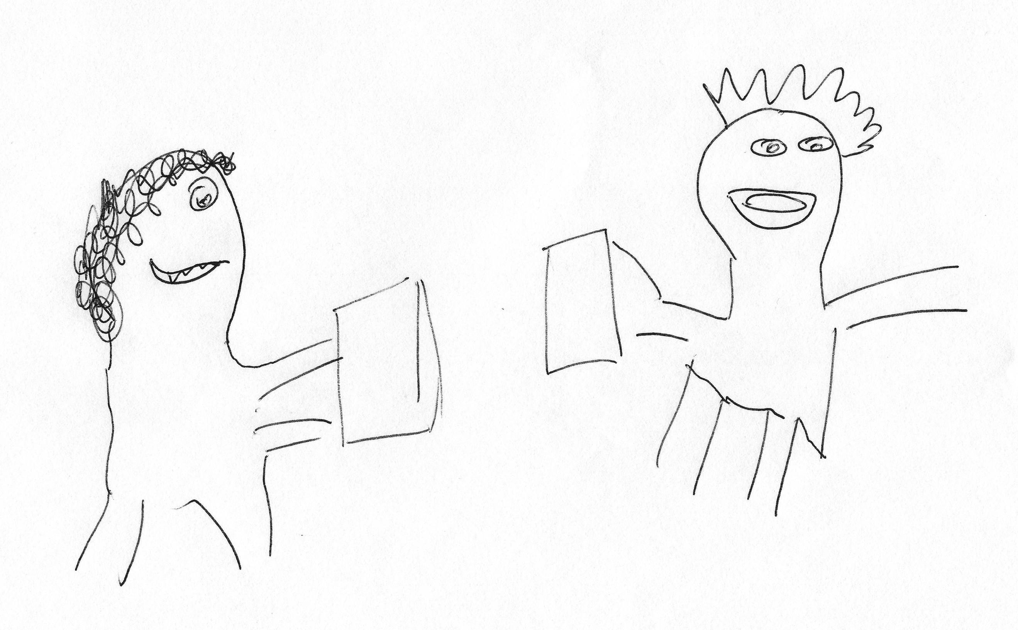

I: Yeah, okay brilliant.

P: You really have to interpret that [laughing] as enjoying talking about books.

I: [laughing] Okay brilliant, which one is which or does it not matter?

P: I don’t think it really matters in that moment, that is kind of the point.

I: Okay brilliant. Okay so now – this is the last one – to draw your conception of the opposite, so a bad relationship with a student?

P: Oh [inaudible]. So, it’s this thing that they do, when they sit and they fold their arms at me. Crikey. [pause for drawing] Right their arm’s going to go back there. So, in this one, this is what drives me mad, is where I’m frantically smiling with my book going, “Look this is really interesting” [pause for drawing]. Yeah if I’m sitting there saying, you know, “Look how interesting this is and it’s great, it’s something that I love and I want to share with you” and they’re just going, you know, their arms folded and staring at me and yeah, I think, I almost prefer the one where they fall asleep actually to that, because at least I think, “Maybe they’re just really hungover”, but it’s when they’re clearly physically in the room with me and awake, but whatever I do has no effect at all. Yeah, it’s just like having all my energy scooped out with a spoon.

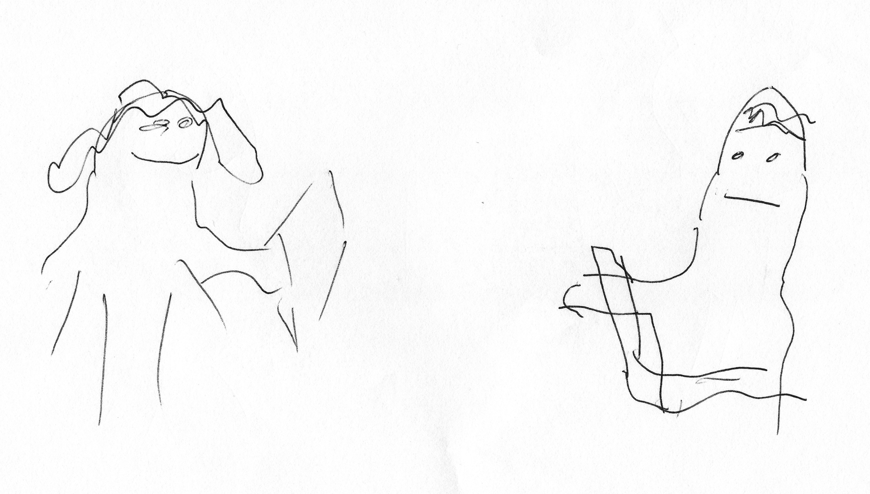

I: Okay, well thank you for doing that, it’s very interesting. So, last few questions. There’s often a lot of encouragement for students to engage with different experiences that the university offers, such as joining societies, or volunteering, or getting involved with the SU. So, what are your thoughts on this?

P: I wish they’d do more of that. I wish I’d done more of it as a student so I’m completely hypocritical, but I know that sometimes the odd student will say, “Oh we’re only getting this much teaching, or this, or we’re paying this la la la la la” and we actually offer really lovely things. We have a [removed for confidentiality], where writers will come and talk about – they’ll read a bit of their books and talk about being a writer which, of course, for the writing students is amazing and very often it’s the students who complain about not being offered enough or not having enough teaching and I’ll say, “Well, have you been to [removed for confidentiality]? Did you volunteer as a student ambassador? Did you go to this event we put on?” and they look a bit sheepish and say, “Well no” and I think that’s really, that’s – it’s partly, it’s always, student apathy has always been there, but partly it’s that feeling that, “If I’m not getting a mark for this, if I’m not getting something tangible, then it’s not worth my while” and yet, at the same time, “Why am I not getting more for my money?” And I think sometimes students are very confused in their thinking about this because that media message, again, just constantly – it’s that consumer model! “You’re paying this, therefore, you ought to be getting that” and no they shouldn’t be getting whatever that is, but in fact we’re offering lots of other things that they then don’t engage with, which, you know, is, again, sad.

I: Okay. What are your thoughts on the role of the Student’s Union in terms of engaging undergraduates?

P: I hope they do. I don’t – my dealings with the Student’s Union have been very limited. I think I’m being unfair because of the context in which I always see them, but it sometimes feels a little bit like the Student’s Union thinks it’s there to defend the students from lecturers, rather than actually build bridges [laughing], and I suppose I say that because when I see them they’re normally attending a student who’s up for plagiarism or something like that, but it can feel a little like there’s a tension there that isn’t necessarily a productive tension, and that’s a real pity as well.

I: Okay. What are your thoughts on the university’s attempts to engage its prospective undergraduate students?

P: Probably we could do more. I don’t know a great deal about – I mean in Humanities we have a [removed for confidentiality] which I think is a really nice, sort of easy fix, way of attracting new students and doing something for our current students, which in my mind, is really what it should be about. I like the idea that marketing isn’t some kind of fishing exercise where you go out and, you know, we’re not selling cars here. I would like to think, naïvely, that students want to come here because of all the great things we’re doing anyway, that we’re just making more visible, but that’s completely unrealistic and utopian [laughing]. That’s how it should work. In terms of how it really works, I think maybe we could do more than we do, although who knows what?

I: Okay. Okay so do the university’s attempts to engage undergraduate students differ at all from the departmental attempts, do you think?

P: I suppose it’s a different remit. University puts things on for them, so there’s a [removed for confidentiality] coming up, so the university will offer them, I don’t know, a free trial of the gym or sporting activities or well-being activities, which isn’t really what we do as academics so, you know, at its best that works I think. I like that idea that the university will provide a framework where there are lots of extracurricular things that they can do, whereas we are more about, “Come and read this book, you’re going to enjoy it”.

I: Okay. Okay so last question then. The university is obviously very successful in engaging its undergraduates, but there is probably more that could be done, perhaps ways it could broaden engagement across the student body. So, I wonder whether you had any comments or thoughts around that?

P: [pause] I think, you know, given a magic wand, there are things – it would be lovely if they had something like a [removed for confidentiality], more social spaces that aren’t in the library, which just seems like the wrong place. I think it would be really nice for them to have a social space where they could go and hang out and do things. I think that would be good. They are already encouraged to come and join us to be student ambassadors, or join us for outreach activities and, again, very often that’s the students themselves just don’t take up those opportunities. So, I think, in justice, the university’s probably trying as hard as it can, but it’s aiming it at 18-year-olds and 18-year-olds are, by their nature, not always great joiners.

I: Okay, well, that was the last question, but is there anything you want to add that we haven’t discussed?

P: Did we mention that I don’t like the consumer model? [laughing] Did we touch on that at all? No, I don’t think so, I don’t think so, I think it’s all there [laughing].

I: [laughing] Okay, well brilliant, thank you very much.

[End of Recording]

