Interview #2 Transcript: Third Year Female English Literature and Sociology Student (06.10.17) (University B)

Interviewer (I): Okay, so, why have you chosen to do an English degree at this particular university?

Participant (P): I want to teach Literature – English – in secondary schools so I always wanted to do English and then I wanted – because I’m from [location removed] originally, I wanted – I didn’t want to go too far away so that was quite nice to only be, sort of, like an hour and a half. But then when I came on the Taster Day to here and I went to one at [pre-92 university] as well. So, I came to look here and I liked the modules here because they did Victorian Literature last year, which I really liked. I quite like, sort of, Charles Dickens and things, so that was really interesting to do, and then, I met really nice, like, the lecturers on the Taster Day so that was really good, they were quite nice and friendly so they seemed really nice, and then, the other modules were really different things I’d never heard of so, we did [removed for confidentiality] Literature, so I didn’t know anywhere else doing that, so that was quite different, so that was good to do.

I: Okay, cool. Are you the first person in your family to go to university?

P: Yeah.

I: Okay. What does value for money mean for you? And is it important that you get it from your university?

P: Yeah, I see it as, like, enjoyment, is the value because I’m not really – because this isn’t seen as one of the Russell Group universities or anything but, I wasn’t really concerned about that, like the status sort of thing, it was: “Am I going to enjoy it?” I’m spending £9,000, so I need to have – I’m going to need to get something out of it, but need to – I’m going to be here 3 years so if I don’t like it, I need to make sure it’s going to be enjoyable but that I’m going to get something from it, but yeah.

I: Okay. Do you agree with paying fees?

P: Yeah, I do agree – I don’t think they should be as much as they are. I think you should pay because it’s not compulsory so if they were going to make it compulsory education, then that needs to be free, but because everyone is choosing to come here, so I think – I think it should be, you have to pay but, I don’t think it should be £9,000, that’s not worth it to be honest [laughing].

I: Fair enough. What does being a university student mean to you?

P: Like, independence, I think that’s one of the bigger things with, obviously living away from home, as well as with studying, if you don’t – if you choose not to do the work, that’s up to you, it’s not really – obviously school will go, “Okay have a detention”, but here it’s, it’s much more independence and it’s more – it’s more, what you put in, what you’re going to get out of it, it’s – if you need to do it, like some people need to go to university for a job, or, like some people just choosing to come because they enjoy studying, so it’s more of, it’s more enjoyment and more like you’re – you’re wanting to get more education, not you have to be here.

I: Okay, what do you think being a university student means to people outside of the university?

P: A lot of people see students as quite annoying. Because in – well there’s, like, [removed for confidentiality] universities around here, so a lot of people in the town get a bit annoyed and think students are a bit lazy or, quite messy or loud in town, but a lot of people – I think a lot of people see it… because when people used to say, “Oh I could get a job and pay for university” in… back in the day, but you can’t really do that anymore so I think people think that students are being lazy because nobody has a job now or, nobody can afford – everybody comes out with, like, £50,000 of debt so I think people don’t really understand how much work there is, actually, and how hard now it is, how much debt you have to come out with.

I: Okay. What meaning does the word engagement have for you?

P: I think it’s the relationships between – so if you have the engagement with a lecturer or, like, a lot of people find it quite boring if they just stand there reading out, there’s not – there isn’t any interaction so if they ask questions, or it’s in – if you’ve done prior work, you already have an understanding, you can ask questions, you can give questions, so it’s more of a two-way, rather than lecturers just standing there talking at you.

I: Yeah. Okay. So, using what you’ve just said, in what ways do university staff attempt to engage you as a student?

P: A lot of – so we have discussions, activities, a lot of the time and I think the best thing is where we have a lecture and then a few days later, we’ll have a seminar, with a lot, so the lecture will have – well we have, like 80 people, and a seminar we’ve had like 10, so it’s a lot better to have more group work and you can have more – more of a discussion. So, in Literature, it’s quite needed so you can all sit around discussing a text for quite a while because you can’t really do deep analysis of a line of poetry when there’s like, 80 people, it doesn’t really work. So, you can understand each other’s ideas more in a seminar as well.

I: Okay. So how do administrators or other non-academic staff members engage you?

P: One of the – oh one of the good things is the student representatives, it gives you – so I’m one for [removed for confidentiality] but then there’s ones for like, every module – every class and then that’s quite good because you can get – so we go to meetings every term and then it’s just giving – you can give everyone in the class a voice, they can bring comments forward about any ideas of modules or if anything’s not working, so we can feed that back so that’s – we’ve got student liaison teams and the Student Union, which is quite good, so some people don’t really want to go and speak to a lecturer directly, they might not want to do that, so you can get engaged in other ways if you don’t want to go directly to them. It’s quite good.

I: Okay. What are your thoughts on the concept of student as consumer in higher education?

P: Yeah, I think the idea of having to buy more education, so you can then go onto get a better job, like you have to invest – you’re investing, like, 3 years just to get a better job or higher paying at the end, so I think it’s… all these research [sic] or all the further things academics have done, to be able to get that first-hand and to be able to understand that, is really good, you can get more interpretation from them.

I: Okay. Would you agree that students are consumers now?

P: Yeah, I think so more now than, sort of, quite a few years ago, where it’s now more expensive. And I think it’s more – more people are seeing higher education as necessary to get a better job now.

I: Okay. Do you think paying fees gives you more entitlement as a student?

P: No I don’t think it should, no, because everybody – now it’s become more – seen as more necessary to come to university so it’s not really a defined feature anymore to have a degree, so I don’t think it’s very – it’s not really setting you apart so much anymore now so whether you’ve – so where people come on, get grants and that, they’re not having to pay anything back so they’re – but they’re still coming to university, people coming on academic scholarships, so that doesn’t make it any less, like, they’re having to work for it.

I: Okay. Do you ever feel as though the university is engaging you as a consumer rather than a student?

P: No, I think they do focus on the student more. They are very – it’s not like a business, it’s not seen as… So they do – it is more of a focus on our education, so when they do Open Days and things, you can see that as more of, like, a business side, so when they’re trying to get so many people in, to get – they need more of the funding to get people in, so when you do that, you can see that side of it but, when you’re actually a student here it is – it is fair, it is the engagement with us as a student.

I: Okay. Moving onto learning, then, how engaging and/or useful for learning do you find lectures?

P: I find them very useful. I prefer them; to sit and listen, I quite enjoy that, to – when we do introductions to a book or a time period, it’s quite helpful for them to stand and say, “This was written in 1900” or whatever. That’s needed. So, I think lectures can be engaging if they’re done well, like that. So, we tend to have maybe, like, an hour lecture and a longer seminar so you have more discussion time, but a lecture gives you just a good basic understanding to give you – and then we’ll do reading based on that, we’ll get more – it gives you a nice background to everything.

I: Okay. So how engaging and/or useful for learning do you find seminars?

P: They can be really helpful, especially in English, but where there’s not really a right answer, so everybody can sit around and you can say, “Well I read it as this”, somebody else read it in a different way so maybe in, like, I don’t know, like, Maths or Physics or something, that’s probably – that might not be very helpful when there is a right answer, so a seminar can just give you more understanding of how other people are reading things and you can see, maybe if people have come from different places, all over the country, or different backgrounds, you can understand how that affects their interpretations more.

I: Okay. Where do you choose to sit in seminars and lectures, like, the back, front or do you have no preference?

P: I sit at the front, yeah, maybe like the second row. I quite like to be engaged, I do ask questions so… I feel like I’m paying to be here so, I’m going to get the most out of it that I can.

I: Is that in lectures and seminars?

P: Yeah.

I: Okay. How engaging and/or useful for learning do you find one-to-one sessions with tutors if at all?

P: They can be really good after – if we’ve just got feedback from an assignment, that’s one of the best things to have one-to-one then, and if they’ve given comments that you’re not quite sure what they mean by it when they’re marking them, that’s quite helpful to go through and then they can say, “Okay, on the next assignment, work through it this way” so that’s quite useful. And then when we’re – if we’re planning an essay out, that’s quite useful to go to them and say, “I’ve got this idea, but I’m not sure how to go this way about it or is there a best bit in the play or poem to do?” That’s quite useful to do.

I: Okay. Do you ever find them intimidating?

P: Yeah, they can be a bit, depending on who it is as well, like some people – but it’s very… people can be quite embarrassed to go. They feel like if – that they’ve not understand [sic] – because they’ve not understood the lecture, like “Oh they’ve not tried hard enough”, it’s embarrassing to go and ask, “Oh, what did you mean?” So that can be intimidating to be like, “I don’t understand what you said” so whether – you’re making the lecturer feel bad, they’ve not explained it very well so it can be quite hard but, you need to go, it needs to be done so you just have to go.

I: Okay. Which of the above, out of lectures, seminars and one-to-ones do you find the most engaging and/or useful for learning?

P: Probably a seminar is most useful, with the group work you can do is good and you can do more, like, range of learning styles, like so we tend – if we have a presentation or something we have to do, we can do that in a seminar or like group discussions, much more engaging. You can get more – sometimes you get more information from a lecture, where they just stand and say, “I’ve done this research” or “This person”, that can be quite useful, but a seminar gives you more – you can bring more ideas forward and then they can say, “Okay, I don’t think that’s quite working” or “How do you – can you explain more?” So that’s quite useful.

I: Okay. Is there anything you particularly like about the learning styles of universities compared with compulsory education?

P: I think having the difference between lectures and seminars is quite nice. In a classroom, where there’s, like, 30 people, you don’t really get a chance to engage much or, you’ve got a lot of – a lot of people are quiet and won’t bring up anything. So, in a seminar and there’s, like, 10 of you, everyone gets to speak and then in a classroom in school, it tends to be very – they’ll just stand there and talk for, like, an hour and you’re not really getting much out of it, so when you have 3-hour seminars, it’s much more useful, you can get more in depth, more detailed analysis.

I: Yeah, okay. Do you always understand what your teachers and explaining to you? Or the material you’re set to read?

P: No, not always. Sometimes that can be the thing with reading, can be quite hard [sic] because we’re doing that first and then having the lecture, so sometimes you feel like you’re not understanding it, so then when you go to a lecture, that’s quite helpful, they’ll clear up what we’ve just read, so that can be quite hard if you’re not understanding what they’re saying or how they’ve come to some conclusions. That can be quite hard.

I: Okay. Would you say it’s more to do with the content of what you’re reading or, the language they’re using to explain it, do you think?

P: Probably the content. So, where we did – so I’m doing [removed for confidentiality] this year so that can be quite hard to do independent reading on, when obviously it’s using a lot of different words and expressions so that can be quite hard, but then, the lecturers are very good at putting it in a way we’d understand in a lecture, so giving modern interpretations and examples so we can really understand it how, sort of, if it was now, we could understand it more.

I: Okay. From your own experience, is there anything you would change to improve your own learning, in terms of teaching, resources you have access to, curriculum and assessment, or anything else?

P: [pause] I wouldn’t change anything with the curriculum, I think that’s really nice and the range of different types of modules there are, so we do everything from, like, [removed for confidentiality] so that’s good. But I think some of the – sometimes the resources can be a bit hard to understand, we’ll use or they’ll give us chapters of journals but sometimes they’re quite – too in depth to do before we’ve covered anything so that’ll be prior reading, which is a 20-page journal and that can be quite hard, we won’t understand what we’re doing and that’s quite off-putting before you’ve even covered anything, so that can be quite hard.

I: Okay. Okay, so I sent you the – I sent you two documents, but we’ll only look at one, so the document that refers to the Student Charter [name changed]. So, in your opinion, how evident is this policy in your day-to-day experience of being a student here?

P: The Student’s Union is actually really prominent in university and they do – even things, like, every – sending emails out saying, “These are the events we’ve got going on” even things like that, makes it really prominent, but they do really good, like, really good at looking out at the interests of students, so they did a big focus, when it was exam period last year, they did a big mental health awareness times [sic]. They had stress-free zones you could go to and they had puppy days so you could – and they were coming round with food and drink for people in the library, so they are really aware of the needs of students and they’re really – very engaged. It’s not like a board that you could never go and speak to, like we have, where they do elections and everybody votes so they are really good at engagement.

I: Okay. In your opinion, should undergraduate students have greater control over, or input in, the curriculum and/or assessment design of their chosen courses?

P: Yeah, I think so. So, like, we do this student-liaison committees where we vote for representatives, so that’s quite good, and then we bring forward ideas of what should happen in the module and that but, with the curriculum, we understand you can’t really change anything about that, that’s not really set by the – that’s not something that can be changed, depending on what people’s specialisms are, so they can’t really change that. But with the assessments, that can be quite – if we have presentations, sometimes people think, “Okay, well I don’t really – I’m not really getting anything out of this, we could just be doing an essay or something”. So, I think that needs to be discussed, I think that’s quite – even to keep the presentation would be fine, but give us an understanding of what we’re getting out of it, like, what skills we could be gaining from it would be helpful.

I: Okay. Okay, what are your thoughts on the idea of students as partners in the learning experience? If you’ve ever heard of that concept?

P: I think with the – like the Student’s Union and that, and giving us – so we all vote for who we want to be the representatives and that, so I think that gives us more of, like, a partnership with the lecturers and putting us more on, like, an even level so I think that’s quite good. But it’s not very – they’re not very dictatory [sic] to us, so that’s good yeah. It is quite even.

I: Okay. In recent government policy on higher education, students have been placed at the heart of the system. So, for you personally, how central or important are students in this university?

P: I would say they are – they are top priority, it is really good and it is very – student experience is one of the biggest things, not just lecture-wise, but we do lots – there’s things, like, more extra-curricular activities, that’s one of the biggest things and all of the societies and things are quite well esteemed, so they’re good, and with them it’s not just a focus on the lectures and then they’re quite understanding of if you have other commitments, so they’re not just seeing – they appreciate that if we have – like, if you’re part of the Student’s Union or the student rep, they’re very encouraging of that. It’s good.

I: Okay. What meaning does the word relationship have for you, in the context of interacting with university staff?

P: I see it as like a two-way relationship. They’re not just standing there saying, “Oh because I’ve published books, I’ve done research, I’m better”. It is – like if we bring forward ideas that maybe they’ve not thought about, or if we read interpretations or something in a different way, they’re very appreciative and they’re very happy that we’ve brought up different ideas and they are – they do take things on board so it’s not – it is like a two-way system, it’s not – yeah, they’re not like an authority too much. It’s good.

I: Okay. What do you consider to be the main purpose for building a relationship with university staff? Both teachers and administrators.

P: Probably to be able to get more out of your experience, so if you have a relationship with one of your lecturers, they’ll encourage – they might offer you to be an ambassador for an Open Day so you get more – you might get some work out of it. Or they might ask for you to do research with them, that can be quite – people do that. So, you get more of a, like, a holistic experience, not just – they’re not just a lecturer, you get more of a two-way system with them so you can get more of an experience as a whole, more of a – become more of an individual person through that.

I: Okay. So, is this purpose actually apparent in your relationships with staff or is that the ideal?

P: Yeah that is apparent. People – a friend – has just done – who does Sociology – she’s just spent the summer doing research with one of the lecturers. So, it does manifest into something, it’s not just an idea and they’ll be – even things like book clubs or they do poetry readings at the pub down the road. So even things like that does show how the lecturers are supportive of your engagement as a whole, not just in class.

I: Okay. So, do you consider there to be a link between the relationships you build with staff and your levels of engagement as a student?

P: Yeah definitely. If you know the lecturer more on a one-to-one basis, a lot of people are more happy to ask questions, they’re less afraid of being like, “Oh I don’t understand, it’s embarrassing” if they know that, “Okay, I didn’t understand it. I’m happy to go and have a one-to-one with them” or you – the staff, the lecturer might know that, “Okay, I know they might not enjoy presentations, I know they’re shy” So they’ll be able to help more personally. Yeah, it’s quite helpful.

I: Okay. Can you describe to me a typical face-to-face encounter with a university staff member? So, either an academic or an administrator. Yeah, just describe to me what happens in a common interaction with a staff member.

P: They just try to be like – so if you go into someone’s office if you’re having a one-to-one, you can be quite awkward at the start, like you’re not really sure what to do, but they’ll ask, like, “How are you? How’s your week been?” so they’ll try to be very reassuring and then once you’ve done all that, it’s fine, you feel more happy to say, “Okay well on this assignment, I didn’t understand this” and then they’re quite good at – they’ll bring up all your work on the computer and they’ll sit, go through it with you and say, “Oh where you did this bit, you could have read it as this” and that can be quite helpful and then, you end up spending quite a long time in there in the end, it’s quite – it is really helpful.

I: Okay. Are you ever aware of a hierarchy in your interactions with staff?

P: Not really, it’s not made – we’re all aware there is one, but it’s not really made obvious, they’re very – they try to speak to us on, like, a personal level so they’ll – a lot of lecturers will say, “Oh, how’s your work going?” or “How’s –” if you’re in a sports team, they’ll ask about that. So, they know who you are, so it’s not as in they don’t care, they’re not bothered because we’re less than them, sort of thing.

I: Okay. Can you think of any particularly good relationships, without telling me who they are, with any university staff? And why you would characterize it as good?

P: In – I think it’s just the way the relationships are more personal. So, they’ll say, “Oh I’d recommend this to you” they’ll be – know the sort of things we’re interested in and say like, “Oh, I think this would be an experience you’d like” or, “Based on something you did, maybe, last year, this is quite similar, I think you’d enjoy that” so that’s really nice. A good relationship to have.

I: Okay. So, here’s the fun bit, everyone loves doing this bit. Can I ask you to draw your conception of a good relationship with a staff member? So, it can be absolutely anything you want.

P: Okay. Oh God.

I: Doesn’t even have to make sense. [laughing].

P: Okay, right. I can’t draw though [laughing].

I: Everybody says that [laughing].

P: [pause for drawing] [muttering whilst drawing] Yeah…

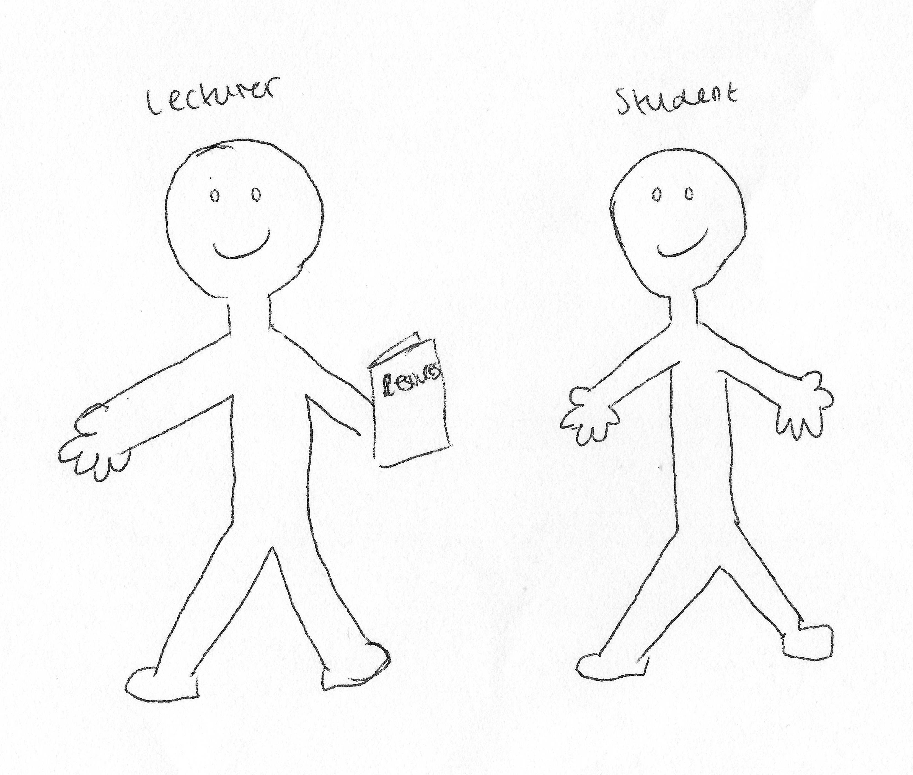

I: Okay so what have you drawn there then?

P: So, it’s just the idea of lecturers giving students resources more – rather than just what’s recommended for class reading, maybe anything extra, any additional reading they think just that we’d be interested more, personally [sic]. Any – if they’ve written in a journal about something, maybe that we’ve expressed an interest in they’ll, sort of, directing us to have a look at it [sic], for just more our enjoyment, rather than for what’s required.

I: Okay, cool. Brilliant. Thank you. Now can I ask you to draw the opposite [laughing].

P: Oh God.

I: A bad relationship?

P: [pause for drawing] Yeah…

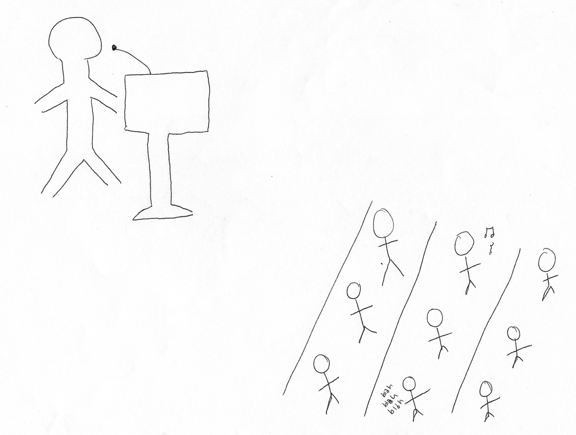

I: Okay, what do we have here?

P: So, this would just be, like, in a lecture when people get – people aren’t getting engaged so people will sit with headphones in, or they’ll just be texting, or people will start playing Snapchat videos, because all the lecturer does is just stand in front of the, like, podium thing just reading out and nobody wants to – nobody’s listening, nobody wants to put their hand up or ask questions.

I: Okay, brilliant. Thank you. Okay, this is the last one I promise.

P: [laughing].

I: [laughing] Can you draw your conception of your relationship with the university, as a whole?

P: Oh God.

I: Everyone finds this the hardest one [laughing].

P: [pause for drawing] Yeah…



I: Ok what do we have here?

P: Okay, so I see the university as lots of different relationships, so obviously the student side of it and obviously I’m here for education, but also I work for part of the university so I see it as that side of it as well, and it’s giving me the job I work for, like, outreach and we do work with schools in local community for, like, encouraging them to be able to come to university, so I see it as that as well, as more of a – they’re having a bigger relationship with the community, rather than just students and giving me the chance to be able to, sort of, give me career advice and information and experience. And then I see it as more, giving me the chance to do extracurricular and get involved in the – where I do outreach, get involved in student representation, giving more than just being here as a student, being here as a person as well.

I: Okay cool. Thank you. That is the last one I promise [laughing], no more drawing. Okay. So, there’s a lot of encouragement for undergraduates to engage with different experiences that the university offers during their studies, such as joining societies, or volunteering or getting involved in the Student’s Union. So, what are your thoughts on this?

P: I think it’s really good. When the first week – in the fresher’s week, one of the big events is the Fresher’s Fair and all the societies, the sports teams, are there and that’s really good for undergraduates to go along and get more – see what else there is to university. But I think a lot of – in the first year, I think it’s – not a bad thing to be joining societies and sports teams, but I think in the first year, you don’t know how much work you’re going to need to be doing and how much time you’ve got, so I wouldn’t want to do anything until second or third year. I think, as much as you are here to do clubs and more – meet friends and things, you are paying to be here so in the first year especially, make sure you are getting a good foundation to your actual education side of it.

I: Okay. What… [muttering to herself] Oh you’ve answered that one really. How valuable do you see the Student’s Union as a space dedicated to students?

P: It is really good, they’re very – yeah it is really student orientated. All of the elections are dictated by us, we all vote online, and it’s very, yeah very student-led where the ways – with the type of events they run, it’s a focus on student enjoyment and student wellbeing, is the big focus. But they also – the wider community also takes a big role, [removed for confidentiality], so it was giving the university a good name in the wider community as well. It was good.

I: Yeah, okay. Do you consider yourself to be a part of the Student’s Union?

P: Yeah on a – I wouldn’t want to do – because there’s Sports representatives and actual Union leaders, but because I’m part of the student representative for one of my [removed for confidentiality], we go to student-liaison committees and that’s part of the Student’s Union – we have to do training for it, to be able to get feedback to lecturers. So, I do on a, sort of, less basis than – I would never want to do the Union President or anything like that, but I’m – yeah, a little bit involved.

I: [laughing] Okay. How much of a valued member of the university do you consider yourself to be?

P: Quite – yeah, quite a lot. They are very keen on everyone mattering so it’s – even the little things, like giving us the chance to vote for the election, the Union President, it’s taken into consideration what everyone thinks. It isn’t just, like, all the same, I don’t know, 10 people doing the same thing every time, like everybody else gets an opportunity.

I: Okay. Brilliant, that was the last question so thank you very much for your time and your answers, those were really valuable. Do you have anything you want to add that we haven’t covered?

P: No, no.

I: No? Okay, brilliant. So, if you want, I can send you a copy of my analysis when I’ve done all my interviews, if you’d like to see it.

P: Ah yeah!! Thank you!

I: Yeah? [laughing] That’s okay.

[End of Recording]

