Interview #5 Transcript: Second Year Female English Literature and Media Student (27.11.17) (University B)

Interviewer (I): Okay, so why have you chosen to do an English degree at this particular university?

Participant (P): So, I chose to do it here, particularly, because I’m from [location removed] originally, and then I moved back to [location removed] with my family and then I decided to come back up here, just to, kind of, re- kind of live around here because, obviously – well when I was little, nothing was, kind of – I didn’t really know anything so, yeah, so that’s why I decided to come to [location removed]. But to do English, I do – I combine it with media and communications as well, and I decided to do both just because it gives me a broad, kind of, scope for possible jobs or further education afterwards because I don’t really know what I want to do, but, yeah, I feel like I’ve got a lot that I could do now so…

I: Okay, are you the first in your family to go to university?

P: No, my mum and my dad have been as well.

I: Okay. What does value for money mean for you, and is it important that you get value for money from your university?

P: Yes, well yes obviously, because it’s not cheap [laughing]. I think that, maybe, having enough lectures and feeling like you can go to your lecturers or your tutors outside of the, kind of, your lecture hours and feeling like they’re not going to be like, “Oh you can’t come to me now” because they’re not supposed to see you now, kind of, thing is all part of it, because I don’t have any contact hours timetabled on because there’s quite a lot of reading I have to do so that’s my independent study, whereas some of my friends have loads and loads of lectures and they do placements and things like that, so I feel like sometimes they’re getting a better value for money but, I don’t know how good their support is whereas I think ours is quite good so… But yeah, I do think it’s definitely important because you’re already in like, I don’t know, £9,000 a year debt, without your loans, maintenance and things, but yeah…

I: Okay. Do you agree with paying fees?

P: Hmm [pause] Yeah, well, I don’t know, I haven’t really thought about it before because I know that in some places you don’t have to pay at all, like in Scotland I think you don’t, and some places in Europe but, so then I think about that and I think “Hmm” that we shouldn’t pay fees either and because you don’t pay for your primary and secondary education, unless you go to a private school so [pause] maybe no I don’t think that. I think it should probably be less, because personally I don’t think that anyone gets enough contact time to pay £9,000, it’s not like – we’re still paying for our accommodation separately so it’s not like boarding school or anything, where it’s all included. So… but then, if you earn – if you get a good enough job at the end of your degree and you earn enough to pay it back then, maybe, it’s not so unfair, I don’t know, but yeah, maybe we shouldn’t be charged, I don’t know! [laughing]

I: Okay fair enough. What does being a university student mean to you?

P: I think that it means – well I quite like the fact that I’m a university student because the people that don’t go to university, I don’t know, they slightly have, not that they have less opportunities, but it’s just when you live away from home, if you choose to, you – like I’m at the [removed for confidentiality] to my family so, you just learn so many more skills than just doing a job I think. So even though I’m not practising a job as such, I’ve got a part-time job and I feel like you’re so much more independent too, being a university student too, you just get a well-rounded experience, as well as the actual work aspect, and obviously it’s a challenging thing to be a university student, otherwise, what’s the point in bothering? But I think it, kind of, shows, or it builds you into a good, well-rounded person I think, especially if you involve yourself in with societies and things like that as well, because I don’t think that life is all about just studying. I’d be so bored [laughing].

I: Okay. What do you think being a university student means to people outside of the university, or people that have never been to university?

P: Depends who you’re talking to because if you’re talking to someone who is maybe – they don’t know anyone who has ever been to university and they’re from, maybe like a less stable background at home and things, they might think it’s a little bit elitist to go to university, which in a way it, kind of, is because you sign your life away to being in debt, and you – or, kind of, being in debt – and you have to pay loads of money to study something for however many years so, in a way, it kind of is, a little bit. But if you talk to someone who’s just chosen to – to not go to university because they can’t think of anything to do, or they are more, kind of, practical then, I think they’d probably say it’s just not for them, kind of thing, I guess. I think you’ve got to be quite dedicated, or like quite diligent and dedicated if you’re going to be a uni [sic] student and if that’s not your, like if you’re not very good at that then, maybe it’s not for you but, I know loads of people who don’t go to uni [sic] just because they don’t want to live away from home as well, and obviously you don’t have to go that far away, you can go close to home, but lots of people just don’t go because they don’t want to have the independent-ness [sic] or they don’t feel mentally ready or whatever. So, I think it’s just – I think it means that they’re not ready, or they just don’t want to commit to something with lots of money and that they feel they might not get as much out of it as they’re putting into it, kind of thing. Yeah, I think so.

I: Okay, what meaning does the word engagement have for you?

P: I think being engaged with, like a study or something, you have to show an interest in it primarily because otherwise, if you’re not interested in it, then I find it really hard to engage with something. So personally, for me, we do quite a lot of reading of texts that are using really old English and sometimes it’s really hard to understand what they’re saying and so, because I can’t understand it, then I don’t find it interesting, because it’s just hard, so I don’t find it interesting and then I don’t feel like I’m engaging with it. So engaging with something, I think you definitely have to have an interest in it as well, but then being engaged, like with a person, I think – or in a work-based environment obviously – then, I think that they, like both people, have to contribute almost equal amounts, so if I go and see my tutors, I don’t want to just be talking at them and they just be like, “Hmm” or “Yes” or “No” because then that’s – I don’t feel like I’m getting anything out of it, whereas – but then if they talk too much and overwhelm what I have to say, then I feel like I’m not really progressing either because all my ideas either won’t have been talked about or will have completely been moulded into something that I don’t want to say so, I think it’s a two-way street, however way you look at it.

I: Yeah, okay. Okay, using what you’ve just said, in what ways do university staff attempt to engage you as a student?

P: In my experience, they offer tutorials if you’re struggling with, or even if you just want to see them about something, which I find really useful, I’ve just had a couple for my assessments which have just gone, and they also – especially my English side of things, I find that they really try to make the lectures and the seminars [pause] fun as well as educational, because then – like one of my lecturers he, every so often, he makes a joke about something which may, or may not, be relevant to what we’re doing, but it, kind of, brings everyone back to thinking about things, so I find when lecturers or whoever engage with you, I think it needs to be, kind of, like an equal balance, or it will be helpful if it’s an equal balance of technical jargon and understandable language because it just makes everything so much more interesting, and just easy to understand, and whatever, so I would say that, and then – well they do different styles, so lectures and seminars, and I find the seminars are more engaging than – or seminar as workshop or – are more engaging than a lecture, because you’re just being talked at in a lecture, whereas you have the – or you have more of an opportunity to interact in a seminar, which I find useful. And then, apart from that, there’s emails and things like that, but it’s better to see someone face-to-face I think.

I: Yeah. Okay. [coughing] What are your thoughts on the concept of student as consumer in higher education? Do you know about this?

P: Yeah, kind of, well I think I know. Well I know what a consumer is.

I: Yeah!

P: I think that, well you consume a lot of knowledge obviously, and – well [pause] I don’t know, can you, kind of, explain it a little bit?

I: Yeah course, yeah so, there’s been loads of stuff written about student as consumer, in that students are now, sort of, being framed as customers rather than students, in the first instance. So, universities are more concerned with pleasing them as customers rather than treating them as students, like they should be. So yeah, I mean, what are your thoughts on that? Do you notice it? Is it impacting on your experience at all, or…?

P: No I wouldn’t say it’s that noticeable, I mean I know there’s – obviously there’s a, kind of, customer service almost, aspect, because you are paying for a service, rather than being given a service because it’s what should happen, like in secondary school, I don’t think it’s that noticeable because the tutors and your lecturers and things, to me, they seem a lot more, like friendly and, kind of, like – it might just be because we’re adults now rather than we were children, so they’re not talking – they’re not talking down to you in any way, there’s some sort of hierarchy, I feel like there’s quite a balance in – kind of a balance in power because you use first names to speak to them, they’re not Mr whoever, or Mrs, so I don’t think it’s that noticeable personally, but I do understand that obviously there’s a lot of buying and selling so they’re probably – it’s some sort of stress on giving – like the time that you have with a pupil should be of the highest quality because that’s your contact and that’s what they’re paying for so… But I don’t think that I’m not treated as a student, and as a customer instead, I don’t think that.

I: Okay. Do you consider yourself to be a customer?

P: A customer of some things, so like if I go to like Business Fairs and things that the university put on, I feel like I’m, kind of, a customer of that because they’re trying to sell you their placements, or their work experience, or their free pen even [laughing] so I feel I’m, kind of, a customer at those kind of events, but in my day-to-day [pause] university lecture-life, I don’t feel like I’m a customer then. I wouldn’t say so.

I: Okay. Do you think paying fees gives you more entitlement as a student, and if so, what kind of entitlement?

P: Yeah I think it does actually, because I think that if you feel like you’re not getting out what you should of your degree then, I think you are entitled to ask for more, or you should – I think every university student expects some sort of level of, like duty of care, from your teachers and like a variety of topics that you learn about and, your hours that you have in contact and how willing your tutors are to see you outside of your contact hours, so I think there’s that, that you should definitely expect something otherwise then your quality of university experience might not be as good as it could have been, so I think you have the right if you don’t feel like you’re getting that, then you should ask for it. But we also have, like, mid-term feedback sheets for each of our modules, and we can fill them in and it says, like, positives and negatives of the teaching, the teacher and the whole module itself, which I find quite useful because they – or it shows how they’re integrating things that we actually want, and I feel that’s quite a fair way to get an insight from us to the lecturers as well, without it being like we’re making complaints, it’s more constructive that way.

I: Yeah, okay. Okay, so moving on to learning. How engaging and/or useful for learning, do you find lectures?

P: I actually find them really useful. I quite like being talked at and being able to write down things that they’re saying, but I find PowerPoints specifically really useful, because if someone is just talking at me without something written down, like I like to copy and then I’ll rephrase it, rather than just be talked at, because then it’s hard to keep up, so I find like visual learning aids really useful. But in our lectures, because most of them are 2 hours or 3 hours, we normally separate it into like half and half, so we have half a lecture, and then half what they call a workshop, so we do slightly more like seminar-based activities as a big group, which I find really useful because I like to hear other peoples’ thoughts, rather than just have my own, because then I can expand on my own thoughts. I do find them quite long sometimes though, a lecture, sometimes I think I prefer to have a longer seminar and then a shorter lecture, whereas in most cases, it’s the other way around for me, which is slightly inconvenient [laughing]. Yeah overall, I think a lecture is quite interesting, and I like to hear what the lecturer has to say and if they expand on what they’re talking about then that’s particularly interesting, especially if it’s their realm of study, like separately to uni [sic] as well so…

I: Okay. How engaging and/or useful for learning do you find seminars?

P: I think they’re equally as useful as a lecture, but just in a different way, because in our lectures you hear more of your lecturers’ thoughts, and then in your seminar, you hear more of your peers’ thoughts, so – and I think, and obviously your lecturer comments on them and stuff, but in – when we do like close reading of things in our seminars, then it helps to pick out bits that we should be focussing on, whereas if you’re doing that on your own, you might not have picked it up. So, I think that we have quite a good balance between the two. Yeah, I like seminars.

I: Okay. Where do you choose to sit in seminars and lectures? Like, the back, front, middle, or do you not have a preference?

P: I don’t like – I like probably around the middle really, because I don’t like to be so far away that, if I want to say something then, I have to shout it, but I don’t want to be right at the front either [laughing], I like to be a good middle ground.

I: Okay. How engaging and/or useful for learning do you find one-on-one sessions with tutors?

P: We don’t have that many of them, you have to schedule one if you want one, so my experience – I didn’t have any last year, but my experience of them this year has been that they’re actually really worth my time [laughing] so I’ll probably do more of them now. But yeah, I think when you have the sole attention of your lecturer, or whoever it is, then – especially when loads of other people aren’t listening, you feel like you can say exactly the point you want to make, rather than being worried that your peers are going to, I don’t know, it’s not that they’re going to laugh at you but, it’s just like extra pressure, isn’t it? So I feel like they’re really useful but I don’t think we – I’m not sure if there’s a limit to how many you can have [laughing] but it seems to be that you can’t go all – like every week [laughing] so – but yeah, I do actually think they’re really useful and I would probably recommend that to – if I had to recommend a session to have, I would say definitely go before you’re writing your, before you start writing your – if I was to talk to my younger self or something, definitely go and speak to your teachers because they’re not there to criticise you or bash you [laughing], they want you to do well so, if you – the more you say, the better you’re going to do, I feel like.

I: Do you think they should be something that’s scheduled all the time, like lectures and seminars?

P: I feel like yeah, but I feel like you should be able to say it’s an optional thing so, if you want them, maybe like, once every fortnight or once every 3 weeks or whatever, you – there’s one scheduled, but you don’t have to go to it, if you don’t want to, because I know lots of people, they don’t like going and speaking to teachers, just in case they say their opinions or they’re going off in completely the wrong direction, that can stress people out. So, I feel like if you want to go then, they’re there for you, but if you don’t then, you don’t have to. So, I feel like that would be a good system actually.

I: Okay. Do you ever find them intimidating?

P: Yeah, I was actually quite nervous when I went to my first one [laughing] but it’s, kind of, like the fear of the unknown though, because you don’t know what they’re going to be like when there’s not a big crowd of people so, having them on their own, like right at the start, you don’t really know what to say so I was like, “I don’t know what to say” [laughing]. I didn’t, yeah – so yeah, but if you have a friendly lecturer or seminar leader anyway, I feel like it’s a lot less daunting than if you have one that’s quite intimidating just anyway. I would be more – I’d be less inclined to go to one that was – there was a barrier between the pupils and the lecturer because that would just really not make me want to speak to them about anything but fortunately, my lecturers are quite friendly [laughing] so I don’t feel, like, I don’t feel scared about it.

I: Okay. Is there anything you particularly like about the learning style of universities, compared to compulsory education?

P: Yes, there’s so many things [laughing]. Well I love that – even though it was like it in A-Levels, I love that you’re treated as an adult, like you’re their equal, kind of thing, the lecturer’s equal. Not necessarily in academic knowledge, otherwise you wouldn’t be there, but in adult, just like your adult life, which I really like, because I hated being patronised, it’s so annoying [laughing]. So yeah I would definitely say that is the best thing, but I do like that you’re all there to learn the same thing, otherwise you would choose a different subject or whatever so, rather than in your compulsory education, you’re in a mixture of people, like in most cases if you’re in your tutor group or something, you’re in a mixture, a mix group, or some people who are really academic, some who don’t care at all, some who are really practical, like, such a mix, whereas you know that everyone is there to learn the same thing in your lectures and things, which is helpful and we have – we used to have last year, people from second and third or fourth year, or postgrads or whatever, they came to talk to us about our degree, and the session was there once a week and you could talk to them about what you were studying because they would have done the degree already so they know what you’re doing, so I found that useful. [pause] But yeah, I do think it’s so much better if you’re mature enough for it [laughing] and you don’t need that system, but obviously, in your compulsory education, you have to go to school, whereas in – you’re on your own time in your lectures so if you don’t want to go, then you don’t have to, but if you don’t do as well in your assignments, that’s your fault kind of thing so, yeah.

I: Okay. Do you always understand what your teachers are explaining to you, or the material you’re set to read?

P: No not always, especially if it’s particularly old or, if we’re set to read something in advance of a lecture or a seminar, sometimes you don’t know how relevant – if it’s going to be relevant or not because some of the further reading we have to do is a little bit abstract and it’s just about a theme rather than a text, so sometimes I’m reading it and I’m wondering, “What’s the point?” but, until you go to the lecture and, if you discuss it, it kind of becomes clear so, that’s useful – it’s kind of useful and not useful at the same time. Sometimes I feel like it needs to be the other way around, like you do reading afterwards to, kind of, back up what you’ve learnt, but then I don’t know what you’d talk about in the lecture so, I don’t know [laughing]. But yeah, I don’t always understand it fully, but then I feel like your lectures always clarify things, unless it’s your assignment and then if you don’t understand, you have to rely on your friends or a website or something [laughing]. Yeah, it’s hard because some of the stuff is quite – I find lots of critical reading, especially for English, the words they use, like the vocabulary, sometimes so, I don’t know, the words are so lengthy that I’m – it’s just like I don’t even understand the first sentence [laughing], and that just puts me off, so I don’t want to do it [laughing].

I: Okay. So, would you say your lack of understanding is more to do with the language they’re using than what they’re actually saying?

P: Yeah, yeah, I feel like, as soon as you get into it, it’s almost like the initial – it’s the hardest to do the first page than the rest of the book, because once you – once you get into it, then you’re fine, because if you don’t skim read a little bit then you understand what their point is, but sometimes, it’s just the first, like, getting-going as soon as something you don’t understand hits you, you don’t want to – or sometimes you don’t want to try anymore, if it’s, like, late at night [laughing].

I: Okay. From your own experience, is there anything you would change to improve your own learning, in terms of either your teaching you receive, the resources you have access to, curriculum and assessment, or anything else?

P: No, I think they have quite a varied curriculum, and I appreciate that we have quite a lot of ongoing assessment rather than exams, because me and some of my friends, who struggle with exams, so doing coursework, where we have a bit more time to think about it is really useful for us. So, in media I have no exams through the whole of my degree and in English, I only have one at the end of every module, so… But we’ve always got something ongoing, which I find much more useful than always having exams, because otherwise you have to revise all the time and know what you learnt in year one – like, in your first week and what you learnt in your last, so I find that stressful. So, in that respect, I find that – I like the way that that is, I wouldn’t change that, although I might get rid of the exams if I had a choice [laughing] because I really don’t like them, but I can’t complain because if I went to another university, it could be all exams and no coursework so… Teaching? No, I quite like the way we’re taught, I find it quite helpful in every aspect. Resources? Maybe if we had more – because we have lists of secondary reading, but it’s not necessarily chunked into the week that it would have been relevant to or, like, even if it’s chunked into themes that it relates to, that might be quite useful if we’re thinking about focussing on a specific theme or period or whatever, for an exam, then we know exactly where to look rather than having to read all of the reading to find out what’s relevant. So that might be useful, but apart from that, I’m quite happy actually.

I: Okay! Okay, I sent you the document that refers to the Student Charter [name changed], this document [hands student the document]. In your opinion, how evident is this policy in your day-to-day experience of being a student here, if it is at all?

P: [laughing] Well, in the [removed for confidentiality] section, I think that the way that students are enriched in their whole student experience is actually really good here, because I feel like there’s always something going on that you can volunteer for, you can be an ambassador, or you can be part of a million different clubs, or I feel like – or my experience of lecturers, they’re pretty friendly so if you want to go and interact with them, you value their time and they value yours, rather than it being just a one-way street, and it says they value the development of the whole person which I think is true, because in some of my other friends’ experiences, they have said to me about they don’t feel like – or they just feel like they’re there to learn something rather than actually, like, become an adult as well. So I feel like there’s loads of workshops that you can do and extra things you can do for your degree, like I do the [University B] [removed for confidentiality] and you can go to all of these workshops, which are about bettering your skill set, so you can do one about communication or, maths, or whatever, whatever it is, you can go and do it and I don’t even think you have to be part of the [removed for confidentiality], if you want to do it, you just have to go. So I think there’s lots of things that maybe people don’t know about that you can do, so maybe it’s worth promoting them a bit more, because I only know about the [removed for confidentiality] because I’m an ambassador for the uni [sic] but I don’t think I would have known otherwise, which is probably something that they should think about, but… [pause] I think the Student’s Union’s pretty good with involving students and things and I think the Student’s Union, like, the presidents, I think they’re really good with interacting with the pupils as well, because they’re almost – they go along to every event and they’re your friend rather than they’re there to, like – it’s not like they’re managing the Student Union, they really want to do it, so I find that really, kind of, supportive in a way. [pause] But yeah, I think that’s all I have to say about that.

I: Yeah, okay. Have you ever seen this document before?

P: Yeah.

I: Yeah, okay. Okay so in your opinion, should undergraduates have greater control over, on input in, the curriculum and/or assessment design of their chosen courses?

P: [pause] Yeah well, I want to say yes, but then it would be really hard to please everyone and if some people really wanted, say, exams and other people really wanted ongoing assessment, if they broke it up so that half could do half and the other half could do the other half, then I feel like it would be really hard to compare whose degree is better, kind of thing. So, I feel like having a balance of both, like I do in English, is quite fair to everyone, who wants a bit of both. But – so like having input would be really hard for a student I think, maybe into the curriculum because then you could – well I don’t know, because in your second and third years, you choose the modules that you want to do anyway so that’s, kind of, your input and then your teachers choose the texts because if you choose a module that you have no idea about and you’re just doing it because you’re, you might be interested and it’s something new, then what would you have – you wouldn’t have any input in it anyway because you’re there to learn so, no I think it’s probably okay as it is, actually.

I: Okay. In recent government policy on higher education, students have been placed at the heart of the system. So, for you personally, how central or important are students in this university?

P: Pretty important I’d say, probably of the highest importance, because I feel like everything is there to make your student experience really good so, all your – all my lecturers seem really enthusiastic and they’re there to help and all the, like, the volunteer numbers for when there’s Open Days, they seem pretty high, when I go round and, like, if I take part or whatever, there’s always loads of people who do it, which I think, like, if you’re volunteering, it shows that you’re actually, like, want to encourage other people to come [sic] and I feel like their accommodation is really good and the way that you feel secure in your accommodation is really important, especially for people who’ve moved quite far away from home, and I feel that there’s a good all-round sense that everyone wants, like, the best for their students so, rather than it just being, “We want you to do really well, academically”, like, everyone seems to want everyone to do well, like, socially and sportily if you’re sporty, or musically, or whatever you want to do, I feel like there’s a good, kind of like, equality of everyone wanting everyone to do well in whatever they’re doing, which I think is really nice and really important, so yeah.

I: Okay. Okay, what meaning does the word relationship have for you, in the context of interacting with university staff?

P: Well I feel like there should be, always, some sort of student-teacher relationship because – or like feeling to the relationship, because you are there to learn from your tutor, so if that wasn’t there and you were just talking to them like a friend, it would be weird, and not appropriate either but, I feel like if you’re, like your teacher or whoever, acts as though they are friendly then that makes the relationship between the two so much more open and you feel like you can express your thoughts and your ideas rather than feeling like you can’t, so… But I feel like, maybe, the relationship changes between – like when you move forward as a student, so if you are taught by someone in year one, year two and year three, I feel like you have a more close relationship – well obviously you have a more close relationship because they know you more but I feel like then the relationship is more, it feels more like they’re there to really encourage you to take up that in your further life and things like that, take up that study, whereas in your first year, then they’re there to encourage you to really like the university experience and give you a well-rounded first year and to encourage them to do their specific line of study, whereas once you’ve chosen it, they want you to feel enriched, rather than just like a student.

I: Okay, what do you consider to be the main purpose for building a relationship with university staff?

P: [pause] The main purpose? Well if you don’t have a relationship, if you don’t have a relationship at all with your university staff, then I feel like you’ll struggle a lot more than if you do because if you feel like you can’t go and talk to them, then I feel that maybe you’re not getting out of your student experience what you should, and then you might need to think about, “Do I need to say something to someone about, like, how can I feel more encouraged or whatever?” Whereas if you talk to your lecturers and you feel like you have a good relationship with them then, your student experience will automatically increase in – I can’t think of the word [pause] being a good experience so… I think that’s probably the main purpose.

I: Okay. So, is this purpose actually apparent in your relationships with staff, or is that, like, the ideal scenario?

P: Probably a bit of both because I feel, personally, like, all of the staff are really kind and helpful and they want the best for you, and if you email them then they’re pretty quick to email back and they’re – even their emails seem, like, nice and, kind of like, nurturing. Whereas – but then, I don’t know, I don’t think everyone feels like that so, it’s, like, their ideal situation because no one wants to feel like they can’t go and speak to someone if they’ve got a problem or, if they’re really worried about something, so I think it’s probably, like, it is the ideal situation for everyone because I don’t think everyone feels like that currently but, personally, I feel pretty comfortable with my student experience.

I: Okay. Do you consider there to be a link between the relationships you build with staff and your levels of engagement as a student?

P: Yeah I do definitely, because if you don’t feel comfortable with the member of staff or they don’t speak in a way that, kind of, like, peaks your interest or they don’t use language maybe, that you would use, then I feel like the relationship is probably harder to build because lecturers who constantly talk to you like you’re always thinking in that academic mind-set, don’t engage as well as with someone else who does, because it’s tiring to always think like that [laughing] so yeah, if someone is talking to me like – not like colloquial but in just a relaxed way then I feel like your engagement is so much better than with someone who talks to you like a student all the time. Yeah.

I: Yeah, okay. Okay, can you describe to me a typical face-to-face encounter with a university staff member? So, for example, when you go and talk to them to discuss an essay, what actually happens in the interactions?

P: So, normally I’ll go to their office or, well normally their office, but you can go to somewhere if you don’t feel comfortable in such a confined space, you can ask to go to, say, the little café or something like that, and then they’ll give you the opportunity to talk to them about what – well what question you’re doing, why you’ve chosen it and then, like, three or four main points and your arguments for those points, and then they might chip in a couple of times about, like, to clarify something you’re saying or, to give a little development or something, but in my experience it will never be they’re trying to put all of their opinions onto you, which I think is really important because if that happened to me, I would feel, kind of like, less confident afterwards than when I went in. So yeah, and then after that, after like you’re one-sided, kind of, lecturing then normally they will give you, like, a couple of pointers or say something like, “How does it link to the question?” or, “In what order are you going to put the points so it flows?” something like, kind of, structural but – and then, they normally tell me some bits of secondary reading that might be useful if I say I’m struggling with that, or if I say, “I want to put this point in but I don’t know how to put it in without sounding like I’m just, like, leaving a chunk that doesn’t really make sense” they might give you some ideas, or advise you to leave it out or… Yeah, it’s, kind of like, they’ll give you advice but they won’t ever push their ideas onto you and they’ll always – even if you’re really struggling, you don’t really have that many ideas and you’re just there for, like, a bit of support, they’ll always find something positive to say, and even if they give you constructive feedback, there’ll always be something positive, which I think is really important as well. Yeah so that’s pretty much standard.

I: Okay, are you ever aware of a hierarchy when you interact with staff?

P: I wouldn’t say it’s, like, that apparent but you, kind of, know it’s there just because just I think it’s, like, drilled in during your secondary education that it’s, like, respect kind of thing. But I feel like, in your higher education, the hierarchy’s more balanced because you’re both adults and I feel like, if you respect them, then they respect you as well and it’s more that all ideas are accepted rather than there’s, like, a right and a wrong answer, so there’s always space for a student to develop and maybe even a lecturer as well. But I don’t think there’s a massive hierarchy anymore, but I think it’s more apparent in your compulsory education, I think.

I: Okay, can you think of any particularly good relationships, without giving away who they are, with any university staff, and tell me why you’d characterise it as good?

P: Yeah, my relationship with my current English lecturer is really positive, I would say, because they always treat the interaction like it’s professional, but it’s not, [pause] like – it doesn’t feel like forced, like they have to be there, it’s quite natural, and I feel like they treat the interaction like there’s no, sort of, hierarchy and there’s always – you feel like you can contribute as equally to a discussion as they can, rather than it being one-sided either way, so I feel like it’s quite a well-rounded conversation or lecture or whatever you’re having. Yeah, I think that would be what I would say is good about it.

I: Okay, now is the fun bit that everyone likes to do. Can I get you to draw your conception of a good relationship with a staff member? So, anything you want to draw, however you visualise it in your head [laughing].

P: [laughing] [pause for drawing] I might do stick men, it’s easiest. [pause for drawing] Looks like they’re a chef [pause for drawing] quite hard to think now [pause for drawing]. There we go.

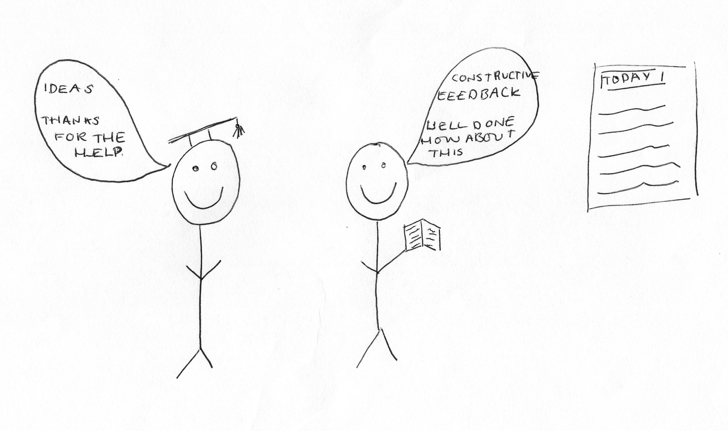

I: Brilliant, okay so let’s – can you explain to me why you’ve drawn this?

P: So, the teacher and the student are both standing, I don’t know, that doesn’t mean anything, but they’re both, like, on an equal level so I didn’t draw one sitting or one taller than the other so they’re both of equal hierarchy. They’re both smiley because they are, like, the teacher’s enjoying hearing the student’s ideas and hearing that the pupil feels like they’re developing, and the student is happy because they’re receiving constructive feedback and, like, encouraging words like, “Well done” and things, and there’s a well-written and presented PowerPoint on the wall because the teacher cares about the student being able to understand what they mean in the lecture and also be able to access it at home if they miss a lecture, or they need to revisit it, and the student is happy about that [laughing].

I: Okay brilliant, thank you very much. Now can I get you to draw the opposite, so a bad relationship?

P: Mmhmm [pause for drawing] There.

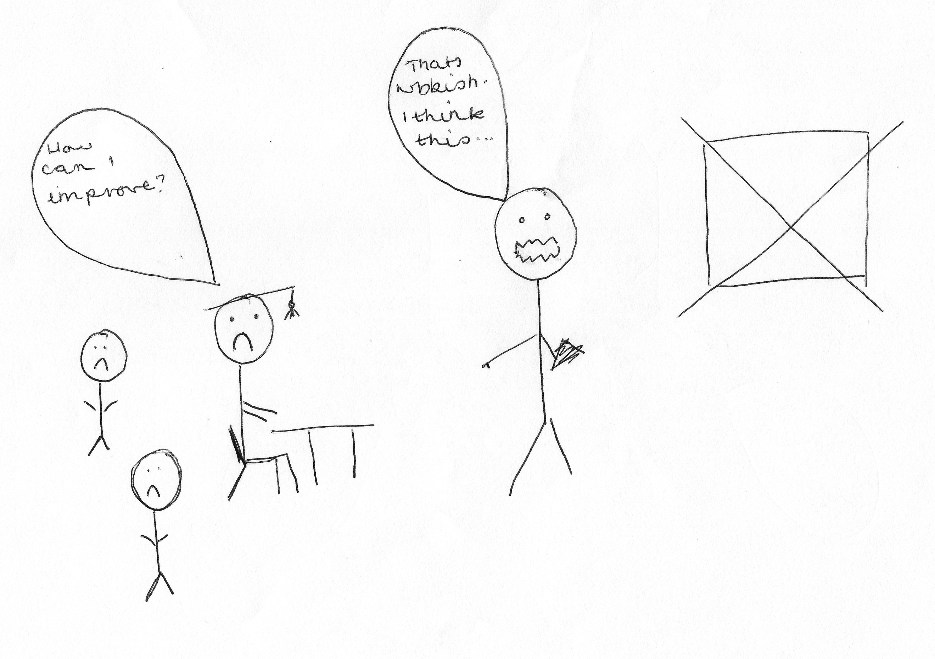

I: Okay.

P: So, this pupil and the others, but I didn’t draw that many, they’re all sitting down in a classroom and they’re trying to express their ideas, but the teacher is projecting their own ideas, rather than trying to either re-work or develop the student’s idea. They’re, like, singling people out because they’re pointing, and, not shouting, but using a raised voice to, kind of, discourage that pupil, and therefore, the other pupils from saying anything. They don’t have a book and they don’t have a PowerPoint, so there’s no visual learning aids, or anything to help contextualise the work that the teacher and the student are doing.

I: Cool. Thank you very much. Okay this is the last one I promise [laughing].

P: [laughing].

I: Can I get you to draw your conception of your relationship with the university as a whole?

P: Yup. [pause for drawing] That’s the smallest bubble ever [laughing] [pause for drawing] There.

I: Brilliant, what’s this?

P: So, the student in the middle is happy because the university have helped them find, or like they’ve got a good housing system for first year and they help them find nice housing for second year. The uni [sic] itself, like, the buildings are well-managed and they have lots of things in them to help encourage students, whether it be posters or staff, and they have cafes and big library. The teachers are encouraging and they’ve got little books to help, and they give nice feedback. The university helps with student finance and if you’ve got any worries you can go to them. They provide lots of things with the Student’s Union so, like, music and sports and volunteering, you can be an ambassador and wear one of the little [removed for confidentiality] “How can I help?” hoodies at, like, events and they encourage you to have a good social life rather than just solely, like, focussing on your studies so there’s often posters around for, like, summer balls or winter ball or whatever, and the uni don’t take them down.

I: Brilliant, excellent, thank you very much for that.

P: That’s okay [laughing].

I: Okay, last couple of questions. There’s often a lot of encouragement for undergraduates to engage with different experiences that the university offers, such as joining societies or taking up volunteering, or getting involved in the SU. So, what are your thoughts on this?

P: I think that it’s, not necessary, but I think it’s important that you even try something, so, like, or even if you don’t directly get involved with a society yourself, if your flatmate is doing, like, a social event and they ask if you want to go, I think it’s important that you at least try it and then, if you like that and you like the people, you might like actually doing the society event. So, I think trying to get involved with at least something that is either going to make you more confident, or it’s going to look good on your CV if you do, like, volunteering or, even if you do part-time work in the cafes or being a cleaner at the library, I don’t know, or you can help move in the Freshers and do all the Fresher’s events. So, I think it’s important that you try something, just maybe push yourself a little bit outside of your comfort zone, it might just, like, change your whole student experience.

I: Okay, do you ever find there’s issues concerning trying to balance learning and extracurricular?

P: I feel like it’s more of a problem in your first year rather than any other years because in your first year – well in your first year it’s not so bad because you have to do well, but it doesn’t count towards your final degree, so you can, kind of, test the waters to see how much work you need to do and how much fun you can have and if you need a part-time job and things like that so, I think having first year where it doesn’t actually count towards your degree is actually, like, so useful to just make sure that you’ve got that, kind of like, set in stone before you actually have to work even harder and things, but I don’t think that personally, it’s a massive problem. But I try and do lots of things, but if it feels like I’m getting, like, if I feel like it’s going to get too much then I’ll stop and just focus on my uni work so, yeah, I think it’s knowing when to stop and just focus, rather than carry on and have no money or whatever [laughing].

I: Okay. What are your thoughts on the role of the Student’s Union, in terms of engaging you as an undergraduate?

P: I think that they play quite an important role because they do put on loads of events at the SU and, like, even volunteering work, they do quite a lot of that as well, and they always put up posters and try and get lots of people involved and they always show their faces at big events, like the sports things and whatever they’re doing. So, I think that it’s quite important that they put on quite a lot of events as well, especially at the start of the year because when the Freshers come and they don’t really know anyone and they don’t know what’s good to do where, especially if they’ve moved a long way from home, then if they have events where they can go and meet people and then, I think that’s a really important thing to have on, rather than it just – having nothing on and the Student Union being not very interactive.

I: Okay. Do you consider yourself to be a part of the Student’s Union?

P: Not really. Well I don’t know, I’ve done some volunteering for them, but I don’t consider myself to be a part of the Union as such because they – it’s quite like a – it’s welcoming, but it’s quite like a close-knit team of people who make lots of things happen so – but I feel like I could go to the Student’s Union and participate with all their activities but I wouldn’t say that I’m, like, a part of it myself.

I: Yeah, okay. Okay last question then. How much of a valued member of the university do you consider yourself to be?

P: I feel like even if you don’t participate and do loads of things, I feel like you’re – or I feel like I’m quite valued just for, like, little things that you do, so like if you choose to turn up to a lecture and it’s only, like, you and one other person then the lecturer is like, “Yay! Thank you” and they’re not like, “Oh there’s only two of you” they actually will still put on a good lecture and session and things and I feel like there’s loads of things for students that they can get involved with where you can feel like you’re a part of a big community of students as well so, like, in a couple of weeks they put on some carol singing at the [location removed] and if you’re a student, then you get it for free, well it’s, like, first come first serve but if you get tickets then you can go for free, so then you can go and feel like an adult because there will be other adults there, but you can feel like a student because you’re part of a students’ group that might be going. So, I think that makes you feel, like, valued because there’s special things on for students – there’s special things on for students, like, all the time and they have great facilities, and I feel like if the uni put effort into making the buildings look nice and putting on events and things like that, then it will make the students want to get involved loads more, rather than just not have a very, like, well-rounded experience.

I: Okay. Well thank you very much for all those answers. Is there anything you want to add that we haven’t covered?

P: [pause] Don’t think so, no.

I: Okay.

[End of Recording]

