Interview #6 Transcript: First Year Female English and Creative Writing Student (16.02.18) (University B)

Interviewer (I): Okay, why have you chosen to do an English degree at this particular university?

Participant (P): Well, I saw online that this university was one of the top universities [removed for confidentiality], just because of the atmosphere, the location, and the, kind of, town it is. Out of all 6 of my choices, it was the closest to home, it was just easier to do the only 2 and a half hour [sic] of travel, rather than, like, 6 hours. Just in case, which was a lot easier, and put my mum at ease.

I: Yeah, and what about English? Why did you choose English?

P: Out of all the subjects that I’d taken from GCSE to now, it was one I consistently got good grades in. I would have taken Art, that was my second choice, but I didn’t like how restrictive, kind of, the marking scheme was so I just decided to go with English instead.

I: Okay. Are you the first in your family to go to university?

P: I’m the first to go to university abroad. My mum has already done her bachelor’s degree, she finished last year, but that was back home. Obviously, she's a single parent looking after two kids so…

I: Okay, so do you currently live in the UK?

P: Yeah. I mean, like, away from home sorry, not abroad. Sorry [laughing].

I: [laughing] Oh okay!

P: It feels like it’s abroad to her anyway.

I: [laughing] What does value for money mean for you, and is it important that you get it from your university?

P: Value for money, for me, in a university sense, would be that each lecture and seminar, or workshop, that I do, I can take something away from, that I can put towards, you know, like, my grade later on or, I can use the skills I’ve gained here later on in life, depending on, like, what job I want to go to or where my interests lie.

I: Okay. Do you get value for money from this university, do you think?

P: Yeah, the lecturers are, like, very positive and are very enthusiastic about their specific fields, so it’s always nice to go to, like, a lecture when you know that the lecturer’s interested in teaching.

I: Okay. Do you agree with paying fees?

P: You mean for, like, this uni [sic] fee?

I: Yeah, yeah, so the yearly uni [sic] fee.

P: Oh. Yes, especially as this is, like, higher education and it’s something I’ve chosen to get a degree in, and I would say yes. It’s just maybe I’d like it to be cheaper [laughing], but that’s it. I mean the lecturers have to make a living, so I don’t mind.

I: Yeah, okay. What does being a university student mean to you?

P: It means that I’m investing in my future, in a subject that I have an interest in and I’m good at, which hopefully English is both. Yeah, I would say that when you tell people that you’re a student, there’s – I mean the reaction is always, you know, pride, because firstly you’ve got into university so you must have done well, but secondly it’s also, kind of, taking charge of what you want to do later on in life.

I: Okay. Okay, what do you think being a university student means to people outside of the university, or who have never been to university?

P: From the people I’ve spoken to, there’s usually a negative stigma around university, as though people that don’t go usually feel as though they’re expected to or pressured to. I mean some people, kind of, don’t want to have to stay in education any longer length of time than is required, and also that the fee is another issue.

I: Okay. What meaning does the word engagement have for you?

P: Engagement, for me, would be whether it’s just one person talking or, you know, a group, where whoever they’re addressing is, like, I want to say engaged [laughing] but that’s not really going to explain it properly. They’re, kind of, focussed, you know, and also interested in what the person has to say. I would say that would be engagement.

I: Okay. Okay, so using what you’ve just said, in what ways do academics attempt to engage you as a student?

P: Firstly I’d say, like, compared to High School, they’re, kind of, like, the stigma between acting as a student and acting as a teacher and the, kind of, line that you have to put between the two is gone, more or less, I mean my lecturers, like, invited us to create Twitter accounts and to follow them to get updates on the class and such, so they’re a lot friendlier. Obviously, they’re still lecturers and there’s still, like, a level of respect there, but that’s, I guess, one way of them being engaged, is also that they’re just much more approachable. I can’t remember half of them, kind of, swear in the lessons as well [laughing], which is also quite funny and they, kind of, you know, mention, kind of like maybe stories, or they talk about themselves as well as, you know, the subject material and they, kind of, give examples, but they also, you know, provide like websites or, like, events that you can go to, to kind of, further your knowledge in the subject or the lesson or the topic that we’re looking at it, which is also – they’re more up-to-date I would say, which is another thing that’s nice.

I: Okay. Okay, what are your thoughts on the concept of student as consumer in higher education, have you heard of this concept?

P: [shakes head]

I: So, when fees began, there was a lot of uproar in the literature on higher education about students being put as consumers before they’re put as students. So, sort of changing their subjectivity to a customer, rather than a student. So, have you noticed this, has it impacted at all on your experience, or…?

P: I haven’t really experienced that personally. I would say here, and in my subject, we’re definitely treated more as a student than a consumer because the lecturers are always really encouraging and they want you to do your best, especially as an individual because they try and get to know everyone on, like, a first-person basis. And also, with the [removed for confidentiality], they kind of, sort of, chase you up, asking you if you’re okay, like, if you need any help or anything – I mean they provide, like, a lot of support so, I guess if I was seen as more of a consumer, I don’t think that would maybe be as in place as much. Yeah, definitely.

I: Okay. What do you think about the idea of student as consumer, do you think it’s, like, a negative, a positive, for universities?

P: I’d say it’s slightly negative. Firstly, because it would dampen, like, a student’s attitudes towards, you know, learning and class if they’re, sort of, seen as more customers rather than students. Ultimately because it is so much money to, kind of, be boxed in, I guess, I don’t think it would be a good thing.

I: Okay. Do you consider yourself to be a customer in any sense?

P: I would say, maybe, but only because I have to pay and, like, because a lot of students have to go through, like, student loans to be able to come to uni and to afford it, but I guess only in that sense.

I: Okay, do you think paying fees gives you more entitlement as a student, and if so, what kind of entitlement does it give you?

P: I’d say yes, and as an entitlement I would say, if – well, it gives you more of a right to complain if the lectures aren’t up to standard, or you’re being taught in a way that isn’t beneficial, you kind of aren’t being taught at all, then I guess since you’re paying for it, you can, sort of, complain about that. But then also, you can give feedback on, like, how the lecturers are doing and, sort of, you request changes or ask them to teach in a different way.

I: Okay. Okay, so moving onto learning. How engaging and/or useful for learning do you find lectures, if at all?

P: I think lectures are good as, like, a groundwork for what you’re going to be looking at in a seminar, because usually it’s just the lecturer, kind of, talking at the class and informing them, to the best of their ability, basically what the subject is about and, like, the context behind it and, kind of, where it came about and the meaning and such, which is good, like if you – I’ve missed a couple of lectures and then I’ve, kind of, been at a loss or I’ve been a bit behind in the seminar, so I think they are quite beneficial as well.

I: Okay. Okay, so how engaging and/or useful for learning do you find seminars?

P: I find the seminars more engaging because you can, kind of, talk back and forth about the topic, and you’re also getting more ideas from other people and you can, kind of, like, push each other’s thinking, which – I think it helps you, kind of, understand and learn it more because you can’t really – well you can ask questions in a lecture, but they’re looked at and explored more thoroughly in a seminar.

I: Yeah, okay. Where do you choose to sit in seminars and lectures, like, at the back, front, or middle, or do you not care?

P: I usually turn up a couple of minutes late, so I just take the seat that’s free. But if I’m on time I usually sit towards the back.

I: Why?

P: Mostly because my hair gets in the way of other people seeing [laughing], because I usually wear it out and it’s quite big, so I just sit at the back so other people don’t have to look around me.

I: [laughing] Fair enough. How engaging and/or useful for learning do you find one-on-one sessions with tutors?

P: They’re probably the most engaging, if not the most awkward, especially if you – well, I feel like, myself, I’m quite a shy person, so having to, kind of, be in such a close proximity with someone, yeah [laughing] I can’t really explain it in words. But I do think that then if you do have questions, then you can really, kind of, like, dig in deep into the topic and, kind of, just get a better understanding because you’re just having a one-on-one session with a lecturer.

I: Okay. Okay, do you find them intimidating?

P: The lecturers aren’t intimidating, but I think it’s just the situation that is more so.

I: Okay. Is there anything you particularly like about the learning style of universities, compared to compulsory education?

P: It’s a lot more laid back, because compulsory education, like High School and Lower School is very, very structured, very strict, yeah, because I just remember it being very – there was a lot of rules, a lot of regulations, but then I got to uni and they were like, “Oh, we’re having a social, going to meet at the pub in, like, an hour” and I’m like, “Oh”. It’s much more laid back and I think, because of that, it’s more enjoyable.

I: Okay. Do you always understand what your teachers are explaining to you, or the material you’re set to read?

P: Not all the time, like, there are some topics that I think they gave you specifically so that you’ll look up and you’ll research on your own, because they also want you to do independent study. I think other than that, I kind of – because it’s not too different from what I looked at in sixth form, it’s not too difficult.

I: Yeah, okay. From your own experience, is there anything you would change to improve your own learning? So, either in terms of teaching, the resources you have access to, curriculum and assessment, or anything else you consider important?

P: No. No, not really.

I: No? Okay, that’s good [laughing]. Okay, so moving onto policy. I sent you this document [hands document to participant], the Student Charter [name changed]. In your opinion, how evident is this policy in your day-to-day experience of being a student here?

P: How honest?

I: How evident. Do you notice the values?

P: Oh, how evident! Yes, I think, especially with what the values are, in that, you know, they want you to meet with your [removed for confidentiality] tutors, and to talk to your lecturers and, kind of, like, if you’re struggling they want you to tell them so they can give you the right help, and also to kind of, like, push you like a person. Usually with a lot of feedback I get on my assignments it’s also, it’s very specific, so I can then work on that, and I can, kind of, go back to the lecturer and be like, “Okay, what do you mean by this?” and I can improve on my work that way. And, yeah, I think, I think everything else is evident as well. You get a lot of emails from the Student’s Union, and also, like, opportunities from the lecturers, and also, to do with the university and also outside of it, so…

I: Okay. Okay, had you seen this document before I sent it to you?

P: It looks familiar [laughing].

I: [laughing] Had you ever read it?

P: Probably not in depth. Or, I may have, I just don’t remember.

I: Fair enough [laughing]. Okay. Okay, in your opinion, should undergraduates have greater control over, or input in, the curriculum and/or assessment design of their courses?

P: Yes and no because the curriculum, kind of, layout isn’t for everybody, like, there are a few people in my class that aren’t enjoying, like, the course because of how it’s structured or how it’s laid out, and how you go about learning. So, it’s not for everyone, I mean most – the majority of people enjoy it and they look forward to it, but I’m just thinking if students did want to have input, they should really communicate more.

I: Yeah, okay. Okay, in recent government policy on higher education, students have been placed at the heart of the system, which is their wording. So, how central or important are students in this university, do you think?

P: I think very important, especially given this is, like, a student-run town, like, the whole area just runs on students, you see them, like they work in the shops and such, kind of thing, it’s just mostly students here, so that firstly for me, kind of, speaks as a very, sort of, successful university, but also it means putting the students’, kind of, best interests at heart, so – because there are a lot of opportunities for students and the Student Union has, like, a big impact on the university and, like, the changes and the, like, yearly elections and such for Union leaders. I would say that, yeah, that is true for this university.

I: Okay. Do you think students should be the centre of universities?

P: Yeah.

I: What meaning does the word relationship have for you, in the context of interacting with academics?

P: Relationship with the academics would mean just, kind of, getting to know the lecturer and also, allowing them to get to know you as a person, like, your, kind of, learning style, like, your strengths and your weaknesses. I’ve – I try to meet, or email, my personal tutors regularly so that they can, kind of, keep up to date with how I’m doing. I think the last time that I met my English academic tutor, they put in place, like, extra help for me because I was struggling a little bit last year.

I: Okay. What do you consider to be the main purpose for building a relationship with academics?

P: It’s mostly so – I gather student – like, what I’ve been told is, since we’re paying to be here, you kind of want to get the best experience that we can, so it’s ultimately for them to, kind of, provide any extra help or, like, advice if we need it and such, so I think that’s the most important thing, especially if you go through uni and you don’t try to establish those relationships, like, because they’re rilling – sorry, they’re willing to write, like, references and, like, help out with CVs and such for, like, jobs in the future so it’s really good to establish those relationships, like, from the beginning.

I: Okay. Okay, do you consider there to be a link between the relationships you build with academics and your levels of engagement as a student?

P: Yeah.

I: Yeah? Okay. Can you describe to me a typical face-to-face encounter with an academic? So, if you go and speak to them about an essay or something, how does – what actually happens in that interaction?

P: I, kind of, usually if they’re free, you either book the meeting [inaudible] or you can just go and drop in, and they, kind of, usually, like, drop whatever they’re doing, and kind of ask what you need or, like, what you’ve come to see them for. So, if it is about essays they, kind of, try to give you the best advice they can on how to go about it or to answer any questions you might have or, kind of, help you structure your time or, that kind of stuff. They just try to help a lot really.

I: Okay. Are you ever aware of a sense of hierarchy when you interact with academics?

P: Only in the sense that they are really knowledgeable about the course. Obviously, they’ve studied it, they’ve got their PhD in it and they’re teaching, but that’s it really.

I: Yeah, okay. Can you think of any particularly good relationships with any academics, without telling me who they are, and why you’d characterise it as good?

P: Yes. Well, they’re not – ah sorry, they are, they are. Recently, this year, the student support officer is teaching one of the classes in English. As I’m repeating my first year because I failed last year [laughing], I’ve been speaking to them a lot for, like, additional help and also, to put in place learning plans, and such, for me, so I’m not too caught up on deadlines and so, when they have their lessons, I always want to be there on time and I always want to, like, really do well in class, like, I want to submit my essays on time and that kind of stuff, because not only have they been so helpful, but they also just – usually when I see them around campus, they’ll always smile and wave and ask me how I’m doing so I, kind of, I want to give back I guess, even though it’s for my own course.

I: Okay. Okay, so now can I get you to draw your conception of a good relationship with an academic? So, it can be anything.

P: Okay [pause for drawing]. Sorry, it’s like a really bad meme [laughing].

I: This is the first drawing that hasn’t been a stick person, so… [laughing].

P: Oh… [pause for drawing].

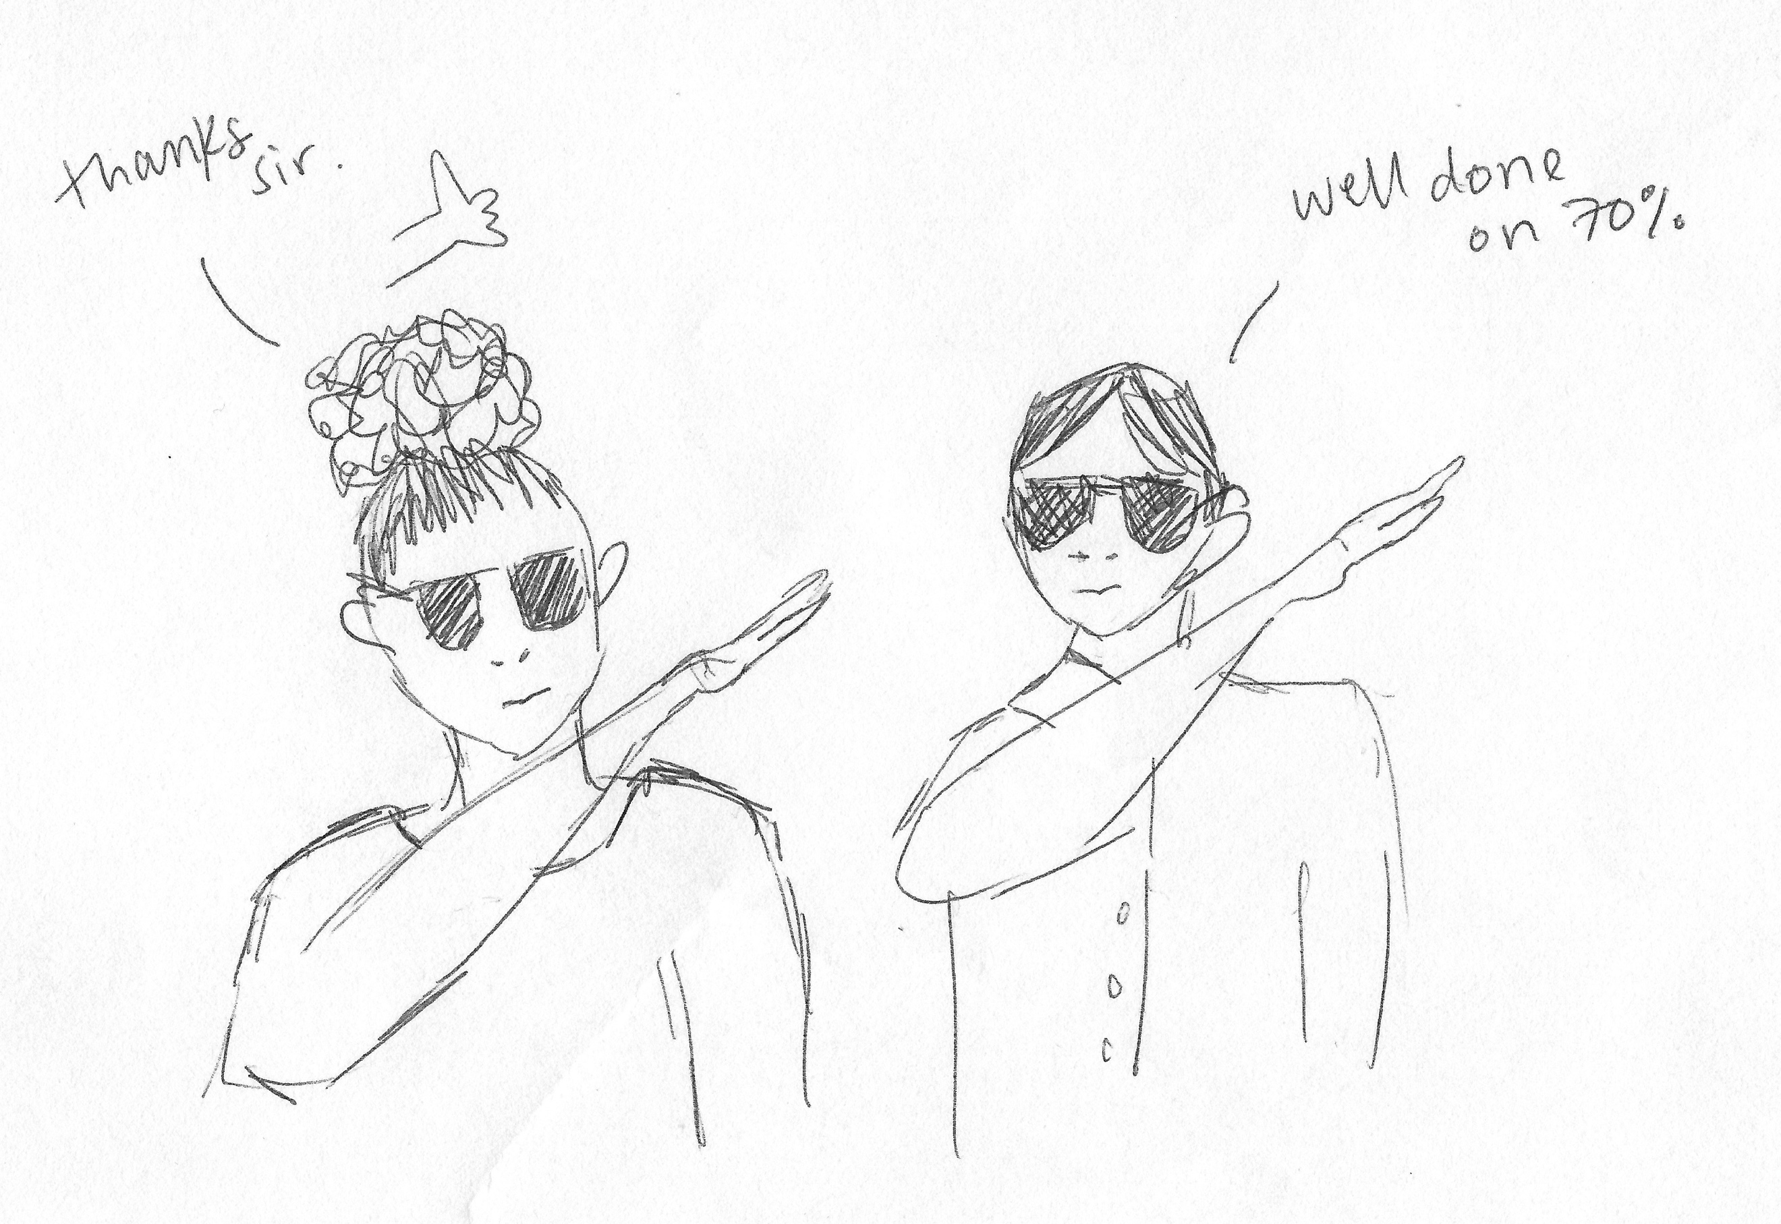

I: Okay great, so why have you drawn this?

P: [pause] I’m not sure, but I just know that it was the only thing that came to mind. Mostly because I guess it’s a representation of very, kind of, relaxed, maybe not so serious relationship with an academic, as in, I guess, maybe not casual but just not, like, it’s just not something that’s, there’s not labels on it, it’s not like between lecturer and student, it’s more, like, as two people just engaging on a topic that they both have interest in.

I: Yeah, okay. Are they dabbing? Dabbing yeah?

P: Yeah [laughing].

I: [laughing] Cool, thank you. Okay, so now can you draw a bad relationship?

P: Okay [pause] Ooo right! [pause for drawing] Okay.

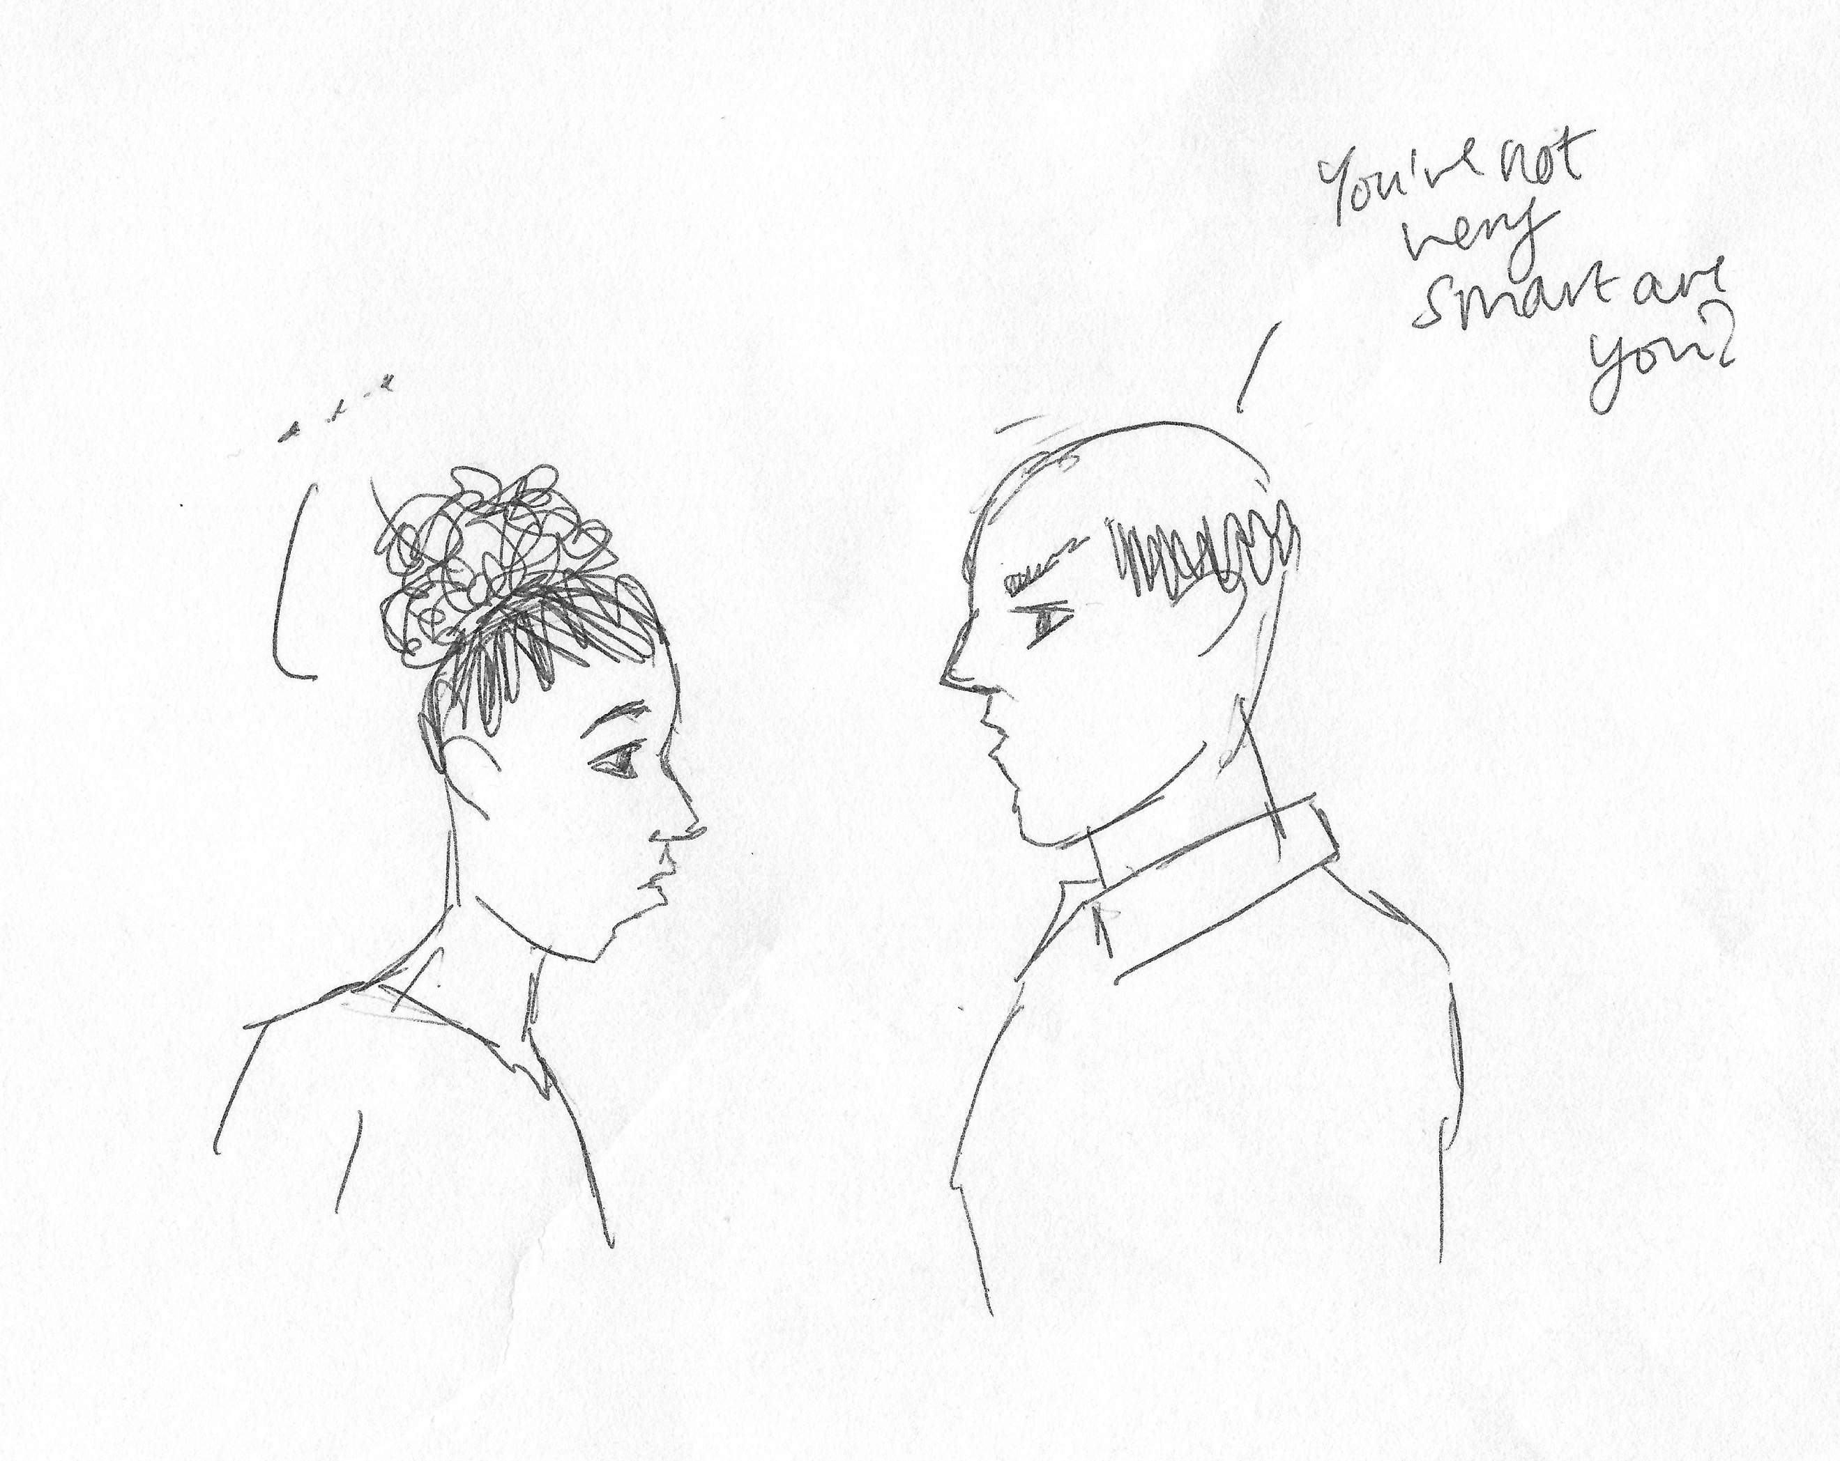

I: Okay, so what’s this then?

P: This actually is, kind of, like, a memory of when I was in High School [laughing]. I was in class and I’d been, kind of – yeah I was in Maths class and the teacher had asked me what, I think, 7 times 8 was, but I was – I didn’t talk a lot back then, again, I was really shy, so I was, kind of, put on the spot and I was, kind of, like, “35, 42”, I knew it was wrong but I couldn’t build my way up there and he, kind of, just said to me, “You’re not very smart are you?” like, in front of the whole class and I really don’t [laughing] I still really don’t like him so, I know only, like, a memory I hold onto, but I think just as a teacher, that’s just not good. So, as for a bad relationship between a lecturer and a student, it would be something along the lines of that.

I: Yeah, okay. Has that ever happened at university level?

P: No.

I: No. Okay. So, last drawing [laughing]. Can I get you to draw your conception of your relationship with the university as a whole?

P: Okay [pause for drawing]. I actually can’t remember what the uni [sic] looks like [laughing] just a weird [removed for confidentiality] thing [pause for drawing].



I: Okay great, so what have you drawn here?

P: I’ve drawn myself hugging the university.

I: Ahh [laughing].

P: I guess, for me, my relationship with the university is that I’m happy to be here, and kind of like, proud of myself for getting here, but in addition, I just also really like, kind of, you know, the town and also this thought of being a student here. Like, after I failed uni the first time because there was a lot of things happening at home at the time, when I came back the lecturers were all like, “Oh, I’m really glad to see you, you know, glad that you’ve – you’re trying again” and just, it was a lot of support. So, I also didn’t feel, I guess, bad, I didn’t feel as though anyone was, sort of, judging me for not doing well the first time, like, obviously, they all knew my circumstances as to why I didn’t do well, but it was just, kind of, the support I got by coming back for this year, that I really like being here.

I: Yeah. Okay, brilliant, well thank you very much for that, they’re some really artistic drawings [laughing]. Okay, so last few questions, there’s a lot of encouragement for undergraduates to engage with different experiences that university offers, such as joining societies, volunteering, getting involved in the SU. So, what are your thoughts on this?

P: I agree with it. This year and last year, last academic year, I did join a couple of societies. The first one I went to was – well actually it was the [removed for confidentiality] society, I thought, “Yeah I might as well, I might as well go” but when I went, I felt very out of place, even though the room was filled of people that, you know, that [removed for confidentiality]. So, I didn’t go back to that one. I did join the [removed for confidentiality], but as it runs, like 7pm on Wednesdays, it was just too dark for me to travel by myself, so I didn’t, I stopped going to that one as well. I’ve also joined, like, the [removed for confidentiality] society and [removed for confidentiality] society but it’s just, when they run, it’s usually pretty late at night and I like to stay at home in my bed so, I haven’t gone. But, I am volunteering this year at a [removed for confidentiality], like, kind of, co-run by the university so…

I: Okay cool. Do you ever find there’s any issues about balancing extra-curricular with your studies?

P: Not really, like, last term I only had, like, 3 days’ worth of studies, of lessons, and they were all, it was like, Tuesday to Thursday, so I had Friday to Monday off, so I could of just done lots and lots of work, whereas this term, I have, like, only Wednesday and the Weekend off, which is still – it’s only 10 hours’ worth of lessons so I still have, like, a lot of time, but I just have to really plan and structure it a bit – in a better way that I could last term.

I: Okay. What are your thoughts on the role of the Student’s Union, in terms of engaging you as an undergraduate?

P: [pause] I haven’t really, beyond the looking at societies, I haven’t really, kind of, engaged much with the Student Union, aside from voting for new leaders last year. I know where the Student Union, kind of, place is, I just don’t usually, kind of, go there. Me and a friend were kind of – because with the Student Union pictures we joke about, kind of, a little bit because they’re all smiling really big, it’s a little bit unnatural, so when you actually see the people around campus and in the town, when they’re not smiling so wide, kind of, it’s just, “Oh they look normal now because…”

I: [laughing] Fair enough. How valuable is the Student’s Union, do you think, as a place dedicated to students?

P: I’d say quite valuable, especially with how often the Student Union members are also, like, sending emails and putting on, like, events as such, like, I think we get, like, an email from them every week or every two weeks, so they’re always working. I think without the Student Union, the university would be quite different. So, yeah.

I: Okay. Do you consider yourself to be a member of the Student’s Union?

P: I think as a student, then yes, kind of, automatically qualify as a member of the Student Union, since – especially as they send out surveys and stuff, which I can participate in, as a student, and also with the elections of Student Union leaders, can also participate in that, so I think yes, by being a student here I’m also a part of the Student Union.

I: Okay. Okay, last question, how much of a valued member of the university do you consider yourself to be?

P: [pause] How much… I would say, I guess there’s two ways of looking at it. I guess I’m just a percentage of all the other people here, like, I don’t know, if we had like 20,000 students, I’d just be like 0.20% or something. But also, I think, my being here is just as important as everybody else’s, so I think collectively, it would seem quite small, like, against everyone else, but also, like, but on my own it would be quite big. Yeah.

I: Yeah, okay. Okay, well thank you very much for your answers, really valuable stuff. Is there anything you want to add about your experience as a student, or interacting with academics, that we didn’t cover?

P: No.

I: No? Okay, brilliant.

[End of Recording]

