Interview #8 Transcript: Second Year Female English and American Studies Student (19.10.18) (University B)

Interviewer (I): Okay, so why have you chosen to do an English degree at this particular university?

Participant (P): I looked around a lot of other universities, places like [post-92 University] and [post-92 University] and that and something – it’s quite difficult to explain but something just didn’t seem right, appealing enough. Whereas when I came here, I was really happy with the sound of the English course and the staff seemed really, sort of, enthusiastic and approachable so, I felt like I’d feel more at home here.

I: Okay cool, why’d you pick English?

P: It’s a subject I’ve always been, sort of, comfortable with and comfortable with the grades that I get in it as well [laughing] but it’s something that I enjoy as well, sort of reading in my own time and that sort of thing.

I: Okay, cool. Are you the first in your family to go to university?

P: No, I’ve got two older brothers but, one’s at university and one’s already graduated and both my parents went as well.

I: Okay, cool. What does value for money mean for you and is it important that you get it from your university?

P: I think money’s less of a concern in university for me, as long as I think that the education I’m getting is worth the time I’m spending so, I think yeah, if the course seems worth it to me, then I don’t think the money matters too much.

I: Okay cool. So the value is more to do with your time than the money you’re spending?

P: Yeah, what I think I’ve learnt from the time here.

I: Yeah. Okay. Do you agree with paying fees?

P: I understand why we pay fees, but I think it does make education less accessible for some people.

I: Yeah, okay. What does being a university student mean to you?

P: The academic side of it is obviously learning about the subject that you’ve chosen to, sort of, focus on, and you learn a lot of different aspects of it and say, a course like English, you learn a timeline of literature and then outside of the academic side, it’s sort of, a step between being a child and being an adult. I’m still learning things like, how to do the ironing and stuff like that [laughing].

I: [laughing] Okay, cool. What do you think being a university student means to people outside the university, or who have never been to university?

P: I think to people who’ve chosen not to go, it probably seems like just another step of education, sort of, an optional step after school that you can take but you don’t need, and I guess students seem how I feel I guess, people probably also see from the way that I act and the age that I am that I’m still between a child and an adult.

I: Yeah, okay. What meaning does the word engagement have for you?

P: Well, I think if a lesson’s engaging, it’s something that’s interesting enough and taught in a way that can really hold your attention, and so, even if you had the class at, say, like, 9 o’clock in the morning and it went on for however many hours, if it’s engaging, then it’s something that you won’t mind spending that long, at that time of day, learning about.

I: Yeah, okay. Okay, so using what you’ve just said, in what ways do academics at try and attempt to engage you as a student?

P: I think a lot of the teachers are quite specific about the texts that they choose for us to study. Ones that they’re passionate about and they know they can teach us a lot about, and then also, I think some teachers like to choose more, sort of, provocative texts that’ll, sort of, it will mean more conversation between students, especially ones that might not like to speak up in class, or speak to each other as much. I think they choose texts that they think are going to start a discussion.

I: Yeah, okay. Do they ever do any, like – do they have any techniques in the classroom to try and engage you, or to try and get you more engaged?

P: Sometimes we’ll be asked, like, an open question to the class and maybe if anyone wants to put their hand up and answer they can, or if not, we can speak to each other, in groups that we choose, of any size that we choose, so it’s quite – it’s quite accessible learning. It’s, sort of, teachers let you learn in the way that you want to because they know that that’s how you’ll be more, sort of, engaged with the subject.

I: Yeah, okay. Okay, what are your thoughts on the concept of student as consumer in higher education? So, have you heard of this concept, or know anything about it? [Participant shakes their head]. Okay, so just to briefly explain then. So, student as consumer concept came about when fees started and basically, people started saying that because universities are charging students money, then they’re having – they should really be positioning them as customers, or consumers because they are paying for their education now, and with the new Consumer Rights Act that’s just been passed, students are legally consumers of their university. So, it’s this whole idea that now universities are thinking of students as customers rather than as students as they used to think of them. So, with that being said, what are your thoughts on this? Do you think that’s happening? Or, do you – ?

P: I haven’t experienced it, say, one-to-one with a teacher or anything like that. The teachers seem like they’re teaching what they want to because they’re interested in it and they want more people to know about it, and I think certainly, the university’s got a big, sort of, stress on wellbeing and, like, sort of being able to look after yourself but if you can’t then there’s lots of pastoral care and that sort of thing at the university. So, I haven’t experienced it. I guess that’s probably why I hadn’t heard about it either [laughing] yeah.

I: Yeah, that’s true [laughing]. Okay, do you consider yourself to be a customer in any way?
P: I don’t consider myself a customer because, I mean, the concept of it is, you pay for a specific service at a specific standard, whereas this is, sort of, you pay to keep the university open, to have the facilities to be able to learn from your teachers and so it’s more – it’s much more educational, I definitely think of it more as a school, that people are here because they want to be here, people have paid to be here because they want to learn.

I: Okay. Do you think paying fees gives students more entitlement or more say in how the university runs, or what they’re learning, or how they’re learning?

P: I think students should always have a say in how the university’s being run because they’re, obviously, if you do think of them as consumers, they are the consumers. But I don’t think that just because you pay a certain fee means that you have more right over anyone else to have a say in the university.

I: Yeah, okay. Okay, so moving on to learning then. How engaging and/or useful for learning do you find lectures, if at all?

P: I find lectures really useful because they give you a lot of context and an outline of things that you can look into in your own time. So we get a lot of historical context and, sort of, say recommended reading around the area so that we can, sort of, learn for ourselves but it acts as a prompt.

I: Okay. How engaging and/or useful for learning do you find seminars?

P: I think seminars are really useful because it’s a lot more discussion with the other students. So, they might pick up on things that you hadn’t but a teacher, maybe for the sake of an assessment, might not be able to say outright to you. So you can, sort of, share ideas and bounce off each other and it helps you build your own work.

I: Yeah, okay. Where do you choose to sit in seminars and lectures? Like at the back, front, middle or do you not really care?

P: I don’t really care, I mean I sit where there’s a space [laughing].

I: [laughing] Okay. How engaging and/or useful for learning do you find one-to-one sessions with tutors? If you’ve had them or…

P: I haven’t really had any one-to-one sessions.

I: No? Have you ever gone to talk about an essay mark or anything?

P: Last year we – I organised a meeting with each of my – we have [removed for confidentiality], so I’ve got one for English and one for American Studies, my other subject, and so I went to a couple of one-to-one meetings with them just to, sort of, talk through university. But a lot of that’s more about, sort of, “How are you doing? Are you keeping up with deadlines?” and that sort of thing. It’s not so much, sort of, learning sessions.

I: Yeah. Okay, so do you tend to get your marks online then rather than –?

P: Yeah, we can find them online and then, if I did have a question, I’d be very happy to contact my teachers. But things like that, people tend to do over email, so none of it’s really face-to-face unless you do have a big problem [laughing].

I: Okay. Do you think you’d find it intimidating to have a one-on-one learning session with a tutor?

P: No, I don’t think so. A lot of the staff here are really approachable so, yeah, I think any staff member I’d be happy to have a one-to-one with.

I: Okay, that’s good. Is there anything you particularly like about the learning style of universities compared to compulsory school?

P: I think it’s a lot more broad, you can pick what modules you want to take, obviously in the first year there are compulsory modules that help you decide what areas you want to focus on, but then you can pick what areas you want to focus on and within that, you can pick what texts you want to study specifically, or what, sort of, subjects you want to study. I think it’s just a lot more free than at school when you’re told, sort of, “This is the curriculum. Read these books by this date and then we’re all going to do the same exam on it”.

I: Yeah, okay. Okay, from your experience, is there anything you would change to improve your own learning. So, either in terms of the teaching you’re receiving, the resources that you have access to, the curriculum, the assessment or anything else?

P: Nothing that I can think of.

I: No? It’s all good?

P: Yeah I’m happy with it, yeah.

I: Awesome, okay. So, I sent you the document that refers to the Student Charter [name changed]. So this is the equivalent of your student charter. So, have you – had you seen this document before I sent it to you?

P: I think it’s – I think I’ve seen it before in – we’re given, sort of, an undergraduate guide, I was given one for English and given one for American Studies, well they’re available online. So, I’ve looked through them and I’m sure it’s in there.

I: Yeah, okay. Had you read it?

P: Not really [laughing].

I: No, that’s fair enough. Okay, so yeah, this basically sets out what you can expect from the university and what they expect from you. So, do you think the ideas and the aims and the values are evident in your experience of being a student here?

P: Mmhmm yeah, I think it’s fair the things that they ask of us, and then obviously, we get – everyone’s happy with what they get from the university otherwise they would be, sort of, contacting people to ask about it. Yeah I think, yeah I think they’re very fair things to ask of each other, for us to be asked of and for us to ask of the university.
I: Yeah, okay. Okay, in your opinion, should undergraduates have greater control over, or input in, the curriculum and/or assessment design of their courses?

P: I think beyond first year, I think people should be able to have a say because, obviously, if a course is less popular, you’d be able to improve it if you listened to input from current students, but then obviously first year, there’s not much you can change. I think it’s quite a broad year where you just, sort of, have to study through everything so that you can decide for the second year what you would want to focus on.

I: Yeah, okay. What kind of input do you think students should have, like, how much input?

P: I think probably only a small level of input because obviously the lecturers have been through a lot more education than we have, they have more experience in the university than we have, but I think they should take on board if a student maybe says, “I don’t think this lecture was done properly” or, “I don’t think we should study this text, how about this instead?”

I: Okay. Okay, what are your thoughts on the idea of students as partners in the learning experience? So, this idea that students and academics, sort of, work collaboratively together to produce new knowledge. So, rather than them just teaching you and you learning, you, sort of, working together?

P: I think it’s – it’s something I’ve noticed before. I’ve noticed, say, one of my lecturers takes a lot of notes from us in classes. I think she, sort of, takes on board what we say and then she can keep that in mind for her own studies and for teaching again next semester or next year or anything like that. So yeah I think, the lecturers do learn from us, to an extent, and it is a more mature relationship between teacher and student here as opposed to, like primary and secondary school. So yeah I think that is a fair way to judge it.

I: Okay. Okay so in recent government policy on higher education, students have been placed at the heart of the system, which is their wording. So how central or important do you think undergraduates are in this university?

P: I think they’re probably the most important thing in the university because, obviously, students are the focus of the university, they’re the people that the university is built to teach. So I think there’s definitely a really big focus on, sort of, if we feel we’re getting the right quality of education and our wellbeing, there’s a lot of – there are a lot of measures taken to make sure that we get, sort of, the care that the university promises, both academically and outside of that.

I: Yeah, okay. Do you think that students should be the central part of a university?

P: Yeah.

I: Okay. What meaning does the word relationship have for you, in the context of interacting with academics?

P: I think that there is, sort of, there’s a more – there’s more of a relationship than some people that don’t go to university might not realise [sic]. I don’t know if I said that right. Because there’s, sort of, there’s a lot of trust between students and then academics, but also the teachers because, say, we look up to them to help us with our work, and to help us further our studies and then, they can, sort of, bounce ideas back off us to help their studies as well. So yeah, I think there is a relationship there.

I: Okay. What do you consider to be the main purpose for building a relationship with academics?

P: I think it is, for both parties, to help further studies really because university’s all about education so I think, for both parties, it really helps to have someone with a different viewpoint to discuss with.

I: Okay. Do you think there’s a link between the relationships that you have with academics and your levels of engagement as a student?

P: Yeah I think if they’re better relationships, or if they are ones where you feel, maybe you have different ideas so it’s easier to debate with each other, I think that definitely helps, sort of, your own studies.

I: Yeah, okay. Okay, so are you ever aware of a hierarchy when you interact with academics?

P: It doesn’t really feel like there is one when you interact because they – some students aren’t, sort of, 18, 19, 20, fresh out of school, things like that, some students are, sort of, mature students, some are adults. And so I think there’s quite a, sort of, importance to the relationship not being, sort of, student-teacher like in a school context, I think it is more as peers, people can talk more freely as peers.

I: Okay. Do you think that’s quite – that’s linked quite a lot to the age then? The fact that there’s not a massive age gap between all the students?

P: Yeah, I think it certainly helps, but it is also the environment of a university, it’s just more that people act as peers rather than as one person above another.

I: Yeah, okay. Can you think of any particularly good relationships, without telling me who the academic is, with any staff and why you’d characterise it as good?

P: I can think of quite a few teachers that – it’s a good relationship because, say, if I had any problems or even if I just wanted to discuss an idea, I think any of the – any of my teachers that I’ve had I’d feel happy to approach either face-to-face or by email or anything like that. Yeah I think it’s a good relationship because I wouldn’t feel, sort of, embarrassed or too shy to ask anything.

I: Okay. Okay, so now, can I ask you to draw your conception of a good relationship with an academic? So it can be – you can draw whatever you want, it can be abstract, it can be stick people if you want, it can be whatever, it’s more, like, the discussion that comes from it that’s important than the actual drawing [laughing].

P: I don’t know what to draw [pause] I really can’t think of anything. I don’t know, it’s easier to say in words than it is to draw it.

I: Yeah, well you can just draw words if you want, you can just put on paper however you would put it in words so, it can be abstract, it doesn’t have to be actual people or anything.

P: [pause] I don’t know I’m really struggling [pause for drawing] [laughing] This feels very weird [laughing] [pause for drawing] I don’t know if that’s too abstract.



I: No, no that’s fine. So what have you drawn here?

P: Just, sort of, a school environment basically but, the students, obviously they’re at the front of the room, they’re engaged, they’ve written a lot, and the teacher – it doesn’t matter what they have up on, say on an interactive board or a white board or whatever, so I didn’t think I needed to put anything there [laughing] but yeah, it’s basically, the interaction is, sort of, there’s so much to be learnt that that’s why there’s so many notes and that’s why there doesn’t need to be anything specific on the board.

I: Okay. Okay, cool. Okay so, you’re going to hate me, can I get you to draw me the opposite, so a bad relationship?

P: [pause for drawing]



I: [laughing] Okay what’s this then?

P: If the relationship is bad, students just don’t turn up if there’s no – if there’s no interest in the class, they’ll do the bare minimum, they’ll work from, sort of, the university website, they’ll do as much as they can at home and just not turn up to lessons.

I: Yeah, okay cool. Okay, this is the last one I promise [laughing]. So can I get you to draw your conception of your relationship with the university as a whole? How you think of your relationship with the university.

P: [pause for drawing] I don’t know if it seems a bit weird [laughing] it’s basically, the university just seems like such a, sort of, a busy place but not in a way that I can’t catch up, so there’s lots of people always learning, there’s lots of people always talking to each other, always making new friends, so it seems like a really positive environment to be in, even if you’re just walking through the campus.

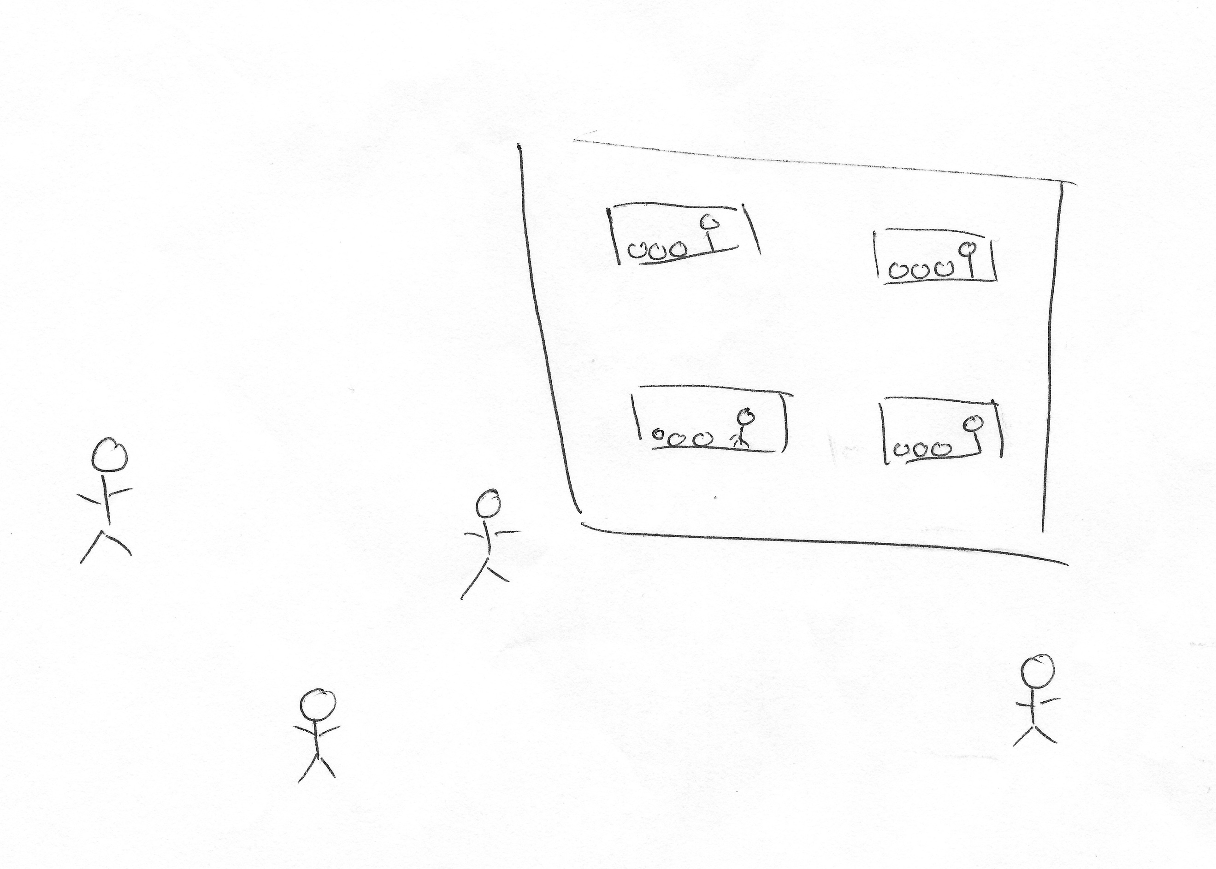

I: Yeah, okay. Brilliant, thank you very much for them. You don’t have to draw anymore [laughing]. Okay, so last few questions. There’s often a lot of encouragement for undergraduates to engage with the different experiences that university offers, such as joining societies, volunteering, or getting involved with the SU. So, what are your thoughts on this?

P: I think it’s really important that there are lots of societies because, I’m not in one myself, but people that I do know that are in them, there’s a real sense of community and you can just pick something really vague like, Film or History and you’ll get a big community of people that can all bond over it, whether it’s, sort of – there is an academic sense to it, people do go to Film Club and analyse film, they do go to History Club and, sort of, maybe study a period of time by doing something like a quiz or something like that. But then there is also the non-academic, sort of, friendship side, people enjoy themselves more if they have more friends around, more people they know and are happy to talk to.

I: Yeah. Okay. What are your thoughts on the role of the Student’s Union in terms of engaging you as an undergraduate?

P: I think it’s really helpful having the Student Union, having people that are in the same situation as you that you can go and talk to, and then obviously they’ll have on a lot of events around the uni but there’s no pressure to go to them if it’s not something you’re interested in, there’s no pressure at all that you have to go, but it’s something that’s, sort of, they let you know via, maybe, posters or, sort of, adverts on the university page or anything like that. They are always there, and it’s just another person out of the university you can talk to.

I: Okay. Okay, last question. How much of a valued member of the university do you consider yourself to be?

P: I think everyone at the university is a valued member, maybe some people feel that certain staff members are valued over others, but I think the students in general, regardless of what courses you’re doing, what modules you’re doing, if you are in a society or not, I think everyone seems valued the same.

I: Yeah, okay. Okay brilliant, well thank you very much. Is there anything you want to add that we didn’t cover, or –?

P: [shakes head]

I: No? Okay, brilliant, well thank you very much.

[End of Recording]

