Interview #9 Transcript: Third Year Male Creative Writing Student (26.02.19) (University B)

Interviewer: Okay, so why have you chosen to do a Creative Writing degree at this particular university?

Participant: Well I did a – I was at [post-92 University] in [city removed]. I went there for a year, and I did Journalism there. I had to drop out because of many problems that I had – not with the uni, with people. So, I was – went back home to [city removed] for the summer, took a breath. I didn’t know what I wanted to do really, but I knew I wanted to go back into uni, and I wanted to do something with my writing. I chose the degree because it was pretty much everything to do with writing, it’s not just, like, literature, it’s really flexible in what you’re doing. I didn’t want to have a degree in a certain thing, like, I wanted to leave university with a degree where I could go off and do pretty much anything, as long as it related to, do you know what I mean? Like, writing. So, it’s not – I didn’t do the degree – it’s more of a passion thing, rather than preparing myself for work.

I: Okay. Any reason for this particular university, or… ?

P: Well, like I said, I dropped out of [post-92 University] and my boyfriend lives here. I didn’t follow him [laughing] but, like, I’d visited a few times and made my own friends so I wasn’t, like, because I was really bad – I was in a bad place with my mental health, like, it was a place where I could come, it was away from home but, I still have, like, friendships and stuff that I’ve already established, so I wasn’t just starting over.

I: Okay, cool. Are you the first in your family to go to university?

P: Yeah.

I: Okay. What does value for money mean for you, and is it important that you get it from your university?

P: It is important. I do think that, you know, like, how much degrees are and how – I do think that it’s, I don’t want to say waste of money because it’s not a waste of money, but I think that the money could be put back into us a lot better. I don’t really think that I’ve seen what I’ve paid for, even in [post-92 University], like, I don’t think I’ve ever seen £9,000 worth of education in a year. So, yeah, I do think value for money is important but I don’t think that it’s possible in this, like, in the state of the education and how everything is.

I: Okay. Do you agree with paying fees?

P: No.

I: Fair enough [laughing]. What does being a university student mean to you?

P: Independence, that was – that’s, like, one of the biggest things uni has given me, and freedom to, like, explore yourself. Not just in terms of, being independent but, like, being able to push yourself in terms of, like, knowing what you can do and knowing what you need to do and that’s very different things. I think that it’s given me a lot of confidence in myself to know that, like, I’m valued and, like, that I have talent. But, I think that also, that’s something that I would have found myself as well. I think that there’s not much happened – I’m just, I’m making it sound like this is an awful university but it’s not. I think that, like, my self-value has come from being at university, but not necessarily being at university.

I: Right, yeah. I see what you mean. Okay, what do you think being a university student means to people outside of the university, or who have never been to university?

P: That you get to be a layabout [laughing]. I think that people don’t really – I think people do underestimate the value of it, especially because, even though it’s a lot of money to pay for university, I think that it’s a lot easier now to go to university than I was taught when I was at school. So I think that people can look at university as, like, another way of avoiding going into the world of work for a couple more years. A lot of my family, they treat me as if I’m some, sort of, scrounger and, “Oh he’s a student”, like, that kind of thing. But, then again I think that younger people look at it in a way that’s, like, they want to enrich themselves. So it is – I think it’s very much a generational thing, whereas people over a certain age look at you and think, especially where I’m from because, like, where I’m from in [city removed], not many people have been to university or would even think about going to university, so it’s, like, everything’s very much vocational up there and I was actually – I’m going to go off on one, but I was speaking to my mum yesterday because we’re moving back to [city removed] when I finish uni just because it’s cheaper, and she was asking me what jobs I’ve been applying for and she was like, “Oh do you want to do that? Do you want to do that?” and it’s, like, “I’ve been doing this for the past 3 years and, like, you don’t know that but you can tell me everything about how my bother lays bricks”, it’s that kind of thing, like, it’s not accessible so she doesn’t… do you know what I mean? Like, yeah. I think it’s just, like, the kind of thing where they look at it as just, like, “Oh, it’s just still school” but like, “No, I’m training myself up for something and building myself up I guess”.

I: Yeah, yeah. Okay. What meaning does the word engagement have for you?

P: I think, on a personal level, it means having someone there to, like, help you and back you up and knowing that university and, like, there’s always something there for you and there’s always feedback to be given, or half an hour spare in a tutor’s time to go and have a chat with them just if you’re feeling a bit shit. And on a, kind of, level where it’s the whole university, I think it’s, kind of, having enough resources there to cater for everyone and cater for loads of different types of learning needs and personal needs. And just being accessible, yeah, I think those two words go hand in hand, accessible – acccessibleness? And engagement, you know what I mean? [laughing]

I: Yeah. Okay, so using what you’ve just said, in what ways do academics attempt to engage you as a student?

P: There’s always – something that I really, really do appreciate with this uni and a massive change from when I was at [post-92 University], is that there’s always been someone there here for me to rely on in terms of if I’m struggling with anything, not just with, like, a course or assignments and stuff, if I’m struggling with anything, I’ve probably used it a bit too much in terms of, like, therapy here but I know it’s there for me and I have been able to establish really good relationships with my tutors so that’s the biggest thing in terms of that, for me, with this, it’s, like, I feel like without that, I wouldn’t have progressed as much as I have here because I’ve had a lot of help, not help but, I’ve had a lot of, like, support.

I: Yeah, okay. Okay, what are your thoughts on the concept of student as consumer in higher education? Have you heard about this concept?

P: No.

I: Okay, so basically when the fees started, lots of people started talking about this idea of the student as consumer and what it means is that universities are now treating students as consumers, rather than students so, you know, they’re treating them as if they have to satisfy the customer and so it’s changing the relationship a little bit. So, having said that, have you noticed it at all? Do you think it impacts on your experience here or your interactions with any of the staff?

P: I wouldn’t say so. I don’t really think that – no, I wouldn’t say that I feel like I’m treated like a consumer. I don’t really think of it as a business to be honest, I think of it as a university. Yeah, I don’t really feel like, I mean I agree with it because I’m paying this money to a business to get this education and I feel like it is very much, you give as much as – you take as much as you give in that, kind of, respect, but I don’t really think that that really applies, no.

I: Okay. So, do you consider yourself to be a customer of the university?

P: Yeah, because, like, I think the first 2 years was £9,000 and then it went up to £9,250 which I think is completely pointless and I understand that, like, I am paying for this. I don’t really feel like I am because it just doesn’t really, like, it goes back to the value for money thing, I don’t really feel like I’m getting that but, yeah I do feel – I guess the easiest way to put it is I feel like a number, rather than an individual. Like a statistic or something, you know?

I: Okay. Do you think paying fees gives you more entitlement as a student? Like, entitlement to complain, or get involved in the running of the university, etc.?

P: I would – that’s interesting actually because I have, recently I had a problem with some feedback that I got, and a grade that I got. Not in the way that I was like, “Ugh I don’t deserve that grade, I need a better grade”, in the way that it wasn’t handled in the best way and it was, kind of, unprofessional in the way that it was handled. So, yeah, I feel like I do have a right to, not complain but, give feedback on feedback and try and sort something out, but I don’t think it’s gone anywhere and I don’t think it’s going to go anywhere so, I don’t really feel like – there’s obviously a hierarchy, and we’re at the bottom of the chain but also, I feel like we need to be – there’s this whole thing about when you come to university, you’re treated as an equal, as like the tutors and things like that, but it’s definitely not the case, I – okay, so basically I had an assignment and she, my tutor, gave me feedback and it was – she talked about mental health, like, that the assignment wasn’t anything to do with that and she talked about how I’ve had a rocky time and that she thinks that I should keep going, and it was really patronising. So I said something about that and was told that they, the people who I complained to, didn’t think it was out of hand whatsoever, so it was left there. So yeah, I do feel like, if it gets too difficult it gets ignored, that kind of thing.

I: Okay, okay. Okay, so moving onto learning then. How engaging and/or useful for learning do you find lectures, if at all?

P: Well, lectures we’ve had – we had lectures in first year for my course and then, ever since that, it’s just been 3-hour seminars for each module that I’ve had, so we have, also, because I’m doing two modules now and my dissertation, I’ve got – I’m in two times a week for three hours and there’s no lectures, it’s just seminar/workshop. I do feel like if I had an hour seminar – an hour lecture and then a two-hour seminar, I would get a lot more from it because we would be talking about what we’re doing and then we could go back, like, reflect on it and then go back to the seminar prepared. Whereas, like, we go into seminars and everything is thrown at us and it’s just, like, a lot. So, I think lectures do benefit me, but obviously I’ve not had that experience to know.

I: Okay. Okay, how engaging and/or useful for learning do you find seminars, if at all?

P: Well I do – it’s the kind of thing where it’s, like, if I’m interested in it, I can sit in a room for 3 hours and engage, but if I don’t have much interest in it, I’m going to find it really difficult to [pause] and, I mean I say that thing about lectures but, all of our PowerPoints that we go through – and that’s another thing with PowerPoints, like, it’s just a PowerPoint, like, that’s all it is, it’s just a person reading from a PowerPoint, but yeah, we get our learning resources before the seminar but, like I said, it’s just a PowerPoint to read through and then we go to the seminar and then it’s read through again so it’s just, like, “I could do this at home”, do you know what I mean?

I: Yeah, okay. Okay, how engaging and/or useful for learning do you find one-on-one sessions with tutors, if at all? Do you have them… ?

P: Yeah. I find them – I’ve found them the most useful, and I’ve found actually as well that with – there’s been quite a big difference in my grade if I was to meet with a tutor a couple of times to talk through things personally, than if I didn’t get the chance to, or only if I did it a couple of times. I do think that it’s very much the kind of thing where it’s, if I’m in a room with, like, say 20 people and a lecturer, I’m going to struggle to find a connection with a lecturer and a tutor to, like, talk about my work but if I go into a one-on-one, then I can talk about it, like, it’s much more engaging. So, I do think that out of, like, everything, one-on-ones have benefitted me the most, definitely.

I: Okay. Do you ever find them intimidating?

P: Not really, no. I – yeah, not really. I just, I find seminars more intimidating.

I: Okay, fair enough. Okay, is there anything you particularly like about the learning style of universities, compared to compulsory education?

P: I really – one of the biggest things that made me want to apply for [University B] is the – especially Creative Writing, is the flexibility of the assignments. When I was at [post-92 University], I was studying for a – it was a Journalism course and it was, NCTJ or whatever it is, like, it was credited for Journalism but it was very much, “You have to learn this, you have to learn this, you have to do this” whereas here, I’ve been able to do what I want a lot of times and be able to apply it to the context. With my assignments I’ve done, we get told that we have to write a screenplay and then, like, a 2,000 word analysis on it so I can write a screenplay about anything. I had a module last year that was working in the Arts and we could do anything we wanted, as long as it was related to Arts, so I did, like, a [removed for confidentiality] and so it’s really, like, flexible and, like, you can do what you want, and it’s interesting because everyone does something different as well so you can see, like, best practice and things like that.

I: Yeah, okay. Okay, from your own experience, is there anything you would change to improve your own learning? So, either in terms of the teaching you’re getting, the resources you have access to, the curriculum and assessment, or anything else?

P: I would do a lot. I would probably make it easier to understand criteria. We get a grid with boxes on that says what we should do but, I never, like, the language is really hard to understand and I don’t think it’s really clear, like, especially this year because I’ve gone from level 5 to level 6, but we’re getting set the same, kind of, assignments so, like, it’s really hard because we don’t really talk about what the difference is. I was saying this to my friend, like, when you do GCSE and go up to AS, there’s a difference and then there’s a difference between AS and A-Level. There’s a massive difference between second year and third year but no one ever prepares you for it and I know that you’re supposed to prepare yourself for it at university but, like, those grading criteria I just don’t understand them whatsoever, like, they say the same thing, so why… do you know what I mean? That’s the biggest thing I think, definitely the criteria.

I: Okay. Okay, I sent you the document that refers to the Student Charter [name changed]. So, this is basically your student contract, Student Charter if you like, so yeah, it’s the contract between you and the university. So, in your opinion, how evident is this policy and the values in your day-to-day experience of being a student here?

P: I would think that, see, some of these, for example, [removed for confidentiality] bla bla bla. I feel like that is something that comes with uni anyway, rather than something that this university is going to do for you, it’s something that happens to you while you’re at university anyway, so it’s not something that they can… do you know what I mean? I think that the teaching and the research here is really good, we’ve had a lot of people come in and speak to us that work in different sectors of, like, the publishing industry, that are writers, things like that and we do have lecturers that are really experienced, and they know what they’re talking about. I do think that it’s really – with teaching and being able to access, I guess like, a lecturer’s understanding, it’s really hard because it’s creative, so if they’re not going to like it, they’re not going to give you the best grade for it because they haven’t been able to, like, regardless of the quality of it, I think that that’s a big issue with creative degrees. I have friends that go to UCA and they’ve said it as well, like, if they make something and they’re really proud of it, and they can explain it well, they’re still not going to get the best grade because their tutors might be against that kind of art or they might not like the style that they’ve done it with and it’s very much the same here. So, yeah I think with creative writing, it’s definitely the same, like, if someone doesn’t – can’t connect to something you write, they’re not going to connect to you. [pause for reading] I’m just looking to see – I feel like, in terms of the community here, it’s very much – I think it’s quite guarded. In first year I was part of a society called [name removed] and it was, like, the Student Union, like, publication, I was the editor for it and I felt like I was part of something then, but then I just, I had to stop doing it because it was going nowhere and, like, we had to stop it for a while and then since then, I haven’t really felt, like, I don’t really feel – I feel, kind of, like, an Open University student here. I don’t really feel like there’s much of a community [inaudible] so I think it’s very much more, like, you have to be in the right place at the right time to feel that, and you have to be part of a certain cause to be made to feel like you’re part of the university because obviously, this is a really good university for teaching so, if you’re a teacher you’re going to feel more part of it because they put more into that, whereas this course that I’m doing, it’s a really, really small course, like, what is it, like, 30 people on the single honours? So, it’s very much, like, we are a bit forgotten.

I: Okay, okay. Had you ever seen this document before I sent it to you?

P: No.

I: Oh okay. Okay, so in your opinion, should undergraduate students have greater control over, or input in, the curriculum and/or assessment design of their courses?

P: Yeah, and it goes back to the value for money kind of thing. I feel like if we’re putting so much into this university, we should be able to have input in it and the only thing really that I’ve known, or been told about, input-wise is the survey that we get to do once a year, and I don’t really think they go anywhere, really. Other than that, like, I really can’t think of any opportunity I’ve had in the past 3 years to be able to make any change or anything. We have course representatives who we tell things and then they go to a meeting and then things happen, but we don’t really get a chance to see them either and I don’t think much happens from them either, like, I don’t think it’s very much – I don’t think it’s very progressive here, yeah.

I: Yeah, okay. Okay, what are your thoughts on the idea of students as partners in the learning experience? So, this is, kind of, the idea that students and academics, sort of, form, like, a learning partnership, so they, like – instead of it being quite student-teacher dynamic, like it is in schools, it’s more of, like, academics and students create knowledge together, like, more as equals?

P: Yeah, that sounds like a really good idea. It would be interesting to see what would come of, for example, if we were to take on a project – if we had a module that we could, we got graded individual, but if something where 10 people including the tutor, worked towards something, to see what the benefits of that was like. My friends at UCA, like, they, at the end of every year they do a degree show where everyone comes together to plan an exhibition and the tutors are very much a part of it, as much as the students are and, like, it’s really back and forth, and that always works really well. It would be interesting to see us be able to, like, put together, I don’t know, like, maybe a book with poems in, like, something like that, do you know what I mean? Just to see if we could make something, like, that was good but also that went towards our degree as well because, like, it’s very much, like, we get told to do this and we have to do this and, the only time we ever get to really talk to our tutors and stuff is if we have a problem with assessments. It would be really cool actually to be able to do something, like, as a collaboration.

I: Okay, that’s quite interesting because this university actually has a policy whereby it calls its students partners [removed for confidentiality]. So, it already apparently, as part of its policy, does work with students in terms of being partners with them. So, are you saying that is not evident in your experience?

P: Not at all, like, I don’t agree with that whatsoever.

I: Okay. Okay, so they’re more just, like, talking? Okay, so in recent government policy on higher education, students have been placed at the heart of the system, which is their wording. How central or important do you think undergraduates are in this university?

P: I think they’re important because they pay and they give money to the university. I don’t know, like, honestly, it might just be because of the course that I’m on, like I said it’s a very small course and it’s very pushed to the side, but [pause] I don’t feel like I’m at the heart of anything. I feel like it’s much more, I don’t know, like, I think if you’re on the right course you will probably feel like that, but because I’m not on a course that the university is known for, it’s not applicable at all. I feel like it’s just, like, an offcut, if you know what I mean.

I: Okay. Okay, what meaning does the word relationship have for you, in the context of interacting with academics?

P: I think that it’s very much, what it should mean at this university is, equal amounts of giving and taking. I think that, if I was to describe my relationship with some of my tutors on the whole, it would be tumultuous because even though I do think that I’ve got support and things like that, I don’t think there’s very much understanding in the way that, like I said I’ve got a small course, a handful of people on the course with a, kind of, okay I don’t want to sound unprofessional but I’m just going to say it, they’re kiss-arses and they’re the kind of people that you sit in a classroom with and you’re just, you’re always rolling your eyes because it’s, like, “You don’t need to do this, like, it’s fine, you don’t need to keep trying to crawl up his bumhole, like, it’s fine”, and I feel like, if you’re not like that in my course, there’s not much you can get from the relationship with your tutors. I think you have to really, really, really, really push yourself and go to everything, like, out of hours, like, go to the pub with tutors and stuff like that because people do that here, to really get the most of that, and that’s fair enough, like, if that’s what the tutors want, that’s what they want but, I have, out of the 12 tutors I’ve had in the past 3 years, I would say 3 of them have left some, sort of, impact on me and I don’t think that’s the best.

I: No, okay. Okay, what do you consider to be the main purpose, then, for building a relationship with academics?

P: I would say, at this point in my life, not my life, in third year, that if I wanted to start building relationships now with tutors and things like that, it would be so I had connections when I left and that they would be able to send me off somewhere, do you know what I mean? But if you had asked me 2 years ago, it would be probably, help and, like, just needing guidance. But I think now that that’s not really necessary. So I think it’s just different for what stage you are in university.

I: Okay. Okay, so is that purpose, then, is that fulfilled for you at this university? Or is that just, like, the ideal of what you would want from it?

P: I think it’s the ideal [pause] knowing – having, like, most of my friends have been to university and knowing what they’re like with their lecturers and what their lecturers have done for them, it’s – I look at it as, kind of, like, a standard now but, here, not so much.

I: Yeah, okay. Okay, do you think there’s a link between the relationships you have with academics and your levels of engagement in their classes?

P: Like I said, like, I think that if you were going, if you’re in class and you’re engaging, there’s a much better chance of you succeeding and, like I said, like, I have seen much – such a big difference between me going in and speaking to tutors one-on-one and the grade that I got from that compared to the grades that I got when I didn’t do that. So I think it’s, it’s really, I don’t want to say favouritism or anything like that, but it does, it very much does feel like if – and it’s not even, like, a matter of you giving and being able to get that back, it’s a matter of [pause] proving yourself? I would say. There could be a person in a classroom who’s nervous to speak out and nervous to go and meet someone just because of their own issues that would be able, but would probably be able to get 90s but get 40s because they don’t engage as much, and it’s not necessarily their fault, but it’s just I think that there’s very much a way of doing it and if you can’t do that way then that’s it.

I: Right, yeah okay. Okay, can you describe to me a typical face-to-face encounter with an academic? So, say you go and talk to them about an essay, what actually happens in that interaction? What goes on?

P: Okay, yeah. I’ve got one after this actually. Normally last about an hour. There’s a lot of feedback and, like, it’s, like, bouncing off of each other. I get a lot of resources for things when I go in, like, obviously they give us resources but I get better resources if I go in and talk to them because they give us more specific. It’s, like, friendly and I do feel like, in one-on-one situations, I do feel like I’m speaking to someone on my level and that I’m respected. Yeah, and it’s just nice, it’s nice to be able to sit and have a cup of tea with your lecturer and, like, talk about what’s going on in your university and stuff like that. I’ve never had – I’ve never walked out of a, like, one-on-one feeling worse than I did going in. I always feel a lot more settled, definitely.

I: Okay, cool. Are you ever aware of the hierarchy between you and an academic in your interactions with them?

P: Like I said, it’s very much like I’m on the same level as them, I don’t think that it’s – I am aware of the hierarchy but I don’t think that that’s a bad thing, I’m aware that I’m speaking to someone who has more experience than I do and can help me because they’ve been through stuff and, like, they know how to write, like, it’s there but it doesn’t feel like it’s being held over you.

I: Yeah, okay. Okay, can you think of any particularly good relationships with any academics you’ve had, without telling me who they are, and tell me why you’d characterise it as good?

P: Yeah. I had a tutor, she doesn’t work here anymore, she’s up at [pre-92 University] and I saw her so much that I thought that she was my personal tutor, and then a couple of weeks ago I met with my personal tutor and he was like, “Oh where have you been for the past 2 years?” and I was like, “Oh, I didn’t know”. But yeah, like, she did – she was my – I don’t know if I had her, I had her for a module last year, I didn’t have her the year before, but I still went and saw her, and she was just, like, she had, like, a similar, like, she was doing a PhD, I think she still is doing a PhD [removed for confidentiality] and it was just, like, that, kind of, thing where we had interests in common and it felt like she wanted to listen and she wasn’t there because she had to listen, it felt like it was very much, she could have got out of it as much as I could have got out of it because she was interested, and she helped me a lot with, like, gaining confidence with, like, going into seminars and lectures and things like that because I had a problem with that. But I honestly feel like I’ve had every, like, the 3 tutors that I’ve seen a lot, they’ve all been really good and there for me. I think that that’s probably the best thing about this university is that, on my course at least, is that everyone is there to listen and there’s a lot of people on my course that struggle with mental health and things like that, and they’re very understanding of that, and they’re very there and present, all the ones that I like anyway [laughing].

I: [laughing] Okay. Okay, so now can I ask you to draw your conception of a good relationship with an academic? So, it can be anything you want, it can be abstract, stick people, whatever comes to mind when you think of a good relationship.

P: Okay. Hmm. I’m going to draw stick people [pause for drawing]. They’ve got very long arms [pause for drawing]. He’s lifting them up [laughing].

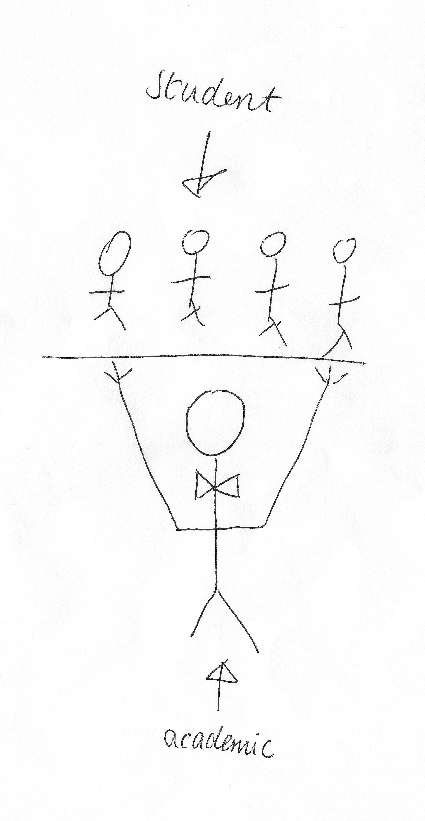

I: Oh nice! Okay, so why did you draw this then?

P: Because I feel like, okay we’ll talk about the hierarchy, like, these – the students – are actually below in terms of how it works here, but I think that it’s the – it’s their responsibility to lift us up and make us feel like we are them as well, and I feel like it’s their, not responsibility, but they’re here for us to enrich ourselves and become academics [laughing].

I: Yeah, nice. I like that, thank you. Okay, so can I get you to do the opposite? So, a bad relationship?

P: Okay, alright. Okay [pause for drawing] although along the same lines [pause for drawing]. This is deep [laughing].

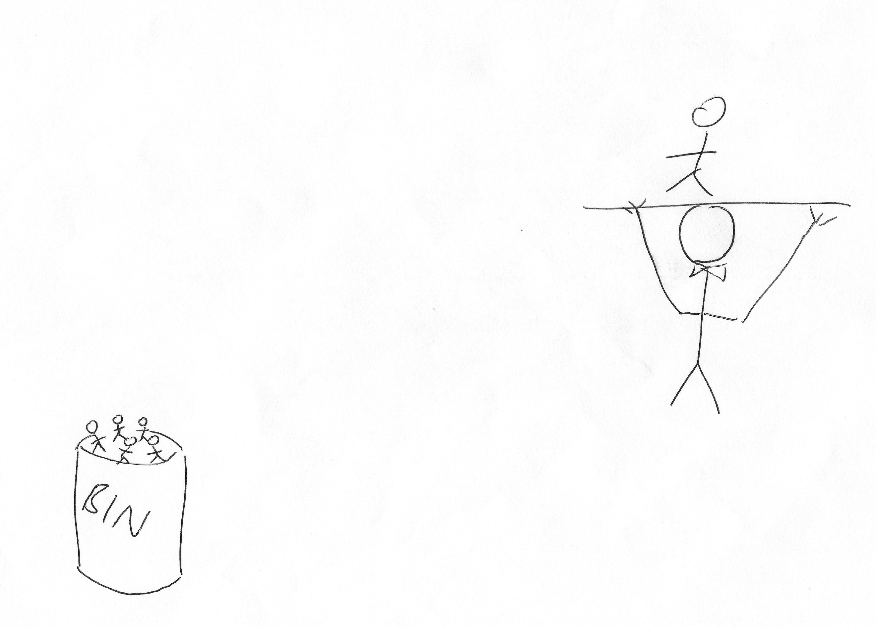

I: [laughing] Okay, so what have we got here?

P: So, it’s basically favouritism [laughing] but also, like, how, like, you can feel if you don’t engage as much or if you can’t engage as much that you just feel like you’re put to the side, and just put in the bin basically [laughing].

I: [laughing] Yeah, okay. Brilliant. Okay, so one more. Can I get you to draw your conception of your relationship with the whole university?

P: Okay [pause for drawing].

I: Okay, so what’s this?

P: This is a bubble and this is a smaller bubble, and I feel like that’s, like, the past 3 years that’s pretty much how I’ve felt, like I said earlier on, I feel like an Open University student here. I’ve had a lot of problems with my health in the past 3 years that’s made it quite difficult for me to come in as much as I’d have liked to. So, it could be partly my fault but also, like, I feel like there’s not been much to make me feel part of the university. So I feel like I’m a bit out of it, if you know what I mean.

I: Yeah, okay. Yeah. Brilliant, thank you very much for doing that. I won’t make you do any more drawing don’t worry. Okay, so the last few questions. There’s a lot of encouragement for undergraduates to engage with different experiences at university, such as joining societies or volunteering, or getting involved with the SU. So, what are your thoughts on this?

P: In first year, I was part of, like I said, I was one of the editors with the publication for the Student Union and I did meet a few people there. We went on society nights and stuff like that and I did meet some friends and I felt part of something then, but since then, I really can’t think of anything, I mean, we have opportunities to go to the [removed for confidentiality] and, like, see things with the course, most of the time it’s free if not really cheap, but I can’t really think of anything that would make me feel – no, there’s not, apart, unless you are part of a society here, I don’t think there’s much in the way of, like, extra-curricular things that make you feel like, no, yeah. But then, with societies as well, it’s very much we were a new society when we started, it was the first year and we weren’t allowed to have anything to do with the uni on it because the SU I think is separate, kind of thing here. So it was the Student Union, Student Union’s Publication, and even though [University B] doesn’t have a publication, we weren’t allowed to say that it was [University B]’s. Everything was reported about [University B], it was all about [University B] but it wasn’t allowed to have this logo on it – it was this logo [points to policy document], and we didn’t get any funding for it, we had to do it all off our own back because all of the funding went into the varsity, which I don’t really understand because [University B] varsity is shit [laughing]. But yeah, that’s what it’s like, it goes back to how I was talking about how this university puts a lot into teaching because it’s a really good university for teaching and everything else is, kind of, forgotten but it’s, like, you have to be part of it already to feel like you are part of it, yeah.

I: Yeah, yeah, okay. Okay, okay, so what are your thoughts, then, on the role of the Student’s Union in terms of engaging you as an undergraduate?

P: It’s [laughing], I mean you get pizza at Fresher’s Fair. I don’t really think that the Student’s Union has much of, like, any significance here at all. I mean it’s nice that we have a bar and it’s cheap but I’ve always felt, even when I was part of [removed for confidentiality], it was really clique-y and the people who, so there’s, like, the President, the Vice-President and, like, there’s four people I think that are, like, run the Student’s Union who were students here but if they don’t like what you’re doing, they’re not going to give you any time and it’s just, it doesn’t feel like that is part of this uni at all. Especially, as well, because it’s [removed for confidentiality] and there’s nothing on campus really that talks about it, so it’s – it’s nice that it’s there, and it’s nice that there is societies there and you can start a society if you want to, but I think that it’s a, kind of, a façade and there’s not much in it when you’re actually in it.

I: Okay, I’ve heard that quite a few times about the Student’s Union. Okay, okay last question. How much of a valued member of the university do you consider yourself to be?

P: I would say that I was bottom of the pile. I don’t really think [pause] no I just think that everyone that is undergraduate is pretty much on par, but not in a way that makes you feel like you’re equal, it’s, like, we’re just another cog, do you know what I mean? It doesn’t feel like we’re held to anything, or doesn’t feel like we’re celebrated even though, I don’t know, why would we be celebrated? I don’t know, it’s just really weird, I feel like you come to university and you pay but, you just end up feeling less, less than, and it might be because, like, obviously there’s so many people here and there’s not much they can do in terms of making an individual feel part of something but, I haven’t done anything at university in the past 3 years that has made me very proud. I feel like everything that I’ve done in the past 3 years that has made me proud has been off my own back, outside of university, and I think that I’ve been incredibly lucky because I’ve been able to have, like, temp work over the past 3 years that is in the sector that I want to go in, that I think without that, I would just be, like, fucked [laughing].

I: Okay [laughing] fair enough, and we’ll end there. Brilliant, so thank you so much, is there anything you want to say that we didn’t cover?

P: I don’t think that it’s a bad university [laughing] I think that it’s just a case of you get what you get and you put – you give money to it, but that doesn’t mean that you’re getting anything, I think that you have to actually be active if you want to get anything from it.

I: Yeah, okay. Okay, well brilliant, thank you very much.

[End of Recording]

