Interview #10 Transcript: First Year Male English Literature Student (04.06.19) (University B)

Interviewer: Okay, so why have you chosen to do an English degree at this particular university?

Participant: Yes, that’s right. I’ve chosen to do it because I’m trying to keep my doors open, more than anything else. I’d like to be a teacher and going into something like English Literature is very good at opening the doors, it’s generally a well-respected degree and I enjoy reading books, which is, you know, quite important I feel.

I: Yeah, okay. Why this university?

P: They do a foundation year, more than anything else. I didn’t do so well on my – well, I flunked my A-Levels so I did a foundation year here and then I’ve chosen to stay on because I quite like it here.

I: Okay. Brilliant. Are you the first in your family to go to university?

P: Nope.

I: Okay. What does value for money mean for you? And is it important that you get it from your university?

P: [laughing] That’s a good question. [pause] I don’t know, it’s a lot of money isn’t it? Value for money, I suppose I want – it’s difficult with teaching. Whereas some degrees, if you go somewhere like, I don’t know, Exeter, Cambridge that like, you have that namesake. [University B] doesn’t have that, which is fine for teaching, it doesn’t matter. So I suppose I want the degree, is the main thing. Student support, nice library, which we have, so those sort of things as well, are being covered.

I: Okay. Do you feel like you get value for money from here?

P: No, but I think with the amount that we’re paying for student loans and things, I think that it’s fairly hard to get value for money at any uni.

I: Yeah, that’s true. Do you agree with paying fees?

P: I understand why they’re there. I think it – I think it puts more of a value on university as a whole, but I think it does disadvantage those who come from, you know, poorer backgrounds. On a whole, I think having a, you know, an education system that wasn’t based upon continued and quite extravagant payments would be better but, again, I understand why they’re there and they’re not going until the Tory government is gone.

I: [laughing] Okay. What does being a university student mean to you?

P: Learning, more than anything else. I’m part of, you know, it’s the first part of education where people are here because they want to be. You don’t, I mean you don’t have to be here on the whole but then it is your choice whether you turn up, it’s your choice whether you participate and that’s down to you. So, it’s passionate, it’s exciting and fun and it’s something everyone wants to do, so it’s about working hard and being involved.

I: Okay. What do you think being a university student means to people outside of the university, or who have never been to university?

P: Oh, I think it depends on what sort of job they’re going into. I’ve been called pretentious quite a bit, which I understand fully, you know, there is certainly, I think there is an exclusivity to university, which does exist and I know that loans are available to everyone but, you know, it doesn’t stop them being discouraged almost, those from lower income backgrounds. But also, for things, like, for things particularly like teaching, which is where I want to go, you have to have a degree, it’s required so there is no choice, you can’t be a teacher without it.

I: Okay. What meaning does the word engagement have for you?

P: It’s about involvement, being – I think, when you’re at university, and I think actually it’s something a lot of students lack, is you are part of, you are part of a team. We, you know, those separations between our tutors and ourselves are not anywhere like they were at school and things, you can have a relationship, which is still professional but beyond just the student-teacher thing, there is that added support. So, it’s recognising that and being engaged as a part of the uni as a whole.

I: Yeah, okay. Okay, so using what you’ve just said, in what ways do academics attempt to engage you as a student?

P: There are various levels of support out there. There is a significant focus on mental health at the moment, which I think is good. I don’t think they’re doing it in the right way, but I think it’s good nonetheless. We have chances to, you know, have [removed for confidentiality] tutorials so, be involved with the students in other years and express their learning, and sometimes the university funds that, but other times they don’t and it’s, you know, voluntary. But there is that varying levels of support and there’s the, I can’t think what we call it, the, sort of, essay writing help in the library, which, you know, I’ve never had to use, can’t imagine I will but, you know, it is there for a lot of people, and particularly for a lot of the students who are coming from abroad, you know, it’s really important to have that because there are, you know, referencing and some things is going to be a real hassle for some people if they’ve never come across it before.

I: Yeah, okay. Okay. What are your thoughts on the concept of student-as-consumer in higher education? Have you heard about this concept?

P: Vaguely, but by all means, give me an introduction.

I: Okay so, basically it started when the fees were introduced, and you’re legally now, as of 2015, you’re legally customers of the university. So, as a customer you have the same customer rights as any other context in which you are paying for goods. So, this idea of student-as-consumer has come about and it’s just the idea that students have a lot more entitlement now to demand more, they’re, sort of, engaged more as a customer rather than a student. So, the university’s more concerned about satisfying their consumer needs rather than treating them as traditional students. So having said that, have you noticed it at all in your experience of being here?

P: Yes, we’ve had, for instance in our second term, they wanted us to come in 5 days a week to do, like, 2 hours a day, which is ridiculous especially for students who aren’t, you know, who travel in. Who has that time? I’ve got other things to be doing. And I know that the tutors, I forget what we call them, tutors, professors, whatever you like, our staff tried on various times to get it changed, nothing happened. We started a little email chain getting it sorted out and it was done within a week. They were like, “Okay no, that’s fine, we’ll knock it down, you can only be in 4 days” and we were like, “Yes! Thank you, appreciate that”. Not so sure about much – anywhere else. I think, honestly I think if we were to treat university like a business, it would be a very badly run business. The level of professionalism on some of our staff, not all of them, by no means all of them, but some of the staff, is appalling, you know, the fact that they can email us an hour before our lessons and be like, “Yeah, we’re not coming in today, we’re not feeling great”, it’s like, that’s – you cannot do that, like, even when I was working at McDonald’s I wouldn’t do that. You have to let them know the night before, that is standard. So, it’s appalling from that particular little point. I think there’s a lot of work that needs to go into it, and I think whilst we are paying such extravagant fees, there should be a level of, you know, consumerism in it. But that’s, I don’t know, it’s a hard line to walk.

I: Okay. Would you say that you’re treated as a consumer more from, like, the institution rather than individual staff members? Or do you think it is individual staff as well?

P: The institution without question. I think the teaching staff certainly don’t look at us like that and I don’t think they should to some extent. We are here to learn as much as we are paying to be here, there still has to be that professional educational setting where it is, you know, you have to turn up, you have to do these things, like, we need to, to some extent at least, take the money out of it, which is fine on the individual classes, but I think when it comes to things like, like using the library, the campus, like, the various systems that they have in place that are meant to make things easier for us, which are definitely part of the institution, then yes there is, sort of, that imbalance between the immediate teaching staff and well, the wider university.

I: Okay. Do you – do you consider yourself to be a consumer of the university in any sense?

P: Yes and no. Yes because I – well it helps me when I need it to, but again, from a wider perspective with the wider university, if something’s not being done and it should, I understand that I do have that, that point as a consumer, to be able to bring that up and have it changed. But I try very hard not to look at myself like that on an individual basis. I am a student as opposed to a customer, so yes.

I: Okay. Okay, so moving onto learning then. How engaging and/or useful for learning do you find lectures, if at all?

P: Not great. I don’t do well being sat and talked at. It doesn’t – it just doesn’t work for me, it makes no sense, like, I appreciate that they need to do it but, like, we tape lectures and stuff, which raises the question of, “Why the hell should I turn up?” If I can just listen to this at home, which is all they’re doing there, might as well do that. So I find them – they’re very outdated. But I think they would – if they were to get rid of them, they would have to increase teaching hours, contact hours, because well, you can’t get the same information so I reckon for, you know, for every 1 hour of lecture you need 2 of seminar, but, you know, the university doesn’t want to pay people for that.

I: Okay, so how engaging and/or useful for learning do you find seminars then?

P: Oh, I love them. I do. They’re fantastic. You get to, you know, argue. You get to find base points, it’s just interesting and I think it’s very important, for that engagement, in creating the atmosphere where people can freely talk and express their ideas, and sometimes have them shot down, but it’s all about learning, you know? That’s what happens, we make mistakes and if, you know, in a lecture you don’t ask questions very much, you don’t do that so if you think something that, I mean it’s hard to be wrong on an English Literature degree, but if you think something that’s unevidenced maybe, and you don’t have the chance to ask that question, then that will remain. Seminar, you do. I’ve been very lucky with the people that I’m in a class with. I never stop talking myself, but there are lots of other people in the class who are always up for a debate, argument, or whatever they’re calling it nowadays. So, that opportunity to talk and go through ideas and see what people think.

I: Yeah, okay. Okay, this is yours yeah, yeah [signalling to the drink]. Okay, how engaging and/or useful for learning do you find one-on-one sessions with tutors, if you have them or have had them?

P: [pause] In terms of information, useless. That sounds rude, that’s not quite what I meant, I’ll try and word that a little better. In terms of, you know, trying to, trying to engage with the course studies, I don’t find them very helpful, like it or not and although they attempt not to be, they’re biased towards their own ideas, which is, you know, it’s human, it’s hard to remove yourself from that situation and take yourself away from it, so they’re bound to have their own points and perspectives on things and if you just do it one on one, there is obviously that slight power imbalance, which means they’re right and you’re wrong but in terms of making sure you’re on track, getting the support that you need, maybe pushing you to work a bit harder, you know sometimes, sometimes that happens, but they can be very useful I think for, well, a good kick in the arse. I was trying to think of a way to phrase that that would sound better on a transcript but…

I: [laughing] Oh I like that phrasing. Okay, do you ever find them intimidating?

P: Some of them. Not the majority. I think they’re brilliant, most of the time. They’re obviously very intelligent. I don’t want to name names, but yes, you know, there are a couple of people who I find intimidating, but I think that’s sometimes quite good. Not all the time, not in a class, but if you are having those one-on-ones for instance, maybe having a little bit of fear is a good teaching tool.

I: Okay, is that down just to the type of people they are, as to why they’re intimidating?

P: Yes, I mean most of the time yes, there is that level to it, but it also does depend on their position in the hierarchy on the course.

I: Oh okay.

P: So the course leader is likely to carry more weight in terms of intimidation, than just our, I don’t know, than our tutors, that’s the one.

I: Okay. Is there anything that you particularly like about the learning style of universities compared to compulsory schooling?

P: Yes, yeah, definitely. We look at things that are generally interesting, they’re usually quite focussed on that particular teacher’s area of study, which means that they are engaged in what they’re doing, and that’s ideal. At the, sort of, compulsory education, so primary, secondary school, it’s, you know, 1. It’s all memory tests, which are bloody useless, they gauge nothing in terms of actual skill and intelligence, and the course is so set, the curriculum is so set in that, sort of, area that there is no getting around it, it does become a case of, you know, they’ve done it so many times that it’s just nothing to them anymore. Whereas the style at university, with – excuse me – with seminars, with the chance to bounce ideas off each other, to, you know, engage with them and their personal views as well on things that you know that they’re passionate about, it’s fantastic.

I: Okay. Okay, from your own experience, is there anything you would change to improve your own learning? So, either in terms of the teaching you get, the resources that you have access to, the curriculum and assessment, or anything else?

P: That’s a lot of questions in one. Get rid of exams to begin with. We don’t need them on our course. Close-book exams on an English Literature course, that’s insane. That is just so counter-intuitive, what are – it makes no sense to me. And I’ve asked all of the tutors and not one of them has been able to give me a good reason as to why we still have them. I understand having, like, time-limited essays, like, even when it’s, you know, we have takeaway exams, I don’t know if you… ?

I: No.

P: So you have effectively 2 or 3 days to write two 1,000 word essays and they get released on that day, and then have to be in a couple days later. That’s fine, I understand it. You have the books at least, you know, that’s key, but having to sit for a 2 hour exam without our books, makes no sense.

I: Memory test.

P: Well yeah that’s the point. What were the other categories?

I: There was the teaching you get, the resources you have, and the curriculum.

P: Okay. Quite happy with the curriculum so far. There have been some areas that I haven’t been so interested in, but it’s been generally quite widespread, which for your first year, is what you want. Not everyone knows what, sort of, area they want to go into, so being able to, sort of, touch in on all of the different periods and eras, great. That’s exactly what’s needed. It’s a bit difficult, where I did a foundation year, a lot of the stuff we did in the first semester, I’d been doing for the last year, so I found that very dull. But, for those who hadn’t had the opportunity or need, to do the foundation year, then I understand that they need to have that. They need to update their website, the Blackboard, the thing that we use is just shockingly awful. It’s ridiculous, you know, universities are a probably, definitely multi-million, I imagine possibly multi-billion, industry [pause] sort it out. Teaching staff – I think we need more hours but I think students have been pressing for more contact hours pretty much since universities were a thing, so that’s probably always going to be something that people say, “Oh, you know, we’re paying £9,000 to do 16 hours a week, when they turn up, for, like, a maximum of 6 months a year, when you take out the holidays”. That seems, that’s quite expensive to me.

I: Yeah, do you think that’s a particular problem for English and the humanities, compared to other subjects?

P: I think there are certain subjects where it, you know, you require more hours but, I can’t say I know whether that’s a problem or not outside. I know there are certain people on the courses who want more hours, but I really don’t know enough to answer that.

I: Okay. Okay, so I sent you the document that refers to the Student Charter [name changed].

P: Yes, thank you.

I: So, how evident is this policy in your day-to-day experience of being a student here? Do you notice what they’ve said on this piece of paper, or…?

P: I have read this once, I may have to read it again.

I: That’s fine, yeah.

P: [pause for reading] I’m going to do it bit by bit, if that’s okay.

I: Yeah!

P: So, I’m looking at the [removed for confidentiality] section, so this is in regards to developing the, you know, [removed for confidentiality] which is great, we need that, you know? We don’t want to come out just with that information, there also wants to be being able to go and use the degree, the thing that we spent so much money on. There is a lack of that, particularly for our older students, mature students. I think there needs to be a far more… recognisation, is that a word?

I: Recognition?

P: Recognition, thank you! Recognition of the real individualities in between students, like, some people are not going to be using this for a career, give them something else to do, you know, I’m sure that there are ways that you could do it, or at least make it vaguely engaging for them because it’s a shame, and having mature students on our course is, it’s enlightening, they have so much to say and it’s very interesting and it’s something that only comes with experience. You can be as bright as you like, but if you’re, you know, if you’re 21, you’re not going to be able to go up against a 50 year old. So, it’s important and I think they lose out on having that because I think they, in themselves, are a fantastic teaching tool, just by being there, let alone anything else and I don’t think they nurture them well enough. [pause] There’s lots of opportunities for students. So, they do that pretty well. I have spoken at a conference – I’m in my first year – spoken at a conference, done presentations to the foundation years, been a – what is it, a student rep? A student rep, going into [removed for confidentiality] and things and I’m starting a [removed for confidentiality], with a few other people not just me, but you know, there’s a whole host of opportunities out there, which does require a little bit of a push from the students because they tend to get their claws onto you if they know that you’re someone that’s involved in this sort of thing, but just like [name removed] suggesting me to come and do this because I would say, “Yes” whereas lots of other people would not so they do, I think they quickly recognise who is actually wanting to be engaged with the university and who isn’t and give up on those who don’t quite quickly, which is a shame because I think, if you give up on them that quickly in the first year, you’re not going to be able to pull them back and for a lot of people, who are coming just out of school and things, you know they’re… No I am going to be rude. They are children, and, you know, I don’t mean that in such a detrimental way as it sounds, so was I when I’d come out of school and I took a few years to, you know, sort my life out and I think there needs to be a bit more of a push to engage with them. [pause] The university section, yeah, sure they do that. There’s lots of guidance, and advice and student support and, like, there is lots of that [pause]. Same with the students, the student section, they mostly do that. I’m – see, I’m not a big fan of – if people turn up late, they can’t come in, which universities don’t tend to enforce. You know, if I’m there on time and you walk in 15 minutes late, you’re disturbing my learning, you know, especially when we start at 10 for crying out loud. But I understand why they don’t have, you know, they have to not do that, because there does have to be that responsibility for themselves, which is fine. Ah the Student’s Union, this is a fun one. I don’t like the Student’s Union.

I: Lots of people don’t [laughing].

P: No, I think they’re awful actually, I think the little bits they do do are very self-beneficial, very focussed on sports and we aren’t, we do a lot of sports, but we’re not, like, we aren’t a ‘Wow’, well recognised sports university, so put some time into everything else, because it’s all they do. Societies and stuff are rubbish, most of them. I mean, we’re not in America, I was quite looking forward, when I was a kid, to going to university and going into all these American societies and then I realised they weren’t really a thing. Very disappointed. So yes, they’re not very good on that. I don’t, yeah, I just don’t like them.

I: Fair enough. Okay. But, all in all, pretty true to –

P: Yeah, most of it. Just not that at all, just not the Student’s Union.

I: [laughing] Okay. In your opinion, should undergraduates have greater control over, or input in, the curriculum and/or assessment design of their courses?

P: No. No, I don’t. Universities are, you know, the departments that they have, all the information is on the website and, I mean, that’s the first thing. Have a look and see. Secondly, you can choose modules in your, not in your first year and I don’t think that you should be able to in your first year. I think everyone, you know, it’s a starting point but the second and third year, you do have options available to pick what one it is you like, and you might end up doing – excuse me – something you don’t like as much, but one out of six that you’re with. Plus, you know, it does just depend on what the specialities are available, you know, I want to learn what they, what our staff are interested in. We’ve got [name removed] who focuses on [removed for confidentiality], and it’s just, it’s amazing, it’s fascinating because it’s not something that I would’ve ever have considered looking into in my life. But it’s, you know, it’s wonderful and it’s an opportunity I never would’ve had if I’d been given the choice to choose and plus, a lot of the time, I don’t think they should be given – we shouldn’t be given a choice because we don’t know what we’re choosing. Yeah, assessments, get rid of exams, past that point I’m fine. I cannot, yeah just, hate exams.

I: [laughing] Yeah, most people do. Okay, what are your thoughts on the idea of students as partners in the learning experience? So, this idea that students are also co-creators of knowledge alongside academics, so rather than it be, like, a teacher-student dynamic, it’s more, like, you work together to create new knowledge.

P: I’ve said, I’ve already, you know, I’ve already been involved in lots of that, exactly that. I presented the – the paper I presented was at a [removed for confidentiality] conference. Yeah I think it’s great, it’s much more, like, a work environment, which is where we’re at and where we should be at, there needs to be a focus on getting people involved. We, you know, they can do what they can do, but without us actually taking a step and doing it ourselves, the results will never be the same and we have to put our own work in, and I think it just makes it, you know, a safer, more enjoyable and more engaging community. And it’s nice to actually like your tutors for the people they are, to actually get on with them as people as well as your tutors, and you can’t have that if it stays strictly in that compulsory education setting, that, you know, doesn’t work there. But if you get to a point where you’re not, they’re not necessarily working for you, but you’re working together, it’s just enriching.

I: Yeah, okay. Do you see any challenges to implementing students as partners?

P: Yes. Engagement, lots of people don’t do it, which is such a shame. But I think there, you know, there has to be a push of people who are actually interested and want to be involved and there is definitely a generation split – mature students seem far more willing to volunteer and participate and do more than they just have to, to get by, and there are the, you know, there are the odd people who are much younger and still want to be involved and actually do things because, why wouldn’t you? I mean, it’s good fun and you learn a lot, but trying to get those people who have just come out of school and things, to take a step and to be involved, I think is really hard to do. I think unless you have some experience working before coming to university, it’s – you’re expecting school, and it isn’t school and it shouldn’t be.

I: Yeah, okay. Okay, in recent government policy on higher education, students have been placed at the heart of the system, which is their wording. How central or important do you think undergraduates are in this university?

P: Well we’re paying £9,000 so, not very. No, if we were that important we wouldn’t be paying as much. We are customers, which amusingly makes us less important I think. Statistics. There are lots of boards up with the 90% of people coming out from this course were engaged in work a year after ending uni and that’s, what the hell does that mean? Like, that’s such a blank – they might be working at McDonalds and they’re still employed for crying out loud, like, it’s just ridiculous. We focus way too much on quantitative data, as opposed to qualitative, which, again, it’s a difficult thing to get the balance right because there are quite a few students in the UK and wider, but when you treat people like consumers, and you run an education setting as a business, you know, it’s the same with schools and things, they’re run by money – each student brings in a certain amount of money, and they become, is it cash-cows? Is that the saying? And it takes away from what it should be, which is teaching, it’s learning about growing and developing.

I: Yeah, okay. What meaning does the word relationship have for you in the context of interacting with academics?

P: Okay. Sorry, can you re-word that a little for me?

I: Yeah, okay so, when you think of a relationship with an academic, how do you conceptualise it? Is it the same as, like, a relationship with anyone, or is – does it have specific characteristics?

P: Okay. No, it’s not the same as anyone, you know, it has to be different. There is, you know, there is the clear, sort of, power dynamic there. They, you know, they are above you essentially, which is fine, you, sort of, have to have that in a professional setting. It gives, you know, respect, so it’s like a manager at work, that sort of thing, you know, you can have a friendly relationship whilst also understanding that you do need to listen to that person and offer them respect, in the same way you would in working life. But, it’s also good to be able to engage with them on a more personal level, we have [removed for confidentiality] for instance, which allows our – allows, it requests, it encourages our tutors to come and give us more information on things that, you know, they’ve read since they were a child, or have been really important books to them or poetry that they love and being able to, to focus and engage on a more personal relationship just helps to enrich the student because you know it’s, you know, it removes that intimidation that we were talking about earlier, and replaces it with respect instead of fear. You, you know, you listen to this person because you actually quite like them and you know they’re intelligent and know they’re worth listening to.

I: Yeah, okay. Okay what do you consider to be the main purpose for building a relationship with academics?

P: To cheat? No I don’t think that. Well, that’s a – I don’t know, that’s a very broad question. It depends what type of relationship it is, I suppose. I think the ideal is to find that, sort of, mix between the personal and the professional where you have that respect but you also understand that there is the support available that makes it into a particularly enriching environment. That would be my personal perspective but, you know, there are lots of people who see it very much as a, just turn up, go home, don’t talk to them, maybe say something in class for a bit and then you have a wholly different relationship, which is just like a teacher, but in the, sort of, negative compulsory education setting. The word teacher as opposed to the, “Yes, I teach” [laughing] Made sense in my head. Sorry.

I: [laughing] Yeah, okay. Okay, can you describe to me a typical face-to-face encounter with an academic, so if you go and see them about an essay or something, what happens in that interaction, like, how does it play out?

P: [laughing] Okay, well it depends on the tutor. With our course leader, sorry I know I’m being recorded, I’m trying to leave names out.

I: That’s okay, I’ll edit them all out anyway.

P: Okay, that’s fine. With [name removed], for instance, she, you know, will come in, tries to make it quite friendly, sit down, she doesn’t toe the line between friendly and patronising very well. But, you know, I’ve worked with her outside of just course stuff, so it’s, I know it’s not – it’s just her as opposed to her actually being rude, which is again, why you have that personal relationship. You know, it does feel a little bit like you’re a school kid being brought into the office to be talked at, but there is a lot more support. If something’s going wrong, you know, if you need help, they’re there to give you that help and I’m a cynicist [sic], so I do feel that’s because they want my money, but I think that is just me being cynical as opposed to the practicalities. I think they actually do care and want to give you that support and want you to learn and want you to do well. But, again, I do think there is a split between those that they like and those that they, not necessarily don’t like so much, but don’t expect so much from, which is bound to happen at this level in education. If you’re not doing it yourself, no one can do it for you, though I do still think it’s sad that they, sort of, focus on those students less.

I: Yeah, okay. Okay, can you think of any particularly good relationships with any academics, without telling me who they are, and why you would say it was good?

P: Okay, yes. Definitely. Gah I have to not say the name. This person is on the foundation – I’m actually being really careful with this, I don’t usually think before I say things. This person was part of the foundation year as well. So engaging, so, you know, there was real love for what she – they did.

I: You can say their gender that’s fine [laughing].

P: Damn [laughing]. It was just very positive, it was, you know, “We want you to learn because it’s interesting. Look at this fun, exciting stuff that no one else finds fun and exciting except in an English Literature course”, like, I’d be looking at [removed for confidentiality] from 50 different perspectives, wonderful. But nowhere else. It is, it’s just about caring about what you do and viewing it as people, as opposed to marks. You know, lots of people don’t do so well in particular areas, I think you need to open the doors for assignments and things, to have things like presentations, like, play to people’s strengths, you know, everyone’s good and bad at some things. If you try and mark everyone by the same, exactly the same, you know, testing processes, it doesn’t work. They went out for a drink with us as well, which was nice, had a meal at the end of the year, it’s just lovely. It’s being part of something, which isn’t, which is more like a – it’s, sort of, like a friendship. Very professional friendship. I never know what the word is because colleague is too harsh, but friendship is too personal. Working friendship I guess, I don’t know. But having that mix, I guess. If that answers that, although I’ve forgotten what the question was.

I: [laughing] It was just a good relationship.

P: Oh sure.

I: Okay so, now something a bit different. Can I get you to draw your conception of a good relationship with an academic? [laughing]

P: I don’t think you can.

I: It can be absolutely anything you want, it can be abstract, stick people, whatever comes into your head when you think of a good relationship. It can be words if you want, doesn’t matter.

P: That’s not drawing. Got to do the task properly.

I: [laughing]

P: I’ve got no idea [laughing]. I really don’t know. I’ve not [pause] no I don’t think I can. I – no.

I: If it was stick people, what would they be doing? Or how would they look if it was a good relationship?

P: They’d look like stick people. I can’t draw for the life of me. I even struggle with stick people, like, I’m good at words not anything else, really.

I: You can do just a mind map of words? It can be anything, just a visual representation.

P: Okay. This is awful, you didn’t prepare me for this.

I: [laughing] I know, I can’t tell people they’re doing this or they won’t do it [laughing].

P: I’d have been mind mapping at home. Okay. I’m not an artsy person.

I: Don’t worry, every single participant has said that. I’ve had a lot of different drawings [laughing].

P: I bet [pause for drawing]. This is horrible. [pause for drawing] Never got on with mind maps but they’re better than drawing. Never understood them, some people find it really useful, I like bullet points and notes.

I: Yeah I’m not really a mind map person.

P: [pause for drawing] I feel like this should have been in the –

I: [laughing] In the information sheet?

P: Yeah. That’s not how you spell pleasantries is it? I’m sticking with it, you know what I mean.

I: Pleasantries? Yeah, yeah that’s how you spell it.

P: Oh it doesn’t look right [pause for drawing]. A lot of these things are shared, some of them aren’t. Very distinctly. Like support, you can’t support them, that’s wildly unprofessional [pause for drawing] [laughing]. That’s all I’ve got. I can’t think of anything else I’m afraid.

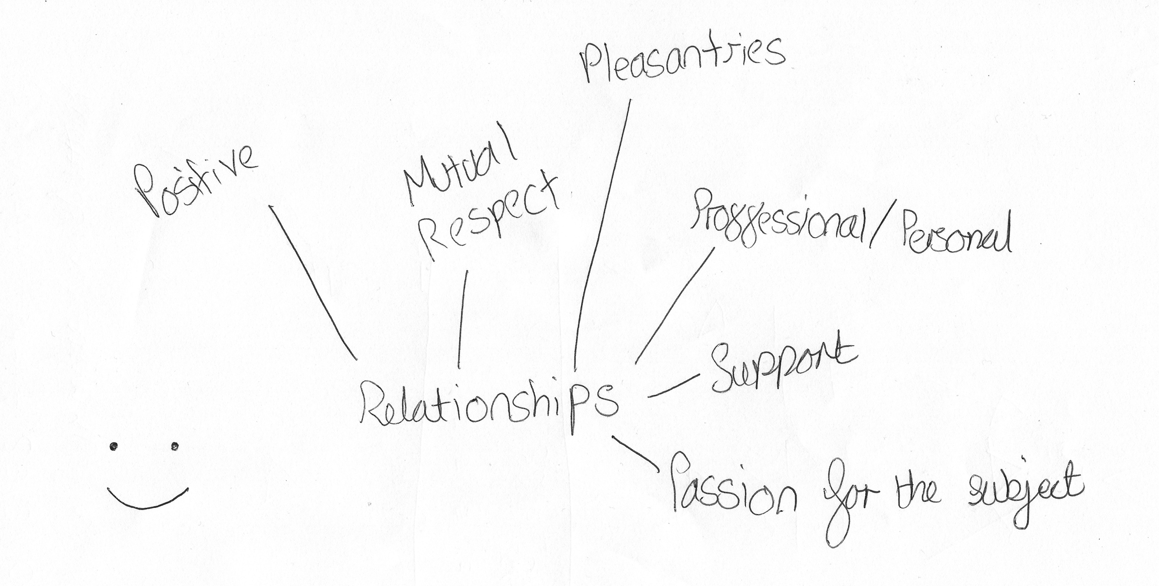

I: Brilliant! No that’s good. Okay so, these are all the things that go into a good relationship?

P: Well, there are lots more, but I feel on the spot.

I: [laughing] These are the main ones that come to your head?

P: Yes, I think so.

I: Okay, brilliant. Excellent, okay [laughing].

P: Oh no! You’re a cruel person.

I: [laughing] So, this is the opposite. So, a bad relationship. So, this should be slightly easier because you’ve already thought of a good one [laughing].

P: I’ll change the centre [pause for drawing] [laughing]. It will always amuse me how the human mind can focus on the negative so much easier than it can on the positives. I’ve got lots for this, nothing for that.

I: [laughing] That’s true.

P: [pause for drawing] I’m used to writing [pause for drawing]. We have one tutor who just talks for 3 hours, it’s a 3 hour lecture and it’s the worst thing in the world.

I: 3 hours?

P: Oh, it’s just awful. Well it’s meant to be 1 hour lecture, 2 hour seminar but he just – they just talk. Oh, it’s shockingly bad. I haven’t learned a damned thing, just doesn’t work.

I: No, sounds awful.

P: [pause for drawing] I really should have spread these out more. [pause] Are we going for, like, extreme here or just, sort of, moderately bad relationship? Because there is, like, you know, abuse, which would be, generally, considered to be quite negative.

I: Yeah.

P: But I feel that’s, you know, that’s dire circumstances.

I: Yeah, that’s quite bad. I don’t know, I guess ones that possibly you’ve experienced before, the types of relationships… things that you didn’t like about certain relationships with people.

P: See I’m really judgemental, so…

I: Well, that’s fine.

P: So, I don’t like some people’s voices and that’s enough to rule me out.

I: Do you know what, I’ve actually heard that from another student as well.

P: That’s good, I’m not the only bad person out there, there are more of us.

I: It’s all about your personal perspective, so whatever you think [laughing].

P: [pause for drawing] Do you get any good drawings?

I: There was one particular one who almost did Art, so that was quite a good drawing.

P: How long did that take?

I: It was actually quite quick [laughing].

P: Oh right, okay. Letting the side down.

I: And then there was one academic who tried to draw people, but they looked like –

P: Oh you talked to academics as well? That’s interesting, I didn’t know that.

I: But they looked like blobs of jelly [laughing].

P: I get that. Even my smiley face looks weird, looks like a grumpy sun at the moment [pause for drawing]. I have to think of one more because I’ve already drawn it [pause for drawing]. Oh, what is that word? Lack of individuality?

I: De-personalisation or de-individualisation? I don’t think there is a word for lack of individuality.

P: Yes, but also no. I’m going to go with clone-mentality.

I: Ah! Nice.

P: [pause for drawing]. There’s that one.

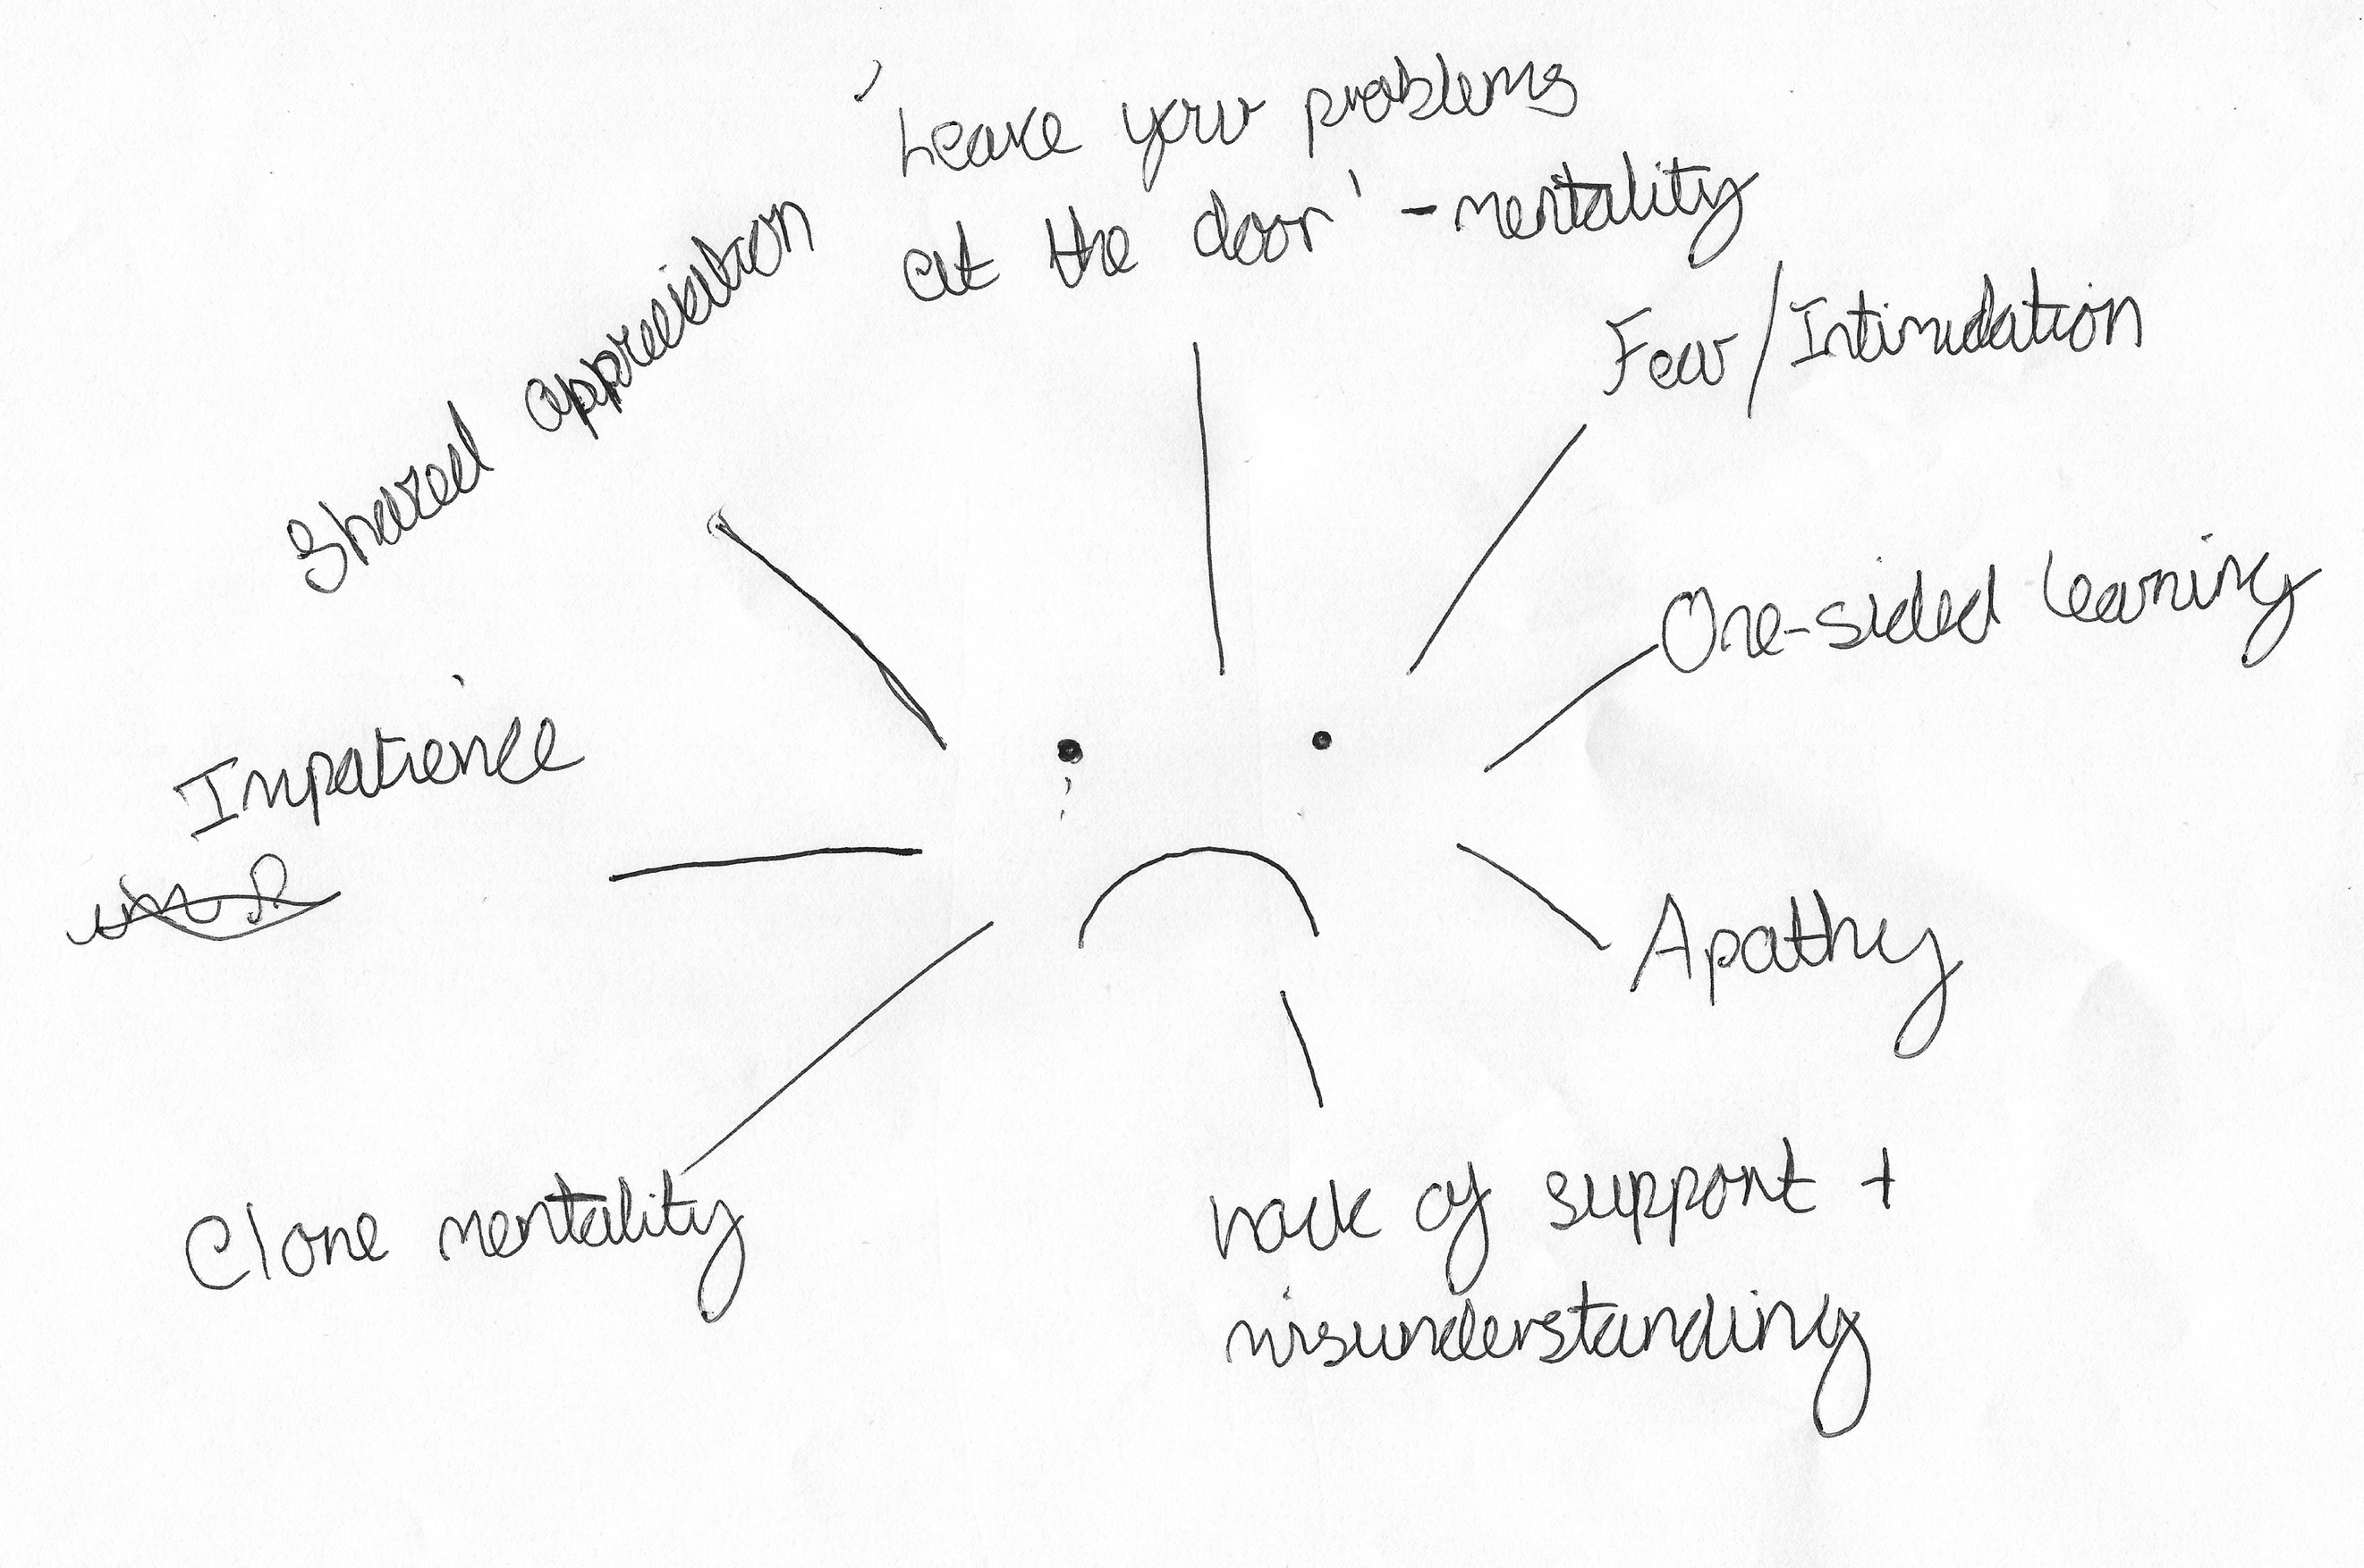

I: Thank you very much.

P: That is not a pleasure.

I: [laughing]. Okay, there is one more.

P: Oh, for crying out loud!

I: [laughing] I’m sorry. Okay, this one is, can you draw your conception of your relationship with the university as a whole?

P: I’ll draw the monopoly man. I’m not even going to try but I’d quite like to. Yeah, alright. Can I use this?

I: Yeah of course you can.

P: If I’m going to do a bad drawing I’m going to do it properly [pause for drawing]. I feel the need to label that [pause for drawing]. I’m refusing to gender my stick people because I think it’s insane. So they’re just stick people who may be men or women. Should have included some [pause] I don’t know… [pause for drawing] Smiley faces and mortar caps [pause for drawing] [laughing] Ah I wasn’t prepared for drawing today [pause for drawing] [laughing] I’m really not very good at this.

I: This is good!

P: No, no it’s not [pause for drawing] [laughing]. So these are going to be included in the research?

I: Yes.

P: So, someone might look at this? Oh good, that’s what I wanted.

I: [laughing]

P: [pause for drawing] How do you spell business?

I: B-U-S-I-N-E-S-S

P: [pause for drawing] I always get it confused with busyness [pause for drawing]. That’s all you’re getting.

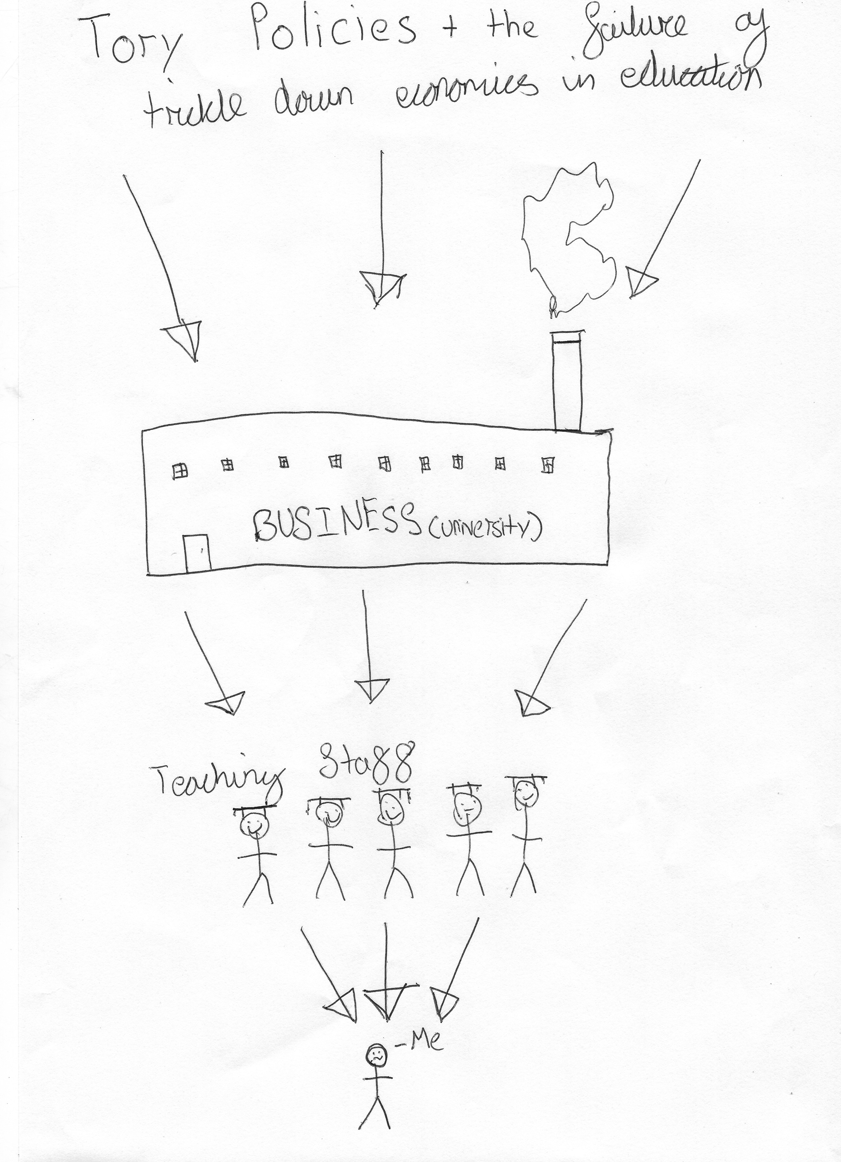

I: Very good okay. So, why have you drawn this? Explain it to me [laughing].

P: Okay. So we have the varying levels here [pause]. So, the – what’s the word? The inclusion, the connection between government and education, particularly when it’s so focussed on money. The idea is that, you know, it benefits everyone, which clearly it doesn’t. These people get paid too little [pointing to staff], these people get too much [pointing to university and government], I get a degree and a shit load of debt, which unfortunately stems from the policies that are in place. We need a government that encourages free education, you know, the whole student loans, like, student loans are good, maintenance loans are rubbish and they’re done very poorly. I have lots of siblings, and don’t get any money from my parents because they can’t afford to, which I don’t judge them for it, like, I understand, I don’t expect to, which you shouldn’t. I get very basic minimum loan, which is not even vaguely enough to cover rent and then you, you know, you’ve got the hassle of, you know, eating. So, you know, there’s a stark failure there. We should be encouraging people to become involved in these sorts of things. It’s the, sort of, fine line between there are lots of career opportunities that you don’t need to go to university for, and going to university is not beneficial but schools encourage all children to go to university, which means that way too expensive for those of us who actually need it, and then you have loads of kids that come out with way too much debt for something that they do not need, and we need an increase in vocational opportunities. That’s all their fault [pointing to the word ‘Tory’], well it’s the wider government, but particularly them, which unfortunately, when you have such an, you know, an importance here and it wasn’t, you know, it wasn’t long ago that universities were free. What was it? I don’t think, my parents might have paid about £5,000 or so, altogether, and that was 20/30 years ago, if that. I mean it’s, you know, the amount of time it’s taken from going free to, I’m going to come out with at least £60,000 worth of debt. My dad’s a [removed for confidentiality] – sorry I don’t know what the, you know [points to the recorder]

I: Yeah that’s fine.

P: And he’s been a [removed for confidentiality] for the last 15 years and he paid his student loans off last year, like, we are not a low income family and he has just paid them off, and that’s insane. That’s ridiculous, most people would never pay them off, and who is that then benefitting? Because they don’t get their money after 30 years, but it still hangs over them. Rubbish. But the importance on this, and the inclusion of business and education, again, it doesn’t work, you know, I don’t have any bright ideas on how we’d do it otherwise but clearly this isn’t working. It’s not working in primary schools, it’s not working in secondary schools and it’s not working in universities. So, yeah, we have going down. These are all the teaching staff, we like them, they get paid way too little for their job, especially when you consider how much money’s going into these [points to the university and government]. Then I get a crap load of debt, I suppose that’s the wider student but, well, I can only speak for me.

I: Okay. Brilliant, thank you very much.

P: That’s alright. That was meant to be, like, a workhouse. That was what I was going for.

I: Oh yeah, I like it with the chimney [laughing].

P: Yeah.

I: [laughing] Brilliant, thank you. That’s no more drawing now, so you can relax.

P: Brilliant. Though I’m not sure I believe you.

I: [laughing] I’ll just spring another one on you. Okay, last few questions.

P: Okay.

I: There’s often a lot of encouragement for undergraduates to engage with the different experiences that university offers, joining societies, volunteering etc., etc. What are your thoughts on this?

P: Societies are rubbish. There are opportunities over the summer, there are internships and things that are very, well, no that’s probably not fair – they’re very focussed on their students, which they don’t need to be. A lot of them are research opportunities and things that would benefit everyone, but they’re very limited and they go only to very few people and usually don’t go to undergrads either, which is rubbish. I understand not giving it to maybe a first year, but when you’re in your second or third year, give them those opportunities. Societies aren’t great, there’s a focus on sport and I’m – I just, there’s something so – it’s a very different discipline but I don’t think there’s a lot of in between – I’m wording this very carefully – between sport and education. I understand why we have it, and it is, you know, without question a skill, one that I’m sure I could never master, I wouldn’t try to. But there, I don’t think there is a good enough go-between for those things that we have so much more focus on sport than debating or research or, you know, the whole host of other opportunities that we can have to encourage people to engage in wider learning, which is what the university is for at its core.

I: Yeah, okay. Okay, last question, how much of a valued member of the university do you consider yourself to be?

P: A lot because I put a lot of work in because I want a scholarship. I intend for them to pay for my Masters and Doctorate, yeah. So, I’m working very hard to be very involved and have done pretty much everything they’ve asked and I’m very good at it as well. So, personally yes I do, but because I’ve made myself not because of anything they’ve done. I’ve put a lot of work into helping them to which they often then steal the credit, which is, yeah I understand why they do it, but it’s very annoying. So, yeah, I think I’ve put myself in a position where I am valued, but as a tool, not in the, “You’re a tool” sort of, derogatory sense but in a, as a useful person to go to as opposed to someone that they can give opportunities to. Not with all of our staff, some of them are fantastic and are very, “You should do this because you’ll enjoy it” but the majority are, I think it’s very much a, “Use him because he’ll actually help”.

I: Yeah, okay. Okay, well thank you so much for all your answers, really, really interesting. Is there anything that we didn’t talk about that you want to add?

P: Nope.

I: No? We covered quite a lot.

P: Should there be?

I: [laughing] No. Okay, so I’ll stop the recording then.

[End of Recording]

