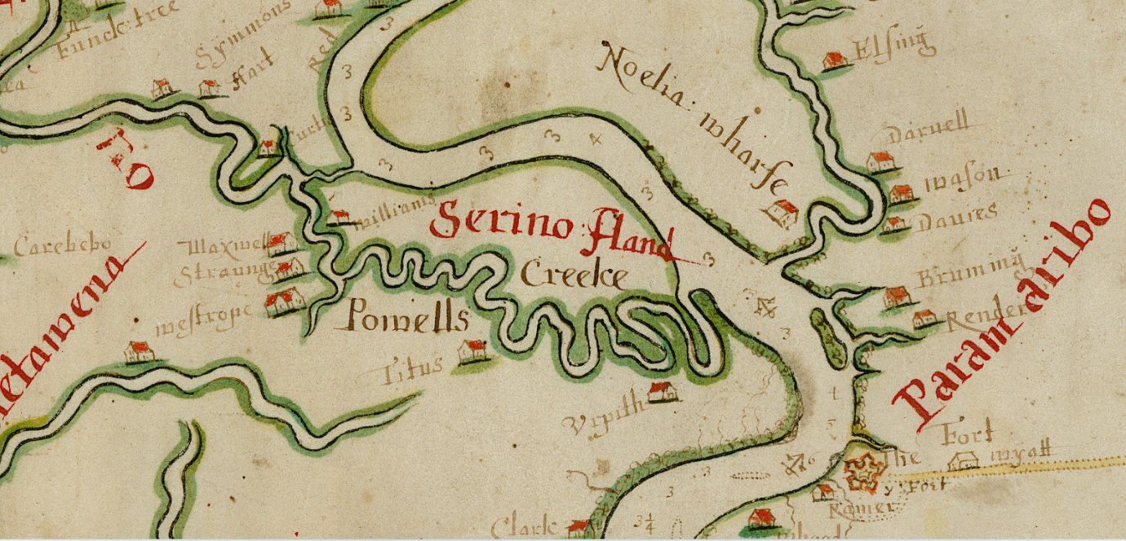

'Dictatorship, liberty, and fish-sticks. Suriname: 1667 and 2011'.

The John Carter Brown Library holds the most expressive map of the seventeenth-century English Caribbean: little-known Surinam in the Guianas. Created in the year the English colony fell to the Dutch, when historian, Sarah Barber, journeyed three days into the interior to experience a little of the lives of early-modern English people saw 350 years ago, remarkably little had changed. Here she explores the value of the map in recreating the anglophone torrid zone: the autocratic rule of Willoughby of Parham and his republican would-be assassins; the remarkable detail and accuracy of the map of the rain-forest; the journey on a bauxite-barge to explore the Suriname and Commerwijne Rivers; and whether the legacy of 1667, despite the short life of English settlement there, has shaped Suriname's turbulent present.

Biographical details
Sarah Barber is a Senior Lecturer at Lancaster University in the UK. Originally an historian of British civil war republicanism, where she first encountered the Suriname connection, she has since been recovering and analysing the surviving seventeenth-century sources for the anglophone torrid zone, and the monograph, Disputatious Societies: the Caribbean World in the Age of the Stuarts is about to go to press.

The reference for the map is John Carter Brown Library, Brown University, Providence, RI., Cabinet Gm667 Di Ms: 'A Discription of the Coleny of Surranam in Guiana Drawne in the Yeare 1667'.

