Computational Modelling and Simulation Requirements Document



Author: Dr R. A. Williams
Creation Date: January 15, 2020
Last Updated: June 1, 2022
Version: DRAFT 1C

Document Control

Change Record

Date | Author | Version | Change Reference
15-Jan-2020 | Dr R. A. Williams | Draft 1a | No Previous Document
18-Sep-2020 | Dr R. A. Williams | Draft 1b | Updated with Conceptual Model

Reviewers

Name | Position

Distribution

Copy No. | Name | Location
 | Project Team | Personal Computers
 | University Data Repository | PURE System
Contents
Document Control 2
Introduction 4
Background 5
The RM Programme 5
The Social Network of the RM Programme 8
Relationships and Interactions within the RM Programme 9
Main Stakeholders within this Research Project 14
Objectives 15
SMART Project Objectives 15
Scope 16
Features and Functions of Product 16
Constraints 17
General Project Constraints or Restrictions 17
Specific Constraints or Restrictions Associated to Scope 17
Assumptions 18
Key Assumptions 18
Risks 19
Key Risks 19
Deliverables 20
Key Deliverables 20
Open and Closed Issues for this Requirements Document 21
Open Issues 21
Closed Issues 21

Introduction
This document provides the functional requirements for the Agent-Based Model (ABM) developed during this research project. Once developed, the ABM will be used for simulation-based experimentation in order to investigate the development and propagation of conflict in large multi-partner enterprise system implementations.
The data has been collected from a case study, which was part-way through implementation when the research team gained access to perform data collection. It was based at a large UK-organization that was upgrading their Information Systems and Information Technology in order to achieve efficiencies to back-office business processes and gain significant cost savings over the longer-term.
The document is structured to provide the background to the case-study, along with the objectives, scope, constraints, assumptions, risks and deliverables of the research project. The background section provides a brief conceptual model with focus on the customer and third-party organizations, the social network of team members and how they were organized into project teams, and the development and propagation of conflict.

Background
The case study for this research project, relates to a UK-based organization (the Customer) that was implementing a large strategic modernization programme, underpinned by the replacement of a significant portion of their IT and IS infrastructure. From an organization-wide business process perspective, the largest organizational costs related to the area of Resource Management. As such, the Customer embarked upon a major business-driven IT/IS programme of work (the RM Programme), which required the integration of new and legacy systems in order to yield meaningful cost savings and more efficient business processes.
The existing IS infrastructure consisted of multiple standalone software packages from different brands/suppliers and were not completely integrated together. The most important of these software packages, with respect to Resource Management, related to Finance, Human Resources (HR), Procurement, and Payroll. These standalone Enterprise Resource Planning (ERP) systems, had historically been developed as discrete solutions to the emerging requirements at the time. The Customer’s aim for the RM Programme, was to install and configure a new Enterprise System that would provide a set of standardized business proceses that were fully integrated across the Financials, HR, Procurement and Payroll functions. In addition, this new enterprise system would be fully integrated with the remaining legacy systems that were not being replaced.
The Customer outsourced the delivery of the enterprise system implementation programme to a number of third-party organizations, all being contracted to work on a fixed-price basis. The most important of these third parties was a global software vendor that specialized in enterprise systems, to act as the sole software vendor to install, configure and test the three ERP modules (Financials, HR, Payroll) and it’s interfacing to the remaining legacy systems through custom technical development. The Customer also employed three Professional Service Providers (PSP), two of which acted as Subject Matter Experts (SME) for the configuration and extension of the business processes that relate to the three modules, whilst the third focused on IT architecture for hosting the enterprise system, and also as SME for the technical development that was required to integrate with legacy systems.
With the above in mind, the case represents a multi-partner enterprise system implementation that requires the effort of Customer, Software Vendor and three PSPs. This introduces the potential for conflict development right from the start of the RM Programme, and once conflict has developed, it has the potential to propagate throughout the social network of the multi-partner implementation programme.

The RM Programme
An SSM approach was used to perform the initial analysis. Along with interviews and workshops with key team members from the Customer, Software Vendor, and three PSPs, there was also documentary analysis of system design and project management documents. This data allowed us to perform Analysis One, Two, Three, along with developing a CATWOE definition, root definition, and rich picture.
Analysis One focused on the roles of actors. There were 159 team members within the RM Programme (at any given point in time), which were organized into the five project teams relating to HR, Financials, Payroll, Technical and Training. The Customer team members were intimately involved in providing subject matter expertise to facilitate the design and configuration of the enterprise system, bespoke extensions, and testing of the system at various stages throughout the RM Programme; the Software Vendor designed and configured the enterprise system, designed and developed bespoke extensions, along with data conversion and integration routines; the three PSPs acted as independent SMEs, providing assurance that the system complies with UK legislation and requirements from regulatory bodies and professional institutions. Finally, the overall problem owner was the Operations Director who acted as Project Sponsor and gave final Customer sign-off at each testing stage (for staged payment to the Software Vendor), and overall acceptance of the system at the end.
Analysis Two focused on the social system and provided insight into the background business drivers for the RM Programme and the main stakeholders. As discussed above, the RM Programme was initiated by the Customer to provide more efficient business processes that would ultimately deliver significant cost savings. Indeed, the majority of the results from Analysis Two have been used in the case-study description in Section 3 above.
Analysis Three focused on the political system, and in particular how power is wielded in various problem situations. With respect to the membership of the RM Programme, the overwhelming majority of team members were part of the RM Programme for the duration of its implementation, however there was some change in personnel on the software vendor side. This was due to a variety of reasons, including personal reasons, such as the need to move onto a project closer to home to reduce the number of nights that team members spent away from home in hotels; resource constraints, such as the Software Vendor only having a limited number of experts in specific functional/technical areas, and needing to withdraw a resource so that they can assist in projects at other customers; or professional relationships, such as the breakdown of working relationships between Software Vendor resources and Customer resources, which required their removal and replacement.
Our CATWOE definition is:
- Customers - the beneficiaries or users that the system is imposed upon - are the Customer resources who will use the Enterprise System that is installed and configured following successful completion of the RM Programme
- Actors - those who will do the Transformation Process - the Customer and third-party team members who work within the RM Programme
- Transformation Process - the conversion of the input to output - the design and implementation of the Enterprise System and associated Information Technologies
- Weltanschauung - the worldview, which makes the Transformation Process meaningful in context - the previous requirements analysis performed by the client as to why the RM Programme is required in order to achieve operational savings and increased performance of back office functions
- Ownership - those who could jeopardise the system - a number of core Customer personnel who are against the successful implementation of the RM Programme
- Environmental Constraints - elements of the system, which incur constraints - Customer policies and procedures, legacy systems, security constraints
The following root definition was developed for our system: ‘A large UK-based organization is engaged in a major strategic modernization programme of their IT and IS infrastructure, with particular focus on installing and configuring a new Enterprise System (and associated IT infrastructure) that is fully integrated with a number of existing (bespoke) legacy systems, in order to standardize back office business processes, which would provide large-scale efficiencies with respect to business processes of administrative functions and significantly reduce the associated operating costs’. In addition, the root definitions were recasted into the form: do P by Q to facilitate the achievement of R. Our PQR definition is therefore:
- P - what to do - Implement a new IT and IS architecture, which is centred around a number of core ERP modules (i.e. HR, Financials and Payroll) and will be fully integrated to existing legacy systems that are being kept.
- Q - how to do it - Outsource the design, development and implementation to a number of third-party providers, which comprise a single Software Vendor and Three PSPs.
- R - why do it - There is an urgent need to standardize back office business processes in order to facilitate significant efficiencies in administrative functions, thus leading to major operating cost reductions.
Rich Picture. Conflict developed within the RM Programme through a number of mechanisms, which are predominantly linked to interactions between individual team members. We hypothesize that once formed; conflict may propagate throughout the social network of the wider programme. This then resulted in deviations away from the agreed scope, time, budget and quality of the RM Programme.

RM Programme Organizational Structure. Organizational structure of the RM Programme, showing that resources are assigned to one of the 6 Project Teams, the Programme Management Office or the Programme Directorate.

The Social Network of the RM Programme
The RM Programme as a whole consisted of 159 resources, with individual resources belonging to a single Project Team, namely: HR, Financials, Payroll, Technical and Training, alongside additional groups of resources that relate to Hosting, Offshore, or the Programme Directorate and Project Management Office (PMO). These 159 resources (the network nodes), along with their workplace relationships (the network edges) were defined within an adjacency matrix, to facilitate formal analysis of the network topology. The RM Programme social network was found to contain 972 undirected workplace relationships, which provided an average degree of connectedness of 12.23. The theoretical maximum undirected edges within the network was found to be 12,561 [defined by n(n-1)/2], which provided a network density of 0.077, indicating that only 7.7% of all theoretically possible connections were used for official workplace relationships.

Social Network Map for the RM Programme. This social network defines the official workplace relationships between the 159 individual resources. It is composed of sub-networks at the project team level

The social network map for the RM Programme is defined above and was derived from the adjacency matrix. As to be expected, the network topology is structured around the individual Project Teams, with the key resource(s) within each project being the relevant PM for the employing organization (i.e. Customer, Software Vendor, or PSP). Of special interest is that a number of knots are identified, which correlate to sub-groups within the projects that correspond to resources from an individual employing organization. We conjecture that these resources have strong ties to each other at the beginning of the relevant project, due to them having relatively similar educational and professional backgrounds, along with working towards the same organizationally imposed objectives. In addition, it is apparent that the PMs within the individual projects and Programme Managers from the different organizations, act as bridgers to officially connect the different Project Teams together.

Relationships and Interactions within the RM Programme
The overall high-level perspective of the RM Programme has been diagrammatically defined using the UML Class Association notation. This represents the associations between the highest-level definitions of components (i.e. agents) within the RM Programme, such as Project Teams, Project Implementation Processes and the various IS and IT. An alternative view, with increased level of granularity, uses the UML Class Containment notation. Here it can be seen that the Enterprise System Implementation (the RM Programme) consists of the high-level concepts of a Project, the PMO & Directorate, an Organization, the RM Delivery Method, and IT & IS Infrastructure. Each of these concepts is then broken down into its constituent components, for instance the Project Class can relate to one of the five different projects within the RM Programme, and is composed of a Project Team, which in turn can be an aggregate of the Customer Team or a Third-Party Team. These are defined through use of clear and filled diamond connectors, which represent the concepts of aggregation and composition, respectively. For instance, the Project Class must be composed of one Project Team, whereas a Project Team is the aggregation of teams from the Customer, Software Vendor and Professional Service Provider.

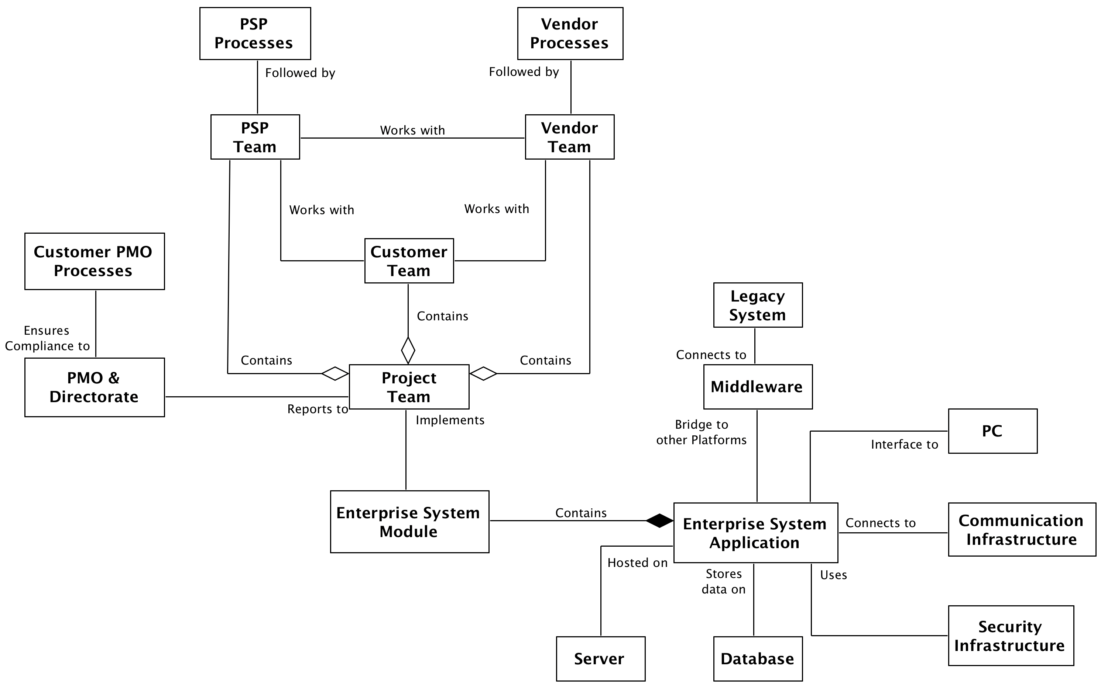

UML Class Association diagram for the RM Programme. This represents the associations between the highest-level definitions of components (i.e. agent Classes) within the RM Programme, such as Project Teams, Project Implementation Processes and the various IS and IT.

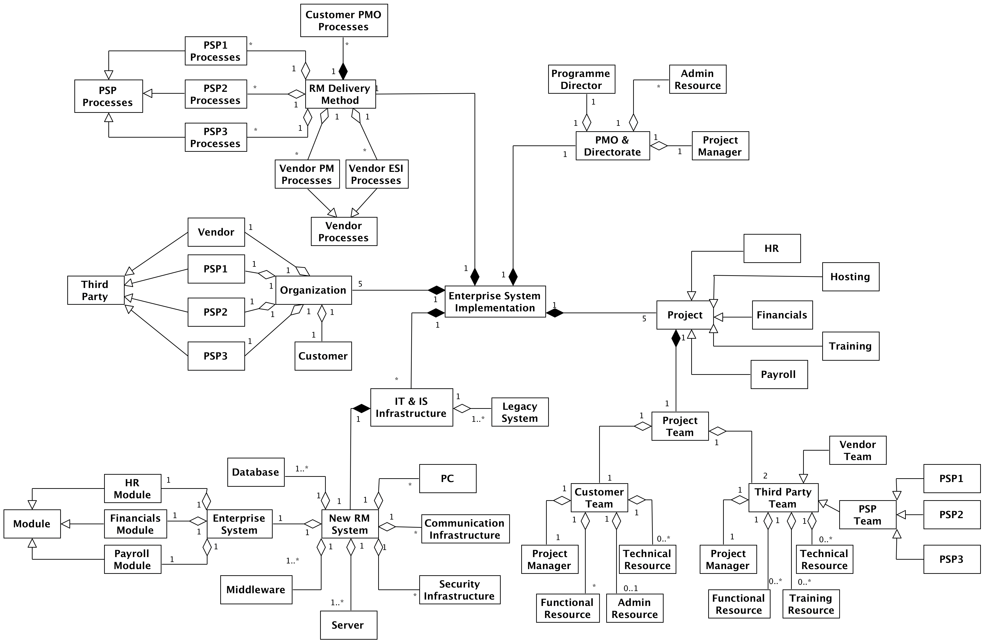

UML Class Containment diagram for the RM Programme. This consists of the high-level concepts of a Project, the PMO & Directorate, an Organization, the RM Delivery Method, and IT & IS Infrastructure.

Conflict development
As discussed above, and defined in the social network map, the RM Programme consisted of 159 team members who were organized into different project teams and represented resources from Customer, Software Vendor and three PSPs. The majority of these resources were assigned for the full 3.5-year duration of the IS/IT implementation programme. The RM Programme demonstrated substantial conflict throughout its duration.
Task conflict development
Although the overwhelming majority of task conflict was detrimental to the programme, some instances of task conflict actually provided positive benefits, such as animated discussions and disagreements during the design phase, leading to more robust requirements analysis, configuration of the out-of-the-box enterprise system, design specifications of custom extensions and problem solving of issues. Unfortunately, too much disagreement during these design and problem solving activities can also lead to negative task conflict, due to reducing the ability of team members to develop concensus, along with distracting team members from focusing on their individually assigned work packages and therefore introducing delays to the project.
Similarly, negative task conflict was found to develop through a multitude of other team member behaviours and interactions. An important example relates to power imbalances between team members and when associated with power from a superior, such as Programme Manager or Project Manager, this can also lead to the assignment of too much work that needs to be completed in unrealistic timescales. Additional examples of task conflict were due to: the forcing of opinions onto other team members due to ego; dependencies on deliverables from other team members, other enterprise system modules, or other infrastructure/architecture, in order to complete tasks; complications around design of interfaces and data conversion routines; complications with implementation of configuration or development of custom extensions; and failed parallel run testing, where the new enterprise system functionality is tested against that of the existing legacy system that it will replace.

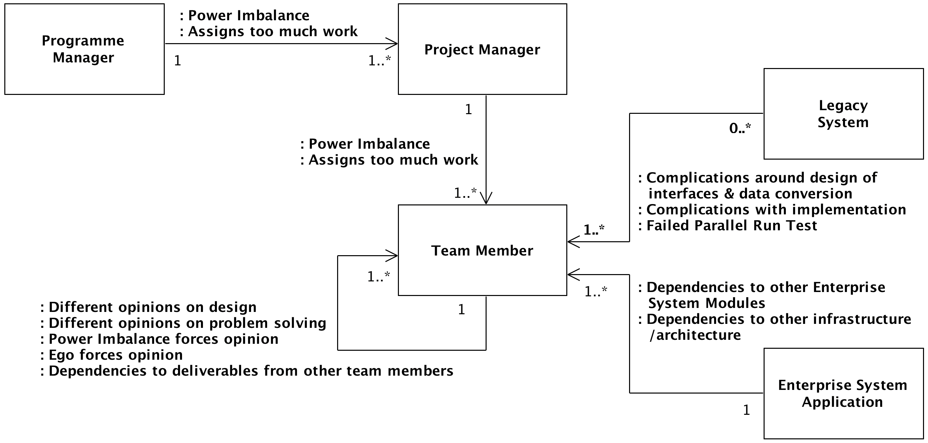
UML Class diagram for Task Conflict in the RM Programme.

Overall, task conflict was usually found to develop between a subset of team members within individual project teams (e.g. through ego and power imbalances giving rise to strong disagreeements on how to solve problems or tackle design challenges), but if not managed effectively, there was potential for the conflict to spread to the wider set of team members, in a similar way to a viral infection propagating throughout a social grouping. Similarly, task conflict was seen between team members from different organizational resources (e.g. due to resource constraints, differing priorities, or dependencies between them), which had the potential to affect the wider project team and foster a them and us mentality, thus negatively impacting on the project team performance.

Process conflict development
Along with a significant number of instances of task conflict, the RM Programme was also regularly impacted by disagreements that led to uncertainty, which is a symptom of process conflict. Notable examples are the passionate and sometimes heated discussions when the Customer was reluctant to make important design decisions, which generated tension and conflict between Software Vendor and PSP resources. These instances of process conflict due to the reluctance of the client to make timely decisions were a direct result of the contractual environment, where the Customer signed fixed-price contracts with all of the individual third-party organizations, meaning that none of the external organizations were contractually accountable for the programme-wide implementation. This resulted in the emergence of behaviours from the third-party organizations that prioritized their own contractual obligations over the needs of the RM Programme. Unfortunately, this brand protection behaviour resulted in disagreements between the Customer, Software Vendor and PSPs around who is ultimately responsible for resolving emerging design, configuration and technical issues that effect the overall enterprise system and not merely one of its constituent modules that is assigned to a specific project team to implement.
Another factor that regularly contributed to process conflict was the high administrative burden through the overly bureaucratic environment in which the RM Programme was implemented. In particular, through the large number of processes that were developed by the client PMO and enforced on the programme by the Customer Directorate, who had a tendency to micro-manage resources. The administrative burden and time-intensive nature of the processes resulted in a large number of third-party resources actively deciding to not follow the processes (e.g. completeness of documentation, formal reporting requirements, or scope management processes for small changes) because they were focused on delivering their work packages and therefore completing their functional or technical tasks assigned to them by their PM. Furthermore, the multi-partner environment, consisting of Customer, Software Vendor and three PSPs, created considerable risk of disagreements around responsibilities for individual tasks, along with developing mistrust when one of the external organizations was dependent on delivery of an intermediate deliverable by another external organization.
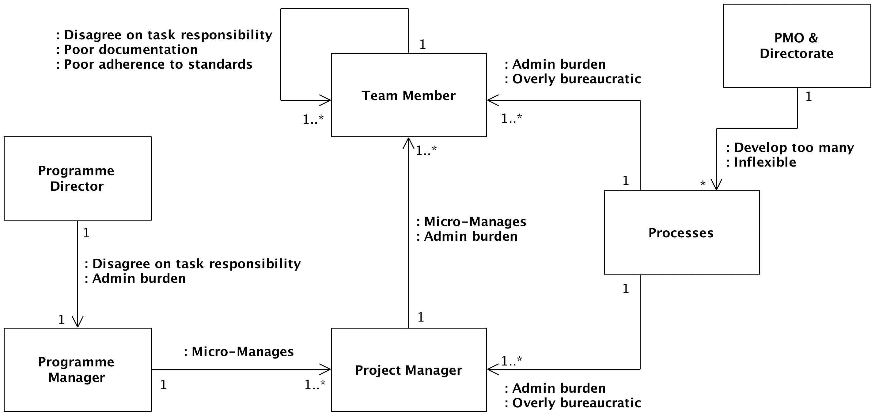

UML Class diagram for Process Conflict in the RM Programme.

Relationship conflict development
Relationship conflict is focused around the differences in personal characteristics (e.g. education [both qualification(s) and School/University attended], family background, or professional history) and how these might lead to personal issues, such as annoyance or mistrust. Importantly, it can also develop through differences in the culture, values or drivers of the employing organization. The RM Programme had a significant number of instances of relationship conflict, with our analysis indicating that these primarily revolved around the misalignment of employing organization objectives, which led to competition between the various organizations, or due to power imbalances between team members, which morphed from process conflict to relationship conflict after the disputes became personal and no longer about the implementation of specific tasks.
Another example of how task or process conflict had morphed to relationship conflict in the RM Programme revolves around bad behaviours emerging from the Software Vendor because they were being blamed for technical issues and delays in delivery of custom extensions and system-wide configuration. However, the cause of these issues, was the Customers unwillingness to take accountability for programme-wide decisions. This caused mistrust between the majority of the Software Vendor and Customer resources, which propagated to also negatively impact relationship between the Software Vendor and PSP resources because the latter resources were employed as SMEs for the Customer, so had a contractual relationship with the Customer and not the Software Vendor.
Of critical importance, is the fact that the RM Programme was underpinned by the need to make significant cost savings and efficiencies by streamlining back-office functions, which would ultimately lead to a reduction in headcount within back-office administrative departments. This led to a misalignment between the Customer organizations’ corporate drivers and the personal drivers of its resources, who part-way through the RM Programme became cognizant of the consequences from successful implementation of the programme. The result was that a number of Customer resources developed negative attitudes (and emotions) towards the RM Programme, became demotivated, proactively decoupled themselves from the aims and objectives of their respective project, and in a few cases became actively hostile to resources from the external organizations and employed subversive behaviours to try and initiate failure within their specific project.

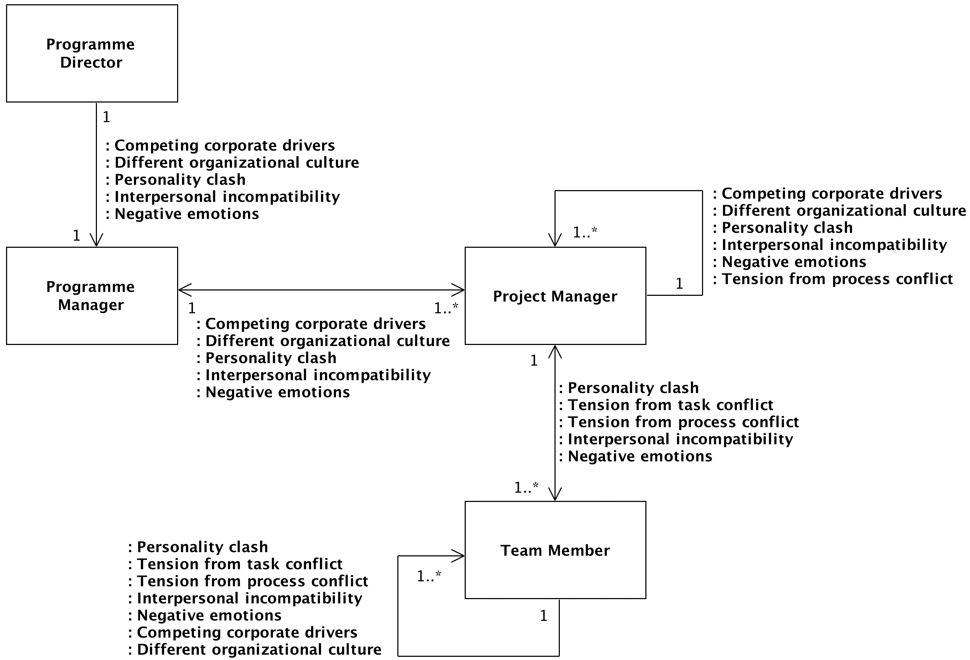

UML Class diagram for Relationship Conflict in the RM Programme.

Main Stakeholders within this Research Project
The main stakeholders within this computational modelling and simulation research project are defined in the Stakeholder Matrix below:

Objectives
- There are 5 main goals for this modelling project:
- Develop a conceptual model of conflict development and propagation
- Develop an agent-based model of conflict
- Investigate causes of conflict development
- Investigate dynamics of conflict propagation
- Develop hypotheses of how conflict can be controlled

SMART Project Objectives
Each of the goals above can be transformed into individual SMART Project Objectives:
- Develop a conceptual model of conflict development and propagation within the RM Programme, which is based upon analysis of the dataset that used Soft Systems Methodology, Social Network Analysis, Thematic Coding Analysis and Unified Modelling Language.
- Develop an agent-based model of conflict development and propagation that is based upon the conceptual model of the RM Programme.
- Perform simulation-based experimentation with the agent-based model in order to investigate the various causes of conflict development within the RM Programme. This will replicate mechanisms of conflict development identified in the qualitative dataset, along with running new experiments in order to identify other mechanisms that might lead to conflict development.
- Perform simulation-based experimentation with the agent-based model in order to investigate the various causes of conflict propagation within the RM Prorgamme. This will replicate mechanisms of conflict propagation identified in the qualitative dataset, along with running new experiments in order to identify other mechanisms that might lead to propagation of conflict.
- Perform simulation-based experimentation with the agent-based model in order to investigate mechanisms by which: a) conflict development can be mitigated; b) it’s propagation can be slowed, or impact reduced, in order to reduce impact to the wider social network.

Scope
The overall scope is the development of a quality-assured agent-based model of conflict development and propagation from the RM Programme, that can be used for simulation-based experimentation in order to develop novel hypotheses on how conflict can be mitigated (or managed once developed) within large multi-partner enterprise system implementations. As such, the ABM will be used to develop hypotheses of how Project Managers can ‘control’ the complex socio-technical system in order to implement a number of 3rd Order Cybernetics feedback loops.

Features and Functions of Product
Develop a quality-assured ABM based upon the conceptual model of conflict within the RM Programme. Specific features must include:
- Configuration of the physical model to ensure the 159 individual agents are connected in accordance with the Adjacency Matrix and Social Network Map that were developed during Social Network Analysis. These connections will correspond to ‘formal’ work-based relationships between team members.
- Configuration of the 159 individual agents to ensure they contain labels/attributes that align to the relevant demographic characteristics identified during the data collection phase, e.g. employer, project, role, gender, approximate age education status, etc.
- The ability to develop the 3 types of conflict that are commonly seen in projects of this nature, i.e. Task, Process and Relationship conflict.
- Communication between agents will be directed, in that conflict can be caused in an individual agent by behaviours of (i.e. interaction with) another agent.
- The physical social network map can be static, so the emergent behaviours within the system (i.e. various types of conflict) result from instances of interactions between agents in the social network. This means that the ABM does not need to explicitly model movement of agents in 2-dimensional space.
- The ability to setup simulation-based experiments using a starting parameters file, i.e. definition of agent demographic values and conflict-related parameter values can be changed between simulation-based experiments by the use of different starting parameter files.
- The ABM should be designed and developed using a modular approach to facilitate easier updating, i.e. to add new functionality in subsequent research projects.
- The ABM is developed using robust software engineering principles, in particular through calibration, validation, verification, testing, sensitivity analysis, and uncertainty analysis.
Finally, it is envisaged that at least 3 manuscripts will be developed and submitted to journals for peer-review and subsequent publication. These could relate to: 1) Qualitative and Social Network Analysis; 2) Conceptual Model; 3) Agent-Based Modelling and Simulation.

Constraints
This research project has a maximum of 3 resources, which correspond to Principal Investigator, Soft Operational Research Resource and Modeller, and a maximum of 24 months duration.

General Project Constraints or Restrictions
No data collection can be performed until institutional research ethics approval has been gained.
Budget for a high-specification digital audio recorder and medium specification video recorder for capturing data from interviews and workshops.
No budget for transcription activities, meaning that the Soft OR Resource will have to perform transcription of audio interviews (and video recordings of workshops) themselves in order to perform qualitative data analysis.
Budget available for medium-specification laptops with access to standard academic software applications through the institutional software repository.
Project reporting needs to be performed in accordance with the funding bodies requirements.
Publication of peer-reviewed journal articles needs to comply with the funding bodies requirements with respect to Open Access publishing.

Specific Constraints or Restrictions Associated to Scope
The ABM must be developed using an existing development framework because there is no budget for development of new frameworks. Examples of ABM development frameworks include MASON, FLAME or NetLogo.
The project should be structured around the functional and technical activities associated with an established computational modelling and simulation lifecycle. There are a number of high-quality examples in Computer Science or Operational Research.
Access to High-Performance Computing equipment cannot be guaranteed. As such, the computational model needs to be as computationally efficient as possible to ensure simulations can be run on a medium-specification laptop if required.
Aleatory and Epistemic Uncertainty Analysis need to be performed in order for us to account for the uncertainty in the system when we analyse simulation output data and develop hypotheses on how we might ‘control’ the real-world socio-technical system regarding conflict development and propagation.

Assumptions
A number of assumptions have been made when deciding the scope of the research project and developing the project schedule. The key assumptions are defined below.

Key Assumptions
- Access to the single case-study, which will act as an exemplar case-study, will be sufficient to gain a detailed understanding of conflict development and propagation in multi-partner enterprise system implementations.
- Analysis of the dataset will provide sufficient insight into how the 3 types of conflict (i.e. Task, Process and Relationship) developed and propagated within the case-study.
- The ABMS paradigm is appropriate to model the data gathered.
- The Objectives, Scope and Deliverables are achievable with the resources (PI, Soft OR Resource and Modeller) and time (24 months) available.
- The Project Schedule is achievable and realistic.
- The Conceptual Model will be a suitable amd realistic representation of the real-world socio-technical system.
- The ABM will act as a realistic Computational Model of the Conceptual Model.
- The simulation-based experimentation with the ABM will elicit new insights into the mechanisms causing conflict development and subsequent propagation.

Risks
This section provides a high-level discussion of risks associated with this research project

Key Risks
The key Project Risks at the Planning Phase of the Project are detailed in the table below:

Deliverables
A number of core deliverables will need to be produced within this research project. These are defined below.

Key Deliverables
- Anonymised qualitative dataset from interviews and workshops.
- Person-level role and demographic dataset, Adjacency Matrix and Social Network Map.
- Conceptual Model.
- Agent-Based Model.
- Qualitative and Social Network Analysis manuscript.
- Conceptual Modelling manuscript.
- ABMS manuscript.
- End of Project Report for funding body.

Open and Closed Issues for this Requirements Document

Open Issues

ID | Issue | Resolution | Responsibility | Target Date

Closed Issues

ID | Issue | Resolution |  | Responsibility | Date Closed
001 | Unable to include conceptual model due to data collection and analysis not yet being performed. |  | Timign issue. This will be resolved as the project progresses through lifecycle and phases. | PI | 30-Sept-20

