Prediction of Fuel Debris Location in Fukushima Nuclear Power Plant using Machine Learning

Saed Alrawash1, Matthew F. Hale2, Barry Lennox2, Malcolm J. Joyce1, Andrew West2, Minoru Watanabe3, Zhongming Zhang*1*, Michael D. Aspinall1

1 School of Engineering, Lancaster University, LA1 4YW, UK

2 Electrical and Electronic Engineering Department, The University of Manchester, UK

3 Okayama University, Okayama, Japan

Abstract. Accurate fuel debris location is crucial part of the decommissioning of the Fukushima Nuclear Power plants. Conventional methods face challenges due to extreme radiation and complex structure of the materials involved. In this study, we propose a novel approach utilising neutron detection and machine learning to estimate fuel material location. Geant4 simulations and pythonTM scripts have been used to generate a comprehensive dataset to train a machine learning model using MATLAB’s regression learner. A Gaussian Process Regression model was chosen for training and prediction. The results show excellent prediction performance to estimate the corium thickness effectively and to locate the nuclear fuel material with a mean square error (MSE) of 0.01. By combining the machine learning with nuclear simulation codes, this promises to enhance the nuclear decommissioning efforts to retrieve nuclear fuel debris.

1. Introduction

Locating fuel debris in the Fukushima Daiichi Nuclear Power Plant Stations (FDNPS) has proven to be a complex challenge during their decommissioning, primarily due to extreme radiation levels that makes visual inspection impractical. Whilst several attempts have utilised gamma-ray spectroscopy, the presence of activated structural materials and the dispersion of 137Cs throughout the primary containment vessels (PCVs) has complicated efforts to locate the exact location of the fuel debris with sufficient accuracy [1]. Neutron detection is a promising alternative, as neutrons emitted solely from nuclear fuel material offer a more direct indicator of its presence. However, to leverage neutron detection effectively, it is essential to understand the neutron intensity and spectrum, which can vary dependent on the composition of the corium mixture [2].

The corium resulting from the 2011 accident comprises various materials, including the fuel (UO2), Zircaloy cladding, control rods (B4C), concrete, and stainless steel. Accurately quantifying the mass of each component is crucial for estimating the location and quantity of the fuel material [3]. Previous studies have employed severe accident codes such as MELCOR (MELtdown Core Response) and MAAP (Modular Accident Analysis Program) to estimate the mass distribution of corium components, providing valuable insights that inform the selection of component masses summarised in **Table 1**[4].

Table 1. This table presents the inventory of corium mixture components after 10 years of the accident, as simulated by MELCOR, MAAP, and MCNPX models (tons) [4].

|  |  |  |  |
| --- | --- | --- | --- |
| Material | MELCOR | MAAP | MCNPX |
| UO2 | 69.4 | 76.15 | 75.77 |
| Zr | 25.8 | 16.59 | 17.8 |
| ZrO2 | 16.6 | 14.14 | 13.82 |
| B4C | 0 | 0.502 | 0.59 |
| Cr | 5.9 | 1.13 | 1.1 |
| Cr2O3 | 0.03 | 2.732 | 2.73 |
| FeO | 0.23 | 11.2 | 11.2 |
| Ni | 2.53 | 0.55 | 0.556 |
| NiO | 0.03 | 1.2 | 1.2 |

This study employs a practical approach to predict the corium thickness using machine learning algorithms focuses on using neutron detectors capable of withstanding extreme radiation environments, particularly diamond detectors. A comprehensive workflow has been developed, as depicted in **Figure** 1, to guide the implementation of the methodology. This workflow encompasses various stages, including the generation of diverse corium mixture, analysis of neutron detector responses, dataset generation using pythonTM, development of machine learning model in MATLAB, and prediction of corium thickness. This workflow serves a roadmap for this study. Furthermore, the Monte Carlo simulations necessary for simulating neutron energy spectra for each scenario were calculated using Geant4 Monte Carlo code. These computations throughout the study have been calculated using the High-End Computer (HEC) cluster of Lancaster University [5], enabling efficient and accurate analysis of the neutron energy spectra. The focus of this is to predict the thickness of the corium layers above the nuclear fuel material to speed up the nuclear decommission process to retrieve fuel debris.

The structure of this paper is as follows:

Section 2 provides an overview of the methodology employed for predicting corium thickness using machine learning techniques. Section 3 details the data acquisition process, simulation setup, and machine learning model development. Section 4 presents the results obtained from training the machine learning model and evaluates its performance.

**Fig. 1**. Workflow diagram illustrates the methodology for predicting corium thickness using machine learning. The diagram outlines the various stages of the process, starting from generating various corium mixture, followed by neutron detector response analysis, training dataset generation in python, machine learning model in MATLAB, and corium thickness prediction.

1. Methodology

The investigation begins by obtaining the fuel composition and radionuclides inventories from the Japan Atomic Energy (JAEA) data [6]. These datasets, calculated using ORIGEN2 isotope generation and depletion code, serve as the foundation of our analysis. This dataset provides crucial information such as mass, radioactivity, and neutron and photon emission rates [7]. A significant aspect of the methodology involves determining the proportion of the primary neuron emission source, identified as the 244Cm spontaneous fission nuclide [8].

Using this information, we model various scenarios by assuming the corium is located in the pedestal area with a known diameter and mass [9,10,11,12]. Geant4 simulations are then used to calculate the detector response for each scenario, including neutron count rate and total energy deposition in the detector. Utilising the High-End Computing (HEC) cluster at Lancaster University, our simulations are performed efficiently, with 256 cores to compute 1800 simulations, each completed in approximately 20 minutes.

For corium thickness prediction, we deployed a machine learning algorithm, specifically an Optimisable Gaussian Process Regression (GPR) model with Bayesian optimisation and nonisotropic exponential kernel function, taking the advantage of the build-in MATLAB algorithms. GPR is chosen for its ability to model complex relationships between datasets and complicated patterns between input and output variables [13].

In preparing the GPR model for training, the features and target variables should be selected. Neutron count rate, neutron source intensity, and total energy deposited in the detector are identified as features, with corium thickness above the neutron source serving as the target variable. The features and target variables have been extracted using a pythonTM script to automate the simulation process. The resultant dataset is then organised and stored in CSV file format, and constitutes the input for training the GPR model in MATLAB. **Table 2** present a sight of the sample data comprising the target and feature variables, demonstrating the scope of the dataset used for training the machine learning model.

Table 2. This table represents the dataset used to train the Gaussian Process Regression (GPR) model, including neutron source intensity, total energy deposited in the detector, detector count rate, and corium thickness.

|  |  |  |  |
| --- | --- | --- | --- |
| Neutron source / 107 n/s | Total energy deposited in the detector / MeV | Detector count rate  / s-1 | Corium thickness cm |
| 6.5 | 5.7 | 2.1 | 2 |
| 6.7 | 5.8 | 2.1 | 2 |
| 0.11 | 97.6 | 0.3 | 2.1 |
| 1.8 | 1.6 | 6.0 | 2.1 |
| 3.5 | 3.0 | 11.0 | 2.1 |
| 5.2 | 4.5 | 17.0 | 2.1 |
| 6.9 | 5.9 | 22.0 | 2.1 |

1. Results and Discussion

After training the GPR model using MATLAB, the response and the prediction plots against true response have been generated. **Figure 2** provides the response plot, indicating the accuracy and precision of the prediction model. The nearly perfect alignment observed in the plot demonstrates the reliability and high performance of the GPR model in capturing the relationship within the data. We further assessed the model’s performance using evaluation metrics. The Root Mean Squared Error (RMSE) value of 0.09 and Mean Squared Error (MSE) value of 0.009 signify a high level of prediction accuracy. **Table 3** presents the model parameters and performance metrics in detail.

In addition to the response plot, a scatter plot is presented to compare the predicted corium thickness values against their true response. **Figure 3** displays the total observations used to train the machine learning model, where true corium thickness values plotted along the *x*-axis and their corresponding predicted values along the *y*-axis. The observations cluster closely along the line of perfect prediction, indicating an excellent agreement between the true and predicted values. This suggests that the model performs exceptionally well in estimating corium thickness based on the input parameters.

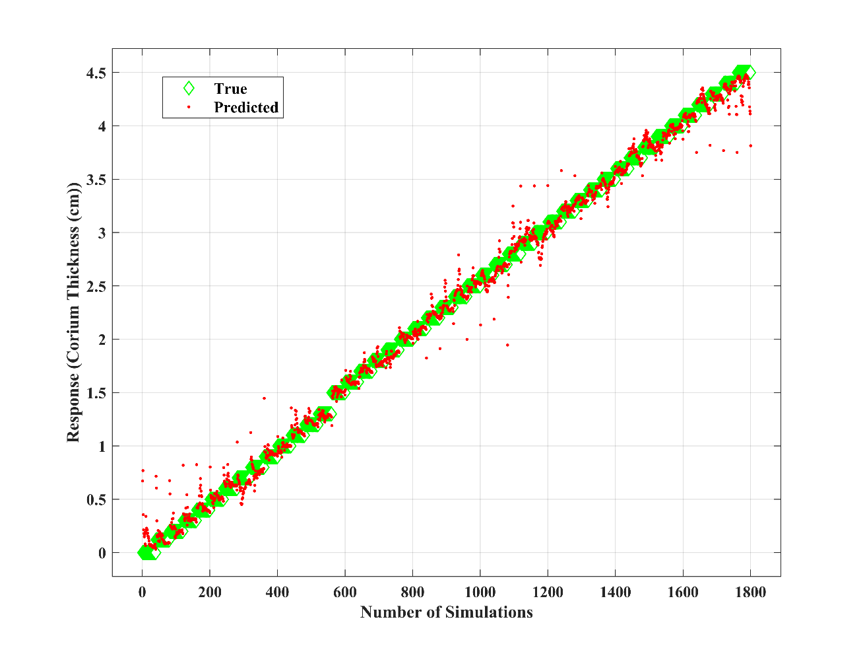

Fig. 2. The response plot of GPR training results. This figure illustrates the response generated from the Gaussian Process Regression (GPR) training process. The x-axis represents the record number, corresponding to the total observations, while the y-axis denotes corium thickness in centimetres (cm).

**Table 3.** This table summarises the optimization parameters and results of the GPR training model.

|  |  |
| --- | --- |
| Parameter | Value |
| Model | Optimizable GPR |
| Kernel function | Nonisotropic Exponential |
| RMSE (Validation) | 0.098685 |
| MSE (Validation) | 0.009738 |
| Prediction speed | 41000 obs/sec |
| Optimiser | Bayesian optimisation |

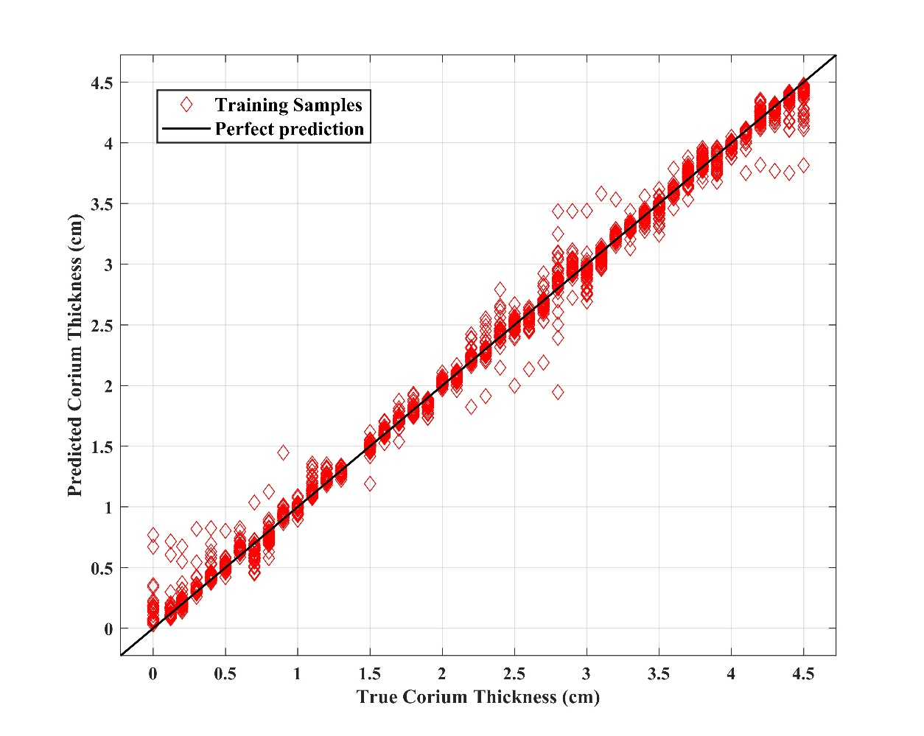

Fig. 3. Scatter plot of True and Predicted Corium Thickness Values. This figure depicts the comparison between true and predicted corium thickness values, displaying the training points alongside a line representing perfect prediction. The x-axis denotes true thickness values (in cm), while the y-axis represents corresponding predicted values.

1. Conclusion

This study shows the applicability of machine learning algorithms to predict the corium thickness above the neutron source with potential application to locate the fuel debris within the Fukushima Daiichi Nuclear Power Plant. The optimizable Gaussian Process Regression model in MATLAB was chosen for the prediction, and shows a high degree of accuracy in predicting corium thickness. This is a critical part of the decommissioning process where the nuclear fuel debris needs to be located for effective retrieval.

In the future, different machine learning algorithms will be used to estimate the quantity of the neutron source and to produce a map showing its location and extent.

References

1. K. Okumura et al., "A method for the prediction of the dose rate distribution in a primary containment vessel of the Fukushima Daiichi Nuclear Power Station," 2019.
2. A. A. Badawi, A. E. Elshahat, R. F. M. Abou Alo, and M. K. Shaat, "An investigation of corium in Fukushima Daiichi Unit-1 accident," Applied Radiation and Isotopes, vol. 186, Elsevier Ltd, Aug. 01, 2022, doi: 10.1016/j.apradiso.2022.110264.
3. S. Galushin and P. Kudinov, "Sensitivity analysis of debris properties in lower plenum of a Nordic BWR," Nucl. Eng. Des., vol. 332, no. April, pp. 374–382, 2018, doi: 10.1016/j.nucengdes.2018.03.029.
4. E. S. Riyana, K. Okumura, and K. Terashima, "Calculation of gamma and neutron emission characteristics emitted from fuel debris of Fukushima Daiichi Nuclear Power Station," J. Nucl. Sci. Technol., vol. 56, no. 9–10, pp. 922–931, Oct. 2019.
5. HEC cluster at Lancaster University," Lancaster University, <http://www.lancs.ac.uk/iss/hec>, Accessed 12/02/2024.
6. K. Nishihara, H. Iwamoto, and K. Suyama, "JAEA-Data/Code Estimation of Fuel Compositions in Fukushima-Daiichi Nuclear Power Plant Japan Atomic Energy Agency 西原 健司 岩元 大樹 須山 賢也," 2012. [Online]. Available: [http://www.jaea.go.jp](http://www.jaea.go.jp/).
7. C.A. Parks, J.C. Wagner, R.Q. Wright, and C.J. Marianno, "ORIGEN2: Isotope Generation and Depletion Code," Oak Ridge National Laboratory, 1986.
8. J. G. Richard, M. L. Fensin, S. J. Tobin, M. T. Swinhoe, J. Baciak, and H. O. Menlove, "Characterization of the Neutron Source Term and Multiplicity of a Spent Fuel Assembly in Support of NDA Safeguards of Spent Nuclear Fuel."
9. J.-I. Katakura and F. Minato, "JAEA-Data/Code," 2015, doi: 10.11484/jaea-data-code-2015-030.
10. K. R. Robb, M. W. Francis, and M. T. Farmer, "Enhanced Ex-Vessel Analysis for Fukushima Daiichi Unit 1: Melt Spreading and Core-Concrete Interaction Analyses with MELTSPREAD and CORQUENCH," 2013.
11. Tokyo Electric Power Company Holdings, "Fukushima Daiichi Nuclear Power Station Unit 2 Primary Containment Vessel Internal Investigation," pp. 1–32, 2018.
12. "Unit 1 Primary Containment Vessel Internal Investigation-Analysis of image data and dose data-Tokyo Electric Power Company Holdings, Inc," 2017.
13. MathWorks, Inc., "MATLAB and Statistics and Machine Learning Toolbox Release 2023b," Natick, Massachusetts, United States.