Ok so we take a sample, study the radiation response with different size and material content.

Depends on the response, training machine learning we can predict material in the sample.

* 1- Samples collected in the early stage of the debris retrieval will be extremely valuable and analysis need to be carried out as completely as possible to meet decommissioning requirements.

For example, recriticality evaluation is inevitably important for designing the debris retrieval process, which requires the accurate concentration of U, Pu, other actinides, Gd, and other

neutron absorbers and distribution of these elements, isotopic ratio etc.

This requires the expert combination of various analysis techniques, including chemical analysis (e.g. ICP-MS, ICP-AES, etc.), microscopic analysis (SEM/EDX, SEM/WDX, TEM, etc.),

and radiation analysis (α/γ-spectrometry, neutron measurement, etc.)

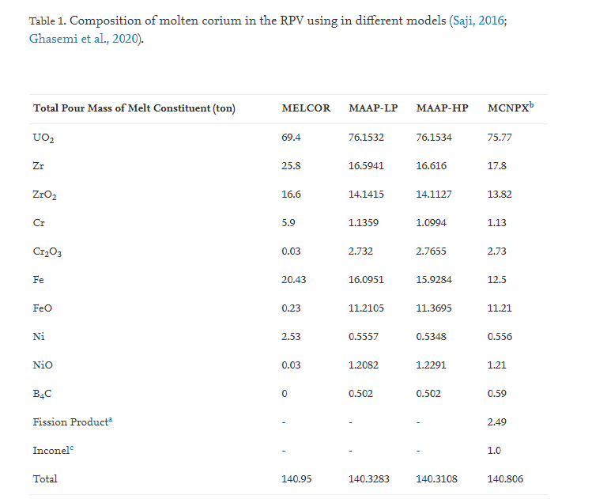

* 2- differences in composition may be caused by the difference in formation mechanism of these particles

**In the FDNPS accident, the interaction between molten fuel and concrete (MCCI: Molten core concrete interaction) might have occurred in the ex-vessel phase**

* 3- The ICP-MS and radiation analysis detected many nuclides contained in the samples, which are roughly categorized to be actinides (U, Pu, Am, Cm), cladding or channel box (Zr), steel (Fe, Cr, Ni, Co, Mn, Sn, Ti, Cu, Mo), paint or shielding (Zn, Al, Pb), fission products (Sr, Rb, Y, Sb, Te, Cs, Ba, RE; RE = rare earth elements), light elements (B, Si, Na, Mg, Al, Ca) and others (Bi, W)
* a significant amount of B4C absorber and far larger amounts of zircaloy (Zry) and stainless steel (SS) than prototypic PWR
* we simulate various Zr content

