# Individual Staff Development report

*(please submit at the completion of the activity or annually for activities spanning multiple years)*

|  |  |
| --- | --- |
| **Name:** | Dr Amara Nwosu |
| **Division:** | Lancaster Medical School |

What was the development activity or training that you undertook? (Include dates and attach any further details)

* I used the funding to attend the Hospice UK National Conference 2022 in Glasgow, to present my research projects related to my growing expertise in technology and palliative care.
* The conference dates were the 22nd – 24th November 2022

*What did you learn from this event and how do you plan to incorporate any insights to further improve your current working practices and/or further the Faculty/Institutional aims and objectives?*

I presented three scientific posters, about technology, design and palliative care, at the conference. The conference provided me with the opportunity to further improve my scientific reputation and network around this my area of expertise subject.

Below is a list of the posters I presented:

* Use of non-invasive technology to evaluate hydration states in people with advanced cancer at the end of life.
* Development of use-cases to a develop a digital bereavement service for palliative care.
* Development of a digital toolkit to facilitate implementation of a hospice-based palliative care journal club

We used the conference to present several posters I am co-author. I have supported junior colleagues to conduct research and quality improvement which were presented at the conference.

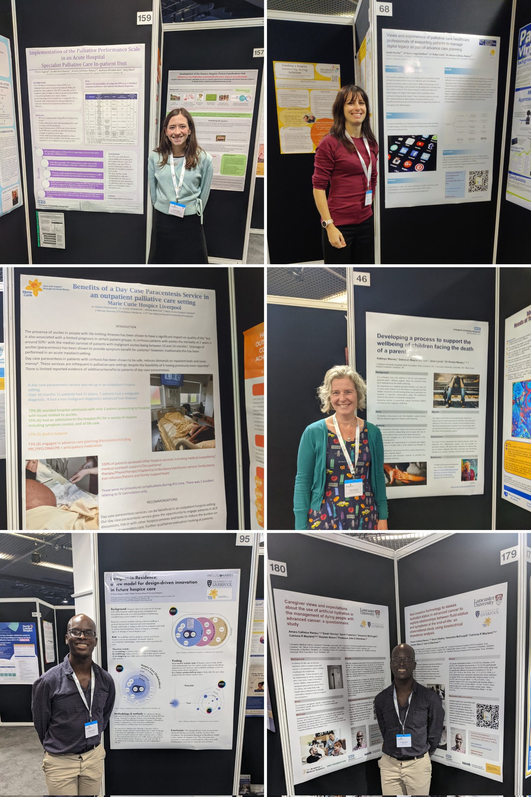

The conference provided an excellent update in palliative care topics around the theme of equity. For example, I enjoyed the attending the following sessions:

* Professor Jason Leitch (national clinical director of healthcare quality and strategy) provided an update about palliative care provision in Scotland in general, and further described the inequalities of access to services in Glasgow.
* Sam Royston (Director of Policy and Research, Marie Curie) provided an update about the National Marie Curie campaign to prevent people with palliative care needs dying in poverty. Specific recommendations were: Special rules for terminal illness changes need to be implemented; people require support for energy bills; Terminally ill people of working age must be entitled to claim the state pension.

I was able to network and strengthen my academic contacts. Here I am meeting socially with the other Research Leads from the Marie Curie Hospices around the country.

*How helpful was the event in relation to your continuing professional development needs and/or Faculty/Institutional aims and objectives?*

**The course has helped me to continue my professional development by:**

* Facilitation partnership and collaboration with national partners in palliative care, including the research leads of the other UK Marie Curie Hospices.
* Providing opportunities to network and socially connect with my peers.
* Providing a platform to engage palliative care researchers and healthcare professionals to consider future opportunities to conduct research in palliative care.

*How will you share the learning or skills that you have gained with a wider group of staff?*

During the conference I shared the work I presented on social media. I also shared some of the emerging themes of discussions from research talks at the conference. I used the Twitter hashtag #HUKConf22 to capture these discussions, to enable someone who was not at the conference to gain an insight of the learning that took place.

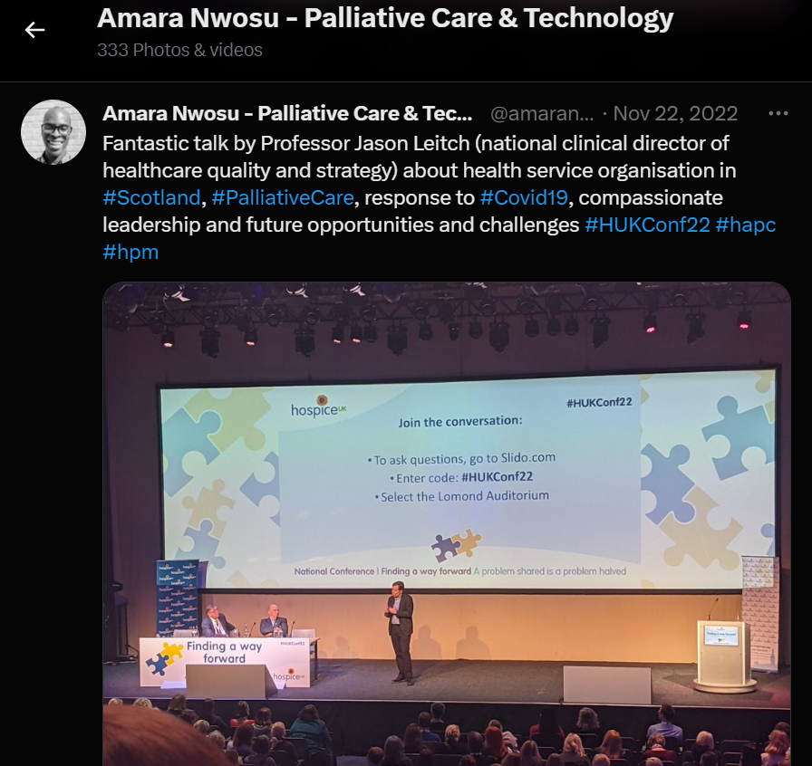

I have also provided feedback of my experience within departmental meetings of the International Observatory for End-of-Life Care, clinical staff at Liverpool University Hospitals NHS Foundation Trust and staff at Marie Curie Hospice Liverpool.

*Would you recommend it to other individual or groups of staff, if so whom?*

**Yes. This conference may be of interested to staff from the following areas.**

* Staff interested in palliative, supportive and end of life care research.
* Staff from the International Observatory for End-of-Life Care.
* Staff from the Centre of Ageing Research.