Evidence of past climates in Kingsdale, Yorkshire Dales

This trip was to Kingsdale in North Yorkshire, and was led by Dr Jacqueline Owen. The purpose of the trip was to look for evidence of past climates. We went back in time 500 million years and used the rocks and landscape to reconstruct the climate/environmental conditions for about six different periods through time.
Locality 1
At locality 1 there are lots of exposure of limestone. This is the main rock type of the area. Limestone is made up of the fossil remains of tiny sea creatures and coral; the sorts of organisms that live in warm shallow seas. This tells us that when this rock formed (about 300 million years ago), the UK had a tropical climate similar to Barbados or the Seychelles today. This was possible because 300 million years ago, the UK was situated much closer to the equator. Unfortunately we’ve drifted a long way north since then!
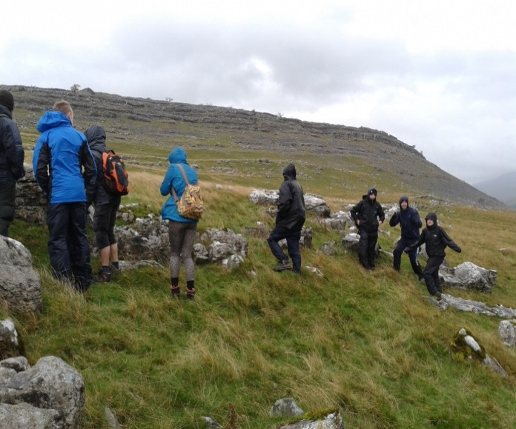
Lancaster students, surrounded by limestone rocks, braving the Yorkshire weather at locality 1. Photo by J. Owen
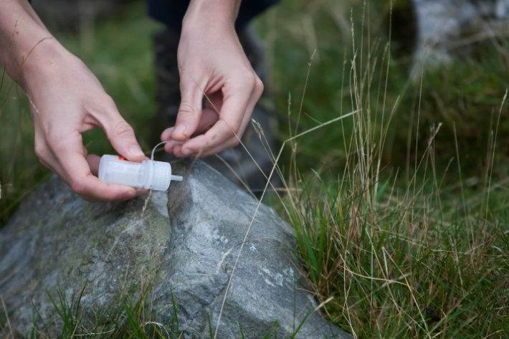
A student using HCl acid to test the rock composition. Limestone is very prone to chemical weathering and so acid fizzes when dropped onto it. Sandstone (pictured), on the other hand, gives no reaction. Photo by I Hughes: www.ianhughesphotography.co.uk
From locality 1 there is a good view of the valley. We can see it is ‘u’ shaped which tells us that this region was most likely glaciated in the past. There is also a large mound of sediment along the far side of the valley and at the end of the valley. These are moraines (lateral and terminal moraines respectively) which are deposits that have been dumped by the glacier as it retreated. Glaciation may also explain the presence of small isolated boulders of sandstone at locality 1.
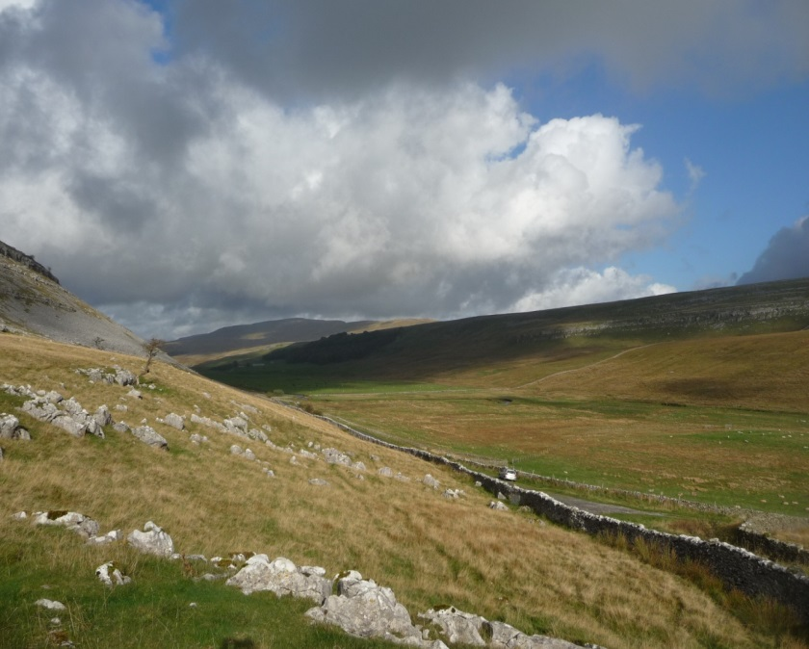
The view looking north in Kingsdale. The ‘u’ shape of the valley suggests that this area was once glaciated. Photo by J. Owen
Locality 2
From locality 2 we can see a gorge. It has steep jagged sides which are over-hanging in places, suggesting that its formation was a very rapid process. Further evidence for this comes from large boulders downstream. To rapidly create such a large gorge implies that a lot of water once flowed through here; where did this water come from? The most likely option is meltwater from the glacier that once filled this valley. But ice melting through climate change is a slow process and this gorge looks like it formed quickly. One explanation is that the terminal moraine, dumped by the glacier as it retreated, blocked the valley, forming a dam. This would allow a lake to form as the glacier melted, until such a point that a threshold was reached, and the dam failed. If this was the case, then the gorge may only be as old as the end of the last glacial period (~10,000 years).
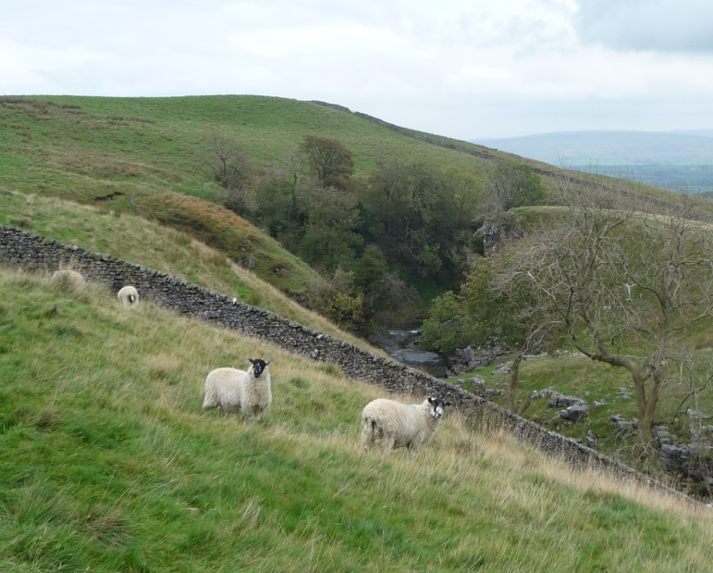
A steep gorge, potentially eroded by water generated when the glaciers melted. Photo by J. Owen

Locality 3
At locality 3 we see into the terminal moraine. A landslide has removed the grassy exterior allowing us to see what the deposit really looks like. We see a large range of rock types, sizes (from boulders to clay) and morphologies but absolutely no sorting. This is because glaciers are anything but fussy. They pick up whatever is in their path, then dump everything unceremoniously as they retreat. The other tell-tale sign that this is a glacial deposit is the presence of ‘striae’ which are scratch marks left on the rocks as they have been dragged along.
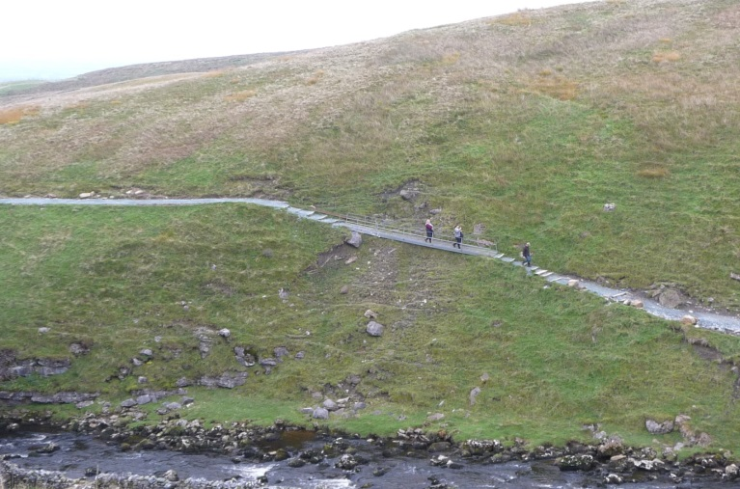
At locality 3, a small landslide allows us to look into the terminal moraine and see what the glacial deposit really looks like. Photo by J. Owen

Locality 4
The grand finale of our Kingsdale fieldtrip is the beautiful waterfall of Thornton Force. The top half of the waterfall is limestone (indicating warm tropical seas) but the bottom half is a special type of sandstone, called a turbidite, which forms in deep oceans. When this rock formed, about 500 million years ago, Scotland and southern England were on two separate tectonic plates and Yorkshire was in the ocean that separated them. There are lots of layers (beds) within the turbidite sequence which would have been laid down horizontal but are now almost vertical. This deformation probably occurred when the two tectonic plates converged to create the UK as we know it today. It is likely that mountains were also produced during this process. However, the contact between the sandstone (turbidites) and limestone is horizontal, suggesting that there was significant erosion between the folding of the turbidites and the limestone formation. In fact it is thought that about 200 million years of the rock record is missing from the middle section of the waterfall due to erosion (we therefore call this contact an unconformity). A thin layer of conglomerate lies between the sandstone and the limestone suggesting that powerful rivers were the cause of this erosion.
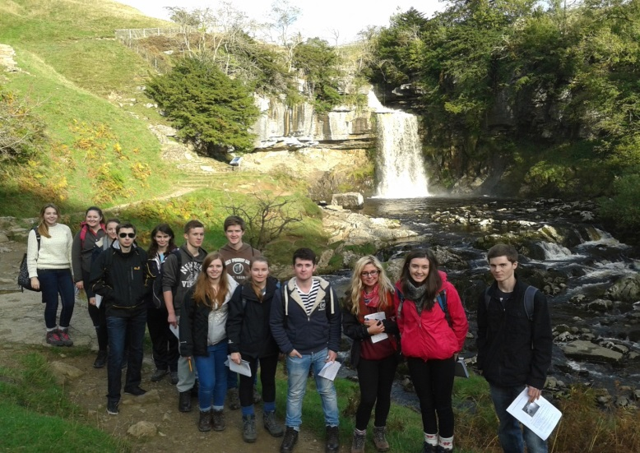
Thornton Force and proof that the sun does sometimes shine in Yorkshire. Photo by J. Owen

Past climates
So there we have it: if you were in Kingsdale in the past you may have been in a deep ocean, climbing a mountain, boating down a powerful river, snorkelling in a warm tropical sea, under a glacier or swimming in a flash flood. What will the future hold?
Written by Dr Jacqueline Owen (j.owen2@lancaster.ac.uk; twitter: @jacquelineowen)
p.s. You can download the “Climate Through Time” poster for free from the BGS website: http://www.bgs.ac.uk/discoveringGeology/climateChange/climateThroughTime.html
Where we’ve been…

