SLEND Sign Language to English by the Deaf: Literacy development with Deaf communities using sign language, peer tuition, and learner-generated online content
Noah Ahereza¹, Marco Nyarko¹, Rita Huhua Fan¹, Julia Gillen², Ulrike Zeshan¹
¹ University of Central Lancashire, UK.
² Lancaster University, UK.

Paper presented at the South Africa International Conference on Educational Technologies 24th – 26th April 2016.

Abstract
This paper reports on a project designed to enhance the employability and wellbeing of a marginalised community: the Deaf. It is funded by the Economic and Social Research Council/Department for International Development in the UK (ES/M005186/1). The project adopts a Deaf-led approach to developing English literacy. This one year project features the development of an online platform: Sign Language to English by the Deaf (SLEND). The project’s ethos stems from a conviction that learning is situated in the demands and contexts of everyday life. People’s learning will develop optimally in situations where their existing purposes and abilities are recognised, and where they can collaborate, including with peers. Nowadays, online environments are significant in everybody’s everyday lives and offer particular opportunities for the Deaf to participate.
This paper explains how the project has been piloted in five centres in India, through a combination of peer to peer face to face and online activities. The different groups contribute their learning activities to the SLEND, finding value in both process and sharing outcomes.
The project includes research in Uganda and Ghana, among Deaf communities. This paper reports on the first elements of the research in those locations. Data were collected using intensive focus groups. Processes of recruitment and activities are described.
Findings of this research show how access to the internet is particularly important for the Deaf, including the improvement of their literacy development. The findings suggest the fruitfulness of an approach to Deaf people’s English literacy needs. It recommends capacity building that is grounded on a “real literacies” approach, which is firmly rooted in an understanding of the place of English literacy in their lives. It also recommends the opportunities that exist for enhancement of their communicative capabilities and social participation in all spheres of life.

1 Introduction
This paper is about an innovative project, Literacy development with deaf communities using sign language, peer tuition, and learner-generated online content – sustainable educational innovation. This project has been piloted among marginalised deaf youth in India. It also has research elements in Ghana and Uganda with the ambition to produce outputs that will be of relevance in more countries, in Africa and beyond. This project explores ways of improving the English literacy and communication skills of deaf young people, to enhance their employability, wellbeing and life prospects. We have designed an online platform called “Sign Language to English by the Deaf” (SLEND).
The project is led by Professor Ulrike Zeshan of the International Institute for Sign Languages and Deaf Studies (iSLanDS) at the University of Central Lancashire, UK (UCLan). She is supported by other academics and learning technologists at UCLan and Lancaster University and leads a team of research assistants and peer tutors in India. In Ghana the research assistant is Marco Nyarko and in Uganda Noah Ahereza.
The project is funded by the UK’s Economic and Social Research Council (ESRC) and the Department for International Development (DFID) “Raising Learning Outcomes in Education Systems”. The project is set to run from June 2015 – July 2016. Full ethical approval was gained from UCLan and Lancaster University. This paper reports on some preliminary findings of the project, that is: the design and implementation of the SLEND in India, with a brief evaluation of the first six months, and the first research activities in Ghana and Uganda which comprised of focus groups.

2 Background
The World Federation of the Deaf estimates that 80% of the world’s 72 million Deaf sign language users live in developing countries. Only 3% of all Deaf signers worldwide have access to education through sign language as advocated in the UN Convention on the Rights of Persons with Disabilities (UNCRPD). Adopting the views on empowerment approaches to Deaf communities as expressed by Ladd (2003) and Bauman and Murray (2010) we take the views that radical educational changes are best driven from within Deaf communities. This motivates the project’s Deaf-led approach with the focus on Deaf learners, community teachers, local trainers, all dynamically interacting within learning and research community. A further aspect of this study is the commitment towards sustainability of the development of digital and mobile forms of learning and teaching that are cost-effective and adaptable to different contexts.

3 Aims
The project aims are:
- to develop and provide a peer-led English-literacy teaching programme for members of the Deaf community in India;
- to undertake pilot work, ascertaining the potential transferability of our approach to other Deaf communities, in Ghana, working with Lancaster Ghana, and with the Uganda National Association of the Deaf;
- to develop the SLEND, Sign Language to English by the Deaf, e-learning platform, to be used both in conjunction with face-to-face tutor-led teaching and for self-study;
- to develop and implement a model of learner-generated and needs-driven curriculum;
- to draft a model of effective language-teaching interventions to guide policy and further innovation;
- to design an adaptation of the Common European Framework of Reference for Languages (CEFR) for the expression of learning outcomes;
- to produce a diverse range of dissemination and knowledge exchange outputs, engaging with policy-makers, practitioners and academic communities.

4 Research and development

4.1 Ethnographic approach to real literacies
Instead of traditional language teaching, this project takes a learner-driven and ethnographic approach, exploiting a virtual/mobile learning platform and supporting Deaf peer tutors and learners to develop their own materials and strategies, including teaching through sign language. Learners focus on functional aspects of English, which means using it to accomplish everyday purposes. This was to ensure responsiveness to learner needs and to allow the researchers to build on the skills available amongst the Deaf community with teachers and learners supporting each other, hence the principle of peer tutoring. Our approach draws on concepts of place-based collaborative ethnography and learner-generated curricula (Comber, 2016). The guiding principle is that we focus learning on real language and real literacy and develop the curriculum together with the learners. The real literacies approach (Street, 2012), originally developed for adult literacy learners, postulates that learning is most useful if based on authentic texts and practices. The aim is that students learn on the basis of activities, situations and texts which they would come across in real life and which are of immediate relevance to their lives. In the contemporary world, many of our purposes are accomplished online; so online is both a site for authentic practices (such as the use of WhatsApp) and offers an opportunity for the development of a project-specific online spacesuch as SLEND.

4.2 Technology and Deaf Education
Information and Communication Technology (ICT) plays a crucial role in transforming communication and education. Ths is the case for the linguistic and cultural minority, the Deaf community, in terms of technology-assisted communication and education. On the one hand, to break down communication barrier with their peer and hearing people who have no knowledge of sign languages, Deaf people tend to resort more to Computer-Mediated Communication (CMC) (Garberoglio et al., 2015), such as email, blog, instant message and text. On the other hand, technology-assisted teaching and learning enhances Deaf learners’ information and knowledge processing and retention (Sadoski & Paivio, 2004) through a combination of visual and verbal information; motivates Deaf learners (Beal-Alvarez & Cannon, 2015); and improves their learning outcomes (Beal-Alvarez & Easterbrooks, 2013; Cannon, Fredrick & Easterbooks, 2010; Cannon et al., 2011).
A typical element in technology-assisted educational transformation for the Deaf is an e-learning platform. Numerous studies in developed countries (Bates, 2005; Wang, 2006; Pandian, 2006; Long et al., 2007; Lang & Steely, 2003; Mertzani, 2006; cited in Denmark, 2013) have been conducted and positive results have been found on the facilitating role of these e-learning platforms for Deaf learners developed with different software such as Moodle, MOOC, Sakai and Joomla. It is only recently that research (Denmark, 2013; Sahasrabudhe, 2010) on English Learning Platform for the Deaf in the Global South has emerged. Nevertheless, these e-learning platforms are developed and maintained by hearing teachers and organizations. It is possible that they may not fully reflect Deaf learners’ needs; further, without continuous human and financial input, sustainable development of the platform may not be feasible. This project’s platform, SLEND, aims to bridge the gaps and establish an eco-learning system.

4.3 SLEND: Key Characteristics and Components
In analogy with a natural ecosystem, the ecosystem of a virtual learning environment aims to be a self-sustaining system that learners can interact with, achieving their learning objectives with the learning resources and activities available. In line with this notion, to set up a Virtual Learning Environment platform for Deaf learners of English literacy, SLEND embraces the following characteristics:
  - Technology-Assisted: The SLEND is a Moodle-based VLE platform and can be used on different digital devices, such as computers, laptops and mobile phones. At the meantime, a Computer Mediated Communication tool, WhatsApp Group Chat, is used for instant communication, information and knowledge sharing at any time anywhere. Finally, a series of Deaf-friendly techniques, such as captioning, pictures and signed videos, are included in the platform.
  - Peer-to-Peer: Peer-to-Peer is a system suited to an e-learning ecosystem as it allows each learner to act as a service user and also as a service provider (Leong & Miao, 2008). Deaf peer tutors and learners are the key content developers and users of the SLEND. Deaf organizations and Deaf research assistants monitor and support the development.
  - Sign Bilingualism: Viewing the Deaf community as a linguistic and cultural minority (Ladd, 2003), an approach of sign bilingualism is adopted to encourage the use of sign language as the language of instruction and to respect, indeed to enhance the further enrichment of Deaf cultures while learning English literacy.
  - Functional Literacy: Marschark, Lang & Albertini (2002) suggest that it might be pointless to adhere to the language order for language teaching for young adults as their previous language learning experience can affect and compensate for their developmental order of language. Rather, the content and function should be the focus. Therefore, the SLEND adopts a functional literacy approach. All the learning materials are collected from Deaf learners’ real life by utilizing an ethnographic technique, clock activity. A Freirean approach is also followed to encourage peer learners to bring real-life English to the class.
  - Common European Frame of Reference (CEFR) Benchmarking: A modified CEFR for Languages is used to guide learning and assess learning outcomes. This enables Deaf learners’ English literacy growth benchmarking against an internationally recognized scheme for the first time and motivates Deaf learners in the way of benefiting their further education and future employment.

Operationalisation of SLEND
Guided by the characteristics, the SLEND comprises of General Introduction, Our Sharing Space, Real Life English Topics, Grammar, and Main Glossary. Among them, Real Life English Topics is the key component for learning to take place. It consists of learning sessions which are developed by Deaf peer tutors and learners themselves.
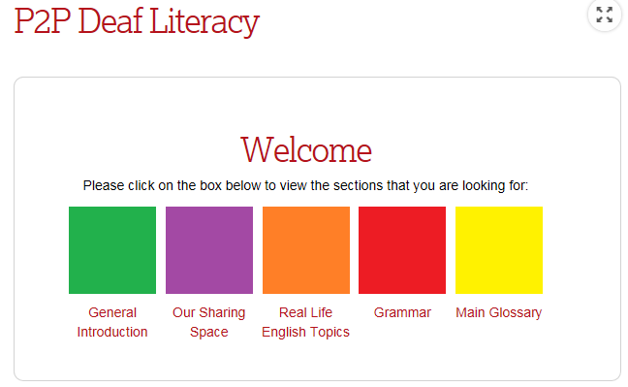
Figure 1: Key Components of the SLEND Platform

Table 1: Key Elements of a Session
For each session, the learning flows in the following structure:
Elements | Moodle Activity | Description
- Real Life English Materials | Database Activity | Learners and Peer Tutors upload materials from Real Life to learn.
- New Vocabulary | Secondary Glossary | Learners and Peer Tutors can upload their new words, share with other students.
- In-Class Video | Page Activity | Peer tutors from different learning centers film the discussion or explanation during class and share it on the platform.
- Useful Language | Lesson Activity | A series of explanation, activities and quizzes to practice useful language distilled from real life.
- Extended Exercise | Quiz | Exercise for the whole session.
- I/We can … | Checklist | Learners check off what they have learnt.

4.4 Piloting of the SLEND in India
The SLEND was introduced into India at the beginning of the pilot project. Fifty Deaf adult learners (aging from 18 to 28) and five Deaf peer tutors enrolled from five different areas of India. They have two-hour laboratory collaborative learning and two-hour classroom learning each day, five days a week excluding holidays. The learning commenced at the beginning of September, 2015 and will end in April, 2016.
The implementation of the SLEND has challenges relating to technological barriers to implementation locally. These include at various times: lack of computers, laptops, limited access to internet, slow internet, etc. The project’s collaborative ethos is expressed through taking whatever measures are situationally appropriate to mitigating against such obstacles, for example sharing computers and laptops; sharing internet from Deaf NGOs.
Although at the time of writing the pilot project is still underway, already rich data is emerging, revealing both participants’ experience and their feedback. So far around forty sessions have been developed by the peer tutors and learners with a wide range of real-life topics, such as in the bank, at the railway station, forms, signs, (online) shopping, news, headlines, sports, invoices, etc. The well-developed sessions are grouped and sequenced for ease of access.
Both groups of Deaf peer tutors and learners produce positive responses about learning on the SLEND. Deaf peer tutors have benefited from attending training. In developing learning content and sharing knowledge with learners, their own literacy skills have been improved. They have become more motivated and confident for learning and teaching. Now and then, they experience difficulties in explaining new knowledge to peer learners. Then they resort to tools such as (online) dictionary, Google, discussing with one another and collaboratively acquire new knowledge.
As for Deaf learners, they provide feedback on the SLEND and acknowledge it to be very helpful and useful for English literacy attainment. Firstly, by providing real-life materials, the SLEND meets their daily English communication needs. Secondly, they feel comfortable, motivated and confident while learning with their peers and seeking help from peer tutors. This is aligned with the findings from previous research (Cannon and Guardino, 2012; Denmark 2013; Sahasrabudhe, 2010) that plead for peer tuition and support. Finally, Indian Sign Language (ISL) in the form of videos on the SLEND. Such mediated interaction is viewed as an efficient tool for English learning in terms of ensuring better communication and enhancing understanding.

5 Experiences in Uganda and Ghana
A range of activities in each of these countries has taken place, including two focus groups and a dissemination workshop. Although activities in these countries is small-scale, being the outcomes of work by one research assistant in each place, rich data has been obtained as to the experiences of Deaf people in everyday life, in schooling, their needs, reflections on practices and opinions on glimpses of the SLEND. The scope of this paper is limited to data from the first focus group in each location, and then further to include just some indicative data regarding Deaf people’s experiences of English literacy in everyday life and schooling that have bearing on the present project.

5.1 Recruitment to the focus groups
The project’s partner in Uganda is the Uganda National Association of the Deaf (UNAD). Recruitment to the focus group was achieved through personal recruitment by the first author, a project Research Assistant who is also UNAD’s Sign Language Program Coordinator. He focussed on personal recruitment through Deaf-led events including a workshop on political awareness organised by a deaf Member of Parliament and a regional Deaf football challenge cup. The 19 participants were all young Deaf adults: 2 teachers of Deaf children, 1 IT teacher of young Deaf people, 5 sign language instructors, 3 university students, 1 college student and 2 high school students from a secondary school for the Deaf, 1 community worker, 1 business professional and 3 UNAD staff members. In Ghana the Research Assistant, the second author, is based at Lancaster University Ghana. He used his networks in the Eastern region of Ghana to recruit participants. The 12 participants included: 3 Deaf teachers at Demonstration School for the Deaf Mampong-Akuapem, 4 students at Senior High Technical School for the Deaf, Mampong-Akuapem and 5 members of the Ghana National Association of the Deaf, Eastern Region.
Both events were filmed. At each session, information about the project was discussed and consent to participate obtained and recorded. There were two main activities conducted by the focus groups.
Activity 1: English around the clock
The purpose of this activity is to explore English language practices participants are already engaging in. This can increase awareness of the range of contexts and activities people are already experiencing and indeed sometimes enhance confidence in itself. In the clock activity (Ivanic et al. 2009) participants record their own uses of English literacy through a typical day. It can be challenging to identify these but working and discussing in small groups can be built upon to create lists.
Activity 2: Discussion
Divided into small groups, the participants shared their findings and then brought them to the whole group. The focus group discussed current uses of English literacy in everyday life, obstacles and barriers for themselves and other Deaf learners.

5.2 Findings from Uganda
English literacy is important to all participants
In Uganda English is an official and national language that is used everywhere. Many participants use English for participating in educational institutions, whether teaching or learning. Many use English in the course of their work. People use both print material and online. While their Hearing counterpart are taught several languages in schools, Deaf are only taught English alongside sign language. Therefore, English is the only mode to bridge communication barrier between them and Hearing people who do not know sign language. Although two participants denied that they used written English often in their lives, further probing ascertained that English is used in many situations. A minority of Deaf people do prefer to stress their main communications is in sign language.
English is used online, for everyday communications, leisure and in the workplace
All participants use written English on social media platforms such as WhatsApp and Facebook for communicating among friends and families and for organising events. Google search engine and email are also used including to access information. Workplaces often demand online use of English.
Facing and overcoming challenges to developing English literacy
Many participants expressed concerns over lack of confidence in English grammar. Some observed they felt much weaker in writing in comparison to reading. Using English in informal contexts such as social media can bolster confidence, although this does not necessarily translate over to workplace use of English. Participants use a range of strategies to assist them to overcome challenges including practicing reading, using dictionaries, online translation tools and asking people for help. Almost all participants agreed that peer tutoring is necessary and desirable, relating to personal experiences at school where they obtained assistance from their peers. They argue that they are shy to ask people whose age is way above their or teachers who will only complain that they are slow learners. Experience with peer Deaf tutors can therefore be very helpful.

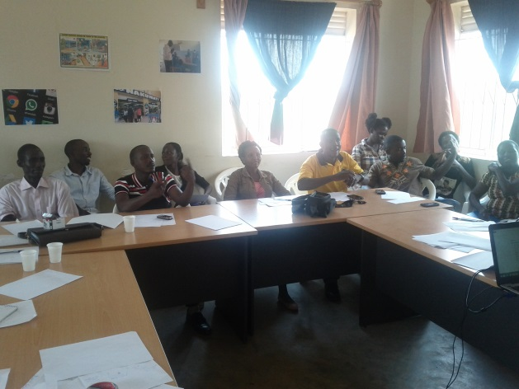 | 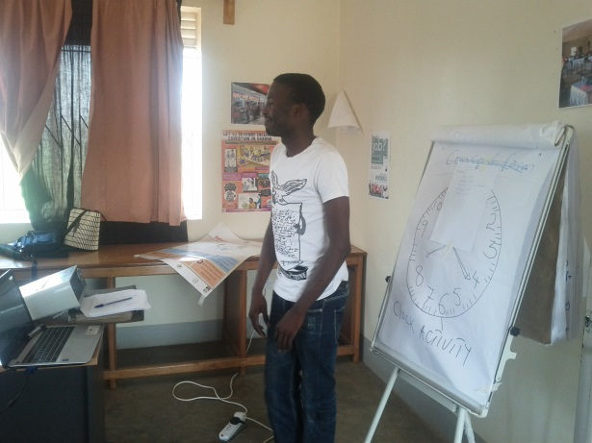

Figure 2: Focus Group, Uganda.
One of the participants is giving a plenary presentation from his group. He is using an example of the clock activity on the flip chart. The walls are plastered with posters of different scenarios where English may be used by Deaf participants in their everyday lives including social media platforms and physical settings.

5.3 Findings from Ghana
English literacy is important to all participants
Reading in English is a very important activity. The Bible is an important and regular activity for most. Everybody uses English in many aspects of their daily lives, in restaurants, homes, markets and everywhere they find themselves. People use news websites to access the news. English subtitles are provided on films. People have used English at schools.
Written English is used often by all participants. All participants use English in order to engage in society and understand their environments. They use it to interact with those in their families and communities who have no sign language background. Pen and paper conversations are frequent. Written English is taught at school.
English is used online, for everyday communications, leisure and in the workplace
In Ghana English is an official and national language that is used everywhere. Most participants use written English through phones, sometimes, for a minority, smartphones. They read and write text messages (short message services SMS), use WhatsApp and use the internet to access information. The cost of digital media is an issue, as internet data bundles are expensive. But people who can afford to prioritise daily use. Students emphasised their use of digital media for research purposes. They also use digital media to work in pairs and in groups, for example connecting through WhatsApp or Facebook Messenger.
Facing and overcoming challenges to developing English literacy
The structure of sign language and English language differ significantly. This causes considerable obstacles for Deaf people in learning English. There are considerable problems facing the Deaf in education. Methods of teaching and assessment are inappropriate. The Deaf therefore run the risk of being left behind in terms of functioning effectively in society and gaining employment. A particular problem reported by the majority is difficulty in communicating effectively with health services. In their endeavours to overcome such barriers Deaf people report that informal support is very important. Peer to peer support is significant both within and beyond formal education.

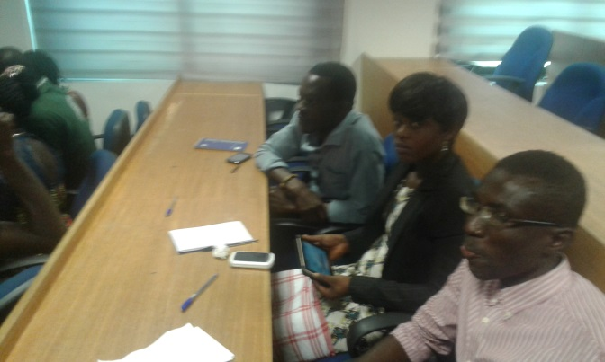

Figure 3 Focus Group, Ghana: participants with mobile technology.

6 Conclusions
Access to the internet is particularly important for the Deaf, including to improve their literacy development. Wherever access to online platforms and services is available, Deaf people make use of opportunities to participate in interactions online, and develop their knowledge and understanding. English literacy is vital to employability and participation as an aspectof everyday life in the countries where the project is active. Sign languages, as the first languages of Deaf people, are greatly valued as an aspect of their culture. The lesson learned from the experiences of piloting the project in India is that the project, with its blend of face to face peer tutoring and online activities, is an effective means of developing English literacy, enhancing bilingualism and promoting appropriate technological skills in Deaf learners and their tutors. Research conducted in Ghana and Ugandaof the first stage confirm the current importance of English literacy in Deaf people’s lives. The potential for further development of their capacity, is evident, including through the incorporation of online activities, peer tutoring and attention to authentic purposes for English literacy in their everyday lives.

References
Bauman, H-D., & Murray, J. (2010). Deaf Studies in the 21st Century: "Deaf-gain" and the future of human diversity. In M. Marschark & P. Spencer (Eds.), The Oxford handbook of deaf studies, language, and education (pp. 210-225). New York: Oxford University Press.
Beal-Alvarez, J.S., & Cannon, J.E. (2015). Captions, Whiteboards, Animation, and Videos: Technology Improves Access. Odyssey, 16, 4-9.
Beal-Alvarez, J. S., & Easterbrooks, S. R. (2013).Increasing children’s ASL classifier production: A multicomponent intervention. American Annals of the Deaf, 158(3), 311-333.
Cannon, J.E., Easterbrooks, S.R., Gagne, P., & Beal-Alvarez, J. (2011). Improving DHH students’ grammar through an individualized software program. Journal of Deaf Studies and Deaf Education, 16(4), 437-457.
Cannon, J. E., Fredrick, L. D., & Easterbrooks, S. R. (2010). Vocabulary instruction through books read in American Sign Language for English-language learners with hearing loss. Communication Disorders Quarterly, 31(2), 98-112. doi:10.1177/1525740109332832
Cannon, J. E., & Guardino, C. (2012). Literacy strategies for Deaf/Hard-of-hearing English language learners: Where do we begin? Deafness and Education International, 14(2), 78-99. doi:10.1179/1557069X12Y.0000000006
Comber, B. (2016). Literacy, place, and pedagogies of possibility. London: Routledge.
Denmark, A. C. (2013). An online learning platform for English as a second language for young Deaf Indian sign language users: Usage patterns and user engagement (Unpublished master’s thesis). University of Central Lancashire, UK.
Garberoglio, C. L., Dickson, D., Cawthon, S., & Bond, M. (2015). Bridging the communication divide: CMC and deaf individuals' literacy skills. Language Learning and Technology, 19(2), 118-133.
Ivanic, R., Edwards, R., Barton, D., Martin-Jones, M., Fowler, Z., Hughes, B., Mannion, G., Miller, K., Satchwell, C. & Smith, J. (2009). Improving learning in college: Rethinking literacies across the curriculum. Abingdon, UK: Routledge.
Ladd, P. (2003). Understanding Deaf culture: In search of Deafhood. Clevedon, England: Multilingual Matters.
Leong, P., & Miao, C. (2008). Ubiquitous digital e-learning ecosystem. 2008 2nd IEEE International Conference on Digital Ecosystems and Technologies, IEEE-DEST 2008, Phitsanulok. 346-351. doi:10.1109/DEST.2008.4635159
Marschark, M., Lang, H. G., Albertini, J. A. (2002). Educating deaf students: From research to practice. NY, UK: Oxford University Press.
Sadoski, M. & Paivio, A. (2004). A dual coding theoretical model of reading. In R. B. Ruddell & N. J. Unrau (Eds.), Theoretical models and processes of reading (5th ed., pp. 1329-1362). Newark, DE: International Reading Association.
Sahasrabudhe, S. (2010). Online elementary-level English literacy programme for young deaf adults using Indian sign language (Unpublished master’s thesis). University of Central Lancashire, UK.
Street, B.V. (2012). Learning for empowerment through training in ethnographic-style research. In M. Grenfell, D. Bloome, C. Hardy, K. Pahl, J. Rowsell, & B.V. Street (Eds.), Language, ethnography and education. (pp. 73-89). New York: Routledge.

Contact details: Julia Gillen, Director, Literacy Research Centre, Lancaster University.
Email: j.gillen@lancaster.ac.uk

Ladd (1995) distinguishes ‘deaf’ from ‘Deaf’. By the lowercase ‘deaf’, it refers to those who experience deafness since an early or late life, resist to sign languages and prefer the majority society for socialisation. Whereas the uppercase ‘Deaf’ indicates those with ‘hearing loss’ ever since born or early (sometimes late) childhood, appreciate the sign language, communities and cultures of the Deaf, perceive themselves as similar to other language minorities.

