Young Infants' Visual Fixation Patterns in Addition and Subtraction Tasks Support an Object Tracking Account

J. Gavin Bremner
Lancaster University
Alan M. Slater
Rachel A. Hayes
University of Exeter
Uschi C. Mason, Caroline Murphy, Jo Spring, Lucinda Draper, & David Gaskell
Lancaster University
Scott P. Johnson
University of California, Los Angeles

Submitted 11.10.16, Resubmitted 12.05.17 Text + References 5,454 w.
Author note
J.G. Bremner, Psychology Department, Lancaster University, U.K. e-mail j.g.bremner@lancaster.ac.uk: A.M. Slater, School of Psychology, University of Exeter: Scott P. Johnson, Department of Psychology, University of California at Los Angeles. Uschi Mason, Jo Spring, and Barrie Usherwood, Lancaster University. This research was funded by a grant from the Nuffield Foundation (SGS/32130) to the first author, a grant from the ESRC (RES-000-22-1113) to the second author, and grants from the NIH (HD-48733 and HD-40432) to the last author. We thank infants and parents for contributing to the research.
Abstract
Investigating infants' numerical ability is crucial to identifying the developmental origins of numeracy. Wynn (1992) Nature, 358, 749-750, claimed that 5-month-old infants understand addition and subtraction as indicated by longer looking at outcomes that violate numerical operations (i.e., 1 + 1 = 1, or 2 – 1 = 2). However, her claim is contentious, with others suggesting that her results might reflect a familiarity preference for the initial array, or that they could be explained in terms of object tracking. To cast light on this controversy, Wynn’s conditions were replicated with conventional looking time supplemented with eye tracker data. In the incorrect outcome of 2 in a subtraction event (2 – 1 = 2) infants looked selectively at the incorrectly present object, a finding that is not predicted by an initial array preference account or a symbolic numerical account, but which is consistent with a perceptual object tracking account. It appears that young infants can track at least one object over occlusion, and this may form the precursor of numerical ability.
Keywords: addition, subtraction, infant number, object tracking, object files
Young Infants' Visual Fixation Patterns in Addition and Subtraction Tasks

Numeracy is a key aspect of adult cognition and identifying its origins is vital to understanding its development in childhood and thereafter. Thus a key area of research concerns infants’ ability to understand number. One strong claim is that young infants compute the outcomes of addition and subtraction manipulations. This was first suggested in a study by Wynn (1992). In an addition (1 + 1) condition, 5-month-old infants saw a doll being placed on a stage. A screen then concealed the doll and a hand appeared holding a second doll and placing it behind the screen. In a subtraction (2 – 1) condition, infants saw two dolls being placed on the stage followed by the screen concealing them. A hand then appeared, went behind the screen, and emerged holding one doll. On subsequent test trials, for both conditions, the screen was raised revealing either one or two dolls. In both conditions infants looked longer at the impossible (either 1 + 1 = 1 or 2 – 1 = 2) than the possible (either 1 + 1 = 2 or 2 – 1 = 1) outcome, longer looking being interpreted as violation of their expectation regarding the numerical outcome. Replications of Wynn’s findings have used both 3D displays (Clearfield & Westfahl, 2006; Simon, Hespos, & Rochat, 1995; Slater, Bremner, Johnson, & Hayes, 2010; Uller, Carey, Huntley-Fenner, & Klatt, 1999; Walden, Kim, McCoy, & Karrass, 2007) and 2D displays (Berger, Tzur, & Posner, 2006; Moore & Cocas, 2006).
These findings are in keeping with at least three types of converging evidence: 1) that infants look more at their caregivers’ faces following unexpected arithmetic outcomes (Walden et al., 2007); 2) that infant ERP data show a similar pattern of activity to that of adults when observing correct and incorrect arithmetical outcomes (Berger et al., 2006); and 3) that newly hatched domestic chicks were reported to track small numbers of objects (Rugani, Fontanari, Simoni, Regolin, & Vallortigara, 2009). Collectively, these results are consistent with the larger claim that infants can perceive number (Antell & Keating, 1983; Feigenson & Carey, 2003; Feigenson, Carey, & Hauser, 2002; Lipton & Spelke, 2003; McKrink & Wynn, 2004; 2007; Xu, 2003; Xu & Arriaga, 2007; Xu & Spelke, 2000) and track numerosity of small number sets (Berger et al., 2006; Clearfield & Westfahl, 2006; Moore & Cocas, 2006; Simon et al., 1995; Uller et al., 1999; vanMarle, 2013; Walden et al., 2007). Wynn concluded that the ability to perform simple arithmetical calculations is innate and may be the foundation on which subsequent arithmetical ability builds. She argues that her results are evidence for a true symbolic number concept, favoring an accumulator mechanism (Meck & Church, 1983) as the basis on which numerical judgements are reached. A key point in this account is that a single symbol represents the number concerned.
On the other hand, lower level interpretations of Wynn's (1992) findings are possible due to the simple nature of the dependent measure. For example, from a standpoint in which cognitive abilities such as numerical knowledge are constructed progressively during infancy (Cohen, Chaput, & Cashon, 202), Cohen and Marks (2002) suggested an interpretation in terms of a perceptual process based on two principles: a) a preference for familiarity (i.e., the display originally seen before the screen occluded it); and b) a preference for displays containing a larger number of items. This interpretation is clearly important because, if correct, it would indicate that performance on Wynn's task indicates little about the infant's ability to keep track of objects across occlusion, let alone whether they understand operations of addition and subtraction of small numbers. Inevitably Wynn’s conclusions will continue to attract controversy while the evidence is based on duration of looking anywhere in the display, because this measure is open to lower level interpretations such as Cohen and Marks’s. Thus it is vital to obtain a measure of infants’ response that allows a choice between low level accounts and those based on enumerating or keeping track of objects.
Even if an interpretation in terms of familiarity preference can be dismissed, it must be recognised that Wynn's (1992) claim that infants understand the operations 1+1=2 and 2-1=1 can be questioned. It is possible that longer looking at violation outcomes is not based on infants' realisation that the specific operations 1+1=2 or 2-1=1 have been violated, but rather on noting that an object added to the scene is not present, or that an object removed from the scene is still present. An alternative to Wynn's symbolic account is based on object file accounts derived from adult research (Kahneman, Treisman, & Gibbs, 1992; Pylyshyn & Storm, 1988; Scholl, 2001), and locates performance in tracking discrete objects and noting violations of continuity for any of these objects. For the present purposes, the key claim of this object file account is that each object is represented separately; there is no symbolic representation of the number of objects. According to Uller et al. (1999) the object file account is numerical in the sense that the system counts objects (there is one object and there is another) but falls short of a symbolic number concept in the sense that there is no symbol for the collection of objects. Additionally, the process is very much perceptual rather than based on reasoning and understanding, and thus tends to be considered an implicit numerical system (vanMarle, 2013)
Our rationale in this investigation is that the precision of eye-tracker data should allow further evaluation of the perceptual preference, object tracking, and symbolic numerical accounts through differential predictions regarding fixation patterns that would appear to arise from each account. The clearest predictions arise in the case of the subtraction violation condition in which two objects remain. If Cohen and Marks's familiarity preference is correct, there should be equal looking at each object because both would be equally part of the familiar starting array. Wynn's symbolic numerical also predicts longer looking at both objects. The unexpected outcome following the removal of one of the original two dolls is the incorrect numerical outcome (two dolls). Thus we would expect infants to direct increased looking to both objects, since together they constitute the incorrect number. It seems likely, however, that a particularly high proportion of loooking would be directed to the object that should not be there, because it is at the root of the numerical violation. The important point, however, is that if infants are evaluating the symbolic numerical outcome, the object that was not subject to subtraction should also be a focus of particular attention. In contrast, in the object file account, objects maintain separate files, and only one object file is violated (by its continuing presence despite its earlier removal). Thus infants should devote a high proportion of their looking to the object that should no longer be there, but should show no increase in looking to the other object, because its file remains unviolated.
Although in principle the object file or symbolic numerical accounts might predict greater looking at the empty location in addition violation (one toy outcome), this cannot be a strong prediction because there is nothing to fixate there and so infants' looking is likely to be drawn to other features, particularly the one toy that is present. But it is possible that infants responding on the basis of object tracking or number violation will look elsewhere, particularly to the place objects appear from, as if searching for the missing object, or that they will look more at the empty location in the addition violation than in the correct outcome of subtraction when the position is correctly empty.
Thus, here we followed Wynn’s (1992) procedure for testing infants’ responses to addition and subtraction events. Crucially, however, we gathered precise eye-tracker records of visual fixation. To ensure we could replicate Wynn’s results we also measured looking duration to the stage in the conventional way.
Method
Participants
Thirty-four 4- to 5-month-old infants provided usable data (M = 148.06 days, SD = 13.48, range 119 – 168 days), 17 in the addition condition (9 boys and 8 girls. M = 148.76 days, SD = 14.67) and 17 in the subtraction condition, (11 boys and 6 girls. M = 147.35 days, SD = 12.98). They were recruited from the local maternity unit with appointments arranged by follow-up phone calls. The majority of infants were White, and all were full term with no known developmental disabilities, and from English-speaking families. Data from 28 additional infants could not be used because of experimenter error (8), failure to obtain individual calibration of the point of gaze (4), or excessive movement such that insufficient eye tracking data were collected (16). In our experience, this attrition rate is typical for the type of eye-tracker we used.
Apparatus
The events were presented on a lit stage presenting an aperture 37 cm wide x 27 cm high x 60 cm deep, in a dimly lit testing room. A 14 cm high screen located 30 cm behind the front of the stage could be rotated to conceal the toys, and a blind could be lowered to conceal the whole stage. The objects were two 11 cm tall toy men that squeaked when pressed. The experimenter presenting the toys wore a long maroon glove. A video camera, placed at the top center of the stage recorded infants’ head and eyes for live recording of preferential looking and for subsequent reliability testing by a naïve observer. A remote-optics corneal reflection eye-tracker (ASL Model 5000), located below and at the mid-point of the stage, was used to collect fixation data. A plasma display was mounted immediately behind the stage and, prior to testing, each infant’s point of gaze was calibrated in standard fashion by presenting attention-getting videos.
Procedure
Infants sat either in an infant car seat or on a caregiver’s lap, approximately 60 cm from the screen behind which the toys were placed. In the latter case, the caregiver’s eyes were above the stage and s/he could not see the displays. A technician controlled the eye-tracker and another researcher recorded preferential looking during familiarization and test trials. After gaze calibration, the procedure followed Wynn (1992). Infants saw two pretest trials of one and two toys respectively, in counterbalanced order across infants. The blind was raised to reveal either one or two toys and the observer recorded looking at the toy(s). Toys were placed 35 cm behind the front edge of the stage. When one was presented it was placed 7.5 cm to the right of stage midline, and when two were presented, the other was 7.5 cm to left of midline. The trial continued until the infant had accumulated at least 2 s looking time and looked away from the display for 2 s or more. The blind was then lowered and the procedure was repeated with the other number of toys. Six arithmetic trials were then presented, with each infant being tested in either the addition (1 + 1) or the subtraction (2 – 1) condition, with trials alternating, in counterbalanced order, between the possible and impossible outcomes in terms of the number of toys revealed.
The test trial sequences are illustrated in Figure 1. In the addition condition the experimenter’s gloved hand emerged stage left (that is, to the infant's left) holding a toy that she squeaked to capture the infant’s attention. She then moved the toy, still squeaking, and placed it on the right hand location used during familiarization. She then slowly withdrew her hand whereupon the screen was raised to hide the toy. This event, from appearance of the toy to withdrawal of the hand, took approximately 5 s. The hand then reappeared from stage left,
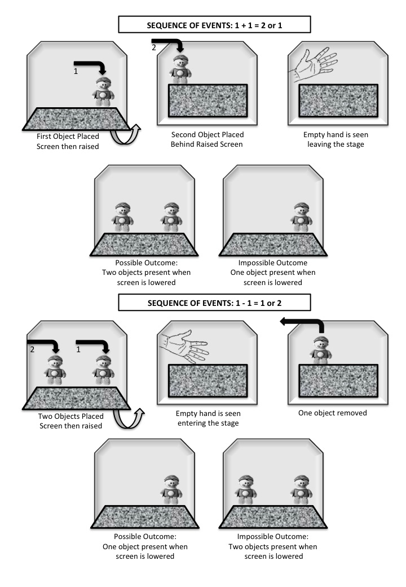
Figure 1: The sequence of events in addition and subtraction test trials.

above the screen, clutching another identical squeaking toy. When she had the infant’s attention the experimenter placed the toy in the left hand location used during familiarization, raised her hand, clasped and unclasped it to emphasize that it was empty, and then slowly withdrew it, whereupon the screen was lowered to reveal the outcome of either one or two toys. The period from appearance to disappearance of her hand took approximately 6 s. In order to replicate Wynn's (1992) procedure closely so as to be able to interpret our eye-tracking data relative to her original findings, and because we have not detected side preferences in other work with this age group, we did not counterbalance the side from which objects were manipulated, and so the impossible event (presence or absence) always concerned the left-hand object. We were comfortable with this decision for two reasons. Firstly, a looking bias to one side would be revealed in our analyses. Secondly, our primary analyses concerned comparisons between addition and subtraction conditions in looking to each side respectively, and thus would not be affected by an overall side bias.
In the subtraction condition the experimenter placed two squeaking toys, consecutively, on the stage, an event that took approximately 9 s. Following the raising of the screen her empty hand reappeared above the screen, lowered to the left hand floor of the screen and reappeared holding one toy which she squeaked above the screen and withdrew screen left, an event that took approximately 6 s, followed by lowering of the screen to reveal the outcome of one or two toys. Between each trial in each condition the roller blind was lowered to obscure the stage.
The impossible outcome (either 1 + 1 = 1 or 2 – 1 = 2) was accomplished by silent removal (addition condition) or addition (subtraction condition) of a toy from the left hand floor of the screen: each of the toys was mounted on a velvet-covered disc to ensure that the addition or removal of the toy was not audible either to the infant or the observer. The observer who recorded infants’ looking was aware of which condition (addition or subtraction) the infant was in but was unaware on each test trial of whether the outcome was possible or impossible. Preferential looking (violation of expectancy) data were recorded on a Mac G4 using Habit software (Cohen, Atkinson, & Chaput, 2004). Twenty-seven infants’ data, both for the pretest and test trials, were independently scored by a second observer from the video records and interobserver reliability was high (r = .986, p < .001).
Results
Preferential looking data
We replicated Wynn’s results very clearly. On the test trials the infants looked at the unexpected/impossible outcome for a mean of 17.82 s (SD = 8.19), and at the expected/possible outcome for a mean of 10.36 s (SD = 5.21). Thirty-one infants looked longer at the impossible outcome and 3 looked longer at the possible outcome (binomial, p < .0001). Sixteen of the 17 infants in the addition condition looked longest at the impossible outcome (p< .001), and 15 of the 17 infants in the subtraction condition did so as well (p< .001).
Analysis of Variance performed on the data confirmed significantly longer looking at the impossible outcomes than correct outcomes, F(1, 32) = 55.0, p < .001, η_{p}² = .63. This effect was qualified by a 2 (Condition, addition or subtraction) x 2 (Test Trial, expected or unexpected) x 3 (Trial Block) interaction, F(2, 31) = 4.5, p = .019, η_{p}² = .23. This effect stems from a slight increase in looking at expected outcomes accompanied by a slight decrease in looking at unexpected outcomes across the first and second trial blocks by infants in the addition condition; these trends were reversed in the subtraction group. There were no other reliable main effects or interactions.
Eye-tracker data
Using Applied Science Labs’ EYENAL software, we reduced the raw data to a list of fixations, and the data analysed consisted of dwell times in areas of interest (AOIs) that comprised the regions surrounding the two men on the stage. Preliminary analysis of eye tracker data indicated that the vast majority of looks were to the location of the toy man/men that was/were present on the stage and there was little looking elsewhere—for instance, at the location the hand emerged from—and no evidence for different patterns of looks in these regions (top left and right quadrants) depending on condition. Thus, we concentrated on the looking times to AOIs surrounding the locations of the two men. These AOIs measured 18.5 cm horizontally and 13.5 cm vertically, and thus corresponded to the lower left and right quadrants of the stage aperture. Although infants typically focused on the toys when they were visible, relatively large AOIs were necessary to detect looking towards an empty object position whose exact location might be uncertain to the infant. The raw dwell times for these two AOIs, accumulated for each trial, were converted to proportions of total dwell times recorded for each infant. We performed separate analyses of these data for the two object outcomes (Fig. 2) and one object outcomes (Fig. 3) respectively.
For the two object outcome there was a reliable main effect of condition, F(1, 18) = 5.32, p = .033, η_{p}² = .23, the result of longer dwell times overall by infants in the subtraction condition, consistent with the looking time data reported previously, i.e., greater looking at the impossible two object outcome (see Figure 2). There was also a reliable main effect of position, F(1,18) = 4.86, p = .041, η_{p}² = 21, qualified by a significant condition x position interaction, F(1,18) = 6.31, p = .022, η_{p}² = .26. This effect stemmed from greater looking toward the left position than the right by infants in the subtraction condition, F(1,9) = 7.48, p = .023, η_{p}² = .45, but not by infants in the addition condition, F(1,9) = .09, p = .77 , η_{p}² = .01. Additionally, infants looked longer at the left man when it should not be there (subtraction) than when it should be there (addition), F(1,33) = 9.76, p = .006, η_{p}² = .35. In summary, infants in the subtraction condition showed particularly long dwell times to the most recently manipulated left man that should have been absent. This was confirmed by analysis of the number of infants who
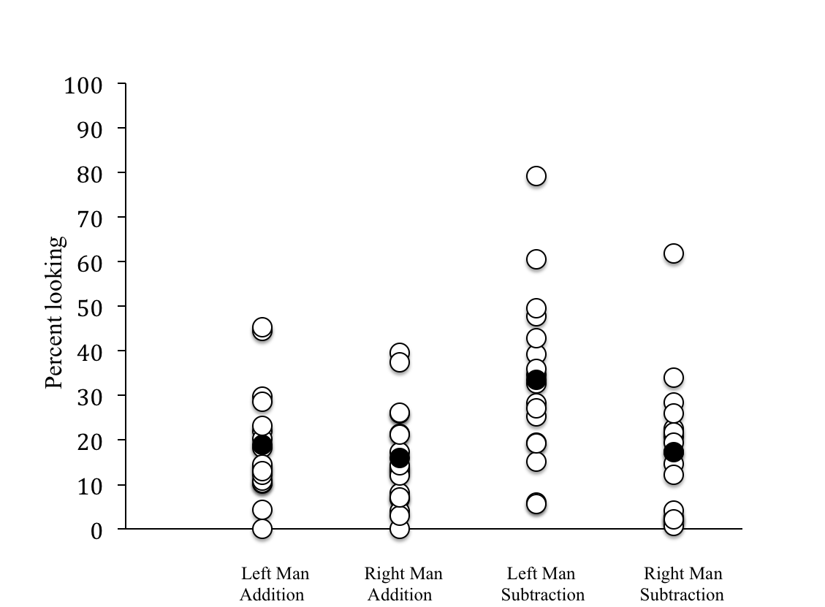
Figure 2: Percentage dwell times on two toy outcomes to left and right toy men in addition (possible) and subtraction (impossible) conditions. Filled circles are means; unfilled circles are individual data points.

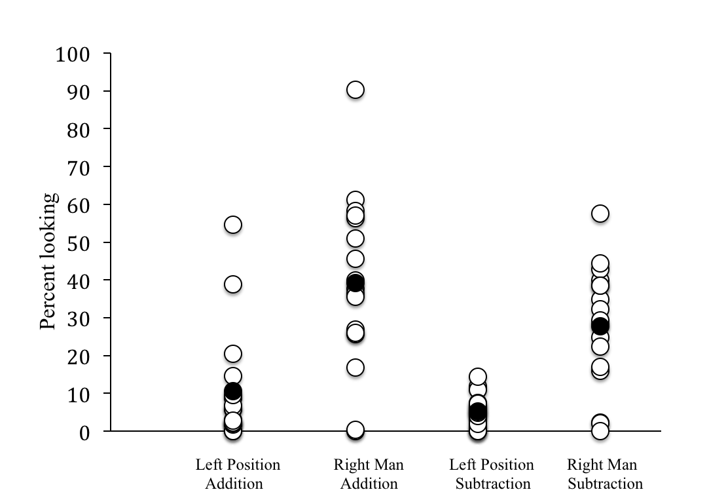

Figure 3: Percentage dwell times on one-toy outcomes to left position (empty) and right toy man in addition (impossible) and subtraction (possible) conditions.

looked longer at the left man than at the right man. Whereas 10 out of 17 infants (binomial p = .63) looked longer at the left man than the right man in the addition condition, 15 out of 17 infants (binomial p = .002) looked longer at the left man than the right man in the subtraction condition. A 2x2 χ² test on these data confirmed a larger number of infants looking at the left man in the subtraction condition compared with the addition condition, χ²(1) = 3.78, p = .026.
For the one object outcome there was a reliable main effect of condition, F(1, 18) = 8.78, p = .008, η_{p}² = .33, the result of longer dwell times overall by infants in the addition condition, consistent with the looking time data reported previously, i.e., greater looking overall at the impossible one man outcome (see Figure 3). This effect was qualified by a reliable condition x familiarization order interaction, F(1, 18) = 6.85, p = .017, η_{p}² = .28, which stemmed from longer dwell times overall by infants in the addition condition who were first familiarized with the two men event relative to the one man event, p = .031 (the reasons for this effect are unclear); the dwell time difference for infants in the subtraction condition was not significant, p = .10. There was also a reliable main effect of position, F(1, 18) = 15.96, p = .001, η_{p}² = .47, due to longer dwell times toward the right man position (M = 33.34 s: SD = 20.33) than the (empty) left man position (M = 7.84 s: SD = 11.11). The interaction between condition and position was not statistically significant, F(1,18) = .96, p = .42, η_{p}² = .04; in other words, there was no reliable difference between conditions in looking duration to either the left man position or the right man position. Significantly more infants looked longer at the right man than at the left man in both the addition condition (binomial p = .02) and the subtraction condition (binomial p = .013).
The lack of longer looking to the left hand location in the addition violation condition is unsurprising, given that there was no object to look at in that location. However, it is possible that during addition violation trials infants initially looked there, upon detecting an empty place. To check this, we analysed data for the first look infants made after the screen lowered sufficiently to reveal the top of the man or men. This analysis revealed broadly the same pattern as the dwell time analysis: Totaled across test trials, in the case of one-object outcomes, the majority of first looks were to the right hand position (Addition violation: Left = 5: Right = 35: Subtraction correct: Left = 3: Right = 35) with no difference in left position looks between these conditions. It is also possible that infants faced with addition violation looked with high frequency to the empty left hand location, but looked away quickly upon seeing nothing there. Thus we compared mean number of looks across trials to the empty left position and the occupied right position for the same conditions as above (addition violation: Left M = 5.88, SD = 5.32: Right M =10.76, SD = 7.58; subtraction correct: Left M = 3.94, SD = 3.03: Right M = 8.24, SD = 4.87). Although infants looked more often at the empty left location in the addition violation case than the subtraction correct case, this difference did not reach significance, t (32) = 1.31, p = .2.
Discussion
Our key finding from use of the eye tracker is that infants looked reliably longer at the left-hand man in the subtraction violation two-toy outcome than in the addition correct two-toy outcome. In the subtraction violation condition, they also looked reliably longer at the left hand man than the right hand man. In other words, infants looked particularly long at an object that they had just seen removed from the occluded scene. This result is not explained by the Cohen and Marks’s (2002) interpretation, namely that infants look longer at the outcome that matches the initial array before the numerical manipulation. This account would not predict differential looking in the subtraction two men outcome because it posits that infants are looking preferentially at a two object array in which both objects are equally expected. Similarly, our results do not provide strong support for a symbolic numerical account. If infants noted a violation of number one would expect increased attention to both objects, not just the one most recently manipuated. A third interpretation, which our data support, is that infants can track the existence and locations of objects for brief intervals of occlusion. Object tracking/object file accounts would predict that they “index” both objects in this task, but that their attention is directed to the object whose “file” has been violated. This is still a higher level account than Cohen and Marks (2002) presented, and it can be argued that noting a violation of a movement of a single object actually constitutes the fundamental addition or subtraction operation, namely 0+1=1 or 1-1=0.
Our findings indicate clearly that eye tracker data can be used to compare alternative interpretations of the findings from violation of expectancy (VoE) studies with infants, and it is our view that eye tracking could also clarify the interpretation of results arising from a number of key VoE experiments investigating different aspects of object knowledge in infancy. For instance, Baillargeon (1986) demonstrated that 6- to 8-month-olds who had seen an obstruction placed in an object’s path behind an occluder looked longer at object remergence than when there was no obstruction, evidence that they represented the hidden obstruction and understood that the object could not pass through it. Confidence in this conclusion would be strengthened if infants also showed reduced anticipatory tracking (Johnson, Amso, & Slemmer, 2003) when an obstruction was present.
Additionally, our findings point to a possible perceptual basis for infants’ awareness of number, an account that carries the advantage of avoiding many of the theoretical problems regarding the concept of innateness (Haith, 1998). In the subtraction condition, infants’ attention in the impossible test outcome – two toys on stage – was directed largely at the one that “should not be there.” Thus, performance may be accounted for on the basis of tracking presence or absence of one object at one location, namely, the location where the toy was added or taken away. Thus, even relatively parsimonious object tracking accounts of small number judgements (e.g. vanMarle, 2013) may be more complex than the findings from this task demand. Although a representation of the other object may be formed (Uller et al., 1999), its presence may act primarily as a referent for the arithmetic operation constituted by the physical manipulation of the added or subtracted object. Possibly this forms the initial implicit perceptual basis for later arithmetic abilities. Specifically, prediction of the outcome of tracking a single object across occlusion effectively consists of adherence to the principles that 0+1=1 and 1-1=0. In this respect, this account is consistent with the argument that awareness of object permanence develops from perception of object persistence across occlusion (Bremner, Slater, & Johnson, 2015). We know that young infants' perception of object persistence across occlusion is limited to short spatio-temporal gaps in perception (Bremner, Johnson, Slater, Mason, Foster, & Cheshire, 2005; Johnson, Bremner, Slater, Mason, Foster, & Cheshire, 2003), and it is likely that this same perceptually constrained process operates in Wynn's (1992) task, such that they form a perceptual expectation about the persistence of an added object when the screen is lowered. The additional process revealed in the present work is that infants apparently track an object off the scene and form a perceptual expectation of its absence behind the screen, an expectation that is violated when it is revealed remaining in its original location.
In summary, to our knowledge this is the first study to derive eye tracking data from a task involving addition and subtraction of objects from a three-dimesional scene. The clearest results were obtained in the subtraction violation condition, in which infants directed particular nattention specifically to the object that should no longer be there. Selective attention of this sort is not predicted by a low level account based on familiarity preference (Cohen & Marks, 2002). However, the fact that there was no increase in looking to the object that was not subject to the subtraction operation does not support a symbolic numerical account, according to which detection of a numerical violation should lead to an increase in attention to both objects in the outcome scene. Our results are more closely in keeping with an object file account in which each object is tracked separately, such that attention is only directed to the object whose file is violated. We favour the view that processing at this level forms a precursor of symbolic numerical ability, which may well develop through the constructionist processes advanced by Cohen and Marks (2002).
References
Antell, S.E. & Keating, D.P. (1983). Perception of numerical invariance in neonates. Child Development, 54, 695-701.
Baillargeon, R. (1986). Representing the existence and the location of hidden objects: Object permanence in 6- to 8-month-old infants. Cognition, 23, 21-41.
Berger, A., Tzur, G. & Posner, M.I. (2006). Infant brains detect arithmetic errors. Proceedings of the National Academy of Sciences of the United States of America, 103, 12649-12653.
Bremner, J.G., Johnson, S.P., Slater, A.M., Mason, U., Foster, K., Cheshire, A., & Spring, J. (2005). Conditions for young infants’ perception of object trajectories. Child Development, 74, 1029-1043.
Bremner, J.G., Slater, A.M., & Johnston, S.P. (2015). Perception of object persistence: the origins of object permanence in infancy. Child Development Perspectives, 9, 7-13. DOI: 10.1111/cdep.12098
Clearfield, M.W., & Westfahl, S.M-C. (2006). Familiarization in infants’ perception of addition problems. Journal of Cognition and Development, 7, 27-43.
Cohen, L.B., Atkinson, D.J., & Chaput, H. H. (2004). Habit X: A new program for obtaining and organizing data in infant perception and cognition studies (Version 1.0). Austin: University of Texas.
Cohen, L.B., Chaput, H.H., & Cashon, C.H. (2002). A constructivist model of infant cognition. Cognitive Development, 17, 1323-1343.
Cohen, L.B., & Marks, K.S. (2002). How infants process addition and subtraction events. Developmental Science, 5, 186-212.
Feigenson, L. & Carey, S. (2003). Tracking individuals via object-files: Evidence from infants’ manual search. Developmental Science, 6, 568-584.
Feigenson, L., Carey, S. & Hauser, M. (2002). The representations underlying infants’ choice of more: Object files versus analog magnitudes. Psychological Science, 13, 150-156.
Haith, M.M. (1998). Who put the cog in infant cognition? Is rich interpretation too costly? Infant Behavior and Development, 21, 176-179.
Johnson, S.P., Amso, D., & Slemmer, J.A. (2003). Development of object concepts in infancy: Evidence for early learning in an eye-tracking paradigm. Proceedings of the National Academy of Sciences (USA), 100, 10568-10573.
Johnson, S. P., Bremner, J. G., Slater, A., Mason, U., Foster, K., & Cheshire, A. (2003). Infants’ perception of object trajectories. Child Development, 74, 94-108.
Kahneman, D., Triesman, A., & Gibbs, B. (1992). The reviewing of object files: Object specific integration of information. Cognitive Psychology, 24, 175-219.
Lipton, J.S. & Spelke, E.S. (2003). Origins of number sense: Large-number discrimination in human infants. Psychological Science, 14, 396-401.
McCrink, K. & Wynn, K. (2004). Large-number addition and subtraction by 9-month-old infants. Psychological Science, 15, 776-781.
McCrink, K. & Wynn, K. (2007). Ratio abstraction by 6-month-old infants. Psychological Science, 18, 740-745.
Meck, W. H., & Church, R. M. (1983). A mode control model of counting and timing processes. Journal of Experimental Psychology: Animal Behavior Processes, 9, 320-334.
Moore, D.S., & Cocas, L.A. (2006). Perception precedes computation: Can familiarity preferences explain apparent calculation by human babies? Developmental Psychology, 42, 666-678.
Pylyshyn, Z.W., & Storm, R.W. (1988). Tracking multiple independent targets: Evidence for a parallel tracking mechanism. Spatial Vision, 3, 1-19.
Rugani, R., Fontanari, L., Simoni, E., Regolin, L., & Vallortigara, G. (2009). Arithmetic in newborn chicks. Proceedings of the Royal Society B – Biological Sciences, 276, 2451-2460.
Scholl, B.J. (2001). Objects and attention: The state of the art. Cognition, 80, 1-46.
Simon, T.J., Hespos, S.J., & Rochat, P. (1995). Do infants understand simple arithmetic? A replication of Wynn (1992). Cognitive Development, 10, 253-269.
Slater, A.M., Bremner, J.G., Johnson, S.P., & Hayes, R. (2010). The role of perceptual and cognitive processes in addition-subtraction studies with 5-month-old infants. Infant Behavior and Development, 33, 685-688.
Uller, C., Carey, S., Huntley-Fenner, G., & Klatt, L. (1999). What representation might underlie infant numerical knowledge? Cognitive Development, 14, 1-36.
vanMarle, K. (2013). Infants use different mechanisms to make small and large number ordinal judgements. Journal of Experimental Child Psychology, 114, 102-110.
Walden, T., Kim, G., McCoy, C., & Karrass, J. (2007). Do you believe in magic? Infants’ social looking during violations of expectations. Developmental Science, 10, 654-663.
Wynn, K. (1992). Addition and subtraction by human infants. Nature, 358, 749-750.
Xu, F. (2003). Numerosity discrimination in infants: Evidence for two systems of representation. Cognition, 89, B15-B25.
Xu, F. & Arriaga, R.I. (2007). Number discrimination in 10-month-old infants. British Journal of Developmental Psychology, 25, 103-108.
Xu, F. & Spelke, E.S. (2000). Large number discrimination in 6-month-old infants. Cognition, 74, B1-B11.

