This is the accepted manuscript version of an article published by S. Karger AG in [Nurturing a Healthy Generation of Children: Research Gaps and Opportunities, Vol. 91, pp. 169-178. Karger Publishers; (DOI: 10.1159/000493708) and available on https://www.karger.com/Article/Abstract/493708

Breakfast, glycemic index and cognitive function in school children: evidence, methods and mechanisms

Sandra I. Sünram-Lea
Department of Psychology, Lancaster University

Running head: Glycemic index and cognitive function in school children

Author to whom correspondence should be addressed:

Sandra I. Sünram-Lea
Department of Psychology
Lancaster University
Lancaster LA1 4YF
United Kingdom

Tel.: 0044 (0)1524 593834
Email: s.sunram-lea@lancaster.ac.uk

Abstract
Breakfast has been claimed to improve cognitive function and academic performance, leading to the provision of breakfast initiatives by public health bodies. Children may be particularly sensitive to the nutritional effects of breakfast due to greater energetic needs compared to adults. However, there is a lack of acute intervention studies assessing what type of breakfast is optimal for cognitive performance. In this paper, the impact of breakfast-based glycemic response on cognition in children will be reviewed. The data suggest that a more stable blood glucose profile which avoids greater peaks and troughs in circulating glucose is associated with better cognitive function across the morning. Although the evidence to date is promising, it is currently insufficient to allow firm and evidence-based recommendations. What limits our ability to draw conclusions from previous findings is that the studies have differed widely with respect to subject characteristics, cognitive tests used and timing of cognitive assessment. In addition, few studies have profiled glycemic response in children specifically. There is therefore an urgent need for hypothesis-driven, randomized controlled trials that evaluate the role of different glycemic manipulations on cognition.

Breakfast is recommended as part of a healthy diet because it is associated with healthier macro- and micronutrient intakes [1], BMI and lifestyle [2]. Breakfast has also been claimed to improve cognitive function and academic performance, leading to the provision of breakfast initiatives by public health bodies. Broadly speaking nutritional interventions offer opportunities to: i) optimize cognitive development during infancy and childhood; ii) ensure the highest levels of cognitive function during adulthood; and iii) prevent cognitive decline in older age (see Figure 1). Whether breakfast consumption is key to optimizing various health outcomes across different populations is debated. Nevertheless, children may be particularly sensitive to the nutritional effects of breakfast on brain activity and associated cognitive outcomes because of their greater energetic needs compared to adults [3].

The central role of glucose as the major nutrient of the brain, its metabolism and control, has been well documented. All cell processes (including nerve cells) require energy, and aerobic carbohydrate metabolism is both the major source of energy available for brain tissue and of biological energy [4]. The rate of glucose brain metabolism changes across the life span. Initially, there is a rise in the rate of glucose utilization from birth until about age 4 years, at which time the child's cerebral cortex uses more than double the amount of glucose compared to adults. Childhood is also a time of intense learning and children learn many basic reading, writing and arithmetic concepts during these years. Consequently, the high rate of glucose utilization maintained in children from age 4 to 10 years coincides with a period of metabolically expensive cognitive processes [5]. Moreover, it has been suggested that overnight fast induces greater metabolic stress in young children as the higher the ratio of brain to liver weight and the greater the metabolic rate per unit of brain weight, the greater the demand on glycogen stores [6].

To maintain this higher metabolic rate, a continuous supply of energy is needed. Hence, breakfast consumption may be vital to providing adequate energy supply for school children, especially if breakfast is missed, as food intake ad libitum is not possible or is limited during school time. Reviews of the effect of breakfast on cognitive performance in children and adolescents suggest that breakfast has beneficial effects, with effects most readily apparent when nutritional status is compromised [7]. Moreover, in developed countries it has been found that skipping breakfast can result in impaired cognitive performance [7,8]. However, there is a lack of acute intervention studies assessing what type of breakfast is optimal for cognitive performance. Dietary carbohydrates are of interest as they provide the main source of energy for the brain’s metabolic functioning, and there is mechanistic evidence linking postprandial glycaemia to cognitive performance in both children and adult populations [9]. Therefore, when considering what type of breakfast may be beneficial, the rate at which breakfast increases and maintains blood glucose, i.e. ‘the glycemic index’ (GI) might be an important factor. After a high-GI meal, plasma glucose concentrations rise rapidly causing a high peak glucose level and a concomitant high insulin response, resulting in a rapid blood glucose disposal which in turn may cause blood glucose levels to decrease to below the fasting concentration in the later postprandial period. Low-GI foods result in more moderate peak blood glucose increments and may also maintain a prolonged net increment in blood glucose above the fasting concentration [10]. Related to this is the concept of glycemic load (GL) which takes into account the amount of carbohydrates consumed and is calculated by multiplying the GI by the amount of available carbohydrate, then dividing by 100 [11]. In the following section, effects on school children’s cognitive performance as related to glycemic properties of breakfast interventions will be reviewed (for more general reviews on the effects of breakfast on cognitive performance see [12-15]).

Breakfast based postprandial glycemic response and cognition
Wesnes et al. [16] tested children aged 9-16, on 4 separate days under different breakfast conditions, namely a glucose drink, two different cereals, and no breakfast. Assessment of children’s cognitive performance was carried out prior to breakfast and 30mins, 90mins, 150mins and 210 mins after breakfast consumption. The results showed a decline in memory and attention across the morning which was ameliorated when children consumed the cereals. However, both cereals had a high-GI (approx. 74), albeit lower than the glucose drink. Mahoney et al. [17] looked at the optimal rate of glucose supply in children aged 6-8 years or 9-11 years and found that 60 minutes after consumption of a low GI breakfast children in both age groups remembered significantly more than after a high GI breakfast or no breakfast. The effect was more pronounced in younger children. When comparing the effects of a low GI breakfast and a high GI breakfast across the morning (10 min, 70 min and 130 min post ingestion) in children aged 6–11 years old, Ingwersen et al. [18] found that a low GI cereal prevented decline in attention and memory 130 min after breakfast administration (compared to a high GI breakfast). Investigating a slightly older age group (12-14 years), Cooper et al. [19] gave children aged 12 – 14 years old either a low-GI breakfast, a high-GI breakfast or no breakfast and tested performance 30 and 120 min after breakfast consumption. The findings revealed faster response times (reaction times) 120 min after consumption of the low-GI breakfast on the Stroop task (assessing executive function) and Flanker task (measuring attention) compared with no breakfast, and on the Sternberg paradigm (working memory task) compared to the high-GI breakfast intervention. In addition, children’s accuracy on all tests was better maintained after the low-GI breakfast compared with the high-GI breakfast and no breakfast condition. Defeyter and Russo [20] tested participants aged 13-15 years before and 120 min after the intake of a low GI breakfast or no breakfast and found that the low GI breakfast led to improved long-term and working memory performance. Amiri et. al [21] found that consumption of a high-carbohydrate breakfast impaired attention relative to a high-protein breakfast in girls (but not boys) aged 9–11 years old, whereas another study found no effect from a high-carbohydrate compared with high-protein breakfast on attention [22]. The fact that in both studies only one breakfast GI condition was used limits our ability to draw firm conclusions about the optimal nature of the postprandial response.

The combined effects of breakfast GI (low GI versus high GI) and 10 min mid-morning exercise on cognition in children aged 11 to 13 years was also assessed recently [23]. Cognitive performance was assessed 15 and 105 min after breakfast consumption and those allocated to the exercise condition did 10 minutes of exercise (shuttle runs) approximately 45 minutes after breakfast. The results showed that a low GI breakfast led to improved response times across the morning on an executive function and working memory task (Stroop and Sternberg paradigm) irrespective of exercise condition. Furthermore, mid-morning exercise had an additional benefit for response times on the executive function task when combined with a low GI breakfast. No single or combined effect of breakfast GI or a mid-morning exercise was found on measures of accuracy, and no effects were observed on measures of attention (visual search) and mood.

Glycemic load (GL) - as opposed to Glycemic Index (GI) - has also been shown to affect cognitive performance. Benton, Maconie & Williams [24] investigated the effects of three isocaloric breakfasts differing in GL (high, medium and low GL) on cognitive performance and behavior in children aged 5-7 years old. They found 140-210 min post consumption significantly fewer signs of frustration and more time on task for low GL, but no effects on cognitive performance (although correlation analysis suggested that lower GL improved children’s memory and attention). Using a wider age range (5-11 years), Young and Benton [25] compared three breakfasts varying in GL and found that memory and mood were improved 180 min (but not 60 min) after ingestion of the lower GL breakfast. Micha, Rogers and Nelson [26] investigated both GI and GL. Within each GL condition (high or low) children aged 11-14 years received either a high-GI or low-GI breakfast. Low-GI breakfasts predicted better memory performance when cognitive performance was assessed 103 to 136 min after consumption. In addition, children reported to feel more alert and happy and less nervous after they had the low-GI breakfast. These effects were observed across GL conditions. Interestingly, although a lower postprandial glycemic response was associated with improved long-term memory performance, the high-GI breakfast led to improved performance on a task pertaining to executive function, information processing and working memory.

Some studies have found no evidence for improved performance following a breakfast that results in lower postprandial glycemic response [27,28]. In one study the effects of three isocaloric drinks which varied in GL (high, medium and low) was assessed in children aged 10-12 years [27]. Children were tested before and after drink administration at hourly intervals for 180 min, and glycemic response was assessed using a continuous glucose monitoring system. Analysis of the glycemic response revealed significant differences in glycemic response as indexed by incremental area under the curve values) between the drinks (high GL>medium GL>low GL); however, no drink effects were observed on cognitive performance. A later study conducted by the same group, brought about similar results [28]. In this study, children aged 10-12 years were given three isoenergetic drinks differing in GI and GL; a glucose drink (GI 100, GL 65), milk drink (GI 27, GL 5) and a milk/glucose drink (GI 84, GL 35). Following baseline assessment of cognitive performance, children were tested again hourly, for 3 h post-consumption. As before glycemic response was assessed using a continuous glucose monitoring system. Although postprandial glycemic responses were significantly different between the drinks, there were no effects on cognitive performance. Yet, further analysis revealed sex differences in the susceptibility to cognitive enhancement. Girls, but not boys, had better short-term memory after consumption of drinks with the lower GL compared to the glucose drink.

To summarize, there are fewer studies comparing breakfast type than there are comparing breakfast with no breakfast, and even fewer that specifically assess the influence of postprandial glycemic response on cognitive performance. Within the limited data available, the evidence suggests that a lower postprandial glycemic response may be protective against a decline in cognitive performance over the morning. However, the evidence is far from conclusive. What limits our ability to draw strong conclusions from the findings of previous studies is that the studies differ widely with respect to subject characteristics, cognitive tests used and timing of cognitive assessment; and that few studies have profiled glycemic response in children. In the following section, some of the conceptual and methodological factors that might have contributed to the inconsistent set of findings are briefly discussed (see [29] for a more general discussion of methodological issues in studies examining the effects of breakfast).

Breakfast, postprandial glycemic response and cognitive function; important methodological and conceptual factors
Tasks pertaining to attention, executive function skills and memory have been identified as aspects of cognition most likely to be susceptible to breakfast interventions [15]. In studies that compared breakfast type, a low-GI breakfast was most consistently associated with beneficial effects on attention [16-19, 21], with effects limited to females in one study [21]. Fewer studies reported beneficial effects on memory [24; 16; 18], and again one study only observed effects for girls [28]. Few studies have included executive function tasks in their assessment. One reported beneficial effects on task speed, but not accuracy [23]; one showed evidence for improvement after high-GI breakfast [26]; and some showed no effects [16,18]. Different aspects of cognition pertain to different neural structures and networks, which allows speculation about the areas of the brain that might be particularly susceptible to glycemic manipulation. However, categorization of cognitive tasks to a specific cognitive domain is not consistent throughout the literature. Moreover, a key issue in cognitive assessment of any nutritional intervention is test sensitivity. Cognitive tests that were designed to discriminate between groups and populations for diagnostic purposes are unlikely to be sufficiently sensitive to detect subtle changes in performance due to nutritional interventions [30]. Therefore, in studies where a number of tests were administered, beneficial effects observed in one domain, might simply be due to greater test sensitivity, rather than domain specificity.

There is a clear need for studies using cognitive tasks that are sensitive to nutritional manipulations, but also relevant to the specific learning situation encountered. For school children, learning and educational attainment are strongly related to memory and attention (31). This is because many typical classroom activities depend on these cognitive resources. Another important aspect of the learning situation encountered by school-aged children is the ability to self-regulate. Self-regulation involves modulating systems of emotion, attention, and behavior in response to a given situation or stimulus [32]. Children’s ability to self-regulate is critical for their academic success [33]; consequently, aspects of effortful control and self-regulation are highly relevant to children’s school performance. Assessment of breakfast interventions on tasks involving aspects of executive function such as cognitive flexibility, working memory, and inhibitory control are therefore important. However, as mentioned earlier, few studies have incorporated such tasks and consequently we have an insufficient knowledge base about the effects of breakfast on an aspect of cognitive performance that is vital to children’s educational success.

Temporal differences in cognitive testing (i.e. at what time after breakfast intake cognitive performance was assessed) is another important factor that might have led to some of the inconsistent findings observed in the literature. To date, for studies examining the effects of postprandial glycemic manipulation these timing ranged from 10 min [18] to 220 min [16; 27]. In addition, some studies assessed cognitive performance repeatedly across the morning [16, 18, 27,28] whereas others included only one post-intervention assessment [17]. Findings to-date suggest that effects are usually observed in the late postprandial period (75-222 min [17,18]. For future studies, multiple assessments at various time-points and especially in the late morning are likely to help reveal the effects and time course of glycemic effects on cognition. Baseline assessment of cognitive performance is another important methodological difference between studies although it is important for controlling inter- and intra-individual differences [30]. Cognitive status at baseline will affect intervention outcomes, and failure to account for them will make a clear interpretation of findings difficult.

Furthermore, there is a clear lack of intervention studies that employ ecologically valid research conditions, such as school-based testing. Although laboratory-based studies allow greater experimental control, the fact that children are tested in a novel environment is likely to result in changes in mood and arousal which in turn can affect cognition. This is particularly important to consider when children are tested in clinical environments such as a hospital. In such instances, familiarization will be an important component to mitigate the confounding effects of the novel environment. In addition, familiarization to tests and testing procedure is also important when testing children in the field. This relates to the point made earlier about establishing baseline cognitive performance and, more specifically, controlling for baseline cognitive performance to allow assessment of ‘true’ treatment effects. In a similar vein, statistical analysis of the data needs to control for differences within subjects and in the case of repeated testing, order effects.

Finally, few studies have profiled the glycemic response in children [27,28]. Technical advances have led to the development of minimally-invasive 24hr continuous glucose monitoring (CGM) devices. The minimal invasiveness of CGM devices compared to traditional intravenous or capillary glucose monitoring, provides an opportunity to assess glycemic responses on children. Results obtained using CGM devices in children have shown that they are sensitive to detect differences in postprandial glycemic response in normoglycemic children [27,28]. In addition, the possibility of differences in postprandial response to glycemic index manipulation across various populations, as apparent from differences in metabolic demands, general homeostatic and glucose regulatory mechanisms, requires further study. In terms of age, there is a large variation in studies investigating the effect of breakfast-based glycemic index manipulations, at times ranging from 5 to 16 years [16]. From a metabolic perspective, adolescence might also be a time when greater susceptibility to glycemic variations is observed due to the specific metabolic conditions observed during that time of development [34]. Investigations using clearly defined age groups are needed. These will also help to clarify the nature of the relationship between postprandial blood glucose concentrations and cognition. The precise mechanisms by which increased peripheral and/or central glucose availability affects cognitive processes are still unclear (see [9] for an outline of potential underlying mechanisms). More biological data are needed to understand how developmental differences in glucoregulation may moderate the effects of GI or GL on cognitive performance in children.

Conclusion
Understanding the potential influence of breakfast interventions on children’s cognitive function remains a high priority, given its application to learning and achievement at school. There is evidence to suggest that children may be more susceptible to breakfast interventions due to higher metabolic and cognitive demands. In terms of nutritional recommendations, based on the evidence above it appears low-GI or -GL breakfasts which minimize oscillations in glucose concentrations might be beneficial for optimal cognitive performance across the morning. What limits our ability to draw strong conclusions from the findings of previous studies is the fact that they often differ widely with respect to subject characteristics, cognitive tests used and timing of assessment. Future research needs to carefully consider conceptual and methodological factors including potential inter-individual differences, adequate selection of tests and control of extraneous (confounding) variables [9, 29] (see Figure 2).

Conflict of interest
The author declares no potential conflict of interest with respect to the research/authorship, and/or publication of this article.

Funding
Sandra Sünram-Lea received funding (travel and accommodation) to attend the 91 Nestlé Nutrition Institute Workshops meeting entitled “Nurturing a healthy generation, call on research gaps and opportunities”.

References
1. Ruxton CH, Kirk TR: Breakfast: a review of associations with measures of dietary intake, physiology and biochemistry. British Journal of Nutrition 1997;78(2):199-213.
2. De la Hunty A, Ashwell M: Are people who regularly eat breakfast cereals slimmer than those who don’t? A systematic review of the evidence. Nutrition Bulletin 2007; 32(2):118-28.
3. Chugani HT: A critical period of brain development: studies of cerebral glucose utilization with PET. Preventive medicine 1998;27(2):184-8.
4. McIlwain H, Bachelard HS: Biochemistry and the central nervous system 1972
5. Haymond M. Hypoglycemia in infants and children. Endocrinology and metabolism clinics of North America 1989; 18(1):211-52.
6. Pollitt E, Leibel RL, Greenfield D: Brief fasting, stress, and cognition in children. The American journal of clinical nutrition 1981; 34(8):1526-33.
7. Hoyland A, Dye L, Lawton CL: A systematic review of the effect of breakfast on the cognitive performance of children and adolescents. Nutrition research reviews 2009; 22(02):220-43.
8. Benton D, Parker PY: Breakfast, blood glucose, and cognition. The American journal of clinical nutrition 1998; 67(4):772S-8S.
9. Sünram-Lea SI, Owen L: The impact of diet-based glycaemic response and glucose regulation on cognition: evidence across the lifespan. Proceedings of the Nutrition Society 2017; 76(4):466-77.
10. Granfeldt Y, Nyberg L, Björck I: Muesli with 4 g oat β-glucans lowers glucose and insulin responses after a bread meal in healthy subjects. European journal of clinical nutrition 2008; 62(5):600.
11. Gilsenan MB, de Bruin EA, Dye L: The influence of carbohydrate on cognitive performance: a critical evaluation from the perspective of glycaemic load. The British journal of nutrition. 2009; 101(7):941.
12. Edefonti V, Rosato V, Parpinel M, Nebbia G, Fiorica L, Fossali E, Ferraroni M, Decarli A, Agostoni C: The effect of breakfast composition and energy contribution on cognitive and academic performance: a systematic review–. The American journal of clinical nutrition 2014; 100(2):626-56.
13. Edefonti V, Bravi F, Ferraroni M: Breakfast and behavior in morning tasks: Facts or fads?. Journal of affective disorders 2017; 224:16-26.
14. Adolphus K, Lawton CL, Dye L. The effects of breakfast on behavior and academic performance in children and adolescents. Frontiers in human neuroscience 2013; 7:425.
15. Adolphus K, Lawton CL, Champ CL, Dye L: The Effects of Breakfast and Breakfast Composition on Cognition in Children and Adolescents: A Systematic Review–. Advances in Nutrition 2016; 7(3):590S-612S.
16. Wesnes KA, Pincock C, Richardson D, Helm G, Hails S: Breakfast reduces declines in attention and memory over the morning in schoolchildren. Appetite 2003;41(3):329-31.
17. Mahoney CR, Taylor HA, Kanarek RB, Samuel P: Effect of breakfast composition on cognitive processes in elementary school children. Physiology & behavior 2005; 85(5):635-45.
18. Ingwersen J, Defeyter MA, Kennedy DO, Wesnes KA, Scholey AB: A low glycaemic index breakfast cereal preferentially prevents children's cognitive performance from declining throughout the morning. Appetite 2007; 49(1):240-4.
19. Cooper SB, Bandelow S, Nute ML, Morris JG, Nevill ME: Breakfast glycaemic index and cognitive function in adolescent school children. British Journal of Nutrition 2012; 107(12):1823-32.
20. Defeyter MA, Russo R: The effect of breakfast cereal consumption on adolescents' cognitive performance and mood. Frontiers in human neuroscience 2013; 7:789.
21. Amiri F, Amani R, Khajemogahi N, Rashidkhani B, Saxby B, Wesnes K: Assessing the effects of two breakfasts (high-carbohydrate vs high-protein) on cognitive function, mood and satiety status of 9–11 year-old primary school children with a new technology in Iran. Brain Inj 2014; 28:754-5.
22. Morrell G, Atkinson D: Effects of breakfast program on school performance and attendance of elementary school children. Education 1977; 98:111–6
23. Cooper SB, Bandelow S, Nute ML, Morris JG, Nevill ME: Breakfast glycaemic index and exercise: Combined effects on adolescents' cognition. Physiology & behavior 2015; 139:104-11.
24. Benton D, Maconie A, Williams C: The influence of the glycaemic load of breakfast on the behaviour of children in school. Physiology & behavior 2007; 92(4):717-24.
25. Young H, Benton D: The effect of using isomaltulose (Palatinose™) to modulate the glycaemic properties of breakfast on the cognitive performance of children. European journal of nutrition 2015; 54(6):1013-20.
26. Micha R, Rogers PJ, Nelson M: Glycaemic index and glycaemic load of breakfast predict cognitive function and mood in school children: a randomised controlled trial. British journal of nutrition 2011; 106(10):1552-61.
27. Brindal E, Baird D, Danthiir V, Wilson C, Bowen J, Slater A, et al: Ingesting breakfast meals of different glycaemic load does not alter cognition and satiety in children. European journal of clinical nutrition 2012; 66(10):1166-71.
28. Brindal E, Baird D, Slater A, Danthiir V, Wilson C, Bowen J, et al: The effect of beverages varying in glycaemic load on postprandial glucose responses, appetite and cognition in 10–12-year-old school children. British Journal of Nutrition 2013; 110(03):529-37.
29. Adolphus K, Bellissimo N, Lawton CL, Ford NA, Rains TM, Totosy de Zepetnek J, Dye L: Methodological Challenges in Studies Examining the Effects of Breakfast on Cognitive Performance and Appetite in Children and Adolescents. Advances in Nutrition 2017; 8(1):184S-96S.
30. de Jager CA, Dye L, de Bruin EA, Butler L, Fletcher J, Lamport DJ, Latulippe ME, Spencer JP, Wesnes K: Criteria for validation and selection of cognitive tests for investigating the effects of foods and nutrients. Nutrition reviews 2014; 72(3):162-79.
31. Cain K, Oakhill J, Bryant P: Children's reading comprehension ability: Concurrent prediction by working memory, verbal ability, and component skills. Journal of educational psychology 2004; 96(1):31.
32. Calkins SD, Fox NA: Self-regulatory processes in early personality development: A multilevel approach to the study of childhood social withdrawal and aggression. Development and psychopathology 2002; 14(3):477-98.
33. McClelland MM, Cameron CE, Duncan R, Bowles RP, Acock AC, Miao A, Pratt ME: Predictors of early growth in academic achievement: The head-toes-knees-shoulders task. Frontiers in psychology 2014; 5:599.
34. Caprio S, Plewe G, Diamond MP, Simonson DC, Boulware SD, Sherwin RS, et al: Increased insulin secretion in puberty: a compensatory response to reductions in insulin sensitivity. The Journal of pediatrics 1989; 114(6):963-7.

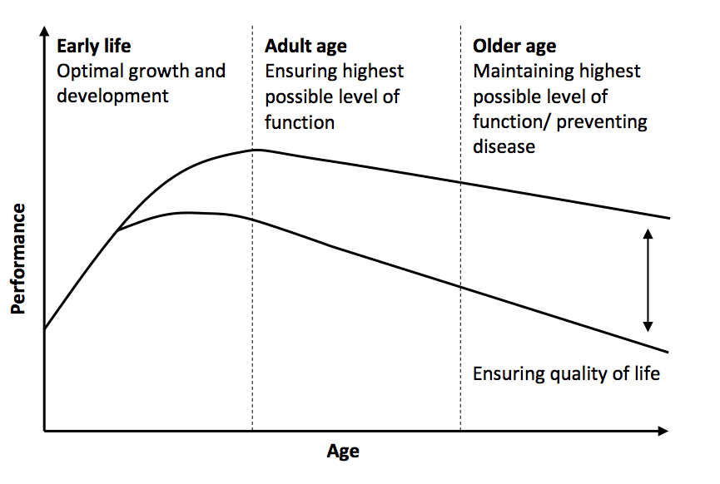
Figure 1: Nutrition and cognition: potential for optimizing cognitive performance across the lifespan

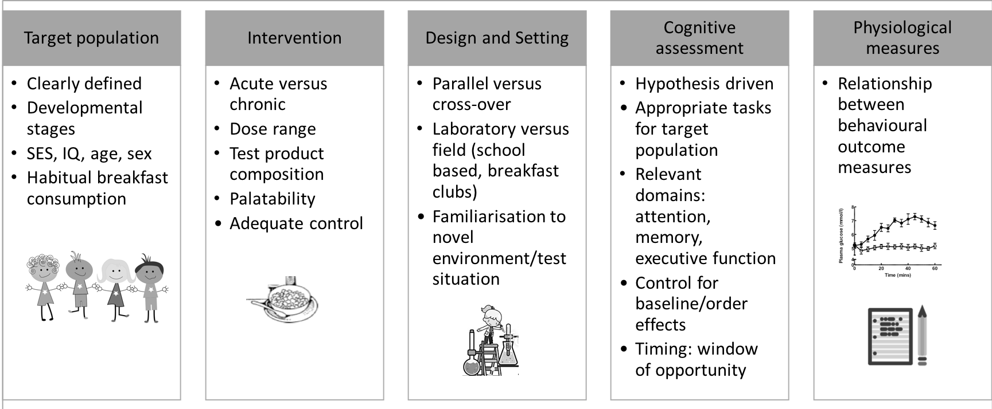
Figure 2: Evaluation of breakfast interventions in children: conceptual and methodological considerations

