Title: A mesocosm-based assessment of whether root hairs affect soil erosion by simulated rainfall.
Running title: Root hairs and soil erosion.
Authors: Emma Burak, Ian C. Dodd, and John N. Quinton
Institution: Lancaster Environment Centre, Lancaster University, Lancaster, LA1 4YQ, UK
Corresponding author: Emma Burak (b.burak@lancaster.ac.uk, ORCID: 0000-0001-5641-4112)

Abstract
Although plant canopies are widely recognised to protect the soil and help mitigate soil erosion, recent research has shown that the majority of soil scour prevention can be attributed to the roots. Since roots are more difficult and time-consuming to measure than shoots, research in this area has largely been limited to understanding the influence of large roots and/or whole root systems, and there is little understanding on how smaller root traits, such as root hairs, contribute to the root system’s ability to mitigate soil erosion. Therefore, this study subjected a root hairless mutant (brb) of barley (Hordeum vulgare L. cv. Pallas) and its wild-type (WT) to simulated rainfall. The results showed that increasing root presence significantly reduced soil erosion but the impact of root hairs were less clear. Soil detachment significantly decreased as root length density increased, with no apparent genotypic difference in this relationship. The brb root systems produced significantly thinner (0.8-fold) roots and higher percentage (1.1-fold) of fine roots, with both traits previously associated with increased ability to mitigate soil erosion. However, brb mesocosms produced a similar quantity of eroded soil to WT mesocosms, suggesting that root hairs in WT plants could have compensated for their root systems’ reduced ability to mitigate soil erosion.

Keywords
Barley, brb, Roots, Root hairs, Simulated rainfall, Soil erosion.

Highlights
- It is not known whether root hairs affect a root system’s ability to mitigate soil erosion.
- Soil yield following simulated rainfall was compared for a root hairless mutant (brb) and its WT.
- Root traits of brb favoured erosion mitigation, but brb and WT mesocosms eroded to the same degree.

Introduction
Erosion of agricultural soil is of global concern (Quinton et al., 2010; Borrelli et al., 2017) with severe financial implications and threats to food security (Verheijen et al., 2009; Posthumus et al., 2015). Soil can be eroded by both wind and water, with water being the prominent cause in the UK (Verheijen et al., 2009). The mechanisms that cause soil to erode via water are governed by the detachment force of water versus the cohesive and adhesive bonds between the soil particles (Laflen et al., 1991). Plants have long been known to influence these interactions between soil and water, resulting in a reduction in soil erosion (Acostasolis, 1947; Singer et al., 1980).
Although most research has focused on the impact of above-ground plant matter (such as leaves and stems), the relative contribution of roots to preventing soil erosion can outweigh the contribution of above-ground matter (Zhou & Shangguan, 2007). Up to 95% of a plant’s ability to reduce soil erosion, caused by overland flow, can be attributed to its root system (De Baets et al., 2006; Zhou & Shangguan, 2007; Burylo et al., 2012). Similar results have also been found with simulated rainfall (Ghidey & Alberts, 1997; Zhou & Shangguan, 2007, 2008). Determining the quantitative variation in the contribution of the root system to ameliorate soil erosion requires an understanding of the mechanisms by which roots mediate erosivity.
Previous studies have found that a variety of root parameters are significantly correlated with reducing sediment yield including: root surface area (Li et al., 1991; Prosser et al., 1995; Zhou & Shangguan, 2007, 2008), root length density (Bui & Box, 1993; Ghidey & Alberts, 1997; Mamo & Bubenzer, 2001; De Baets et al., 2006), root density (Tengbeh, 1993; Gyssels & Poesen, 2003), and diameter (Li et al., 1991; Burylo et al., 2012), percentage of fine roots (Burylo et al., 2012), and a combination of the above (Shit & Maiti, 2012; Burylo et al., 2012). Therefore, all root systems do not have an equal impact on erosion mitigation.
At just a cell thick, root hairs are only just visible to the naked eye, but have been associated with characteristics attributed to reducing soil loss. For example, their abundance throughout the root system means that over 90% of root surface area can be attributed to root hairs (Gilroy & Jones, 2000). Root hairs can grow as long as 1.5 mm (Brown et al., 2017) and their total length can be 20 times that of the rest of the root system (Wulfsohn & Nyengaard, 1999). Due to their small diameter, root hairs can physically penetrate and enmesh soil aggregates (Rasse et al., 2005; Keyes et al., 2013). Further to this, White and Kirkegaard (2010) show that roots actively increase root hair density to increase soil contact. As well as physical enmeshment, root hairs are considered the main water uptake pathway into the root system (Wasson et al., 2012). So, theoretically the presence of root hairs should have an impact on erosion mitigation.
Root hairs have been shown to play a role in anchoring plant roots to the soil (Ennos, 1989; Czarnes et al., 1999), but investigations into the inverse of this relationship are lacking. The only recorded mechanism by which root hairs influence soil reinforcement is by binding soil to the root through the formation of the rhizosheath, where root hairs are believed to be a key component alongside mucilage production (Watt et al., 1994; McCully, 2005; Brown et al., 2017; Pang et al., 2017). The strength of rhizosheaths have previously been estimated in sonic baths (Brown et al., 2017), but their resistance to rainfall erosion is yet to be explored. So, while root hairs have been shown to reinforce soil at the root:soil interface and provide anchorage for roots, their impact on the whole root system’s ability to mitigate soil erosion is currently unknown.
In this paper, a root hairless mutant (brb) from barley (Hordeum vulgare L. cv. Pallas) was grown in adapted mesocosms, subjected to simulated rainfall, and compared to its respective wild-type (WT) genotype (with root hairs) with the aim to investigate whether the presence of root hairs ameliorates soil erosion. We hypothesised that the presence of root hairs would provide greater soil reinforcement and result in less soil detachment in comparison to a root system lacking root hairs.

Materials and methods

Mesocosms
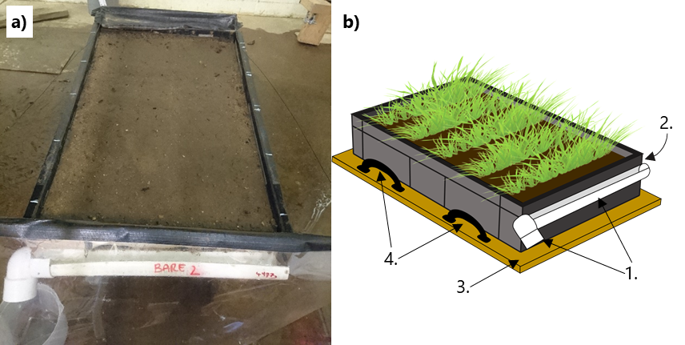
The mesocosms were constructed out of 21 litre plastic containers (Euro Container ref. 9230001, Schoeller Allibert Ltd, UK), with internal dimensions of 55.5 cm length x 3.6 cm width x 11.5 cm height (Figure 1). Drainage holes were drilled in the base in a 5 cm grid to aid drainage during growth. The top 2.5 cm of the front edge was removed (Figure 1a) so that the surface of the soil would be above the edge of the plastic, with 1.5 cm leeway, to remove any obstacles to drainage. The detached section was temporarily re-attached during the growth stage to maintain the front edge of the soil profile.
Figure 1. Mesocosms under the rainfall simulator with the cover over the outlet drainpipe and the collection container (a) and a schematic of the boxes (b) showing; 1. Gutter and 90° bend spout, 2. Removable box section that is kept in place during the growth stage to support the soil, 3. Plywood base for reinforcement and 4. Lifting handles.

Guttering was constructed out of 40 mm pipe with a 90° bend, which was solvent welded to one end and affixed to the box with small nuts and bolts, silicone sealant was used to prevent leakage. The whole box was then affixed to a piece of 18 mm thick marine plywood, cut with corresponding drainage holes and oversized to allow handles to be attached to either side of the box. The plywood and handles were necessary to minimise any disturbance to the soil structure whilst moving the mesocosms.
The mesocosms had a layer of 20 mm gravel lining the bottom to aid drainage and then filled with a sandy loam textured top soil (Bailey’s of Norfolk LTD; 12% clay, 28% silt, 60% sand and 3% gravel D50 6 mm, no particles greater than 8 mm). The soil was packed to a bulk density of 1.4 g cm^{–3} and filled in 3 cm increments and scouring the surface of each layer to achieve a uniform profile .
The experiment consisted of three treatments, a barley root hairless mutant, its WT, and an unplanted control. Due to time and growth space constraints, these three treatments were grown in four blocks (one of each treatment per block). Each block was prepared, watered, and exposed to simulated rainfall at the same time. The mesocosms were kept in a walk-in controlled environment room set at 24 °C during the day and 19 °C at night with a 12 hour photoperiod. To limit any effect of climatic variation in the walk-in controlled environment room, all three treatments per block were grown adjacent to each other in a random order. While regular spatial rotation of the mesocosms would have been preferable, they were too heavy and fragile to move repeatedly.
The barley root hairless mutant (brb – bald root barley) is a spontaneous mutation with its genetic background in Pallas, a spring barley cultivar. Seeds were germinated directly in the soil. Five trenches were dug laterally across each mesocosm, approximately 1 cm deep, and spaced at 11.5 cm intervals. Assuming an 80 % germination rate, 12 seeds were planted per row to achieve a density of 245 seeds m⁻². The trenches were then filled in and the surface smoothed over and wetted. For continuity, this process was also carried out on the unplanted mesocosms (minus the seeds). Each mesocosm was watered until a film of water appeared on the surface, using a watering can with a spray rose attached, every 2−3 days for 35 days until harvest. This was sufficient water for the barley to grow, any more resulted in excessive movement of surface soil.
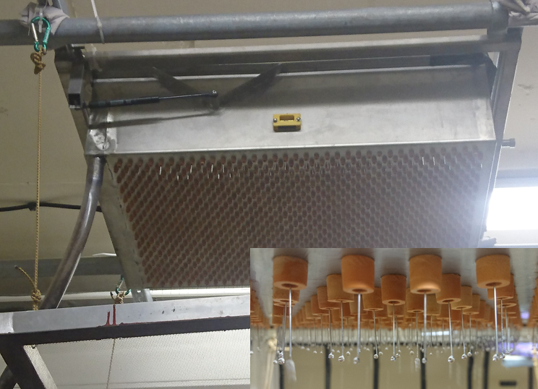
Figure 2. Gravity-fed rainfall simulator and the mesh hanging below with a close up of the droplets on the needle points.

Rainfall simulator
This experiment used a gravity-fed rainfall simulator (Armstrong et al., 2012), approximately 3 m above the mesocosm surface (Figure 2). The simulator consisted of 958 hypodermic needles (25G x 25 mm, BD Microlance™ 3, Fisher Scientific, UK) in 27 staggered rows of 35 and 36 needles in a grid 47.25 x 72.00 cm, producing a rainfall rate of approximately 23 mm h^{–1} (CU = 86.6). A 2 mm mesh was suspended approximately 20 cm below the needles to disperse the water droplets and make them less uniform in size and distribution on the mesocosm surface. The simulator was run with tap water and there is a weir and outlet pipe in the chamber above the needles to ensure a consistent water pressure through the needles.
The day before harvest, the mesocosms were left standing in approximately 5 cm of water overnight to pre-wet from the base to achieve a consistent soil water content. Soil moisture measurements, made using a soil moisture probe (HH2 Moisture Meter with a ML3 probe, Delta-T Devices Ltd), before each experiment proved that this method was effective (WT = 33.8 ± 1.0 %, brb = 33.1 ± 0.9 %, and unplanted = 32.5 ± 1.2 %; p = 0.208), however, there was a significant block effect (p < 0.01) on soil moisture content (ANOVA table can be found in supplementary material). The rainfall simulator was turned on 1−2 hours before the experiment, to give time for the needle reservoir chamber to fill. The shoots and leaves were removed with care so as not to disturb the surface soil immediately prior to each test. Any large gaps (approx. > 3 mm) which formed as a result of soil shrinkage or movement of the temporary barrier were filled with plumber’s putty (Plumbers Mait, Evo−Stik, UK), this also served to reinforce the front edge of the soil, preventing it from slumping.
Each mesocosm was then placed on a 6 % slope under the rainfall simulator for 1 hour. Sediment and runoff were continually collected in a beaker: at 5 minute intervals the contents of the gutter was washed into the beaker using a measured amount of water from a 60 ml syringe and the beaker replaced with an empty one. The beaker contents were weighed and then washed into a metal tray to be dried in an oven at 105 ℃.

Statistical analysis
The amount of erosion for each interval was equal to the weight of the dry soil collected in the container every 5 minutes and is displayed as soil detachment rate (SDR). The amount by which the presence of roots reduced the quantity of eroded soil in comparison to their respective unplanted mesocosms (relative soil detachment reduction rate, RSDR) is calculated as a percentage decrease from the unplanted mesocosms:
$$RSDR=\left(\frac{E_{c}-E_{r}}{E_{c}}\right)×100$$
where $E_{c}$ is the sum of the erosion from the control unplanted mesocosm and $E_{r}$ is the sum of the erosion from the rooted mesocosm, RSDR was calculated for each of the four replicates.
The amount of runoff was calculated from the weight of the beaker’s initial content, minus the weight of soil and beaker. Sampling the roots from the whole mesocosms was impractical so roots were harvested from the top 1.5 cm using a modified guillotine, as this was easily accessible due to the removable front section of the mesocosm. The roots were washed out of the soil, stored in a 50 % ethanol and DI water solution and kept at approximately 4 ℃ until they were measured. The roots were then scanned at 600 DPI using an Epson expression 11000 XL pro scanner, analysed using WinRHIZO (2013a Pro, Regent, Canada). Root length density (RLD) was calculated as follows:
$$RLD=\frac{RL}{V_{s}}$$
where RL is the total length of live roots (cm) and $V_{s}$ is the volume of soil sampled (cm³). Root surface area density was similarly calculated:
$$RSAD=\frac{\left(πD\right)×RL}{V_{s}}=\frac{RSA}{V_{s}}$$
where D is the diameter (cm) of the root and RSA is the root surface area (cm²) is under the assumption that the root is cylindrical. Percentage of fine roots is calculated using the diameter threshold described by Burak (2019). Pearson’s Correlation and ANOVA were used to assess the root data and two-way ANOVA was used to assess the amounts of erosion and runoff produced as well as the soil water content of the mesocosms. Linear relationships between RLD and RSDR for both brb and WT were assessed by ANCOVA. Full ANOVA tables can be found in supplementary material. 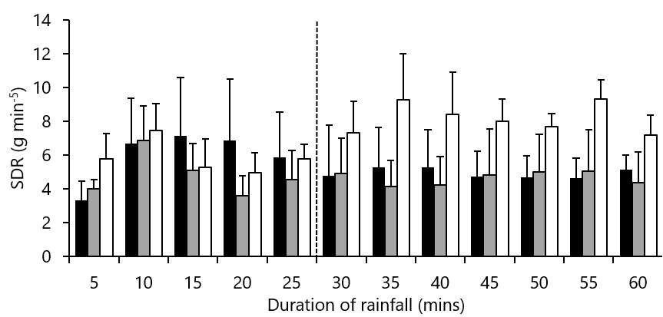
Figure 3. Erosion per each 5 minute interval. The solid black bars = brb, grey bars = WT and the white bars = unplanted. The dashed line depicts the threshold where erosion from unplanted mesocosms begins to consistently surpass those of rooted mesocosms. Bars are means + SE of 4 replicates.

Results

Erosion
The impact of roots on soil detachment rate (SDR) was initially delayed (Figure 3). Since it took 25 minutes of rainfall for the mean of the unplanted mesocosms to exceed that of both the rooted treatments, 25 minutes was taken as the threshold for root impact. The mean total amount of erosion produced in the first 25 mins, before roots became influential, was 29.3 ± 4.6 g for unplanted, 29.9 ± 13.1 g for brb and 24.1 ± 5.7 g for WT mesocosms. Assuming erosion occurred uniformly across the mesocosms, this would equate to an average eroded depth of 0.10 ± 0.01 mm across all treatments. Due to the lack of discernible root influence during the first 25 minutes, these data are discarded from further analysis of erosion rates.
In the subsequent 35 minutes, there was a significant treatment affect (p < 0.05) and a significant block effect (p < 0.01). The rooted mesocosms produced the least mean total erosion (32.6 ± 14.4 g and 34.5 ± 11.8 g for WT and brb, respectively) in comparison to the unplanted mesocosms (57.1 ± 10.4 g). These results equate to reductions in SDR associated with plant roots of 44.0 ± 16.8 % for WT and 40.7 ± 10.8 % for the brb. However, although both rooted treatment consistently produced less erosion than their respective unplanted mesocosms, only the reduction from the WT mesocosms were significant (p < 0.05 and p = 0.067 for WT and brb, respectively).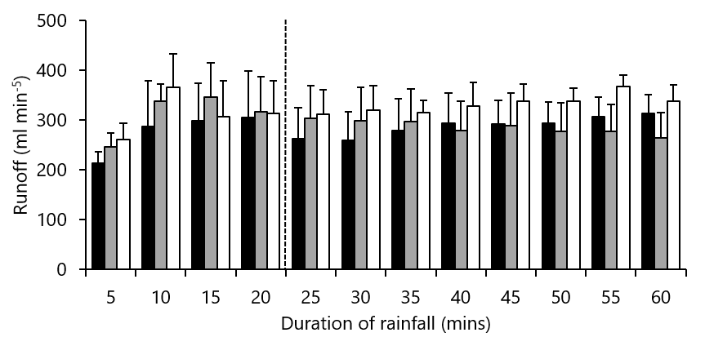
Figure 4. Runoff per each 5 minute interval. The solid black bars = brb, grey bars = WT and the white bars = unplanted. The dashed line depicts the threshold where erosion from unplanted mesocosms begins to consistently surpass those of rooted mesocosms. Bars are means + SE of 4 replicates.

Runoff
Unlike erosion rates, runoff rates were much less susceptible to temporal fluctuations. After a brief peak 10 minutes into the experiment, the runoff rates remained relatively steady for the rest of the hour (Figure 4). However, total runoff and erosion (for the whole hour of rainfall) were significantly positively correlated (R = 0.82, p < 0.05). As with erosion rates, there was a delay in the observable difference between rooted and unplanted mesocosms. The mean of the unplanted mesocosms consistently exceeded both the rooted treatments after the first 20 minutes of rainfall, in comparison to the first 25 minutes with erosion rates. The runoff from both unplanted and brb mesocosms seemed to increase over time but runoff from WT mesocosms appears to decrease over time. In the last 40 minutes of the experiment, runoff from WT (2.29 ± 0.48 L) and brb (2.30 ± 0.39 L) mesocosms was less than unplanted mesocosms (2.66 ± 0.27 L) by 14.6 ± 5.5 % for brb and 11.8 ± 7.5 % for WT. However, unlike with erosion, there was no significant treatment effect across the blocks (p = 0.24), though there was a significant block effect (p < 0.01).

Root parameters
There were genotypic differences in some of the root traits. Wild type root systems had a significantly greater average diameter than the brb root systems (18.6 %, p < 0.05). This difference in average diameter is most likely driven by the significant difference in percentage of fine roots (p < 0.01), in WT fine roots made up 11.3 % less of the root system than in brb. Other root traits differed but not significantly. For example, for each block, WT produces less root length density (RLD) than their respective brb, resulting in a mean RLD more than twice that of WT (2.2-fold greater), in the top 1.5 cm of the mesocosms, though overall these differences were not statistically significant. Table 2 illustrates that all measured root parameters were auto-correlated. However, although all the measured root parameters were positively correlated with relative soil detachment rate (RSDR) for brb (Table 3), except percentage fine roots which were negatively correlated, only RLD was significantly correlated with RSDR for both WT and brb.
Compared to the unplanted mesocosms, less soil was detached as RLD increased in both genotypes (Figure 5). For each unit increase in RLD equates to and extra 14 % reduction in eroded soil in comparison the unplanted mesocosms. WT roots appeared to be more effective than brb roots at reducing erosion (in comparison to unplanted soil) as RLD increased, although the interaction between RLD and genotype was not significant (p = 0.06).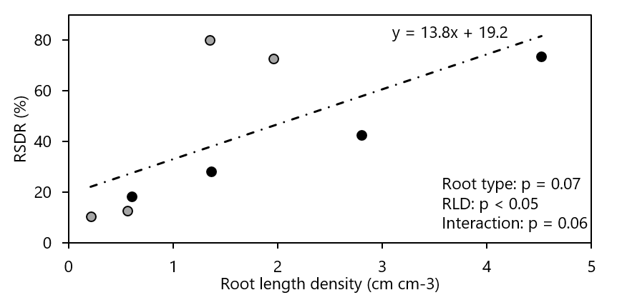
Figure 5. Linear relationships between root length density (RLD) and relative soil detachment rate (RSDR) for both brb (black markers) and WT (grey). There was no genotypic effect so a single regression line was fitted to pooled WT and mutant data. A 50 % RSDR means that the planted mesocosm produced half as much erosion as the unplanted mesocosms, whereas a 0 % RSDR would mean it produced the same amount. P values are from ANCOVA.

Discussion
The initial delay of 25 minutes before a root effect on erosion (Figure 3) is likely due to the presence of easily eroded surface soil (Armstrong & Quinton, 2009). In the subsequent period of rainfall, both brb and WT roots reduced erosion similarly, but only WT roots significantly reduced soil detachment compared to the unplanted treatment. Since the thicker roots and lower percentage of fine roots in WT plants should have resulted in increased soil erosion (Burylo et al., 2012), the lack of genotypic differences suggests an important role of root hairs in erosion mitigation.
Roots are known to reduce runoff by increasing the amount of water able to penetrate the soil, either by lowering the soil water content through evapotranspiration or physically increasing infiltration by increasing either soil porosity (Stokes et al., 2009) or hydraulic conductivity (Carminati, 2013). To eliminate potential effects of evapotranspiration and porosity, the soil was intentionally saturated before initiating the simulated rainfall. As there was no genotypic differences in runoff rates it can be assumed that WT and brb root systems had similar impact on soil porosity and hydraulic conductivity.
Consistent with previous studies (Bui & Box, 1993; Ghidey & Alberts, 1997; Mamo & Bubenzer, 2001; De Baets et al., 2006), the presence of roots consistently decreased soil loss from both rooted treatments compared to the unplanted mesocosms (Figure 3). However, the effect of root hairs on erosion cannot be assessed in isolation of the differences in other root traits (such as root length density, diameter, and percentage of fine roots– Table 2).
Increased root length density (RLD) is one of the most recognised traits by which a root system can mitigate erosion (Bui & Box, 1993; Ghidey & Alberts, 1997; Mamo & Bubenzer, 2001; De Baets et al., 2006). While RLD and relative soil detachment rate (RSDR) were correlated, genotypic differences in RLD were not significant (Figure 5). Like RLD, root diameter is positively correlated with erosion rates and percentage of fine roots negatively correlated with erosion rates (Burylo et al., 2012), therefore differences in average root diameter and percentage of fine roots in a root system also impact a root systems ability to reduce erosion. Thus, brb root systems with significantly smaller diameter roots (0.8-fold) and with significantly greater percentage of fine roots (1.1-fold) than WT, should have been more effective at reducing erosion than WT. This was not the case and it is hypothesised that the presence of root hairs may have compensated for the thicker roots and less abundant fine roots of the WT root systems; explaining why there was no difference between the soils eroded from the WT mesocosms than the brb mesocosms. However, more replication and/or a greater range of root length densities is needed to adequately test this hypothesis.

Conclusion
In the absence of above-ground plant matter, this study showed that root systems with and without root hairs can reduce soil erosion, and increasing root length density clearly enhanced this effect. The impact of root hairs, however, was less clear. Barley brb root systems had a significantly thinner root diameters and higher percentage of fine roots, traits associated with erosion reduction and suggesting that brb (without root hairs) should reduce erosion more than WT (with root hairs). However, mesocosms permeated with brb root and WT roots eroded to a similar degree suggesting that the presence of root hairs on WT may have increase soil resistance to erosion, although further work is required to test this hypothesis.

Acknowledgements
This work was supported by a Soils Training and Research Studentship (STARS) grant from the Biotechnology and Biological Sciences Research Council and the Natural Environmental Research Council [Grant number NE/M009106/1 to E.B.]. STARS is a consortium consisting of Bangor University, British Geological Survey, Centre for Ecology and Hydrology, Cranfield University, James Hutton Institute, Lancaster University, Rothamsted Research, and the University of Nottingham.

Data availability statement
The data that support the findings of this study are available from the corresponding author upon reasonable request.

References
Acostasolis, M. 1947. The Soil Erosion in the Agricultural Highlands of Ecuador and Suggestions for Their Protection by Appropriate Plants, Principally by Setaria Cernua Hbk. American Journal of Botany, 34, 608–608.
Armstrong, A. & Quinton, J.N. 2009. Pumped rainfall simulators: the impact of rain pulses on sediment concentration and size. Earth Surface Processes and Landforms, 34, 1310–1314.
Armstrong, A., Quinton, J.N. & Maher, B.A. 2012. Thermal enhancement of natural magnetism as a tool for tracing eroded soil. Earth Surface Processes and Landforms, 37, 1567–1572.
Borrelli, P., Robinson, D.A., Fleischer, L.R., Lugato, E., Ballabio, C., Alewell, C., Meusburger, K., Modugno, S., Schütt, B., Ferro, V., Bagarello, V., Oost, K.V., Montanarella, L. & Panagos, P. 2017. An assessment of the global impact of 21st century land use change on soil erosion. Nature Communications, 8, No. 2013.
Brown, L.K., George, T.S., Neugebauer, K. & White, P.J. 2017. The rhizosheath: A potential trait for future agricultural sustainability occurs in orders throughout the angiosperms. Plant and Soil, 418, 115–128.
Bui, E.N. & Box, J.E. 1993. Growing corn root effects on interrill soil erosion. Soil Science Society of America Journal, 57, 1066–1070.
Burak, E. 2019. The influence of root traits on soil reinforcement and erosion mitigation. PhD, Lancaster University.
Burylo, M., Rey, F., Mathys, N. & Dutoit, T. 2012. Plant root traits affecting the resistance of soils to concentrated flow erosion. Earth Surface Processes and Landforms, 37, 1463–1470.
Carminati, A. 2013. Rhizosphere wettability decreases with root age: a problem or a strategy to increase water uptake of young roots? Frontiers in Plant Science, 4, (At: https://www.ncbi.nlm.nih.gov/pmc/articles/PMC3742997/. Accessed: 28/11/2017).
Czarnes, S., Hiller, S., Dexter, A.R., Hallett, P.D. & Bartoli, F. 1999. Root:soil adhesion in the maize rhizosphere: the rheological approach. Plant and Soil, 211, 69–86.
De Baets, S., Poesen, J., Gyssels, G. & Knapen, A. 2006. Effects of grass roots on the erodibility of topsoils during concentrated flow. Geomorphology, 76, 54–67.
Dodd, I.C. & Diatloff, E. 2016. Enhanced root growth of the brb (bald root barley) mutant in drying soil allows similar shoot physiological responses to soil water deficit as wild-type plants. Functional Plant Biology, 43, 199.
Ennos, A.R. 1989. The mechanics of anchorage in seedlings of sunflower, Helianthus annuus L. New Phytologist, 113, 185–192.
Ghidey, F. & Alberts, E.E. 1997. Plant root effects on soil erodibility, splash detachment, soil strength, and aggregate stability. Transactions of the ASAE, 40, 129–135.
Gilroy, S. & Jones, D.L. 2000. Through form to function: root hair development and nutrient uptake. Trends in Plant Science, 5, 56–60.
Gyssels, G. & Poesen, J. 2003. The importance of plant root characteristics in controlling concentrated flow erosion rates. Earth Surface Processes and Landforms, 28, 371–384.
Keyes, S.D., Daly, K.R., Gostling, N.J., Jones, D.L., Talboys, P., Pinzer, B.R., Boardman, R., Sinclair, I., Marchant, A. & Roose, T. 2013. High resolution synchrotron imaging of wheat root hairs growing in soil and image based modelling of phosphate uptake. New Phytologist, 198, 1023–1029.
Laflen, J.M., Elliot, W.J., Simanton, J.R., Holzhey, C.S. & Kohl, K.D. 1991. WEPP: Soil erodibility experiments for rangeland and cropland soils. Journal of Soil and Water Conservation, 46, 39–44.
Li, Y., Zhu, X.M. & Tian, J.Y. 1991. Effectiveness of plant roots to increase the anti-scourability of soil on the Loess Plateau. Chinese Science Bulletin, 36, 2077–2082.
Mamo, M. & Bubenzer, G.D. 2001. Detachment rate, soil erodibility, and soil strength as influenced by living plant roots part I: Laboratory study. Transactions of the ASAE, 44, 1167.
McCully, M. 2005. The rhizosphere: The key functional unit in plant/soil/microbial interactions in the field. Implications for the understanding of allelopathic effects. pp. 43–49. Centre for Rural Social Research, Charles Sturt University.
Pang, J., Ryan, M.H., Siddique, K.H.M. & Simpson, R.J. 2017. Unwrapping the rhizosheath. Plant and Soil, 418, 129–139.
Posthumus, H., Deeks, L.K., Rickson, R.J. & Quinton, J.N. 2015. Costs and benefits of erosion control measures in the UK. Soil Use and Management, 31, 16–33.
Prosser, I.P., Dietrich, W.E. & Stevenson, J. 1995. Flow resistance and sediment transport by concentrated overland flow in a grassland valley. Geomorphology, 13, 71–86.
Quinton, J.N., Govers, G., Van Oost, K. & Bardgett, R.D. 2010. The impact of agricultural soil erosion on biogeochemical cycling. Nature Geoscience; London, 3, 311–314.
Rasse, D.P., Rumpel, C. & Dignac, M.-F. 2005. Is soil carbon mostly root carbon? Mechanisms for a specific stabilisation. Plant and Soil, 269, 341–356.
Shit, P.K. & Maiti, R. 2012. Effect of plant roots on soil anti-scouribility of topsoil during concentrated flow. International Journal of Engineering Research, 1, 8.
Singer, M., Blackard, J. & Huntington, G. 1980. Plant cover helps control rangeland soil-erosion. California Agriculture, 34, 8–10.
Stokes, A., Atger, C., Bengough, A.G., Fourcaud, T. & Sidle, R.C. 2009. Desirable plant root traits for protecting natural and engineered slopes against landslides. Plant and Soil, 324, 1–30.
Tengbeh, G.T. 1993. The effect of grass roots on shear strength variations with moisture content. Soil Technology, 6, 287–295.
Verheijen, F.G.A., Jones, R.J.A., Rickson, R.J. & Smith, C.J. 2009. Tolerable versus actual soil erosion rates in Europe. Earth-Science Reviews, 94, 23–38.
Wasson, A.P., Richards, R.A., Chatrath, R., Misra, S.C., Prasad, S.V.S., Rebetzke, G.J., Kirkegaard, J.A., Christopher, J. & Watt, M. 2012. Traits and selection strategies to improve root systems and water uptake in water-limited wheat crops. Journal of Experimental Botany, 63, 3485–3498.
Watt, M., McCully, M.E. & Canny, M.J. 1994. Formation and stabilization of rhizosheaths of Zea mays L.: Effect of soil water content. Plant Physiology, 106, 179–186.
White, R.G. & Kirkegaard, J.A. 2010. The distribution and abundance of wheat roots in a dense, structured subsoil – implications for water uptake. Plant, Cell & Environment, 33, 133–148.
Wulfsohn, D. & Nyengaard, J.R. 1999. Simple stereological procedure to estimate the number and dimensions of root hairs. Plant and Soil, 209, 129–136.
Zhou, Z.C. & Shangguan, Z.P. 2007. The effects of ryegrass roots and shoots on loess erosion under simulated rainfall. CATENA, 70, 350–355.
Zhou, Z.-C. & Shangguan, Z.-P. 2008. Effect of ryegrasses on soil runoff and sediment control. Pedosphere, 18, 131–136.

Tables

Table 1. Summary statistics for the measured root parameters. RLD = root length density, RSAD = root surface area density. Data are means ± SE of 4 replicates. P values are from ANOVA, full ANOVA tables can be found in the supplementary information tables 4 to 8.
 | Averages
 | brb | WT | P value
Diameter (mm) | 0.188 ± 0.012 | 0.223 ± 0.005 | 0.035
Fine roots (%) | 89.39 ± 2.01 | 79.37 ± 1.52 | 0.007
RLD (cm cm⁻³) | 3.37 ± 1.25 | 1.48 ± 0.57 | 0.220
RSAD (cm² cm⁻³) | 0.13 ± 0.04 | 0.07 ± 0.03 | 0.287
Volume (cm³) | 1.68 ± 0.49 | 1.13 ± 0.40 | 0.415

Table 2. A list of Pearson’s Correlation Coefficients for all measured root parameters. RLD = root length density, RSAD = root surface area density.
* = p < 0.05, ** = p < 0.01, *** = p < 0.001.
 | Diameter  (mm) | Fine roots  (%) | RLD  (cm cm⁻³) | RSAD  (cm² cm⁻³)
Fine roots (%) | −0.96***
RLD (cm cm⁻³) | −0.91** | 0.82*
RSAD (cm² cm⁻³) | −0.87** | 0.79* | 0.99***
Volume (cm³) | −0.80* | 0.73* | 0.95*** | 0.98***

Table 3. Pearson’s Correlation coefficients between the measures root parameters and RSDR. RLD = root length density, RSAD = root surface area density.
* = p < 0.05, ** = p < 0.01.
 | brb | WT
Diameter (mm) | -0.86 | -0.89
Fine roots (%) | 0.82 | 0.82
RLD (cm cm⁻³) | 0.99** | 0.97*
RSAD (cm² cm⁻³) | 1.00** | 0.90
Volume (cm³) | 0.99** | 0.92

