Communicating the Value of Design Research
Joseph Lindleyª, David Philip Greenª, Mayane Doreª, Zach Masonª, Claire Coultonª, Arne Berger^{b}, Miriam Sturdeeª
ªLancaster University, United Kingdom
^{b}Hochschule Anhalt University of Applied Sciences, Germany
*Corresponding author e-mail: j.lindley@lancaster.ac.uk
https://doi.org/10.21606/drs.2022.888
Abstract: The overarching theme for this Conversation was How can we communicate the value of Design Research? This was accompanied by the more specific question, How we can get Design Research into ‘Research Methods 101’? At the Conversation, which was attended by approximately 30 participants, five groups were formed, and a ‘Question Bridge’ format was adopted to explore these themes—a structure which uses question and answers pairs to explore challenges and mitigation strategies around the theme. The Question Bridge exercise demonstrated that there are clear divisions and contrasting perspectives in the Design Research community. The subsequent plenary discussion showed that while divisions are evident, any disruption caused by the lacking consensus can be straightforwardly mitigated by acknowledging contrasts and adopting deliberate communication strategies to clarify them.
Keywords: design research, communication, epistemology, question bridge

1. Context
The session is being convened by a team who all contribute to Design Research Works. Design Research Works is a 4-year project that aims to gather evidence about and promote the value of Design Research. The proposed Conversation is part of a programme of workshops and other events running throughout 2022 that are all intended to engage the Design Research community and draw upon their expertise to support the goals of Design Research Works (see 1.4 Question Bridges and the Conversation So Far for a brief discussion of related initiatives). This Conversation specifically seeks to contribute to these aims by exploring strategies for Communicating the Value of Design Research.

1.1 The Importance of Design Research
Design Research is one of our most powerful and versatile tools for both shaping and making sense of our rapidly changing world (Sudjic, 2009). It sheds light on “complex social, environmental and cultural challenges” (Rodgers, Francesco and Conerney, 2019) both through the “material world” but also “less tangible domains such as service, interaction and transformation design” (Cooper, 2014). Across systemic issues like climate change, the impact of AI and other emerging technologies, to prevailing inequalities, injustices and health crises, Design Research can be leveraged in myriad ways to critically explore and respond to the 21st century’s complex and interdependent challenges (Cooper et al., 2018). It can achieve this through a variety of practices, methods, and perspectives, including (but not limited to) Research through Design, Critical Design, Speculative Design and Participatory Design. The optimism surrounding Design Research is based on the premise that these tools are excellent facilitators of change, helping us to acknowledge the past, apprehend the future, and focus these lenses on the material concerns of the present; “Design research is a creative and transformative force that can help to shape our lives in more responsible, sustainable, meaningful, and valuable ways” (Rodgers, 2020).

1.2 The Diversity of Design Research Practice
Notwithstanding its growth and success, the assertion that Design Research is “pre-paradigmatic” (Gaver, 2012) remains true, with contemporary scholars grappling to define archetypes, typologies, and taxonomies for Design Research (e.g., Pierce, 2021). The impact of this pre-paradigmatic character is that much effort is spent on inward discussions relating to the field’s still-maturing epistemologies, methods, and conventions (Durrant et al., 2017), meanwhile reducing the scope of the field’s potential impact. The panoply of methods that Design Researchers utilise, the diverse—and usually interdisciplinary—skills which they draw upon, and the broad scope of impact, are factors that make the Design Research field one defined by its heterogeneity (Lindley and Coulton, 2020). This heterogeneity is what makes Design Research so powerful, but it also makes it difficult to break free from the pre-paradigmatic mould. The practical impacts of this are evident through the disappearance of otherwise exemplary Design Research projects into “liminal” spaces between disciplines (Green and Kirk, 2018) and a plethora of initiatives that “do not self-describe in a way that makes them discoverable as examples of Design Research” (Lindley and Coulton, 2020). We note that encouraging diversity (e.g., in terms of geographic and cultural backgrounds) among the attendees of the Conversation will enhance our ability to capture the pluriversality of Design Research and ultimately strengthen and triangulate the insights which we seek to capture. Notwithstanding the relative homogeneity of the conveners, we will proactively seek to ensure diversity across those in attendance.

1.3 Design Research Could be More Ubiquitous in the Future
This proposal builds on the assertion that the world needs the unique perspectives Design Research can offer. Moreover, we recognise that while Design Research is ‘alive and kicking’, for newcomers to the field value of Design Research, the distinction between epistemologies, methods, and applications can be hard to disentangle (Green and Lindley, 2021). From this position, we wish to explore the possible future of the field and consider what actions would lead Design Research to becoming more ubiquitous. It is this endeavour which frames our research questions.

1.4 Question Bridges and the Conversation so Far
This Conversation event built on existing initiatives, both of which also leveraged the Question Bridge concept. Our interpretation of this concept was inspired by the 2012 film Question Bridge. In the film, black males ask question, which are then posed to other black men, who in turn ask their own question. In early 2021 we aspired to use answer and question pairs in the same way, to delve into contemporary concerns and issues relating to the Design Research landscape.
Due to the Covid-19 pandemic we had to establish a way to do this while respecting lockdown arrangements. Our approach was to design an Interview Box which could be capture broadcast-quality interviews remotely, we have published papers describing both the process (Green and Lindley, 2022) and outcomes (Green and Lindley, 2021) of those interviews, as well as a short film summarising the insights (see https://vimeo.com/597226068). Key among those findings was the inherent ambiguity of the Design Research field, and ambiguity that is constructed of a complex, contested and interdisciplinary space made up of diverse and interdisciplinary individuals.
In addition to the ‘Interview Box’ approach, in parallel we launched an online-only community-driven version of the same initiative, codenamed QuBr (see https://qubr.designresearch.works). QuBr is an abbreviation of Question Bridge that employed to try and avoid any confusion with the 2012 film also a homonym for the central American country Cuba, whose name is said to refer to rich and fertile lands (which, metaphorically, we liken to the Design Research landscape we are interested with). The QuBr project is ongoing, the library of question/answer pairs is growing, and the scope of topics concerned with advancing the Design Research community’s interests grows with it. The focus of this DRS2022 Conversation came from one of the questions generated through the QuBr platform. That question was How can we get Design Research into ‘Research Methods 101’? (see https://qubr.designresearch.works/bridge-explorer/view-video/89).
Notwithstanding Design Research’s huge growth and success, this question is a proxy for the fact the field and community is still, relative to other stances, a niche. If Design Research and its constituent practices such as Speculative Design are to become part of the mainstream (cf. Lindley and Green, 2021), then it is necessary to understand why it is not currently part of introductions to research. Hence, we organised this DRS 2022 Conversation to dive deeply into this issue using the Question Bridge structure as an organising principle for the 2-hour session.

1.5 Structure and Details of the Session
The Conversation took place on Thursday 30th June 2022 and lasted for two hours. There were approximately 32 people in the room and an additional 6 online participants. Extracts of the online conversation were relayed to the room via one of the organising team at key points. The session began with roughly 30 minutes of introduction, primarily focusing on the rationale for the Conversion.
The introduction was followed by a 10-minute exercise where participants were invited—without any need for in-depth discussion—to share one-sentence statements articulating aspects of Design Research that they ‘love’ and/or ‘hate’. For example, one participant said, “The thing I love about design research is that it leads to unpredictable outcomes”, which was quickly followed with the next participant saying, “The thing I hate about design research is that it makes it hard to be strategic and organised”. The purpose of this exercise was to underline the aspiration for the Conversation to be open and inclusive. By inviting quick-fire comments on Design Research in this style, we hoped to follow up our verbal request that the discussions be as open as possible (which was mentioned in the introduction) by showing participants what this felt like and looked like in practice.
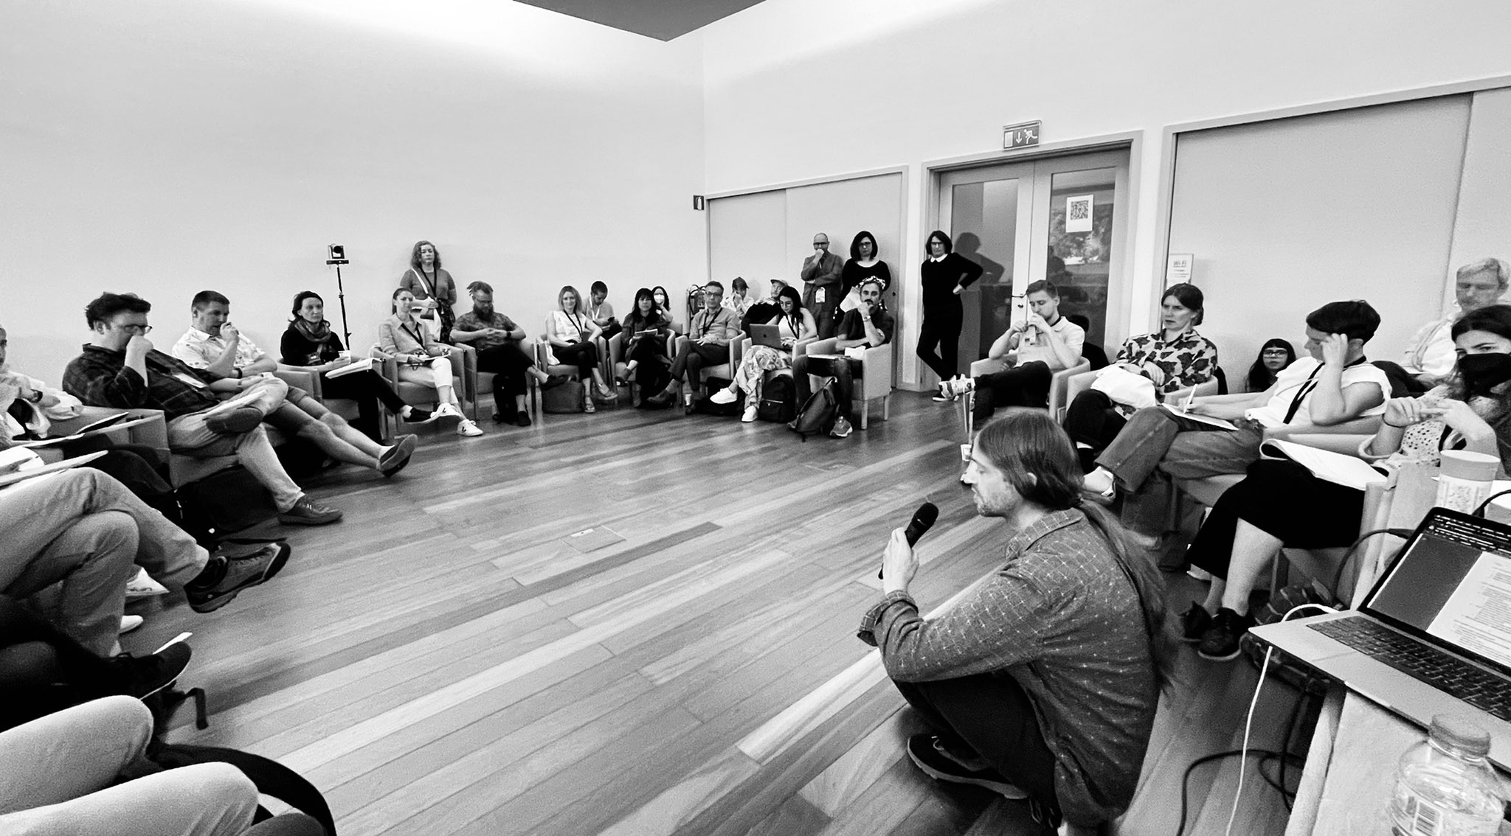
Figure 1 The room arranged with participants sitting in a circle for the introductory sections.
At this point everyone in attendance broke into smaller groups for more focused discussions. We asked that these discussions aligned with the QuBr concept. Hence, every group began with the same question—How can we get Design Research into ‘Research Methods 101’?—using worksheets (see Figure 2), the groups were asked to provide tentative answers to the question, as well as generating follow-up questions. The process was then repeated with those follow-up questions generating around 30 answer and question pairs.
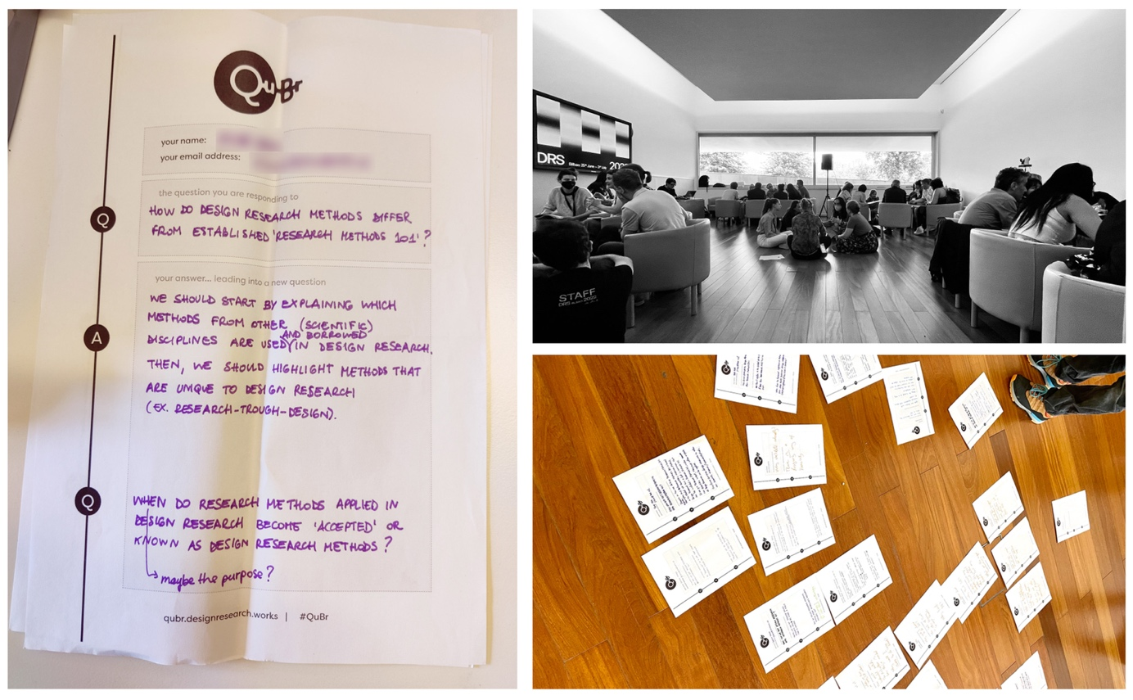
Figure 2 Example QuBr worksheet (left), group work in progress (top right), plenary discussion around completed worksheets (bottom right).
In the final 15 minutes of the session a plenary discussion took place with some commentary provided by each group and with a review of the Question Bridges captured on the worksheets.

2. Content of the Conversation
In this section we provide a commentary on some of the answers, questions, and discussions emerged from asking How can we get Design Research into ‘Research Methods 101’?

2.1 Is Design Research a ‘field’ or a ‘method’ and what is the consequence of the answer?
One answer proffered to the question about getting Design Research into Research Methods 101 was the suggestion that “Maybe, we can not” (see Figure 3) because Design Research is a field and not a method. Hence, arguably, striving for Design Research to appear in a methods book would be folly.
To unpack some aspects of this query, it seems fair to say that there is a Design Research community, in part comprised of the people who attend events like the DRS conference. That community is made up of individuals united by participating in the same field (where ‘field’ refers to a particular sphere of interest). The relationship between that field and the methods it uses, or indeed the methodological traditions it identifies with, is not straightforward, however (see figure 4, top).
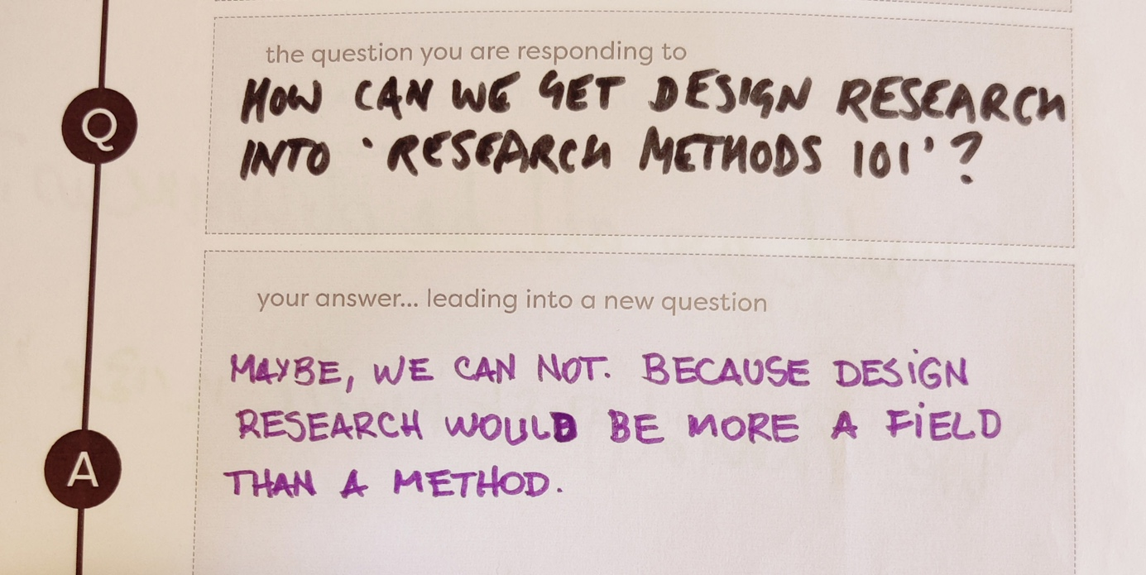
Figure 3 Maybe, we cannot (or should not try to) get Design Research into methods textbooks, because it’s a field not a method.
For example, a specific Design Research project may employ quantitative or qualitative methods (see Figure 5, right) that are used by wide ranges of disciplines (e.g., surveys or ethnography) to understand some aspect of what Design is or how it acts in the world. In this scenario the reason the work identifies as Design research (as opposed to some other kind of research) is that the findings are relevant for the world of Design. Per Frayling’s popular typology this would be termed Research into Design (1993).
In another example, however, a different Design Research project may employ a method such as Speculative Design to understand something about that world that is, in and of itself, nothing to do with Design or how it acts in the world. In this scenario the reason the work identifies as Design research is that the method is one that is grounded in a Design process, even though the findings may be most relevant for a policy analyst rather than a Designer. Frayling’s typology would describe this as Research through Design (ibid). One participant described these as methods that are ‘unique to Design Research’ (see Figure 4, bottom).
We can complicate matters further by imagining research is conducted using some other method to support the actual design of a thing (e.g., a focus group with potential users). Frayling would call this Research for Design. Such research is frequently part of other projects. Hence, it is entirely possible that—referring to examples above—the Research for Design using focus groups is done to support a Research through Design process using Speculative Design which is part of a larger project which also includes some Research into Design using a survey method.
So, would it make sense to include a section on Design Research in Research Methods 101 or in a textbook introducing Research Methods? Taken literally, perhaps not. However, perhaps it would make sense to include a section discussing Design Research Methodology. The distinction being that a method usually refers to a single technique or strategy (from the examples above, Speculative Design, Focus Group, Survey, or Ethnography), whilst methodology is the study and analysis of those methods. A section on Design Research Methodology—in ‘Design Methods 101’—would help clarify the difference between methods that have emerged from the practice Design Research field (e.g., Research through Design) and how the Design Research field uses other methods to either support Design processes (Research for Design) or to understand Design itself (Research into Design).
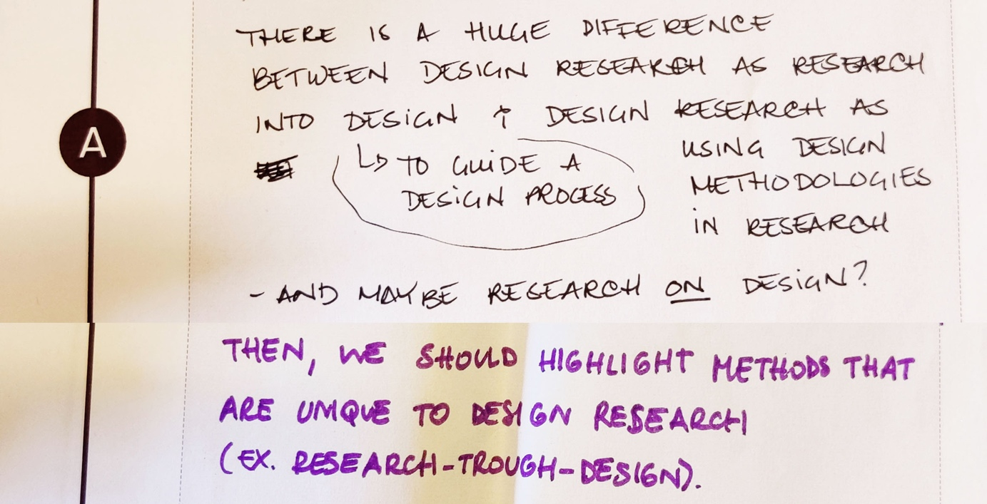
Figure 4 Complementary notes exploring the nuances within the term Design Research (see figure 2 for the full version of the bottom example).

2.2 Is there no such thing as ‘Design Research’ Methods?
In a relation discussion the question What methods are there that are specifically Design Research Methods? resulted in a range of discussions. One response proposed that there are in fact very few categories of Research Method. These methods correlate to even fewer underlying epistemological families, e.g., positivism, interpretivism, empiricism, etc. Through this lens, the factor differentiating Design Research from non-Design Research is simply about the context within which the methods are executed, e.g., a context where the findings will be relevant for Design in some way or other.
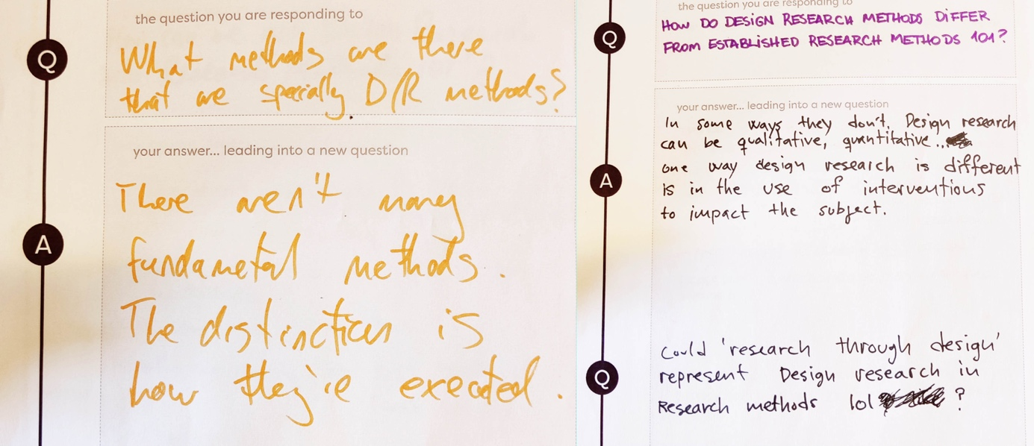
Figure 5 Worksheets exploring the unique qualities of Design Research methods (or lack thereof)
If we cross-reference this line of reasoning with the discussion in 2.1, it seems that this view suggests that Research through Design (i.e., conducting research where the research method itself is inseparable from a Design process) is a distinct category from Design Research (i.e., conducting research where the aim is to either serve a Design process or the subject of the research is Design itself). This position arose in more than one group within the conversation session (see figure 5).

2.3 Should we ‘repackage’ Design Research for those beyond the field?
A separate discussion group suggested that packaging Design Research in a targeted manner could promote its value outside of the existing Design Research community (see Figure 6).
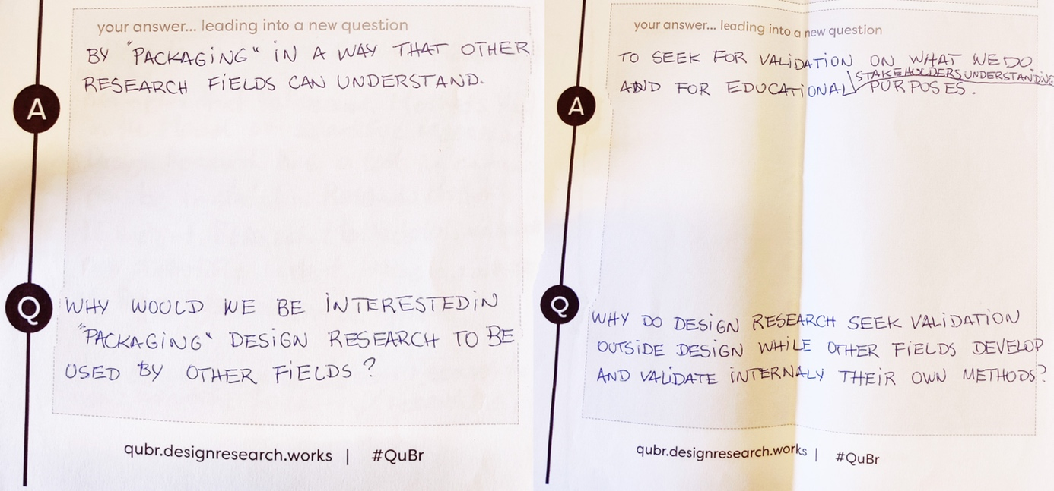
Figure 6 Two worksheets exploring whether (or not) ‘packaging’ Design Research specially to cater for other disciplines needs may be a productive strategy to communicate its value.
This line of reasoning reflects the position that most Design Researchers have for the field; although there is a shared tacit understanding about the value of Design Research, there is a notable lack of consensus around where that value comes from and/or how it manifests. This duality sets up a situation where any attempt to ‘dumb down’ communications about the value of Design Research set up a spectrum of risks/rewards relating to communicating the value. During the plenary discussion the Design Thinking movement was raised as an example of how making Design Research reducing the inherent ambiguity and complexity of Design Research to make it more accessible and shareable, has the side effect of—arguably—reducing its utility substantially.

2.4 Why choose Design Research?
This question produced two quite different responses. The first response appears optimistic and bold, the reason to choose Design Research is because it ‘has the potential to think wicked problems are solvable’. In a separate question, the notion of the ‘abductive leap’ was tabled as a discussion point, as was the flexibility of Design Research, and its orientation towards action—i.e., ‘it does stuff’. There appeared to be some consensus here; most agreed that Design Research is uniquely positioned to at least attempt to engage with so-called wicked problems (complex problems that are ill-defined and rarely do not have a single ‘fix’). Combining this point with the discussion in 2.1 and 2.2 (that identifies a distinction between ‘normal methods’ and ‘Design Research methods’) an important question to explore is whether using generic methods in a Design context is what can uniquely-proficiently explore wicked problems, or whether it is using Design Research specific approaches such as Research through Design, or both? A separate answer to this question, perhaps delivered in a tongue-in-cheek style, noted the reason to choose Design Research is due to ‘lack of Trust in other primary sociological research methods. The participant who made this observation was, arguably, suggesting that orienting Design Research around the unpredictability and iterative nature of creative and making activities represent a more dynamic and responsive alternative to the hegemonic traditions of sociology.

3. Reflection on the Conversation
These extracts, examples, and discussions from the Conversation are just a fraction of the dialogue that took place in the session itself. Moreover, those dialogues represent only the tip of the iceberg of the underlying issues. Notwithstanding these limitations, the session served to support the hypothesis that underpinned the rationale for the Conversation—that despite much shared ground among members of the community, there are divisions and contrasts in how the Design Research community self-identify and communicate the value of our work. Perhaps the most obvious of these points of division is the distinction between Design Research that uses generic methods and Design Research that uses methods that are unique to Design Research. Of course, by extension this issue quickly descends into the murkiness of epistemological allegiances, and thus it can be rather tricky to navigate.
Demonstrated by the breadth of insight that was passionately and tactfully delivered, it was clear that the value of Design Research—in all its forms—was palpably understood by all present. In the face of global challenges such as climate change it is imperative that we both understand the world of Design so we can Design things better and that we can understand (and act) in the social world. If we take these assertions on face value, then Design Research should be in its hay day. It stands to reason, however, that if—even in a Conversation among expert-attendees at the Design Research Society conference—the diversity of what is represented by Design Research poses communication and clarity challenges, then something ought to be done about it. Several suggestions arose in the Conversation. Some of these related to the concept of incorporating Design Research into the archetypal ‘Design Research 101’ course. As already discussed, (see 2.3) one of these is the matter of how to present Design Research to the rest of the world. It seems that, perhaps, rather than simplifying (which was successful for Design Thinking, for example) we should embrace the complexity, but put efforts into more clearly communicating it. One way of demonstrating this value, which repeatedly came up in the Conversation, is the importance of an accessible corpus of excellent examples and case studies that show the value Design Research (and that should differentiate between the different types of Design Research too).
Referring to the underlying project that facilitated the convening of this Conversation—Design Research Works; a 4-year project to evidence and promote the value of Design Research—the Conversation proved invaluable and will underpin a range of outputs that will be produced over the next 2 years. A variety of suggestions and possible devices to better communicate the value of Design Research arose at the Conversation including writing a Design Research book for a general audience, hosting (and curating) a range of excellent Design Research examples in an accessible manner, clarifying the distinction between Design Research and Design Research methods, striving for Design Research to be taught more widely, striving for mass exposure for the field. Subsequently all of these are actively being pursued by the Design Research Works team and have directly informed by the insights that were generously shared by participants in this Conversation. We hope that the Conversation event was edifying and interesting for those that took part, that this summary and post-hoc discussion of the proceedings may offer some new insights (or reassurance) to those navigating their way through waters of the Design Research world, and finally that the ongoing work resulting from this Conversation result in interesting and useful outcomes that promote the value of Design Research and help Design Research to contribute towards positive change in the world.
Acknowledgements: We would like to thank all the online and in-person participants for making this rich and enjoyable Conversation possible. We thank the reviewers of the original proposal for identifying the value in the work.
This work was support by Design Research Works (https://designresearch.works) under UKRI grant reference MR/T019220/1 and EPSRC grant references EP/X009947/1, EP/W024780/1 and EP/V00784X/1.

5. References
Cooper, R. (2014) ‘Design Research, Exploring the Space, Moving from One Era to Another’, The Design Journal, 17(2), pp. 165–168. Available at: https://doi.org/10.2752/175630614X13915240575906.
Cooper, R. et al. (2018) ‘ImaginationLancaster: Open-Ended, Anti-Disciplinary, Diverse’, She Ji: The Journal of Design, Economics, and Innovation, 4(4), pp. 307–341. Available at: https://doi.org/10.1016/j.sheji.2018.11.001.
Durrant, A.C. et al. (2017) ‘Research Through Design: Twenty-First Century Makers and Materialities’, Design Issues, 33(3), pp. 3–10. Available at: https://doi.org/10.1162/DESI_a_00447.
Frayling, C. (1993) ‘Research in Art and Design’, Royal College of Art Research Papers, 1(1), pp. 1–9.
Gaver, W. (2012) ‘What should we expect from research through design?’, in Proceedings of the 2012 ACM annual conference on Human Factors in Computing Systems - CHI ’12. New York, New York, USA: ACM Press, pp. 937–946.
Green, D. and Kirk, D. (2018) ‘Open Design, Inclusivity and the Intersections of Making’, in Proceedings of the 2018 Designing Interactive Systems Conference. New York, NY, USA: ACM, pp. 173–186. Available at: https://doi.org/10.1145/3196709.3196718.
Green, D.P. and Lindley, J. (2021) ‘Design Research and Ambiguity’, in 14th International Conference of the European Academy of Design, pp. 291–297. Available at: https://www.proceedings.blucher.com.br/article-list/ead2021-364/list#articles.
Green, D.P. and Lindley, J. (2022) ‘The Interview Box: Notes on a Prototype System for Video-Recording Remote Interviews’, in Designing Interactive Systems Conference. New York, NY, USA: ACM, pp. 1044–1057. Available at: https://doi.org/10.1145/3532106.3533504.
Lindley, J. and Coulton, P. (2020) AHRC Design Fellows Challenges of the Future: AI & Data.
Lindley, J. and Green, D.P. (2021) ‘The Ultimate Measure of Success for Speculative Design is to Disappear Completely’, Interaction Design and Architecture(s), (51), pp. 32–51. Available at: https://doi.org/10.55612/s-5002-051-002.
Pierce, J. (2021) ‘In Tension with Progression: Grasping the Frictional Tendencies of Speculative, Critical, and other Alternative Designs’, in Proceedings of the 2021 CHI Conference on Human Factors in Computing Systems. New York, NY, USA: ACM, pp. 1–19. Available at: https://doi.org/10.1145/3411764.3445406.
Rodgers, P. (2020) AHRC Design Leadership Fellowship Final Report.
Rodgers, P., Francesco, M. and Conerney, L. (2019) ‘The Evolving Landscape of Design Research in the UK’, in Proceedings of the Interactional Association of Societies of Design Research Conference 2019.
Sudjic, D. (2009) The Language of Things. Penguin.

About the Authors:
Joseph Lindley leads Design Research Works, a project aimed at promoting and understanding the value of Design Research.
David Green is a Senior Research Associate and a Design Researcher with a background in participatory documentary making and Human-Computer Interaction.
Mayane Pereira Dore is a Research Associate with a background in Anthropology and Design currently conducting fieldwork around the concept of an Observatory for Design Research.
Zach Mason is Doctoral Research Student using Design Research to explore how to promote an accessible and diverse future of the online world.
Claire Coulton works for leading Design Research lab ImaginationLancaster and has over 10-years’ experience managing and supporting large-scale Design Research projects.
Arne Berger is a Professor of Human Computer Interaction at Hochschule Anhalt their research uses Design Research to democratize the adoption of emerging technologies.
Miriam Sturdee is a Research Fellow and Artist, their research is focused on enabling those outside of creative disciplines to benefit from practice and creativity-led methods.

https://designresearch.works/
http://questionbridge.com/
https://designresearch.works

