Binaural Temporal Coding and the Middle Ear Muscle Reflex in Audiometrically Normal Young Adults
Authors: Adnan M. Shehabi^{1,2*}, Garreth Prendergast¹, Hannah Guest¹, Christopher J. Plack^{1,3}
1: Manchester Centre for Audiology and Deafness, University of Manchester, UK. 2: Department of Audiology and Speech Therapy, Birzeit University, Palestine. 3: Department of Psychology, Lancaster University, UK.
* Corresponding author: ashehabi@birzeit.edu

Abstract
Noise exposure may damage the synapses that connect inner hair cells with auditory nerve fibers, before outer hair cells are lost. In humans, this cochlear synaptopathy (CS) is thought to decrease the fidelity of peripheral auditory temporal coding. In the current study, the primary hypothesis was that higher middle ear muscle reflex (MEMR) thresholds, as a proxy measure of CS, would be associated with smaller values of the binaural intelligibility level difference (BILD). The BILD, which is a measure of binaural temporal coding, is defined here as the difference in thresholds between the diotic and the antiphasic versions of the digits in noise (DIN) test. This DIN BILD may control for factors unrelated to binaural temporal coding such as linguistic, central auditory, and cognitive factors. Fifty-six audiometrically normal adults (34 females) aged 18 – 30 were tested. The test battery included standard pure tone audiometry, tympanometry, MEMR using a 2 kHz elicitor and 226 Hz and 1 kHz probes, the Noise Exposure Structured Interview, forward digit span test, extended high frequency (EHF) audiometry, and diotic and antiphasic DIN tests. The study protocol was pre-registered prior to data collection. MEMR thresholds did not predict the DIN BILD. Secondary analyses showed no association between MEMR thresholds and the individual diotic and antiphasic DIN thresholds. Greater lifetime noise exposure was non-significantly associated with higher MEMR thresholds, larger DIN BILD values, and lower (better) antiphasic DIN thresholds, but not with diotic DIN thresholds, nor with EHF thresholds. EHF thresholds were associated with neither MEMR thresholds nor any of the DIN outcomes, including the DIN BILD. Results provide no evidence that young, audiometrically normal people incur CS with impacts on binaural temporal processing.
Keywords: Cochlear synaptopathy; Noise exposure; Middle ear muscle reflex; Binaural temporal coding; Speech perception in noise

- Introduction
Excessive noise exposure has been shown, across several animal species, to destroy the synapses that connect cochlear inner hair cells with the auditory nerve, before outer hair cells (OHCs) are lost (Kujawa and Liberman, 2009; Lin et al., 2011; Möhrle et al., 2016; Valero et al., 2017; Wang and Ren, 2012). This cochlear synaptopathy (CS) occurs in the absence of permanent hearing threshold elevations (Furman et al., 2013; Hickman et al., 2018; Kujawa and Liberman, 2009; Valero et al., 2017). CS has been shown to result in the subsequent loss of auditory nerve fibers (ANFs) across several animal species (for review, see Kujawa and Liberman 2015). Human temporal bone studies have confirmed the loss of ANFs secondary to noise exposure and aging (Viana et al., 2015; Wu et al., 2021, 2019).
Low- to medium-spontaneous rate (SR) ANFs, which may be preferentially lost in noise-induced CS (Bourien et al., 2014; Furman et al., 2013; Song et al., 2016), have been shown to exhibit high thresholds (Evans and Palmer, 1980; Huet et al., 2016; Liberman, 1978). Thus, low- to medium-SR ANFs are thought to code moderate-to-loud acoustic signals such as speech (Bharadwaj et al., 2014; Kujawa and Liberman, 2015). In humans, CS is hypothesized to manifest as speech-perception-in-noise (SPiN) difficulties (Bharadwaj et al., 2014; Kujawa and Liberman, 2015; Plack et al., 2014). These difficulties are thought to arise secondary to degraded temporal neural coding as a result of CS (Bharadwaj et al., 2014; Parthasarathy and Kujawa, 2018; Plack et al., 2014).
In mice, CS has been shown to be associated with smaller amplitudes of the envelope following response (EFR; Shaheen et al., 2015). The EFR is an electrophysiological measure of auditory temporal neural coding in which the evoked neural responses are phase-locked to the amplitude modulations of the stimulus (Dolphin and Mountain, 1992). The EFR has been used as a proxy measure of CS in humans, and computational simulations suggest that CS results in smaller EFR amplitudes (Vasilkov et al., 2021; Verhulst et al., 2018a, 2018b). However, the evidence for CS based on EFRs in humans is mixed and inconclusive. For instance, using EFR stimuli with relatively low modulation frequencies (around 100 Hz), Bharadwaj et al. (2015) and Bramhall et al. (2021) reported that greater noise exposure was associated with steeper positive EFR slopes (i.e., the slope of the graphical line across EFR amplitudes as a function of modulation depths) and smaller EFR amplitudes in normal-hearing adults. In contrast, several studies found no association between EFR amplitudes and noise exposure or SPiN difficulties (Carcagno and Plack, 2020; Grose et al., 2017; Guest et al., 2018b; Maele et al., 2021; Paul et al., 2018; Prendergast et al., 2017a; Suresh and Krishnan, 2022). Evidence from mice suggest that CS-related EFR amplitude reductions are marginal at low modulation frequencies (e.g., around 100 Hz) compared to higher modulation frequencies (e.g., around 1000 Hz; Shaheen et al., 2015). EFR amplitudes elicited using low modulation frequencies are thought to reflect greater contributions from higher central neural generators, which could be less affected by CS compared to the auditory nerve (Shaheen et al., 2015). Therefore, the use of low modulation frequencies to detect CS in human EFR studies may be an inherent limitation that casts doubt on the relevance of some human EFR findings to CS.
Several human studies have evaluated the hypothesized effects of noise-induced CS on behavioral measures of temporal coding. The findings of these studies have been mixed and inconclusive. For instance, noise exposure has been associated with worse interaural phase difference (IPD) discrimination (Shehorn et al., 2020), and poorer amplitude modulation detection (Kumar et al., 2012; Stone and Moore, 2014; Verhulst et al., 2018b). Conversely, several other studies did not find any effects of noise exposure on amplitude modulation detection, frequency discrimination, IPD discrimination, and sound localization (Grose et al., 2017; Prendergast et al., 2019, 2017b; Yeend et al., 2017).
Alongside temporal coding deficits, the noise-induced elevation of extended high-frequency (EHF; >8 kHz) thresholds, which may accompany noise-induced CS (Liberman et al., 2016), may contribute to poorer SPiN ability (Monson et al., 2019; Zadeh et al., 2019). This is because EHFs are hypothesized to provide temporal and spectral information which supports SPiN processing (Monson et al., 2019; Trine and Monson, 2020; Zadeh et al., 2019). However, research testing for effects of noise exposure on SPiN performance, in the absence of threshold elevations in the standard audiometric range (<= 8 kHz), has produced mixed results and generally does not support such effects (for reviews see Bramhall et al., 2019; Le Prell, 2019; and Shehabi et al. 2022b).
The middle ear muscle reflex (MEMR), which is clinically known as the acoustic reflex, is a non-invasive objective measure of shifts in middle-ear immittance following exposure to intense sounds (Gelfand, 2018; Mukerji et al., 2010). The MEMR is mediated by a peripheral efferent neural feedback mechanism that contracts the stapedius muscle (Gelfand, 2018; Mukerji et al., 2010). Since low-SR ANFs have been shown to form part of the afferent MEMR pathway (Kobler et al., 1992; Liberman and Klang, 1984; Rouiller et al., 1986), MEMR strength is hypothesized to decrease as a consequence of CS, and thus could be used as a non-invasive objective measure of CS (Bharadwaj et al., 2019). Studies in mice and chinchillas have shown that both MEMR thresholds and amplitudes are strongly related to synapse survival (Bharadwaj et al., 2022; Valero et al., 2018, 2016). In attempts to detect and quantify CS using the MEMR, wideband probes and standard tonal probes have been used. The wideband probe technique quantifies middle ear immittance at a broad range of probe frequencies (Schairer et al., 2013). The standard tonal probe technique, which is typically used in clinical settings, involves the use of a single probe frequency (typically 226 or 1000 Hz) to determine middle ear immittance (Schairer et al., 2013).
Using wideband probes, mice and chinchillas with noise-induced CS have been shown to exhibit elevated MEMR thresholds and reduced MEMR growth functions (i.e., MEMR strength in relation to elicitor level; Bharadwaj et al., 2022; Valero et al., 2018, 2016). The wideband probe technique has been adopted in human studies testing for CS. Table 1 summarizes human studies on the effects of noise-induced CS in humans using wideband and tonal probes.
Table 1 Summary of studies that investigated relations between lifetime noise exposure and MEMR thresholds/growth using wideband and tonal probes in audiometrically normal adults.
Study | Participants | Methods | Findings
Guest et al. (2019a) | 83 audiometrically normal young adults aged 18 – 39 | MEMR thresholds were measured using tonal elicitors at 1, 2, and 4 kHz and a 226 Hz probe  Lifetime noise exposure was assessed using the NESI | No association between lifetime noise exposure and MEMR thresholds
Causon et al. (2020) | 48 normal-hearing adults aged 18 – 40 | MEMR thresholds and growth functions were measured ipsilaterally and contralaterally using a 226 Hz probe tone and broadband noise, 0.5, and 2 kHz elicitors  Lifetime noise exposure was assessed using the NESI | No association between lifetime noise exposure and MEMR thresholds or growth functions
Shehorn et al. (2020) | 41 audiometrically normal adults aged 21 – 54 | MEMR magnitudes (defined as maximum difference in middle ear absorbance) were measured using a wideband click probe and a broadband noise-burst elicitor  Lifetime noise exposure was assessed using the NESI | MEMR magnitudes, averaged across ipsilateral and contralateral measurements, significantly decreased with increasing lifetime noise exposure at elicitor levels of 66 dBA and 81 dBA, but not at 96 dBA
Bramhall et al. (2022) | 92 audiometrically normal military veterans and non-veterans aged 19 – 35 | MEMR growth functions were measured contralaterally using a wideband click probe (0.2 – 8 kHz) and a broadband noise elicitor (low-pass filtered at 8 kHz)  The Lifetime Exposure to Noise and Solvents Questionnaire (LENS-Q) was used to assess lifetime noise exposure | The high noise veteran group exhibited higher MEMR thresholds and smaller MEMR growth functions than the non-veteran group; however, these effects were not statistically significant
Bharadwaj et al. (2022) | Three groups of audiometrically normal adults: (a) Young adults with low exposure to intense noise (n = 55; aged 18 – 35); (b) Young adults with regular and extensive exposure to noise (n = 53; aged 18 – 35); (c) Middle-aged adults (n = 58; aged 36 – 60) | MEMR growth functions were measured in two conditions: (a) wideband probe and a high-pass noise elicitor (3 – 8 kHz) and (b) clinical 226 Hz tonal probe and a 4 kHz tonal elicitor | Audiometrically normal adults with high risk of CS either due to aging or noise exposure exhibited significantly smaller MEMR growth functions compared to young adult controls when wideband probe and a high-pass noise elicitor (3 – 8 kHz) were used (OHC function was controlled for in the analyses). When a broadband noise elicitor (0.5 – 8 kHz) was used, the MEMR remained sensitive to the effects of aging but not noise exposure alone.  The clinical approach using a 226 Hz probe produced smaller MEMR growth functions in groups with high risk of CS (due to age and noise exposure), though effects were less pronounced than those obtained using the wideband-probe technique.

As can be seen from Table 1, there is some evidence that noise exposure may reduce MEMR thresholds/growth functions when wideband probes are used. Although none of the aforementioned studies that used the clinical tonal probe method found any CS-related effects except for Bharadwaj et al. (2022), MEMR thresholds obtained using this clinical technique were found to exhibit high test-retest reliability in audiometrically normal young adults (Guest et al., 2019b).
It is important to consider carefully how wideband and tonal probes might differ in their sensitivity to CS. The benefits of wideband probes stem from the fact that effects of the MEMR on middle ear immittance vary across probe frequency: negative at some frequencies and positive at others, with the patterns of zero-crossings differing between individuals (Feeney and Keefe, 2001, 1999). If a tonal probe frequency lies at or near an individual subject’s zero-crossing, the MEMR strength may be underestimated (Feeney and Keefe, 2001, 1999). By recording and integrating MEMR-induced immittance changes at a range of frequencies (often 0.5 – 2 kHz), the wideband-probe technique provides more sensitive detection of the reflex (Feeney and Keefe, 2001). This allows reflexes to be recorded at lower elicitor levels (which is important for safety and comfort) and removes unwanted between-subject variability from the data (which enhances statistical power; Feeney and Keefe, 2001, 1999). Of course, this does not preclude the tonal-probe MEMR as a measure of CS, but does mean that the use of tonal probes could reduce statistical power, especially if the probe frequencies are not carefully selected. Helpfully, Wojtczak et al. (2017) showed that measurements obtained using a broadband probe were dominated by a small range of high-amplitude frequency components around 1 kHz. Similarly, Feeney and Keefe (2001) showed that MEMR-induced changes in admittance are maximal at around 1 kHz. Feeney and Keefe (2001) noted that, in individuals without middle-ear pathology, the use of a 1 kHz probe might yield similar results to those obtained with a wideband probe. Therefore, Causon et al. (2020) argued that the standard clinical tonal probe method may still offer some sensitivity to capture the proposed effects of CS. Aiming to enhance the sensitivity of the tonal probe MEMR to CS, the current study protocol involved averaging the MEMR thresholds obtained using two probe frequencies that dominate the MEMR admittance spectrum in otologically normal people: 226 Hz and 1 kHz (Feeney and Keefe, 2001, 1999).
Some studies have investigated relations between MEMR thresholds/growth functions and SPiN performance in normal-hearing adults (shown in Table 2). As can be seen from Table 2, the findings of the different studies are mixed and inconclusive.
Table 2 Summary of studies that investigated the relation between MEMR thresholds/growth and SPiN in audiometrically normal adults.
Study | Participants | Methods | Findings
Mepani et al. (2018) | 165 audiometrically normal adults aged 18 – 63 | MEMR was measured using three different techniques: (1) the standard clinical tonal probe MEMR using a 226 Hz probe tone and tonal elicitors of 0.5, 1, 2, and 4 kHz, (2) the wideband-probe MEMR using a white noise elicitor, and (3) a custom probe MEMR technique that employed a click probe and a noise elicitor.  Word recognition scores were measured in three conditions: (a) 0 dB signal-to-noise ratio, (b) 45% time compression with reverberation, (c) 65% time compression with reverberation, (d) modified version of the QuickSIN test | MEMR thresholds obtained both using the standard clinical and custom probe techniques were significantly negatively associated with word recognition scores in all tests except for the modified version of the QuickSIN test
Guest et al. (2019a) | 70 audiometrically normal adults aged 18 – 39 | MEMR thresholds were measured using tonal elicitors at 1, 2, and 4 kHz and a 226 Hz probe  SPiN thresholds were assessed using the Coordinate Response Measure (CRM) test | No significant associations between MEMR thresholds and SPiN thresholds.
Shehorn et al. (2020) | 41 audiometrically normal adults aged 21 – 52 | Ipsilateral MEMR magnitude were measured using a wideband probe and broadband elicitor  Monosyllabic words were presented at levels of 74, 89, and 104 dBA. The words were presented at +8 dB SNR (the masker was speech-shaped noise). | Statistically significant positive association between the MEMR and word recognition score at 104 dBA. Non-significant trends of higher word recognition scores at 74 and 89 dBA as a function of greater MEMR magnitudes were observed
Drennan et al. (2022) | 61 young audiometrically-normal adults | MEMR growth functions were measured using a 1 kHz elicitor presented with 1.5 – 4 kHz masking noise and a 226 Hz probe.  SPiN was assessed using words presented in background noise | No statistically significant association between MEMR growth functions and word-recognition-in-noise scores

The current study assessed the association between ipsilateral MEMR thresholds (obtained using tonal probes at 226 Hz and 1 kHz) and the binaural intelligibility level difference (BILD) for the digits-in-noise (DIN) test. Similar to the definition adopted by Wolmarans et al. (2021), we define the DIN BILD as the threshold difference between the diotic and the antiphasic versions of the DIN test, with larger absolute values indicating greater binaural unmasking. In the diotic condition, both the digits and the background noise are presented in phase across the two ears; in the antiphasic condition, the digits (but not the background noise) are presented 180° out of phase across the ears. In listeners with normal hearing, the identification of antiphasic digits in diotic noise is improved compared to diotic digits presented in diotic noise (De Sousa et al., 2019). The BILD has been shown to be sensitive to disruptions in binaural temporal coding in both normal-hearing and hearing-impaired individuals (De Sousa et al., 2019; Goverts and Houtgast, 2010), since the BILD reflects the coding of precise interaural phase information (Wolmarans et al., 2021).
We propose that the DIN BILD may offer greater sensitivity than conventional SPiN tasks in detecting temporal coding deficits related to CS, since it controls for irrelevant between-subject variables such as cognitive, linguistic, and central auditory factors. CS, which is thought to disrupt the temporal coding of suprathreshold moderate-to-high-level acoustic stimuli such as speech (Bharadwaj et al., 2014), may decrease binaural unmasking by reducing the ability of the listener to make use of the phase difference cues between the digits and the noise (Gilbert et al., 2015; Jerger et al., 1984; Palmer et al., 2000).
The primary hypothesis was that higher MEMR thresholds would be associated with smaller absolute values of the DIN BILD (i.e., with reduced binaural unmasking). The secondary, exploratory, hypotheses were: (1) higher MEMR thresholds would be associated with higher diotic and antiphasic DIN thresholds (with greater effects observed for antiphasic than diotic thresholds); (2) greater lifetime noise exposure would be associated with higher MEMR thresholds, smaller DIN BILD values, higher diotic and antiphasic DIN thresholds, and higher EHF thresholds; (3) higher EHF thresholds would be associated with higher MEMR thresholds, smaller values of the DIN BILD, and higher diotic and antiphasic DIN thresholds.
- Methods
To ensure transparency of the methods and analyses, the protocol for the current study, including the primary and secondary aims, data collection tools and procedures, and the planned statistical analyses, was pre-registered on the Open Science Framework prior to the beginning of the data collection (https://osf.io/wxpku). All study methods and procedures presented below are consistent with the pre-registered protocol except for the exclusion of the forward digit span score as a covariate in the primary regression model. This deviation is due to typographical error in the pre-registered protocol, which should have listed the forward digit span score as a covariate only in the secondary regression models, rather than in the primary model using DIN BILD. Since the DIN BILD is a difference measure, composed of DIN thresholds that should be affected similarly by cognition, cognitive ability is inherently controlled; additional control for digit span scores is inappropriate.
  - Participants
Participants were 56 young native British English-speaking adults (34 females) aged 18 – 30 (mean age = 21.98, SD = 2.62). Based on the correlation between MEMR thresholds obtained using a tonal probe of 226 Hz and an elicitor of 2 kHz and word recognition performance (r = -0.32) reported by Mepani et al. (2018), the sample size was calculated a priori to give 80% power with an alpha of 0.05 (one-tailed) to detect smaller DIN BILD at higher MEMR thresholds. Participants had normal audiometric thresholds within the standard frequency range (≤ 20 dB HL at 0.25, 0.5, 1, 2, 4, and 8 kHz) with no more than a 10 dB air-bone gap at each of these frequencies bilaterally. Air-conduction thresholds were within 10 dB across both ears at all frequencies tested. Participants had no current or past diagnosis of hearing or cognitive impairments, and they reported no history of head/neck traumas, ototoxic exposure, nor neurological disorders.
Healthy middle ear status was determined by otoscopy and by clinically normal tympanometry (i.e., compliance of 0.3 – 1.6 cm³; pressure -50 to +50 daPa). Six participants were excluded from the study due to abnormal hearing thresholds (n = 3), asymmetric air-conduction hearing thresholds across the ears (n = 1), and tympanometric results outside the normal range (n = 2).
Following the completion of the test session, which lasted for about 90 minutes, participants were awarded monetary compensation for their time and travel expenses. The study procedures were approved by the University of Manchester Research Ethics Committee (ethics application reference: 2022-13880-22560) and all participants gave their written informed consent upon participation.
  - Audiometric Thresholds
Stimuli were presented using a GSI Pello audiometer and HDA-300 supra-aural headphones in a double-walled sound-treated booth. Standard air- and bone-conduction pure tone audiometry (PTA) thresholds were measured at 0.25, 0.5, 1, 2, 4, and 8 kHz and at 0.5, 1, and 2 kHz respectively, in accordance with the recommended procedures of the British Society of Audiology (British Society of Audiology, 2018). EHF thresholds were established at 10 and 14 kHz using the same procedures as for standard PTA. These frequencies were selected in order to obtain a two-point estimate of EHF thresholds, without using so high a frequency that significant numbers of participants would have thresholds exceeding the upper limits of the audiometer. Threshold averages were defined as the mean air-conduction hearing threshold across 0.5, 1, 2, 4, and 8 kHz (for PTA), and across 10 and 14 kHz (for EHF), averaged across both ears in each case.
  - Middle ear compliance and middle ear muscle reflex thresholds
A GSI Tympstar was used to obtain all measurements of immittance. Peak middle ear compliance and pressure were measured bilaterally using the recommended tympanometry procedures of the British Society of Audiology (British Society of Audiology, 2013). For analyses including compliance as a covariate, compliance was averaged across the two ears. MEMR thresholds were measured ipsilaterally using probe tones of 226 Hz and 1 kHz with a 1.5-second 2 kHz elicitor. The same threshold-finding protocol employed by Guest et al. (2019a) was used in the current study. The MEMR threshold per participant was determined by averaging MEMR thresholds obtained in one ear using the 2 kHz elicitor across the 226 Hz and 1 kHz probes.
To minimize the testing burden on the participant, MEMR thresholds were recorded from one ear only. MEMR thresholds were obtained in the right ear of 52 participants; for the remaining four, the left ear was tested due to the presence of some wax in the right ear canal that prevented clear observation of the tympanic membrane. The noise exposure levels and durations during the MEMR test were within the safe limit of 85 dBA Lq_{8h} as defined by the National Institute of Occupational Safety and Health (NIOSH, 1998). Upon completion of the test session, participants were advised to avoid any exposure to loud sounds for the rest of the day to ensure that the safe daily noise exposure limit was not exceeded.
  - Speech-perception-in-noise tasks
Participants performed the DIN task using HD 650 supra-aural headphones in a double-walled sound-treated booth. Each trial of the DIN test was comprised of a carrier phrase followed by three sequentially presented spoken digits ranging between 1 and 9 (“The digits {digit 1} {digit 2} {digit 3}”). Digits were articulated by a female British English speaker and were embedded in speech-shaped Gaussian background noise with the same long-term average speech spectrum as the digits. Both the digits and the background noise were low-pass filtered at a knee-point of 8 kHz in order to minimize the contribution of EHF cochlear regions. Following each trial, participants entered their answers using a mouse and keypad on a computer screen. Visual feedback was presented indicating whether the answer was correct or incorrect.
The test comprised three blocks: a two-minute unscored practice block, followed by two scored test blocks: diotic and antiphasic. In the diotic block, both the digits and the background noise were presented in phase across the ears. In the antiphasic block, the digits were presented 180° out of phase across ears, while the noise remained diotic.
Participants completed each block of the testing phase within five minutes and the order of blocks was randomized across the study participants. A correct response was defined as three out of three correct digit identifications. The digits were presented at a fixed level of 62 dB SPL, while the background noise changed using a one-up and one-down tracking rule. A step size of 4 dB was employed to vary the signal-to-noise ratio (SNR) for the initial three turnpoints, and then a 2-dB step size was used for the final six turnpoints. The threshold was computed as the average SNR of the last six turnpoints. The DIN BILD was defined as the antiphasic DIN threshold minus the diotic DIN threshold, so that a more negative number represents a larger DIN BILD.
  - Lifetime noise exposure
The Noise Exposure Structured Interview (NESI; Guest et al., 2018a) was employed to estimate participants’ lifetime cumulative exposure to sounds estimated as exceeding 80 dBA. Participants detailed their participation in noisy occupational, recreational, and firearm activities. For free-field exposures, the sound level was estimated based on the difficulty of communication at a distance of four feet. For exposures via headphones and earphones, the noise level was estimated based on the participant’s typical volume control setting. For each activity, participants identified the number of years, weeks per year, days per week, and hours per day that they were exposed to the noise. The exception was for firearm exposure, for which the noise dose was estimated from type of firearm and rounds fired. However, no participants reported firearm exposure in the current study. Finally, for each occupational/recreational noisy activity, participants were asked to indicate whether they used any kind of hearing protection, and if they did, to specify their type/s and the proportion of time they were worn.
Noise exposure scores were computed for occupational and recreational activities (with the exception of firearms) using the following formula:
U = ${10}^{(L-A-90)/10}$ x $\frac{T}{2080}$
Where U = units of noise exposure (energy); L = level (dBA); A = attenuation of ear protection; T = total exposure time. The scores of the different exposure activities (i.e., occupational, recreational, and firearm) were then added to produce a cumulative lifetime noise exposure score. The cumulative lifetime noise exposure score is an energy-based value that is equivalent to the total number of working years of exposure at 90 dBA (i.e., 40 hours per week; 52 weeks per year). Since the raw NESI scores did not follow a normal distribution, the cumulative lifetime NESI score was log-transformed [log₁₀(U)] to produce a normally distributed dataset such that one logarithmic NESI unit is equivalent to a factor of 10 in terms of lifetime noise exposure energy. Log-transformed NESI scores in the present study ranged from around -1 to 2. The former would be achieved by someone who attended nightclubs (with an assumed sound level of 99 dBA and duration of four hours) on seven occasions in their lifetime; the latter would be achieved by someone who attended such nightclubs five times a week for 25 years..
  - Cognitive function
A computerized auditory version of the forward digit span test (Wechler, 1997) was employed to assess participants’ attention and verbal working memory using Inquisit 5 software (Millisecond Software, 2022). Participants completed two practice trials before the beginning of the scored section. In each trial, participants were presented with a sequence of digits through HD 650 supra-aural headphones and were instructed to input the digits with the same sequence on a keypad on a computer screen using a mouse. Following each correct trial, the length of the sequence increased by one digit. Two consecutive incorrect trials decreased the sequence by one digit. The forward digit span score was computed as the maximum number of digits recalled correctly after the completion of 14 trials.
  - Statistical analyses
The data were analyzed using the Statistical Package for Social Sciences (SPSS) version 26. Figures were generated using a custom-written code on R software (R Core Team, 2020). To test the primary and secondary hypotheses, multiple linear regression models were used. Table 3 shows the predictor variables, the outcome variables, and the covariates used in each of the primary and secondary regression models. Separate linear regression models were performed to test each component (numbered as a,b,c, and d in Table 3) of the secondary aims such that one linear regression model was performed per secondary outcome measure. The alpha level was set to maintain a familywise error rate of <0.05. For secondary analyses, the alpha level was corrected for 12 multiple comparisons using the Bonferroni-Holm method.
Table 3 Summary of the linear regression models used to test the primary and secondary hypotheses.
Aims | Outcome measure(s) | Predictor variable | Covariates
Primary | DIN BILD | MEMR threshold | Age  Sex  PTA threshold average  Middle ear compliance
Secondary | (a) Diotic DIN threshold | MEMR threshold | Age  Sex  PTA threshold average  Middle ear compliance  Forward digit span
 | (b) Antiphasic DIN threshold
Secondary | (a) MEMR threshold | Lifetime noise exposure | Age  Sex  PTA threshold average  Middle ear compliance
 | (b) DIN BILD |  | Age  Sex  PTA threshold average
 | (c) Diotic DIN threshold |  | Age  Sex  PTA threshold average  Forward digit span
 | (d) Antiphasic DIN threshold
 | (e) EHF threshold average |  | Age  Sex
Secondary | (a) MEMR threshold | EHF threshold average | Age  Sex  PTA threshold average  Middle ear compliance
 | (b) DIN BILD |  | Age  Sex  PTA threshold average
 | (c) Diotic DIN threshold |  | Age  Sex  PTA threshold average  Forward digit span
(d) Antiphasic DIN
threshold

- Results
  - Relations between MEMR thresholds and DIN BILD and SPiN
Fig. 1A illustrates the DIN BILD in relation to MEMR thresholds. The linear regression model showed that the DIN BILD scores did not vary significantly as a function of MEMR threshold (Adjusted R² = -0.083, F(1,56) = 0.005, p = 0.944). The other covariates of age, sex, standard PTA threshold average, and middle ear compliance were not significant predictors.
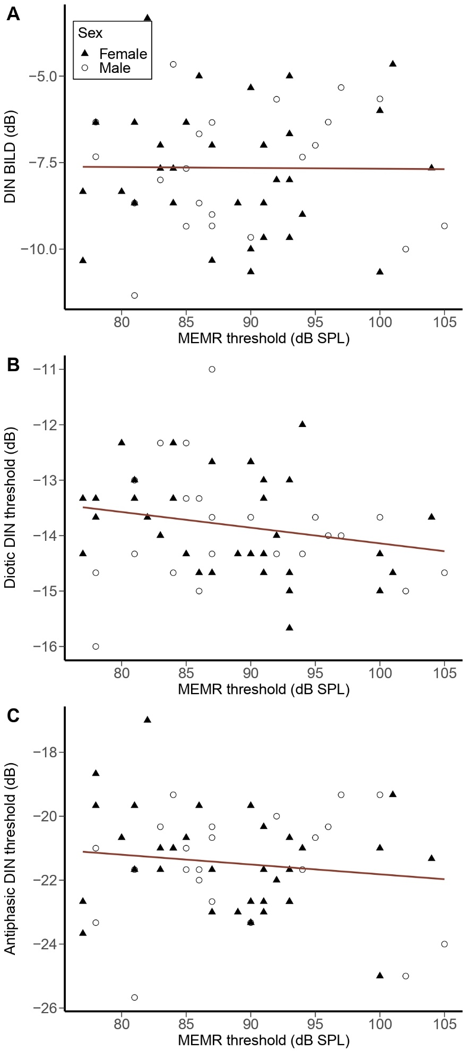
Fig. 1. (A) DIN BILD (i.e., antiphasic DIN – diotic DIN) as a function of MEMR threshold. (B) Diotic DIN threshold as a function of MEMR threshold. (C) Antiphasic DIN threshold as a function of MEMR threshold. A best-fit regression line is drawn through the data points. For all panels, black triangles and open circles correspond to individual female and male participants respectively.
Fig. 1B and Fig. 1C show the diotic and antiphasic DIN thresholds (respectively) as a function of MEMR thresholds. The secondary linear regression models show that MEMR threshold did not predict significantly either the diotic DIN thresholds (Adjusted R² = 0.076, F(1,56) = 2.295, p = 0.136) or the antiphasic DIN thresholds (Adjusted R² = -0.071, F(1,56) = 0.967, p = 0.330). For both of these models, the covariates of forward digit span scores, age, sex, standard PTA threshold average, and middle ear compliance were not significant predictors.
  - Relations between noise exposure and MEMR thresholds, DIN BILD, SPiN, and EHF thresholds
Fig. 2A, Fig. 2B, Fig. 2C, and Fig. 2D show MEMR thresholds, DIN BILD, diotic DIN thresholds, and antiphasic DIN thresholds respectively as a function of lifetime noise exposure. The outcomes of the linear regression models used to assess these relations are shown in Table 4. Lifetime noise exposure was not significantly associated with MEMR thresholds, DIN BILD scores, diotic DIN thresholds, nor antiphasic DIN thresholds after correction for multiple comparisons. None of the covariates was a significant predictor in any of the regression models.
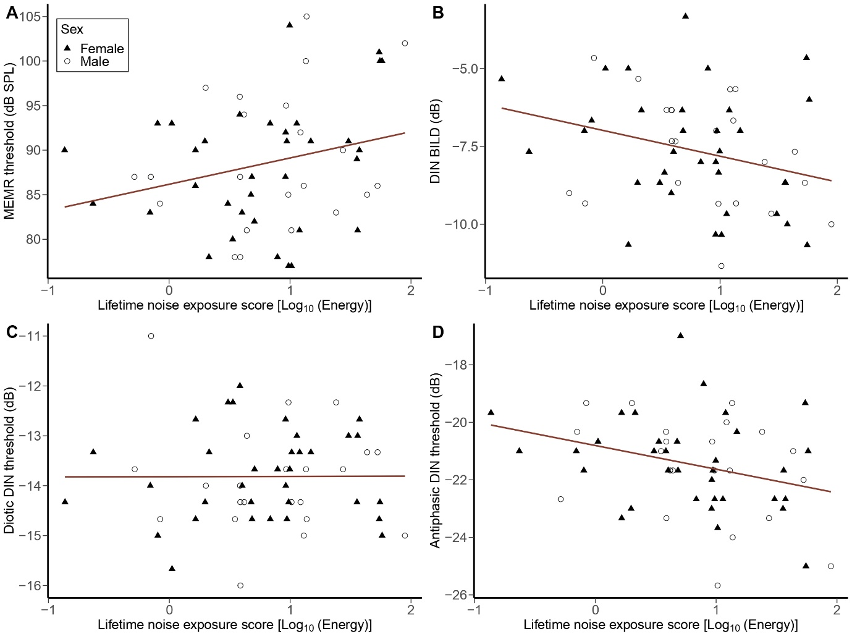
Fig. 2. (A) MEMR threshold as a function of lifetime noise exposure. (B) DIN BILD (i.e., antiphasic DIN – diotic DIN) as a function of lifetime noise exposure. (C) Diotic DIN threshold as a function of lifetime noise exposure. (D) Antiphasic DIN threshold as a function of lifetime noise exposure. Opposite to the hypothesized effects, higher lifetime noise exposure was associated with more negative DIN BILD scores and antiphasic DIN thresholds.

Table 4 The outcomes of four secondary multiple linear regression models where lifetime noise exposure is a predictor variable.
Outcome variable | Adjusted R² | F(df) | p-value | Significant covariates
MEMR threshold | 0.067 | 4.760 (1,56) | 0.034 | None
DIN BILD | 0.011 | 4.298 (1,56) | 0.043 | None
Diotic DIN threshold | -0.006 | 0.306 (1,56) | 0.583 | None
Antiphasic DIN threshold | 0.062 | 7.123 (1,56) | 0.010 | None
EHF threshold | -0.006 | 0.306 (1,56) | 0.583 | None

Fig. 3 shows the EHF threshold average as a function of lifetime noise exposure. As Table 4 shows, lifetime noise exposure was not a significant predictor of the EHF threshold average. The covariates of age and sex were also not significant predictors.
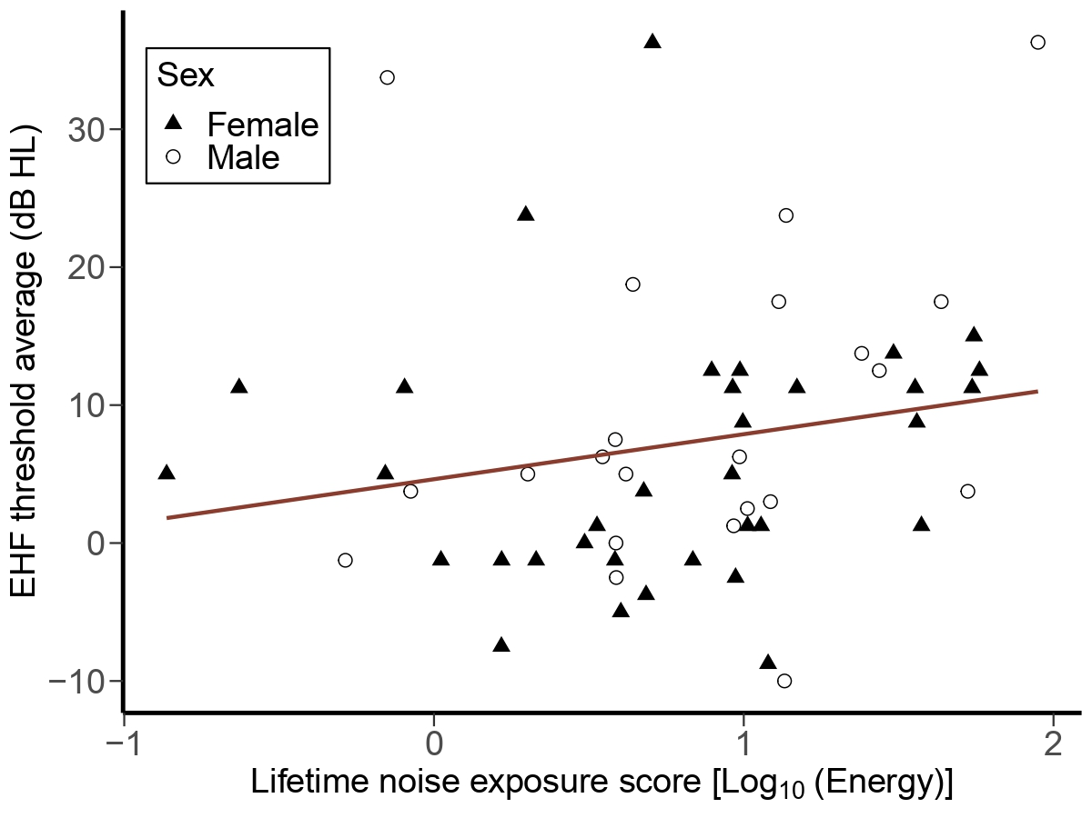
Fig. 3. EHF threshold average as a function of lifetime noise exposure.
  - Relations between EHF thresholds and MEMR thresholds, DIN BILD, and SPiN
Fig. 4A, Fig. 4B, Fig. 4C, and Fig. 4D show the relations between the EHF threshold average and MEMR threshold, DIN BILD, diotic DIN threshold, and antiphasic DIN threshold respectively. The outcomes of the linear regression models used to assess these relations are shown in Table 5. EHF threshold average did not significantly predict MEMR thresholds, DIN BILD, diotic DIN thresholds, nor antiphasic DIN thresholds. No covariate was a significant predictor in any of the regression models.
Table 5 The outcomes of four secondary multiple linear regression models where the EHF threshold average is a predictor variable.
Outcome variable | Adjusted R² | F(df) | p-value | Significant covariates
MEMR threshold | -0.019 | 0.131 (1,56) | 0.719 | None
DIN BILD | -0.055 | 0.810 (1,56) | 0.372 | None
Diotic DIN threshold | -0.009 | 0.151 (1,56) | 0.699 | None
Antiphasic DIN threshold | -.0041 | 1.456 (1,56) | 0.233 | None

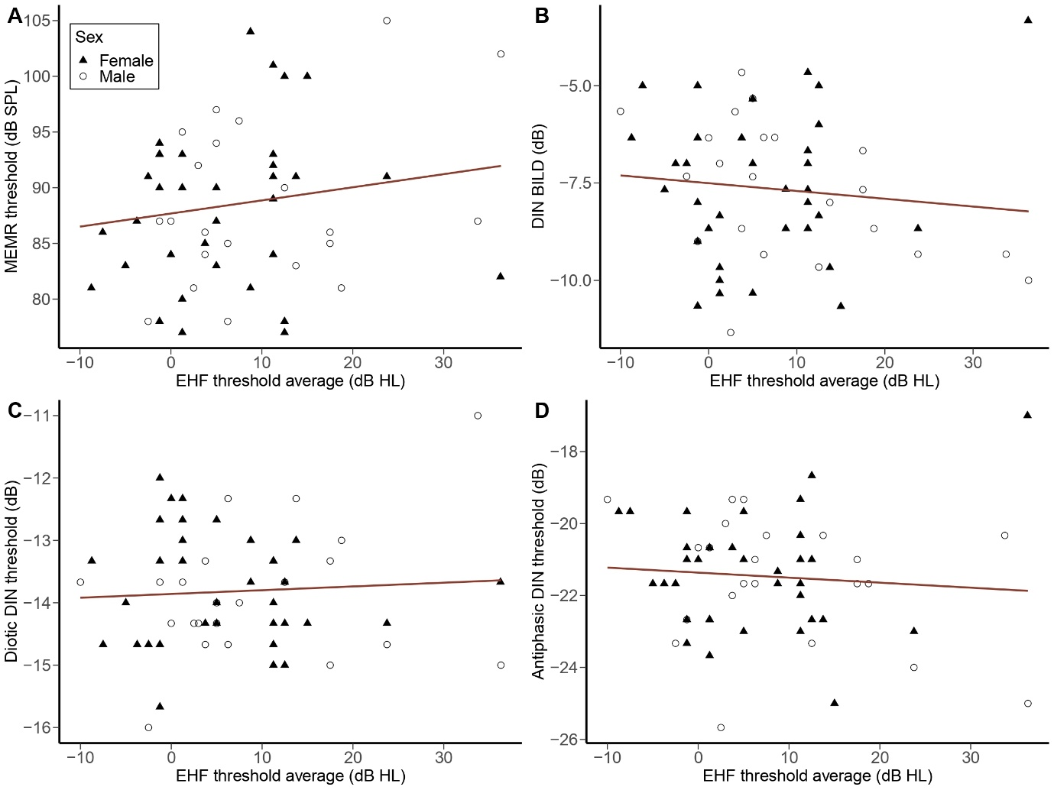
Fig. 4. (A) MEMR threshold as a function of EHF threshold average. (B) DIN BILD (i.e., antiphasic DIN – diotic DIN) as a function of EHF threshold average. (C) Diotic DIN threshold as a function of EHF threshold average. (D) Antiphasic DIN threshold as a function of EHF threshold average.
- Discussion
  - MEMR thresholds and DIN BILD
The DIN BILD was used as the current study’s measure of auditory temporal coding because it should be less affected by between-subject factors such as linguistic ability, cognitive function, and central auditory processing than other speech-based measures of temporal coding. Our primary regression analysis showed that MEMR thresholds measured using 226 Hz and 1000 Hz tonal probes and a 2 kHz elicitor did not predict the DIN BILD. These findings ostensibly contrast with the associations observed by Mepani et al (2020) between the MEMR and a range of speech measures, though it should be noted that Mepani and colleagues analysed raw speech-perception thresholds, rather than a within-subject difference measure. However, our data are broadly consistent with those of Bramhall et al. (2022) who found no association between the MEMR growth function, measured from young normal-hearing adults using a wideband MEMR probe, and EFR amplitude, which is another measure of temporal coding.
There are several possible explanations for our non-significant results. First, it may be that the studied population does not incur sufficient CS to cause perceptually significant alterations in temporal coding. Human temporal bone data by Wu et al. (2021) suggest that noise exposure is associated with a significant ANF loss. However, these findings, which were derived from deceased middle-aged and older humans who may have been in poor health before death, may not apply to young healthy adults. The extent of CS in young normal-hearing British adults may be so minimal that it is not detectable behaviourally. It has been proposed that CS could result in the preferential loss of ANFs that have a minimal role in speech coding (Johannesen et al., 2019). This proposition could be applicable if, in humans, CS turns out to be selective to high-threshold ANFs, whilst speech encoding is primarily dependent on low-threshold ANFs (Carney, 2018). Recent evidence from guinea pigs suggests that noise-induced CS affects not only low-SR, high-threshold ANFs but also a substantial proportion of high-SR, low-threshold ANFs (Suthakar and Liberman, 2021). These findings suggest possible between-species variability in the type of ANFs affected by CS. It is worth pointing out that much of the human work in this area has been designed based on the expectation that a wide array of phenomena observed in animals will translate to humans. In humans, the absence of single-cell recordings precludes understanding of the distributions of ANF SRs and thresholds (and relations between SR and threshold) in either healthy or synaptopathic ears (Shehabi et al., 2022b).
According to a model proposed by Oxenham (2016), the perceptual effects of CS in humans may not be apparent unless a substantial degree of CS (e.g., >50%) occurs. Wu et al. (2021) showed that ANF loss was highly correlated with OHC loss and it is therefore possible that widespread CS does not occur before audiometric threshold elevations. These findings, alongside the model of Oxenham (2016), may offer some explanation for the null effects. Lack of statistical power is unlikely to account for the present results, since not even a slight trend for a relation between MEMR and BILD was observed (adjusted R² = -0.083, p = 0.944).
Second, the present results were obtained using a perceptual measure that is previously untested in the context of CS research, the DIN BILD. We based our hypothesis and sample size on the effects reported by Mepani et al. (2018), but that work analysed raw thresholds obtained in complex word recognition tasks (i.e., with compression and reverberations), which could have been influenced by non-CS factors (for more discussion of this issue, see Section 4.2). The current study used simple digit stimuli in Gaussian noise, but computed a within-subject difference measure reliant on binaural temporal coding, controlling for non-CS factors. It may be that these methodological differences underlie the divergent results.
Third, we must consider the sensitivity to CS of the MEMR as measured in the present work. The MEMR has been proposed as an alternative sensitive non-invasive objective measure of CS that correlates strongly with synapse survival as shown in rodents (Bharadwaj et al., 2022; Valero et al., 2018, 2016). It is worth highlighting that the findings of the human studies of CS that investigated young normal-hearing adults using both tonal and wideband MEMR probes have produced mixed and inconclusive results (Bharadwaj et al., 2022; Drennan et al., 2022; Guest et al., 2019a; Mepani et al., 2018; Shehorn et al., 2020; Wojtczak et al., 2017). As discussed in Section 1, the use of a tonal rather than wideband probe is unlikely to account for the present null result, since responses across probe frequency are dominated by responses around 1 kHz and below 500 Hz in individuals without middle-ear dysfunction (Feeney and Keefe, 1991, 2001). A recent study in chinchillas showed that the MEMR strength measured using a 226 Hz tonal probe in subjects with substantial inner hair cell (IHC) loss (but normal OHCs) was not affected compared to subjects with normal counts of IHCs (Trevino et al., 2022). These findings add doubt as to whether the MEMR is sensitive enough to detect subclinical damage in the peripheral auditory system.
The variability in middle ear compliance across participants is thought to influence MEMR measurements (Causon et al., 2020). In the current study, we controlled for middle ear compliance. The studies discussed above have not considered this aspect of middle-ear function in their analyses (Bharadwaj et al., 2022; Drennan et al., 2022; Guest et al., 2019a; Mepani et al., 2018; Shehorn et al., 2020). Future studies may benefit from measuring and controlling for this potential confound.
  - MEMR thresholds and SPiN
In secondary analyses, we found that there was no association between MEMR thresholds and the diotic or antiphasic DIN thresholds. These findings are in line with several studies that tested for associations between electrophysiological measures of CS (e.g., the amplitude of wave I of the auditory brainstem response, ABR) and SPiN performance using various SPiN tasks in normal-hearing adults (Bramhall et al., 2018; Fulbright et al., 2017; Guest et al., 2018b; Johannesen et al., 2019; Prendergast et al., 2017b). Even in a study where a noise-exposure-related reduction in ABR wave I amplitude was seen, no association was found between wave I amplitude and SPiN performance (Grose et al., 2017).
Consistent with our findings, Guest et al. (2019a), who also used the clinical 226 Hz MEMR probe, found no association between MEMR thresholds and CRM thresholds. Similarly, Drennan et al. (2022) also reported no association between the MEMR growth function, elicited using the clinical probe approach of 226 Hz, and words in noise in audiometrically normal adults. Mepani et al. (2018) reported mixed outcomes. The authors documented a significant negative association between MEMR strength obtained using (a) the clinical 226 Hz probe using tonal elicitors of 0.5, 1, 2, and 4 kHz and (b) a custom wideband probe MEMR using click probe and noise elicitor, and word recognition performance in three out of four conditions. These conditions were: (1) 0 dB signal-to-noise ratio, (2) 45% time compression with reverberation, and (3) 65% time compression with reverberation. No effects were seen across both types of MEMR probes when the QuickSIN test (i.e., SPiN task) was used, which is in line with our findings. Likely, the effects seen across the conditions with time compression and reverberations were not purely CS-related. These task conditions are typically more complex than the conventional speech tasks (i.e., without compression and reverberations), potentially emphasizing factors such as cognition and central auditory processing. Moreover, the authors found no association between word recognition in any of the four conditions and the MEMR strength measured using the standard wideband MEMR probe method that involved a white noise elicitor. Shehorn et al. (2020) reported inconsistent effects across presentation levels such that higher MEMR magnitudes significantly predicted lower CNC word scores at 104 dBA but not at 74 dBA or 89 dBA. The words were presented at a relatively high SNR of +8 dB across the three levels.
The different CS studies mentioned above employed various types of SPiN tasks with different forms of speech stimuli and maskers, which exhibit different levels of sensory, cognitive, central auditory processing, and linguistic demands (DiNino et al., 2022). SPiN tasks with speech stimuli that require minimal linguistic processing and use low SNRs are thought to be more likely to detect CS compared to tests that are more reliant on a higher level of linguistic and contextual cues (DiNino et al., 2022). In the current study, we chose to employ the DIN test given that it may reflect peripheral, rather than central, auditory function (Heinrich et al., 2015; Shehabi et al., 2022a). Despite this, no effects were found in relation to the MEMR threshold. As mentioned earlier, for young adults, CS may only produce subtle perceptual deficits that are not detectable by SPiN tests.
Given that MEMR and SPiN thresholds were measured at variable stimulus intensities in the current study, and the former were generally much higher than the latter, a potential concern is whether it is reasonable to hypothesize effects of CS on both measures. We believe that there is no inherent contradiction, since CS is hypothesized to affect the MEMR and SPiN via different mechanisms (Shehorn et al., 2020), rather than effects of CS on SPiN being mediated by MEMR deficits. Moreover, even if the MEMR relies predominantly on high-threshold AN fibers, MEMR deficits may still be a biomarker of more generalised CS (affecting both high- and low-threshold fibers), which would be expected to have more pronounced effects on SPiN.
  - Noise exposure and MEMR thresholds, DIN BILD, SPiN, and EHF thresholds.
In secondary regression analyses, although there is a trend of higher MEMR thresholds as a function of higher lifetime noise exposure, consistent with the findings of the rodent studies (Valero et al., 2018, 2016) and a few human studies (Bramhall et al., 2022; Drennan et al., 2022; Shehorn et al., 2020), this effect does not survive correction for multiple comparisons. The effect size for this non-significant trend is low (adjusted R² = 0.067). Future researchers may consider verifying the effects of noise exposure on tonal-probe MEMR thresholds and growth functions using well-powered studies.
Higher lifetime noise exposure was associated with larger (more negative) DIN BILD scores and lower antiphasic DIN thresholds, but not with diotic DIN thresholds. These findings are contrary to our hypothesized effects. We cannot rule out the possibility that the effects of noise exposure on DIN BILD and SPiN outcome measures are a result of type I error. Several other studies found no evidence for CS-related deficits using different SPiN tests (including the DIN) and various psychophysical measures in audiometrically normal young adults (for reviews see Bramhall et al., 2019; Le Prell, 2019; Shehabi et al. 2022b)). These mixed findings add further doubt on whether the currently used DIN tasks (and the DIN BILD) are sensitive enough to capture CS and/or if CS exists to a measurable extent in noise-exposed young normal-hearing adults.
Some studies have proposed that elevated EHF thresholds, which reflect reduced basal OHC function, may serve as an early clinical marker of noise-induced cochlear damage (Grose et al., 2017; Le Prell et al., 2013; Maccà et al., 2014; Prendergast et al., 2017b; Somma et al., 2008; Sulaiman et al., 2014). Our data showed no significant association between lifetime noise exposure and EHF thresholds, which is consistent with the null effects reported by Wei et al. (2017) and Yeend et al. (2017). We acknowledge four possible explanations for these null effects. First, the current secondary statistical models may not have sufficient power to detect this association. Second, it is possible that participants with the highest lifetime noise exposure in the sampled population (young British people) did not experience sufficient exposure to yield substantial EHF threshold elevations, which might be noticeable only after exposure to higher levels and/or durations of lifetime noise. Since we observed a trend for higher MEMR thresholds with increasing noise exposure, it is possible that MEMR changes might precede elevations in EHF threshold. Third, since lifetime noise exposure was quantified using a self-report technique, which mainly relies on the ability to remember details about noise exposure situations throughout the lifespan, there is a risk that noise exposure was not accurately estimated across participants (although note the trend for a relation with MEMR thresholds). Fourth, it is possible that EHF thresholds are minimally affected or unaffected by noise exposure.
  - Relations between EHF thresholds, MEMR thresholds, DIN BILD, and SPiN ability
In the current study, we showed no relation between EHF thresholds and MEMR thresholds. Therefore, the elevation in MEMR thresholds as a function of noise exposure (as presented above) may not be attributable to OHC loss in the basal cochlear regions. A similar lack of effect was found in studies such as Yeend et al. (2017) and Drennan et al. (2022).
Some studies suggest that EHF threshold loss is associated with poorer SPiN performance in audiometrically normal adults (Badri et al., 2011; Liberman et al., 2016; Mishra et al., 2021; Prendergast et al., 2017b; Yeend et al., 2019, 2017). EHF threshold elevation is thought to result in the loss of salient information of speech sounds as well as reduce speech sound localization ability (Hunter et al., 2020; Zadeh et al., 2019). The DIN BILD and the diotic and antiphasic DIN thresholds reported here provide no evidence of such an effect. These findings are not surprising since the stimuli of both the antiphasic and diotic DIN tasks were low-pass filtered at a 8 kHz. Thus, basal cochlear regions may play a limited role in the perception of our stimuli. In contrast, Mepani et al. (2021) used wideband speech stimuli with EHF components. Yet, the authors failed to document an association between EHF thresholds and word recognition scores after adjusting for the effects of age and sex. Moreover, by inspecting Fig. 3 in the current study, the homogeneity of the EHF thresholds across participants with different noise exposure scores can be seen (most EHF thresholds across participants are within the clinically normal range of ≤ 20 dB HL). Hence, there may not have been sufficient variability to observe an effect of EHF threshold.
- Conclusions
We tested the hypothesis that MEMR thresholds, which are thought to serve as an objective proxy measure of noise-induced CS, are associated with binaural temporal coding deficits as assessed by the DIN BILD. The results showed no association between MEMR thresholds and the DIN BILD. Additionally, no effects were seen between MEMR thresholds and the individual diotic and antiphasic DIN tests. Secondary analyses revealed a non-significant trend for higher MEMR thresholds in those with higher lifetime noise exposure. Further secondary analyses showed weak (non-significant) negative associations between lifetime noise exposure and DIN BILD and antiphasic DIN thresholds (running counter to hypothesized effects). Finally, EHF thresholds were not associated with MEMR thresholds, nor with any of the SPiN measures. Overall, the data provide no evidence for the existence of CS with impacts on binaural temporal processing in audiometrically normal young adults.
Acknowledgments
We would like to thank all our participants for their time and commitment to this study. We also would like to thank our funders: the Faculty of Biology, Medicine, and Health at the University of Manchester, the Medical Research Council, and the NIHR Manchester Biomedical Research Centre.
Funding
This study was funded by a Ph.D. studentship by the Faculty of Biology, Medicine, and Health at the University of Manchester, the Medical Research Council (Grand number: MR/V01272X/1), and supported the NHIR Manchester Biomedical Research Centre.
Data availability statement
The datasets presented in this study can be found online on the Open Science Framework repository (https://osf.io/57fks/files/osfstorage).
Ethics statement
This study was approved by the University of Manchester Research Ethics Committee before the beginning of the data collection. Upon participation, participants provided their written informed consent.
Author contributions
All authors listed have made a substantial, direct, and intellectual contribution to the work, and approved it for publication.
Conflict of interest
The authors declare that the research was conducted in the absence of any commercial or financial relationships that could be construed as a potential conflict of interest.
List of references
Badri, R., Siegel, J.H., Wright, B.A., 2011. Auditory filter shapes and high-frequency hearing in adults who have impaired speech in noise performance despite clinically normal audiograms. J. Acoust. Soc. Am. 129, 852–863.
Bharadwaj, H.M., Hustedt-mai, A.R., Ginsberg, H.M., Dougherty, K.M., Prakash, V., Muthaiah, K., Hagedorn, A., Simpson, J.M., Heinz, M.G., 2022. Cross-species experiments reveal widespread cochlear neural damage in normal hearing. Commun. Biol. 5, 1–10.
Bharadwaj, H.M., Mai, A.R., Simpson, J.M., Choi, I., Heinz, M.G., Shinn-Cunningham, B.G., 2019. Non-invasive assays of cochlear synaptopathy – candidates and considerations. Neuroscience 407, 53–66.
Bharadwaj, H.M., Masud, S., Mehraei, G., Verhulst, S., Shinn-Cunningham, B.G., 2015. Individual differences reveal correlates of hidden hearing deficits. J. Neurosci. 35, 2161–2172.
Bharadwaj, H.M., Verhulst, S., Shaheen, L., Liberman, C.M., Shinn-Cunningham, B.G., 2014. Cochlear neuropathy and the coding of supra-threshold sound. Front. Syst. Neurosci. 8, 1–18.
Bourien, J., Tang, Y., Batrel, C., Huet, A., Lenoir, M., Ladrech, S., Desmadryl, G., Nouvian, R., Puel, J.L., Wang, J., 2014. Contribution of auditory nerve fibers to compound action potential of the auditory nerve. J. Neurophysiol. 112, 1025–1039.
Bramhall, N., Beach, E.F., Epp, B., Le Prell, C.G., Lopez-Poveda, E.A., Plack, C.J., Schaette, R., Verhulst, S., Canlon, B., 2019. The search for noise-induced cochlear synaptopathy in humans: Mission impossible? Hear. Res. 377, 88–103.
Bramhall, N.F., Konrad-Martin, D., McMillan, G.P., 2018. Tinnitus and auditory perception after a history of noise exposure: Relationship to auditory brainstem response measures. Ear Hear. 39, 881–894.
Bramhall, N.F., McMillan, G.P., Kampel, S.D., 2021. Envelope following response measurements in young veterans are consistent with noise-induced cochlear synaptopathy. Hear. Res. 408, 1–12.
Bramhall, N.F., Reavis, K.M., Feeney, M.P., Kampel, S.D., 2022. The impacts of noise exposure on the middle ear muscle reflex in a veteran population. Am. J. Audiol. 31, 126–142.
British Society of Audiology, B., 2013. Recommended Procedure: Tympanometry, British Society.
British Society of Audiology, B., 2018. Pure-tone air-conduction and bone-conduction threshold audiometry with and without masking, British Society of Audiology.
Carcagno, S., Plack, C.J., 2020. Effects of age on electrophysiological measures of cochlear synaptopathy in humans. Hear. Res. 396, 1–15.
Carney, L.H., 2018. Supra-threshold hearing and fluctuation profiles: Implications for sensorineural and hidden hearing loss. J. Assoc. Res. Otolaryngol. 19, 331–352.
Causon, A., Munro, K.J., Plack, C.J., Prendergast, G., 2020. The role of the clinically obtained acoustic reflex as a research tool for subclinical hearing pathologies. Trends Hear. 24, 1–14.
De Sousa, K.C., Swanepoel, D.W., Moore, D.R., Myburgh, H.C., Smits, C., 2019. Improving sensitivity of the digits-in-noise test using antiphasic stimuli. Ear Hear. 41, 442–450.
DiNino, M., Holt, L.L., Shinn-Cunningham, B.G., 2022. Cutting through the noise: noise-induced cochlear synaptopathy and individual differences in speech understanding among listeners with normal audiograms. Ear Hear. 43, 9–22.
Dolphin, W.F., Mountain, D.C., 1992. The envelope following response: Scalp potentials elicited in the mongolian gerbil using sinusoidally AM acoustic signals. Hear. Res. 58, 70–78.
Drennan, W.R., Langley, L., Wei, Z., 2022. The effects of noise exposure and aging on the acoustic reflex in normal-hearing people. J. Acoust. Soc. Am. 151, A259–A260.
Evans, E.F., Palmer, A.R., 1980. Relationship between the dynamic range of cochlear nerve fibres and their spontaneous activity. Exp. Brain Res. 40, 115–118.
Feeney, M.P., Keefe, D.H., 1999. Acoustic reflex detection using wide-band acoustic reflectance, admittance, and power measurements. J. Speech, Lang. Hear. Res. 42, 1029–1041.
Feeney, M.P., Keefe, D.H., 2001. Estimating the acoustic reflex threshold from wideband measures of reflectance, admittance, and power. Ear Hear. 22, 316–332.
Fulbright, A.N.C., Le Prell, C.G., Griffiths, S.K., Lobarinas, E., 2017. Effects of Recreational Noise on Threshold and Suprathreshold Measures of Auditory Function. Semin. Hear. 38, 298–318.
Furman, A.C., Kujawa, S.G., Liberman, C.M., 2013. Noise-induced cochlear neuropathy is selective for fibers with low spontaneous rates. J. Neurophysiol. 110, 577–586.
Gelfand, S.A., 2018. Hearing: An introduction to psychological and physiological acoustics, 6th ed. CRC Press, New York.
Gilbert, H.J., Shackleton, T.M., Krumbholz, K., Palmer, A.R., 2015. The neural substrate for binaural masking level differences in the auditory cortex. J. Neurosci. 35, 209–220.
Goverts, S.T., Houtgast, T., 2010. The binaural intelligibility level difference in hearing-impaired listeners: The role of supra-threshold deficits. J. Acoust. Soc. Am. 127, 3073–3084.
Grose, J.H., Buss, E., Hall, J.W., 2017. Loud music exposure and cochlear synaptopathy in young adults: isolated auditory brainstem response effects but no perceptual consequences. Trends Hear. 21, 1–18.
Guest, H., Dewey, R.S., Plack, C.J., Couth, S., Prendergast, G., Bakay, W., Hall, D.A., 2018a. The noise exposure structured interview (NESI): An instrument for the comprehensive estimation of lifetime noise exposure. Trends Hear. 22, 1–10.
Guest, H., Munro, K.J., Plack, C.J., 2019a. Acoustic middle-ear-muscle-reflex thresholds in humans with normal audiograms: no relations to tinnitus, speech perception in noise, or noise exposure. Neuroscience 407, 75–82.
Guest, H., Munro, K.J., Prendergast, G., Millman, R.E., Plack, C.J., 2018b. Impaired speech perception in noise with a normal audiogram: No evidence for cochlear synaptopathy and no relation to lifetime noise exposure. Hear. Res. 364, 142–151.
Guest, H., Munro, K.J., Prendergast, G., Plack, C.J., 2019b. Reliability and interrelations of seven proxy measures of cochlear synaptopathy. Hear. Res. 375, 34–43.
Heinrich, A., Henshaw, H., Ferguson, M.A., 2015. The relationship of speech intelligibility with hearing sensitivity, cognition, and perceived hearing difficulties varies for different speech perception tests. Front. Psychol. 6, 1–14.
Hickman, T.T., Smalt, C., Bobrow, J., Quatieri, T., Liberman, M.C., 2018. Blast-induced cochlear synaptopathy in chinchillas. Sci. Rep. 8, 1–12.
Huet, A., Batrel, C., Tang, Y., Desmadryl, G., Wang, J., Puel, J.L., Bourien, J., 2016. Sound coding in the auditory nerve of gerbils. Hear. Res. 338, 32–39.
Hunter, L.L., Monson, B.B., Moore, D.R., Dhar, S., Wright, B.A., Munro, K.J., Zadeh, L.M., Blankenship, C.M., Stiepan, S.M., Siegel, J.H., 2020. Extended high frequency hearing and speech perception implications in adults and children. Hear. Res. 397, 1–14.
Jerger, J., Brown, D., Smith, S., 1984. Effect of peripheral hearing loss on the masking level difference. Arch. Otolaryngol. 110, 290–296.
Johannesen, P.T., Buzo, B.C., Lopez-Poveda, E.A., 2019. Evidence for age-related cochlear synaptopathy in humans unconnected to speech-in-noise intelligibility deficits. Hear. Res. 374, 35–48.
Kobler, J.B., Guinan, J.J., Vacher, S.R., Norris, B.E., 1992. Acoustic reflex frequency selectivity in single stapedius motoneurons of the cat. J. Neurophysiol. 68, 807–817.
Kujawa, S.G., Liberman, M.C., 2009. Adding insult to injury: Cochlear nerve degeneration after “temporary” noise-induced hearing loss. J. Neurosci. 29, 14077–14085.
Kujawa, S.G., Liberman, M.C., 2015. Synaptopathy in the noise-exposed and aging cochlea: Primary neural degeneration in acquired sensorineural hearing loss. Hear. Res. 330, 191–199.
Kumar, U., Ameenudin, S., Sangamanatha, A., 2012. Temporal and speech processing skills in normal hearing individuals exposed to occupational noise. Noise Heal. 14, 100–105.
Le Prell, C.G., 2019. Effects of noise exposure on auditory brainstem response and speech-in-noise tasks: a review of the literature. Int. J. Audiol. 58, 1–28.
Le Prell, C.G., Spankovich, C., Lobariñas, E., Griffiths, S.K., 2013. Extended high-frequency thresholds in college students: Effects of music player use and other recreational noise. J. Am. Acad. Audiol. 24, 725–739.
Liberman, M.C., 1978. Auditory-nerve response from cats raised in a low-noise chamber. J. Acoust. Soc. Am. 63, 442–455.
Liberman, M.C., Epstein, M.J., Cleveland, S.S., Wang, H., Maison, S.F., 2016. Toward a differential diagnosis of hidden hearing loss in humans. PLoS One 11, 1–15.
Liberman, M.C., Klang, N.Y.S., 1984. Single-neuron labeling and chronic cochlear pathology. IV. Stereocilia damage and alterations in rate- and phase-level functions. Hear. Res. 16, 75–90.
Lin, H.W., Furman, A.C., Kujawa, S.G., Liberman, M.C., 2011. Primary neural degeneration in the guinea pig cochlea after reversible noise-induced threshold shift. J. Assoc. Res. Otolaryngol. 12, 605–616.
Maccà, I., Scapellato, M.L., Carrieri, M., Maso, S., Trevisan, A., Bartolucci, G.B., 2014. High-frequency hearing thresholds: effects of age, occupational ultrasound and noise exposure. Int. Arch. Occup. Environ. Health 88, 197–211.
Maele, T. Vande, Keshishzadeh, S., De Poortere, N., Dhooge, I., Keppler, H., Verhulst, S., 2021. The variability in potential biomarkers for cochlear synaptopathy after recreational noise exposure. J. Speech, Lang. Hear. Res. 64, 4964–4981.
Mepani, A.M., Kirk, S.A., Hancock, K.E., Bennett, K., de Gruttola, V., Liberman, M.C., Maison, S.F., 2018. Middle ear muscle reflex and word recognition in “normal-hearing” adults: Evidence for cochlear synaptopathy? Ear Hear. 41, 25–38.
Mepani, A.M., Verhulst, S., Hancock, K.E., Garrett, M., Vasilkov, V., Bennett, K., de Gruttola, V., Liberman, M.C., Maison, S.F., 2021. Envelope following responses predict speech-in-noise performance in normal-hearing listeners. J. Neurophysiol. 125, 1213–1222.
Millisecond Software, M., 2022. Auditory Digit Span Test (Forward) - English.
Mishra, S.K., Renken, L., Hernandez, M., Rodrigo, H., 2021. Auditory development of frequency discrimination at extended high frequencies. Ear Hear. 42, 700–708.
Möhrle, D., Ni, K., Varakina, K., Bing, D., Lee, S.C., Zimmermann, U., Knipper, M., Rüttiger, L., 2016. Loss of auditory sensitivity from inner hair cell synaptopathy can be centrally compensated in the young but not old brain. Neurobiol. Aging 44, 173–184.
Monson, B.B., Rock, J., Schulz, A., Hoffman, E., Buss, E., 2019. Ecological cocktail party listening reveals the utility of extended high-frequency hearing. Hear. Res. 381, 1–7.
Mukerji, S., Windsor, A.M., Lee, D.J., 2010. Auditory brainstem circuits that mediate the middle ear muscle reflex. Trends Amplif. 14, 170–191.
NIOSH, 1998. Criteria for a recommended standard: Occupational noise exposure, revised criteria 1998.
Oxenham, A.J., 2016. Predicting the perceptual consequences of hidden hearing loss. Trends Hear. 20, 1–6.
Palmer, A.R., Jiang, D., McAlpine, D., 2000. Neural responses in the inferior colliculus to binaural masking level differences created by inverting the noise in one ear. J. Neurophysiol. 84, 844–852.
Parthasarathy, A., Kujawa, S.G., 2018. Synaptopathy in the aging cochlea: Characterizing early-neural deficits in auditory temporal envelope processing. J. Neurosci. 38, 7108–7119.
Paul, B.T., Bruce, I.C., Roberts, L.E., 2018. Envelope following responses, noise exposure, and evidence of cochlear synaptopathy in humans: Correction and comment. J. Acoust. Soc. Am. 143, EL487–EL489.
Plack, C.J., Barker, D., Prendergast, G., 2014. Perceptual consequences of “hidden” hearing loss. Trends Hear. 18, 1–11.
Prendergast, G., Couth, S., Millman, R.E., Guest, H., Kluk, K., Munro, K.J., Plack, C.J., 2019. Effects of age and noise Exposure on proxy measures of cochlear synaptopathy. Trends Hear. 23, 1–16.
Prendergast, G., Guest, H., Munro, K.J., Kluk, K., Léger, A., Hall, D.A., Heinz, M.G., Plack, C.J., 2017a. Effects of noise exposure on young adults with normal audiograms I: Electrophysiology. Hear. Res. 344, 68–81.
Prendergast, G., Millman, R.E., Guest, H., Munro, K.J., Kluk, K., Dewey, R.S., Hall, D.A., Heinz, M.G., Plack, C.J., 2017b. Effects of noise exposure on young adults with normal audiograms II: Behavioral measures. Hear. Res. 356, 74–86.
R Core Team, 2020. R: A Language and Environment for Statistical Computing. R Foundation for Statistical Computing.
Rouiller, E.M., Cronin‐Schreiber, R., Fekete, D.M., Ryugo, D.K., 1986. The central projections of intracellularly labeled auditory nerve fibers in cats: An analysis of terminal morphology. J. Comp. Neurol. 249, 261–278.
Schairer, K.S., Feeney, M.P., Sanford, C.A., 2013. Acoustic reflex measurement. Ear Hear. 34, 43S-47S.
Seneff, S., 1988. A joint synchrony/mean-rate model of auditory speech processing. J. Phon. 16, 55–76.
Shaheen, L.A., Valero, M.D., Liberman, M.C., 2015. Towards a diagnosis of cochlear neuropathy with envelope following responses. J. Assoc. Res. Otolaryngol. 16, 727–745.
Shehabi, A.M., Prendergast, G., Guest, H., Plack, C.J., 2022a. The effect of lifetime noise exposure and aging on speech-perception-in-noise ability and self-reported hearing symptoms : An Online Study. Front. Aging Neurosci. 14, 1–18.
Shehabi, A.M., Prendergast, G., Plack, C.J., 2022b. The relative and combined effects of noise exposure and aging on auditory peripheral neural deafferentation: A narrative review. Front. Aging Neurosci. 14, 1–30.
Shehorn, J., Strelcyk, O., Zahorik, P., 2020. Associations between speech recognition at high levels, the middle ear muscle reflex and noise exposure in individuals with normal audiograms. Hear. Res. 392, 1–11.
Somma, G., Pietroiusti, A., Magrini, A., Coppeta, L., Ancona, C., Gardi, S., Messina, M., Bergamaschi, A., 2008. Extended high-frequency audiometry and noise induced hearing loss in cement workers. Am. J. Ind. Med. 51, 452–462.
Song, Q., Shen, P., Li, X., Shi, L., Liu, L., Wang, Jiping, Yu, Z., Stephen, K., Aiken, S., Yin, S., Wang, Jian, 2016. Coding deficits in hidden hearing loss induced by noise: The nature and impacts. Sci. Rep. 6, 1–13.
Stone, M.A., Moore, B.C.J., 2014. Amplitude-modulation detection by recreational-noise-exposed humans with near-normal hearing thresholds and its medium-term progression. Hear. Res. 317, 50–62.
Sulaiman, A.H., Husain, R., Seluakumaran, K., 2014. Evaluation of early hearing damage in personal listening device users using extended high-frequency audiometry and otoacoustic emissions. Eur. Arch. Otorhinolaryngol. 271, 1463–1470.
Suresh, C.H., Krishnan, A., 2022. Frequency-following response to steady-state vowel in quiet and background noise among marching band participants with normal hearing. Am. J. Audiol. 245, 1–18.
Suthakar, K., Liberman, M.C., 2021. Auditory-nerve responses in mice with noise-induced cochlear synaptopathy. J. Neurophysiol. 126, 2027–2038.
Trevino, M., Escabi, C., Swanner, H., Pawlowski, K., Lobarinas, E., 2022. No reduction in the 226‑Hz probe tone acoustic reflex amplitude following severe inner hair cell loss in chinchillas. J. Assoc. Res. Otolaryngol. 1–10.
Trine, A., Monson, B.B., 2020. Extended high frequencies provide both spectral and temporal information to improve speech-in-speech recognition. Trends Hear. 24, 1–8.
Valero, M.D., Burton, J.A., Hauser, S.N., Hackette, T.A., Ramachandran, R., Liberman, M.C., 2017. Noise-induced cochlear synaptopathy in rhesus monkeys (Macaca mulatta). Hear. Res. 353, 213–223.
Valero, M.D., Hancock, K.E., Liberman, M.C., 2016. The middle ear muscle reflex in the diagnosis of cochlear neuropathy. Hear. Res. 332, 29–38.
Valero, M.D., Hancock, K.E., Maison, S.F., Liberman, M.C., 2018. Effects of cochlear synaptopathy on middle-ear muscle reflexes in unanesthetized mice. Hear. Res. 363, 109–118.
Vasilkov, V., Garrett, M., Mauermann, M., Verhulst, S., 2021. Enhancing the sensitivity of the envelope-following response for cochlear synaptopathy screening in humans: The role of stimulus envelope. Hear. Res. 400, 1–17.
Verhulst, S., Altoè, A., Vasilkov, V., 2018a. Computational modeling of the human auditory periphery: Auditory-nerve responses, evoked potentials and hearing loss. Hear. Res. 360, 55–75.
Verhulst, S., Ernst, F., Garrett, M., Vasilkov, V., 2018b. Suprathreshold psychoacoustics and envelope-following response relations: Normal-hearing, synaptopathy and cochlear gain loss. Acta Acust. united with Acust. 104, 800–803.
Viana, L.M., O’Malley, J.T., Burgess, B.J., Jones, D.D., Oliveira, C.A.C.P., Santos, F., Merchant, S.N., Liberman, L.D., Liberman, M.C., 2015. Cochlear neuropathy in human presbycusis: Confocal analysis of hidden hearing loss in post-mortem tissue. Hear. Res. 327, 78–88.
Wang, Y., Ren, C., 2012. Effects of repeated “benign” noise exposures in young cba mice: Shedding light on age-related hearing loss. J. Assoc. Res. Otolaryngol. 13, 505–515.
Wechler, D., 1997. Administration and Scoring Guide. In: WAIS-III, Wechsler Adult Intelligence Scale. TX: Psychological Corporation, San Antonio.
Wei, W., Heinze, S., Gerstner, D.G., Walser, S.M., Twardella, D., Reiter, C., Weilnhammer, V., Perez-Alvarez, C., Steffens, T., Herr, C.E.W., 2017. Audiometric notch and extended high-frequency hearing threshold shift in relation to total leisure noise exposure: An exploratory analysis. Noise Heal. 19, 263–269.
Wojtczak, M., Beim, J.A., Oxenham, A.J., 2017. Weak middle-ear-muscle reflex in humans with noise-induced tinnitus and normal hearing may reflect cochlear synaptopathy. eNeuro 4, 1–8.
Wolmarans, J., De Sousa, K.C., Frisby, C., Mahomed-Asmail, F., Smits, C., Moore, D.R., Swanepoel, D.W., 2021. Speech recognition in noise using binaural diotic and antiphasic digits-in-noise in children: Maturation and self-test validity. J. Am. Acad. Audiol. 32, 315–323.
Wu, P.-Z., O’Malley, J.T., de Gruttola, V., Liberman, M.C., 2021. Primary neural degeneration in noise-exposed human cochleas: Correlations with outer hair cell loss and word-discrimination scores. J. Neurosci. 41, 4439–4447.
Wu, P.Z., Liberman, L.D., Bennett, K., de Gruttola, V., O’Malley, J.T., Liberman, M.C., 2019. Primary neural degeneration in the human cochlea: evidence for hidden hearing loss in the aging ear. Neuroscience 407, 8–20.
Yeend, I., Beach, E.F., Sharma, M., 2019. Working memory and extended high-frequency hearing in adults: Diagnostic predictors of speech-in-noise perception. Ear Hear. 40, 458–467.
Yeend, I., Beach, E.F., Sharma, M., Dillon, H., 2017. The effects of noise exposure and musical training on suprathreshold auditory processing and speech perception in noise. Hear. Res. 353, 224–236.
Zadeh, L.M., Silbert, N.H., Sternasty, K., Swanepoel, D.W., Hunter, L.L., Moore, D.R., 2019. Extended high-frequency hearing enhances speech perception in noise. Proc. Natl. Acad. Sci. U. S. A. 116, 23753–23759.

