Multi-lingual literature searches are needed to unveil global knowledge

Rafael D. Zenni¹,*, Jos Barlow¹,², Nathalie Pettorelli³, Phil Stephens⁴, Romina Rader⁵, Tadeu Siqueira⁶, Rowena Gordon⁷, Thomas Pinfield⁷ and Martin A. Nuñez^{8,9}

¹Programa de Pós-Graduação em Ecologia Aplicada, Instituto de Ciências Naturais, Universidade Federal de Lavras, Lavras, Brazil
²Lancaster Environment Centre, Conservation Ecology Group, Lancaster University, Lancaster, UK
³Zoological Society of London, Institute of Zoology, London, UK
⁴Conservation Ecology Group, Department of Biosciences, Durham University, Durham, UK
⁵Ecosystem Management, School of Environmental and Rural Science, University of New England 2351, Armidale, Australia
⁶Departamento de Biodiversidade, Instituto de Biociências de Rio Claro, Universidade Estadual Paulista Júlio de Mesquita Filho (UNESP), Rio Claro, Brazil
⁷British Ecological Society, London, UK
⁸Grupo de Ecología de Invasiones, INIBIOMA, CONICET – Universidad Nacional del Comahue, Bariloche, Argentina
⁹Department of Biology and Biochemistry, Division of Ecology & Evolution, University of Houston, Houston, USA
* rafael.zenni@ufla.br

Scientific syntheses integrate and assess knowledge in a field of research by laying out the current state of knowledge and identifying gaps, thereby fostering research on new or overlooked questions (Wyborn et al., 2018). From an applied ecological perspective, scientific syntheses are important tools for comparing the effects of management actions across ecosystems. Through rigorous and comprehensive scientific syntheses, managers and researchers can learn what works best to increase the efficacy of solutions to ecological problems. Because of their integrative nature, scientific syntheses in Ecology often aim to be global in scope. However, standards for what characterizes a comprehensive research synthesis of global scope are variable and, currently, literature search efforts of published scientific syntheses rarely match their proposed scope. An important issue with global scientific syntheses is language as reviews and meta-analyses tend to limit the scope of their search to few or only one language.
Arguably, most contemporary science is published in English. However, from a historical perspective, English was not the main language of science until the mid-20th century. Even now, from a socio-cultural perspective, English is not the first language of most scientists globally (Chowdhury et al., 2022). There are regionally important Applied Ecology journals publishing articles in languages other than English (Amano et al., 2021). And, in most countries, theses, dissertations and technical literature are primarily written in the home-country language.
The relevance of an applied science is directly related to its ability to relate to, and engage with, practitioners, managers, researchers, students and stakeholders around the world. Thus, limiting the scope of a synthesis in Applied Ecology to only one language means narrowing the relevance and reach of that work, and missing opportunities to enrich scientific knowledge (Rasmussen & Montgomery, 2018; Konno et al., 2020; Angulo et al., 2021). Despite this, most meta-analyses and systematic reviews continue to neglect literature not published in English. Importantly, multi-language searches are not only about comprehensiveness; they are also about valuing and recognizing diversity and inclusion in science.
Journal of Applied Ecology receives submissions from all parts of the world and aims to publish papers relevant to, and built on the work of, scientists and practitioners, globally (Nuñez et al., 2019). As such, we expect these papers to include broad-reaching data and literature relevant to the research topic, regardless of language. Here, we evaluate the extent to which language inclusivity of literature searches of published scientific syntheses match the proposed scope of the papers. We then use the outcomes of our analyses to discuss steps authors can take to overcome language barriers and biases.

Languages and literature syntheses published in Journal of Applied Ecology
To evaluate whether the breadth of literature reviews published in Journal of Applied Ecology matches the broad-reaching coverage we target, we evaluated 189 review papers published in the journal between 1970 and April 2022. All papers classified by the journal as Reviews and/or Essays were included for screening. For each paper, we compiled the search engines used for the literature search, the languages used in the search and the geographic scope of the study. 100 of these contributions (53%) were essays, conceptual frameworks or conceptual reviews and did not qualify as literature syntheses (e.g., systematic reviews or meta-analyses). For the remaining 89 contributions, only 60 described the literature screening protocol. None of the contributions published before 2000 described literature search methods.
Any database of scientific or grey literature was counted as a search engine. Search language was determined based on self-declaration or language of search terms described. When the language was not explicitly indicated by the authors or search terms were not included in the paper, we considered it as “omitted.” For the geographic scope, we recorded the geographical scope indicated by the authors. Papers that did not indicate any geographical scope were considered global.
Out of 60 syntheses published in the Journal of Applied Ecology between 1970 and April 2022, 49 were limited to the English language, nine papers omitted the language used in the search and two were multilingual (3%) (Fig. 1). 87% of these syntheses were considered global in scope, yet only included literature in English. The tendency of monolingual searches did not change over time (Fig. 1). Exceptions to mono-lingual literature compilations were Sandström et al. (2019), which included nine languages in their search (English, French, German, Danish, Norwegian, Swedish, Finnish, Estonian, and Russian) and Bertocci et al. (2015), which included four languages (English, French, Spanish, and Portuguese) (Fig. 1). The launch of free online translation services, such as Google Translate in 2006 (which now offers free translation services for over 100 languages), did not increase the diversity of languages considered in literature searches.
Authors tended to use one or two databases for their reviews and those most used were Web of Science (n = 47), followed by Google Scholar (n = 17) and Scopus (n = 9). All other databases or search engines were used four times or fewer, in total. Interestingly, we saw a sudden increase in number of search engines used between 2000 and 2010 followed by a return to 1-2 search engines after 2020 (Fig. 1). The launch of open-source scientific libraries, such as Scielo launched in 1997, did not encourage authors in Journal of Applied Ecology to broaden the scope of their literature searches.

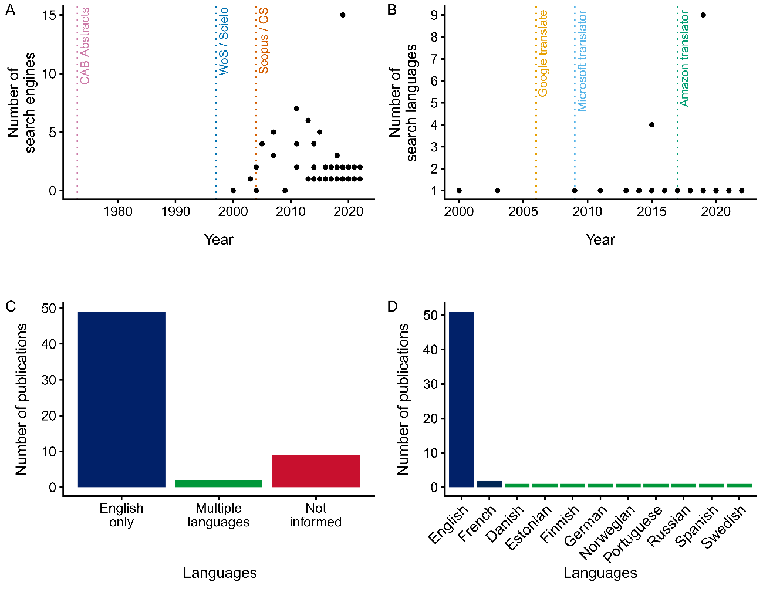
Fig. 1 Language diversity in literature reviews published in the Journal of Applied Ecology. (A) Number of search engines used for literature searches over the years; for comparison, the year when some of the main databases used by researchers were launched is included (WoS = Web of Science, GS = Google Scholar). None of the review papers published before 2000 described literature searches. (B) Number of languages included in the literature searches over the years; for comparison, the year when some of the main translation services were launched is included. (C) Number of review articles in the journal by language diversity. (D) Number of times each language was included in literature searches.

How do we improve?
Our results are clear: scientific syntheses published in Journal of Applied Ecology are overwhelmingly based on literature published in English; this dominance has not changed over time and monolingual literature searches continue to be the norm. How such a language bias affects the conclusions of these syntheses is unclear, with previous research on the topic having reached different results. For instance, when looking at evidence for nature conservation efforts across 16 languages, researchers found information in non-English publications that was poorly covered (or altogether absent) from studies published in English (Amano et al., 2021). In another contribution, however, language diversity did not systematically lead to different effect sizes in meta-analyses when the effects of taxa and landscape types were controlled for (Konno et al. 2020). Based on this, researchers are unlikely to be able to assess the importance of language diversity until they start including multiple languages in their literature searches.
The number of non-English publications in Ecology and Conservation is increasing globally (Amano et al., 2021, Chowdhury et al., 2022), with a large proportion of scientific knowledge now being digitized. Free online translation services and search engines including literature in multiple languages are accessible to all. Clearly, things have changed, and we are now in a position where scientific advances would be faster, and more robust, if researchers were to use available technology to include all the evidence at hand, independently of the language in which it is reported.
To help increase language diversity in ecological syntheses we suggest, below, a few steps authors can take to avoid and overcome language barriers and biases (Fig. 2).

Factor in language in research
Considering the literature published in the languages widely spoken by the scientists based in the region where a given research project is being conducted should be a no-brainer. For instance, if your topic of study is the Amazon region, including English, French, Portuguese and Spanish in your literature search will likely support your understanding of the system, and the identification of knowledge gaps for this area. This should really happen at the study design stage (Nuñez et al., 2021). Literature searches should ideally use the same keywords translated in all relevant languages. Although this can seem overwhelming at first, a large number of papers not published in English include a title and abstract in English. If that’s not the case, free online translation services can be used to assist reading.
If no literature is found when some was expected, authors might consider contacting and collaborating with local scientists fluent in the language to help with search design and alternative sources. WoS and Scopus have been the gold standard for literature searches, but both mostly consider work in English. Google Scholar can now search for papers in any language and regionally important databases such as Scielo (Scientific Electronic Library Online) index many open-access journals publishing in English, Portuguese, and Spanish.

Be explicit about how language was accounted for
Listing all languages included in literature searches should be standard. What keywords were used, and in which languages, should be detailed in the Methods and/or supplementary material. Outcomes of syntheses and meta-analyses should be discussed in relation to languages, whenever relevant and possible, so that the languages in which data were found and on which results are based are clearly indicated. Similarly, acknowledging data gaps in the Results and Discussion sections despite comprehensive literature searches in multiple languages should be encouraged. This is important as differences in results due to language can provide the evidence needed to foster more research in specific parts of the world.

If you see something, say something
A large part of the problem at hand is the tacit agreement that English is the main language of science, and all the other languages can be ignored. Authors, reviewers and readers can all help to redress that status quo and ensure that more literature syntheses acknowledge work not published in English. Sometimes it may be difficult to say something and make a change, but at other times it may be feasible. If we all start talking about the need for multiple languages in science, positive change should happen faster.

Fig. 2 Six proposed strategies to overcome language barriers and potential biases in literature reviews and meta-analyses.

References
Amano, T., Berdejo-Espinola, V., Christie, A., Willott, K., Akasaka, M., Baldi, A., Berthinussen, A., Bertolino, S., Bladon, A., Chen, M., Choi, C., Kharrat, M., de Oliveira, L., Farhat, P., Golivets, M., Aranzamendi, N., Jantke, K., Kajzer-Bonk, J., Aytekin, M., … & Sutherland, W. (2021). Tapping into non-English-language science for the conservation of global biodiversity. PLOS BIOLOGY, 19(10). https://doi.org/10.1371/journal.pbio.3001296
Angulo, E., Diagne, C., Ballesteros-Mejia, L., Adamjy, T., Ahmed, D. A., Akulov, E., Banerjee, A. K., Capinha, C., Dia, C. A. K. M., Dobigny, G., Duboscq-Carra, V. G., Golivets, M., Haubrock, P. J., Heringer, G., Kirichenko, N., Kourantidou, M., Liu, C., Nuñez, M. A., Renault, D., … & Courchamp, F. (2021). Non-English languages enrich scientific knowledge: The example of economic costs of biological invasions. Science of The Total Environment, 775, 144441. https://doi.org/10.1016/j.scitotenv.2020.144441
Bertocci, I., Araújo, R., Oliveira, P., & Sousa‐Pinto, I. (2015). Potential effects of kelp species on local fisheries. Journal of Applied Ecology, 52(5), 1216-1226. https://doi.org/10.1111/1365-2664.12483
Chowdhury, S., Gonzalez, K., Aytekin, M. Ç. K., Baek, S.-Y., Bełcik, M., Bertolino, S., Duijns, S., Han, Y., Jantke, K., Katayose, R., Lin, M.-M., Nourani, E., Ramos, D. L., Rouyer, M.-M., Sidemo-Holm, W., Vozykova, S., Zamora-Gutierrez, V., & Amano, T. (2022). Growth of non-English-language literature on biodiversity conservation. Conservation Biology, 36(4), e13883. https://doi.org/10.1111/cobi.13883
Konno, K., Akasaka, M., Koshida, C., Katayama, N., Osada, N., Spake, R., & Amano, T. (2020). Ignoring non-English-language studies may bias ecological meta-analyses. Ecology and Evolution, 10(13). https://doi.org/10.1002/ece3.6368
Neimann Rasmussen, L., & Montgomery, P. (2018). The prevalence of and factors associated with inclusion of non-English language studies in Campbell systematic reviews: A survey and meta-epidemiological study. Systematic Reviews, 7(1), 129. https://doi.org/10.1186/s13643-018-0786-6
Nuñez, M. A., Barlow, J., Cadotte, M., Lucas, K., Newton, E., Pettorelli, N., & Stephens, P. (2019). Assessing the uneven global distribution of readership, submissions and publications in applied ecology: Obvious problems without obvious solutions. Journal of Applied Ecology, 56(1), 4-9. https://doi.org/10.1111/1365-2664.13319
Nuñez, M. A., Chiuffo, M. C., Pauchard, A., & Zenni, R. D. (2021). Making ecology really global. Trends in Ecology & Evolution, 36(9), 766-769. https://doi.org/10.1016/j.tree.2021.06.004
Pullin, A. S., & Stewart, G. B. (2006). Guidelines for Systematic Review in Conservation and Environmental Management. Conservation Biology, 20(6), 1647–1656. https://doi.org/10.1111/j.1523-1739.2006.00485.x
Sandström, J., Bernes, C., Junninen, K., Lõhmus, A., Macdonald, E., Müller, J., & Jonsson, B. G. (2019). Impacts of dead wood manipulation on the biodiversity of temperate and boreal forests. A systematic review. Journal of Applied Ecology, 56(7), 1770–1781. https://doi.org/10.1111/1365-2664.13395

