[sarah.casey@lancaster.ac.uk]

Visual Essay

Melting Memories: Footwear Drawn out of Ice

Sarah Casey

Sarah Casey PhD is a visual artist and researcher who uses drawing to explore material artifacts, often working with dress collections, resulting in solo exhibitions at Kensington Palace, The Bowes Museum, and Brantwood John Ruskin Museum. She is currently working with glacial archaeologists in Switzerland responding to artefacts emerging from melting ice. She is Senior Lecturer in Drawing and Installation and Director for the School of Art, Lancaster University, UK.
Acknowledgements:
I offer my thanks to Pierre-Yves Nicod, archaeologist and curator at the Musée d’histoire du Valais, for the introduction to glacial archaeology and for his support of this research project. Thanks also to archaeologists Regula Gubler and Marcel Cornelissen and Philippe Curdy for their insights into glacial archaeology. Thanks to Drawing Projects UK for hosting the exhibition. Thanks to Ingrid Mida for editorial assistance and support.
Abstract:
This visual essay presents drawings related to a research project that sought to develop a visual language which communicates the precarity of items of clothing that have emerged from alpine glaciers in Europe. These artworks achieve a poetic effect that recalls the tensions and challenges of preserving these artifacts of glacial archaeology. This essay focuses on selected drawings of footwear from the exhibition Emergency! at Drawing Projects UK (November 10, 2022—February 4, 2023) and articulates how drawing was used as a form of touching to imaginatively translate the experience of encountering these items of footwear into artworks. The artworks offer an example of how artistic engagement with museum collections can generate a creative response to traces of the past and invite reflection on the future of our planet.
Keywords: footwear, drawing, glacial archaeology, climate change, glaciers, ice
Objects like shoes and dress accessories have emerged from melting alpine glaciers due to global warming. While these artifacts of glacial archeology provide valuable knowledge about the human past, once out of the ice, these objects become extremely vulnerable to processes of decay. This practice-led creative project titled Emergency! sought to develop a visual language to communicate the precarity of these items of clothing, using poetic effect to recall the tensions and challenges of preserving these garments. This visual essay focuses on footwear and presents selected drawings from the exhibition of related works in Emergency! at Drawing Projects UK (November 10, 2022—February 4, 2023).
From 2018-2022, I studied artifacts of glacial archaeology at Musée d’histoire du Valais with assistance of curator Pierre-Yves Nicod. This project builds on my prior body of work and research in analyzing and drawing the absent presence of artifacts held in dress collections. Given that the objects that have been retrieved from the glacier are highly unstable and cannot be handled, drawing was deployed as a form of material touching, resting the eye on the artifact in lieu of the hand, imprinting the sensation of encountering these artifacts in the mind and on the page. Following this initial ‘data’ gathering, the next step was translating this information into artworks that communicated this encounter and reflected the precarity of the artifacts (Figure 1).

Figure 1 Installation of Emergency! drawings at Drawing Projects UK in 2022. ©Sarah Casey. Image credit Sarah Casey.

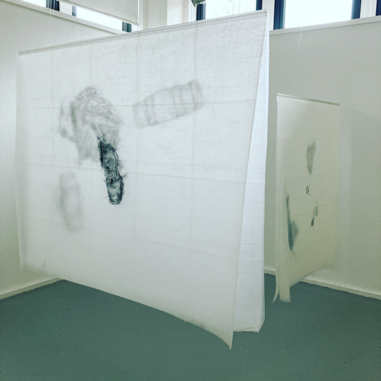

This visual essay concentrates on footwear since the lost shoe is a potent symbol of absent human presence that has been used effectively by numerous artists to reflect on loss and tragedy. The iconography of the lost shoes was used here to evoke emotional intimacy with environmental loss and to prompt reflection on the entanglement between natural and cultural heritage. My study included boots worn by a woman in the seventeenth century (Figure 2), a snowshoe dating to 3800 BCE (Figure 3), woven boot liners and legwarmers dating from sixth to eighth century BCE (Figures 4 & 5), slipper-like leather shoes from the seventeenth and eighteenth centuries (Figure 6), boots from 1940 (Figure 7), and a fragment of a leather sandal from 2900-2700 BCE that is so vulnerable to decomposition that it was housed in its own atmospherically controlled Perspex box within the vitrine.

Figure 2 Drawing of a boot from the seventeenth century found on the Porchabella glacier. From the Emergency! series. ©Sarah Casey. Image credit Benjamin Jones Photography.
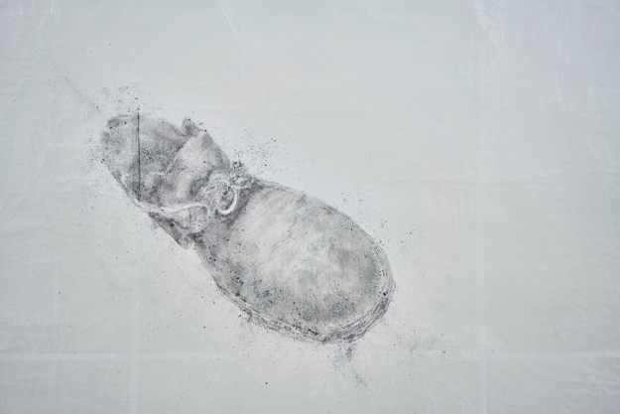

Figure 3 Drawing of a snowshoe from 3800 BCE. ©Sarah Casey. Image credit Sarah Casey.
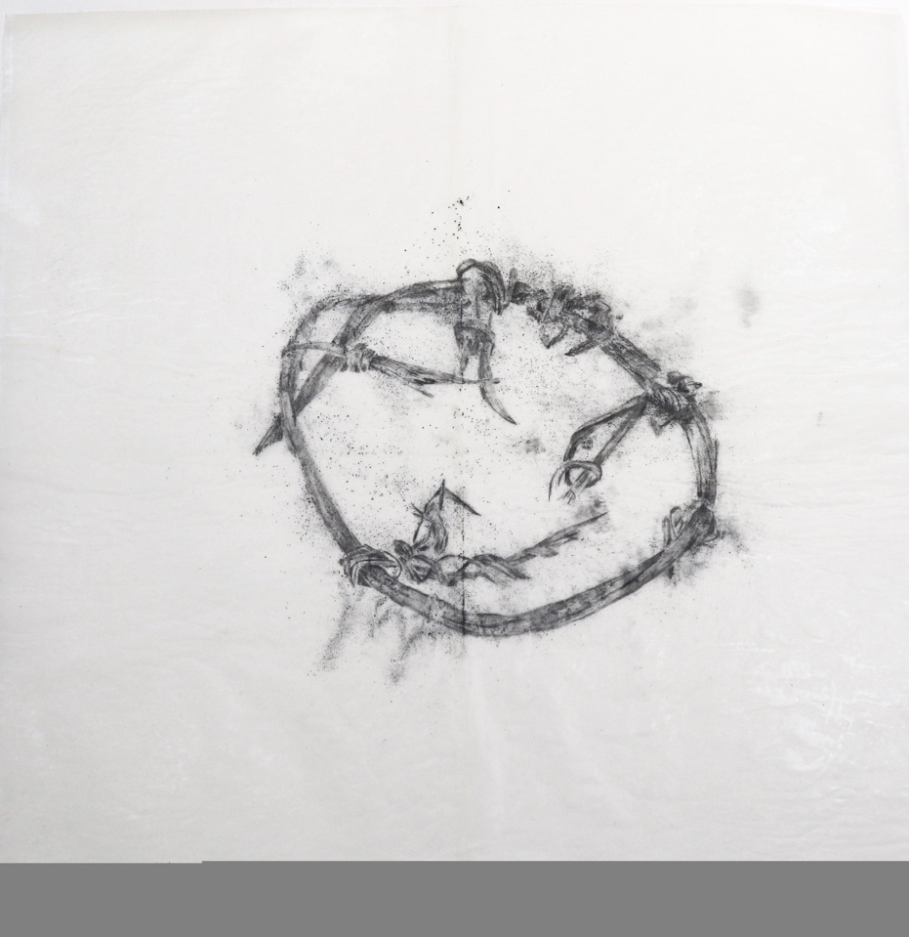
Figure 4 Installation shot showing a drawing of boot liner dating from sixth-eighth century BCE layered up with drawings of other personal accessories from the Emergency! series. ©Sarah Casey. Image credit Benjamin Jones Photography.
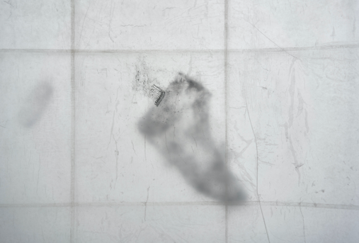

Figure 5 Drawing of legwarmers dating from sixth-eighth century BCE ©Sarah Casey. Image credit Benjamin Jones Photography.
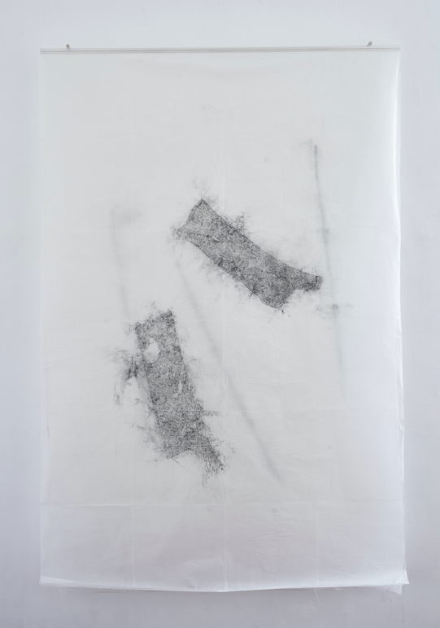

Figure 6 Drawing of shoes from the early seventeeth and late eighteenth centuries from the Emergency! series. ©Sarah Casey. Image credit Sarah Casey.
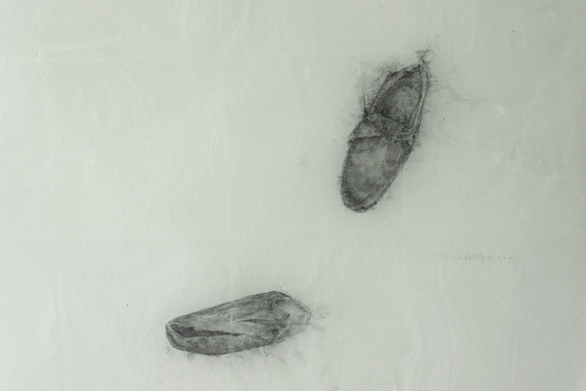

Figure 7 Drawing of shoes from 1940 from the Emergency! series. ©Sarah Casey. Image credit Benjamin Jones Photography.
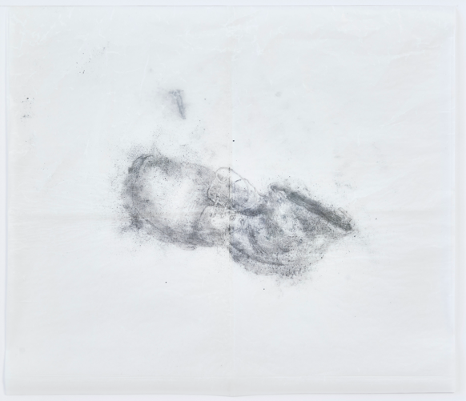

Shoes are visual evidence of entangled histories of makers, wearers, and landscapes. Each is marked by clues that can reveal aspects of its life before and after being buried under ice including information about technology, wayfaring, communications, and spiritual life. Notably, the nails of hobnail boots act as a reminder that footwear technologies have been in use for a millennium. Redrawing the footwear that has emerged from the melting glacier was a process of reflecting upon and documenting the complex histories of each. This involved finding a method of drawing that echoed the sense of layered time within the glacier itself and of the emergent artifacts being suspended and subjected to the vagaries of environmental forces. The drawing method sought to show specific details of the shoes, while also creating a tantalizing sense of the object slipping out of our grasp akin to the melting of the ice.
The outcome was a series of large, layered drawings made with graphite dust encased inside wafer-thin sheets of waxed paper fused together with heat. Visually, this surface took on a reflective sheen with craquelure reminiscent of ice. Lifted from the table and hung in space, the shoes appear suspended. When several drawings are layered, the lower layers become hazy, like shadows of something out of reach or on the cusp of disappearance. Fixed by heat, the melting of wax that holds the pigment in place, but wax, like ice, melts. The drawings are subject to environmental forces including heat from the sun, body heat and light, and as such, they represent a visual and material equivalent to glacial archaeology.
Unlike terrestrial archeology, ice-bound archeological finds do not follow an orderly stratigraphy. Some sites yield finds dating from the prehistoric to the present. This sense of jumbled histories was also reflected in the presentation of the drawings. Composed of individual layers, they enact a fanciful stratigraphy, imagining the assortment of shoes and accessories layered in the ice. The sheets can be layered up interchangeably, meaning the compositions seen in these images are temporary, and, like glaciers, are also contingent.

Figure 8 Installation view of Emergency! exhibition at Drawing Projects UK. Image credit Benjamin Jones Photography.
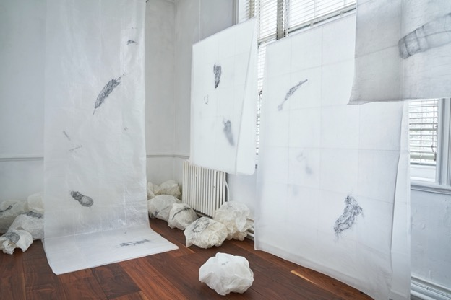

Intended to be displayed unframed, the drawings were presented in a way that made them vulnerable to damage (Figures 1 & 8). The format of the installation invited touch and intimate viewing, but also sought to generate an awareness of responsibility in the viewer since drawing has the capacity to awaken “kinetic responses in the viewer.” Drawing is mediated through hand and brain, and the extended period of time spent documenting each shoe generated emotional and sensory responses. These sensations were then externalized by manipulation of the visual and material qualities of the exhibited artwork in such a way that the viewer’s encounter with the artwork echoed my own encounter with the footwear. The artworks reflected the aura of these lost shoes, the sense of their presence, and the ‘affect’ of an encounter with them — an uncanny feeling of absent presence that we get from viewing historic dress. However, in this particular case, the heightened awareness of absence and loss was channeled toward reflections on anthropogenic environmental loss and the entanglement of humans within this global crisis.
This project demonstrates the usefulness of drawing as a tool to generate alternative forms of interpretation of traces of the past. More importantly, the project also presents an example of how artistic engagement with museum collections not only facilitates communication with interdisciplinary and non-specialist audiences, but also invites reflection on the future of our planet.

Notes:

The relevance of glacial archaeology to the study of dress is supported by the fact that the arid subzero conditions of ice have preserved objects made of fugitive material such as leather and textiles that would not survive terrestrial burial. Glacial archeology has provided examples of some of earliest extant clothing. See for example, Marcel Cornelission. “Bergeis. Rock crystal from the Alps in the Mesolithic.” Institute for the Culture of the Alps. 2019. https://www.kulturen-der-alpen.ch/en/bitte-in-englisch-uebersetzen-bergeis Accessed January 7, 2022; Edward A. Jolie, Thomas F Lynch, Phil R. Geib, and J. M., Adovasio, “Cordage, Textiles, and the Late Pleistocene Peopling of the Andes,” Anthropology Faculty Publications 52, 2 (2011): 285-296; Pierre-Yves Nicod and Philippe Curdy, “Schnidi, le chasseur du Néolithique” in Laurie Tremblay Cormier (ed.), Archéologie Glaciare Vestiges des Cimes (Milan: Silvana Editoriale, 2022), 91; Marianne Vedeler and Lise Bender Jørgensen, “Out of the Norwegian Glaciers: Lendbreen- a tunic from the first millennium AD” Antiquity 87 (2013): 788-801; Alois G. Püntenera and Serge Moss, “Ötzi, the Iceman and his Leather Clothes” CHIMIA 64, 5 (2010): 315-320.
On display during my initial visit were objects from the museum’s collection and on loan from the exhibition Mémoire de Glace Vestiges en Péril, Le Musée d’histoire du Valais, Sion, October 6, 2018—March 3, 2019.
See for example, Sarah Casey, Hidden Drawers (London and Lancaster: Kensington Palace & Lancaster University, 2013); Sarah Casey, Common Grounds: Lace Drawn from The Everyday (County Durham: The Bowes Museum 2015); Ingrid Mida and Sarah Casey “Drawing as a Creative Approach to Researching Extant Garments: A Case Study Involving John Ruskin's Clothing” Costume 54, 2 (2019): 202-221.
Andrew Causey, Drawn to See Drawing as an Ethnographic Method (Toronto: University of Toronto Press, 2017); Sarah Casey and Gerry Davies, Drawing Investigations in Science Culture and Environment (London: Bloomsbury, 2020).
See for example the following artworks: Chiharu Shiota, Over the Continents (2014); Doris Salcedo, Atrabiliarios (1992/2004), Jean Shin Worn Soles (2001), Vahit Tuna, 440 Heels (2019).
For information about these shoes see: Thomas Reitmaier, Manuela Camichel, Nakita Frater, Sabrina Meyer, Roger Seiler, Martin Häusler, Frank Rühli, Marquita and Serge Volken, “Une dépouille féminine des environs de 1690 dans le Grisons” in Laurie Tremblay Cormier (ed.), Archéologie Glaciare Vestiges des Cimes (Milan: Silvana editorial, 2022), 113-121; Pierre-Yves Nicod and Philippe Curdy “Le ‘Mercenaire’ du Théodule” in Laurie Tremblay Cormier (ed.) Archéologie Glaciare Vestiges des Cimes (Milan: Silvana editoriale, 2022), 99; Regula Gubler, “Bergausrüstungen aus dem Eis der Alpen” in Dossier «Gletscherarchäologie» – «Archéologie glaciaire» Bulletin Schweizerische Akademie der Geistes 2 (2019), 47.
For instance, repairs to shoes testify to practices of care. See Regula Gubler, Archaeology of the Schnidejoch, trans. Andrew Lawrence (Bern: Archäologischer Dienst des Kantons Bern, 2019) 2. See also Pierre-Yves Nicod and Philippe Curdy, “Archéologie glaciare dans les alpes suisses” in Laurie Tremblay Cormier (ed.) Archéologie Glaciare Vestiges des Cimes (Milan: Silvana Editoriale, 2022), 81-90.
Pierre-Yves Nicod and Philippe Curdy, “Glacial Archaeology in the Swiss Alps” in Emergency!, ed. Sarah Casey (Trowbridge: Drawing Projects UK, 2023), 13.
Gubler, Archaeology of the Schnidejoch, 2.
Philip Rawson, Seeing Through Drawing (London: BBC 1979), 27.

