CASE STUDY

An Updated Show of Hands
Helen Berrington, Learning Development/Department of Mathematics & Statistics, Lancaster University, Lancaster, United Kingdom. Email: h.berrington@lancaster.ac.uk
Anna Karapiperi, Learning Development, Lancaster University, Lancaster, United Kingdom. Email: a.karapiperi@lancaster.ac.uk
Eleftherios Kastis, Learning Development/Department of Mathematics & Statistics, Lancaster University, Lancaster, United Kingdom. Email: l.kastis@lancaster.ac.uk
Abstract
It is a tried and tested technique to gauge the overall understanding of a class: a multiple-choice quiz with a show of hands for who thinks the answer is a, b or c. Although quick and easy, how much does it really measure the students’ understanding? On top of that, how useful is it as an informal formative assessment? A few students usually dominate the class and less confident students may not put up their hand, or may follow what their classmates are doing, and hence both the learner and educator may never know the individuals’ true answer.
Here we discuss “an updated show of hands”, whereby students scan a QR code to take them to a real-time quiz hosted on Moodle Virtual Learning Environment (VLE) that they can answer on their smart device. All students answer the same question at the same time, and after a set time, the correct answer is revealed and the class results for that question are then displayed to everyone as an anonymous percentage. Whilst this updated method has the obvious advantage of anonymity and the obvious disadvantage of potential technical problems, in this case study we provide full description of the implementation and an in-depth discussion on the pedagogy and practicalities of the updated show of hands – the real-time smart device quiz.
Keywords: Smart Device Quiz, QR Code, Interactivity, Digital Technology, Student Engagement.

Introduction
As educators, we are continuously looking for ways to update teaching methods and approaches. Whilst the move to online teaching in 2020 brought with it many challenges, it also introduced new ways to embrace technology in teaching, many of which can also be used in a face-to-face classroom setting. Almost all students at Lancaster University bring a smart device to teaching sessions (since attendance recording also requires the use of a smart device) and hence we can make use of this technology within the session itself.
A traditional show of hands is a well-used technique when teaching groups of students to assess the group’s understanding of a topic. It might be a multiple-choice quiz, or a true or false question, where students are asked to raise their hands in favour of a particular response. However, there are reasons why this technique may not truly assess the group’s understanding, nor act as a useful learning exercise for the students themselves. For example, stronger or more confident students may dominate, with less confident students waiting to see what others answer before raising their own hand. Some students may not even raise their hand at all, especially if they are worried about answering incorrectly in front of their peers. Cold calling techniques may not be appropriate in many teaching sessions, where there is time pressure that hinders students’ self-confidence (Lemov, 2021) as well as many other anxiety inducing factors related to cold calling. Therefore, we may not truly be assessing the understanding of all students as a group.
In the following section, we describe the implementation of “an updated show of hands”, using a real-time smartphone quiz, as used in an in-person teaching session. Whilst we recognise that the use of a smartphone quiz is not novel in itself (see for example Licorish et al., 2017 and Zainuddin et al., 2020) this particular implementation is noteworthy for its simplicity and efficiency. We then discuss the pedagogy and practicalities of its usage, including recommendations for future use.

Implementation

Class Setting
The Maths and Stats Hub (MASH) at Lancaster University provides additional workshops for students for a number of modules. In this case study, we focus on a face-to-face workshop on differentiation for first year Accounting & Finance students. This workshop is optional for students to attend and usually has 10-15 students attending per week. These may be students who have not studied A-Level Mathematics, or may be less confident in their maths skills and wish to have more practice and support with topics in maths. Since these classes are not compulsory, note that from week to week we may have different students. This brings extra constraints in the attempt to build student engagement.
In this particular workshop, the focus was on applying the chain, product and quotient rule to differentiate functions. Before asking students to apply these rules, there was a focus on recognising when to use each rule, which is the topic of this example.

Use of Technology
In the classroom, a PC connected to a projector screen is used to display material to the class. To fully interact in the real-time quiz, students require a device that can connect to the internet. A QR code to the quiz is generated using a web browser.
Students can either scan the QR code to take them to the web address, or can enter the URL on their laptop. For those students who for whatever reason cannot access the quiz in this way, they can still take part in the activity via a paper handout or reading from the projector screen. Although they will not experience the full interactivity, they can still attempt the quiz at the same time.
The quiz is a “Realtime Quiz” on the MASH Moodle page, which students are enrolled on. Therefore, when connecting, students are prompted to login using their University login details.

Execution
Students are asked to scan the QR code displayed on the projector screen to take them to the quiz. It is clearly labelled as a “non-assessed real-time quiz”, so that students are aware that although it is conducted through Moodle, their results will not contribute towards their grade in any way. It is also reiterated verbally that this quiz is to test their own understanding as part of their learning and is not a formal assessment.
Once students have reached the page, the class leader starts the quiz. Students are given a function and have 30 seconds to choose which rule they would use to differentiate this function. Figure 1 shows the projector view that the whole class can see, and the smart device view that the individual student sees when answering the question.
After the 30 seconds have elapsed, the correct answer is displayed both on the projector screen and the smart device. Everyone can see how many students chose each of the options, but importantly, students cannot see others individual results. For example, if three students had selected the incorrect answer, those students themselves would know their result, but the rest of the class would not know which three students they were.
Before proceeding to the next question, the class leader can take time to answer any queries or add any explanation to the question, depending on the needs of the students and their responses.
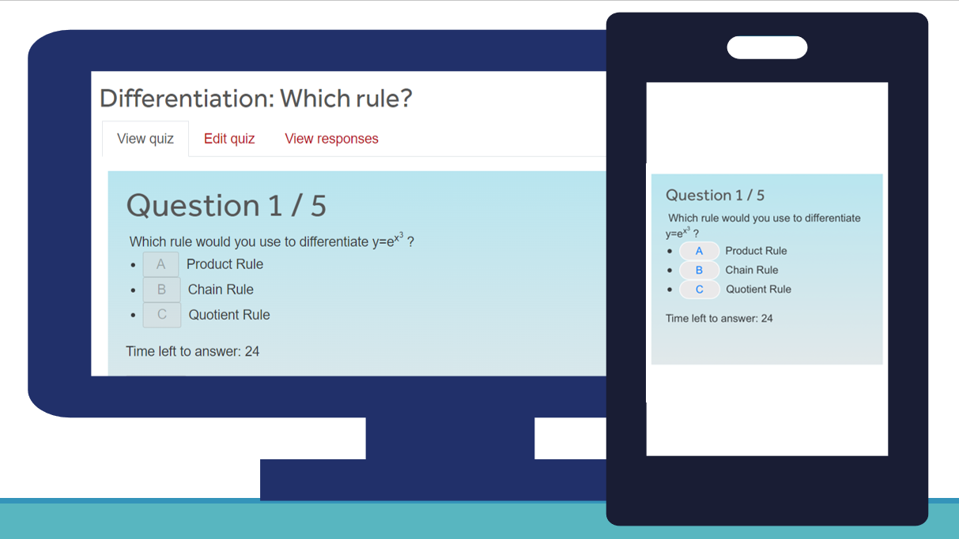
Figure 1. Projector view (left) and smart device view (right) of Realtime Quiz.
Questions continue to proceed in this way until the end of the quiz, whereupon the students can see their individual score and the overall class score. Again, students cannot see each other’s individual scores.

Results
The overall results for the quiz are available after the quiz has finished and can be viewed by the class leader (not students). Figure 2 shows a table of results for this quiz. In this way, the class leader can quickly and easily see which questions were answered in which way and therefore can adaptively plan for topics that may need more focus for this particular group of students.
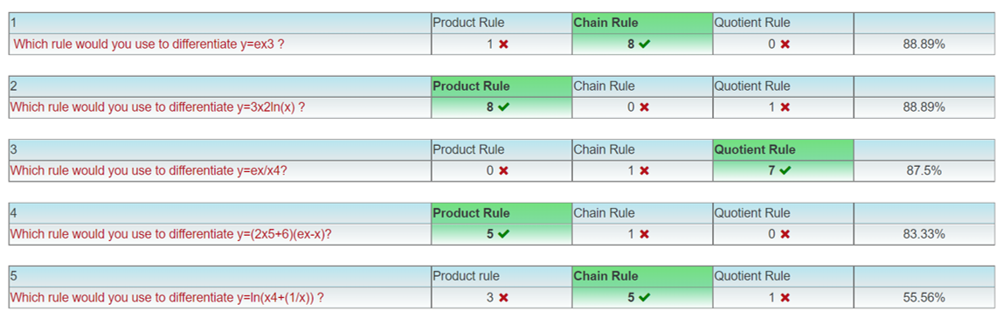
Figure 2. Table of results of Realtime Quiz, as viewed by the class leader.
A breakdown of individual results may also be viewed by the class leader privately after the class.

Discussion
The decision was made to host the quiz using the University’s VLE software, Moodle, as this gives many advantages over using a third-party software. It means that there is no cap on the number of participants, no subscriptions or additional accounts needed for staff or students, and it provides a seamless student experience within the VLE. It also gives more consistency to be used year after year, since third-party companies can often update their software without warning, which hinders forward planning. The VLE also allows for formatting of mathematical equations, which is of upmost importance in our application. The layout of the software is familiar to students, as they use it to access course materials. It is also very useful as a formative assessment, since the formatting is similar to the summative assessments used in the VLE.
One of the main advantages that the updated show of hands brings as opposed to a traditional show of hands is the anonymity of responses between the students in the class. In not seeing the responses of fellow students, it allows each student to use their own knowledge and reasoning to answer the question, giving an independence that the traditional show of hands does not allow. With the timer set for each question, this also allows students to answer the question when they are ready, without being influenced by others that may have answered earlier. In addition, the fact that others do not see their response, gives the individual more confidence to attempt the question, with less fear of embarrassment if they do not select the correct answer, which unfortunately can be ingrained from past school lessons (Royer & Walles, 2007). It has been shown that maths anxiety has a negative relationship with performance in mathematics (Zhang et al., 2019), and therefore anything we can do to reduce maths anxiety by boosting confidence is a positive step forward.
In implementation, the updated show of hands clearly is much more time-consuming to plan. Questions and answers must be thought of in advance and a QR code has to be generated. One may wonder that given how stretched many teaching staff are for planning time, if the time consuming to plan quiz is worth it, when a traditional show of hands can be done in an impromptu manner. However, once set up, such a quiz may be used year after year. There is also the very real issue of temperamental technology in the teaching session itself. Whilst digital technology can be extremely helpful in pedagogy, it must be used with caution when there is the potential of using valuable contact time solving computer problems and we must also ask ourselves if this is the best use of our time. Especially in larger class sizes, there may be many more technical issues.
When implemented, the updated show of hands also brings with it the advantage that the results are recorded. This not only makes judging the proportions of correctly answered questions much easier, but gives a useful record that can be revisited when planning further activities.

Aspects to Consider for Future Implementation
Here we presented the updated show of hands as used in our optional small group workshops. When considering whether to use the updated or traditional method, a number of factors must be considered.
Firstly, it is important to consider the subject matter of the quiz. Here we presented a choice of rules to use for differentiation, but we have also used it for choosing whether to use a paired or non-paired t-test in statistics. In mathematics and statistics at university level, there are limitations on what you can feasibly answer in 30 seconds. Therefore, this is a great opportunity to consider activities solely based on the solution strategy to answering questions, and not necessarily doing the individual steps to the solution (Suurtamm, et al., 2016). This can really help students understand their approach and thought processes in attempting questions; a great exercise in assessment for learning. By using a setup that appears similar to summative assessment, but has no consequence on grading, such a quiz is an opportunity for formative assessment where students can see their progress without worrying about their marks. It also gives immediate interactive feedback (Sambell, et al., 2013) after each individual question, which can be extremely helpful for learners to develop their skills in approaching mathematics exercises.
The class size and setting is important to consider, as well as any additional support needs. We anticipate the updated method works best with small to medium size classes and may be more difficult to implement smoothly in a large class size, although we have not yet tried it in the larger classes. The updated method was very useful in our MASH workshops as many of the students that come lack confidence in mathematics, and in implementing the updated version, they can gain confidence in their ability. Many students have been pleasantly surprised that their intuition guided them correctly, when they may otherwise have been afraid to raise their hand. We believe that the most important aspect to consider when choosing whether to use the updated or traditional show of hands is the benefit to learning that each activity can bring. If the updated show of hands can truly enhance the students’ learning experiences by giving a confidence boost without the risk of embarrassment, then it is a worthwhile venture.

References
Lemov, D., 2021. Teach Like a Champion 3.0: 63 Techniques that Put Students on the Path to College. 3 ed. San Francisco: Jossey-Bass.
Licorish, S.A., George, J.L., Owen, H.E. and Daniel, B., 2017, December. “Go Kahoot!” enriching classroom engagement, motivation and learning experience with games. In Proceedings of the 25th international conference on computers in education (pp. 755-764). Asia‐Pacific Society for Computers in Education.
Royer, J. M. and Walles, R., 2007. Influences of Gender, Ethnicity, and Motivation on Mathematical Performance. In: D. B. Berch & M. M. M. Mazzocco, eds. Why Is Math So Hard for Some Children?. Baltimore: Paul H. Brookes Publishing Co., pp. 349-369.
Sambell, K., McDowell, I. and Montgomery, C., 2013. Assessment for learning in higher education. 1 ed. London: Routledge.
Suurtamm, C., Thompson, D.R., Kim, R.Y., Moreno, L.D., Sayac, N., Silver, E., Ufer, S., and Vos, P., 2016. Assessment in Mathematics Education: Large-Scale Assessment and Classroom Assessment. Cham: Springer
Zainuddin, Z., Shujahat, M., Haruna, H. and Chu, S.K.W., 2020. The role of gamified e-quizzes on student learning and engagement: An interactive gamification solution for a formative assessment system. Computers & Education, 145, p.103729.
Zhang, J., Zhao, N. and Kong, Q.P., 2019, The Relationship Between Math Anxiety and Math Performance: A Meta-Analytic Investigation. Front. Psychol. 10(1613)

